TITANIC DATA CLEANING
AND PREPROCESSING
Internship Technical Task Report
Dataset: Kaggle Titanic - Machine Learning from Disaster
Tools: Python, Pandas, Matplotlib, Seaborn, Scikit-learn, uv, Git, GitHub
GitHub Repository
https://github.com/ARraj14/Titanic_Data_Cleaning_Project
September 2026

Executive Summary
This report documents the acquisition, assessment, cleaning, preprocessing, visualization, and downstream validation of the Kaggle Titanic training dataset. The original dataset contains 891 passenger records and 12 columns. Initial quality checks identified 177 missing Age values, 687 missing Cabin values, and 2 missing Embarked values. No duplicate rows or duplicate PassengerId values were found, and checks for impossible negative values in Age, Fare, SibSp, and Parch returned zero issues.
Missing Age values were imputed using the median within Pclass and Sex groups, Embarked values were filled with the mode, and the heavily incomplete Cabin field was represented through a new binary feature named Cabin_known rather than by inventing cabin numbers. Potential outliers were assessed using the 1.5×IQR rule. Because statistical outliers are not necessarily erroneous observations, Age, SibSp, and Parch values were retained. For Fare, the original values were preserved while a separate Fare_capped feature was created using an upper cap of 65.6344.
Feature engineering added FamilySize and IsAlone. The final cleaned dataset contained 891 rows and 16 columns, with zero missing values in the ten model features and zero duplicated rows. A Scikit-learn ColumnTransformer and Pipeline standardized numerical features, one-hot encoded categorical features, and trained a Logistic Regression classifier on an 80:20 stratified split. The model achieved 79.89% test accuracy. This model is included as a downstream usability check rather than as an attempt to optimize prediction performance.

Contents
1. Introduction
2. Objectives
3. Dataset Selection and Collection
4. Tools and Project Structure
5. Initial Data Exploration
6. Data Quality Assessment
7. Missing-Value Treatment
8. Outlier Analysis and Treatment
9. Feature Engineering
10. Exploratory Analysis
11. Machine-Learning Preprocessing Pipeline
12. Model Validation Results
13. Final Dataset Validation
14. Challenges and Solutions
15. Impact of Preprocessing
16. Limitations and Future Improvements
17. Conclusion
18. References
Appendix. Key Code Snippets

1. Introduction
Data cleaning and preprocessing are fundamental stages in data science because real-world datasets frequently contain missing values, inconsistent records, extreme observations, and variables that cannot be used directly by machine-learning algorithms. Poor preprocessing can lead to misleading analysis, unstable models, or conclusions driven by data-quality problems rather than genuine patterns.
This project uses the Titanic - Machine Learning from Disaster dataset from Kaggle to demonstrate a complete and reproducible data-cleaning workflow. The work focuses on understanding the raw data, identifying quality issues, selecting defensible treatment strategies, engineering useful features, visualizing important patterns, and preparing a final feature set for downstream analysis.
A Logistic Regression model is used only as a validation step to confirm that the processed data can successfully move through a practical machine-learning pipeline. The central deliverable remains the documented cleaning and preprocessing process.

2. Objectives
- Acquire a relevant public dataset from a reliable source and document the collection method.
- Explore the dataset structure, data types, distributions, and target variable.
- Identify missing values, duplicate records, invalid values, and potential outliers.
- Apply justified strategies for missing-value handling and outlier treatment.
- Engineer additional features that preserve useful information for analysis.
- Prepare numerical and categorical features for machine learning using a structured pipeline.
- Generate visual evidence that supports data-quality and exploratory findings.
- Validate the resulting data with a simple classification model and standard evaluation metrics.
- Document challenges, preprocessing impacts, limitations, and lessons learned.

3. Dataset Selection and Collection
The selected dataset is Kaggle's Titanic - Machine Learning from Disaster dataset. The project uses train.csv because it includes the Survived target label required for validating the cleaned features. The companion test.csv file is retained in the project data folder, but it is not used by the current cleaning script or model evaluation because its survival labels are not provided.
The training file was downloaded from Kaggle and stored under data/train.csv. The raw file contains 891 rows and 12 columns.
Column | Description
PassengerId | Unique passenger identifier
Survived | Target: 0 = did not survive, 1 = survived
Pclass | Passenger class: 1, 2, or 3
Name | Passenger name
Sex | Passenger sex
Age | Passenger age
SibSp | Number of siblings/spouses aboard
Parch | Number of parents/children aboard
Ticket | Ticket identifier
Fare | Passenger fare
Cabin | Cabin identifier
Embarked | Port of embarkation: C, Q, or S

4. Tools and Project Structure
The project was developed in Visual Studio Code using Python. uv was used for environment and dependency management, while Git and GitHub were used for version control and project publishing.
- Python
- Pandas
- Matplotlib
- Seaborn
- Scikit-learn
- uv
- Visual Studio Code
- Git and GitHub
The final project organization separates source data, generated outputs, figures, and Python code. The cleaned dataset is saved as outputs/titanic_cleaned.csv and the main script is stored as src/titanic_cleaning.py.
The local learning backup script is excluded from Git tracking through .gitignore, so src/ contains only the final titanic_cleaning.py in the published repository.
Titanic_Data_Cleaning_Project/
├── data/
│ ├── train.csv
│ └── test.csv
├── outputs/
│ ├── titanic_cleaned.csv
│ └── figures/
├── src/
│ └── titanic_cleaning.py
├── .gitignore
├── .python-version
├── README.md
├── pyproject.toml
└── uv.lock

5. Initial Data Exploration
Initial exploration was performed with head(), shape, columns, dtypes, info(), and describe(). These checks established the dataset dimensions, identified categorical and numerical variables, and highlighted missing values before any transformation was applied.
DATA_PATH = Path("data/train.csv")
df = pd.read_csv(DATA_PATH)
print(df.head())
print(df.shape)
print(df.columns.tolist())
print(df.dtypes)
df.info()
print(df.describe())

Measure | Age | Fare
Mean | 29.699 | 32.2042
Median | 28.0 | 14.4542
Minimum | 0.42 | 0.0
Maximum | 80.0 | 512.3292

The large difference between the mean and median of Fare, together with a maximum fare above 500, suggested a strongly right-skewed distribution and motivated dedicated outlier analysis.

6. Data Quality Assessment

6.1 Missing Values
Column | Missing Count | Missing %
Age | 177 | 19.87%
Cabin | 687 | 77.10%
Embarked | 2 | 0.22%

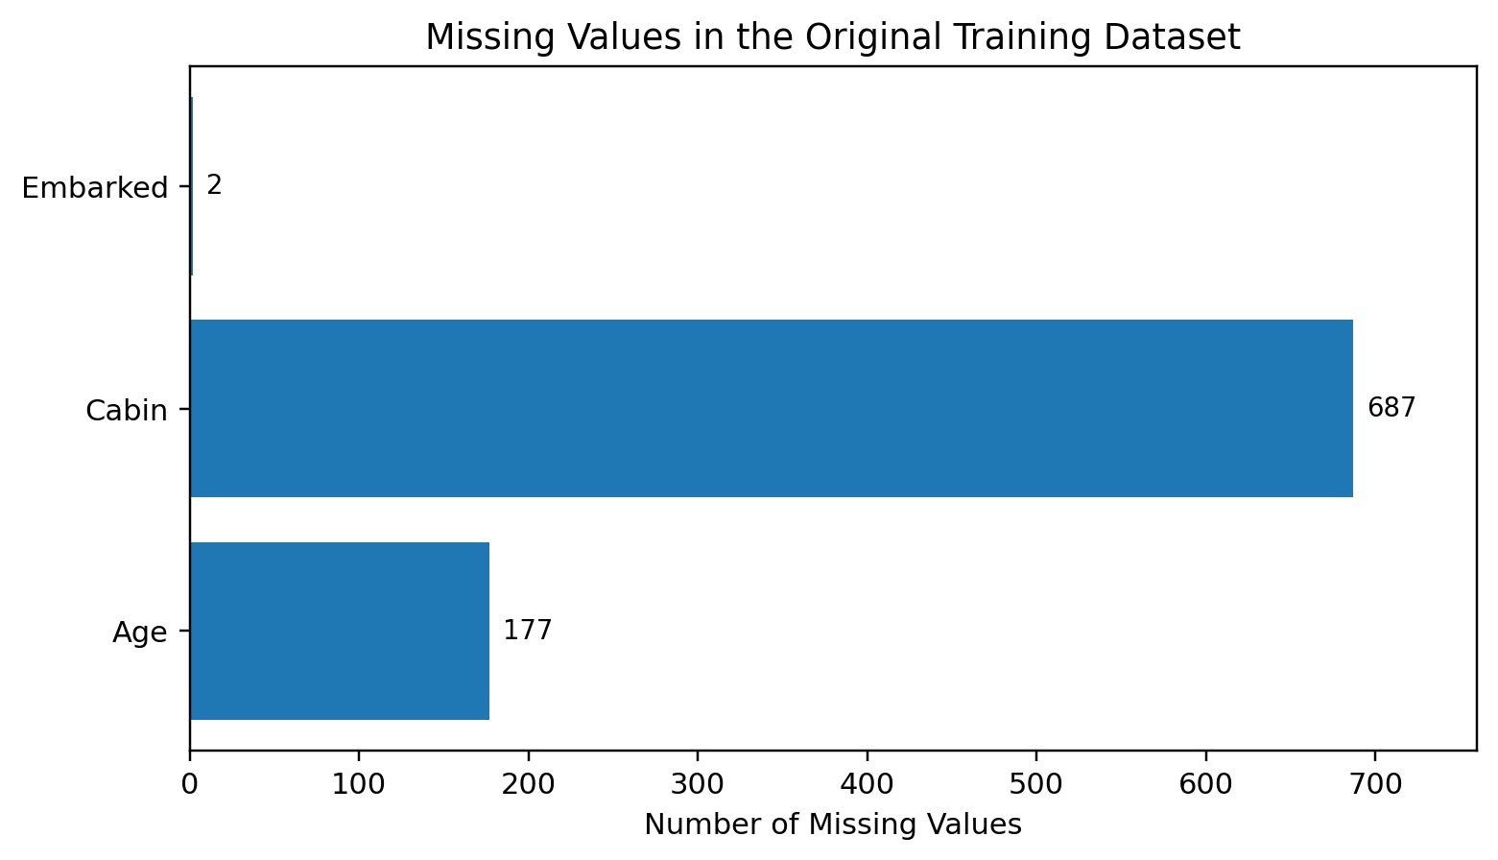
Figure 1. Missing-value counts in the original training dataset.
Cabin is missing for more than three quarters of the passengers, while Age has a moderate level of missingness and Embarked has only two missing values. These different levels of missingness justify different treatment strategies rather than a single blanket imputation rule.

6.2 Duplicate and Consistency Checks
Check | Result
Duplicate full rows | 0
Duplicate PassengerId values | 0
Negative Age values | 0
Negative Fare values | 0
Negative SibSp values | 0
Negative Parch values | 0

Categorical-value inspection also confirmed the expected values for Sex, Embarked, Pclass, and Survived. No malformed category was identified in the verified project output.

7. Missing-Value Treatment

7.1 Age
Missing Age values were filled using the median age within Pclass and Sex groups. This is more context-sensitive than applying one overall age median, because passenger age distributions can differ by travel class and sex.
cleaned_df["Age"] = cleaned_df.groupby(
["Pclass", "Sex"]
)["Age"].transform(
lambda x: x.fillna(x.median())
)

cleaned_df["Age"] = cleaned_df["Age"].fillna(
cleaned_df["Age"].median()
)

7.2 Embarked
Because only two Embarked values were missing, they were filled with the mode, i.e., the most frequent embarkation category.
cleaned_df["Embarked"] = cleaned_df["Embarked"].fillna(
cleaned_df["Embarked"].mode()[0]
)

7.3 Cabin
Cabin had 687 missing entries, so directly imputing cabin numbers would create large amounts of artificial information. Instead, the project preserved the fact that cabin information was known or unknown through a binary feature called Cabin_known. The original Cabin column remained available for audit purposes but was not used as a final model feature.
cleaned_df["Cabin_known"] = (
cleaned_df["Cabin"].notna().astype(int)
)

Cabin_known | Meaning | Count
0 | Cabin information missing | 687
1 | Cabin information available | 204

8. Outlier Analysis and Treatment
Potential outliers were detected with the 1.5×IQR rule. For each numerical variable, Q1 and Q3 were calculated, the interquartile range was defined as Q3 - Q1, and observations below Q1 - 1.5×IQR or above Q3 + 1.5×IQR were flagged.
Feature | Q1 | Q3 | IQR | Lower | Upper | Flagged
Age | 20.12 | 38.00 | 17.88 | -6.69 | 64.81 | 11
Fare | 7.91 | 31.00 | 23.09 | -26.72 | 65.63 | 116
SibSp | 0.00 | 1.00 | 1.00 | -1.50 | 2.50 | 46
Parch | 0.00 | 0.00 | 0.00 | 0.00 | 0.00 | 213

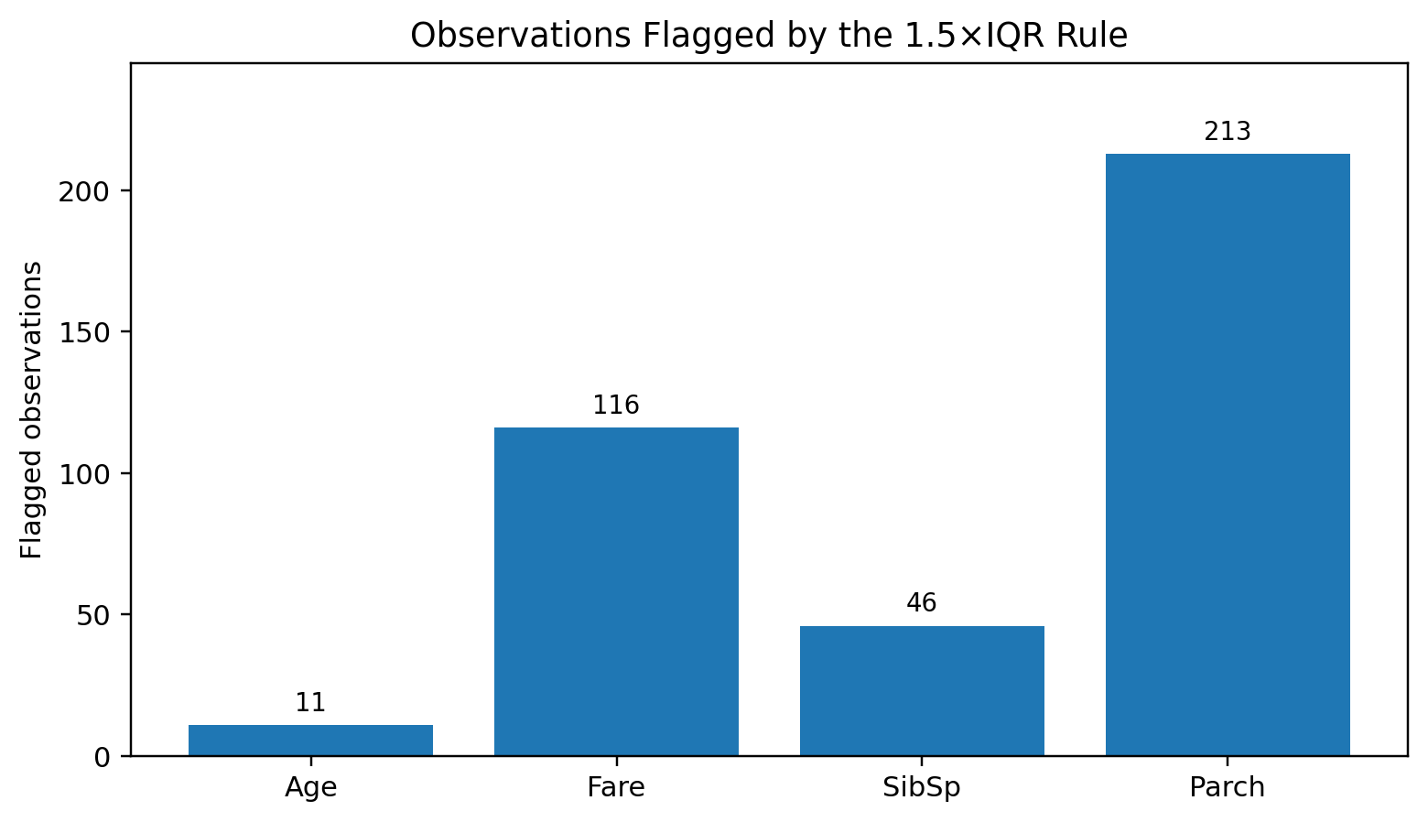
Figure 2. Number of observations flagged by the 1.5×IQR rule.
A statistical outlier is not automatically an error. Age values above the IQR boundary can still represent valid elderly passengers, and high SibSp/Parch values can represent large families. Parch is a particularly useful example of why automated deletion would be inappropriate: because both Q1 and Q3 are zero, the IQR is zero and every non-zero Parch value is flagged. This reflects the distribution of the variable, not invalid data.

8.1 Fare Capping
Fare had 116 observations above the calculated IQR boundary. These values may still be legitimate, particularly for premium accommodation or shared/group tickets, so passenger rows were not deleted. Instead, the original Fare field was retained and a separate Fare_capped feature was created at the upper IQR boundary of 65.6344.
q1 = cleaned_df["Fare"].quantile(0.25)
q3 = cleaned_df["Fare"].quantile(0.75)
iqr = q3 - q1
upper_fare_limit = q3 + (1.5 * iqr)

cleaned_df["Fare_capped"] = cleaned_df["Fare"].clip(
upper=upper_fare_limit
)

Statistic | Original Fare | Fare_capped
Mean | 32.2042 | 24.0468
Std. dev. | 49.6934 | 20.4816
Median | 14.4542 | 14.4542
75th percentile | 31.0000 | 31.0000
Maximum | 512.3292 | 65.6344

9. Feature Engineering

9.1 FamilySize
FamilySize combines the number of siblings/spouses and parents/children aboard and adds one for the passenger themself. This creates a compact measure of the passenger’s travelling family group.
cleaned_df["FamilySize"] = (
cleaned_df["SibSp"]
+ cleaned_df["Parch"]
+ 1
)

The resulting FamilySize values ranged from 1 to 11, with a median of 1.

9.2 IsAlone
IsAlone was derived from FamilySize. A value of 1 indicates FamilySize equals 1, while 0 indicates the passenger travelled with at least one family member.
cleaned_df["IsAlone"] = (
cleaned_df["FamilySize"] == 1
).astype(int)

IsAlone | Interpretation | Count
1 | Travelling alone | 537
0 | Travelling with family | 354

10. Exploratory Analysis
Exploratory plots were generated to understand important relationships in the data and to support the report narrative. These descriptive patterns are not causal claims; they summarize the observed training sample.
The final script saves a missing-value chart; boxplots for Age, Fare, SibSp, and Parch; a Fare before/after capping comparison; survival-rate charts by Sex and Pclass; an Age distribution histogram; and the final confusion-matrix heatmap. These files are written to outputs/figures/.
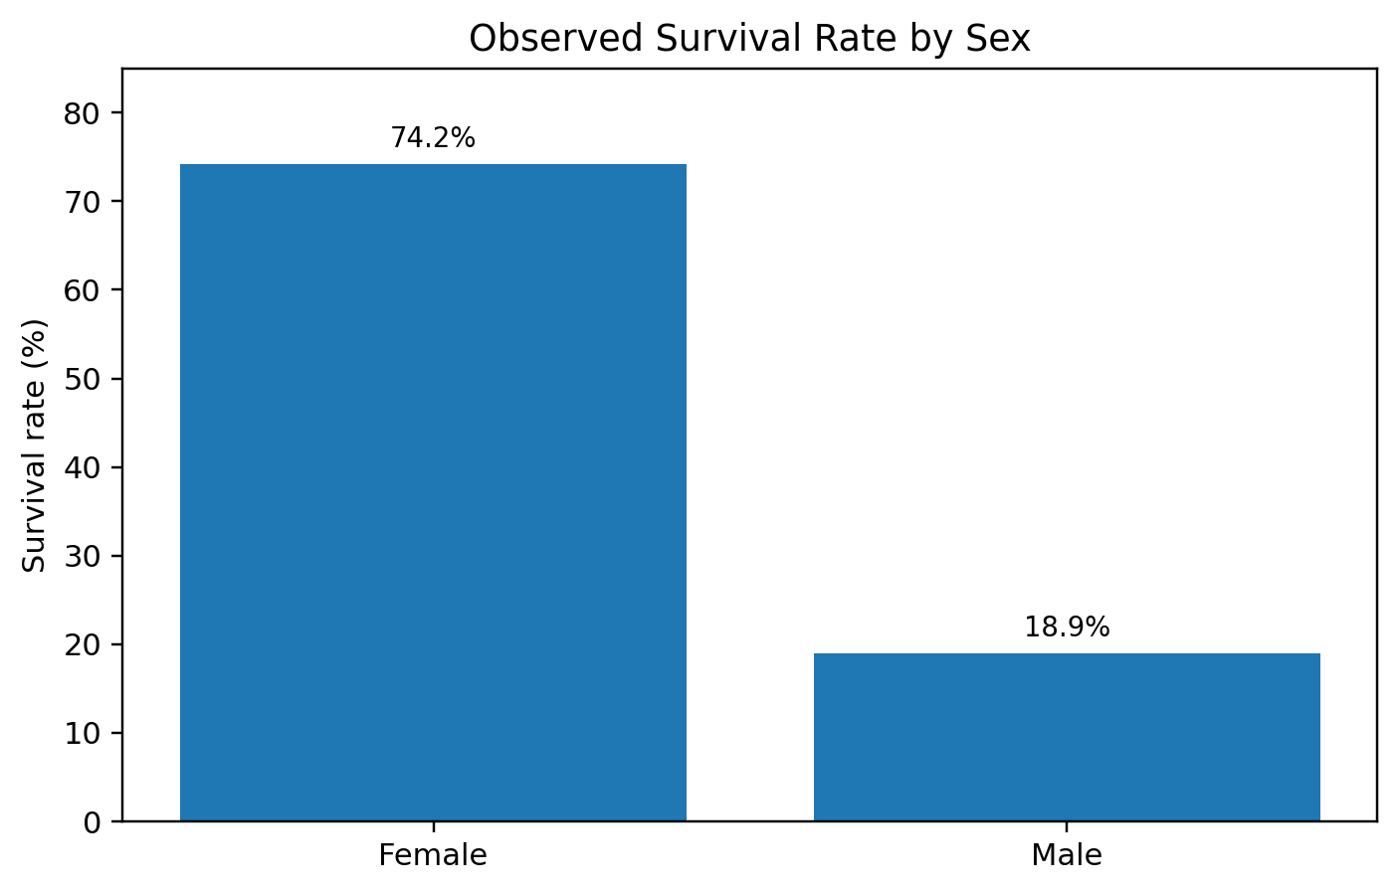
Figure 3. Observed survival rate by sex in the training dataset.
The observed survival rate was approximately 74.2% for female passengers and 18.9% for male passengers.
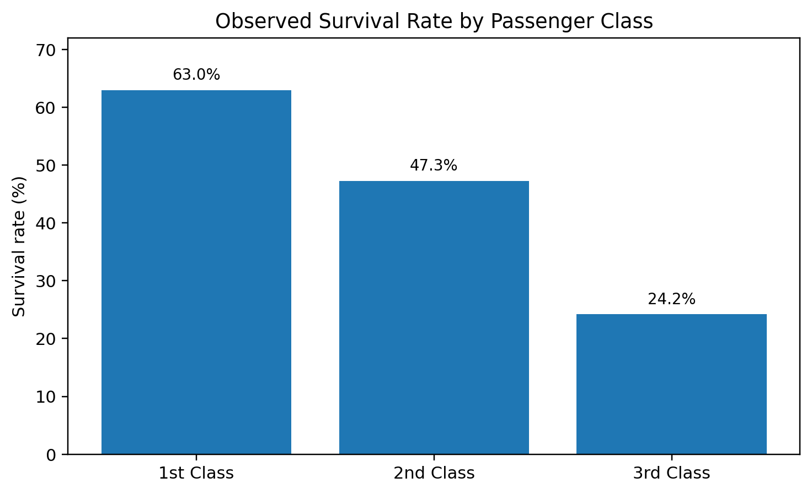
Figure 4. Observed survival rate by passenger class.
Survival also varied by passenger class: approximately 63.0% for first class, 47.3% for second class, and 24.2% for third class.

11. Machine-Learning Preprocessing Pipeline
Ten final features were selected for the downstream model. The target variable was Survived.
Feature Type | Features
Numerical / binary | Pclass, Age, SibSp, Parch, Fare_capped, Cabin_known, FamilySize, IsAlone
Categorical | Sex, Embarked
Target | Survived

The data was divided into an 80:20 training and testing split with random_state=42 and stratify=y. This produced 712 training rows and 179 test rows while maintaining class proportions.
X_train, X_test, y_train, y_test = train_test_split(
X, y,
test_size=0.2,
random_state=42,
stratify=y
)

A ColumnTransformer handled numerical and categorical columns separately. Numerical variables were median-imputed as a defensive fallback and standardized with StandardScaler. Categorical variables were mode-imputed as a defensive fallback and one-hot encoded with OneHotEncoder. These transformations were placed inside a Scikit-learn Pipeline with Logistic Regression.
preprocessor = ColumnTransformer(
transformers=[
("num", numerical_pipeline, numerical_features),
("cat", categorical_pipeline, categorical_features)
]
)

model = Pipeline(
steps=[
("preprocessor", preprocessor),
("classifier", LogisticRegression(max_iter=1000))
]
)

Because StandardScaler and OneHotEncoder are fitted inside the model pipeline after the train/test split, their learned parameters are derived from the training data and then applied to the test data.

12. Model Validation Results
The Logistic Regression model achieved a test accuracy of 0.7989, or 79.89%. The model is used as a downstream validation check: it demonstrates that the cleaned data can be transformed and used by a classifier without missing-feature failures or incompatible categorical data.
Class | Precision | Recall | F1-score | Support
0 - Did not survive | 0.82 | 0.86 | 0.84 | 110
1 - Survived | 0.76 | 0.70 | 0.73 | 69
Macro average | 0.79 | 0.78 | 0.78 | 179
Weighted average | 0.80 | 0.80 | 0.80 | 179

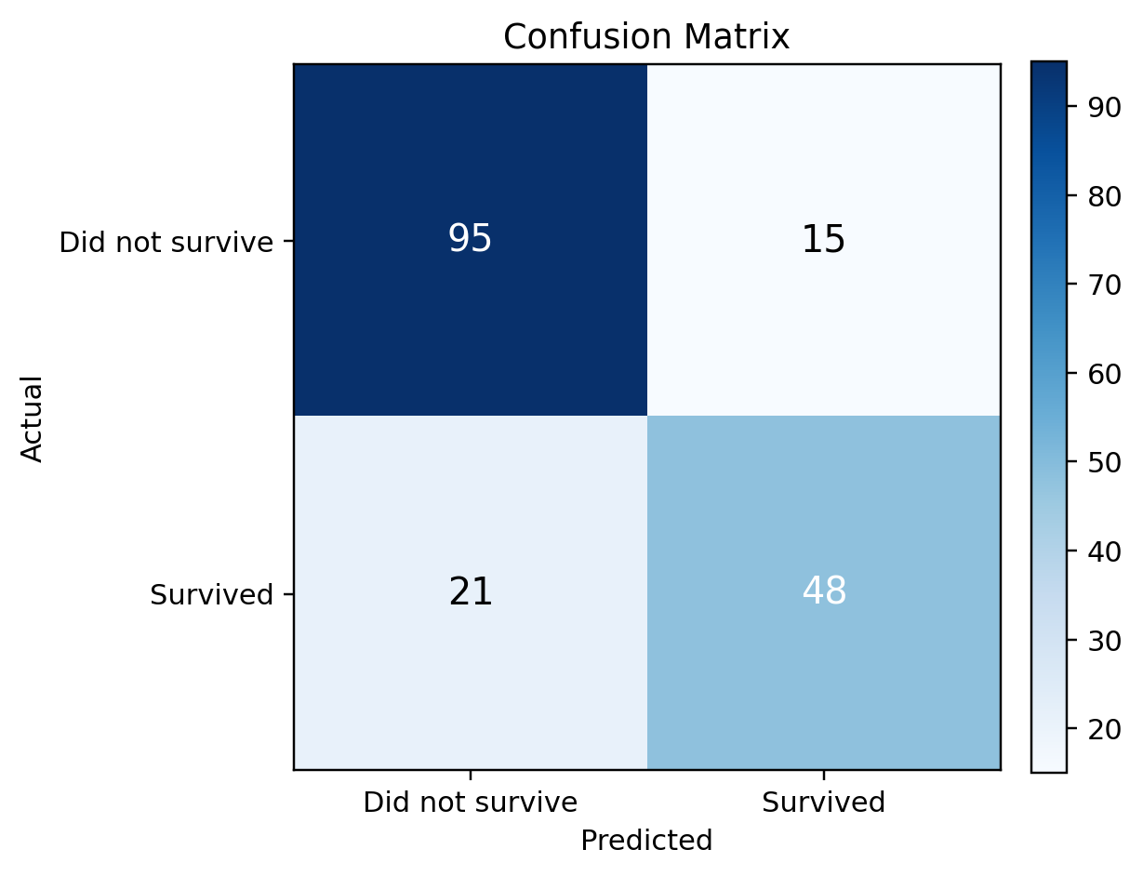
Figure 5. Confusion matrix on the 179-row test set.
The confusion matrix contains 95 true negatives, 15 false positives, 21 false negatives, and 48 true positives. Accuracy alone therefore does not describe the full model behavior; class-specific precision, recall, and F1-score provide additional context.

13. Final Dataset Validation
Validation Item | Result
Original dataset shape | (891, 12)
Cleaned dataset shape | (891, 16)
Rows removed | 0
Missing values in final model features | 0
Duplicate rows in cleaned dataset | 0
Final model feature count | 10
Saved cleaned file | outputs/titanic_cleaned.csv

The increase from 12 to 16 columns is explained by four added features: Cabin_known, Fare_capped, FamilySize, and IsAlone. The original columns were retained where useful so the transformations remained transparent and auditable.
features = [
"Pclass", "Age", "SibSp", "Parch", "Fare_capped",
"Cabin_known", "FamilySize", "IsAlone", "Sex", "Embarked"
]

cleaned_df.to_csv(
OUTPUT_DIR / "titanic_cleaned.csv",
index=False
)

14. Challenges and Solutions
Challenge | Why it matters | Solution
Different missingness patterns | Age, Cabin, and Embarked had very different levels of missingness. | Used grouped median imputation for Age, mode for Embarked, and a missingness indicator for Cabin.
Outlier interpretation | IQR flags can be mistaken for invalid data. | Reviewed the meaning of each variable and avoided automatic row deletion.
Parch with IQR = 0 | The rule flags all non-zero values when Q1 = Q3 = 0. | Treated the result as a distribution warning, not an error rule.
Extreme Fare values | Large fares can strongly influence scaled numerical inputs. | Created Fare_capped while retaining original Fare for traceability.
Categorical model inputs | Logistic Regression cannot directly consume raw strings. | Used OneHotEncoder in a ColumnTransformer pipeline.
Consistent scaling | Training and test data must receive the same learned scaling. | Fitted StandardScaler through the training pipeline and transformed test data through the same pipeline.
Project reproducibility | Local environments can differ between machines. | Used uv, pyproject.toml, uv.lock, Git, README documentation, and a GitHub repository.

15. Impact of Preprocessing
The preprocessing decisions changed both data quality and the statistical meaning of some model inputs. Imputing Age prevents the loss of 177 passenger records but replaces unknown values with estimates, which can reduce natural variability within imputed groups. Mode imputation for two Embarked values has very little effect on dataset size but still assumes that the most common category is a reasonable replacement.
Creating Cabin_known avoids inventing specific cabin identifiers while preserving the potentially informative fact that cabin information was recorded. Fare_capped reduces the influence of extreme fares on the model but deliberately changes the magnitude of high-value observations. Retaining the original Fare column makes that transformation auditable.
FamilySize and IsAlone summarize related family-travel information in forms that may be easier for downstream models to use. Standardization places numerical features on comparable scales, while one-hot encoding converts categorical variables into numeric indicators without imposing an artificial ordinal relationship.
These transformations improve machine-learning usability, but they should not be interpreted as universally optimal. Different analytical goals may justify different treatments, particularly when preserving original distributions is more important than building a predictive model.

16. Limitations and Future Improvements
The project is intentionally focused on a clear internship-level data-cleaning workflow. Several improvements could make a future predictive experiment more rigorous:
- The Age group medians, Embarked mode, and Fare cap threshold are calculated on the full cleaned dataset before the train/test split. For strict leakage control in predictive benchmarking, any statistics learned from data should be fitted only on the training set through custom transformers or other pipeline-compatible preprocessing. The StandardScaler, OneHotEncoder, and defensive SimpleImputer steps are already fitted inside the post-split Scikit-learn pipeline.
- The Logistic Regression model is a validation baseline, not a tuned competition model. Hyperparameter tuning and comparison with tree-based models could be performed in a separate modelling task.
- Name, Ticket, and Cabin text contain additional information that could support features such as title, ticket group size, or cabin deck, but those transformations were intentionally excluded to keep the cleaning task focused.
- The project uses the Kaggle training sample; conclusions from this sample should not automatically be generalized beyond the dataset without considering sampling and historical context.

17. Conclusion
This project completed a full data-cleaning and preprocessing workflow on the Titanic training dataset. The original 891-row dataset was inspected for missing values, duplicate records, invalid numerical entries, and potential outliers. Missing Age and Embarked values were treated with context-appropriate imputation, while Cabin missingness was represented by a new indicator rather than artificial cabin assignments.
Outlier analysis demonstrated that statistical flags require interpretation. Instead of removing all flagged rows, the project retained plausible passenger observations and used a separate capped Fare feature to control extreme magnitudes. FamilySize and IsAlone were engineered to summarize family-travel structure.
The final cleaned dataset contained 891 rows and 16 columns, with no missing values in the selected model features and no duplicate rows. A structured Scikit-learn preprocessing and Logistic Regression pipeline successfully processed the data and achieved 79.89% accuracy on a stratified test split. The result confirms that the cleaned data is usable for downstream machine learning while keeping the primary emphasis on transparent and reproducible preprocessing.

18. References
Kaggle. Titanic - Machine Learning from Disaster. https://www.kaggle.com/competitions/titanic/data
Pandas documentation. https://pandas.pydata.org/docs/
Scikit-learn documentation. https://scikit-learn.org/stable/
Matplotlib documentation. https://matplotlib.org/stable/
Seaborn documentation. https://seaborn.pydata.org/
Project repository. https://github.com/ARraj14/Titanic_Data_Cleaning_Project

Appendix. Key Code Snippets
The following excerpts summarize the main workflow. The complete executable script is available in the GitHub repository.

1. Missing-Value Report
missing_report = pd.DataFrame({
"Missing Count": df.isnull().sum(),
"Missing Percentage": (
df.isnull().sum() / len(df) * 100
).round(2)
})
missing_report = missing_report.sort_values(
by="Missing Count",
ascending=False
)

2. Final Feature Set
features = [
"Pclass", "Age", "SibSp", "Parch",
"Fare_capped", "Cabin_known",
"FamilySize", "IsAlone",
"Sex", "Embarked"
]
X = cleaned_df[features]
y = cleaned_df["Survived"]

3. Evaluation
model.fit(X_train, y_train)
y_pred = model.predict(X_test)

accuracy = accuracy_score(y_test, y_pred)
print(f"{accuracy:.4f}")
print(classification_report(y_test, y_pred))
print(confusion_matrix(y_test, y_pred))

