EXPLORATORY DATA ANALYSIS
AND VISUALIZATION
Titanic - Machine Learning from Disaster Dataset
Week 2 Internship Task Report
Prepared by: Rishi Raj
Data Science with Python Internship
September 2026

1. Introduction
Exploratory Data Analysis (EDA) is the process of examining a dataset through summary statistics and visualizations in order to understand its structure, distributions, relationships, and unusual patterns before formal modeling. This report performs EDA on the cleaned Titanic passenger dataset produced during Week 1 of the internship. The analysis uses Pandas for data manipulation and aggregation, and Matplotlib and Seaborn for visualization.
The central analytical question is how passenger characteristics such as sex, passenger class, age, fare, embarkation port, family size, travel status, and cabin-information availability relate to survival. The report emphasizes descriptive patterns rather than causal claims.

1.1 Objectives
- Summarize the structure and descriptive statistics of the cleaned Titanic dataset.
- Perform univariate analysis to understand the distribution of major variables.
- Perform bivariate analysis to examine how survival varies across passenger characteristics.
- Perform multivariate analysis to study interacting factors such as sex, passenger class, fare, and cabin availability.
- Use correlation analysis to identify linear relationships among numerical and engineered features.
- Interpret the visualizations critically, including important limitations created by preprocessing and small subgroup sizes.

2. Dataset and Data Preparation
The analysis uses the public Titanic dataset from the Kaggle competition “Titanic - Machine Learning from Disaster.” The cleaned dataset contains 891 passenger records. The original Week 1 preprocessing workflow retained the original variables and added engineered features that are useful for EDA.
Feature | Description
Survived | Target variable: 0 = did not survive, 1 = survived
Pclass | Passenger class: 1st, 2nd, or 3rd class
Sex | Passenger sex
Age | Passenger age; missing values were imputed during Week 1
Fare_capped | Fare after upper-outlier capping at 65.6344
Embarked | Port of embarkation: Southampton, Cherbourg, or Queenstown
Cabin_known | 1 when cabin information was recorded, otherwise 0
FamilySize | SibSp + Parch + 1
IsAlone | 1 when FamilySize = 1, otherwise 0

2.1 Data Transformations Used in the EDA
The EDA intentionally uses the cleaned Week 1 dataset rather than repeating the cleaning process. Missing Age values had been imputed using the median within passenger-class and sex groups, with a global median fallback. Missing Embarked values were filled using the mode. Because Cabin contained extensive missingness, a binary Cabin_known feature was created instead of imputing cabin numbers. Fare outliers were capped using the IQR-based upper limit, and FamilySize and IsAlone were engineered from SibSp and Parch.
The original Cabin column remains in the saved dataset and therefore still contains 687 missing entries. This is intentional: the analysis-ready Cabin_known feature has no missing values and preserves the useful distinction between recorded and unrecorded cabin information.

2.2 Libraries and Setup
from pathlib import Path
import matplotlib.pyplot as plt
import pandas as pd
import seaborn as sns
PROJECT_ROOT = Path(__file__).resolve().parents[1]
DATA_PATH = PROJECT_ROOT / "outputs" / "titanic_cleaned.csv"
EDA_OUTPUT_DIR = PROJECT_ROOT / "outputs" / "eda_figures"
df = pd.read_csv(DATA_PATH)

3. Initial Dataset Analysis
The cleaned dataset contains 891 rows and 16 stored columns. No duplicate rows were detected. All variables used directly in the EDA are complete; the only remaining missingness occurs in the original Cabin column, which is retained for traceability.
Measure | Result
Dataset shape | 891 rows x 16 columns
Duplicate rows | 0
Overall survival rate | 38.38%
Mean age | 29.11 years
Median age | 26 years
Mean capped fare | 24.05
Passengers travelling alone | 60.27%
Passengers with known cabin information | 22.90%

4. Univariate Analysis
Univariate analysis examines one variable at a time. It establishes the basic composition of the passenger population before relationships with survival are studied.

4.1 Survival and Passenger Composition
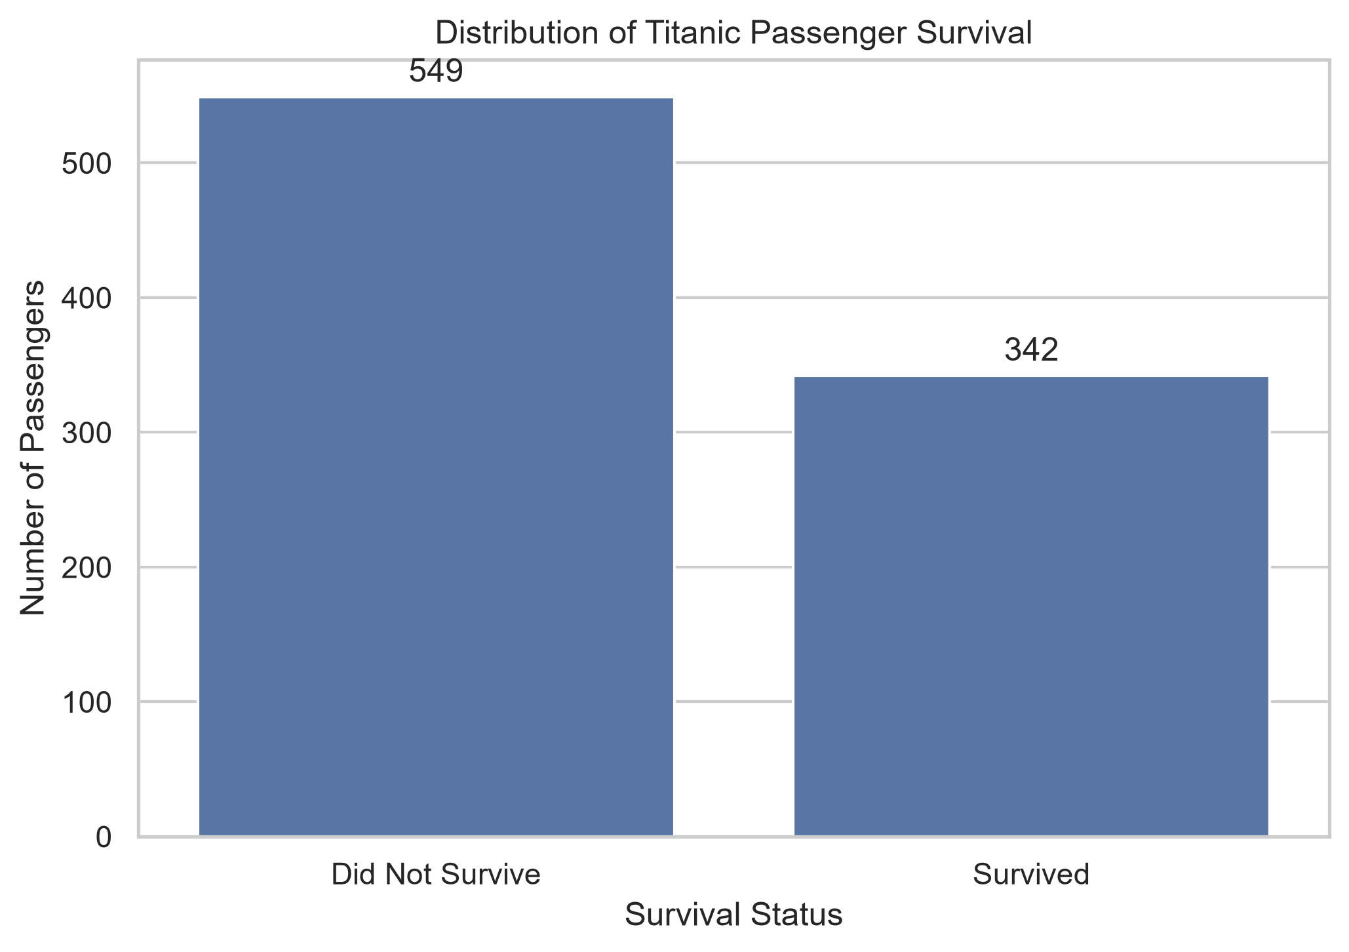  Figure 1. Passenger survival distribution | 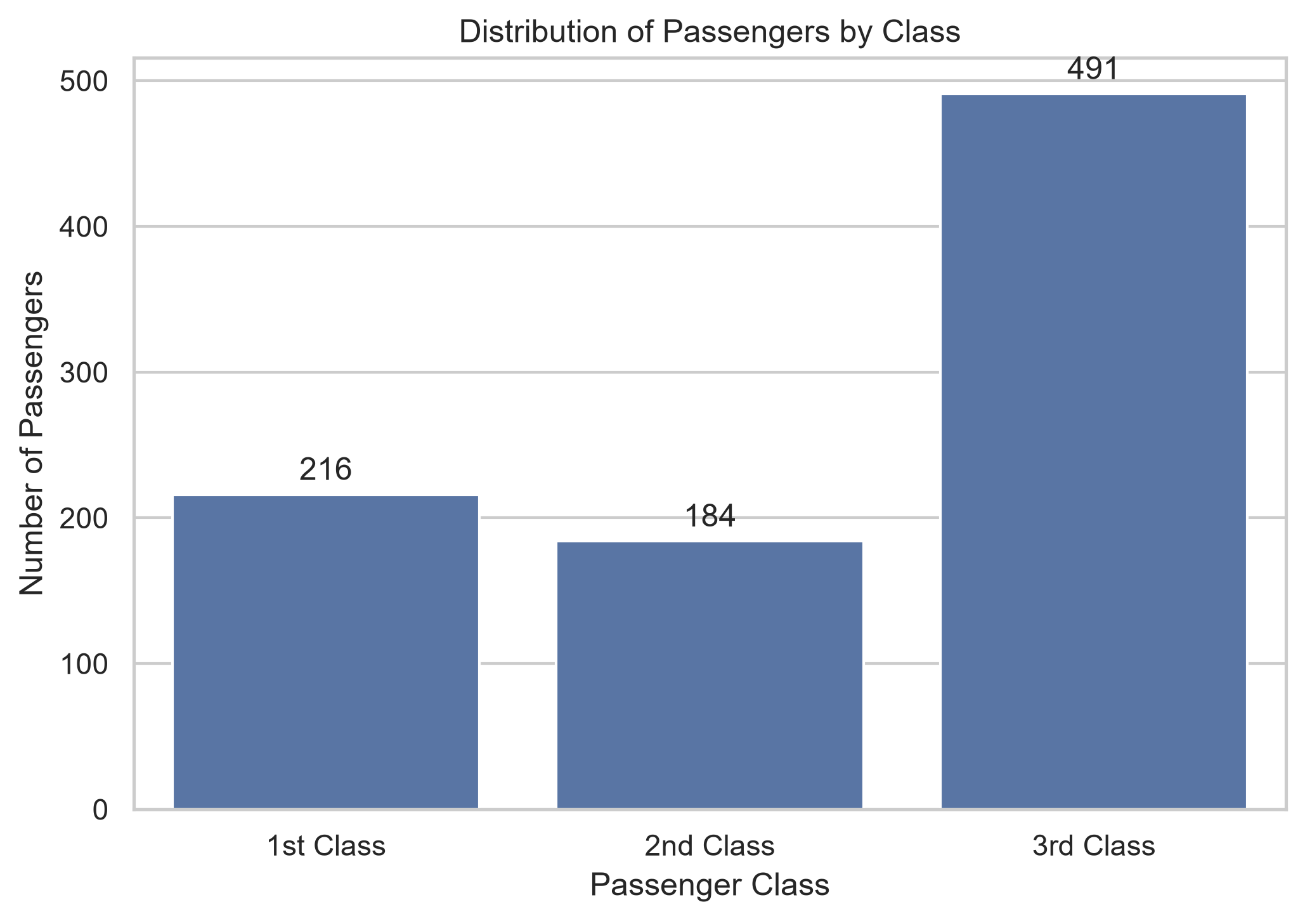  Figure 2. Passenger class distribution

Of the 891 passengers, 549 (61.62%) did not survive and 342 (38.38%) survived. The passenger-class distribution is uneven: 491 passengers were in 3rd class, compared with 216 in 1st class and 184 in 2nd class. This class imbalance is important when interpreting later survival comparisons.
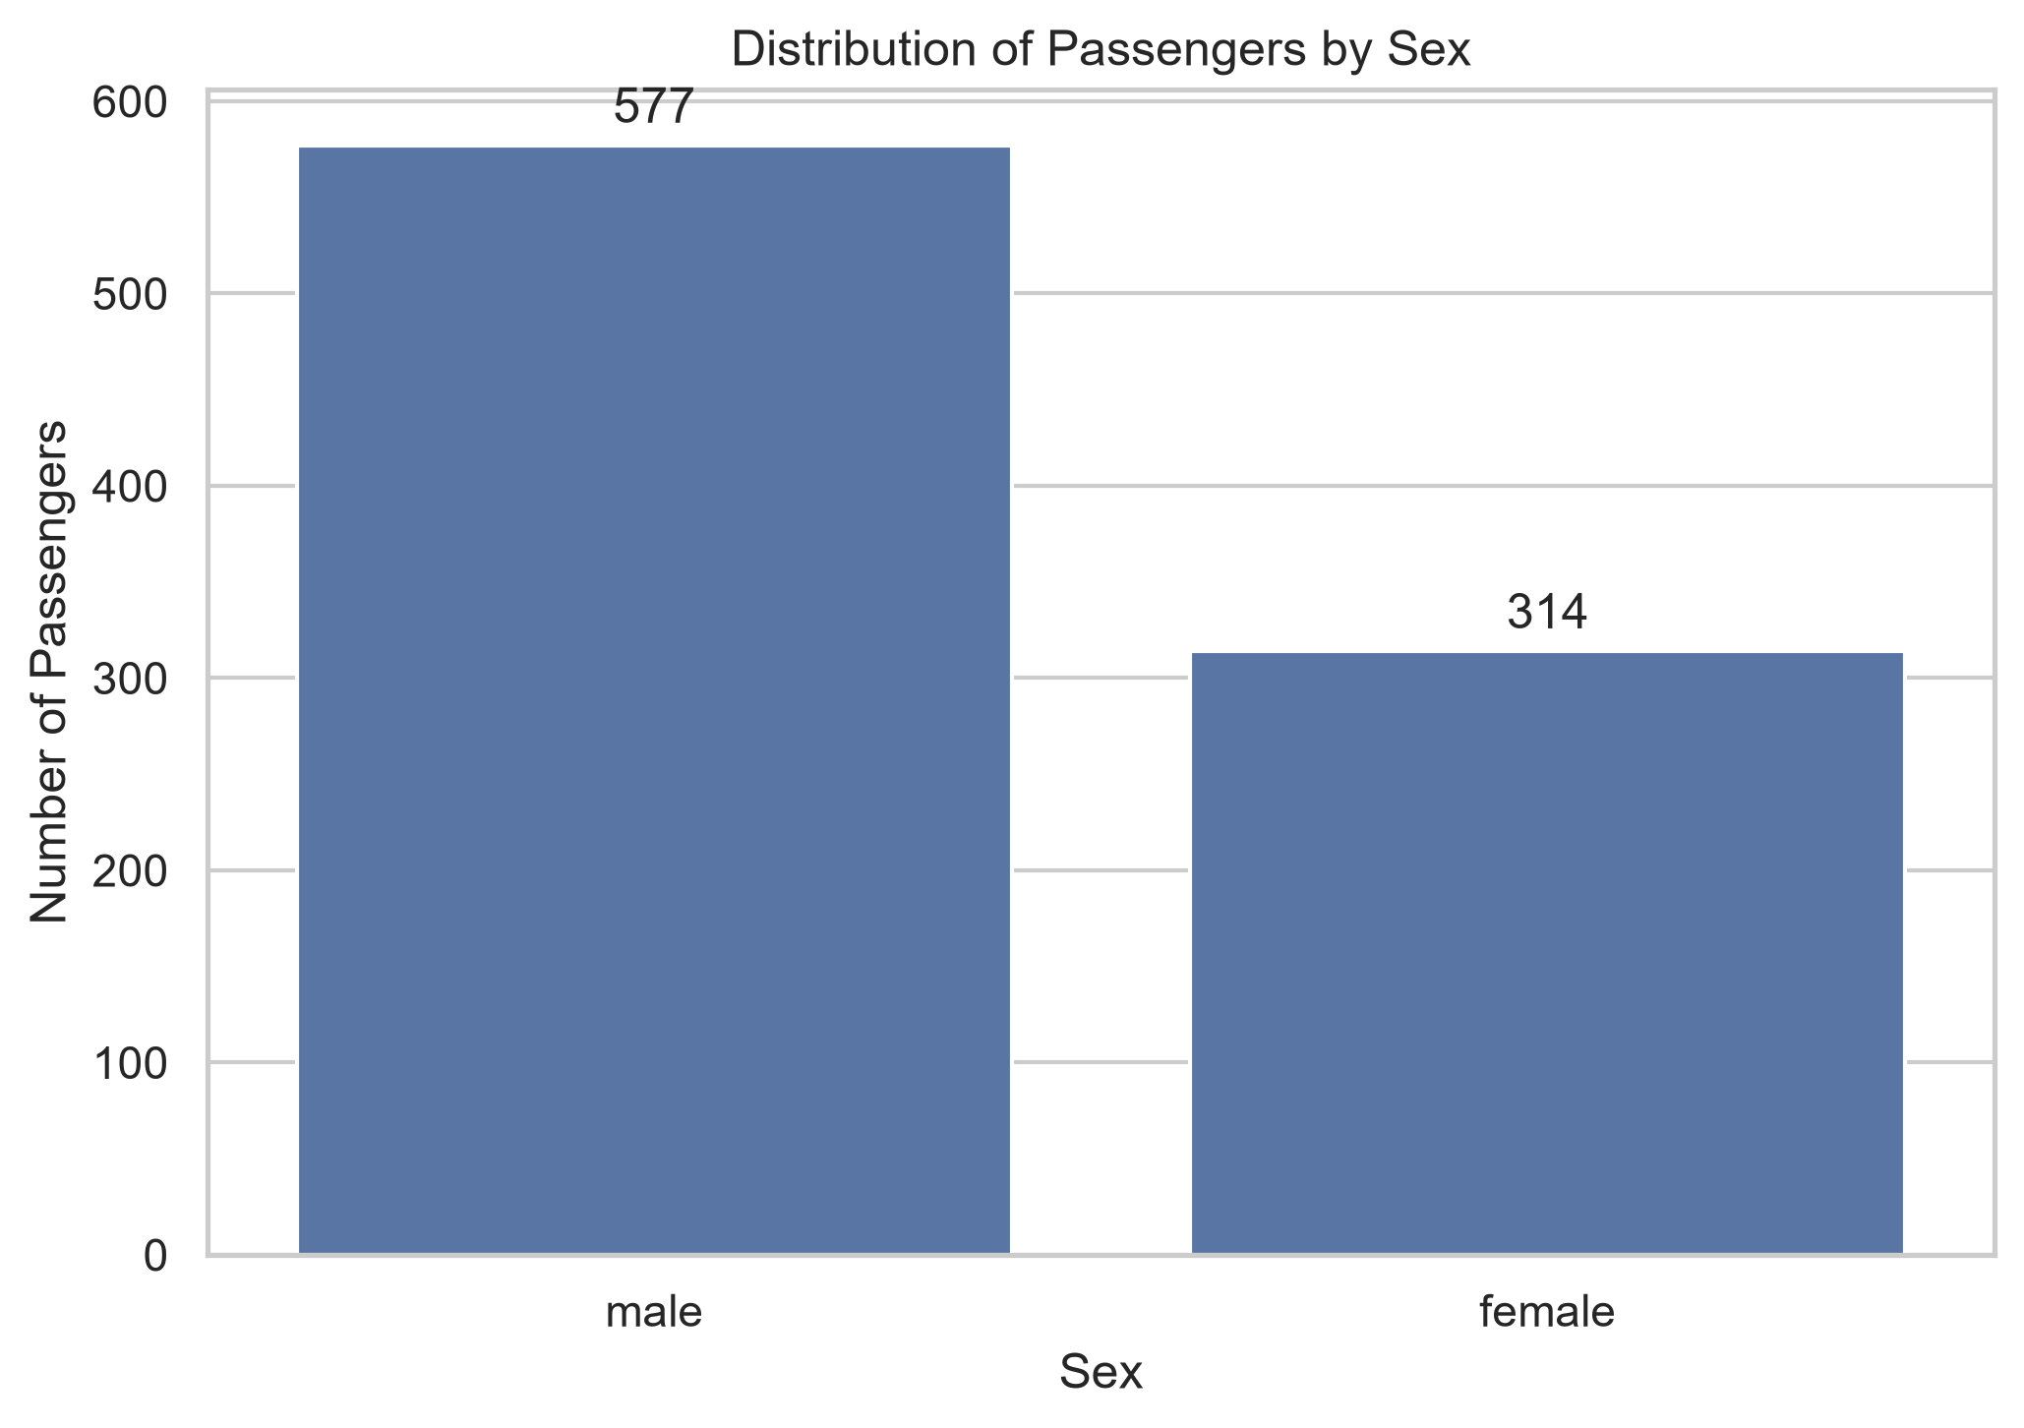  Figure 3. Passenger distribution by sex | 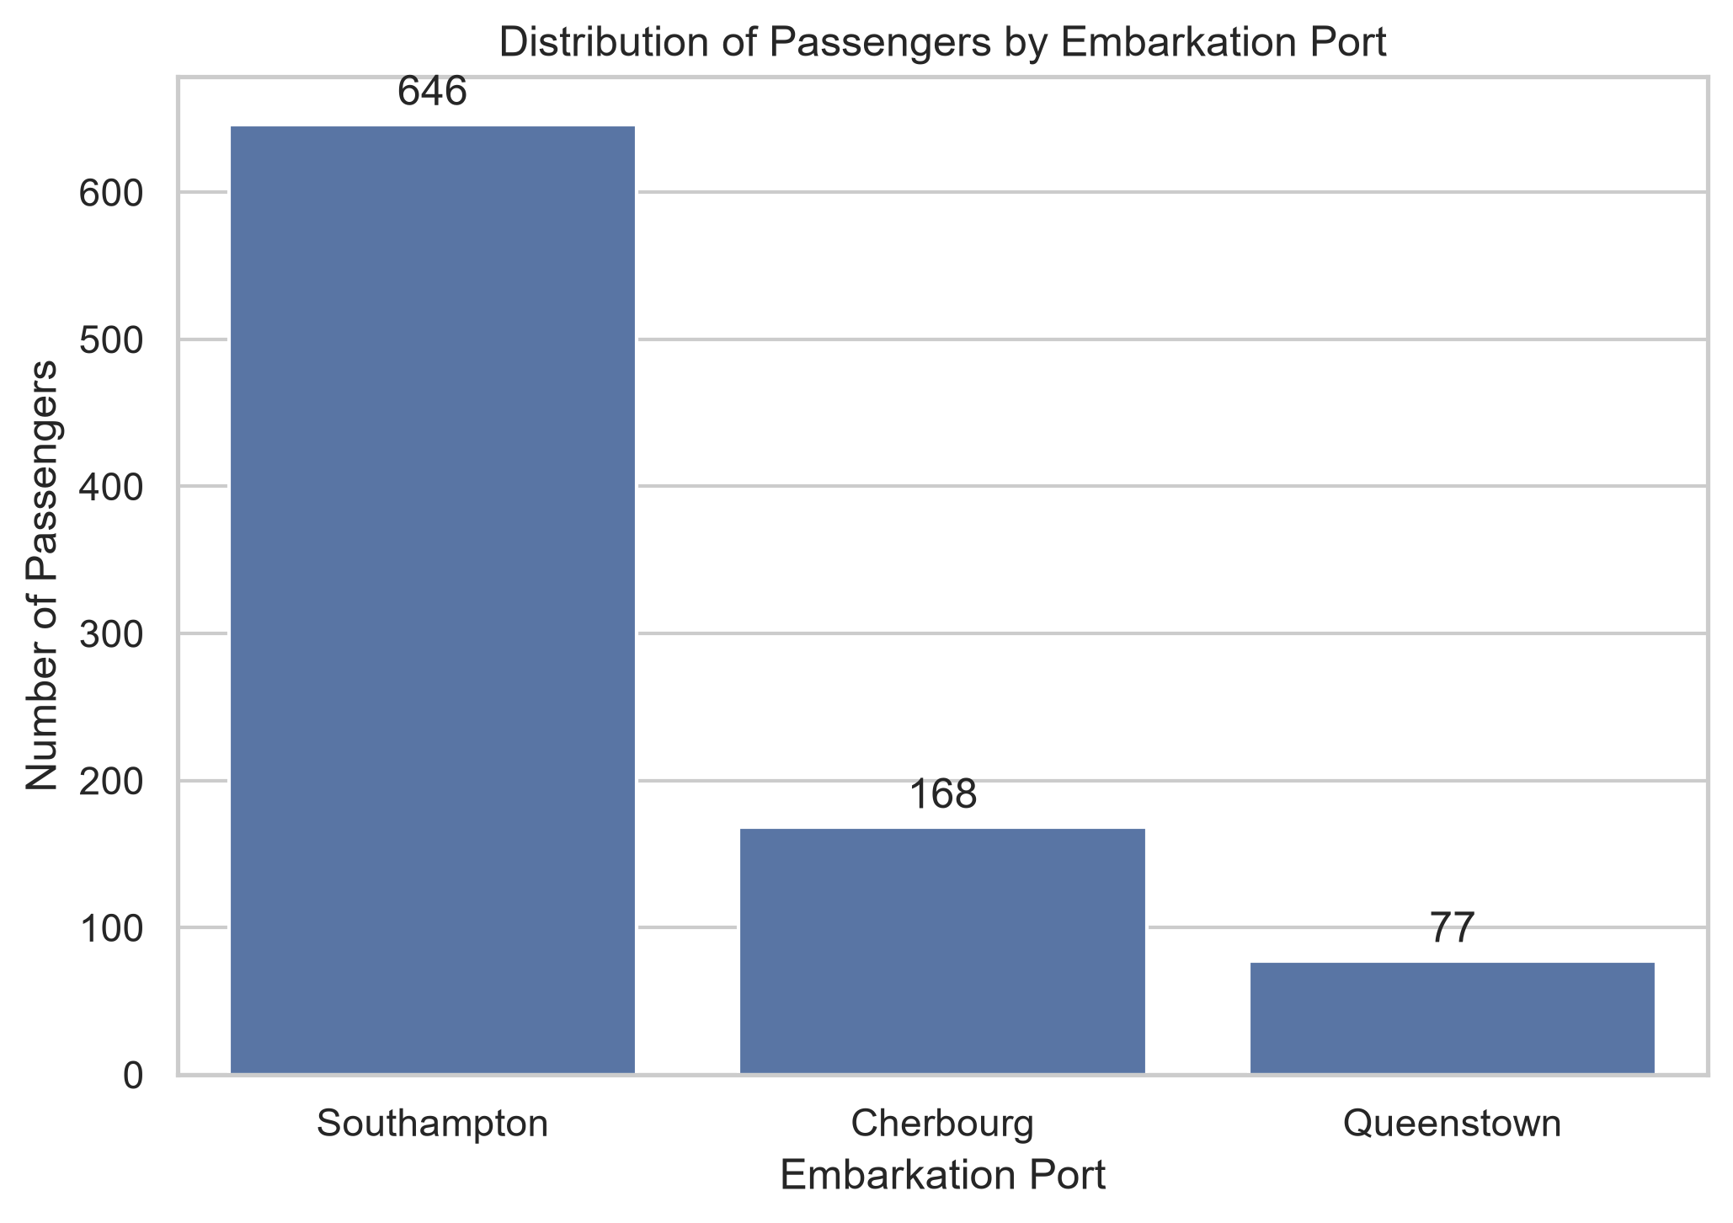  Figure 4. Distribution by embarkation port

The dataset contains 577 male and 314 female passengers. Southampton was the dominant embarkation port with 646 passengers (72.50%), followed by Cherbourg with 168 (18.86%) and Queenstown with 77 (8.64%).

4.2 Age and Fare Distributions
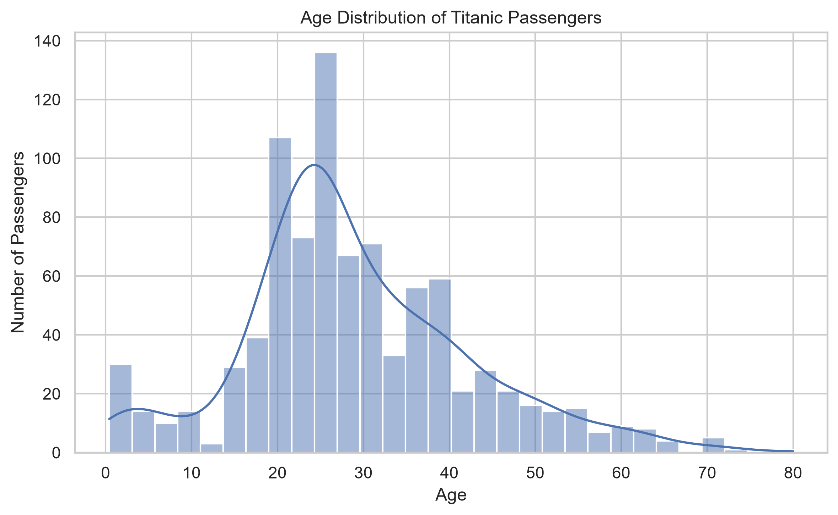  Figure 5. Age distribution | 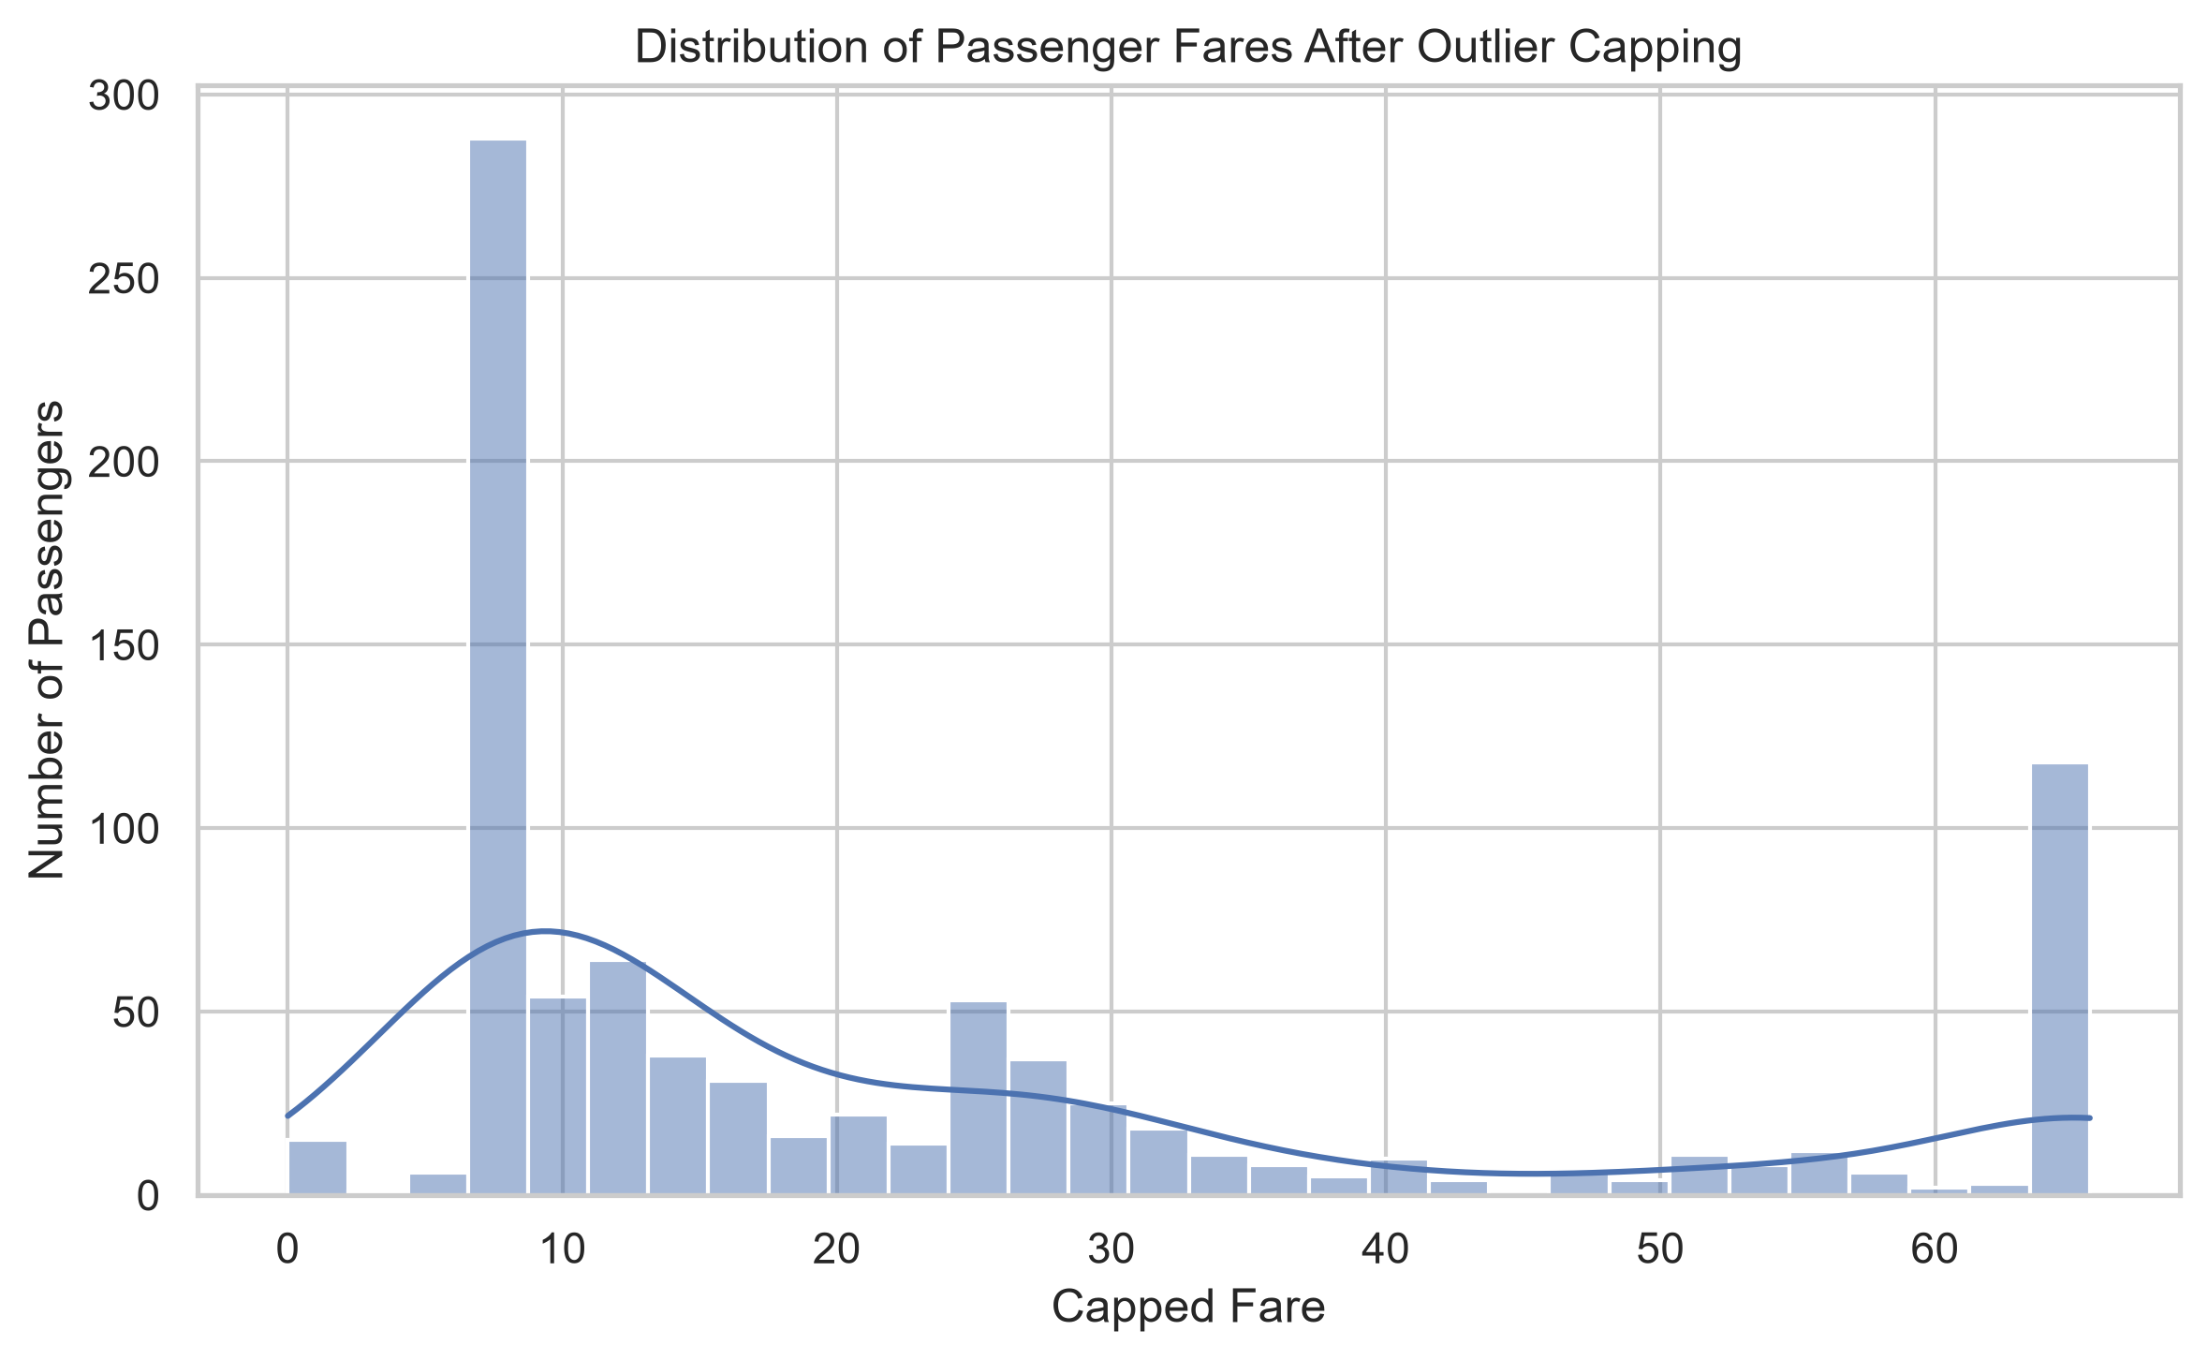  Figure 6. Capped fare distribution

Passenger ages range from 0.42 to 80 years, with a mean of 29.11 years and median of 26 years. The age histogram is concentrated around young adulthood. Because missing Age values were imputed during preprocessing, the distribution represents the cleaned variable rather than only originally observed ages.
The Fare_capped variable has a median of 14.45 and maximum of 65.6344. The visible accumulation at the upper boundary is a direct consequence of outlier capping: all fares above the IQR-based upper limit were set to the same threshold. This improves visual readability but should be remembered when interpreting the upper tail.

4.3 Family and Cabin Characteristics
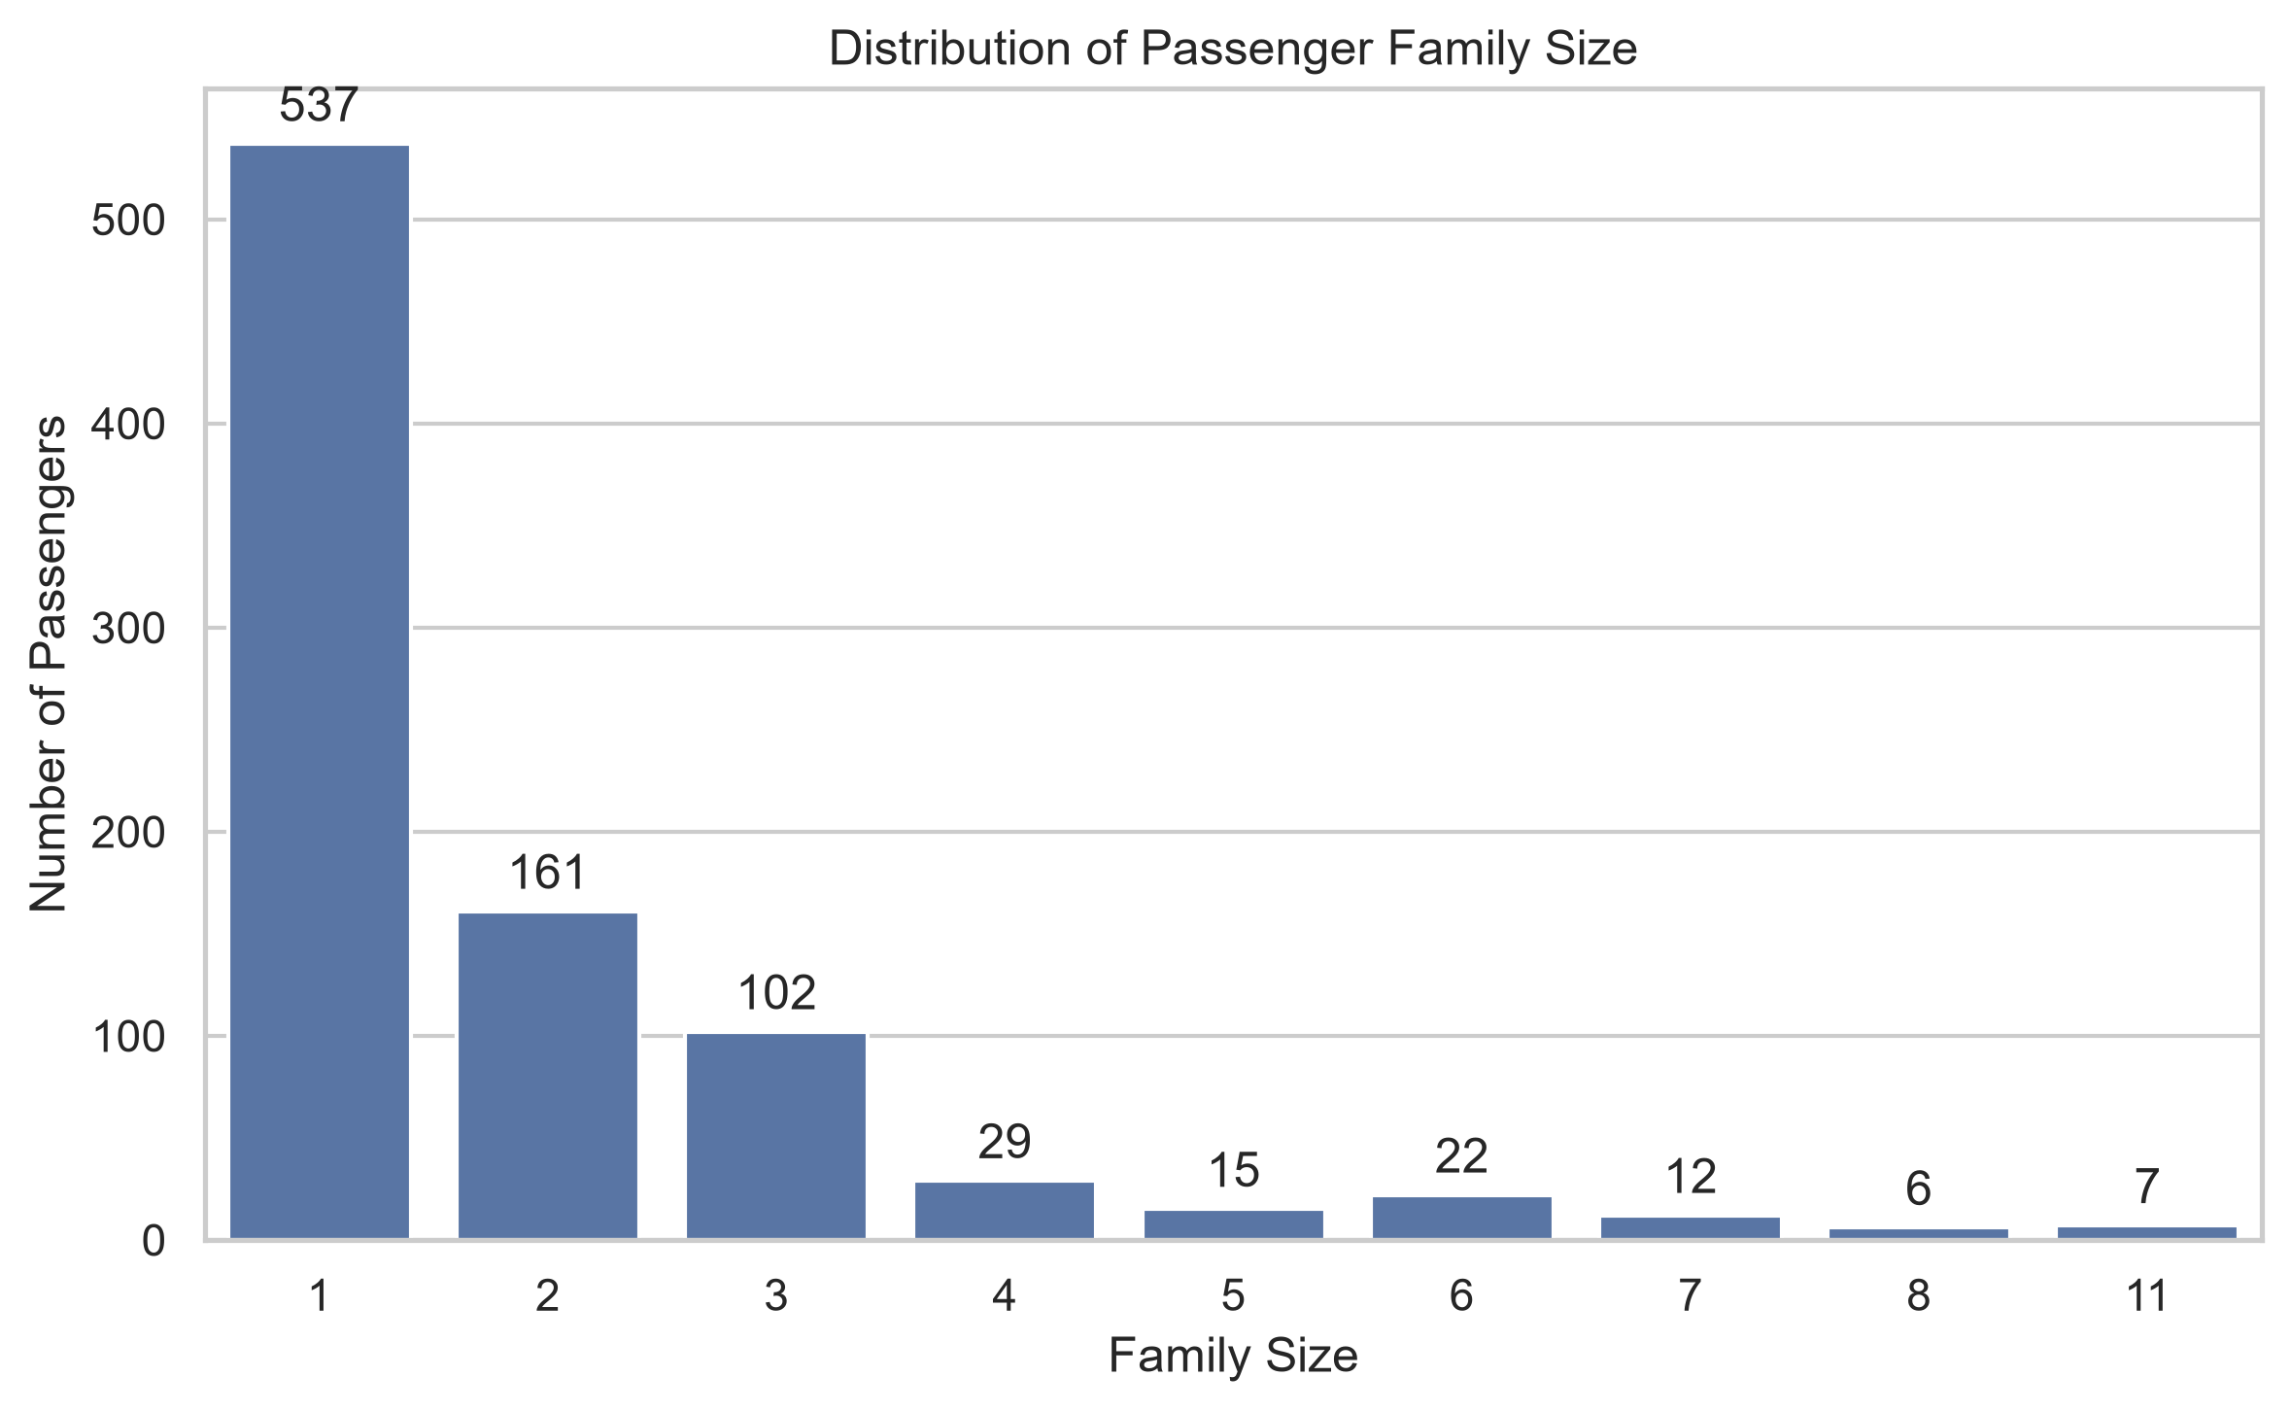  Figure 7. Family size distribution | 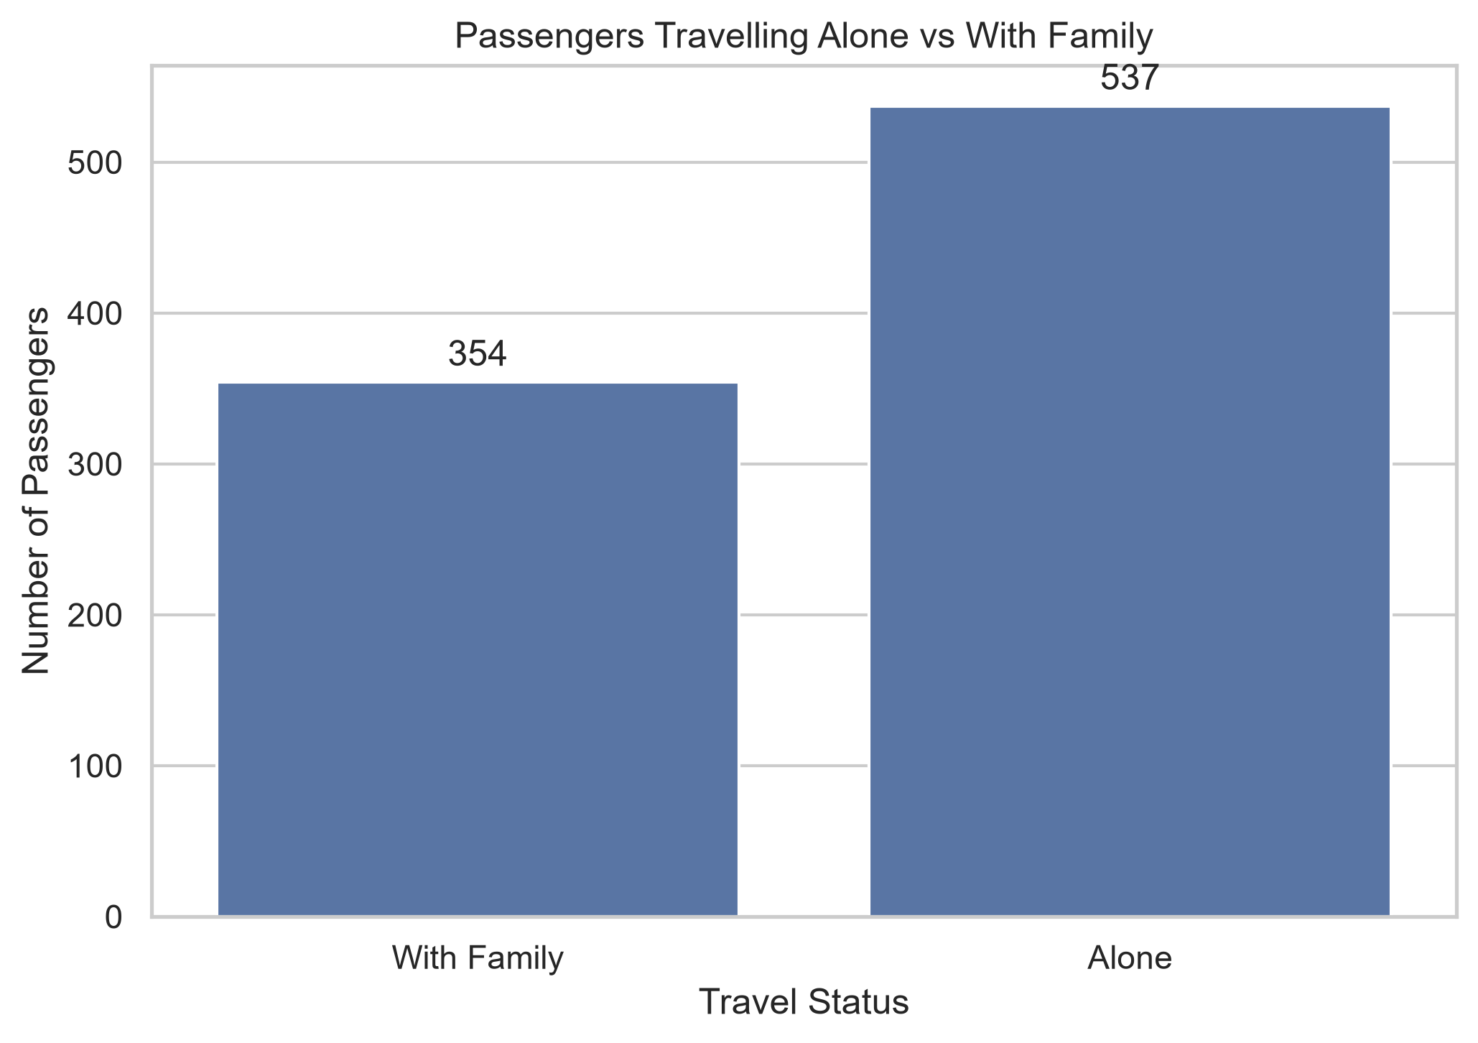  Figure 8. Travelling alone vs with family

Family size is heavily concentrated at one passenger, reflecting the large number of solo travellers. A total of 537 passengers (60.27%) travelled alone, while 354 (39.73%) travelled with at least one family member.
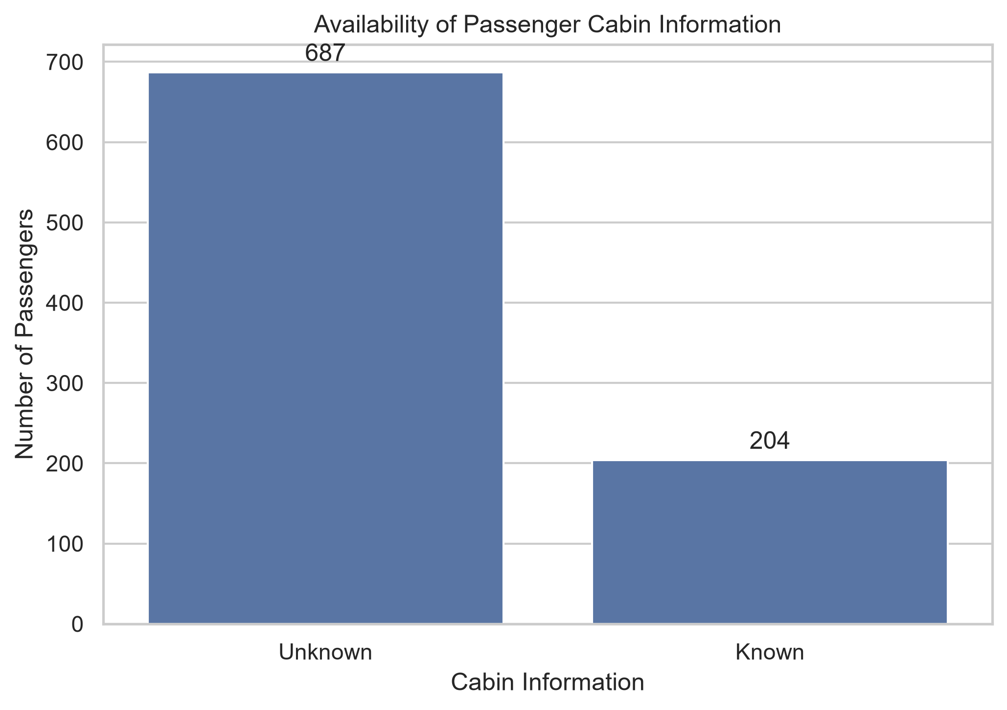
Figure 9. Availability of cabin information
Cabin information is missing for most passengers in the original dataset. Only 204 passengers (22.90%) have a recorded cabin, while 687 (77.10%) do not. The engineered Cabin_known indicator allows this missingness pattern itself to be analyzed as a passenger characteristic.

5. Bivariate Analysis
Bivariate analysis evaluates the relationship between survival and one additional variable. Grouped survival rates are used for categorical variables, while boxplots and distribution summaries are used for numerical variables.

5.1 Survival by Sex and Passenger Class
survival_by_sex = (
df.groupby("Sex")["Survived"]
.mean()
.mul(100)
.round(2)
)
survival_by_class = (
df.groupby("Pclass")["Survived"]
.mean()
.mul(100)
.round(2)
)
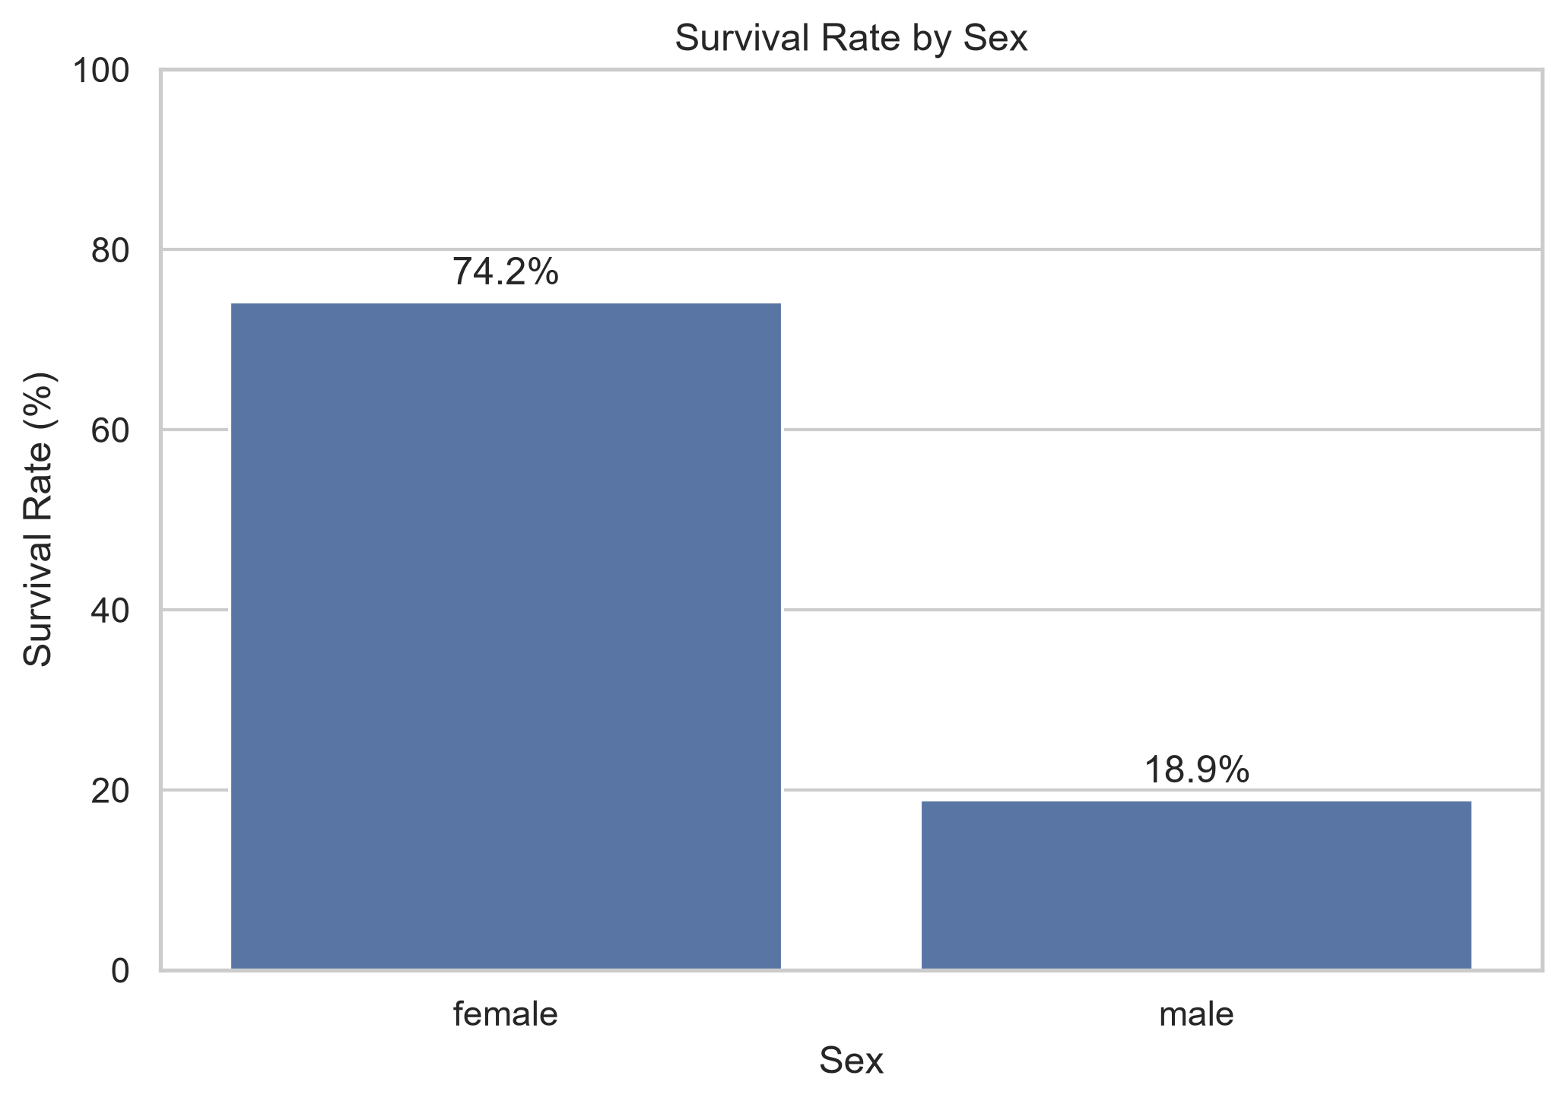  Figure 10. Survival rate by sex | 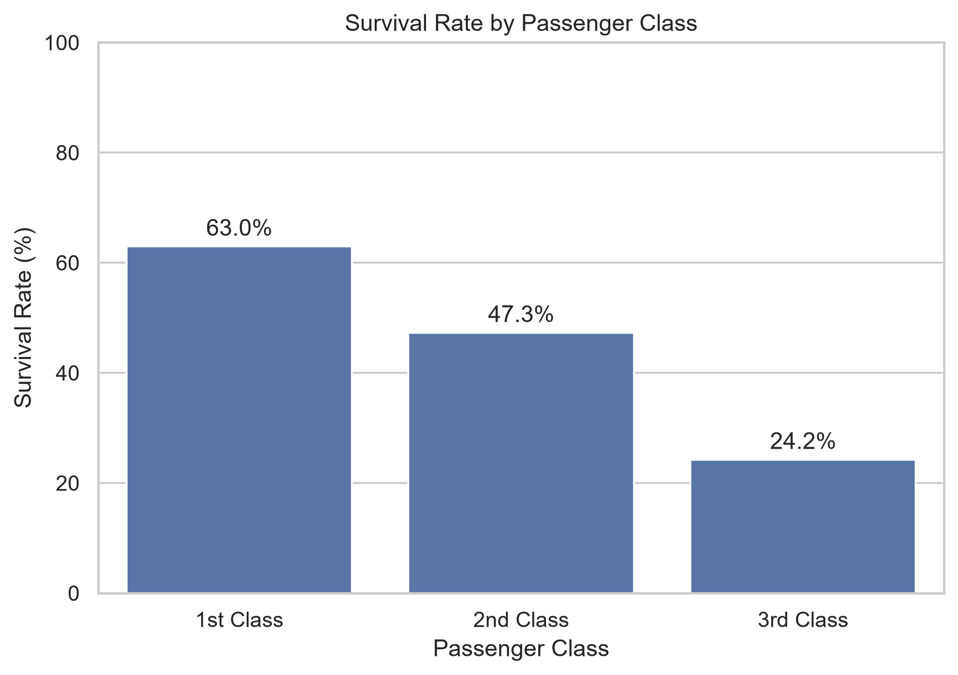  Figure 11. Survival rate by passenger class

Sex shows one of the largest differences in the dataset: female passengers had an observed survival rate of 74.20%, compared with 18.89% for male passengers. Passenger class also shows a strong gradient: survival was 62.96% in 1st class, 47.28% in 2nd class, and 24.24% in 3rd class.
These are descriptive associations. They do not by themselves establish that sex or class independently caused survival differences, because the variables are related to other passenger characteristics and historical evacuation conditions.

5.2 Survival by Embarkation, Travel Status, and Cabin Information
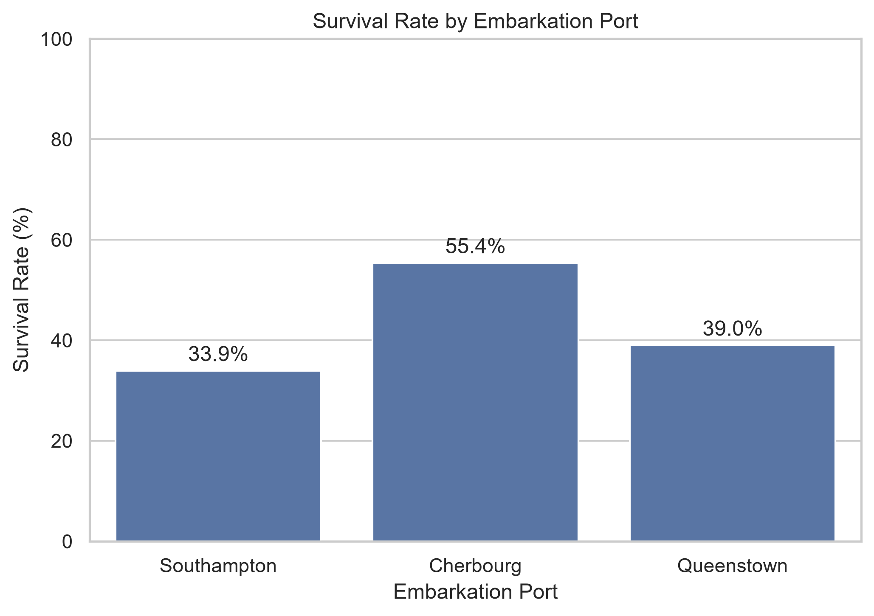  Figure 12. Survival rate by embarkation port | 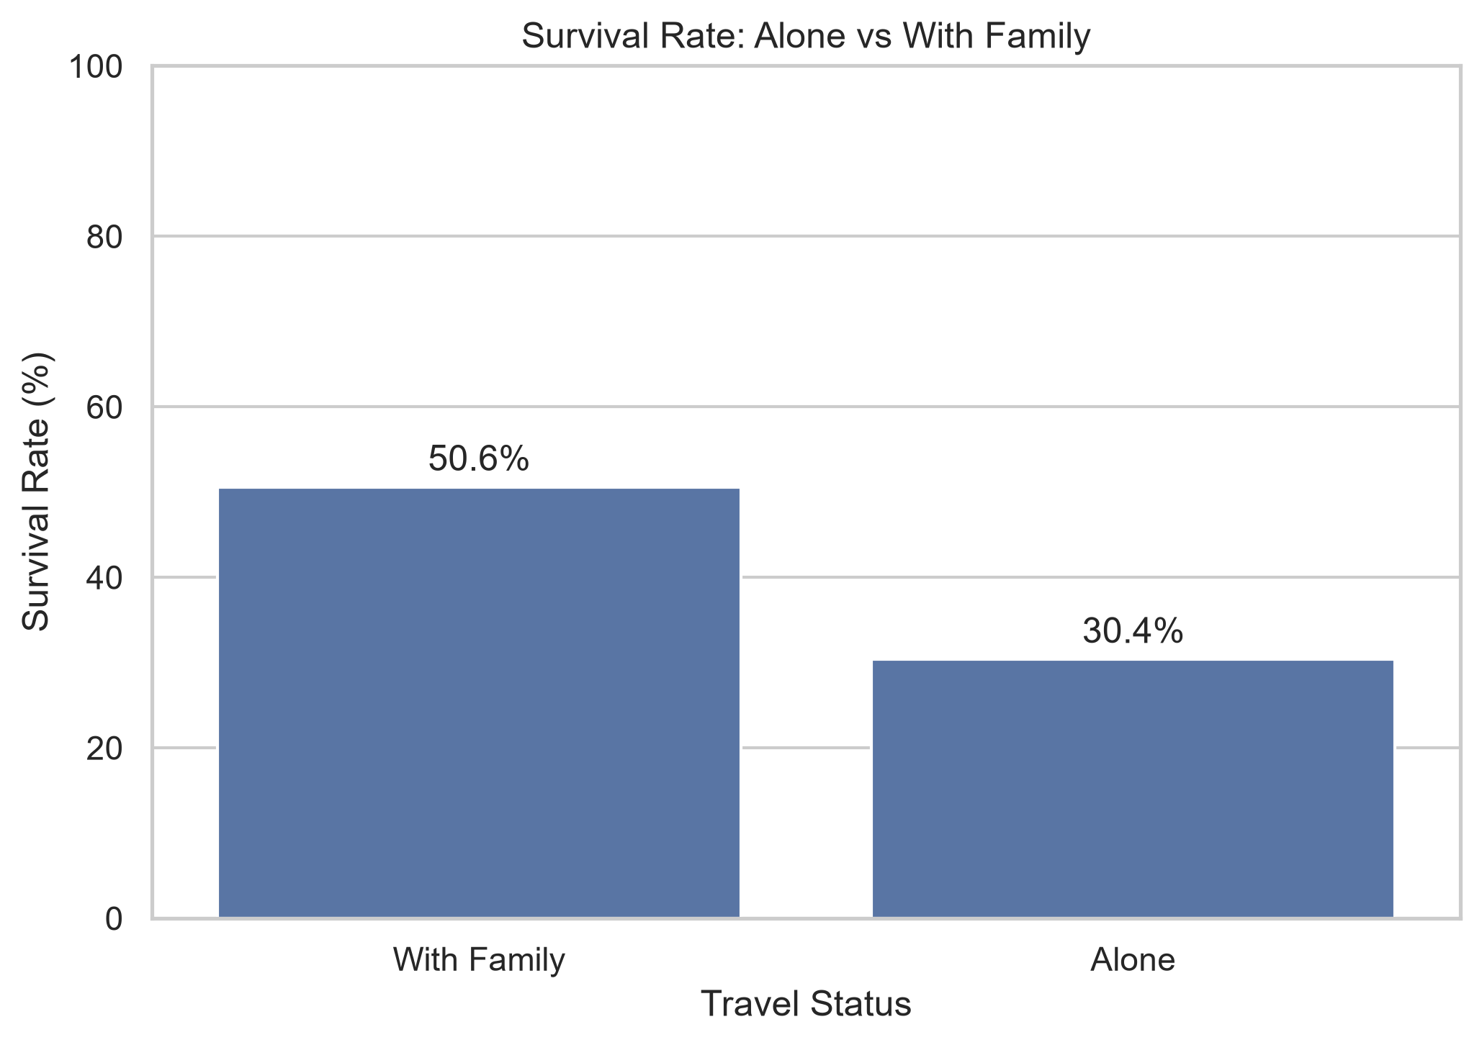  Figure 13. Survival rate by travel status

Passengers embarking at Cherbourg had the highest observed survival rate at 55.36%, compared with 38.96% for Queenstown and 33.90% for Southampton. This difference may partly reflect the passenger-class and demographic composition of each embarkation group rather than the port itself.
Passengers travelling with family had a survival rate of 50.56%, compared with 30.35% for those travelling alone. This suggests that family context is informative, although later family-size analysis shows that the relationship is not simply linear.
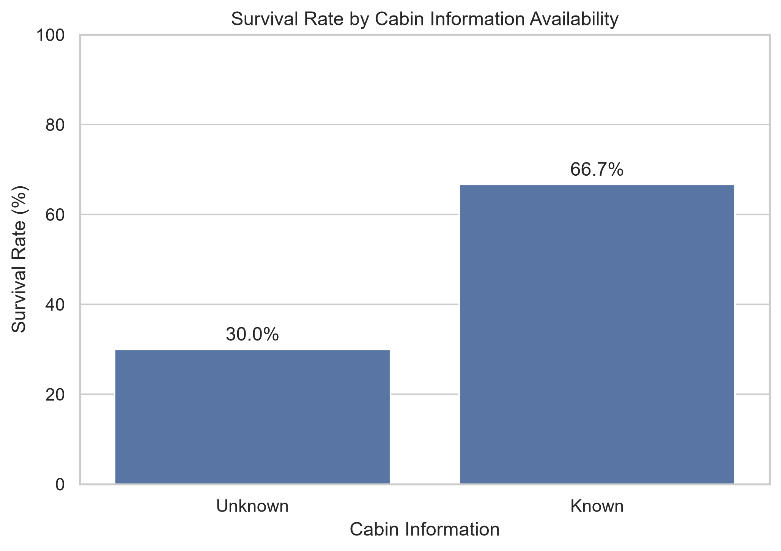
Figure 14. Survival rate by cabin-information availability
Passengers with known cabin information had an observed survival rate of 66.67%, versus 29.99% among passengers without recorded cabin information. Cabin availability is strongly associated with passenger class, so this difference should not be interpreted as an independent cabin-information effect.

5.3 Survival by Age, Fare, and Family Size
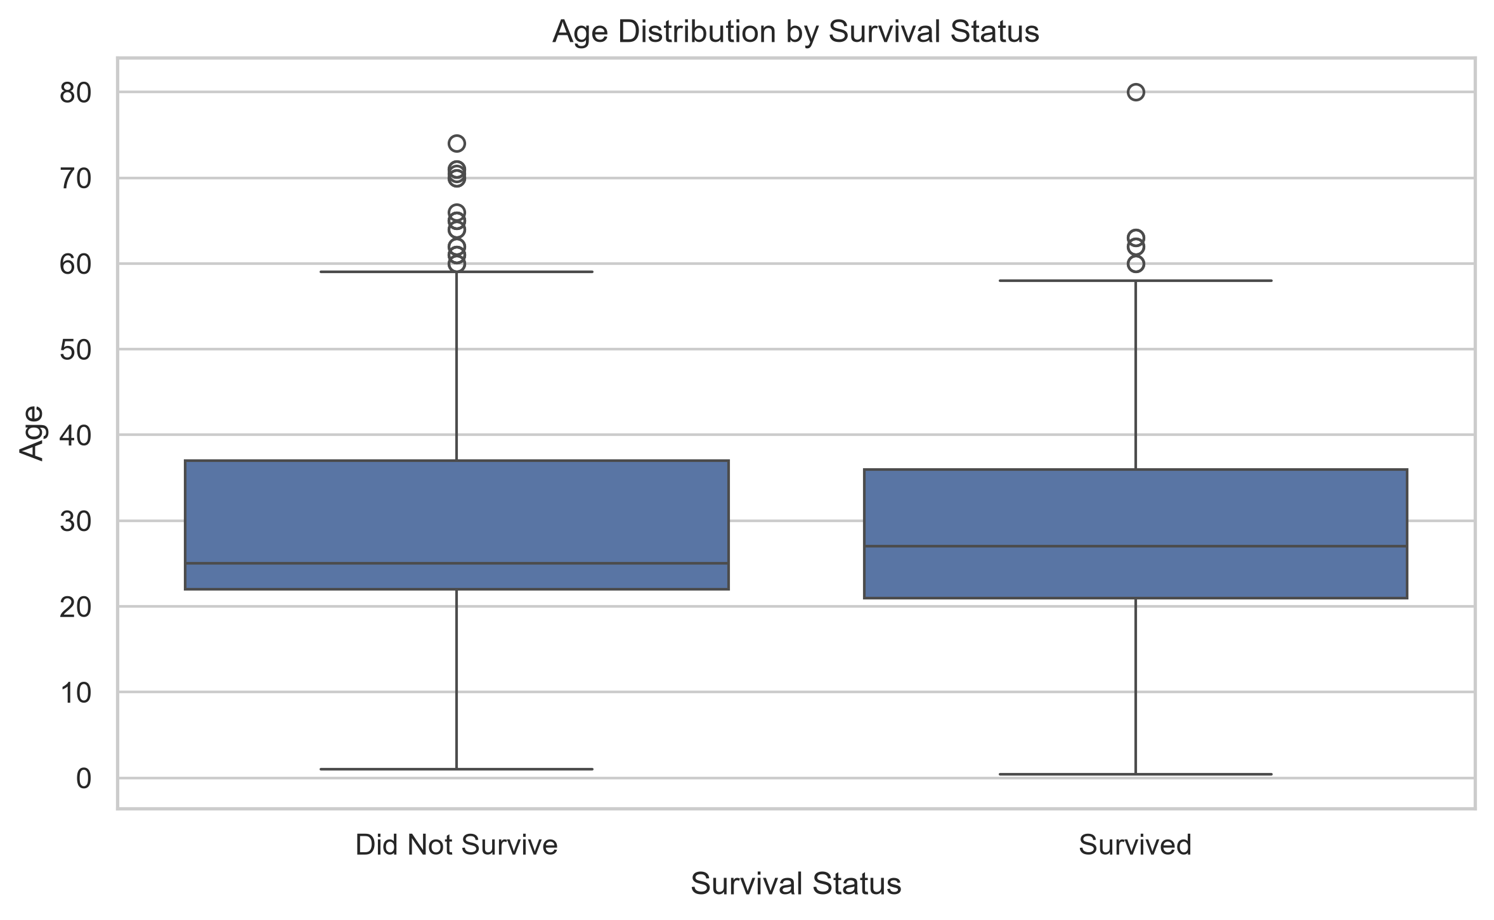  Figure 15. Age distribution by survival status | 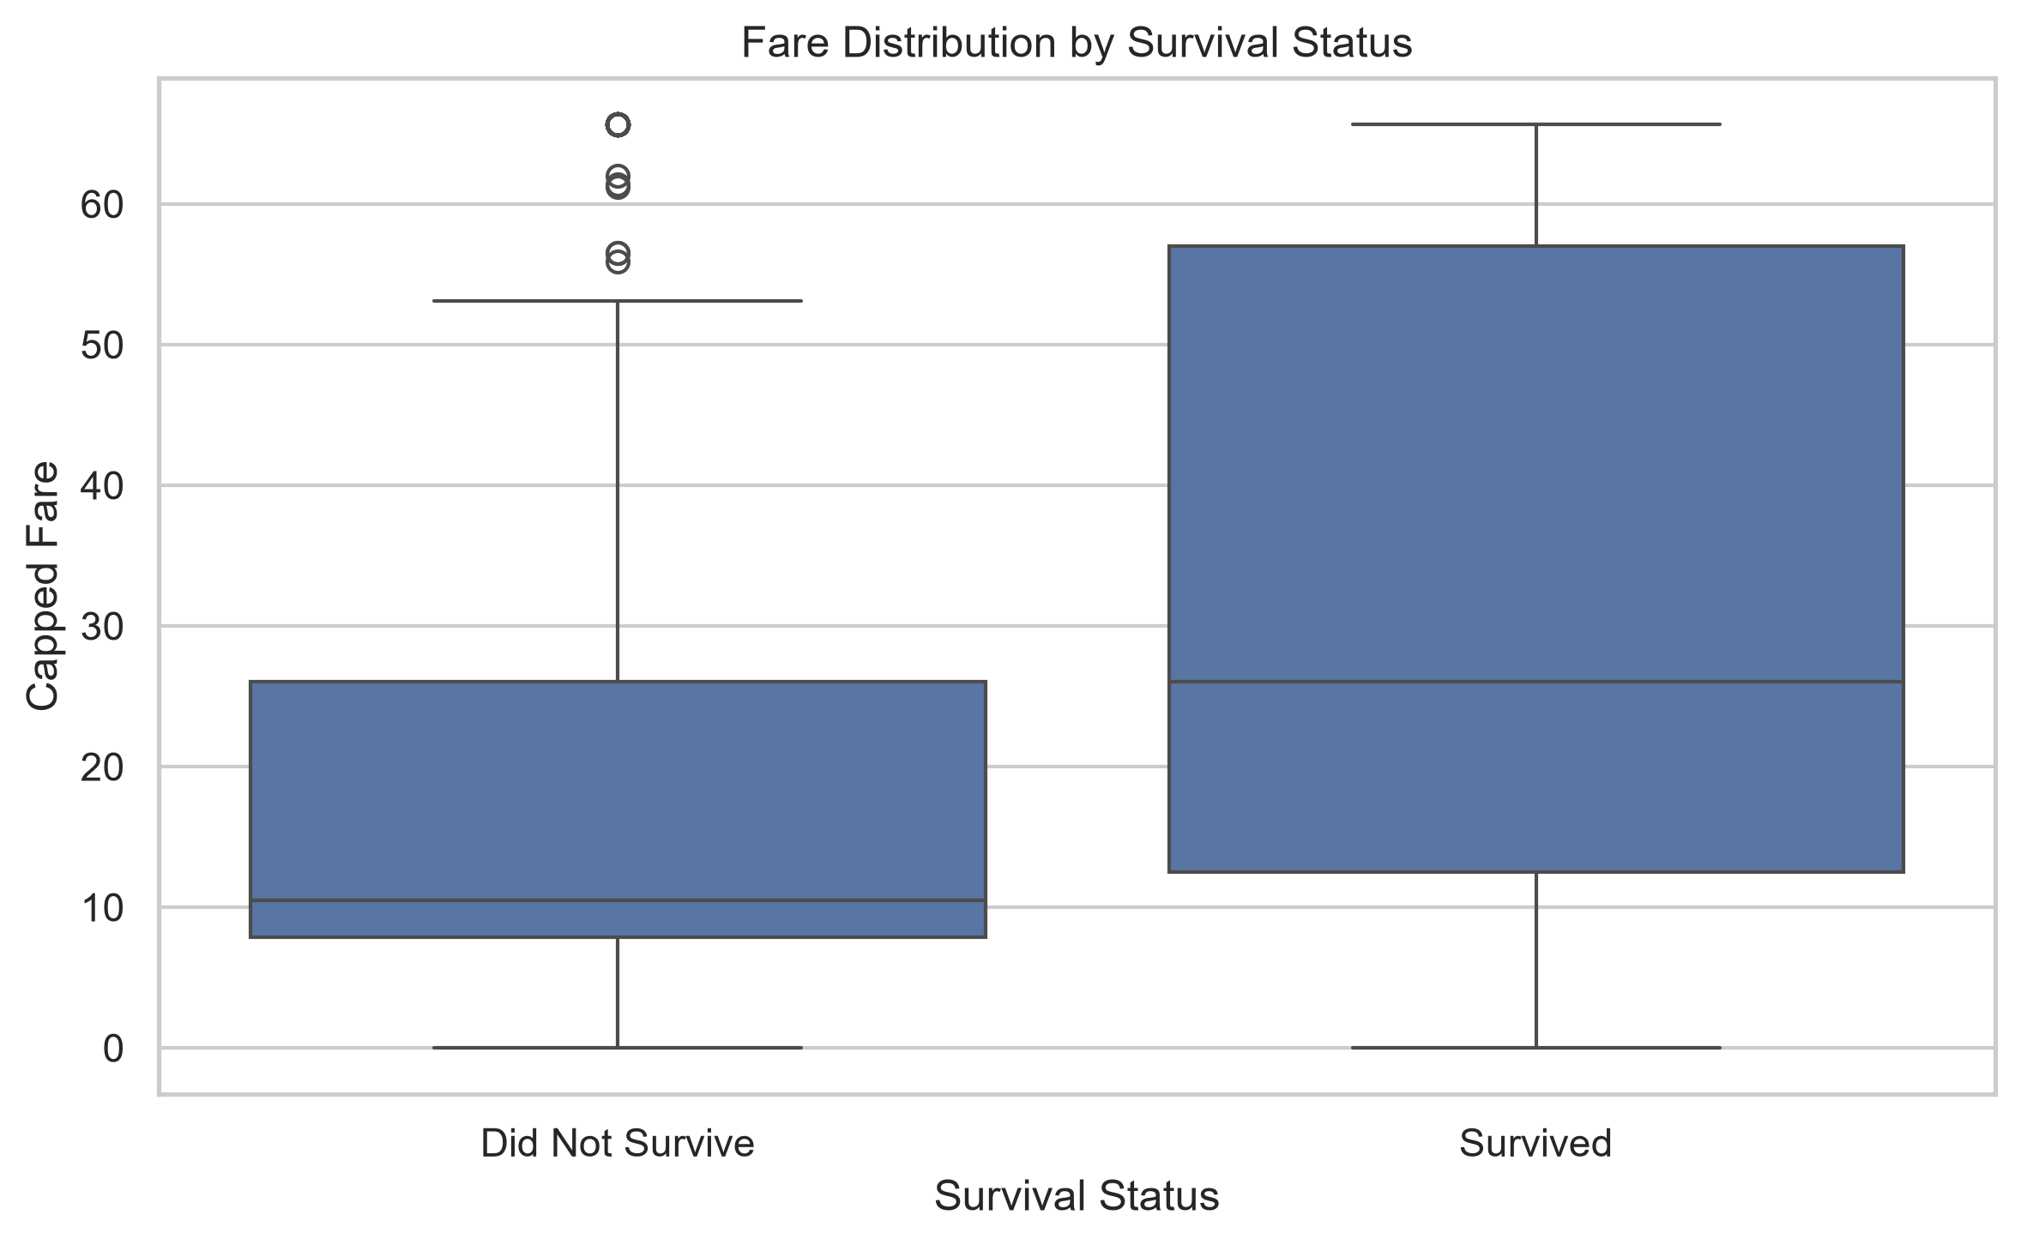  Figure 16. Capped fare by survival status

Age alone shows limited separation between the two survival groups. Non-survivors had a mean age of 29.74 years and survivors 28.11 years; the medians were 25 and 27 years respectively. The substantial overlap indicates that Age has only a weak linear relationship with survival in the cleaned dataset.
Fare shows a clearer difference. Survivors had a mean capped fare of 32.28 and median of 26.00, compared with a mean of 18.92 and median of 10.50 for non-survivors. Because fare is strongly associated with passenger class, both variables should be interpreted together.
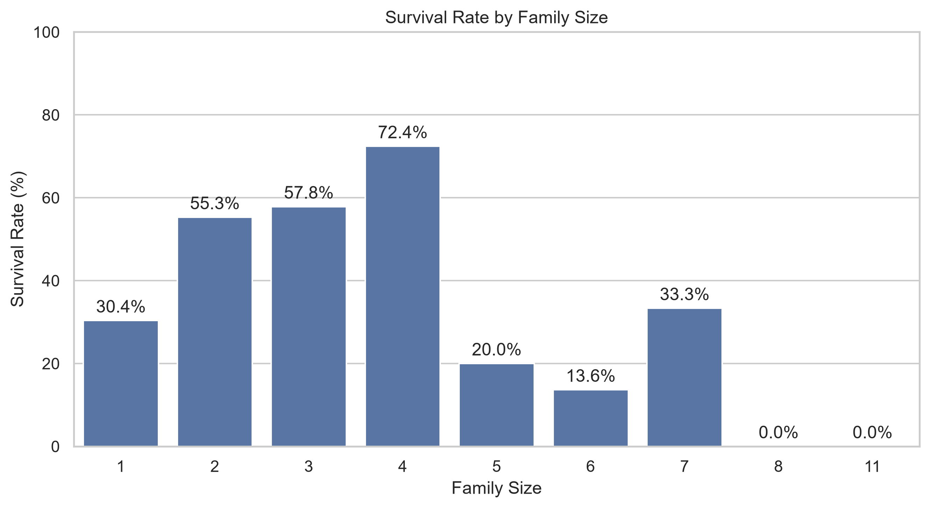
Figure 17. Survival rate by family size
Family size shows a non-linear pattern. Survival was 30.35% for solo travellers, increased to 55.28% for family size 2, 57.84% for size 3, and 72.41% for size 4, then generally decreased for larger families. Very large family groups contain few observations—for example, only six passengers had family size 8 and seven had family size 11—so the 0% survival rates in those groups should be interpreted cautiously.

6. Multivariate Analysis
Multivariate analysis examines several variables simultaneously to determine whether patterns observed in bivariate analysis persist within other passenger groups.

6.1 Passenger Class, Sex, and Survival
survival_sex_class = (
df.groupby(["Pclass", "Sex"])["Survived"]
.agg(["count", "mean"])
.reset_index()
)
survival_sex_class["Survival_Rate"] = (
survival_sex_class["mean"] * 100
).round(2)
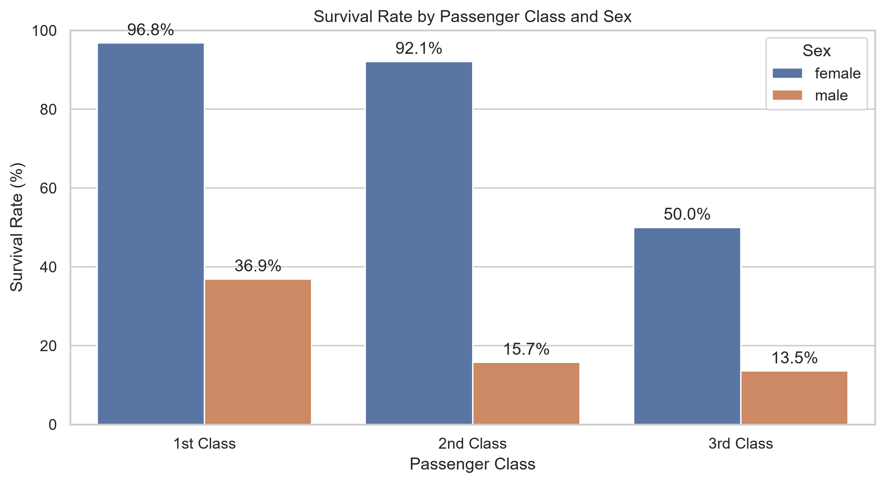
Figure 18. Survival rate by passenger class and sex
Female passengers had substantially higher survival rates than male passengers in every class. The observed rates were 96.81% for 1st-class females versus 36.89% for 1st-class males; 92.11% versus 15.74% in 2nd class; and 50.00% versus 13.54% in 3rd class. Passenger class also remains relevant within each sex, indicating that the two variables provide distinct descriptive information.

6.2 Passenger Class, Cabin Information, and Survival
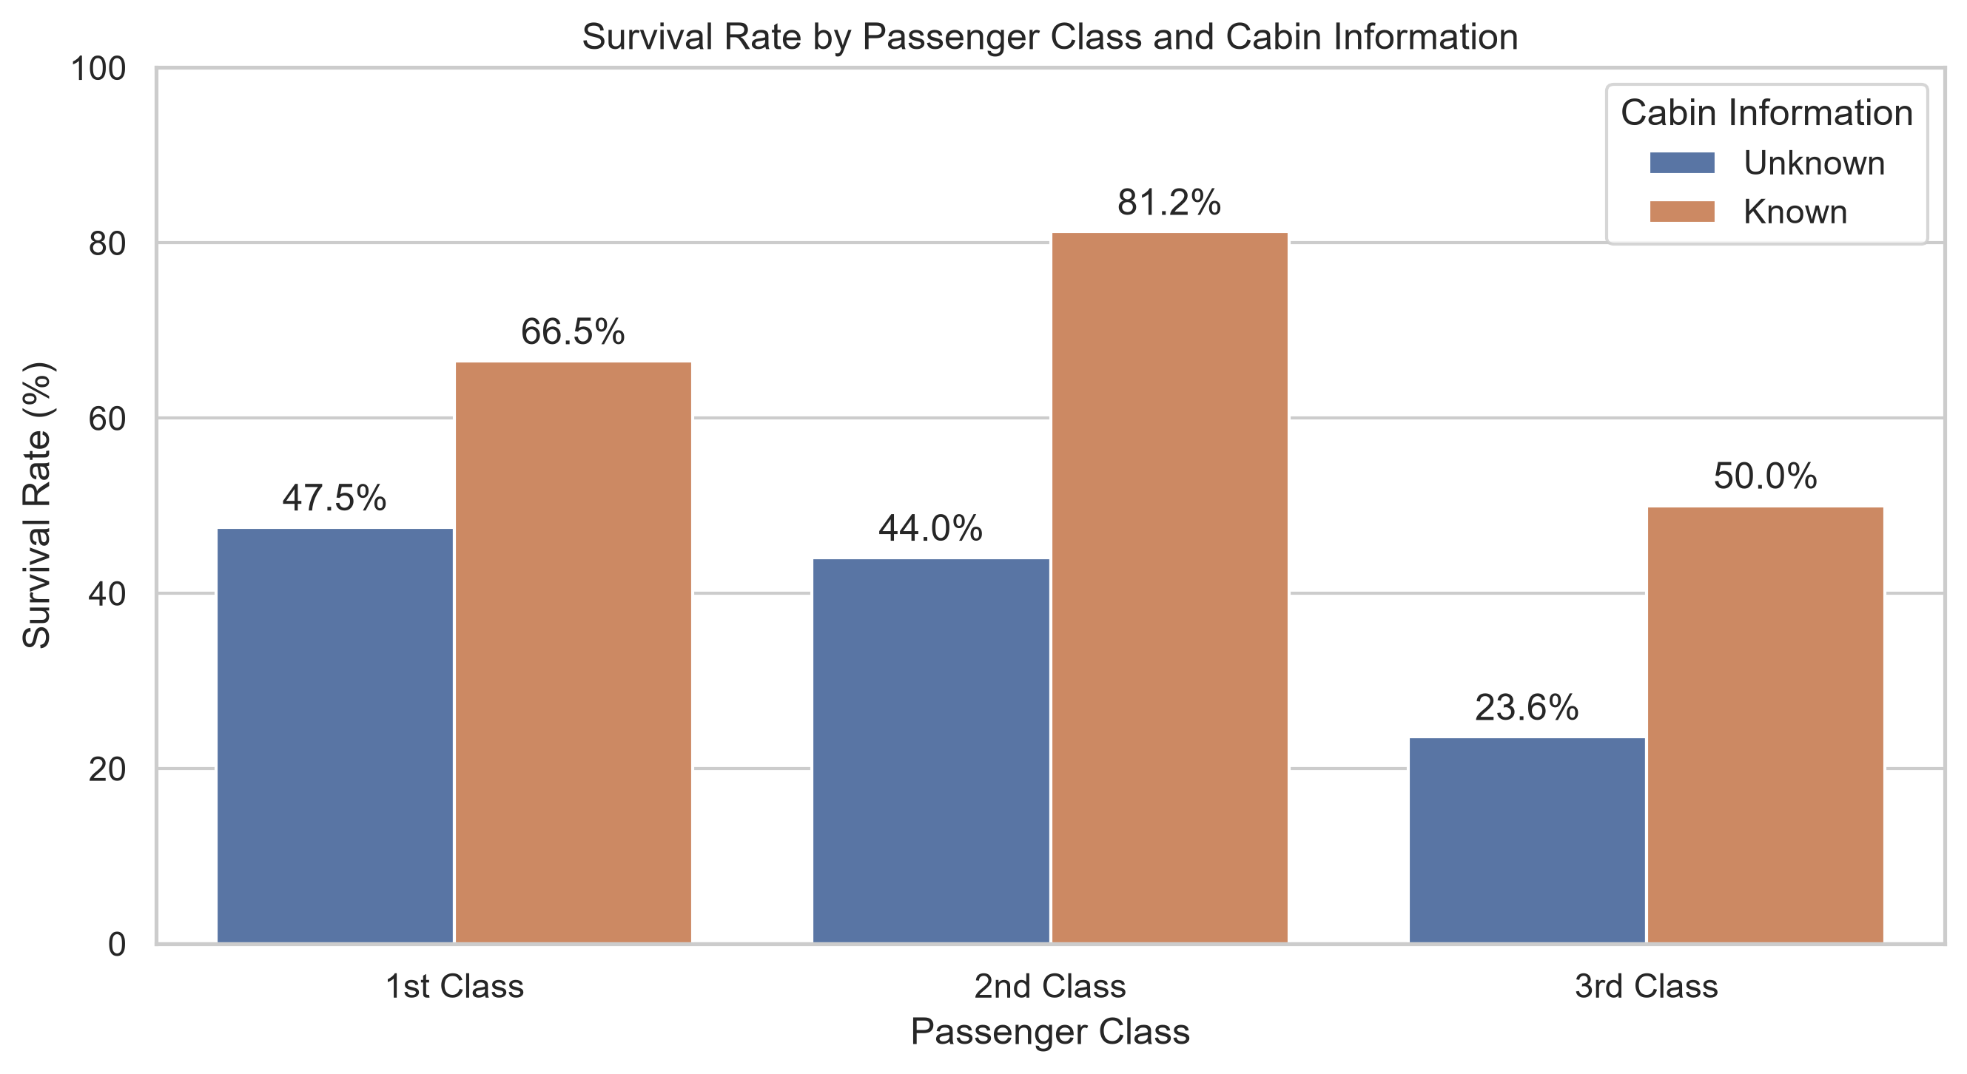
Figure 19. Survival by passenger class and cabin-information availability
Within each passenger class, the group with recorded cabin information had a higher observed survival rate. In 1st class, the rates were 66.48% for known cabins and 47.50% for unknown cabins. In 2nd class the corresponding rates were 81.25% and 44.05%, and in 3rd class 50.00% and 23.59%. However, the cabin-known subgroups in 2nd and 3rd class contain only 16 and 12 passengers, so those percentages are based on small samples.

7. Correlation Analysis
correlation_columns = [
"Survived", "Pclass", "Age", "SibSp", "Parch",
"Fare_capped", "Cabin_known", "FamilySize", "IsAlone"
]
correlation_matrix = df[correlation_columns].corr()
sns.heatmap(
correlation_matrix,
annot=True,
fmt=".2f",
cmap="coolwarm",
center=0,
)
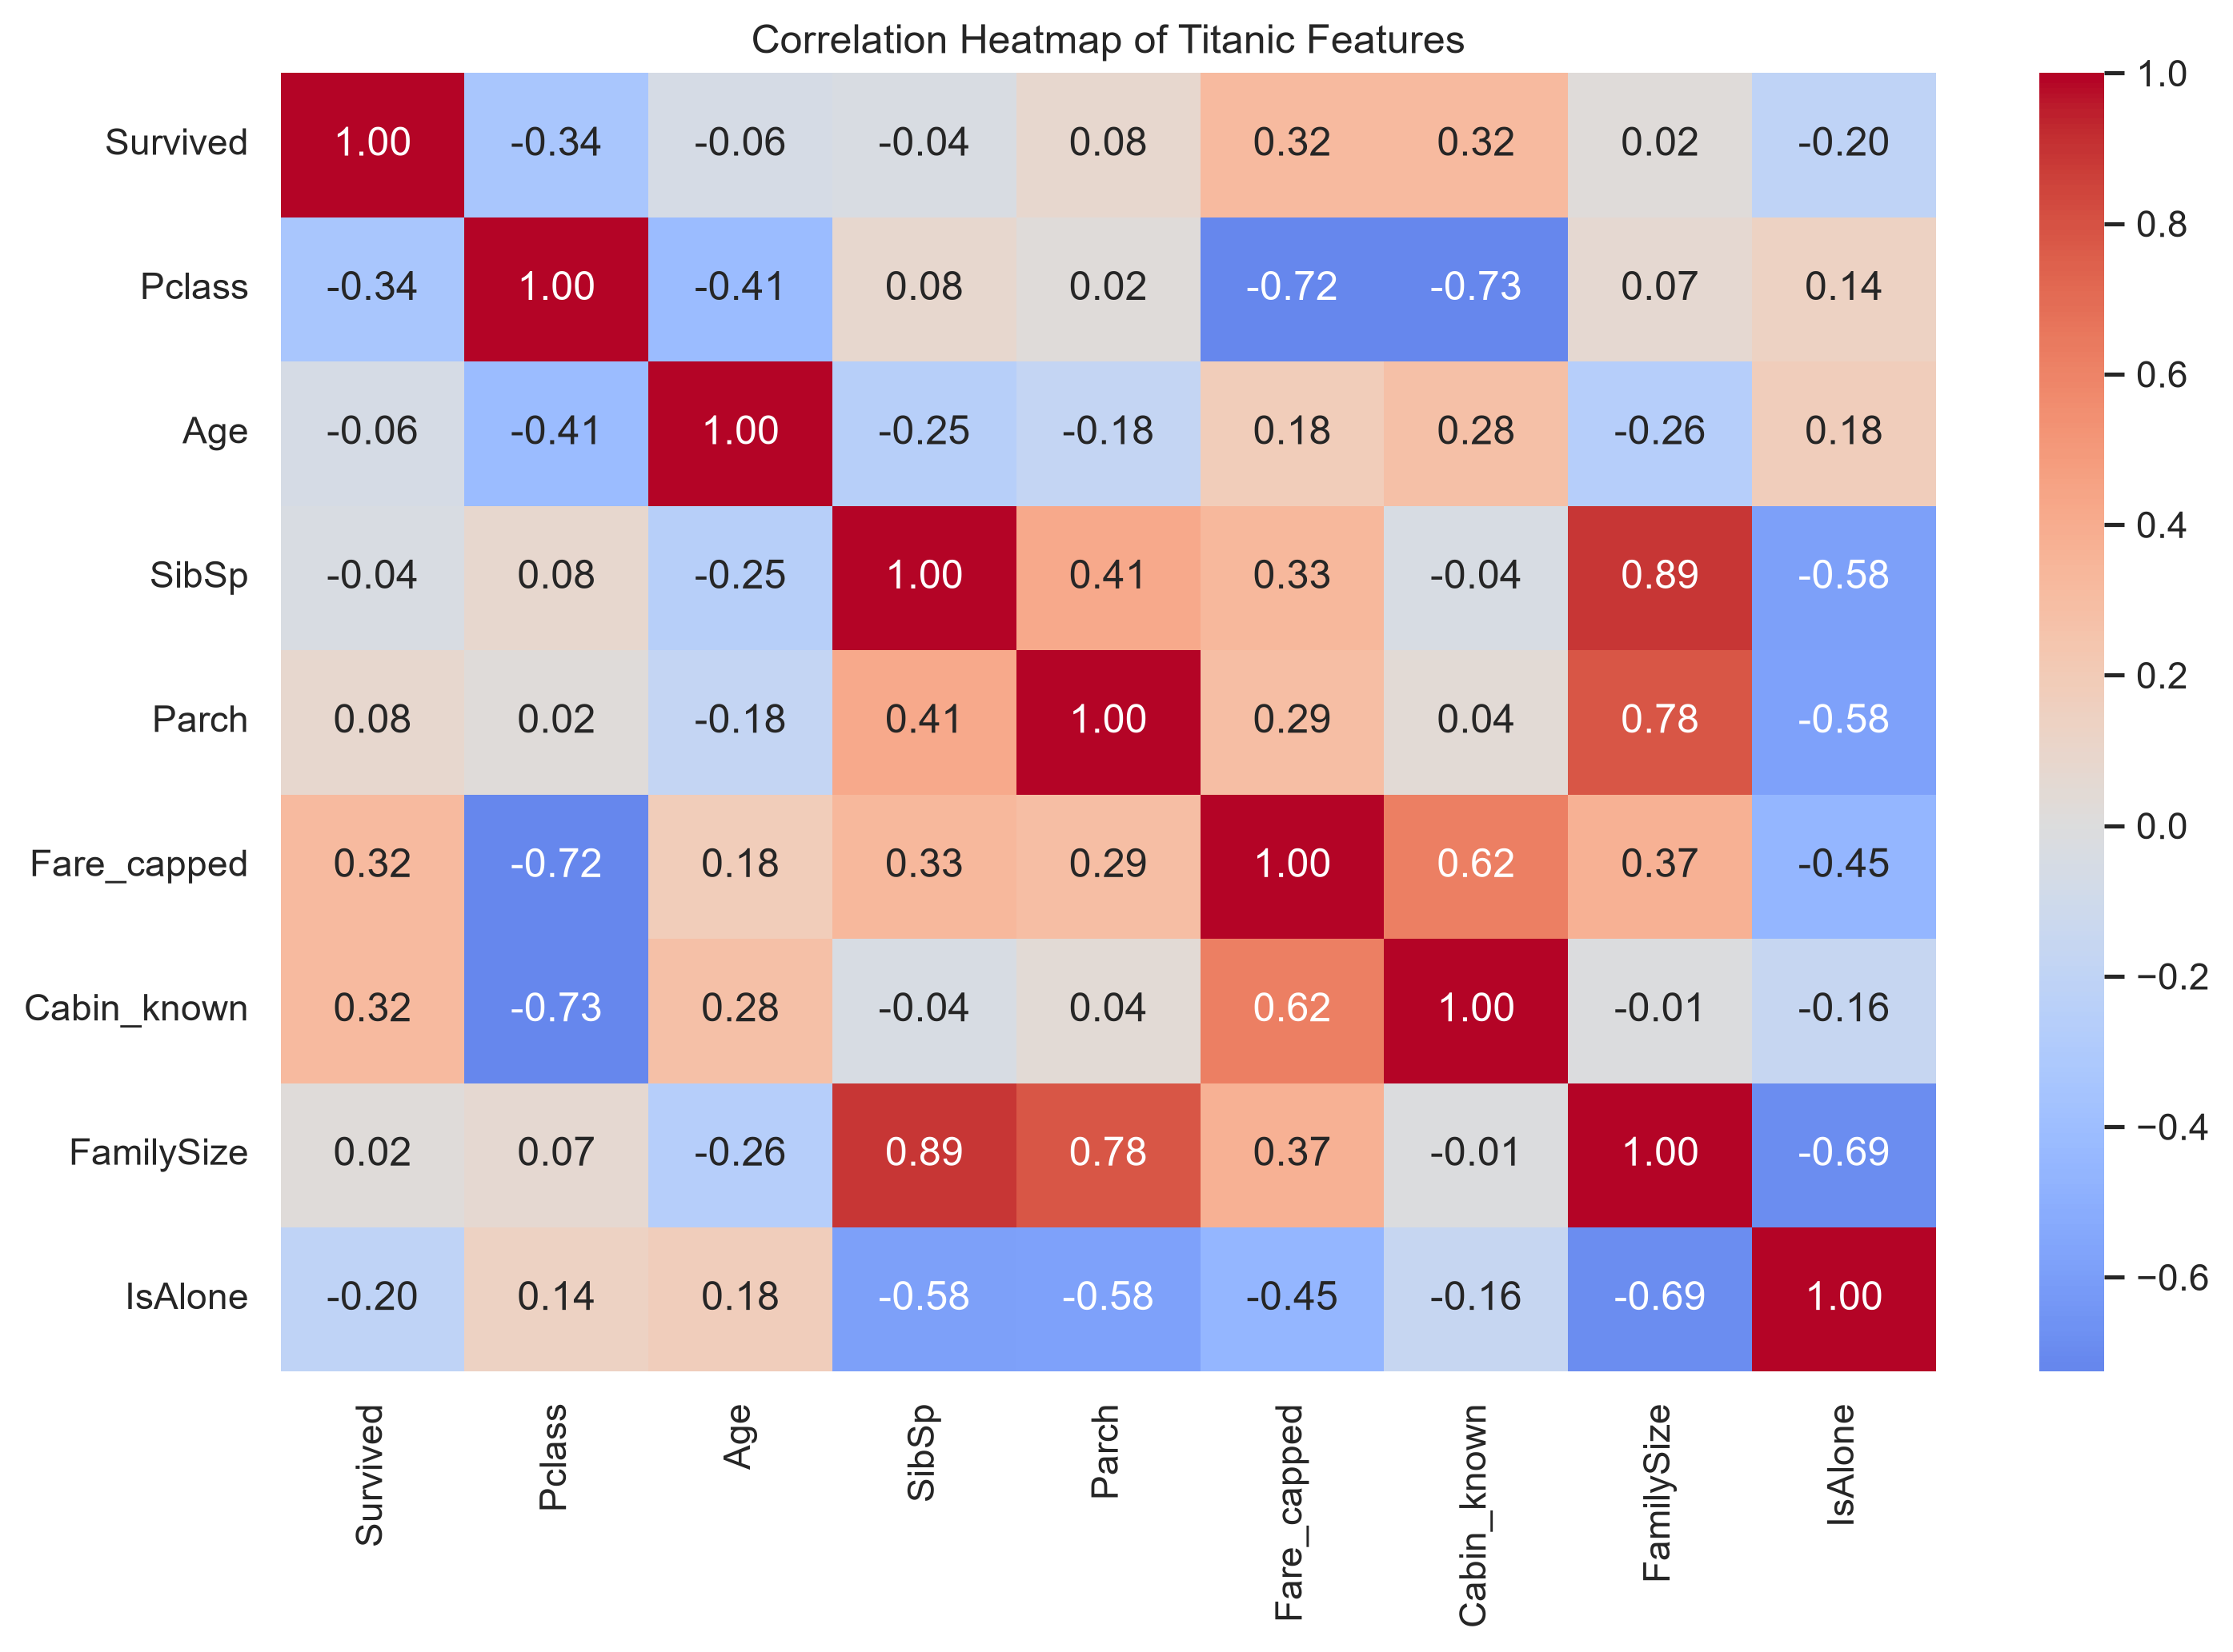
Figure 20. Correlation heatmap of selected Titanic features
Among the numerical variables included in the heatmap, the strongest correlations with Survived are Pclass (-0.34), Fare_capped (+0.32), Cabin_known (+0.32), and IsAlone (-0.20). Age has only a weak correlation of -0.06, while FamilySize has a near-zero linear correlation of +0.02.
The near-zero FamilySize correlation is a useful reminder that Pearson correlation measures linear relationships. The earlier family-size survival plot showed a clear non-linear pattern in which medium-sized families had higher observed survival than solo travellers and some large families.
Several predictor variables are strongly related to each other. Pclass is negatively correlated with Fare_capped (-0.72) and Cabin_known (-0.73), while Fare_capped and Cabin_known are positively correlated (+0.62). FamilySize is strongly correlated with SibSp (+0.89) and Parch (+0.78) because it was constructed directly from those variables. These relationships should be considered in later predictive modeling.

8. Key Findings
Finding | Observed result
Overall survival | 342 of 891 passengers survived (38.38%)
Sex | Female: 74.20%; Male: 18.89%
Passenger class | 1st: 62.96%; 2nd: 47.28%; 3rd: 24.24%
Embarkation | Cherbourg had the highest observed survival rate (55.36%)
Travel status | With family: 50.56%; Alone: 30.35%
Cabin information | Known: 66.67%; Unknown: 29.99%
Fare | Survivors had higher mean capped fare: 32.28 vs 18.92
Age | Weak overall separation between survivor and non-survivor age distributions
Family size | Highest observed rate at size 4 (72.41%), but the relationship is non-linear
Sex + class | Female survival remained much higher than male survival within every class

9. Critical Interpretation and Limitations
- EDA identifies associations, not causation. Differences in survival should not be interpreted as proof that a single feature independently caused the outcome.
- Age values include imputed observations from Week 1, so the cleaned age distribution is not identical to the distribution of originally recorded ages.
- Fare was capped at 65.6344. This reduces the influence of extreme outliers but compresses variation among high-fare passengers and creates a visible pile-up at the cap.
- Cabin_known represents whether cabin information was recorded, not cabin quality or physical location. It is also strongly related to passenger class.
- Some family-size and cabin/class subgroups are very small. Percentages based on these groups have greater uncertainty and should not be generalized strongly.
- Sex and Embarked are categorical string variables and are therefore not directly included in the numerical Pearson correlation heatmap. Their relationships with survival were analyzed through grouped rates and categorical plots instead.
- The dataset is historical and specific to Titanic passengers; patterns should not be generalized beyond this population without additional evidence.

10. Conclusion
The exploratory analysis reveals substantial variation in Titanic survival across passenger characteristics. Sex and passenger class show the clearest descriptive differences, while fare, travel status, and cabin-information availability are also meaningfully associated with survival. Age by itself shows much less separation between survivors and non-survivors. Family size demonstrates an important non-linear pattern that is not captured by its near-zero Pearson correlation.
The multivariate analysis strengthens the interpretation by showing that the survival difference between female and male passengers persists within each passenger class, and that cabin-information availability is closely tied to class. These findings provide a strong basis for the supervised learning task planned for a later stage of the internship, where the predictive value of these variables can be evaluated using formal model validation rather than descriptive analysis alone.

11. References
1. Kaggle. Titanic - Machine Learning from Disaster. Public competition dataset.
2. Pandas documentation - data manipulation and aggregation.
3. Matplotlib documentation - Python visualization library.
4. Seaborn documentation - statistical data visualization.

Appendix A. Analysis Workflow
Data Acquisition -> Cleaning & Preprocessing -> Cleaned Dataset -> Initial EDA -> Univariate Analysis -> Bivariate Analysis -> Multivariate Analysis -> Correlation Analysis -> Interpretation & Report

Appendix B. Selected EDA Code Structure
def main() -> None:
df = load_data()
dataset_overview(df)
univariate_analysis(df)
bivariate_analysis(df)
multivariate_analysis(df)
print("EDA COMPLETED SUCCESSFULLY")
The final script was organized into reusable functions for loading data, dataset overview, univariate analysis, bivariate analysis, multivariate analysis, plot saving, and percentage labeling. This reduces repetition and makes the workflow easier to maintain and extend.

