SUPERVISED LEARNING
MODEL IMPLEMENTATION
Titanic - Machine Learning from Disaster Dataset
Week 4 Internship Task Report
Prepared by: Rishi Raj
Data Science with Python Internship
October 2026

Executive Summary
This report documents the design, implementation, validation, and evaluation of a supervised machine-learning solution for Titanic passenger survival prediction. The task extends the same Titanic project developed during Week 1 data cleaning and Week 2 exploratory data analysis, creating a continuous workflow from raw data preparation to predictive modeling.
The prediction target is Survived, where 0 represents a passenger who did not survive and 1 represents a passenger who survived. The original dataset contains 891 passenger records. A stratified 80/20 split produced 712 training passengers and 179 independent test passengers. To avoid data leakage, preprocessing statistics were learned only from training data inside Scikit-learn pipelines rather than reusing statistics calculated from the complete Week 1 dataset.
Three classifiers were evaluated using 5-fold stratified cross-validation: Logistic Regression, Decision Tree, and Random Forest. After hyperparameter tuning with GridSearchCV, Random Forest achieved the strongest cross-validated ROC-AUC of 0.8832 and was selected without consulting test-set performance. On the untouched test set, the final model achieved 77.09% accuracy, 77.04% balanced accuracy, 67.95% precision, 76.81% recall, a 72.11% F1 score, and a ROC-AUC of 0.8366.
Beyond basic performance reporting, the analysis evaluates feature importance, the measurable contribution of Week 1 feature engineering, subgroup error behavior, high-confidence mistakes, baseline-versus-tuned performance, and probability calibration. These analyses are included to provide evidence for model behavior, limitations, and generalization rather than relying on accuracy alone. A majority-class sanity baseline, worked metric calculations, and an end-to-end passenger example are also included so that the evaluation is concrete rather than purely descriptive.

Task Requirement Coverage
Requirement | Evidence in this report
Problem definition | Binary classification of Titanic passenger survival
Data preparation | Leakage-safe imputation, fare capping, encoding, scaling
Feature engineering | Cabin_known, Fare_capped, FamilySize, IsAlone
Models | Logistic Regression, Decision Tree, Random Forest
Validation | 5-fold stratified cross-validation and independent holdout set
Tuning | GridSearchCV with ROC-AUC as the refit metric
Evaluation | Accuracy, balanced accuracy, precision, recall, F1, ROC-AUC, AP
Analysis | Confusion matrix, ROC/PR curves, feature importance, errors, calibration
Limitations & improvements | Generalization, subgroup sample size, calibration, future features
Worked evidence & originality | Naive baseline, metric arithmetic, Week 2-to-Week 4 evidence bridge, and an end-to-end passenger prediction example

1. Introduction
Supervised learning uses labeled examples to learn a mapping from input features to a known outcome. In this project, the label is the historical survival status of each Titanic passenger. Because the target contains two classes, the task is formulated as binary classification rather than regression.
The Week 4 task is intentionally built on the Week 1 and Week 2 work instead of starting with a new dataset. Week 1 established a reproducible cleaning and feature-engineering process. Week 2 then identified descriptive relationships between survival and variables such as sex, passenger class, fare, family structure, and cabin-information availability. Week 4 tests whether those relationships can support reliable out-of-sample predictions.

1.1 Objectives
- Clearly define a supervised binary-classification problem using a public dataset.
- Reuse the Week 1 preprocessing strategy while preventing data leakage during model validation.
- Compare multiple classification algorithms rather than selecting a model arbitrarily.
- Use stratified cross-validation and hyperparameter tuning to support model selection.
- Evaluate the selected model on an independent holdout test set using multiple metrics.
- Analyze feature importance, prediction errors, subgroup behavior, and calibration.
- Discuss model strengths, limitations, possible improvements, and practical implications.

1.2 Problem Statement
Given passenger demographic and travel-related information, predict whether the passenger survived the Titanic disaster. The output is a probability and a binary class prediction: 0 = did not survive, 1 = survived.

1.3 Why Classification Is Appropriate
The target variable contains two discrete categories and is known for every training record. Classification algorithms are therefore appropriate. Logistic Regression provides a linear probabilistic baseline, Decision Tree provides an interpretable nonlinear baseline, and Random Forest provides an ensemble capable of learning nonlinear patterns and feature interactions.

2. Dataset Foundation and Continuity with Earlier Weeks
The project uses the public Kaggle Titanic dataset. The original training file contains 891 rows and 12 columns. Week 1 produced a cleaned dataset with 16 columns by retaining the original variables and adding four engineered features. Week 2 used that cleaned dataset for descriptive and multivariate analysis.
Item | Value
Original dataset | 891 rows x 12 columns
Week 1 cleaned dataset | 891 rows x 16 columns
Target | Survived (0 = no, 1 = yes)
Non-survivors | 549 (61.62%)
Survivors | 342 (38.38%)
Duplicate rows | 0
Modeling features with missing values after preprocessing | 0

2.1 Week 1 Preprocessing Decisions Reused in Week 4
Feature / Step | Week 1 Decision | Week 4 Use
Age | Median within Pclass x Sex groups | Same logic, statistics fitted on training data only
Embarked | Mode imputation | Mode learned from training data only
Cabin_known | 1 if cabin recorded, otherwise 0 | Retained as predictive feature
Fare_capped | IQR-based upper capping | Cap learned from training data only
FamilySize | SibSp + Parch + 1 | Retained as predictive feature
IsAlone | 1 when FamilySize = 1 | Retained as predictive feature

2.2 Week 2 Findings Used as Modeling Context
Week 2 EDA showed large descriptive differences in survival by sex and passenger class, higher survival among passengers with recorded cabin information, higher survival among passengers travelling with family, and higher average fares among survivors. Correlation analysis also showed that Pclass, Fare_capped, and Cabin_known were among the strongest numerical relationships with survival. These findings motivated retaining those variables in the Week 4 feature set, while the model evaluation determines whether they remain useful for prediction on unseen data.
Week 2 relationship | Observed survival rate
Female | 74.20%
Male | 18.89%
1st class | 62.96%
2nd class | 47.28%
3rd class | 24.24%
Cabin known | 66.67%
Cabin unknown | 29.99%
Travelling with family | 50.56%
Travelling alone | 30.35%

2.3 Evidence Bridge: From Week 2 Patterns to Week 4 Predictive Evidence
To avoid treating EDA and modeling as separate exercises, the strongest Week 2 findings were compared directly with the final Random Forest evidence. This comparison shows which descriptive patterns remained useful for prediction and where a nonlinear model discovered information that simple correlation did not capture.
Feature / relationship | Week 2 evidence | Week 4 evidence and interpretation
Sex | Female survival 74.20% vs male 18.89% | 44.81% aggregated importance - the strongest model signal, consistent with the largest EDA separation.
Fare | Mean capped fare: survivors 32.28 vs non-survivors 18.92 | Fare_capped importance 15.02% - higher-fare patterns retained predictive value after validation.
Passenger class | Survival: 62.96% (1st), 47.28% (2nd), 24.24% (3rd) | Pclass importance 8.69% - class remains useful even after accounting for fare, sex, and cabin information.
Cabin information | Cabin known survival 66.67% vs unknown 29.99% | Cabin_known importance 6.89% - availability of cabin information contributes beyond class alone.
Family / travelling alone | With family 50.56% vs alone 30.35% | FamilySize 4.67% + IsAlone 1.32% - modest but measurable contribution from engineered family structure.
Age | Weak linear correlation with survival (about -0.06) | Age importance 11.62% - an important contrast showing that weak linear correlation does not mean no nonlinear or interaction-based predictive value.
Original analysis: Age is the clearest example of why Week 2 correlation and Week 4 model importance should not be interpreted as the same concept. Age had only a weak linear association with survival when considered alone, yet it became the third-largest Random Forest importance. This suggests that age contributes through nonlinear splits and interactions with variables such as sex, class, fare, and family structure rather than through a strong standalone linear trend.

3. Leakage-Safe Data Preparation and Feature Engineering
A key methodological improvement in Week 4 is the separation of descriptive preprocessing from predictive preprocessing. The cleaned Week 1 CSV remains useful for validation and EDA, but the supervised-learning pipeline starts from the raw Titanic training file. The train/test split is performed before learned preprocessing statistics are calculated. This prevents information from the holdout test set from influencing Age medians, Embarked mode, Fare statistics, or feature transformations.

3.1 Custom Titanic Feature Transformer
The reusable TitanicFeatureEngineer transformer implements the Week 1 preprocessing strategy as a Scikit-learn-compatible fit/transform component. In the final repository it is stored separately in src/titanic_transformers.py so the serialized Joblib pipeline can be reloaded in a fresh Python process.
Excerpt: training-only preprocessing statistics
class TitanicFeatureEngineer(BaseEstimator, TransformerMixin):
def fit(self, X, y=None):
self.age_group_medians_ = X.groupby(["Pclass", "Sex"])["Age"].median()
self.age_global_median_ = X["Age"].median()
self.embarked_mode_ = X["Embarked"].mode()[0]
q1 = X["Fare"].quantile(0.25)
q3 = X["Fare"].quantile(0.75)
self.fare_upper_cap_ = q3 + 1.5 * (q3 - q1)
return self

3.2 Final Modeling Features
Type | Features
Numerical | Pclass, Age, SibSp, Parch, Fare_capped, Cabin_known, FamilySize, IsAlone
Categorical | Sex, Embarked
Target | Survived

3.3 Encoding and Scaling
Numerical features are standardized with StandardScaler. Categorical variables are encoded with OneHotEncoder using handle_unknown="ignore" so unseen categories do not cause prediction failures. All preprocessing stages are embedded in the same Pipeline as the classifier, ensuring that each cross-validation fold fits preprocessing only on its own training partition.

4. Train/Test Split and Validation Strategy
The 891 labeled passenger records were divided into training and test subsets using an 80/20 stratified split with random_state=42. Stratification preserves the original class proportions, which is important because survivors represent approximately 38% of the dataset.
Subset | Rows | Did not survive | Survived
Training | 712 | 61.66% | 38.34%
Holdout test | 179 | 61.45% | 38.55%

Excerpt: stratified holdout split and 5-fold validation
X_train, X_test, y_train, y_test = train_test_split(
X_raw, y,
test_size=0.20,
random_state=42,
stratify=y,
)
cv = StratifiedKFold(
n_splits=5, shuffle=True, random_state=42
)

4.1 Why the Test Set Was Kept Untouched
The 179-passenger test set was not used for baseline ranking, hyperparameter tuning, or final model selection. All model-development choices were based on cross-validation within the 712 training records. The holdout set was evaluated only after the final model configuration had been selected. This preserves the test set as an independent estimate of generalization.

4.2 Evaluation Metrics
Metric | Purpose
Accuracy | Overall fraction of correct predictions
Balanced Accuracy | Average recall across both classes; useful when class frequencies differ
Precision | Among predicted survivors, fraction that actually survived
Recall | Among actual survivors, fraction detected by the model
F1 Score | Harmonic balance between precision and recall
ROC-AUC | Ranking/discrimination quality across probability thresholds
Average Precision | Precision-recall summary focused on the positive class
Brier Score | Squared error of predicted probabilities; lower is better

4.3 Naive Majority-Class Baseline
Before interpreting a 77.09% test accuracy as useful, it is important to compare it with a trivial strategy. In the holdout set, 110 of 179 passengers (61.45%) did not survive. A classifier that always predicts the majority class would therefore achieve 61.45% accuracy without learning any passenger-level relationships.
Metric | Always predict non-survivor | Final Random Forest
Accuracy | 110 / 179 = 61.45% | 77.09%
Balanced Accuracy | 50.00% | 77.04%
Survivor Recall | 0 / 69 = 0.00% | 53 / 69 = 76.81%
Survivor F1 | 0.0000 | 0.7211
ROC-AUC | 0.5000 for a constant score | 0.8366
The final model improves test accuracy by 15.64 percentage points over this naive baseline and, more importantly, identifies 53 of the 69 actual survivors instead of zero. This sanity check shows that the model is learning useful structure rather than benefiting only from the majority class.

5. Baseline Model Implementation and Comparison
Three classifiers were selected to provide complementary baselines. Logistic Regression offers a probabilistic linear model, Decision Tree can represent nonlinear rules but is prone to overfitting, and Random Forest averages many trees to capture nonlinear patterns more robustly. Each algorithm was evaluated with the same preprocessing pipeline and identical 5-fold stratified cross-validation splits.
Model | Accuracy | Precision | Recall | F1 | ROC-AUC
Random Forest | 0.8062 | 0.7569 | 0.7288 | 0.7423 | 0.8681
Logistic Regression | 0.8048 | 0.7637 | 0.7145 | 0.7371 | 0.8606
Decision Tree | 0.7725 | 0.6962 | 0.7253 | 0.7101 | 0.7620

5.1 Baseline Interpretation
Random Forest produced the strongest baseline ROC-AUC (0.8681) and F1 score (0.7423), while Logistic Regression was very close in accuracy and achieved the highest baseline precision (0.7637). The unrestricted Decision Tree showed noticeably lower ROC-AUC (0.7620), consistent with the risk that a single unconstrained tree fits idiosyncrasies of the training folds.
The small difference between Random Forest and Logistic Regression is important: it prevents the model-selection decision from being based on an obviously dominant algorithm. Hyperparameter tuning is therefore used to test whether either model can improve reliably.
Excerpt: multi-metric cross-validation
scoring = {
"accuracy": "accuracy",
"precision": "precision",
"recall": "recall",
"f1": "f1",
"roc_auc": "roc_auc",
}
scores = cross_validate(
pipeline, X_train, y_train,
cv=cv, scoring=scoring, n_jobs=-1
)

6. Hyperparameter Tuning and Final Model Selection
GridSearchCV was used to tune all three algorithms. ROC-AUC was the refit metric because it evaluates ranking ability across probability thresholds and is less dependent on a single classification threshold than accuracy. Other metrics were still recorded to ensure that improved ROC-AUC did not conceal poor precision, recall, or F1 performance.

6.1 Search Space
Model | Parameters evaluated
Logistic Regression | C = 0.01, 0.1, 1, 10; class_weight = None/balanced
Decision Tree | max_depth = 3, 5, 7, None; min_samples_leaf = 1, 3, 5; class_weight = None/balanced
Random Forest | n_estimators = 200/400; max_depth = None/6; min_samples_leaf = 1/3/5; max_features = sqrt/0.7; class_weight = None/balanced

6.2 Best Hyperparameters
Model | Best configuration
Logistic Regression | C = 0.1; class_weight = None
Decision Tree | class_weight = balanced; max_depth = 3; min_samples_leaf = 3
Random Forest | class_weight = balanced; max_depth = None; max_features = sqrt; min_samples_leaf = 5; n_estimators = 400

Excerpt: ROC-AUC-based GridSearchCV
grid_search = GridSearchCV(
estimator=pipeline,
param_grid=parameter_grids[model_name],
scoring=scoring,
refit="roc_auc",
cv=cv,
n_jobs=-1,
return_train_score=True,
)

7. Tuned Model Performance
Model | CV Accuracy | Precision | Recall | F1 | ROC-AUC | Train-CV AUC Gap
Random Forest | 0.8175 | 0.7596 | 0.7802 | 0.7675 | 0.8832 | 0.0547
Logistic Regression | 0.7992 | 0.7576 | 0.7034 | 0.7286 | 0.8641 | 0.0074
Decision Tree | 0.7949 | 0.7477 | 0.7288 | 0.7295 | 0.8564 | 0.0176

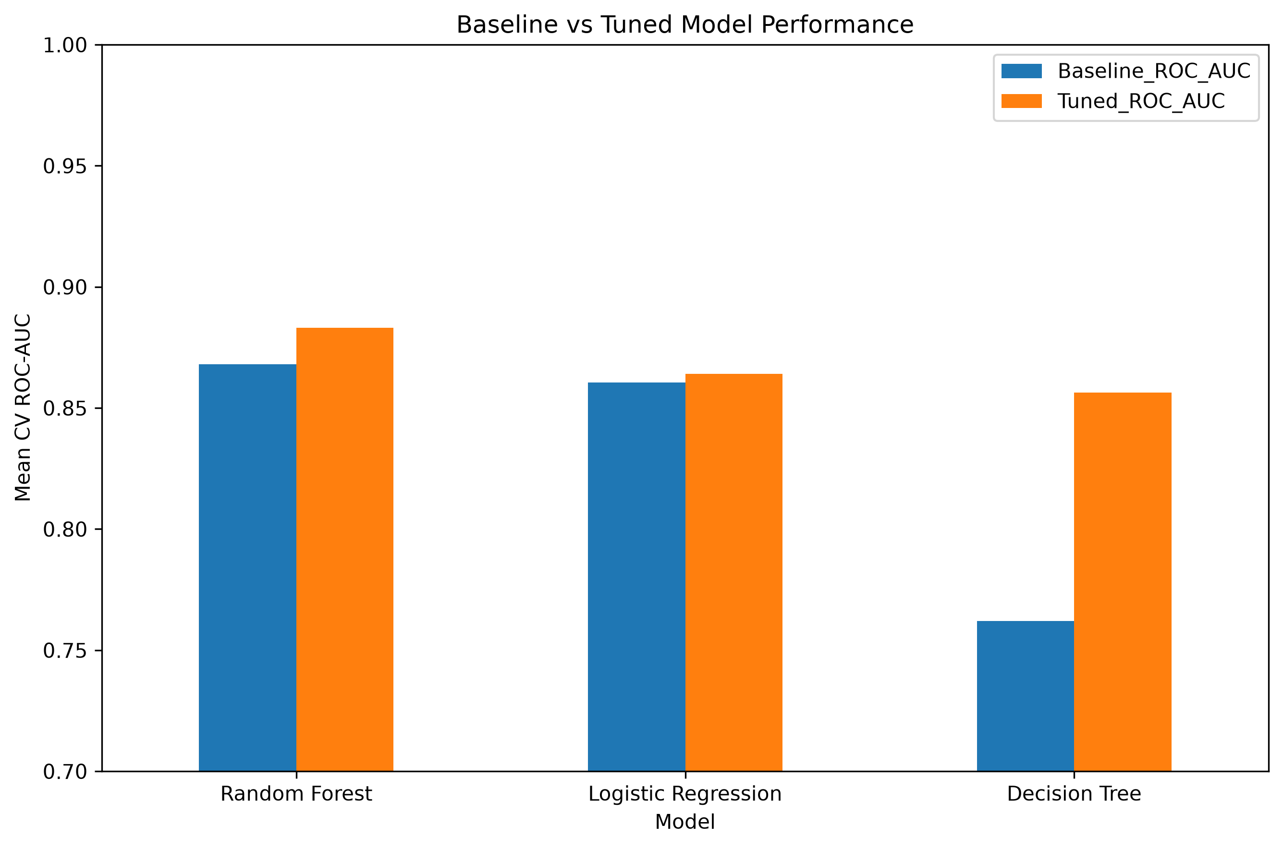
Figure 1. Baseline versus tuned cross-validated ROC-AUC
Tuning improved all three algorithms. Random Forest increased from 0.8681 to 0.8832 ROC-AUC and retained the strongest overall validation profile. Decision Tree showed the largest improvement (0.7620 to 0.8564) after depth and leaf-size regularization, demonstrating that its poor baseline performance was partly caused by excessive flexibility. Logistic Regression changed only slightly, suggesting that the initial regularized linear model was already near its best configuration for this feature set.
Random Forest also has the largest train-to-CV ROC-AUC gap (0.0547), indicating more capacity to fit the training folds than the linear model. The gap is not ignored; it is considered alongside the independent test performance in later sections.

7.1 Final Model Selection
Random Forest was selected because it achieved the highest mean cross-validated ROC-AUC (0.8832), highest cross-validated accuracy (0.8175), highest recall (0.7802), and highest F1 score (0.7675) among the tuned candidates. This selection was completed before the holdout test set was evaluated.

8. Final Holdout Test Evaluation
After model selection, the tuned Random Forest was evaluated once on the 179-passenger holdout set. This is the primary estimate of generalization to unseen records from the same dataset population.
Metric | Final test result
Accuracy | 0.7709 (77.09%)
Balanced Accuracy | 0.7704 (77.04%)
Precision | 0.6795 (67.95%)
Recall | 0.7681 (76.81%)
F1 Score | 0.7211 (72.11%)
ROC-AUC | 0.8366
Average Precision | 0.8198

8.1 Confusion Matrix
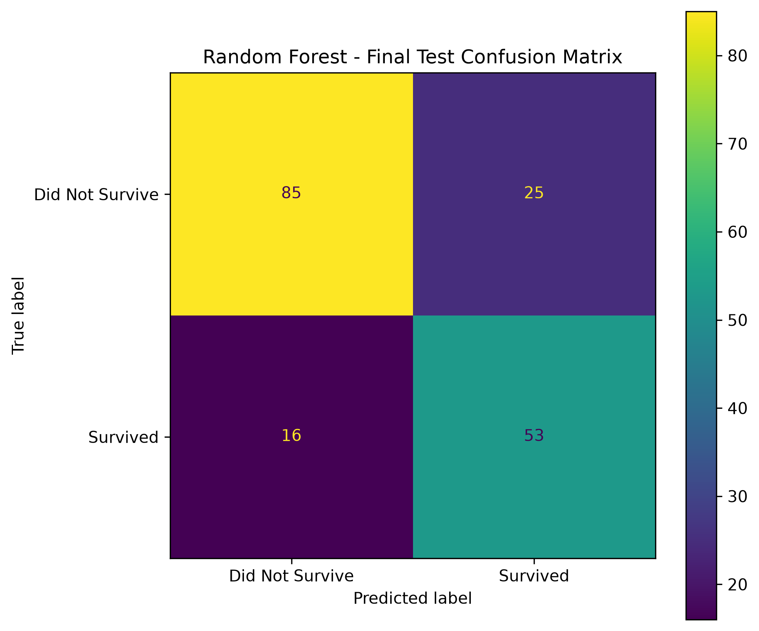
Figure 2. Confusion matrix for the final Random Forest on the holdout test set
Outcome | Count | Interpretation
True Negative | 85 | Correctly predicted non-survivor
False Positive | 25 | Predicted survivor, actually did not survive
False Negative | 16 | Predicted non-survivor, actually survived
True Positive | 53 | Correctly predicted survivor

The model correctly classified 138 of 179 passengers and made 41 errors. Survivor recall (76.81%) is higher than survivor precision (67.95%). The balanced class weighting contributes to this tradeoff by increasing sensitivity to the minority survival class, which helps reduce missed survivors but also produces additional false-positive survivor predictions.

8.2 Worked Metric Calculations from the Confusion Matrix
The reported metrics can be reproduced directly from the final confusion matrix (TN = 85, FP = 25, FN = 16, TP = 53). Showing the arithmetic makes the evaluation auditable rather than presenting metric values as unexplained software output.
Metric | Worked calculation
Accuracy | (TP + TN) / N = (53 + 85) / 179 = 138 / 179 = 0.7709 = 77.09%
Precision | TP / (TP + FP) = 53 / (53 + 25) = 53 / 78 = 0.6795 = 67.95%
Recall | TP / (TP + FN) = 53 / (53 + 16) = 53 / 69 = 0.7681 = 76.81%
F1 score | 2TP / (2TP + FP + FN) = 106 / (106 + 25 + 16) = 106 / 147 = 0.7211 = 72.11%
Balanced Accuracy | [(53 / 69) + (85 / 110)] / 2 = (0.7681 + 0.7727) / 2 = 0.7704 = 77.04%
Worked interpretation: the model makes fewer false negatives (16) than false positives (25). That is why survivor recall (76.81%) is higher than survivor precision (67.95%): the model detects a large share of survivors, but some passengers predicted to survive actually did not.

9. ROC and Precision-Recall Analysis
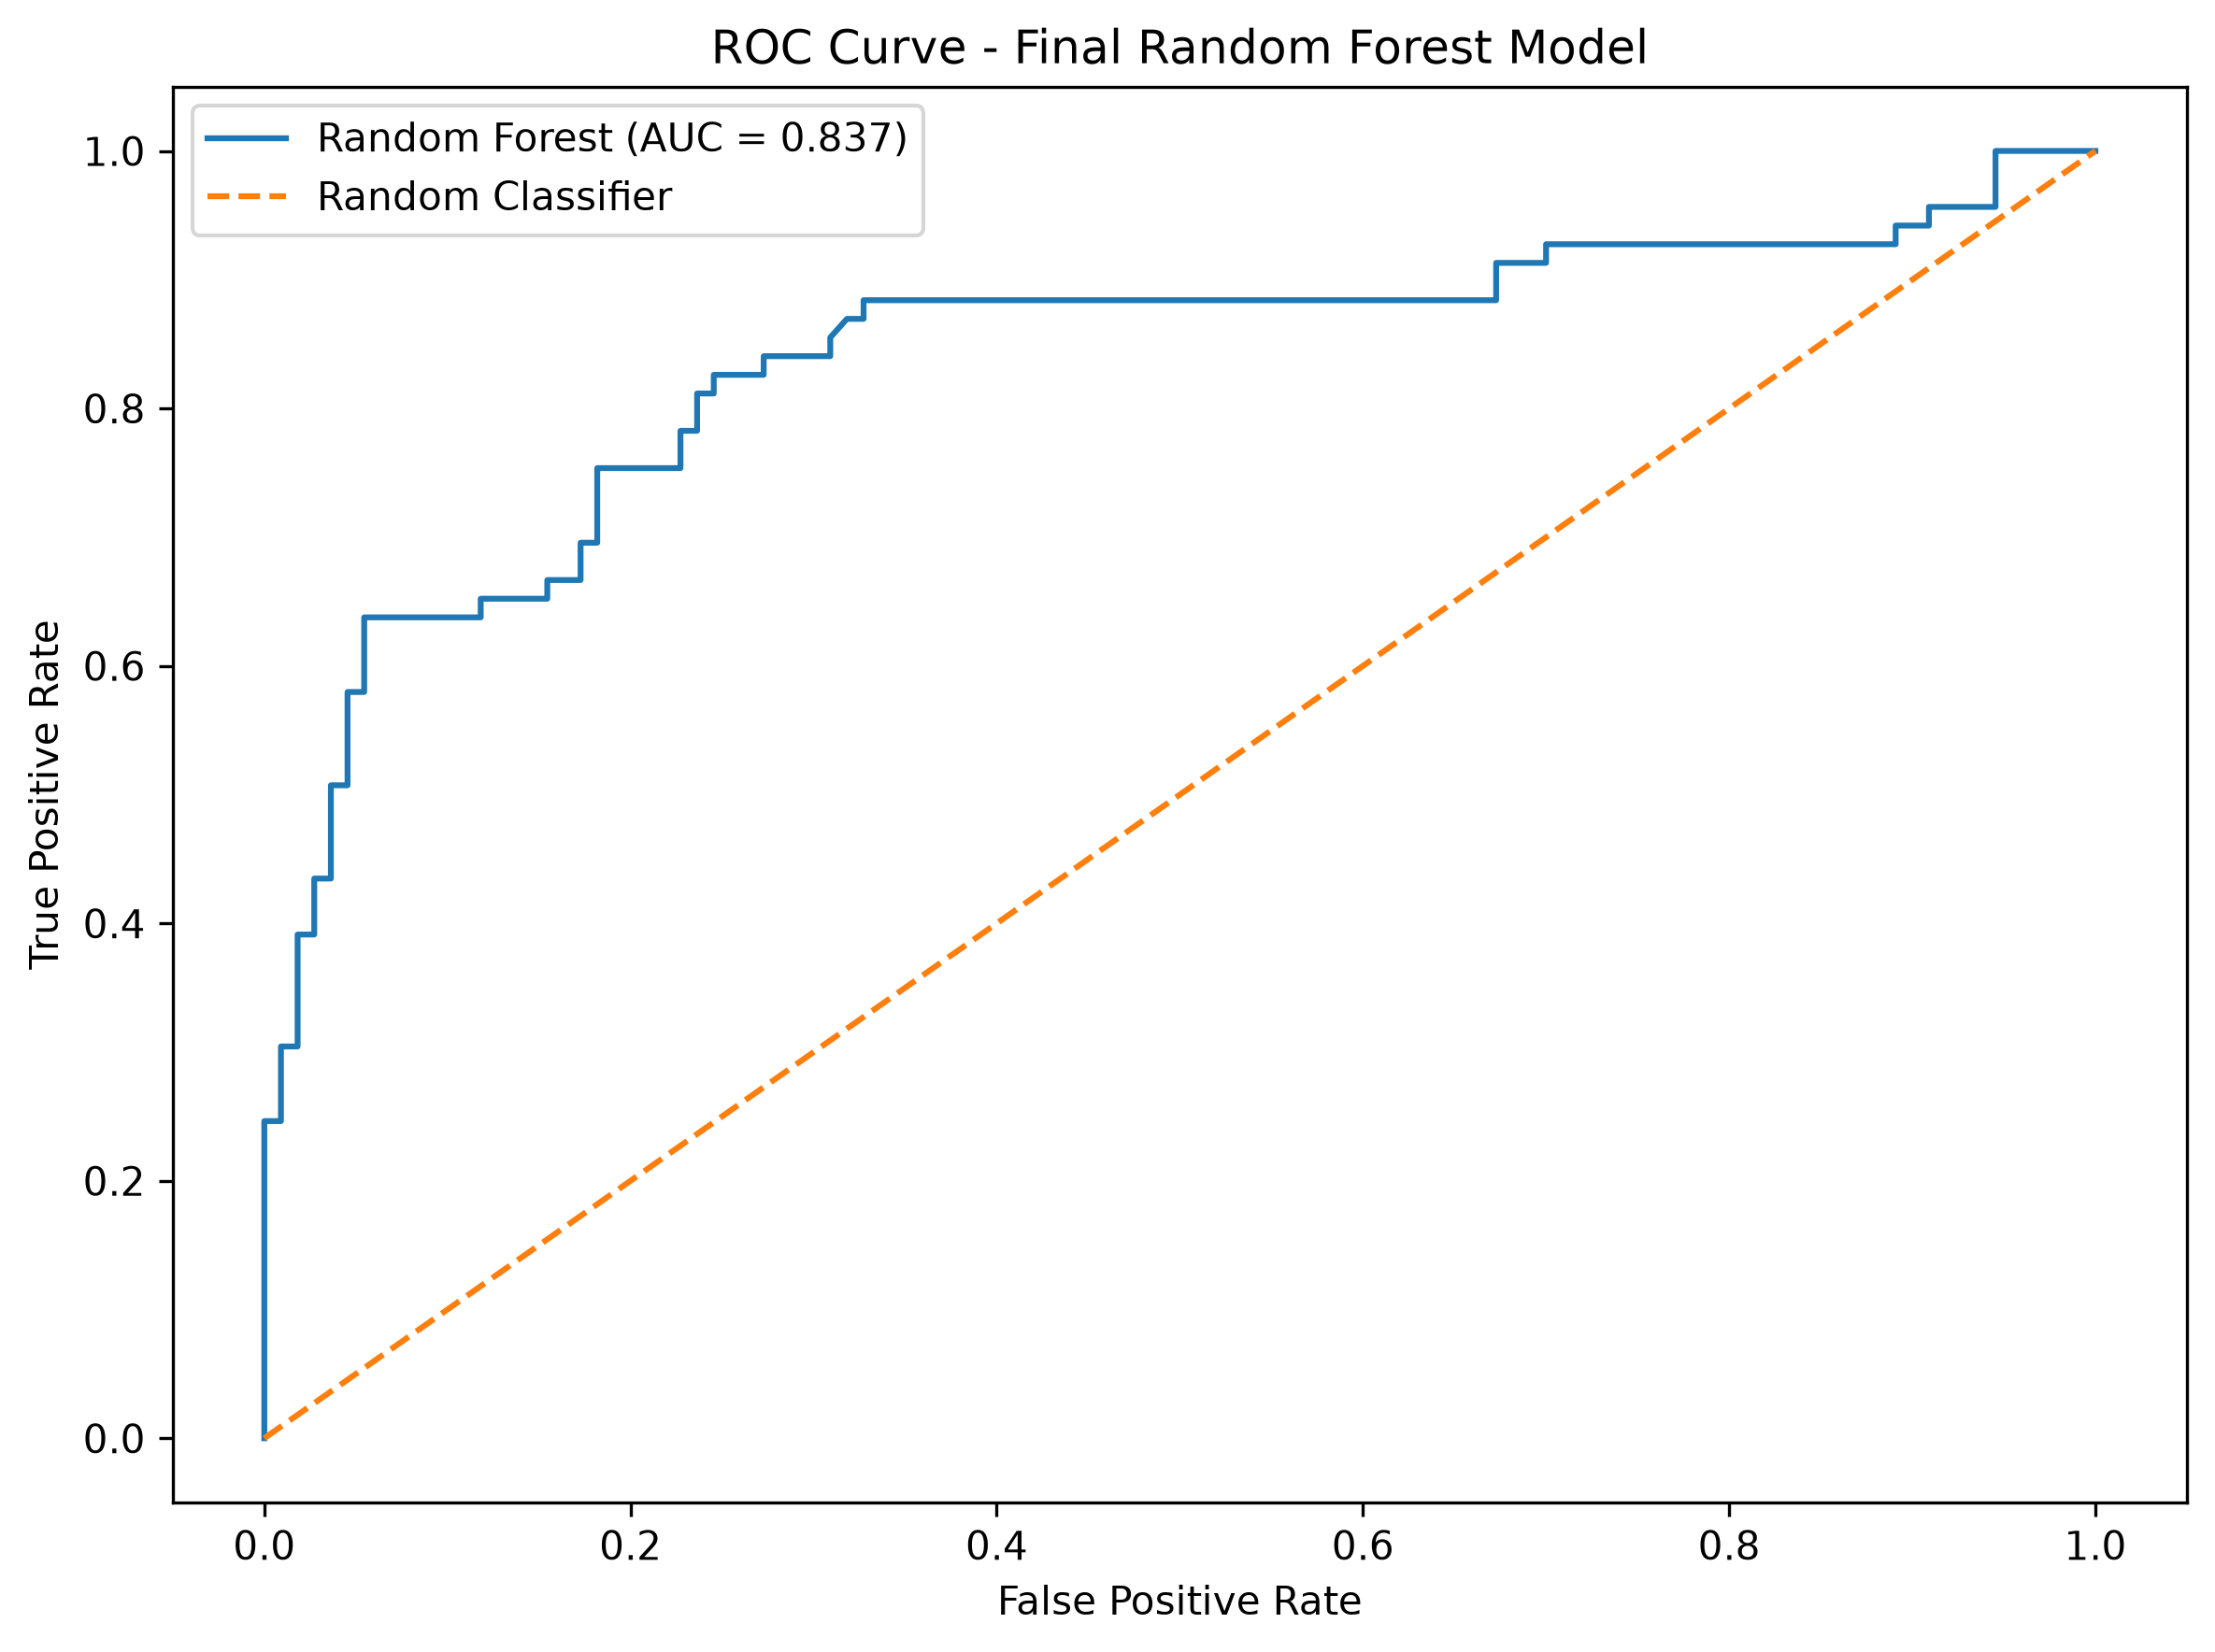
Figure 3. Receiver Operating Characteristic (ROC) curve for the final model
The final ROC-AUC of 0.8366 indicates that the model retains good ranking ability on the independent test set, although it is lower than the cross-validated training estimate of 0.8832. The difference of approximately 0.0466 suggests that the holdout sample is more difficult than the average validation fold and reinforces the importance of independent testing.
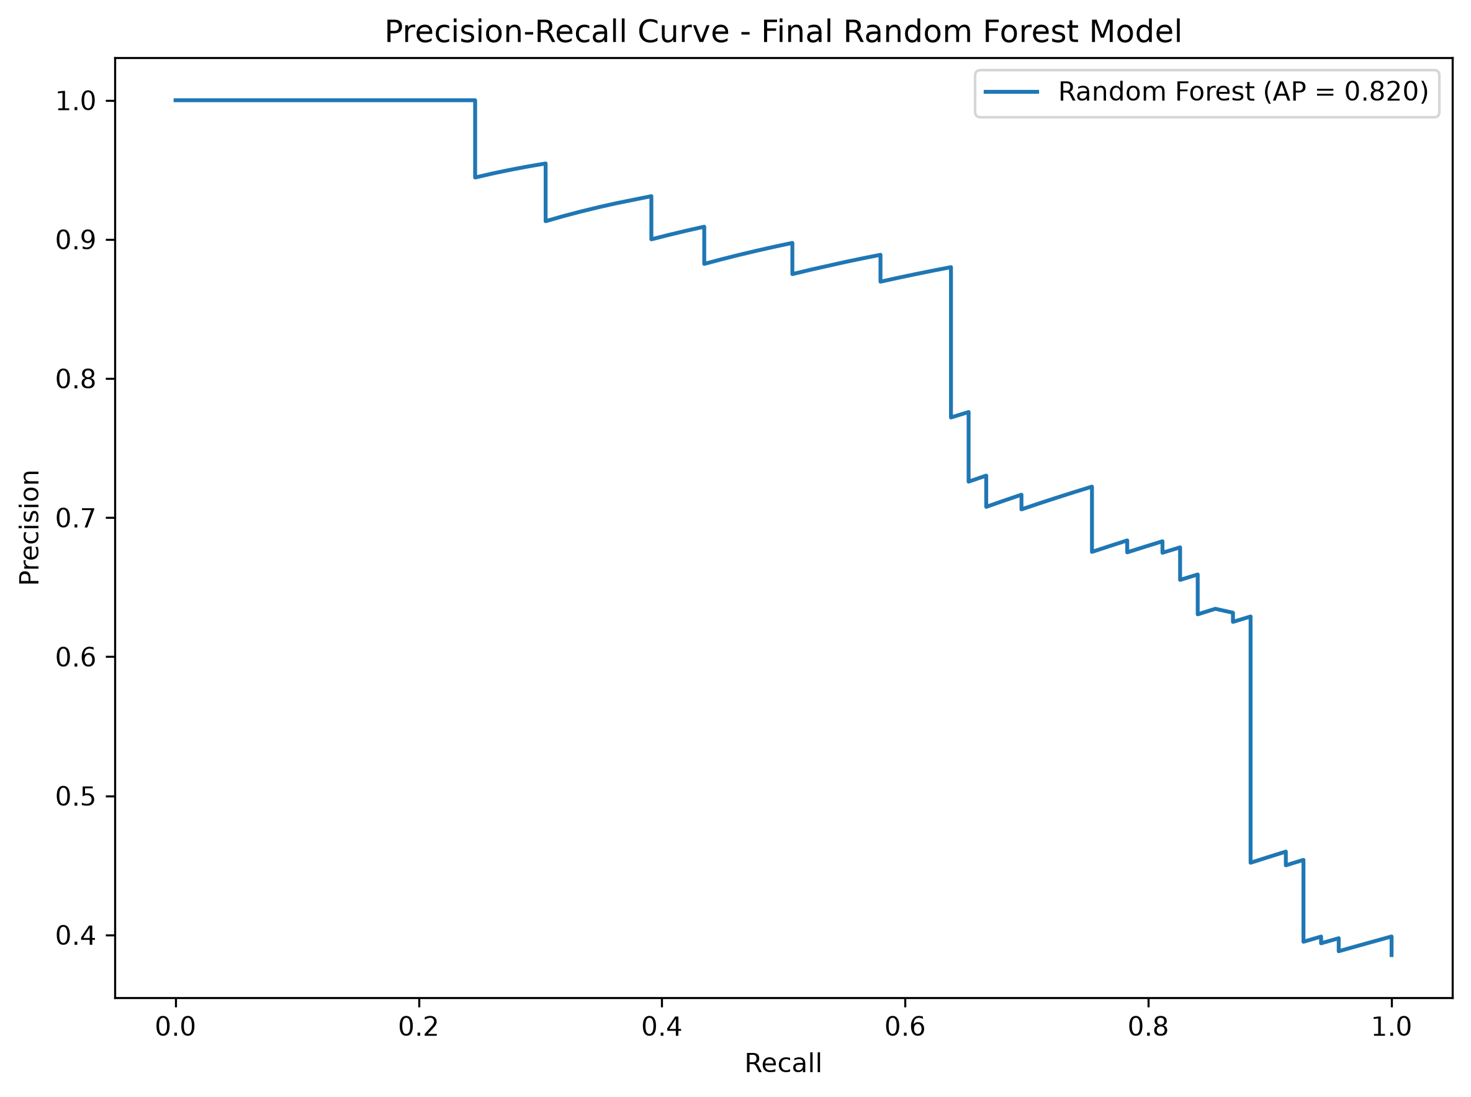
Figure 4. Precision-recall curve for the final model
Average Precision is 0.8198. The precision-recall curve is especially useful because it concentrates on the positive survival class and shows how precision and recall change as the decision threshold changes. The project retains the default decision threshold for the official evaluation; threshold tuning was not performed after viewing the holdout results.

10. Classification Report and Generalization
Class | Precision | Recall | F1 | Support
Did Not Survive | 0.8416 | 0.7727 | 0.8057 | 110
Survived | 0.6795 | 0.7681 | 0.7211 | 69
Macro Average | 0.7605 | 0.7704 | 0.7634 | 179
Weighted Average | 0.7791 | 0.7709 | 0.7731 | 179

10.1 Interpretation of Class-Specific Performance
The model is more precise when predicting non-survivors than survivors. Precision for the non-survivor class is 84.16%, while survivor precision is 67.95%. Survivor recall is 76.81%, meaning roughly three out of four actual survivors in the holdout sample were identified.
These class-specific differences are important because overall accuracy alone would hide the asymmetry. Balanced accuracy of 77.04% confirms that performance is broadly similar across the two classes at the aggregate level, while the subgroup analysis later in the report shows that performance is not uniform across passenger characteristics.

10.2 Cross-Validation versus Holdout Performance
Measure | Cross-validation | Holdout
ROC-AUC | 0.8832 | 0.8366
Accuracy | 0.8175 | 0.7709
F1 | 0.7675 | 0.7211
Recall | 0.7802 | 0.7681

The holdout metrics are lower than the average cross-validation estimates, which is expected to some degree with a small dataset and a single independent test split. Recall remains close to its cross-validation estimate, while ROC-AUC, accuracy, and F1 decrease more noticeably. This pattern supports a cautious conclusion: the model generalizes usefully, but validation performance should not be treated as a guaranteed real-world result.

11. Feature Importance and Relationship to Week 2 EDA
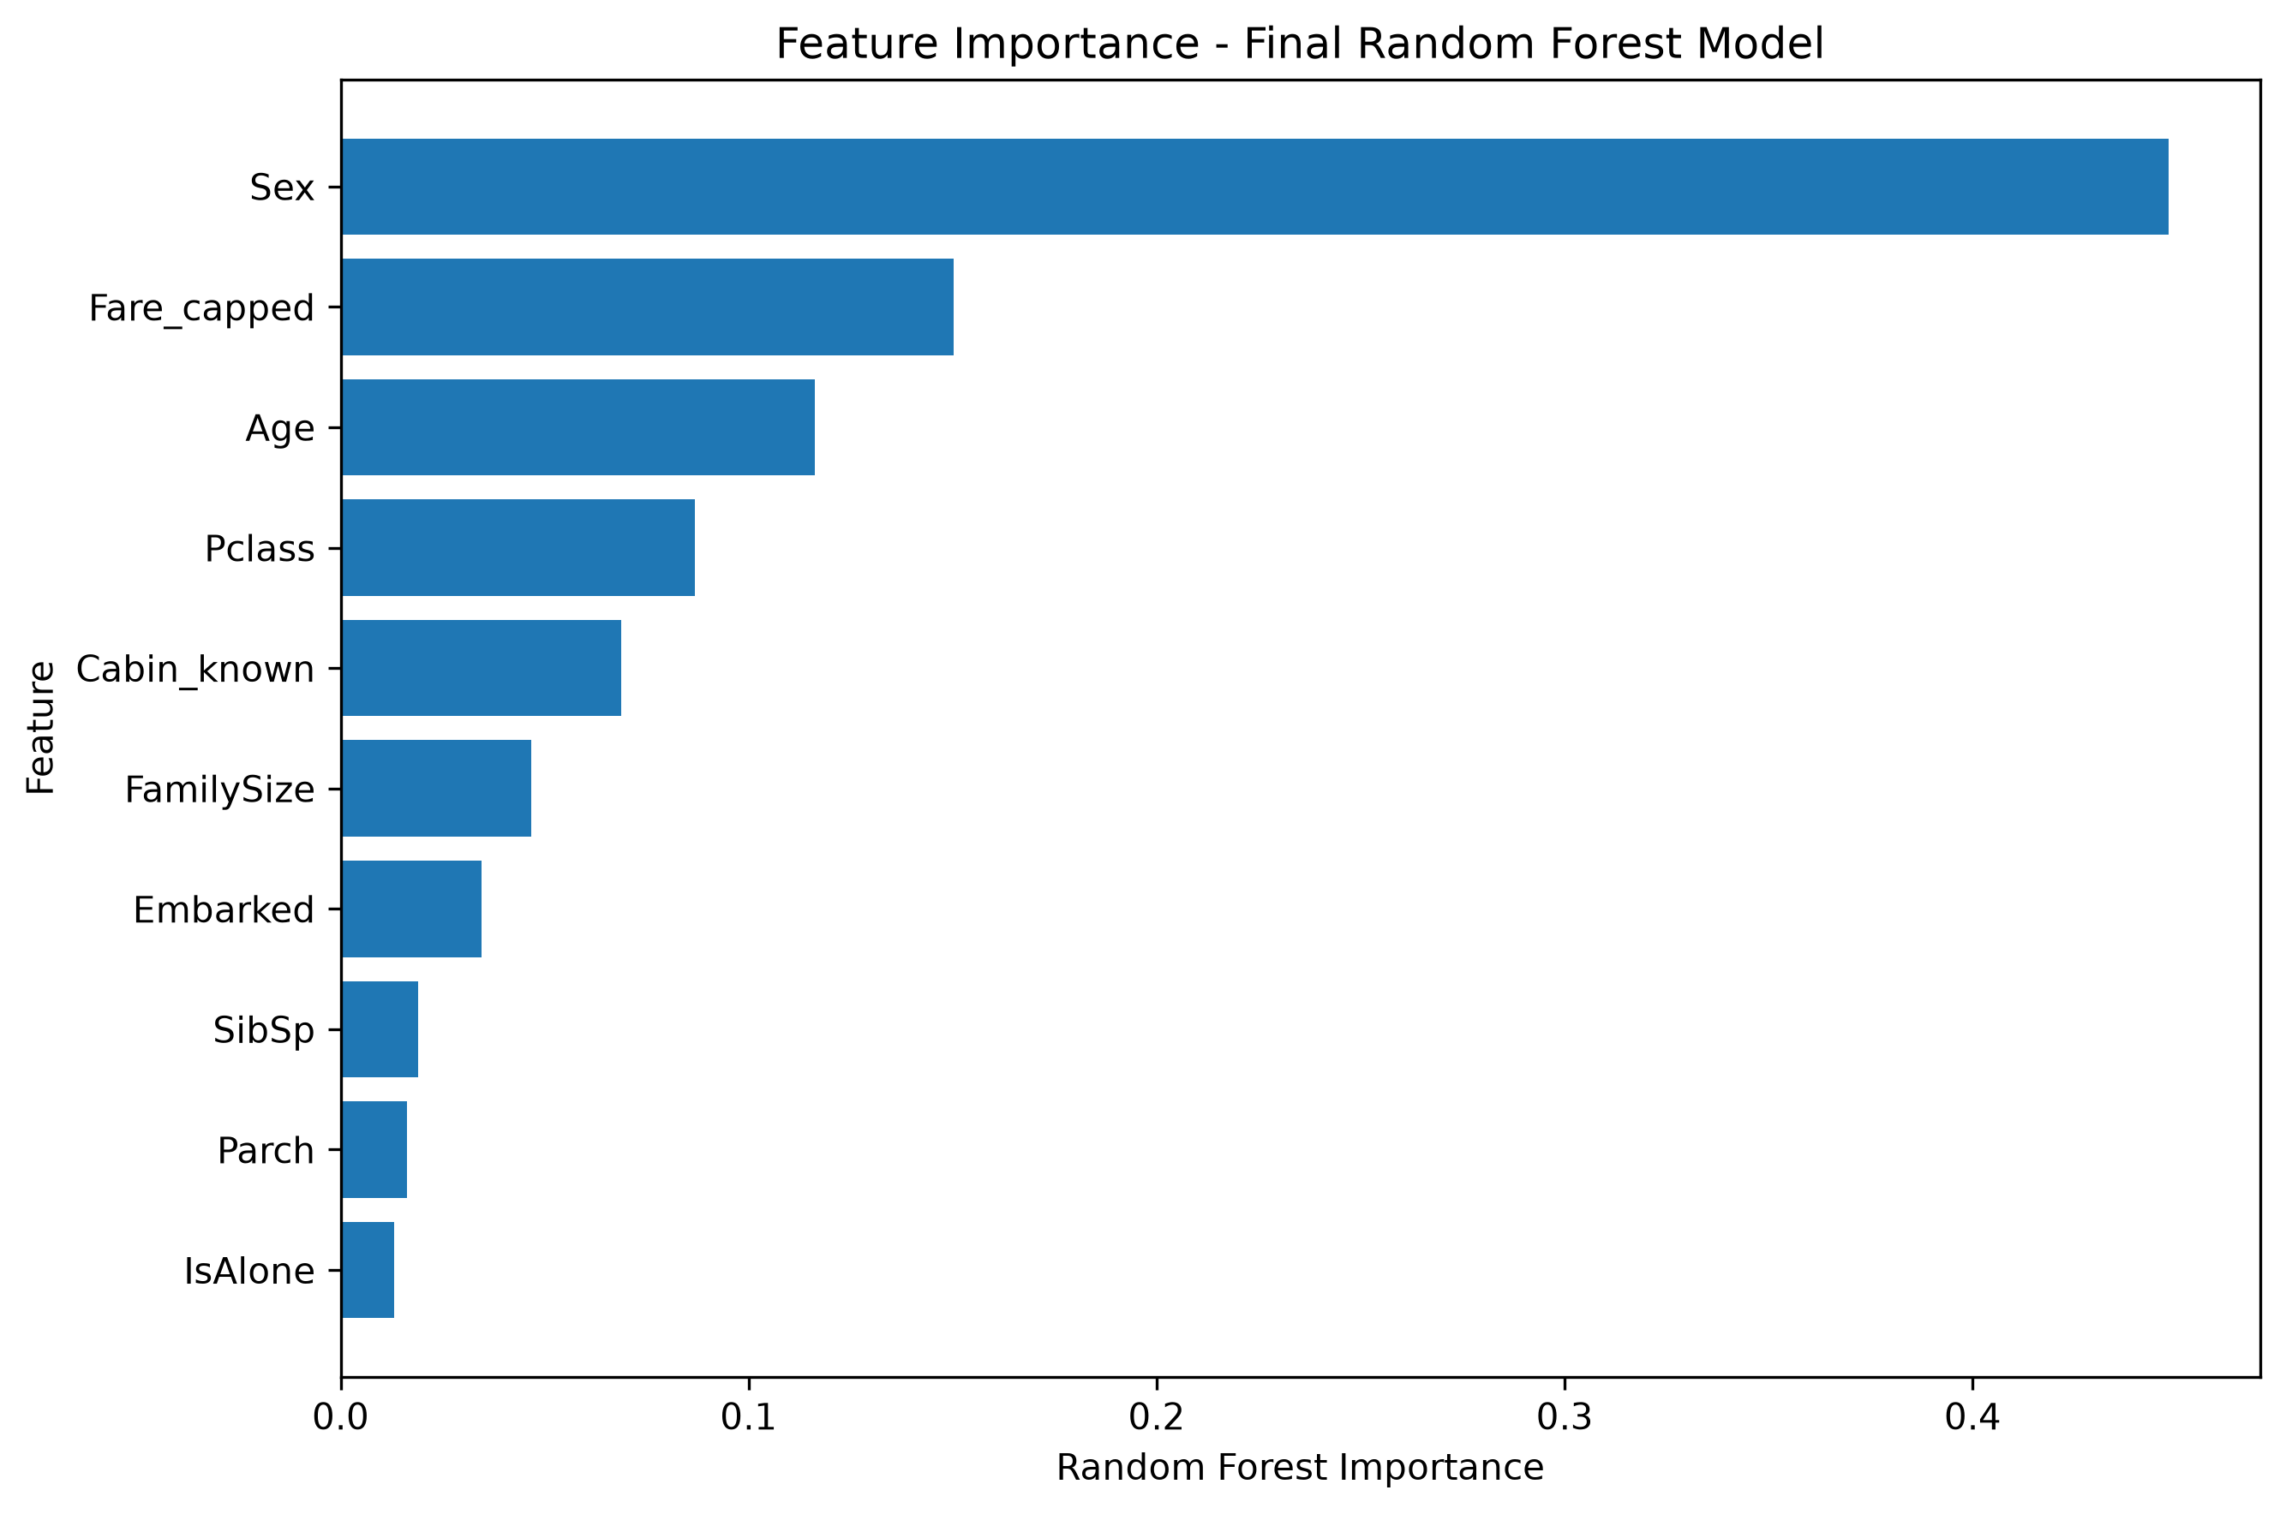
Figure 5. Aggregated feature importance from the final Random Forest
Feature | Importance | Share
Sex | 0.4481 | 44.81%
Fare_capped | 0.1502 | 15.02%
Age | 0.1162 | 11.62%
Pclass | 0.0869 | 8.69%
Cabin_known | 0.0689 | 6.89%
FamilySize | 0.0467 | 4.67%
Embarked | 0.0346 | 3.46%
SibSp | 0.0190 | 1.90%
Parch | 0.0164 | 1.64%
IsAlone | 0.0132 | 1.32%

Sex accounts for approximately 44.81% of the Random Forest impurity-based importance, followed by Fare_capped (15.02%), Age (11.62%), Pclass (8.69%), and Cabin_known (6.89%). This broadly agrees with Week 2 descriptive findings: survival differed strongly by sex and passenger class, survivors tended to pay higher fares, and passengers with recorded cabin information had substantially higher observed survival.
The model also uses engineered family features, although their individual impurity importance is smaller. Random Forest feature importance should not be interpreted as causal influence. It quantifies how useful variables are to the fitted tree ensemble, and correlated variables can share or redistribute importance.

12. Effectiveness of Week 1 Feature Engineering
The internship evaluation criteria explicitly emphasize the effectiveness of feature engineering. To test this rather than merely assume it, a controlled experiment compared a basic feature set with the Week 1 engineered feature set. Both versions used the same Random Forest configuration, the same training data, and the same 5-fold cross-validation procedure.
Feature Set | CV Accuracy | CV F1 | CV ROC-AUC | AUC Std
Basic Features | 0.8077 | 0.7534 | 0.8791 | 0.0259
Week 1 Engineered Features | 0.8175 | 0.7675 | 0.8832 | 0.0257

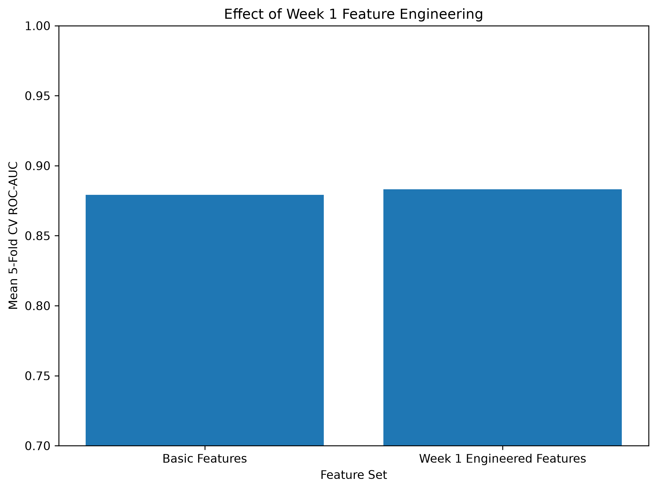
Figure 6. Controlled comparison of basic and Week 1 engineered feature sets
The engineered features increase mean ROC-AUC from 0.8791 to 0.8832, a gain of +0.0040. Accuracy increases by roughly one percentage point and F1 also improves. The effect is modest rather than dramatic, but it is consistent across the main metrics. This provides quantitative evidence that the Week 1 transformations add some predictive value without overstating their contribution.
The modest gain is also understandable because several engineered variables are derived from information already present in the basic features. For example, FamilySize combines SibSp and Parch, while IsAlone is derived from FamilySize. Their value is therefore partly in representing relationships in a form that is easier for the model to use.

13. Subgroup Performance and Error Analysis
Aggregate performance can hide systematic differences between passenger groups. The holdout predictions were therefore analyzed by sex, passenger class, travel status, cabin-information availability, and age group. These results are diagnostic rather than evidence of causal effects or guaranteed performance for broader populations.
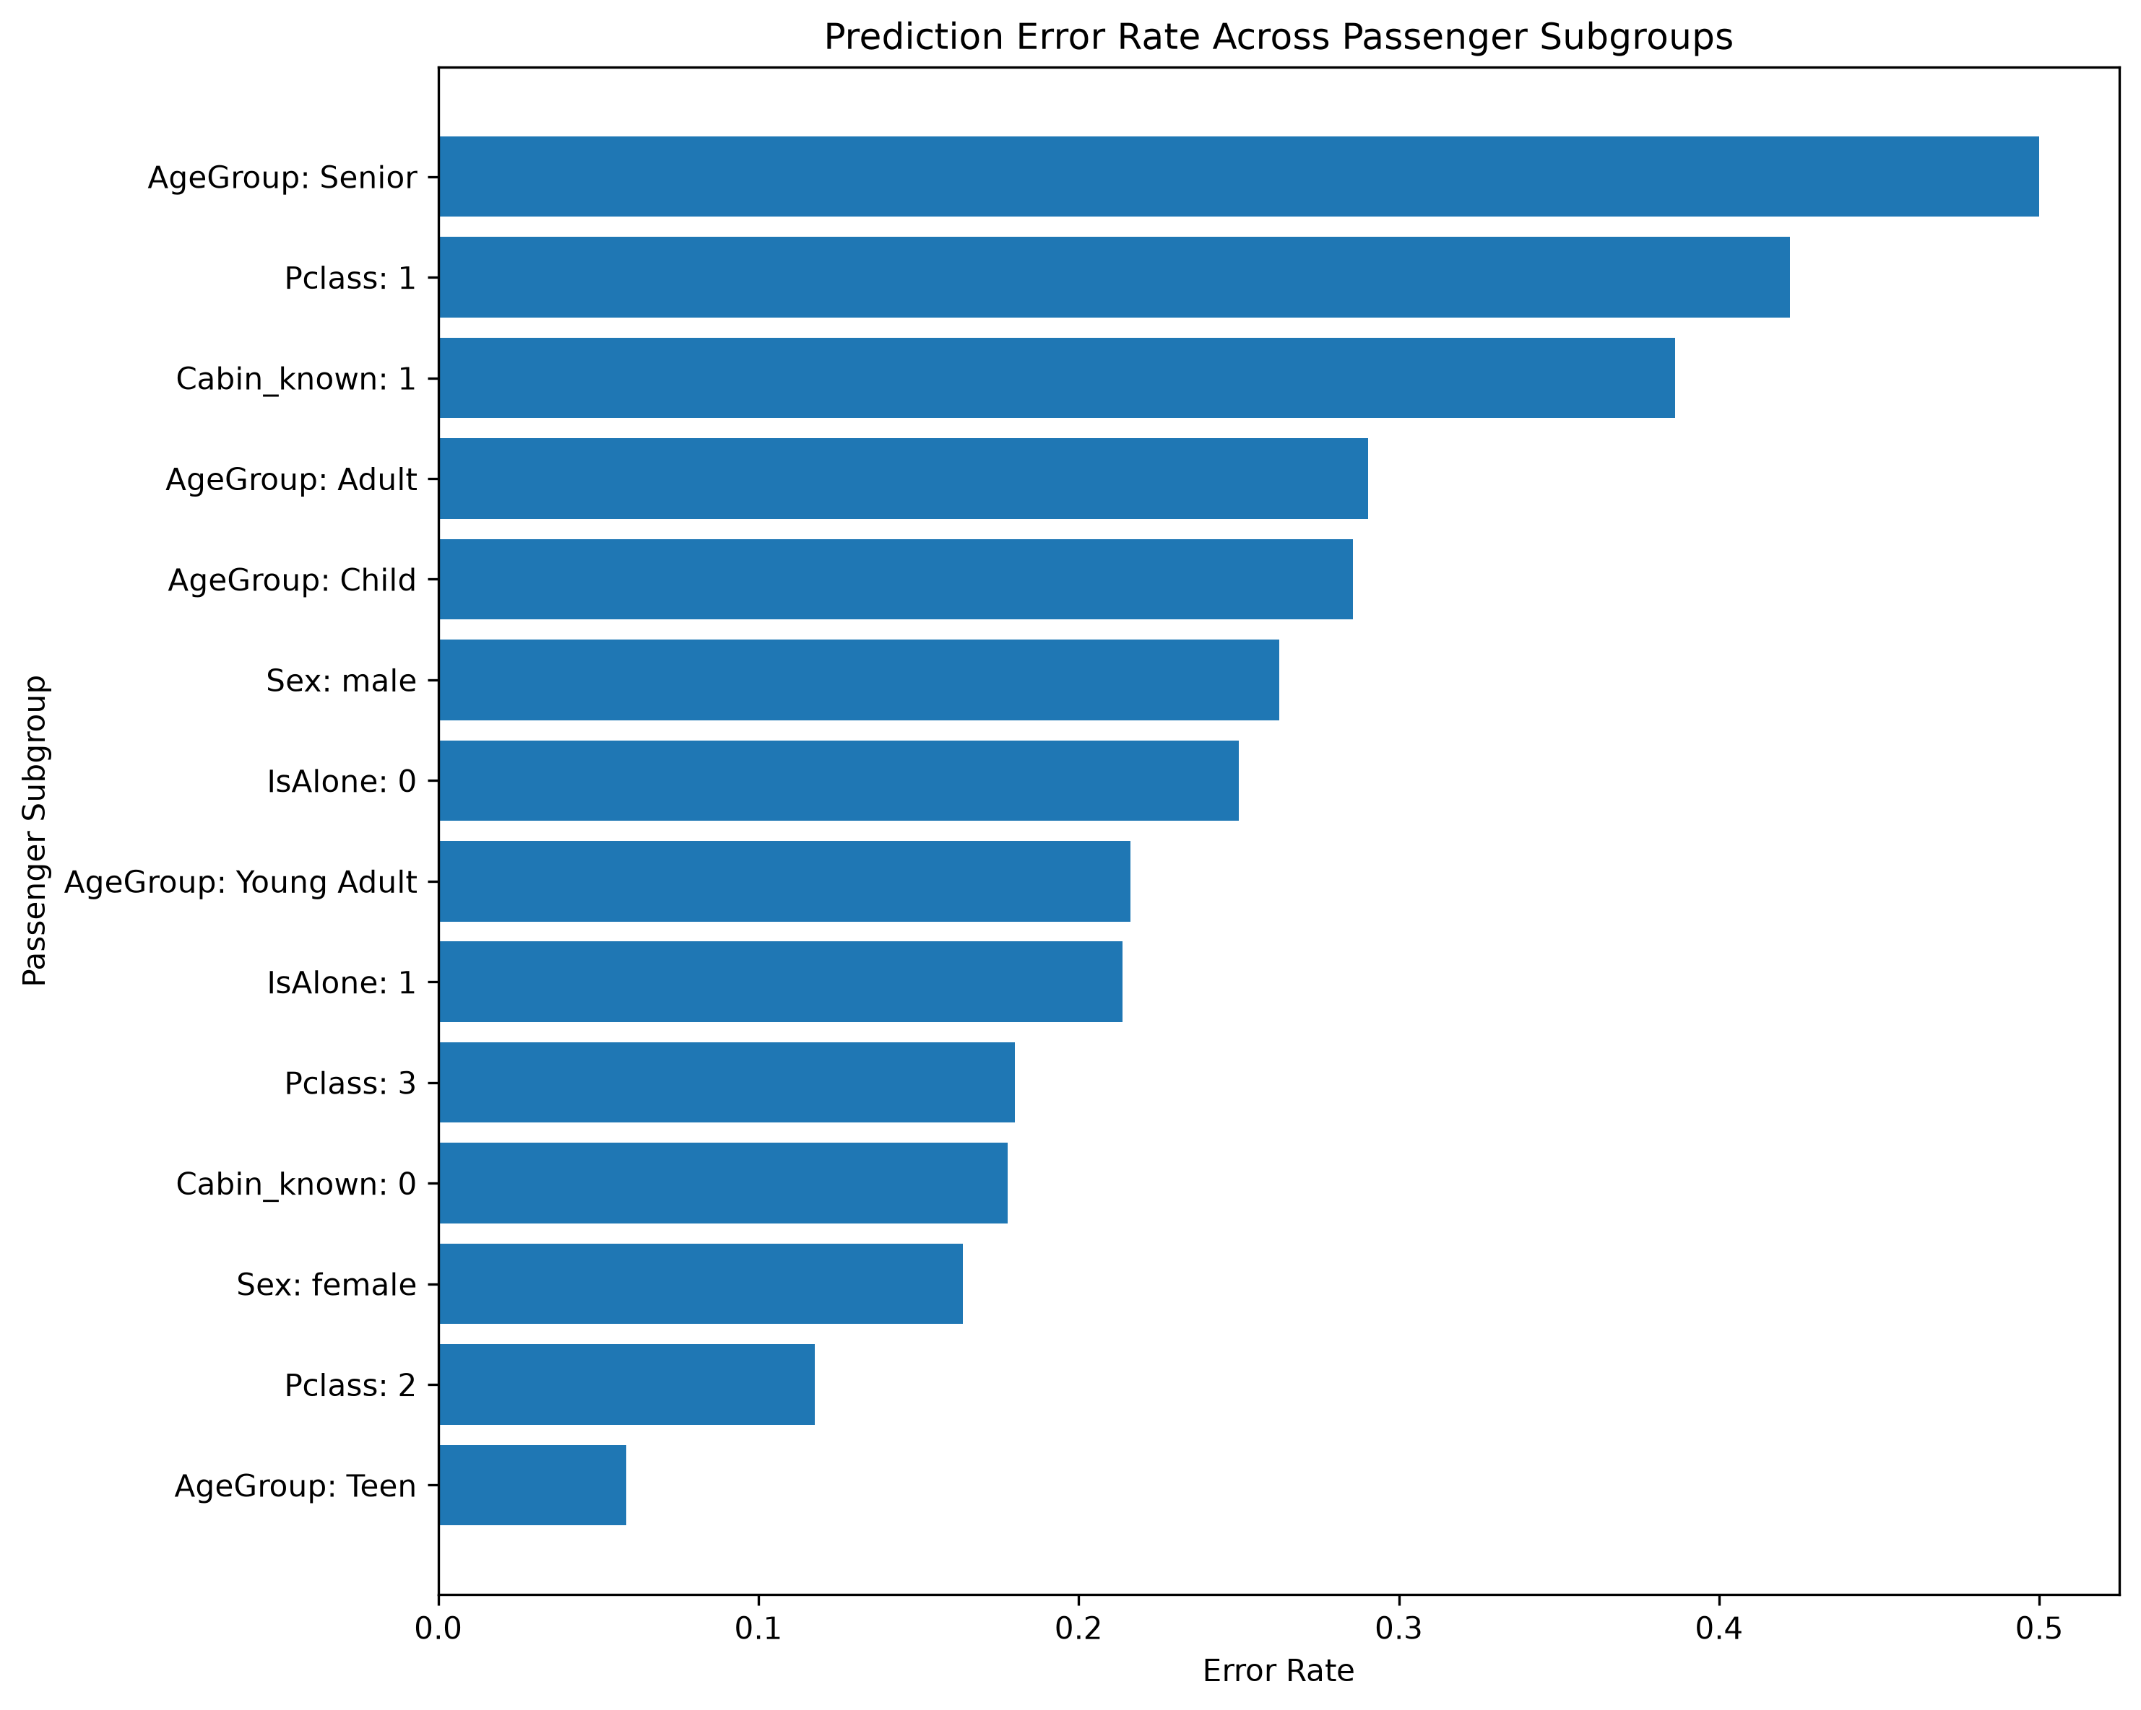
Figure 7. Prediction error rates across passenger subgroups
Group | N | Accuracy | Recall | F1 | Error Rate
Female | 61 | 0.8361 | 1.0000 | 0.9000 | 0.1639
Male | 118 | 0.7373 | 0.3333 | 0.3404 | 0.2627
Class 1 | 45 | 0.5778 | 0.8400 | 0.6885 | 0.4222
Class 2 | 34 | 0.8824 | 0.8500 | 0.8947 | 0.1176
Class 3 | 100 | 0.8200 | 0.6250 | 0.6250 | 0.1800

The largest difference is by sex in this particular holdout split. Female accuracy is 83.61% and survivor recall is 100%, while male accuracy is 73.73% and survivor recall is 33.33%. This pattern is consistent with the strong survival differences seen in Week 2, but it also reveals a weakness: male survivors are relatively difficult for the model to detect because many male passengers share characteristics associated with non-survival in the historical data.
First-class accuracy is only 57.78% in the holdout sample despite passenger class being predictive overall. Cabin-known passengers also have a higher error rate than cabin-unknown passengers. These examples show why feature importance and subgroup accuracy answer different questions: a variable can be useful overall while specific groups remain difficult to classify.

14. Analysis of High-Confidence Errors
The model produced 41 errors: 25 false positives and 16 false negatives. To understand model limitations, incorrect predictions were ranked by prediction confidence. High-confidence errors are especially informative because they show cases where the fitted relationships strongly favored the wrong class.
ID | Sex | Class | Age | Family | Cabin | Actual | Pred. | Confidence
298 | female | 1 | 2 | 4 | Yes | 0 | 1 | 0.918
445 | male | 3 | 26 | 1 | No | 1 | 0 | 0.916
805 | male | 3 | 27 | 1 | No | 1 | 0 | 0.915
272 | male | 3 | 25 | 1 | No | 1 | 0 | 0.914
200 | female | 2 | 24 | 1 | No | 0 | 1 | 0.911
571 | male | 2 | 62 | 1 | No | 1 | 0 | 0.905
18 | male | 2 | 30 | 1 | No | 1 | 0 | 0.883
503 | female | 3 | 21.5 | 1 | No | 0 | 1 | 0.863

14.1 Examples
Passenger 298 was a female first-class child with recorded cabin information. The model predicted survival with approximately 91.8% probability, yet the actual outcome was non-survival. The combination of characteristics strongly resembles groups with high survival rates in the training data, illustrating that group-level patterns cannot determine every individual outcome.
Several high-confidence false negatives were male, third-class, solo travellers. Their characteristics resemble a historically low-survival group, causing the model to assign low survival probabilities even though those specific passengers survived. This is a clear example of the limitation of pattern-based prediction: rare outcomes within a strongly patterned subgroup can be difficult to identify.

14.2 End-to-End Worked Prediction Example: Passenger 298
Passenger 298 provides a complete example of how one raw record moves through the leakage-safe pipeline. This passenger is also useful because the final prediction is confidently wrong, making the example informative rather than selectively choosing an easy correct case.
Stage | Input / transformation | Result
Raw record | Pclass=1; Sex=female; Age=2; SibSp=1; Parch=2; Fare=151.55; Cabin=C22 C26; Embarked=S | Actual Survived = 0
Age handling | Age is already known, so no imputation is required | Age = 2.0
Fare treatment | Fare is capped using the threshold learned from the training subset only | 151.55 -> 65.6563
Cabin feature | Cabin value is present | Cabin_known = 1
Family engineering | FamilySize = SibSp + Parch + 1 = 1 + 2 + 1 | FamilySize = 4; IsAlone = 0
Encoding / scaling | Numerical variables are standardized; Sex and Embarked are one-hot encoded inside the fitted pipeline | Model-ready feature vector
Random Forest output | Predicted survival probability = 0.918055; default binary threshold = 0.50 | Predicted Survived = 1
Observed result | Historical outcome from the dataset | Actual Survived = 0 -> False Positive
Why the model was confident: this passenger combines several characteristics associated with high survival in the training data - female, first class, very young age, travelling with family, and recorded cabin information. The prediction therefore follows the statistical patterns learned by the model, yet the individual historical outcome is the opposite. This demonstrates why model probabilities express pattern-based uncertainty rather than certainty about an individual case.
A second methodological detail is visible in this example. The modeling-time fare cap is 65.6563, slightly different from the Week 1 full-dataset cap of 65.6344. The difference occurs because Week 4 learns the threshold only from the training subset. That small numerical change is direct evidence that the supervised pipeline is genuinely leakage-safe rather than simply reusing full-dataset preprocessing statistics.

14.3 Implication
High-confidence errors demonstrate that predictive probabilities are not guarantees. They also reinforce the need to interpret the model as a statistical classifier trained on historical associations rather than a causal explanation of survival.

15. Probability Calibration
Classification metrics measure whether rankings and class labels are useful, but they do not fully answer whether predicted probabilities are numerically reliable. Calibration analysis compares predicted survival probabilities with observed survival frequencies in groups of passengers with similar predicted probabilities.
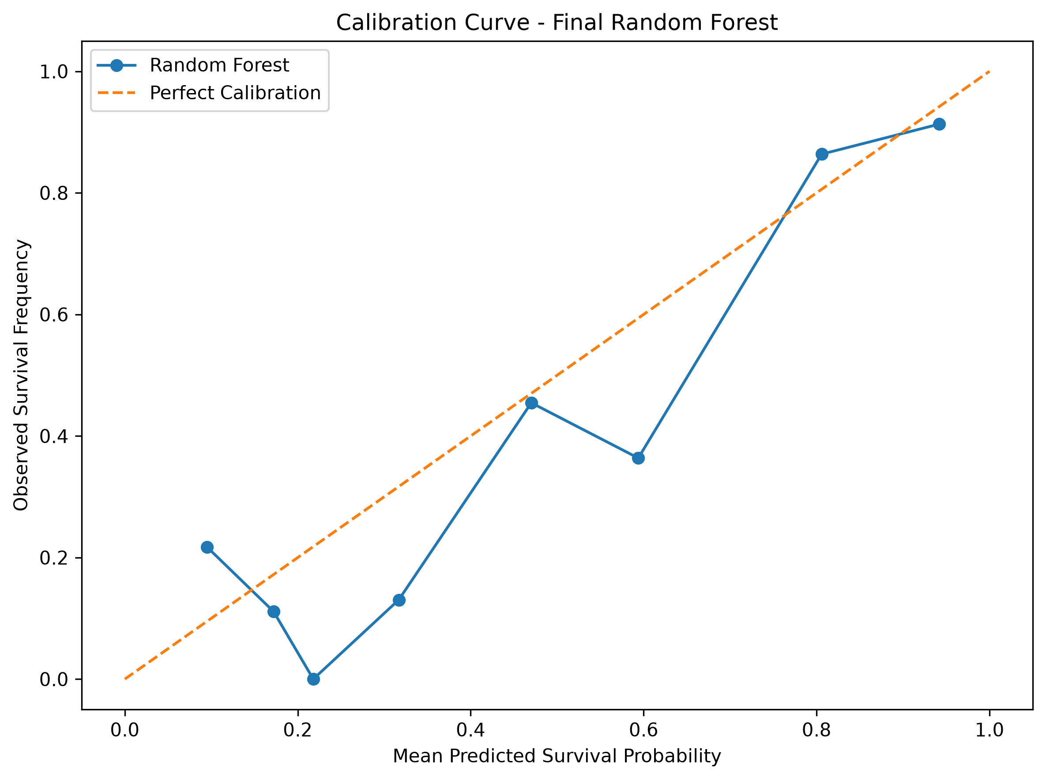
Figure 8. Calibration curve for the final Random Forest
Mean predicted probability | Observed survival rate
0.0950 | 0.2174
0.1720 | 0.1111
0.2179 | 0.0000
0.3168 | 0.1304
0.4701 | 0.4545
0.5938 | 0.3636
0.8059 | 0.8636
0.9418 | 0.9130

The Brier score is 0.1525, where lower values indicate more accurate probability estimates. The highest-probability bins are reasonably close to the perfect-calibration line: a mean predicted probability of 0.8059 corresponds to an observed rate of 0.8636, while 0.9418 corresponds to 0.9130. Some low and middle probability bins deviate more strongly, indicating that probability estimates are not perfectly calibrated.
Calibration was examined only after final model selection and was not used to tune hyperparameters. This preserves the holdout set as a final diagnostic rather than an additional optimization dataset.

16. Strengths and Limitations of the Final Model

16.1 Strengths
- Uses a complete Scikit-learn Pipeline so preprocessing and prediction are reproducible.
- Prevents data leakage by fitting learned preprocessing statistics only on training data.
- Compares three algorithms with identical validation splits instead of reporting one arbitrary model.
- Uses 5-fold stratified cross-validation and GridSearchCV for evidence-based model selection.
- Evaluates multiple metrics rather than relying only on accuracy.
- Demonstrates a measurable benefit from Week 1 feature engineering through a controlled experiment.
- Includes post-model diagnostics: feature importance, subgroup errors, confident mistakes, and calibration.
- Serializes the complete pipeline with Joblib for reuse.

16.2 Limitations
- The dataset contains only 891 labeled passengers, so estimates can vary across splits and small subgroups are unstable.
- The holdout test set contains 179 passengers; a single split is useful but does not eliminate sampling uncertainty.
- The cross-validated ROC-AUC (0.8832) is higher than holdout ROC-AUC (0.8366), showing that validation results should not be treated as guaranteed performance.
- Random Forest feature importance is not causal and can be redistributed among correlated predictors.
- Variables such as Pclass, Fare, and Cabin_known are related, so they should not be interpreted independently without context.
- Survivor precision is lower than non-survivor precision, producing 25 false-positive survivor predictions.
- Performance differs substantially across some subgroups, especially male survivors in this holdout sample.
- Probability calibration is imperfect in several low-to-middle probability ranges.
- The Titanic dataset is a specific historical population; the model is not intended for generalization to unrelated modern populations.

17. Possible Model Improvements
The current model is intentionally based on widely used Scikit-learn algorithms and interpretable engineered features. Several extensions could improve predictive performance or model understanding in future work.
Improvement | Rationale
Richer title features | Extract titles such as Mr, Mrs, Miss, Master, and rare titles from Name to represent age/social-group information.
Cabin deck extraction | Use the first cabin letter as a deck-level feature instead of only whether cabin information is known.
Ticket-group features | Passengers sharing a ticket may represent family or travel groups not fully captured by SibSp/Parch.
Fare per person | Divide group ticket fare by estimated ticket-group size where reliable.
Gradient boosting | Compare Random Forest with Gradient Boosting, XGBoost, LightGBM, or CatBoost when allowed by the task environment.
Repeated or nested validation | Use repeated stratified CV or nested CV to reduce dependence on one set of folds during model-selection studies.
Probability calibration | Apply Platt scaling or isotonic calibration using training-only calibration data if well-calibrated probabilities are required.
Threshold optimization | Choose a decision threshold based on a stated operational cost of false positives versus false negatives, using validation data rather than the test set.
Explainability | Add permutation importance or SHAP-based local explanations to complement impurity importance.

17.1 Why No Further Tuning Was Performed
After the holdout test results were observed, no additional hyperparameter changes were made. Continuing to tune based on test performance would gradually convert the test set into another validation set and make its reported performance overly optimistic. Future improvements should therefore use new validation procedures or an additional untouched evaluation set.

18. Reproducibility, Saved Model, and Project Outputs
The Week 4 implementation is integrated into the same Titanic_Data_Science_Project repository used for Weeks 1 and 2. The final GitHub repository preserves separate scripts and output folders so each internship task remains clear while still forming one portfolio project.
Component | Location
Week 1 cleaning script | src/titanic_cleaning.py
Week 2 EDA script | src/titanic_eda.py
Week 4 ML script | src/titanic_supervised_ml.py
Reusable custom transformer | src/titanic_transformers.py
Model figures | outputs/model_figures/
Model metrics / diagnostics | outputs/model_metrics/
Serialized final pipeline | models/titanic_random_forest_pipeline.joblib
Repository | https://github.com/ARraj14/Titanic_Data_Science_Project

18.1 Saved Pipeline Portability
The custom TitanicFeatureEngineer was moved into an importable module before final submission. This ensures that Joblib can resolve the transformer class when the saved pipeline is loaded outside the original training process. The final pipeline was successfully reloaded in a fresh Python process as a sklearn.pipeline.Pipeline object.
Model portability verification
import sys
import joblib
sys.path.insert(0, "src")
model = joblib.load("models/titanic_random_forest_pipeline.joblib")
print(type(model))
# <class 'sklearn.pipeline.Pipeline'>

18.2 Generated Evidence
The repository stores baseline and tuned model comparisons, selected hyperparameters, final test metrics, classification report, test predictions, feature-importance tables, subgroup performance, complete error analysis, confident errors, feature-engineering comparison, baseline-versus-tuned comparison, and calibration data. This makes the results auditable instead of relying only on narrative statements in the report.

19. Findings and Practical Implications
The project demonstrates that the passenger characteristics identified during Week 2 EDA contain meaningful predictive information. Sex is the dominant Random Forest feature, while fare, age, passenger class, cabin-information availability, and family characteristics provide additional signal. The final model separates survivors from non-survivors substantially better than random ranking, as shown by a holdout ROC-AUC of 0.8366.
However, the model should be understood as a historical prediction exercise rather than an operational decision system. The outcome reflects a unique disaster, and the features encode social and travel conditions specific to the Titanic. The analysis therefore focuses on learning machine-learning workflow skills: preprocessing, leakage prevention, model comparison, validation, tuning, evaluation, diagnostics, and critical interpretation.

19.1 Main Technical Findings
- Random Forest was the strongest tuned classifier with cross-validated ROC-AUC of 0.8832.
- The independent test ROC-AUC was 0.8366, confirming useful but lower out-of-sample performance.
- The final model achieved 77.09% accuracy and 76.81% survivor recall.
- Week 1 engineered features produced a modest ROC-AUC increase of +0.0040 in a controlled comparison.
- Sex was the largest impurity-based feature importance, consistent with Week 2 descriptive patterns.
- Subgroup analysis revealed weaker detection of male survivors and varying performance by passenger class.
- High-confidence errors showed that strong historical group patterns can still fail for individual passengers.
- Calibration analysis showed useful probability behavior at high predicted probabilities but imperfections in several lower ranges.

19.2 Connection Across Internship Weeks
Week 1 answered: How should the raw data be cleaned and transformed? Week 2 answered: What patterns and relationships exist in the cleaned data? Week 4 answers: How well can those patterns support predictions on unseen records? Using the same dataset across these stages creates a coherent end-to-end data-science workflow rather than six disconnected exercises.

20. Conclusion
This Week 4 task successfully implemented a complete supervised-learning workflow for Titanic survival prediction. The solution begins with the data-cleaning and feature-engineering principles developed during Week 1 and uses the descriptive findings from Week 2 as modeling context. The raw dataset is split before learned preprocessing statistics are calculated, preventing test-set leakage and enabling valid cross-validation. The final evaluation also exceeds a 61.45% majority-class accuracy baseline by 15.64 percentage points, and the report documents the exact metric arithmetic and a complete passenger-level prediction trace to make the analysis reproducible and specific.
Logistic Regression, Decision Tree, and Random Forest were compared with 5-fold stratified cross-validation. GridSearchCV then optimized each model using ROC-AUC as the primary selection metric. The tuned Random Forest, configured with 400 trees, balanced class weights, sqrt feature sampling, and a minimum leaf size of five, achieved the best cross-validated ROC-AUC of 0.8832 and was selected without reference to test performance.
On the independent 179-passenger holdout set, the final model achieved 77.09% accuracy, 77.04% balanced accuracy, 67.95% precision, 76.81% recall, a 72.11% F1 score, and ROC-AUC of 0.8366. Feature engineering improved cross-validated ROC-AUC from 0.8791 to 0.8832. Additional analysis identified Sex, Fare_capped, Age, Pclass, and Cabin_known as the most influential model features, while subgroup and high-confidence-error analysis exposed important weaknesses that are not visible from aggregate accuracy alone.
The final result is therefore not only a working classifier but a documented, reproducible, and critically evaluated supervised-learning pipeline. It demonstrates practical understanding of data preparation, feature engineering, validation, hyperparameter tuning, model evaluation, error analysis, calibration, and the limitations of predictive modeling on a small historical dataset.

20.1 Final Performance Summary
Item | Result
Selected model | Random Forest
Tuned 5-fold CV ROC-AUC | 0.8832
Holdout ROC-AUC | 0.8366
Holdout Accuracy | 77.09%
Holdout Balanced Accuracy | 77.04%
Holdout Precision | 67.95%
Holdout Recall | 76.81%
Holdout F1 | 72.11%
Average Precision | 0.8198
Brier Score | 0.1525
Feature-engineering ROC-AUC change | +0.0040

Dataset and Project References
- Kaggle: Titanic - Machine Learning from Disaster dataset.
- Scikit-learn: preprocessing, pipelines, model selection, classification metrics, and ensemble algorithms.
- Project repository: https://github.com/ARraj14/Titanic_Data_Science_Project

Appendix A. Key Implementation Excerpts
The following excerpts summarize the central implementation choices. The complete executable implementation is available in src/titanic_supervised_ml.py and src/titanic_transformers.py.

A.1 Modeling Pipeline
pipeline = Pipeline(steps=[
("week1_feature_engineering", TitanicFeatureEngineer()),
("column_preprocessing", column_preprocessor),
("model", model),
])

A.2 Final Random Forest Configuration
RandomForestClassifier(
n_estimators=400,
max_depth=None,
max_features="sqrt",
min_samples_leaf=5,
class_weight="balanced",
random_state=42,
)

A.3 Final Holdout Metrics
test_accuracy = accuracy_score(y_test, y_pred)
test_balanced_accuracy = balanced_accuracy_score(y_test, y_pred)
test_precision = precision_score(y_test, y_pred)
test_recall = recall_score(y_test, y_pred)
test_f1 = f1_score(y_test, y_pred)
test_roc_auc = roc_auc_score(y_test, y_prob)
test_average_precision = average_precision_score(y_test, y_prob)

A.4 Model Serialization
joblib.dump(
selected_estimator,
MODELS_DIR / "titanic_random_forest_pipeline.joblib",
)

Appendix B. Week 4 Deliverables
- Complete supervised-learning Python implementation.
- Reusable Titanic custom preprocessing transformer.
- Baseline and tuned model-comparison CSV files.
- Final classification report and prediction CSV.
- Eight model-analysis figures.
- Feature-importance and feature-engineering evidence.
- Subgroup and error-analysis outputs.
- Calibration data and Brier score.
- Serialized final Random Forest pipeline.
- This Week 4 DOCX report.

