

Seismic Assessment and Retrofit Optimization Report
AI and Structural Engineering
Student: Arman Hajiha
Role: Research assistant at Politecnico di Torino
Supervisor: Prof. Giuseppe Carlo Marano
Date: 2026-10-27 · Run: example_4storey



Contents
1. Summary
2. Structure and input data
3. Assessment of the existing structure
4. Retrofit alternatives
4.1 Smart search (Bayesian optimization)
5. Selected retrofit strategy
5.1 Verification after retrofit
5.2 Internal forces of the retrofitted frame
5.3 Cost
6. Conclusions and limitations

1. Summary
The existing frame was verified with Eurocode 2 under the ULS and EC8 seismic combinations: 38 of 44 members exceed their resistance. The optimizer evaluated 36 complete retrofit strategies (wall layout plus the jacketing required after it). The selected strategy, SW_B3S1to4_T150, adds 4 wall panel(s) and jackets 22 members, for a total estimated cost of 53,652 EUR. After retrofit the maximum utilization is 0.98.
Key results
Item | Value
Structure | 4 storeys × 5 bays, storey height 3.00 m
Code basis | EN1998-3, KL2 (CF = 1.20)
Seismic action | ag = 0.250 g, ground B, type 1, q = 1.50, EI factor 0.50
Members with η > 1 | 38 before → 22 after walls → 0 final
Max utilization η | 4.05 → 0.98
Max static drift ratio | 0.031% → 0.002% (limit 0.50%)
EC8 DLS utilization | 1.13 → 0.11
Fundamental period T1 | 0.842 s → 0.203 s
Base shear Fb (LFM) | 1044 kN → 2017 kN
Selected strategy | Wall segment(s): B3:S1-4; smart search, tw=150 mm
Jacketed members | 22 (3, 4, 25, 26, 27, 28, 29, 30, 31, 32, 33, 34, 35, 36, 37, 38, 39, 40, 41, 42, 43, 44)
Cost walls / jacketing / total [EUR] | 19,015 / 34,637 / 53,652
Strategy fully feasible | YES

2. Structure and input data
This section describes the analysed structure. The model is a planar reinforced-concrete frame with 4 storeys and 5 bays (storey height 3.00 m), analysed in OpenSees with elastic beam-column elements fixed at the base. Existing infill shear walls, if any, are modelled as equivalent diagonal braces. Figure 1 shows the member numbering used in all tables, and Figure 2 the existing column and beam sections with their reinforcement. The code basis is EN1998-3, with knowledge level KL2 and confidence factor CF = 1.20 applied to the material strengths.
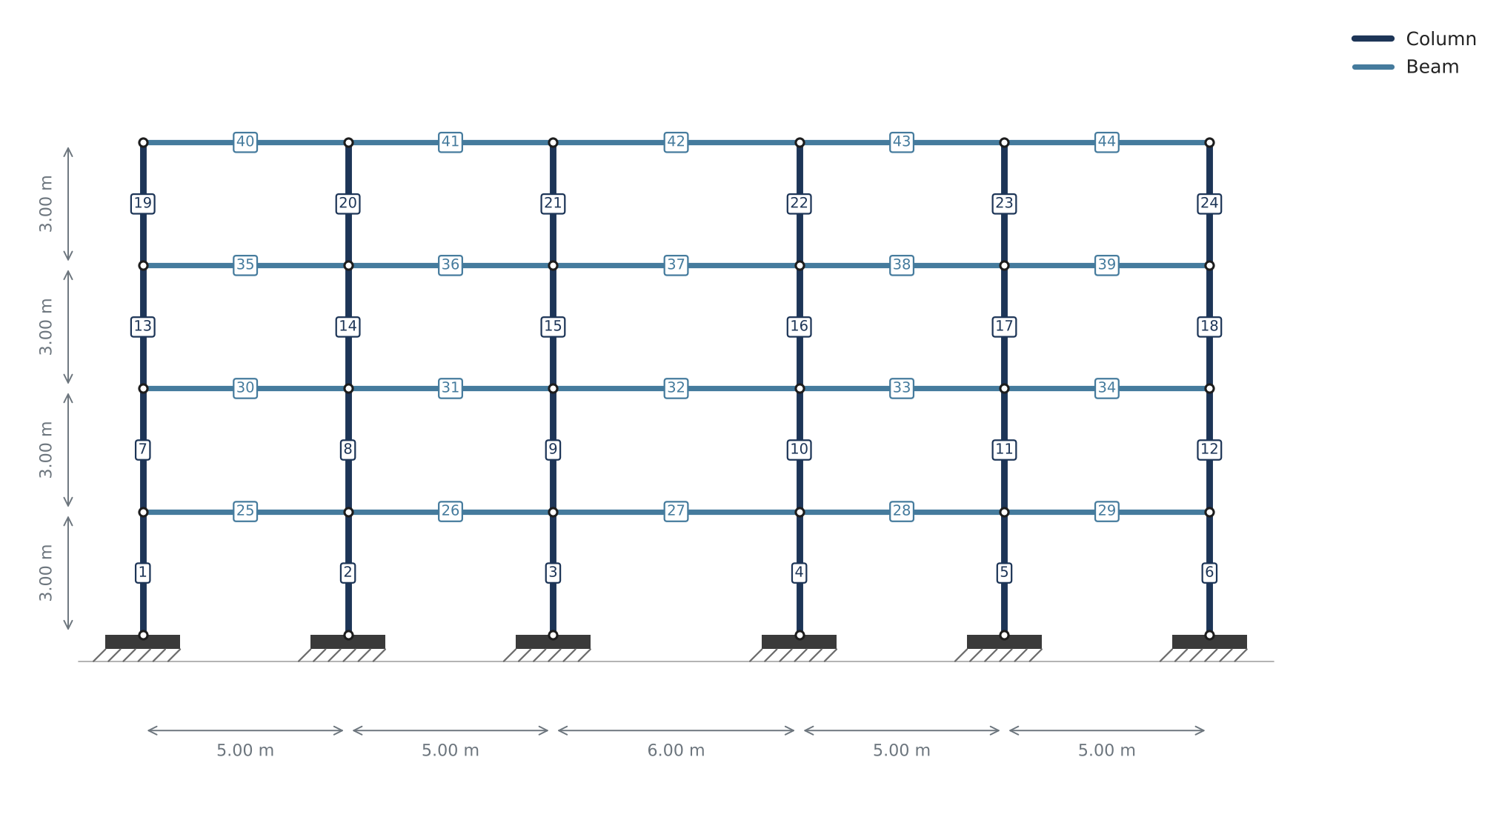
Figure 1. Structural model with member numbering and dimensions.
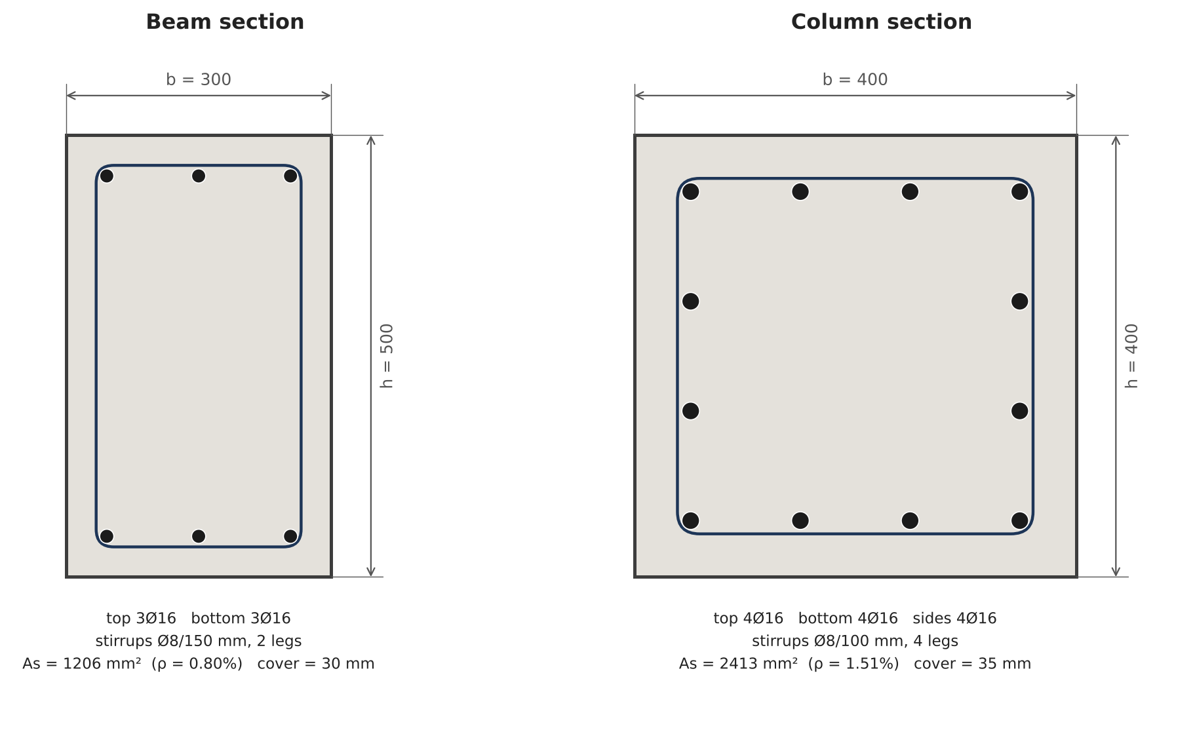
Figure 2. Existing RC sections (dimensions in mm).

3. Assessment of the existing structure
This section checks the existing building before any intervention. Every member is verified with Eurocode 2 for bending with axial force and for shear, under all ULS combinations and the EC8 seismic combinations (lateral force method with the design spectrum). The utilization η is the ratio between the design action and the resistance, taken as the envelope of all combinations; η > 1 means the member does not satisfy the code. In the existing frame 38 of 44 members have η > 1 (maximum 4.05). The modal analysis and the response spectrum below give the dynamic properties used for the seismic action.
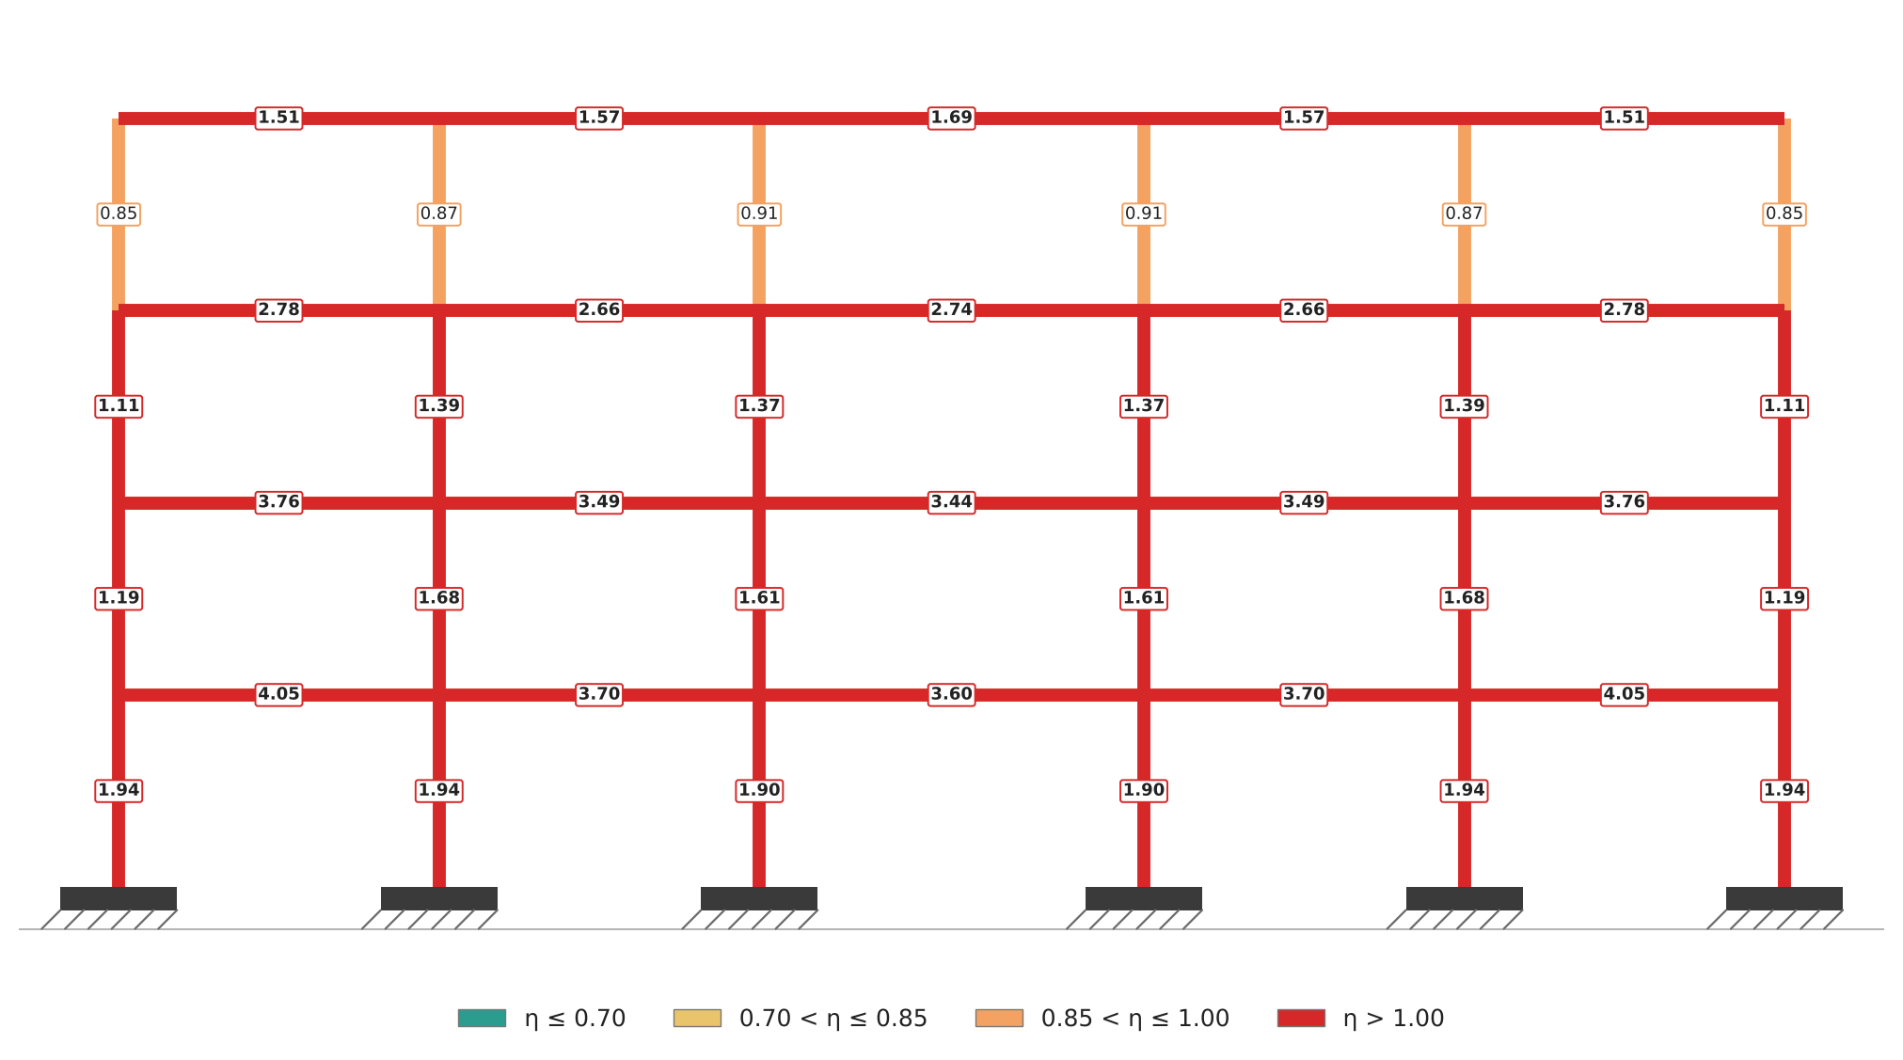
Figure 3. Member utilization η of the existing structure (envelope of the ULS and seismic combinations).
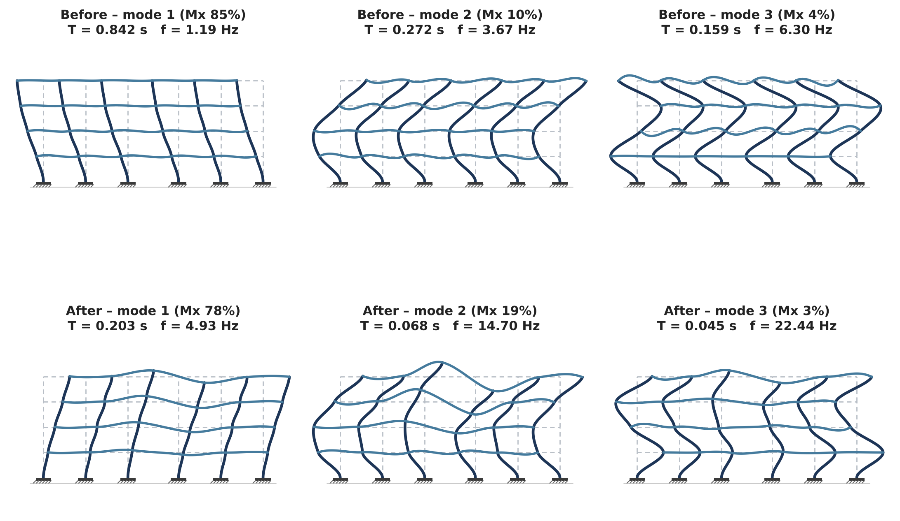
Figure 4. Main lateral modes before and after retrofit (cracked stiffness), with period and effective modal mass in X.
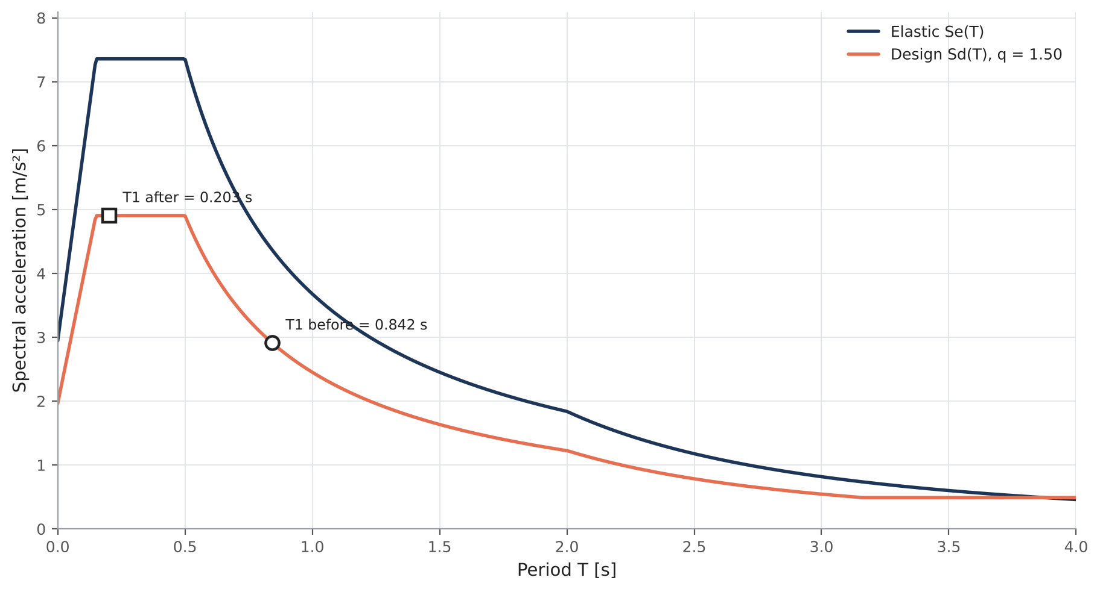
Figure 5. EC8 elastic and design spectra with the fundamental period before and after retrofit.

4. Retrofit alternatives
Each alternative is a complete strategy: a shear-wall layout plus the concrete jacketing required after it. Strategies are ranked by total cost among those satisfying all checks. Only the selected strategy is described in detail; the full ranking is in the Excel file.
Five best strategies
Rank | Strategy | Wall panels | Jacketed | Walls [EUR] | Jackets [EUR] | Total [EUR] | Drift util. | Max η | Feasible
1.00 | SW_B3S1to4_T150 | 4.00 | 22.00 | 19,015 | 34,637 | 53,652 | 0.11 | 0.98 | YES
2.00 | SW_B2S2to4_B3S1to1_T150 | 4.00 | 22.00 | 20,575 | 34,565 | 55,140 | 0.13 | 0.99 | YES
3.00 | SW_B2S1to1_B3S2to4_T150 | 4.00 | 21.00 | 21,868 | 33,479 | 55,347 | 0.10 | 0.98 | YES
4.00 | SW_B3S2to4_B4S1to1_T150 | 4.00 | 21.00 | 21,868 | 33,479 | 55,347 | 0.10 | 0.98 | YES
5.00 | SW_B2S1to4_B3S2to2_T150 | 5.00 | 20.00 | 23,807 | 32,359 | 56,167 | 0.13 | 1.00 | YES

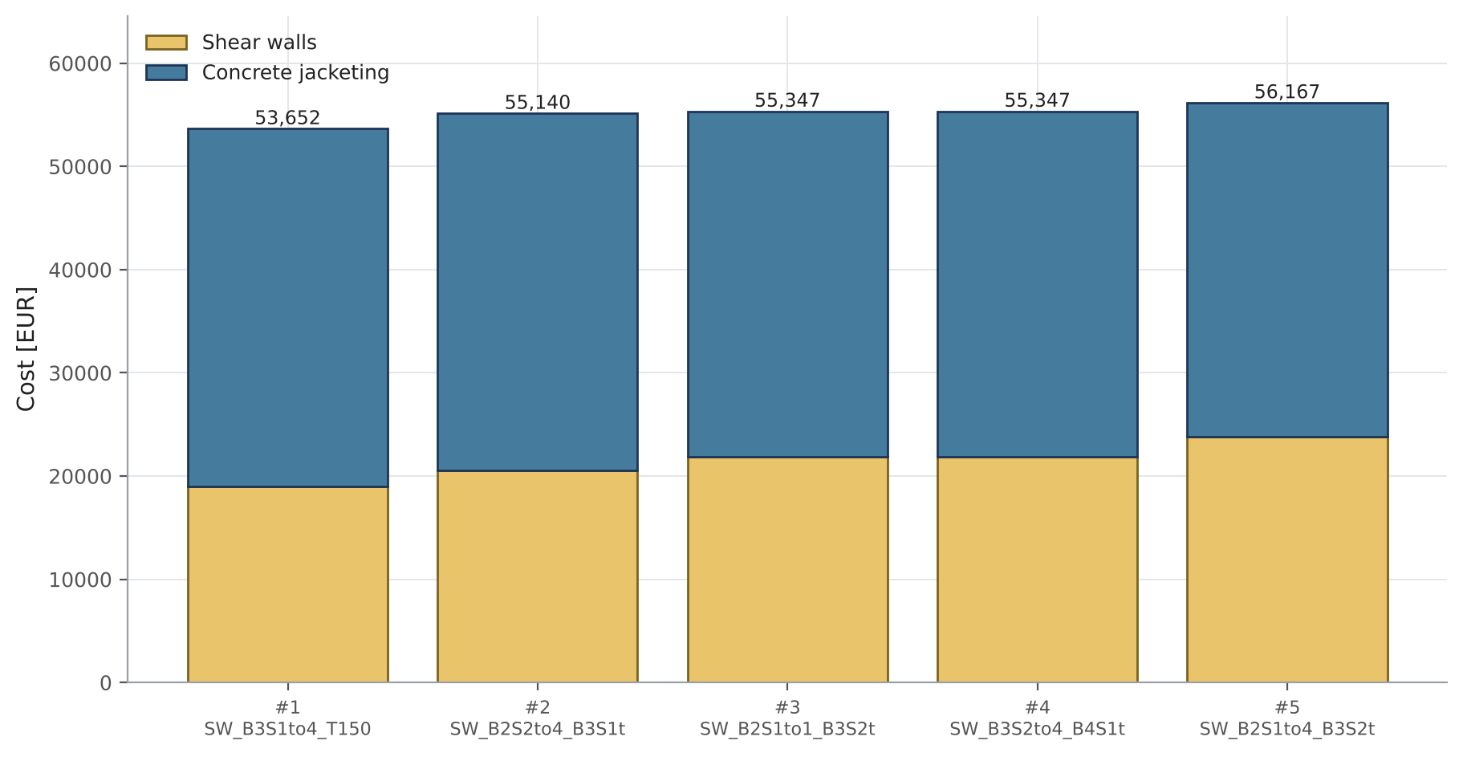
Figure 6. Cost breakdown of the five best retrofit strategies.
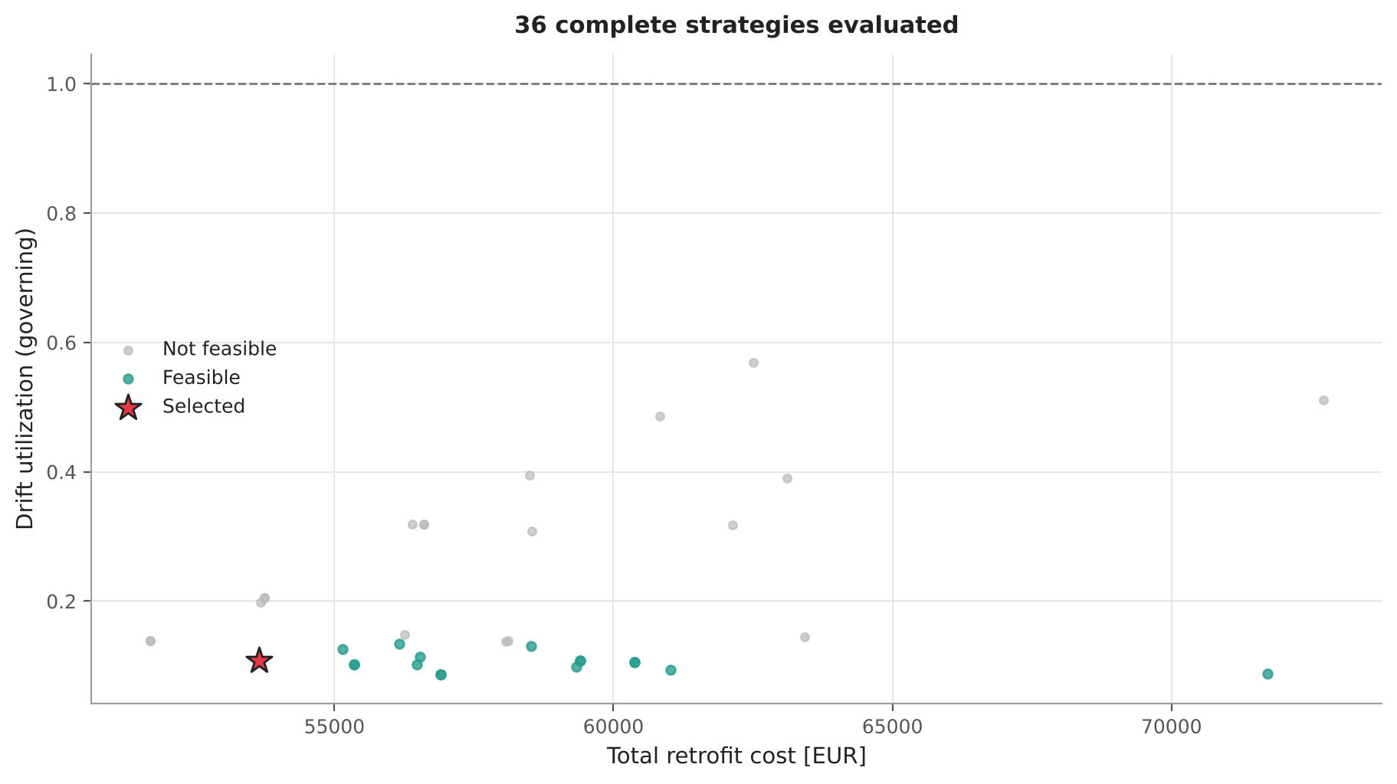
Figure 7. Design space of all evaluated strategies: total cost versus governing drift utilization.

4.1 Smart search (Bayesian optimization)
Wall layouts were searched with a Tree-structured Parzen Estimator (Optuna). The first trials are physics-guided (walls at the failing storeys, full-height walls) and a few are random; afterwards every new layout is proposed from a probabilistic model of the good and bad layouts found so far, with drift, member utilization and jacketing limits as constraints. 88 trials were run (36 unique strategies analysed). The first feasible strategy was found at analysis 2 and the selected one at analysis 8.
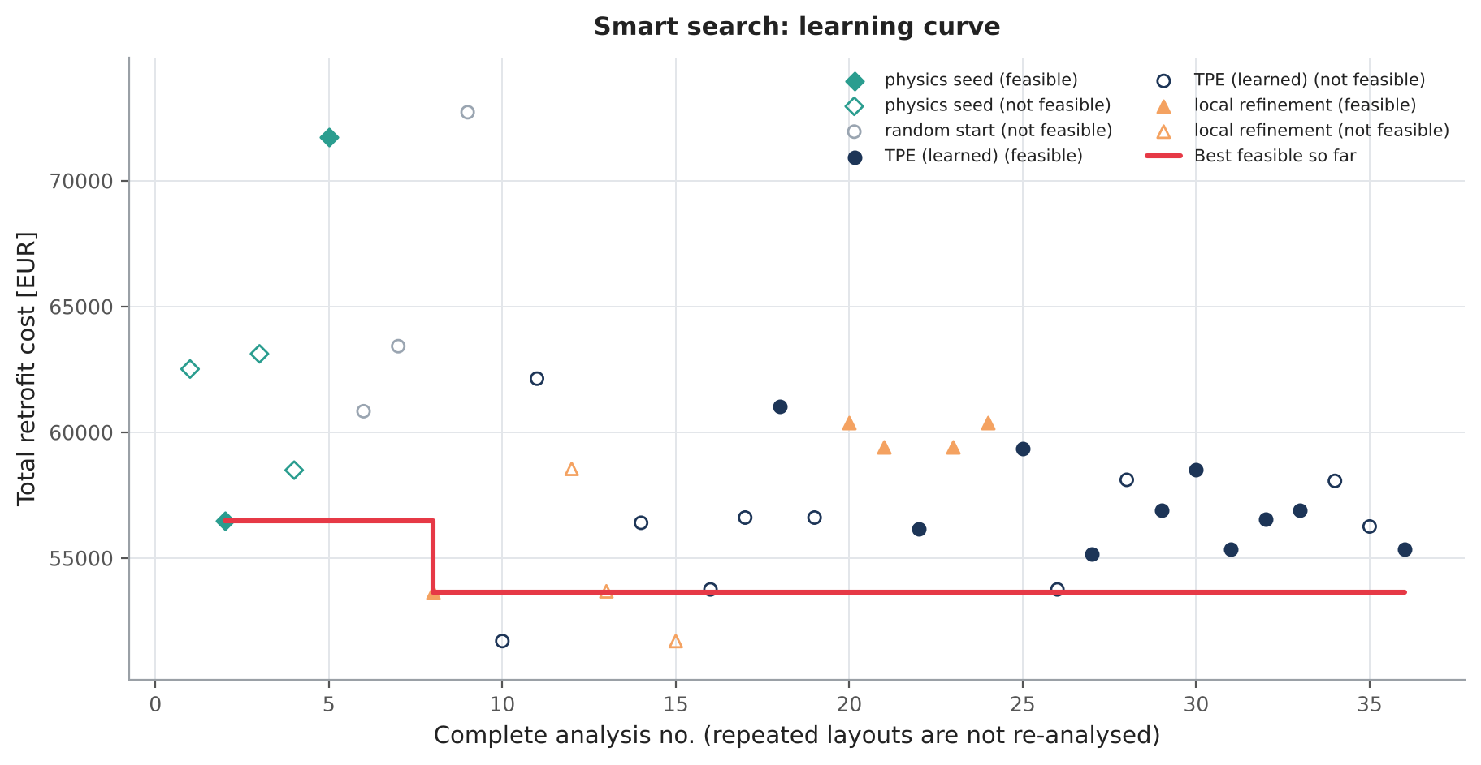
Figure 8. Smart search learning curve: cost of each trial and best feasible cost found so far (filled = feasible, hollow = not feasible).
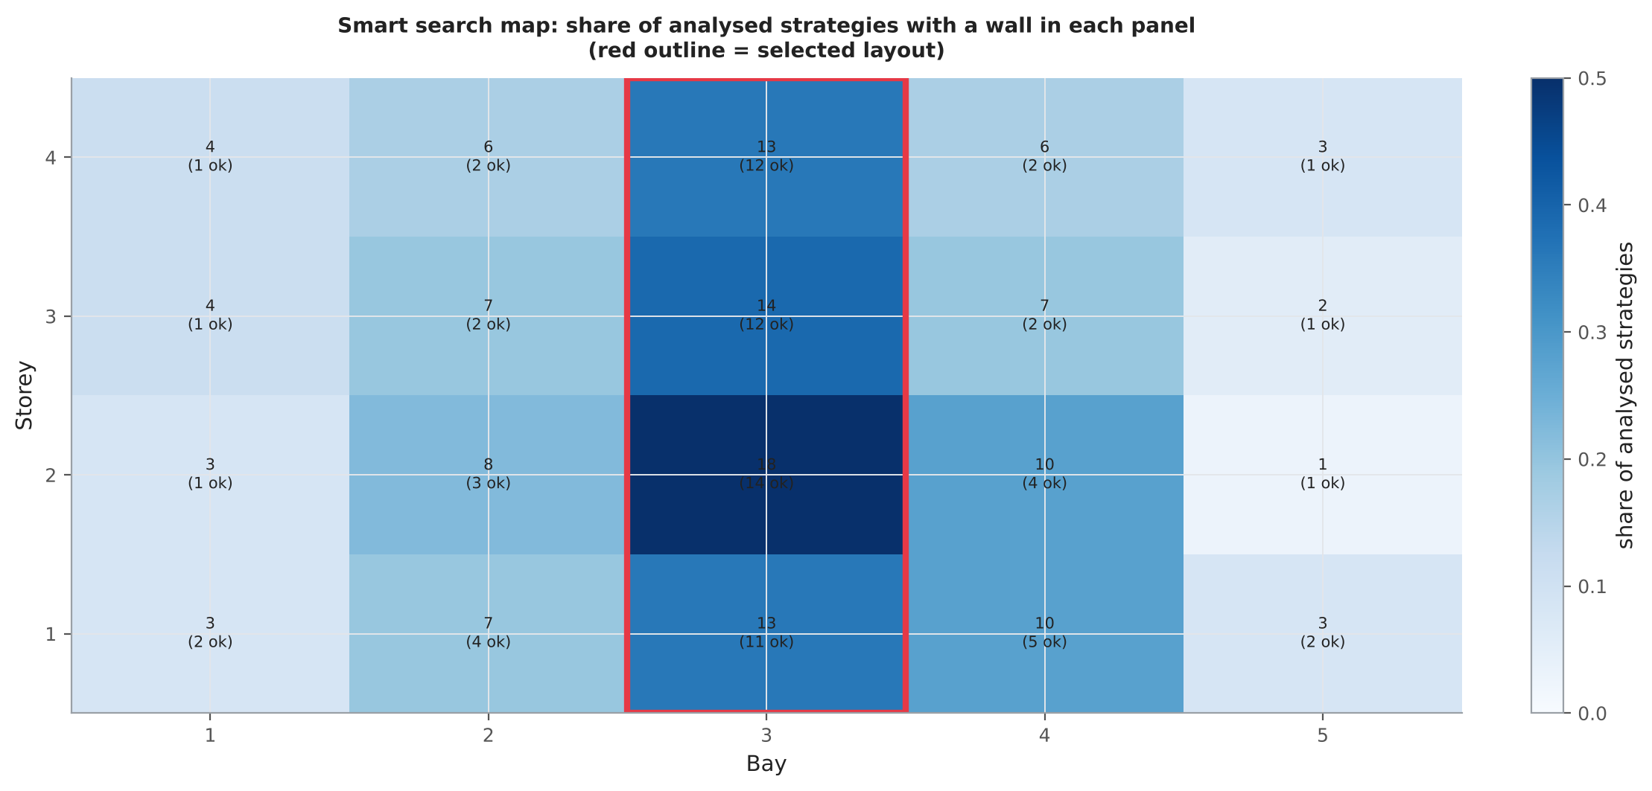
Figure 9. Smart search map: how often a wall was tried in each panel; the selected layout is outlined.

5. Selected retrofit strategy
Strategy SW_B3S1to4_T150: Wall segment(s): B3:S1-4; smart search, tw=150 mm. 22 members are strengthened with RC jackets. Existing bars stay in the core; each jacket has its own cage whose bars respect EC2 8.2(2) minimum clear spacing and, for columns, the EC8 maximum spacing of 200 mm between restrained bars.
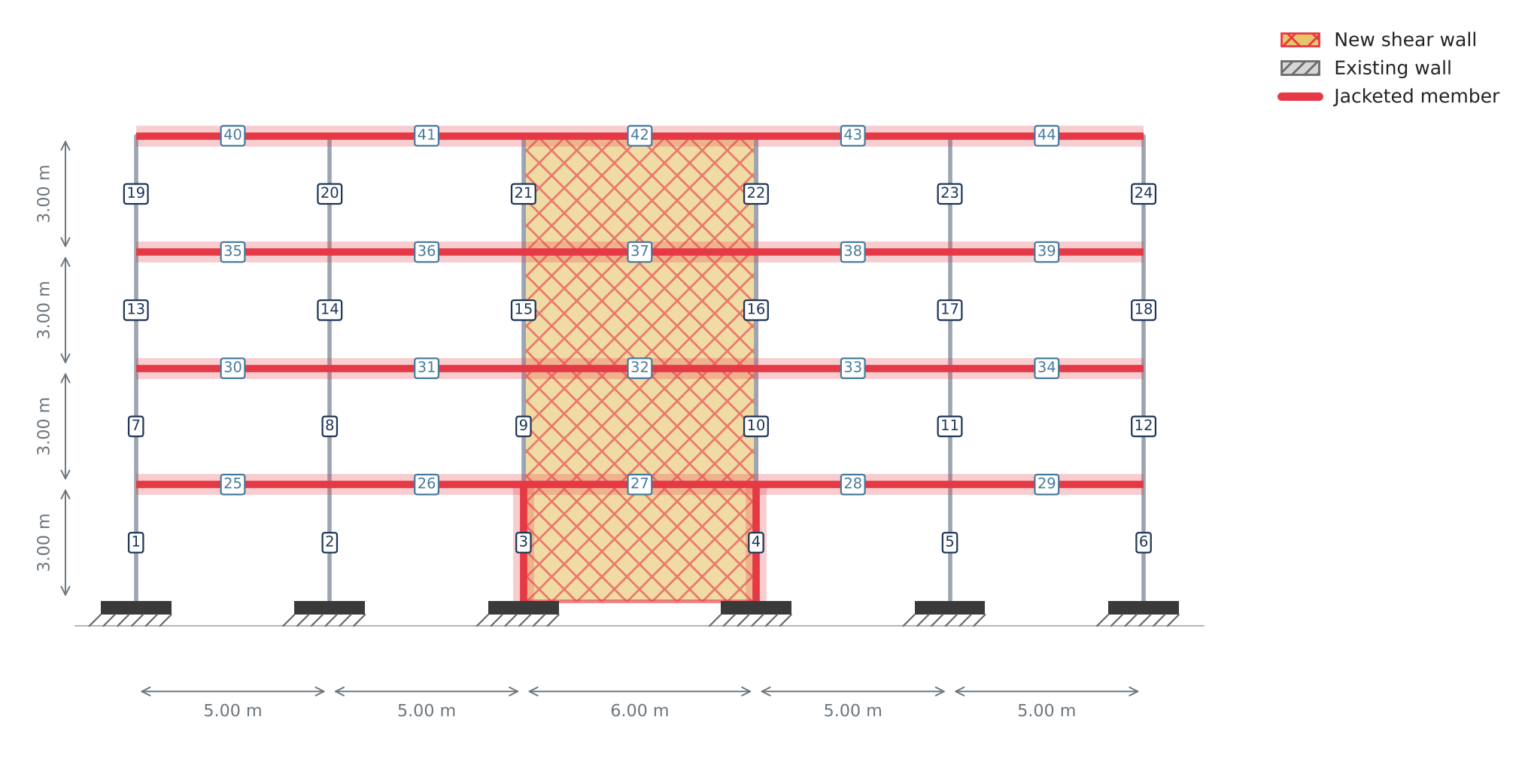
Figure 10. Selected retrofit strategy: new shear walls and jacketed members.
Shear-wall panels
Bay | Storey | Thickness [mm] | Status
3.00 | 1.00 | 150.00 | new
3.00 | 2.00 | 150.00 | new
3.00 | 3.00 | 150.00 | new
3.00 | 4.00 | 150.00 | new

Jacketing design per member
Member | Type | Jacket t [mm] | Section [mm] | Jacket bars | Stirrups | Governing mode | η before | η after walls | η final | Bar spacing
3.00 | column | 75.00 | 550×550 | 12Ø12 | Ø8/100 | MOMENT/FLEXURE-AXIAL | 1.90 | 1.19 | 0.82 | OK
4.00 | column | 75.00 | 550×550 | 12Ø12 | Ø8/100 | MOMENT/FLEXURE-AXIAL | 1.90 | 1.19 | 0.82 | OK
25.00 | beam | 75.00 | 450×650 | 4Ø12 | Ø8/100 | SHEAR | 4.05 | 1.37 | 0.84 | OK
26.00 | beam | 75.00 | 450×650 | 8Ø12 | Ø8/100 | SHEAR | 3.70 | 1.58 | 0.98 | OK
27.00 | beam | 75.00 | 450×650 | 4Ø14 | Ø8/100 | MOMENT/FLEXURE-AXIAL | 3.60 | 1.65 | 0.97 | OK
28.00 | beam | 75.00 | 450×650 | 8Ø12 | Ø8/100 | SHEAR | 3.70 | 1.58 | 0.98 | OK
29.00 | beam | 75.00 | 450×650 | 4Ø12 | Ø8/100 | SHEAR | 4.05 | 1.37 | 0.84 | OK
30.00 | beam | 75.00 | 450×650 | 4Ø12 | Ø8/100 | SHEAR | 3.76 | 1.36 | 0.86 | OK
31.00 | beam | 75.00 | 450×650 | 16Ø12 | Ø8/100 | SHEAR | 3.49 | 1.87 | 0.88 | OK
32.00 | beam | 75.00 | 450×650 | 8Ø12 | Ø8/100 | MOMENT/FLEXURE-AXIAL | 3.44 | 1.65 | 0.93 | OK
33.00 | beam | 75.00 | 450×650 | 16Ø12 | Ø8/100 | SHEAR | 3.49 | 1.87 | 0.88 | OK
34.00 | beam | 75.00 | 450×650 | 4Ø12 | Ø8/100 | SHEAR | 3.76 | 1.36 | 0.86 | OK
35.00 | beam | 75.00 | 450×650 | 4Ø12 | Ø8/100 | SHEAR | 2.78 | 1.39 | 0.92 | OK
36.00 | beam | 75.00 | 450×650 | 16Ø12 | Ø8/100 | SHEAR | 2.66 | 1.96 | 0.95 | OK
37.00 | beam | 75.00 | 450×650 | 8Ø12 | Ø8/100 | MOMENT/FLEXURE-AXIAL | 2.74 | 1.66 | 0.98 | OK
38.00 | beam | 75.00 | 450×650 | 16Ø12 | Ø8/100 | SHEAR | 2.66 | 1.96 | 0.95 | OK
39.00 | beam | 75.00 | 450×650 | 4Ø12 | Ø8/100 | SHEAR | 2.78 | 1.39 | 0.92 | OK
40.00 | beam | 75.00 | 450×650 | 4Ø12 | Ø8/100 | SHEAR | 1.51 | 1.21 | 0.74 | OK
41.00 | beam | 75.00 | 450×650 | 16Ø12 | Ø8/100 | SHEAR | 1.57 | 1.68 | 0.82 | OK
42.00 | beam | 75.00 | 450×650 | 8Ø12 | Ø8/100 | MOMENT/FLEXURE-AXIAL | 1.69 | 1.41 | 0.98 | OK
43.00 | beam | 75.00 | 450×650 | 16Ø12 | Ø8/100 | SHEAR | 1.57 | 1.68 | 0.82 | OK
44.00 | beam | 75.00 | 450×650 | 4Ø12 | Ø8/100 | SHEAR | 1.51 | 1.21 | 0.74 | OK

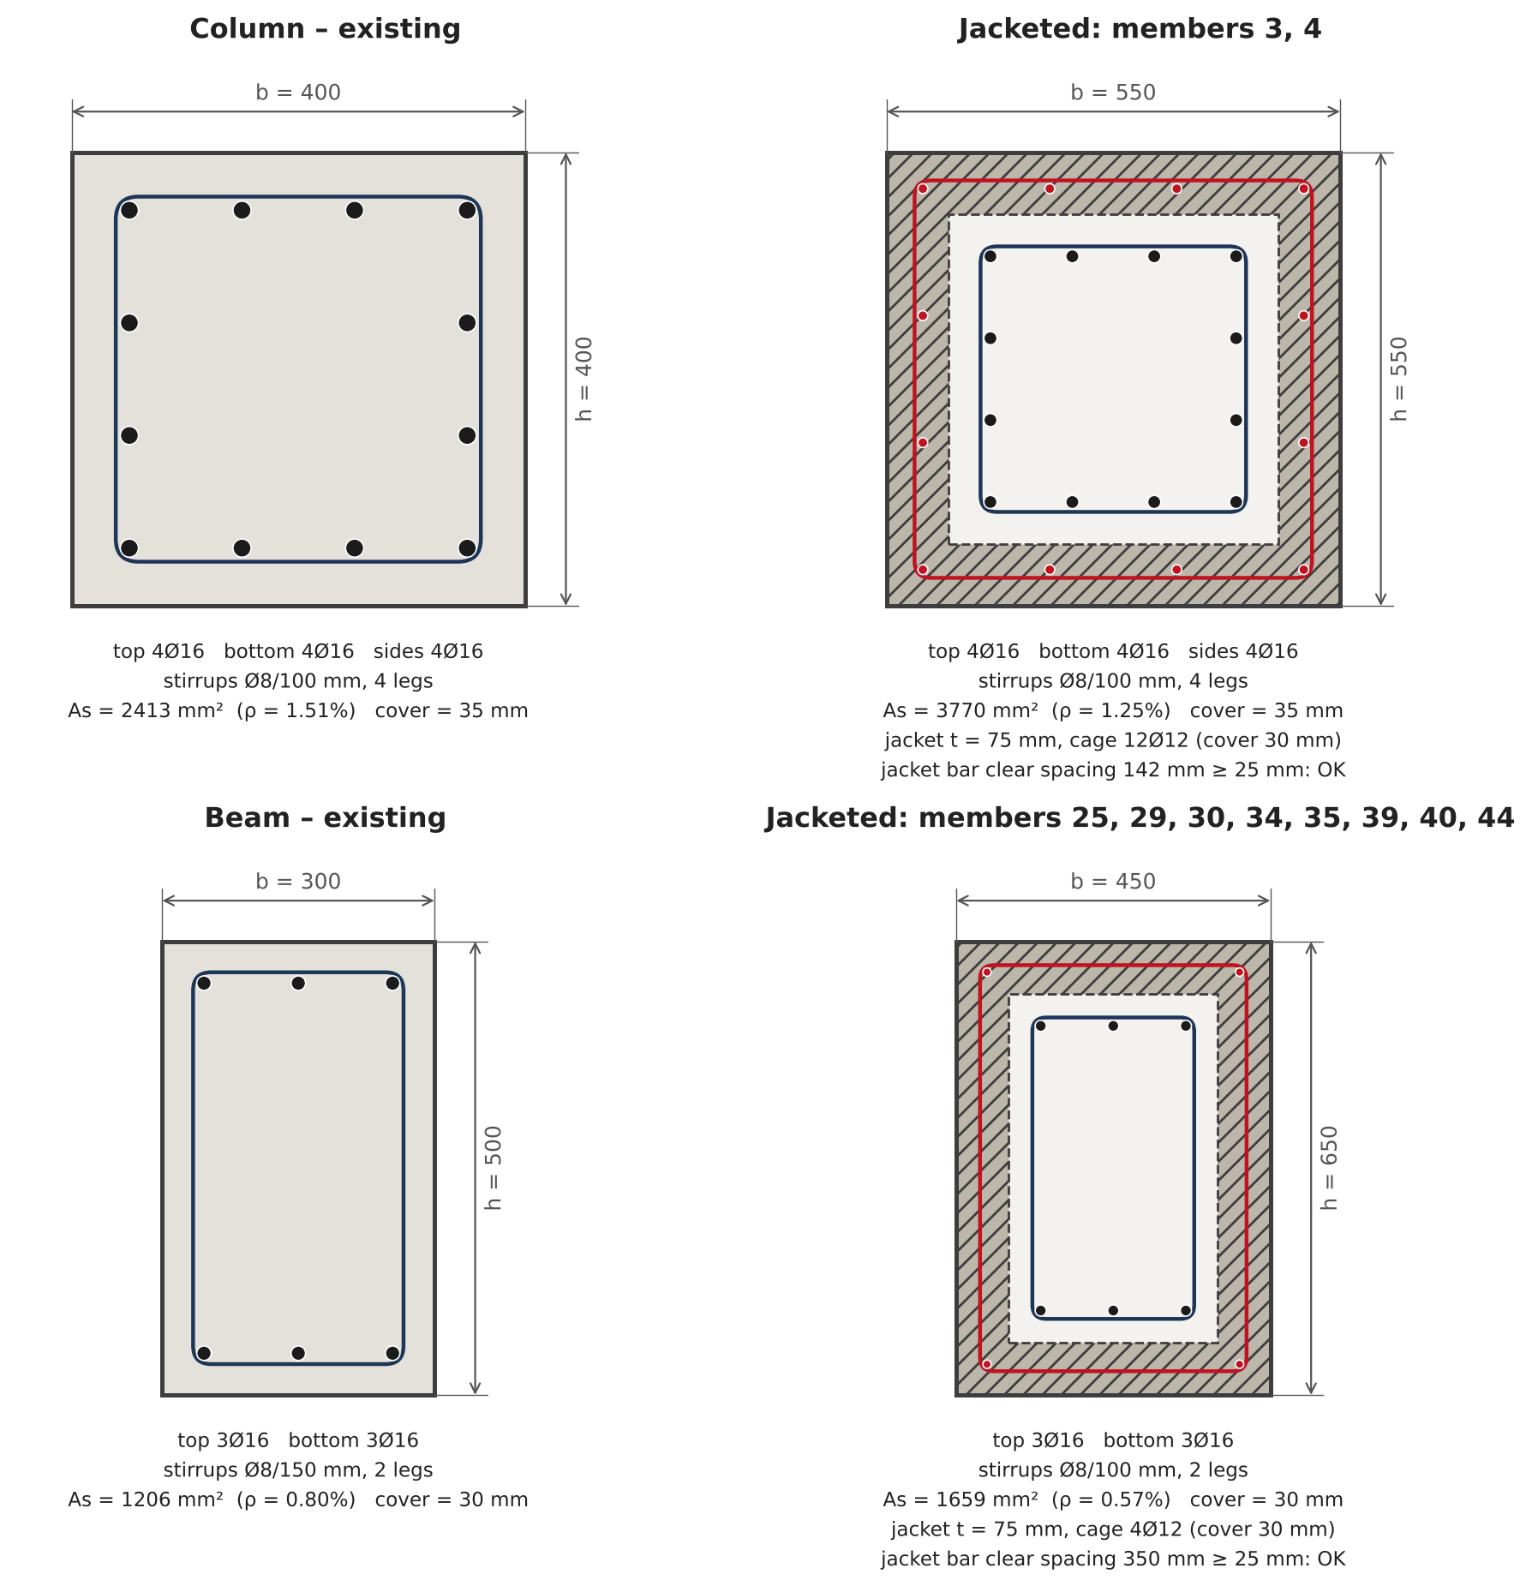
Figure 11. Jacketed sections (before/after). Members with identical jacket design are grouped.
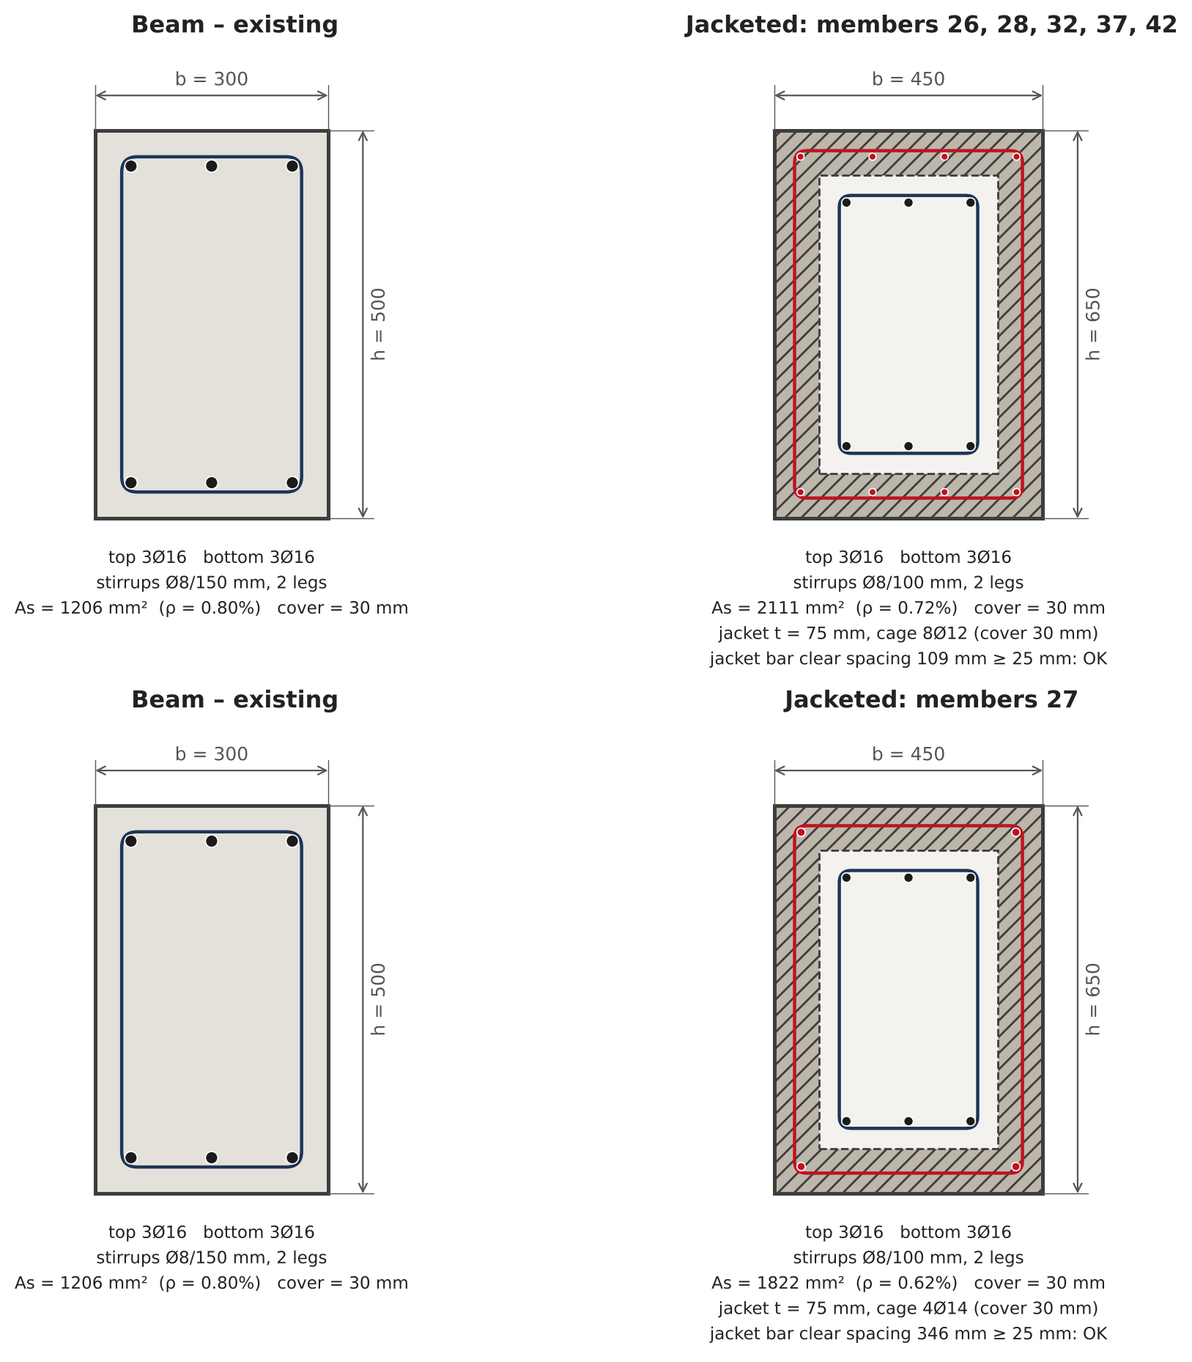
Figure 12. Jacketed sections (before/after). Members with identical jacket design are grouped.
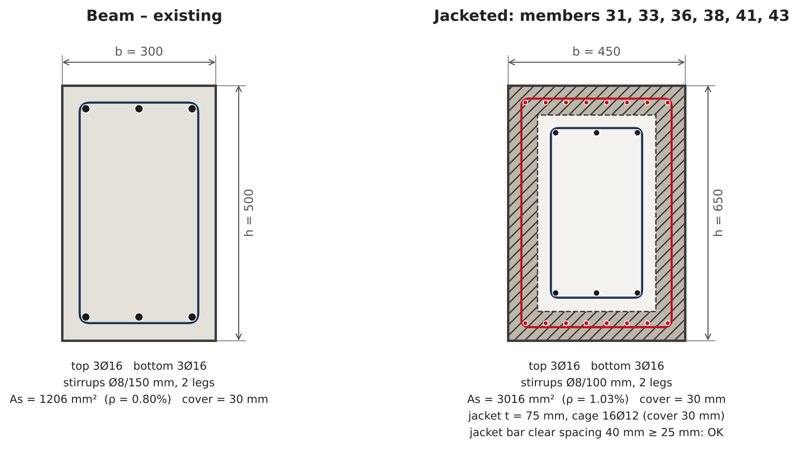
Figure 13. Jacketed sections (before/after). Members with identical jacket design are grouped.

5.1 Verification after retrofit
This part repeats the checks of Section 3 on the retrofitted structure, with exactly the same combinations, so the two states can be compared directly. The utilization maps show the three stages of the strategy: existing frame, after the new shear walls, and after the jacketing. The ranking chart compares η of every member before and after, the drift profiles compare the interstorey drifts with their limits, and the convergence plot shows how the iterative jacketing reduced the maximum utilization. After retrofit 0 member(s) have η > 1 and the maximum utilization is 0.98.
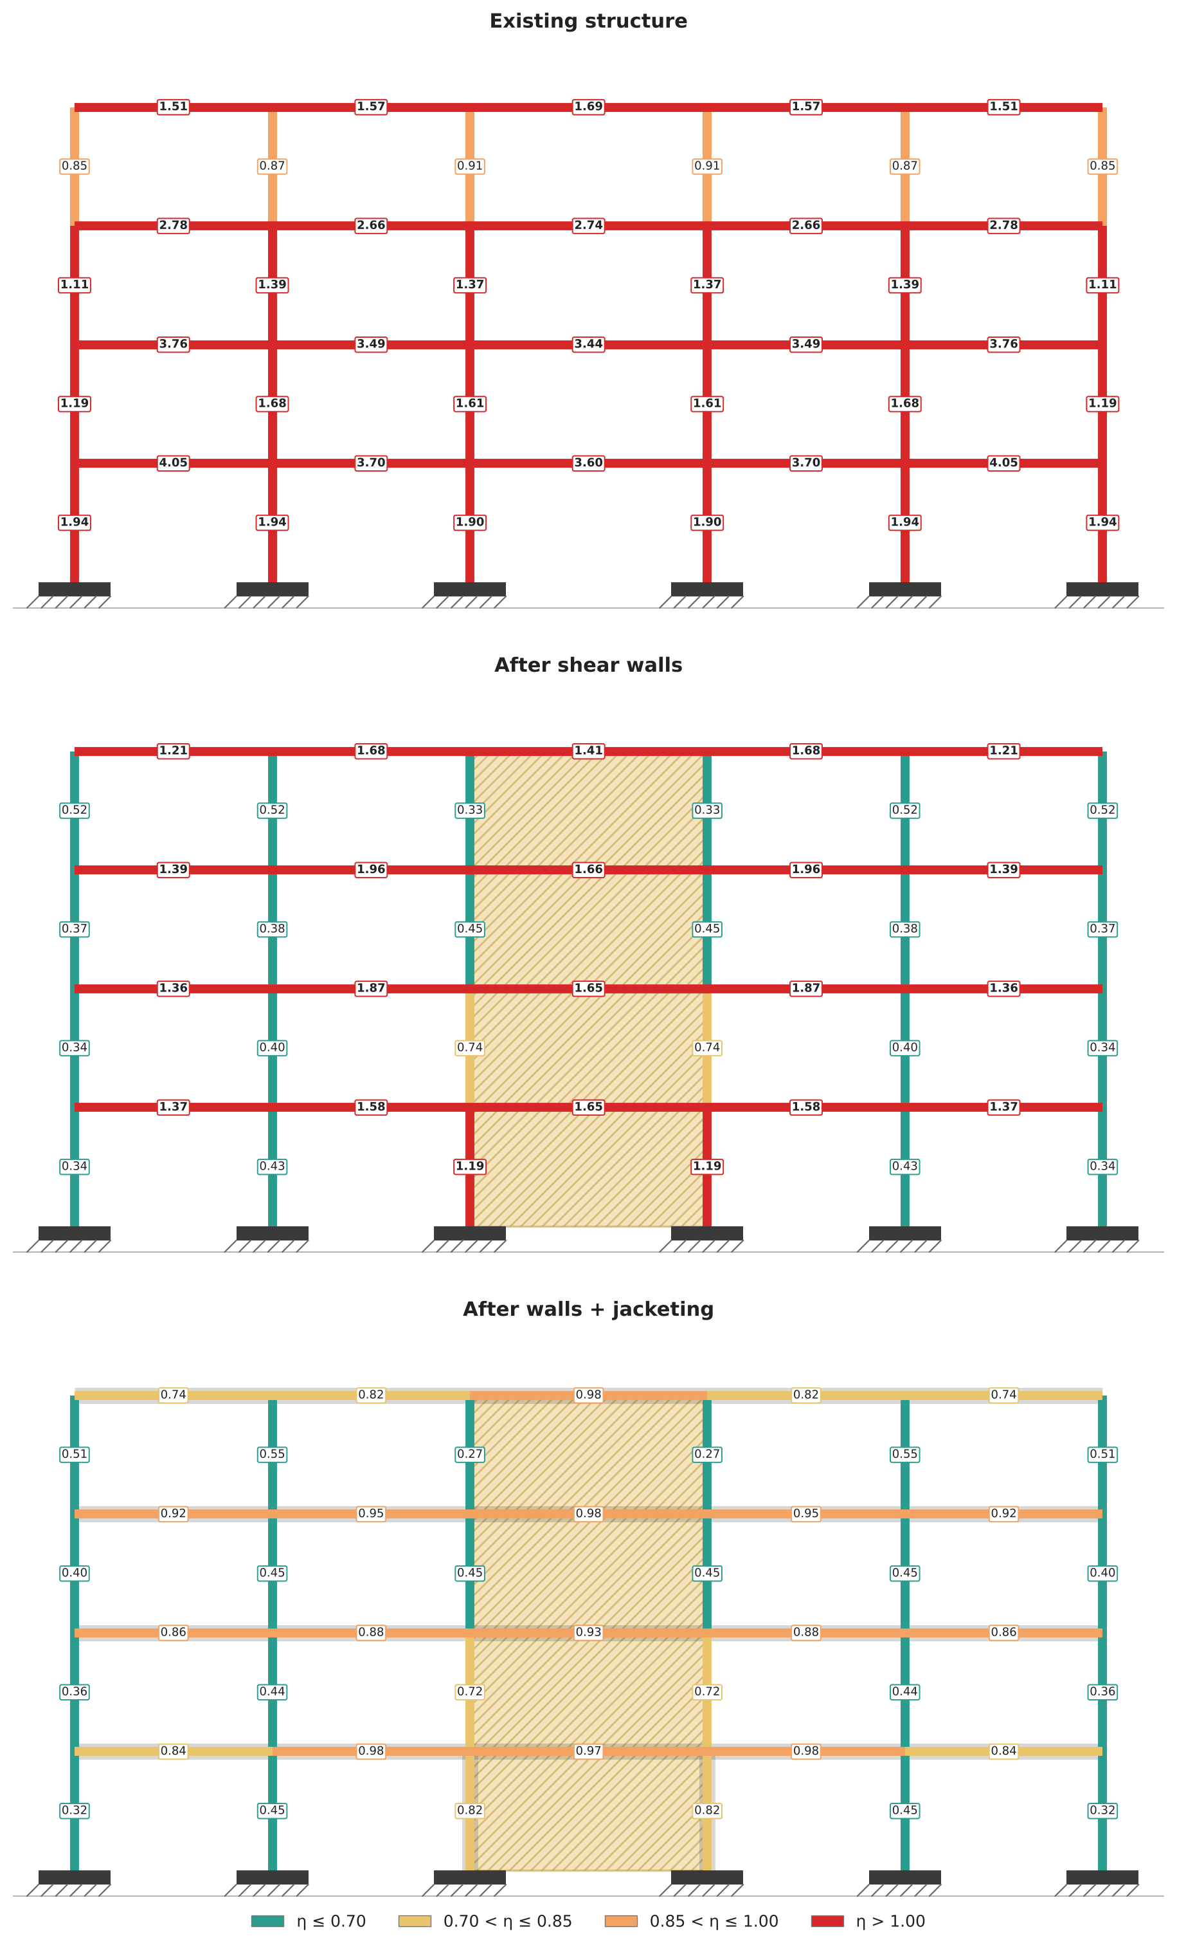
Figure 14. Member utilization at the three stages of the selected strategy (jacketed members shaded).
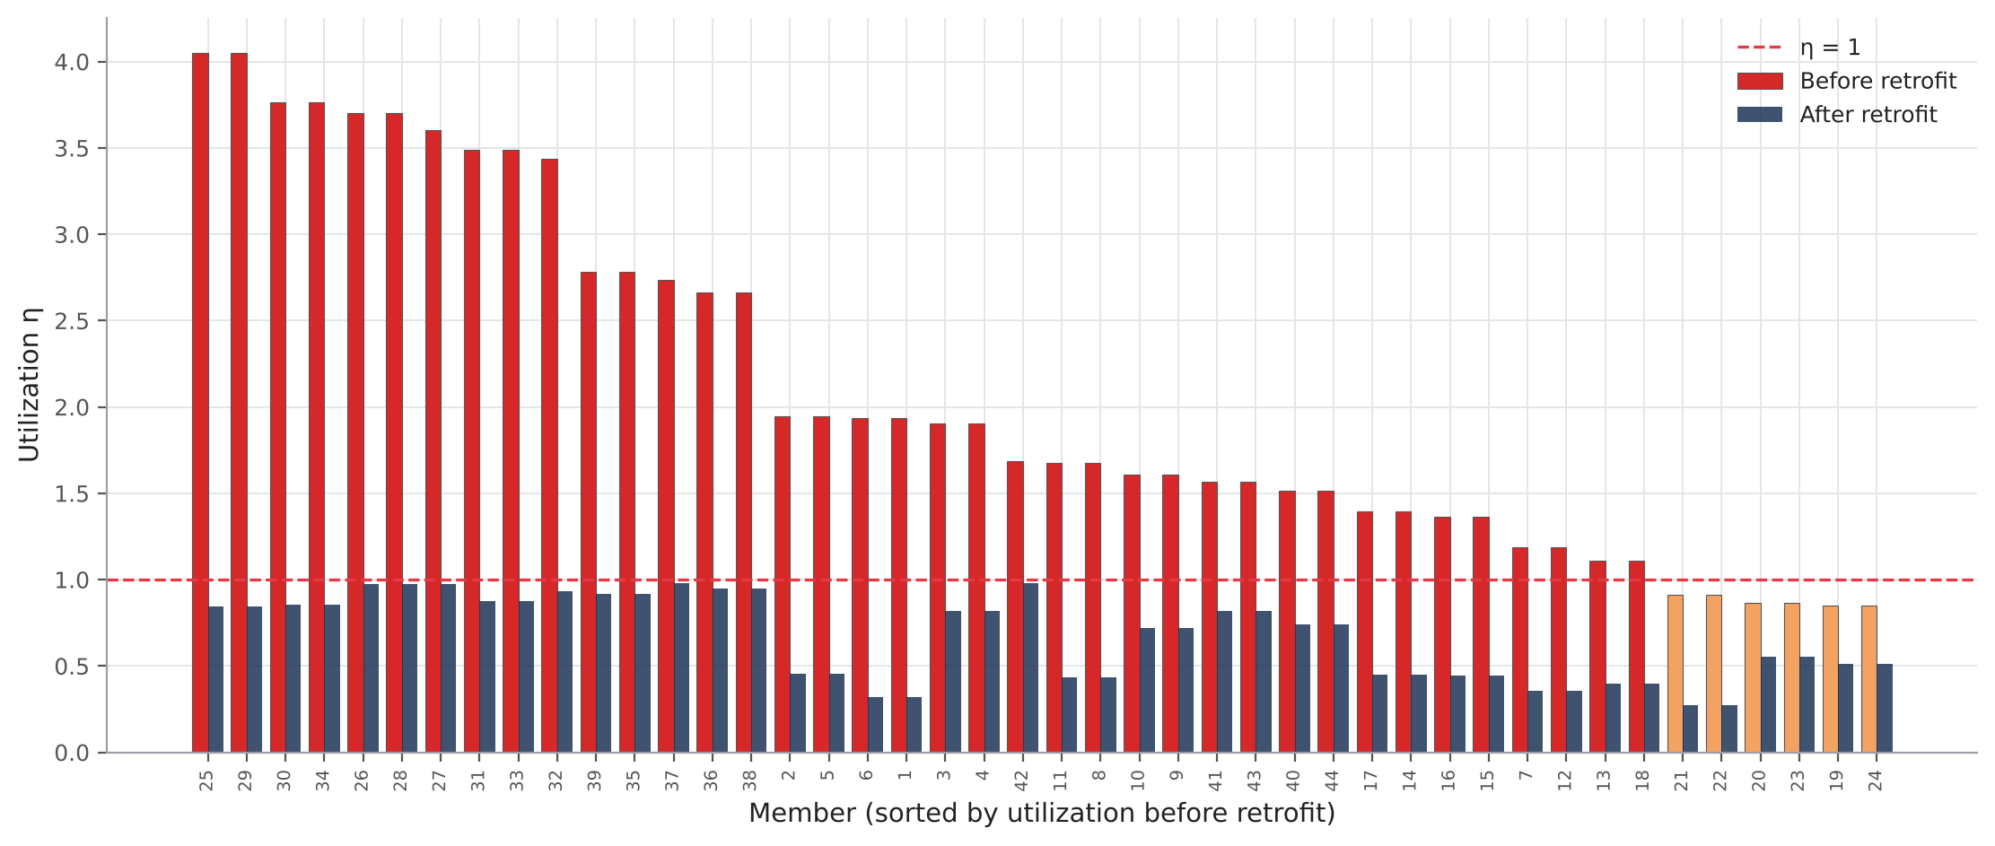
Figure 15. Member utilization before and after the selected retrofit, sorted by the initial utilization.
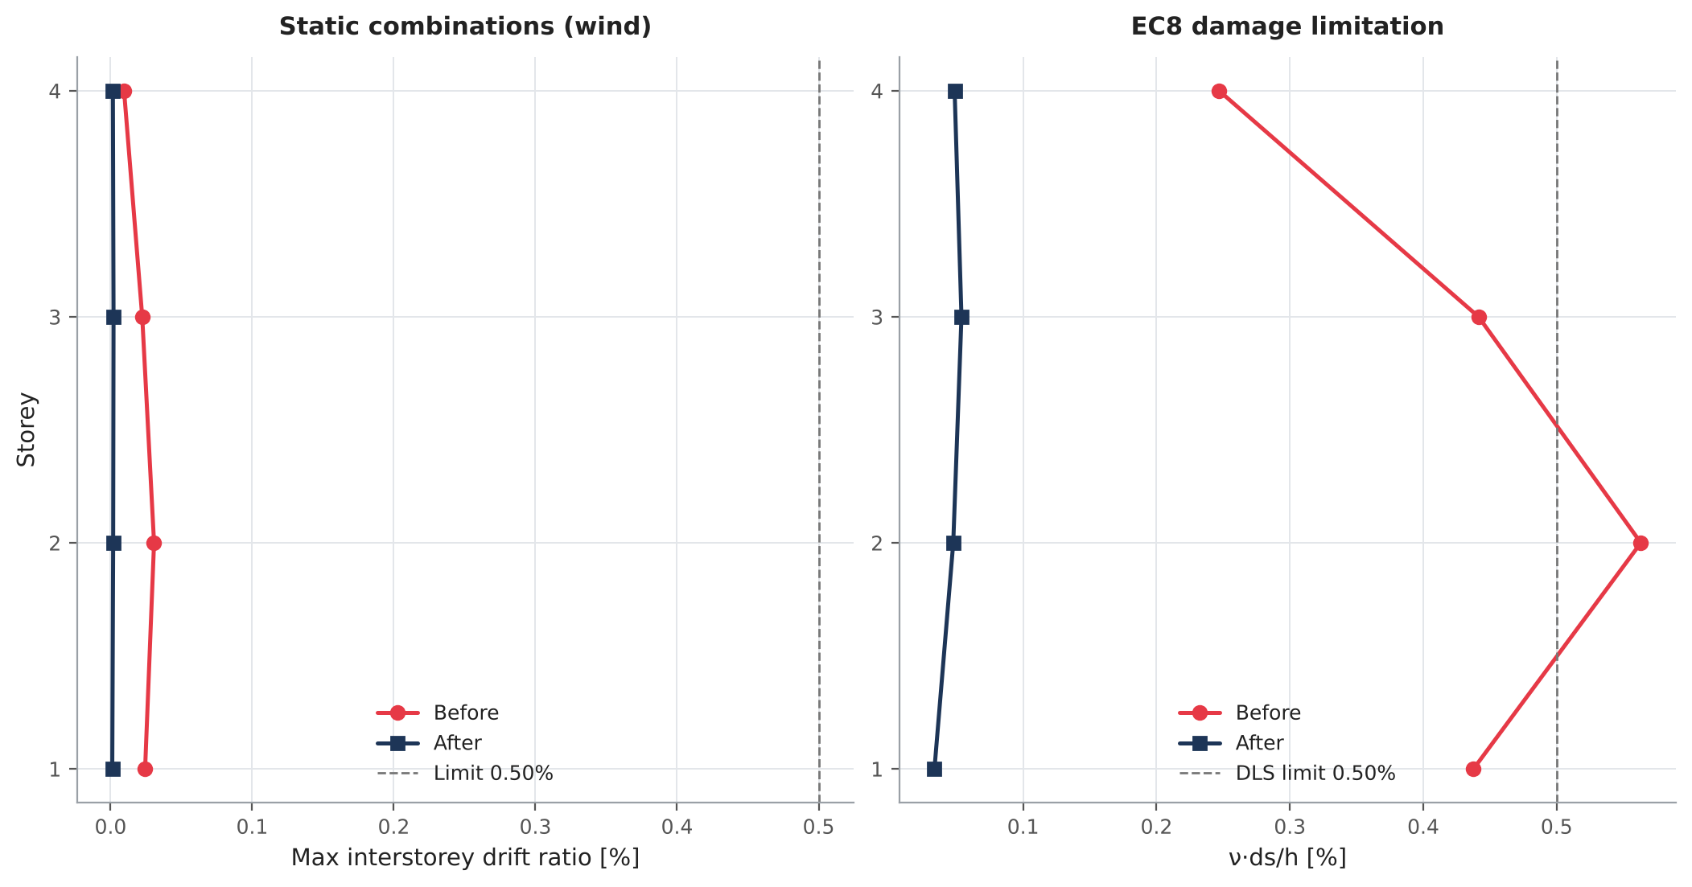
Figure 16. Interstorey drift profiles before and after the selected retrofit.
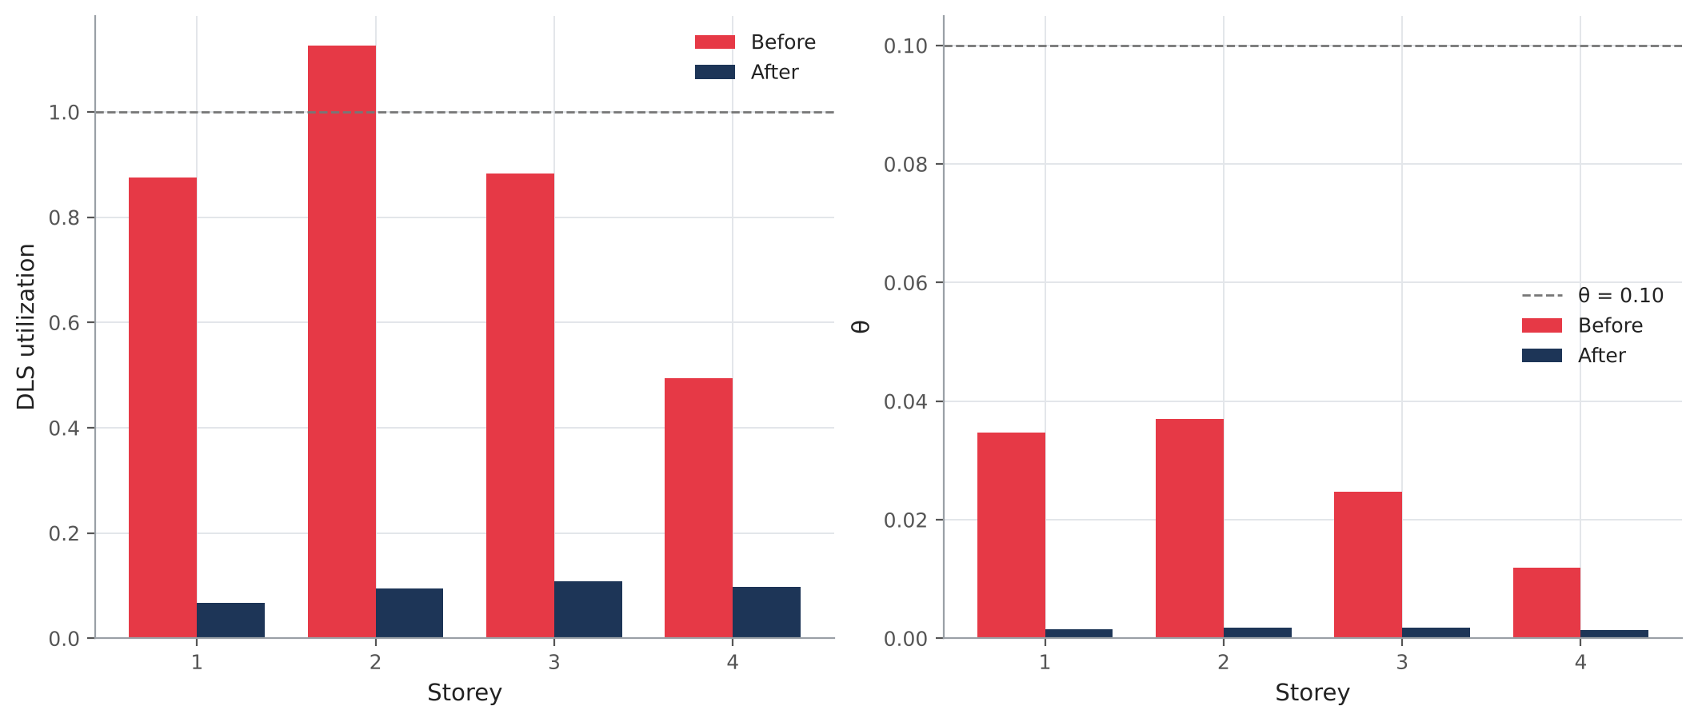
Figure 17. EC8 storey checks: damage-limitation utilization and interstorey drift sensitivity θ, before and after retrofit.
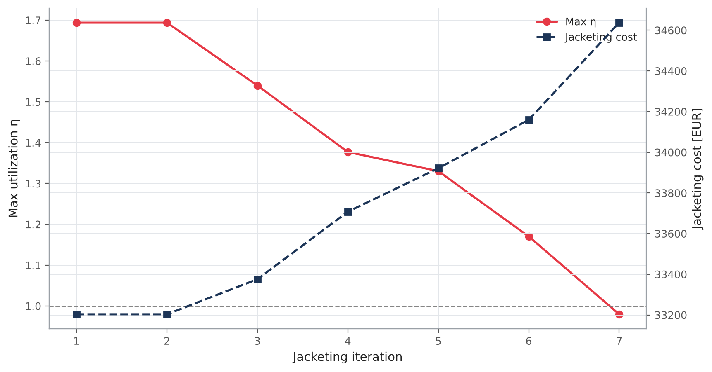
Figure 18. Convergence of the iterative jacketing: maximum utilization and cost per iteration.

5.2 Internal forces of the retrofitted frame
Internal forces are recovered from OpenSees at 41 stations along every member for all ULS and seismic combinations. The envelopes below show the maximum and minimum value at each station; distributed loads give the parabolic moment and linear shear in the beams, and the self-weight gives the linear axial force in the columns.
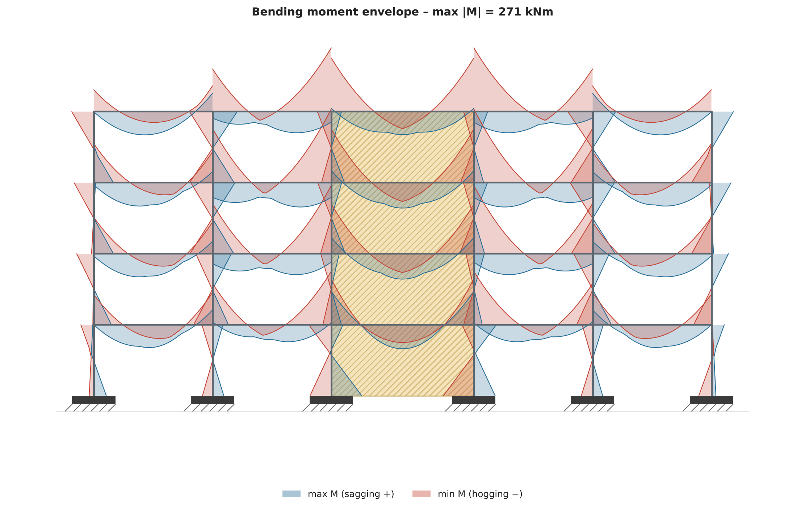
Figure 19. Bending-moment envelope of the retrofitted frame over all ULS and seismic combinations, drawn on the tension side (sagging moments below the beam axis).
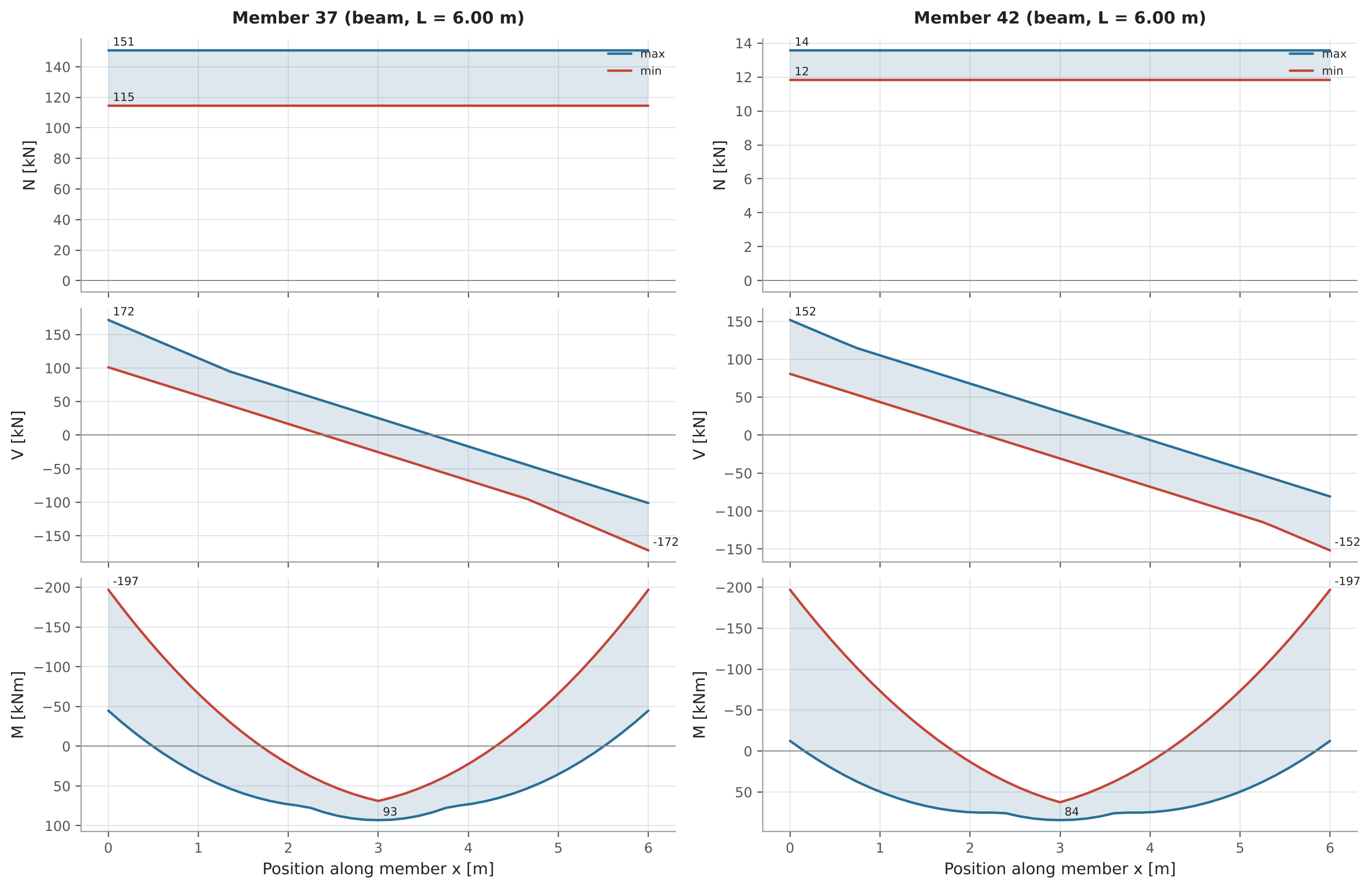
Figure 20. N/V/M envelopes (OpenSees, station by station) of the most utilized members of the retrofitted frame. N is positive in tension; M is positive when sagging and is plotted downward (tension side).
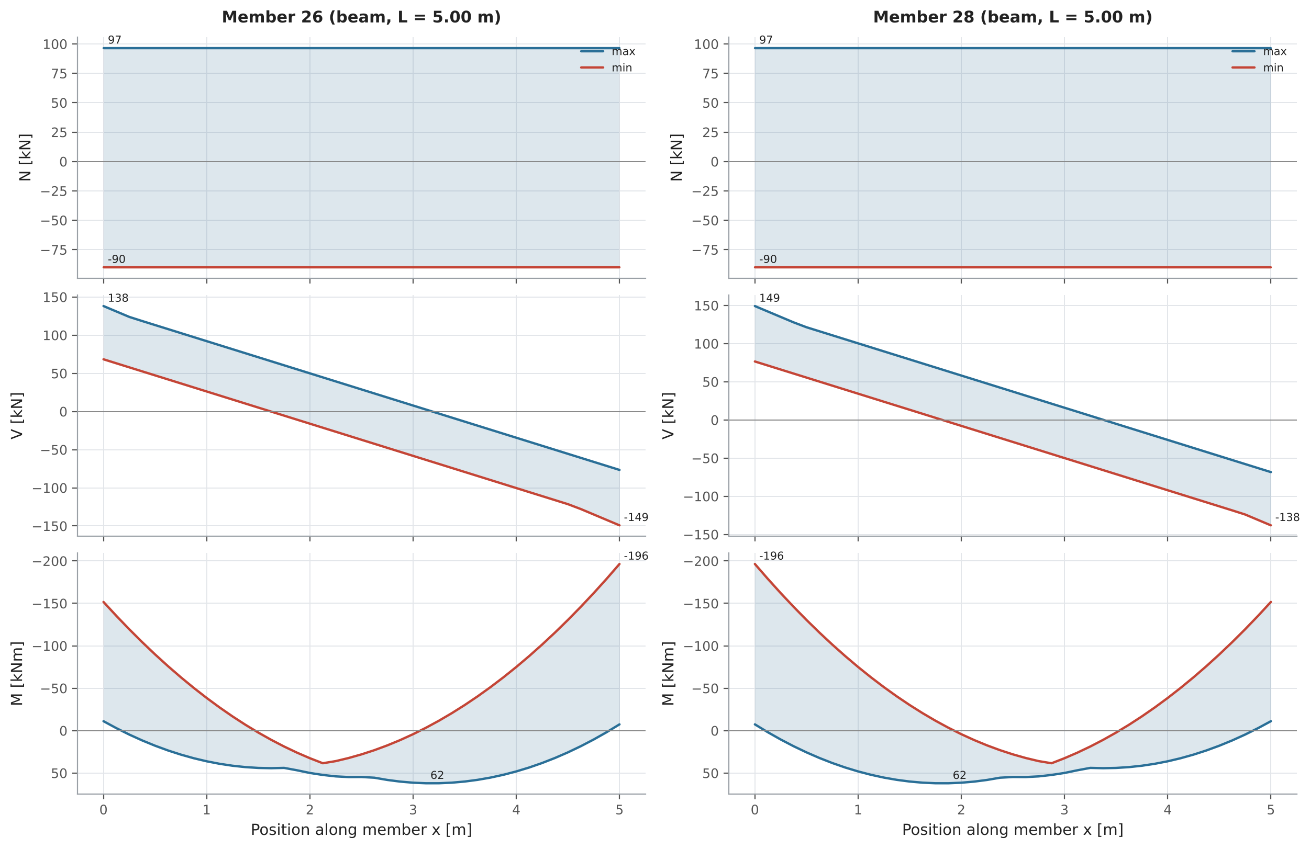
Figure 21. N/V/M envelopes (OpenSees, station by station) of the most utilized members of the retrofitted frame. N is positive in tension; M is positive when sagging and is plotted downward (tension side).

5.3 Cost
The total cost of the selected strategy is the sum of the shear-wall works and the concrete jacketing. For both, the optimizer computes materials and labour from the quantities of the design, then adds indirect costs and site overheads (and, for the walls, the foundation and connection works), using the unit costs given at the start of the optimization. Walls: 19,015 EUR; jacketing: 34,637 EUR; total: 53,652 EUR. The chart below shows the breakdown by cost item.
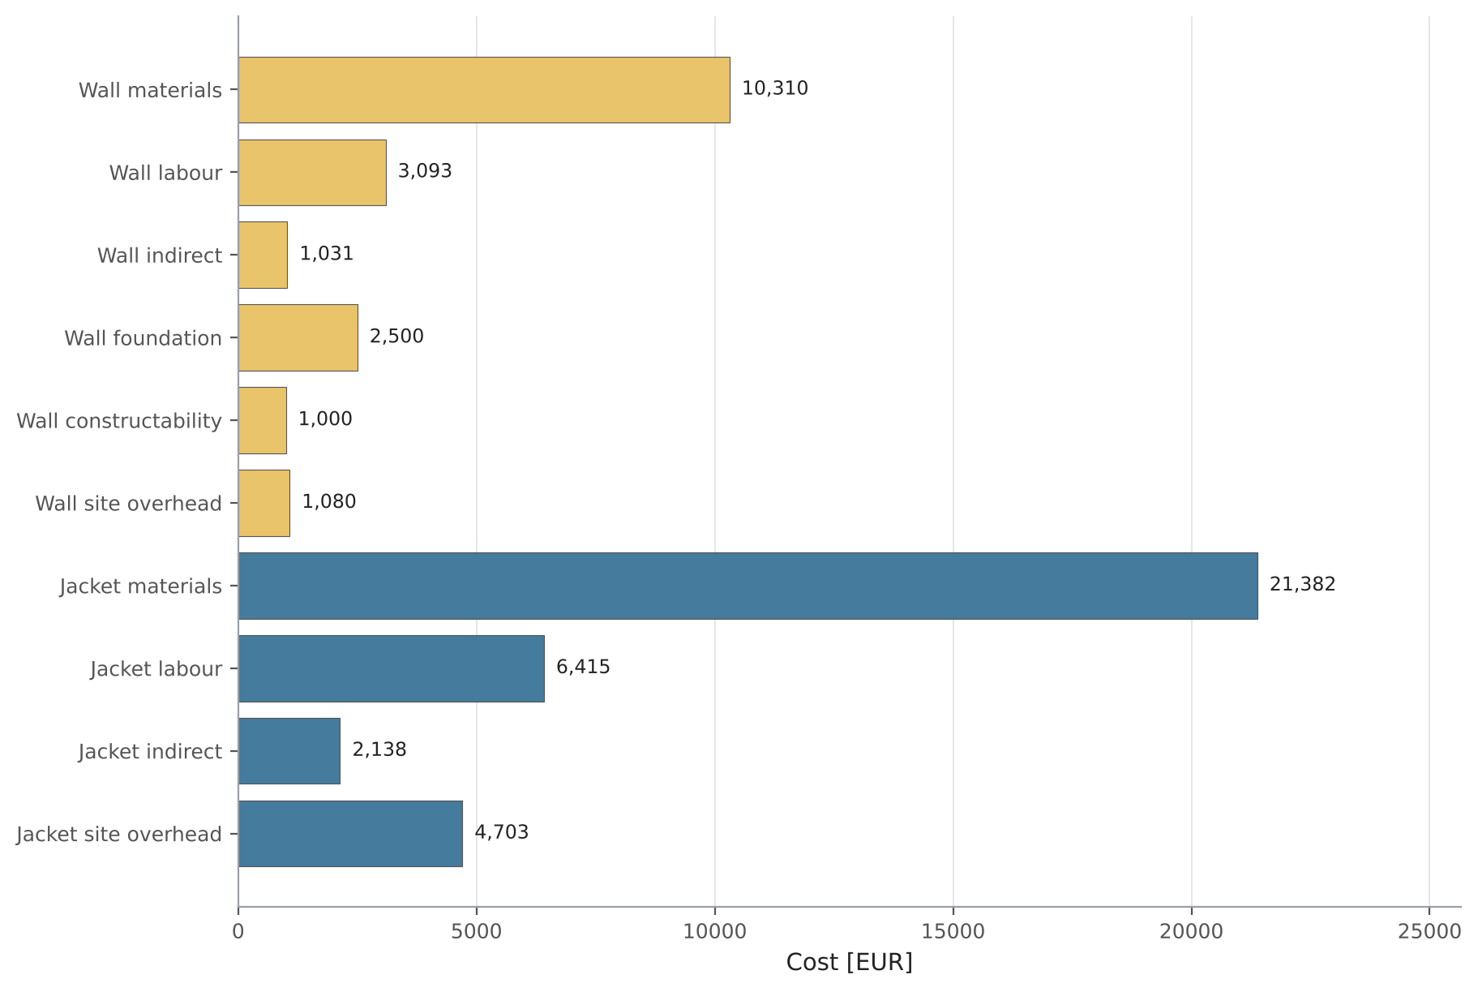
Figure 22. Cost breakdown of the selected strategy.

6. Conclusions and limitations
The selected strategy satisfies all drift, seismic and member checks at an estimated cost of 53,652 EUR.
The assessment is linear elastic and planar. Shear walls are idealized as equivalent braces and are not verified themselves; wall foundations and connections must be designed separately. The selected solution should be confirmed with a nonlinear analysis before design.

