Exam Replicator

Abstract:

It’s a mobile application which is similar to WhatsApp. This application will be use full for teachers, professors, or any educational staffs. They can able to organize a group of students and able to schedule text, exams, feedback forms. The specialty of the application is that the teachers or group admin can able to get a strategical graph of each student’s performance with comparing to previous exams or tests either by selective or overall.

Prototype development:

Since now a prototype is developed with basic functionality. In this process including me three members where in the process of building this prototype.

Namely:

* Arun Guru GP [myself]
* Agilan Y
* Godwin M

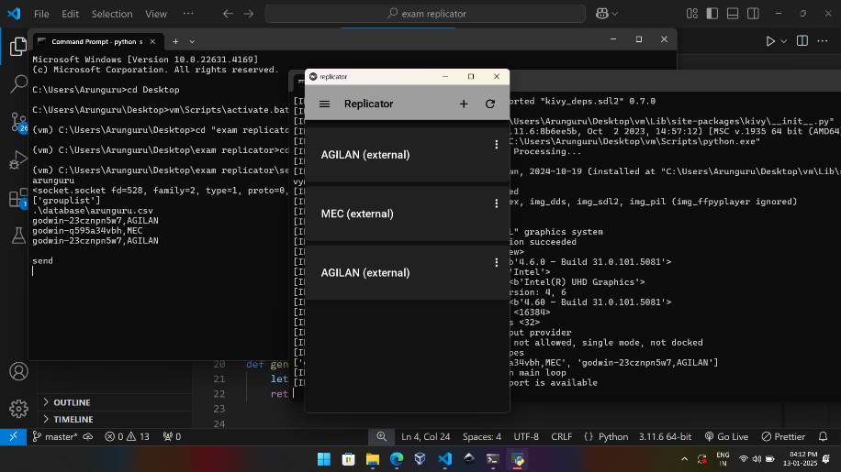Prototype Explanation:

**Fig.1: Preview**

This is the preview of the application. External – defines that the group was created by someone and I am a member (student) of the group. If the group was create by me it will just display the name alone. By clicking the plus icon the user can able to create or able to join a group.

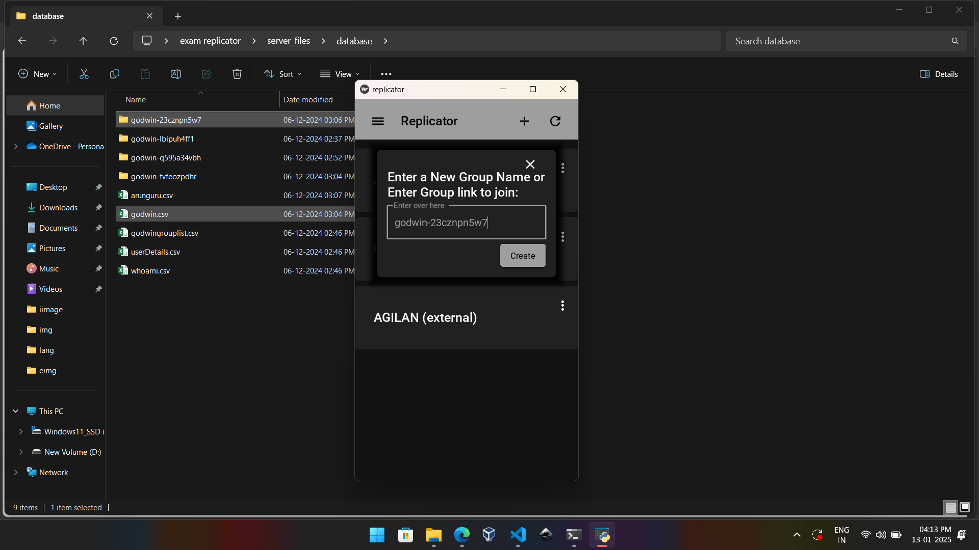

**Fig.2: Joining a group by link**

Other than joining the group, by enter name user can able to create his/her own group.

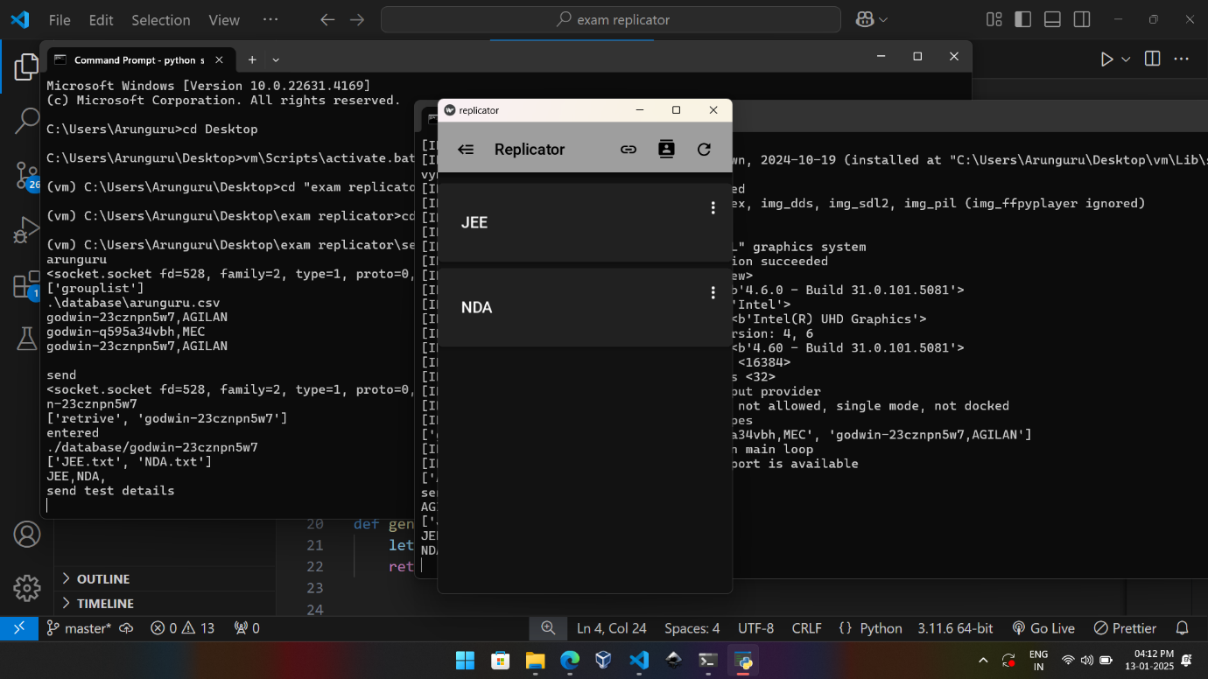By clicking the group name it will display all the test records.

**Fig.3 Test list preview**

Requirements:

Language: **python**

Module: **kivymd, socket, os, threading.**

Summary:

This is just a starting prototype. In this all the server side and client-side code use write on own using sockets in python. And application design was done using kivyMd in python this is what we think as flow of our project. And now I think we must use flutter. In future the idea will come to live with new design and features in more elegant way.