**PIZZA SALES SQL QUERIES**

**A.KPI’s**

**1.Total revenue:**

SELECT SUM(total_price) as Total_Revenue from pizza_sales;

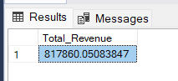

**2.Average Ordervalue:**

SELECT SUM(total_price)/COUNT(distinct(order_id)) as Average_Ordervalue from pizza_sales ;

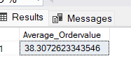

**3.Total Pizza Sold:**

select sum(quantity) as Total_Pizzas_Sold from pizza_sales;

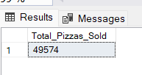

**4.Total Orders:**

select count(distinct order_id) as Total_Order from pizza_sales;

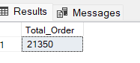

**5.Average Pizza per order :**

Select cast(cast(sum(quantity) as decimal(10,2))/cast(count(distinct order_id)as decimal(10,2)) as decimal(10,2)) as Average_Pizza_Per_order from pizza_sales

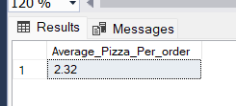

**2.CHART REQUIREMENTS:**

**1.Daily trend for total orders:**

SELECT DATENAME(DW,order_date) as order_day,count(distinct order_id) as Total_orders from pizza_sales group by DATENAME(DW,order_date);

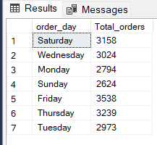

**2.Monthly trend for total orders:**

SELECT DATENAME(MONTH,order_date) as Month_name,count(distinct order_id) as Total_orders from pizza_sales group by DATENAME(MONTH,order_date) order by Total_orders desc;

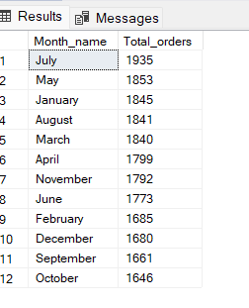

**3.Percentage of sales by pizza category:**

SELECT pizza_category, sum(total_price) AS Total_sales, sum(total_price) *100/(select sum(total_price) from pizza_sales where month(order_date)=2 ) as PCT_sales

from pizza_sales where month(order_date)=2

group by pizza_category order by PCT_sales desc;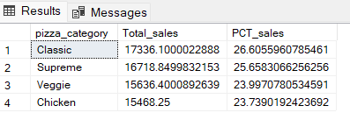

**\*\*Here where month(order_date)=1 indicates PCT_sales for the month of Jan ,in order to get the PCT_sales for consecutive months number can be changed accordingly.\*\***

**3.Percentage of sales by pizza size:**

SELECT pizza_size, cast(sum(total_price) as decimal(10,2)) AS Total_sales,cast( sum(total_price) *100/(select sum(total_price) from pizza_sales )as decimal(10,2)) as PCT_sales

from pizza_sales where datepart(quarter,order_date)=1

group by pizza_size order by PCT_sales desc;

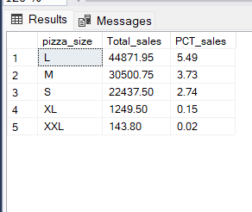

**4.Top 5 best sellers by revenue:**

select top 5 pizza_name,sum(total_price) as Total_revenue from pizza_sales group by pizza_name order by Total_revenue desc ;

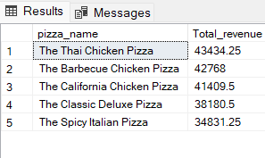

**5. Bottom 5 pizza by revenue :**

select top 5 pizza_name,cast(sum(total_price) as decimal(10,2)) as Total_revenue from pizza_sales group by pizza_name order by Total_revenue ;

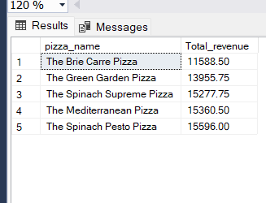

**6.Hourly trend for orders:**

select datepart(hour,order_time)as order_hours,count(distinct order_id) as total_orders from pizza_sales group by datepart(hour,order_time)

order by datepart(hour,order_time);

