I will share my experience/pointers on what went right and what went wrong during my admission process.

1. Choosing Universities is a personal call. I think having a look at what others are going with is not ideally the best idea. Everyone has a different case,profile and expectations. I am not sure how you are using csrankings.org. Here are some questions I would ask myself when looking at csrankings.org.

a. What is the overall reputation of the university?

b. What is the fee structure of the university and what is the ROI?

c. Is there a professor/lab I would want to work with? (If yes does the university reputation matter)

2. Always apply to places where you think You might make a case; it does not necessarily have to be core robotics. For example

a. I applied to georgiaTech because I knew certain professors were working on assistive robots and my experience greatly aligned with their current work and I stressed that on my sop. This helped me get admitted.

b. Cornell did not have a dedicated robotics program. But I had experience in HealthCare robots so I applied to their MS IT + HealthTech program which gave me an admit. I stressed the fact of my contributions towards healthtech via robotics.

c. I worked on computer vision applications again while working on robots and other projects during my internships. I applied to USC cs with that as a point and helped me get an admit. This computer vision thing not only helped me in USC but also for a phd admit in University of Adelaide (CS) which is very well ranked for CV (source csrankings.org)

d. I documented my experience with robotics in terms of how people interacted with them. I made sure I had quantifiable metrics in ways people interacted with robots and how it can be improved. This experience + a paper on studying interaction patterns in another study allowed me to write stuffy on HCI/HRI and helped me bag a phd admit at UCSC

1. At CMU I missed the trick. I should have applied for MS robotics. But instead I applied to MS CV and MS HCI which was fatal because my experience in these fields was decent but was not documented well. In robotics I had proven internship experiences. This boils down to the 2nd point above: Apply to places where you make a case.

2. I was quick to be satisfied with my UMD (Meng Robotics) admit which came out pretty early. So don't settle early. UMD is a great school with a fantastic ROI but don't relax early.

3. Make sure your LORs reflect the case you are making. My first admission cycle I messed this up. I mentioned I was good at robotics and all. But the people who wrote my lors were talking about my coding and other aspects. Get strong lors. By strong not necessarily from a senior professor but someone who can quantify your work. This change really helped me in my second admission cycle. You might get from the HoD but the chance that the admission committee knows your HoD is minimal. Unless it's from a CV jawhar, madhav krishna or some super well known professors i would always stick to someone who can write about me really well than a generic LOR.

4. Don't make generic statements in your SOP/LORs. That will pull you back big time. They have seen statements like "I/He/She am/is hardworking/Enthusiastic". These are pretty lame. Use your words to add technical meat. Talk numbers that will add more value and reflect better that you are serious. Statements might be common among applicants. Numbers would be unique to you setting you apart.

5. Don't iterate your resume in the sop. Talk more about your problem solving approach, your contributions, results of projects you mentioned in your resume

Tips while Shortlisting Universities (Part-1)*

The first thing to be done as a part of your application is to shortlist universities. Ideally, it must be finalized around the first few weeks of this month. One advantage of doing it early is that you can decide which 4 universities you get to send your GRE & TOEFL scores to for free.

While shortlisting universities, it is advised to look at the following factors:

a. Tuition Fees & Cost of Living

Probably the most important for middle-class students. Also, probably where everyone ends up making a HUGE mistake.

Many Indians go crazy behind brands. I have seen too many posts with "I've got into Ivy-League" without knowing whether or not that particular university is even good for their field or not.

Most of the private US universities (including Ivies) consider incoming MS. students as cash cows. It is always recommended to join public universities in the US, as they offer more financial aid with TA/ RA.

When I went through UPenn's website to apply, I was astonished! 8k USD for a single course! (See Fig. below) The total tuition fees come to around 50 lakh INR. What do they teach such that each class is worth 8k USD? Cost of living is also not cheap in Pennsylvania. You'd be set back by at least 60 lakh. Do you think it's worth it?

1. Suppose you're planning to do a job after your MS., research and look at the mean salary in your field. If you feel you'd get enough, then it's worth it. A good example is CMU MS. Robotics. It is highly regarded, and despite the huge tuition fees, you'd receive a lot in return later. So, that's a good RoI.

2. On the other hand, if you're planning to do a PhD immediately after MS., the stipend provided will not be sufficient to balance the massive debt during your MS. since most of it would go to rent and living costs.

An example is UCLA: The cost of living is insanely high in LA and combined with tuition fees, you'd be set back by around 70 lakh.**

But their PhD pays well: 2.5k USD a month. With nearly 1.5k gone towards rent, how much can you save so that you could pay off your MS. debt?

3. If your course is more theory-oriented and doesn't have many industrial applications, it is preferable to go with a PhD directly rather than via an MS. degree.

For instance, in my field (control theory), it's better to apply for PhDs directly. On the other hand, an area like "robotics and control" has no dearth of jobs. The RoI would be high. Hence, going through MS., then a job and a PhD will not harm you financially.

I've seen numerous cases on the net where people have been trapped by huge debts after taking education loans and unable to pay them back since they couldn't get a proper job (even those from "ivies"). They did not do enough research!

Always lookout for these 3 points when you shortlist universities based on financial constraints. Let me know in the comments section if there are more factors!

[#research](https://www.linkedin.com/feed/hashtag/?keywords=research&highlightedUpdateUrns=urn%3Ali%3Aactivity%3A6831568313072652288) [#phd](https://www.linkedin.com/feed/hashtag/?keywords=phd&highlightedUpdateUrns=urn%3Ali%3Aactivity%3A6831568313072652288) [#highereducation](https://www.linkedin.com/feed/hashtag/?keywords=highereducation&highlightedUpdateUrns=urn%3Ali%3Aactivity%3A6831568313072652288)

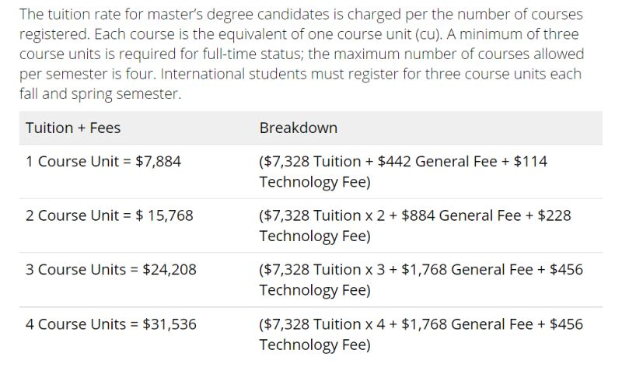

Free education:

1. Technical University of Munich
2. Heidelberg University (Germany)
3. Ludwig Maximilian Universitat
4. University of Oslo
5. University of Bergen
6. Norwegian University of Science and Technology

Tips while Shortlisting Universities (Part-2): EU* vs US Universities

In these few months, many had asked me, “Why did you prefer an EU university over a US one?”. I thought I’d dedicate an entire post on the differences between American and EU academia**.

1. In general, it’s pretty hard to get into US and Canadian universities as they look at your profile holistically. On the other hand, EU universities typically look at very few factors (GPA, course-matching only) and are relatively easy to get in.

2. It’s nearly impossible to do cross-discipline courses in the EU. For e.g. If you have a BS. in Mechanical engineering (even at an IIT) and would like to pursue an MS. in CS, you’d have low chances, as they strictly look at whether you match the course requirements.

In my case, even though my UG courses are closely related to EE, yet I was missing out on many courses to get into MS. EE at ETH. It was a massive stroke of luck that I made it through.

3. Grade inflation is practised to a large extent in US universities. Don’t be surprised if you see many 3.5+/4. In contrast, lecturers in EU universities have complete liberty to fail you (they strictly follow the curve). I’ve seen cases where many students have extended their 2-year course to 3 or more. It’s a lot easier to pass out from US universities than EU ones.

4. Most EU unis charge zero/little tuition fees. Most US universities (esp. private ones) treat incoming MS students as cash cows.

5. Cost of living*** is also cheaper in the EU compared to the US.

6. MS. in the EU is primarily course-based (apart from thesis), as they consider it a continuation of their 3-yr BS. course. You wouldn’t do many courses in the US and would have more time for research and extra-curricular activities.

7. EU universities are generally ranked lower (mainly because they don’t offer many English courses). Don’t be fooled by them, though. Specific departments like the control lab at TUM, TUB and the biomedical engg. dept. at RWTH are one of the best in the world.

8. Most of the PhDs in the US are funded when you do RA work. You’re also expected to work as TAs for courses in which your supervisor is involved. You also have to do coursework. PhDs are treated as student positions. Whereas, in the EU, PhDs are considered jobs, and you’re not expected to work extra. However, working as RA/ TA will gain you additional income.

9. PhDs, as a result, take much longer in the US (5+ years), whereas you can be done within 4 in EU.

10. Direct PhDs from BS are possible in the US but far more difficult than getting an admit for MS. On the other hand, an MS. is required in almost all universities in EU for doctoral studies.

11. ‘Inter-breeding’ is very rare in the US (i.e. PhD graduates immediately getting tenure-track faculty positions in the same university). On the other hand, I’ve observed that PhDs in the EU are offered faculty positions immediately after defence.

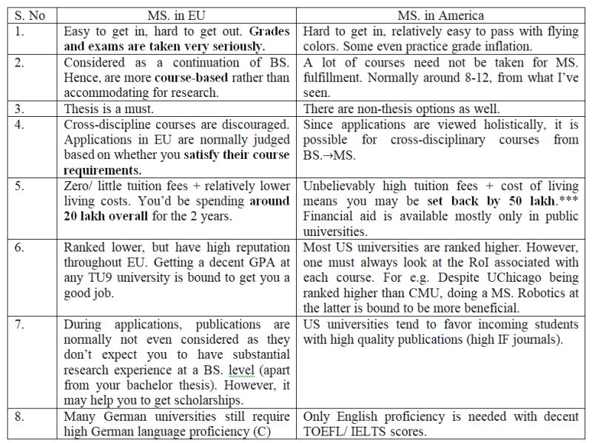

What do universities look out for in your application?"- Is a question that I had last year while applying to US universities.

A trick is to think like you’re in the admissions committee so that you judge your materials from their perspective.

So, I thought I’d list out a “priority list”* that may help current graduate students:

1. Breakthroughs: Although it is nearly impossible to discover anything of significance as early as 3rd year UG, publications in journals with high IF will do the trick, especially if a professor in the admissions committee was also a part of the editorial board in the journal.

2. Letters of Recommendation: Possibly the most crucial part of any application. If the professor writing you a letter talks well about your research potential and is also well known in your field, it heavily influences the decision.

3. Relevant Publications: “Best Paper Awards” at decent Indian, International conferences indicate good research potential. Individual papers (with just your supervisor as a co-author) will play a huge role. Universities require candidates who are capable of individual research work.

4. CV: Publications are often asked separately on the admissions portal. So, your only chance to briefly describe your projects and internships is over here. EVEN if it is stated as “optional”, upload your CV. Limit your CV to 2 pages.

5. Research Projects: Obviously, not everyone has their work published, especially if it is more involved. One can mention their ongoing work in their CV as well as SoP. Just remember to keep it concise!

6. Research Internships: Internships at tier-1 universities in India gives a positive light. Even better if it’s done abroad in some cases. Ensure you put up a certificate on the CV.

7. Courses Taken: (Tougher course, lower grade)>(Easy courses, high grades). In my field, Optimal, Robust, Nonlinear control courses are considered graduate-level. Choosing these at UG level gives a good opinion about you.

8. Rank of University: Tier-1 universities are well recognized outside India.

9. Academic Awards: If you’re in the top 5 of your class, well done! This shows that you’re capable of surviving the academic rigour in universities abroad.

10. GPA: Normally used just for filtering. If you have an 8+, you’re mostly safe. Some universities state explicit cut-offs.

11. SoP: Tbh, the committee won’t have a lot of time to read through a 1000-word essay for around >1000 applicants. They might skim through your article, so it’s better to remain succinct.

12. GRE: Similar to GPA, it’s used just for filtering. A score of 320+ would be safe. DO NOT spend more than 2 weeks on the GRE.

13. TOEFL: Used to test your English proficiency. A score of 90+ should be safe for most universities, whereas some have clear cut-offs. DO NOT spend more than a week on TOEFL. If possible, write it immediately after the GRE, as a few sections overlap and TOEFL is far easier.

“Should I apply for this university? It isn’t even on the top 100!” – Is a question that most of us ponder while applying to grad schools abroad (even I did).

Trust me; rankings matter the least while applying.

Last year, when I was applying to grad schools, I looked at the QS rankings for each university. Although I did find QS to be relatively more credible than the others, there are more important factors to be considered:

Alumni Connections: Check where their previous grad students are working at. Usually, they’re posted on the university website. A strong alumni network ensures a great future for you.

Faculty research profiles: Check if their field of interest is trending currently and not outdated. Also, check out the type of courses that they handle.

Type of Publications: Always see where the students and faculty publish. If they publish at top conferences and journals and are of high quality, try to join this group immediately.

Profiles of current students: Is there diversity? Where did the students do their UG? (Check their LinkedIn/ CV if provided)

Mental health of students: Always contact current PhD students and find out if the research environment is friendly.

I should share one of my mistakes while applying last year- Not applying to UCSB’s PhD in ECE controls.

I didn’t even check universities below the 100 rank mark while applying (UCSB is ranked 146th); this led me to lose a great opportunity.

Only after applying to all universities, I came to know about UCSB:

PhD holders from UCSB became faculty members at the best universities globally, employed at reputed research labs. (Alumni Networks: Check)

UCSB’s Control group publishes top-notch articles and books on Networked systems and control. I’ve personally studied their group’s papers and “Lectures on Network Systems” for one of my control courses. A couple of professors are considered big shots in this field and are editors in top journals. (Faculty Research Profiles: Check)

Moreover, I could see many publications on “Automatica” & “IEEE transactions on Automatic Control” (IF>3.5). (Type of publications: Check)

UIUC-controls as well. Although ranked 82nd, it is probably one of the best places for nonlinear control. MS/ PhDs there are highly sought after and regarded. (Note: I got rejected for MS., I mistook UIUC as a “safe choice” purely based on QS rankings)

TL;DR:

Do not follow rankings blindly (especially overall): Even if you want to look at them, go for highly subject-specific rankings. (For example, the figure shown below: Despite UIUC being ranked low overall, it proves to be equivalent to MIT in controls, which is somewhat true). General rankings are misleading!

Do a lot of research: Spend time trying to find out if the 5 points I mentioned above resonate with your expectations. Only if you get a feel that you may fit here, go ahead and apply.

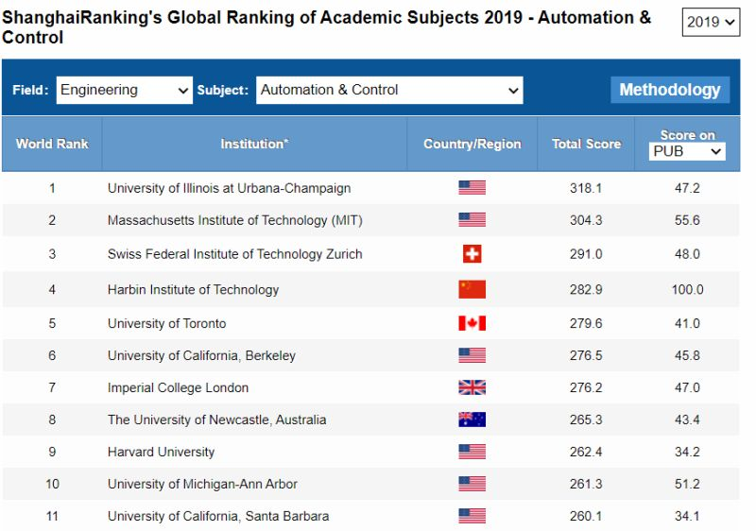

“Why haven’t I chosen Indian Academia (Part-1) – Mental Health & Stress.”

“Why didn’t you apply for the top Indian grad schools? You even have a shot at the PMRF”- This is a question I’ve faced many times, both from classmates, juniors and professors at NITT. This requires a somewhat detailed answer; hence, I decided to divide it into separate posts based on my experience.

DISCLAIMER: These experiences are personal, and it is advised not to generalize Indian academia.

When I was in my 3rd year, I pictured myself doing research at IISc/ top IITs and contributing my part to this country, rather than going out and causing brain drain. But things turned out otherwise.

In my 3rd year summer, I did an online research internship under a professor at a top university in India.

Unfortunately, the prof. created the most toxic environment I had ever seen. Making a small mistake was fatal. The professor would scream, “Your work is garbage and useless, get out and prepare again”. Trivial errors such as the wrong usage of fonts would result in being thrown out and called a “waste of his time”.

If someone had mic/ video/ network problems, prof. would accuse him of lying to cover up his “un-preparedness”. He would deliberately send mails at 3 am and brag about him barely sleeping the next day during the presentations, insisting that his students must do the same.

I have personally seen students giving excellent and detailed presentations, only to be halted by the prof. saying, “You only have 2 minutes more, Hurry!”. As a result, the student would cut-short his presentation. The prof. would then scream, “I don’t understand anything you’re saying; elaborate more!!”. The student would then get scared and make a couple of mistakes. The prof. then wasted no time in shouting at his mistake and throwing him out.

It was almost as though the prof. was eagerly waiting for students to make mistakes and then scream in the most horrific way possible and obtain sadistic pleasure out of it.

The entire experience was traumatic to me, and I cried when I had my last presentation to him after receiving very harsh words. Thankfully, I had the support of my parents, who clearly told me to prioritize peace of mind over everything. So, I decided to quit midway and didn’t leave on good terms with the prof.

My close friends had later told me, “That’s just one prof., not everyone’s like that. Change your guide; go to some other prof. in other top Indian universities for your PhD”.

Although this is possible, it is not that simple. This prof. is considered one of the big shots in my field of interest and is in the chair for almost all conferences and journals in India. This will definitely hinder my future in academia as there is huge scope for biased judgments during publications.

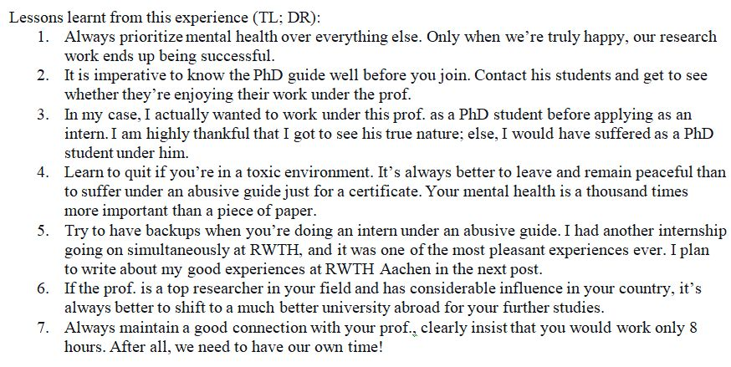

Many students have asked me this question in the past few months: “Is x.xx GPA enough to get into this university? Is a 320 GRE score enough to get into a top university”. Unfortunately, most students are still stuck in the transition between high school and university, where a good JEE mark guarantees a spot at the top IITs and NITs. Universities abroad view applications holistically.

Now, I’m going to make a somewhat controversial statement- Your CGPA doesn’t really matter (That doesn’t mean you get to chill and not study). Your research experience matters a lot more than just marks.

Look at the figure below. UCB admitted only around 9% of the total number of applications for the 2020 Fall session. Many candidates were Indians. Along similar lines, Georgia Tech admitted as few as 90 international students out of 2000 who applied to their ECE program alone. Now imagine, how many Indians would be having a 9.5+ GPA out of these guys? I’ve seen many Indian students complaining on public forums: “I got a 9.8 GPA with 340 GRE score, yet I got rejected”. Some applicants don’t understand that a 10 GPA obtained at a tier-2/3 institute is definitely not the same as a 10 GPA got at a top IIT. Just as GPA varies based on university, it also varies based on the UG program, nature of courses taken, grading of lecturers etc. Even different sections of the same class and batch grade differently. How then would the grad schools discriminate solely based on GPA?

Although it is commendable that one can score a 9.5+ GPA, students should not waste time trying to increase it further. Instead, one can spend time networking with professors, performing experiments and trying to publish research studies. I have personally seen someone with a GPA< 8 who got a PhD admit at the best university in his field. Rather than spending time studying for irrelevant courses that are not going to impact his future research, he’d spend time publishing articles. Believe it or not, he published an astonishing 10+ articles in top journals during his UG program.

I now regret that I spent an unnecessary amount of time on silly courses just to get an A/ S grade, which are in no way related to the research I am doing currently. Despite having quite a high GPA, I still got rejected from UCB’s EECS PhD and UIUC’s MS. ECE program. If I had traded 0.5 of my GPA for 1 or 2 relevant publications, I would have probably been enrolled in these universities currently.

TL; DR: Aim for good grades ONLY in the courses that interest you and may help you in the future. Although you shouldn’t fail in other courses, getting a C/ B in irrelevant classes won’t matter at all for your graduate studies. Spend that time emailing professors requesting RA positions, do research internships outside your university for better exposure, spend lots of time on mini-projects. Who knows? These might end up getting published, and you may have a higher chance of getting admits than someone who has a 9.5+.

