**Semester S1**

**Foundations of electromagnetic wave propagation**

EXAMINATION

O. TANTOT - S. Verdeyme

November 2022

I Consider a plane wave propagating in the air. This wave is reflected on a metallic plane (perfect conductor, x=0), as shown on figure 1.

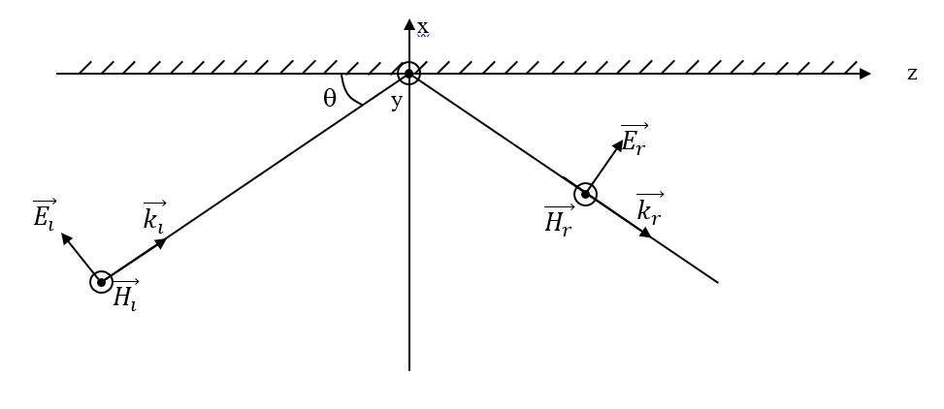

Figure 1

The total magnetic field is directed toward the y direction. The electric field is in the x-z plane. These fields expressions are given above:

$$\vec{E_{T}}=\vec{E_{i}}+\vec{E_{r}}=2 Z_{0}H_{0}(cosθ\cos\left(kxsinθ\right)\vec{e_{x}}+sinθsin⁡(kxsinθ)\vec{e_{z}})$$

$$\vec{H_{T}}=\vec{H_{i}}+\vec{H_{r}}=2 H_{0}\cos\left(kxsinθ\right)e^{-jkzcosθ}\vec{e_{y}}$$

With k the plane wave number, Z0 the plane wave impedance, H0 the magnitude of the incident magnetic field, $θ$ the angle between the z axis and the incident wavec propagation direction (same notations than in the tutorial)

A second perfect conductor metallic plane is placed at the position x=-a, and the 2 metallic plates are parallel.

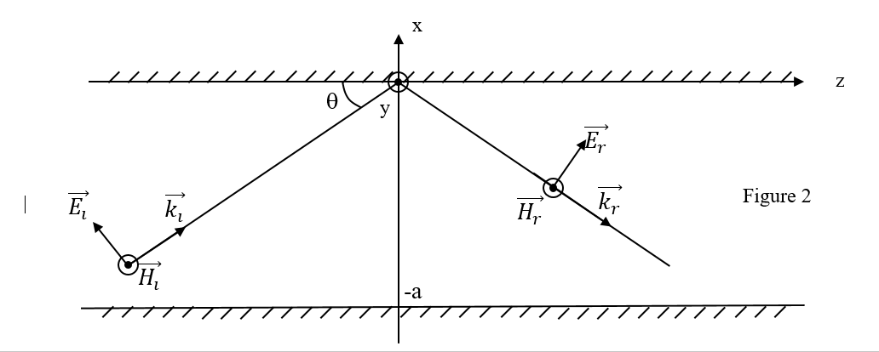

* 1. Considering the boundary condition at x=-a, give a relation between  and .
  2. Give the expression of the lower cut-off frequency Fc1 from which the field propagates between the 2 plates. Draw then the total magnetic field variations, at a given point z, as a function of x (for a frequency higher than Fc1, lower than 2 Fc1).
  3. Give for this first mode the guided wavelength.
  4. What could be the variations of the magnetic field at 2.5 Fc1?

II Transmission lines.

* 1. A lossless transmission line (propagation constant β , characteristic impedance Z0, length l) carries a TEM wave. From the voltage and current expressions along the line, compute its transfer matrix.
  2. Consider now the power divider presented on figure 3. The lines are lossless again. The device is symmetric. For the computations, we consider l1=0, l2=l3=/4 at the frequency f0. The characteritic impedance of the lines connected to ports 2 an 3 est Z1, the characteristic impedance of the line connected to port 1 is Z0.

1. From the transfer matrix, compute the input impedance of a device composed of a line which characteristic impedance is Z1, length /4, loaded at its output on Z0.
2. Conclude then on the input impedance at port 1, when the ports 2 and 3 are loaded on Z0.
3. Compute Z1 to match the device at port 1 on an impedance Z0.

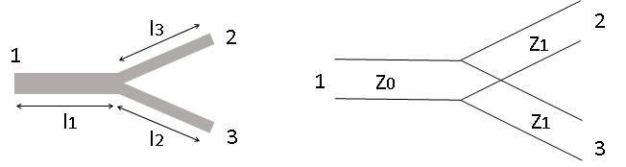

* Figure 3 –
  1. We consider $Z_{1}=\sqrt{2}{ Z}_{0}$. The device under test is described on figure 4.

1. Compute the transfer matrix [C1 ] of the parallel lumped impedance 2 Z0, then the transfer matrix [C2 ] of the line which characteristic impedance is Z1,length 0/4 (figure 4)
2. Compute the transfer matrix, then the S matrix (reference impedance Z0) of the whole device (figure 4)
   1. Explain why the S11 and S21 parameter of the circuits presented on figure 3 and 4 are identical.
3. Is the divider (figure 3) matched on port 1? On port 2?
4. From the relations between the S parameter modulus for a lossless network, demonstrate that ${\left|S_{21}\right|}^{2}={\left|S_{31}\right|}^{2}=1/2$ and ${\left|S_{32}\right|}^{2}=1/4$
5. Do you consider the divider (figure 3) is also a combiner from ports 2 and 3 to port 1?

$$\left[C_{2}\right]$$

$$\left[C_{1}\right]$$

* Figure 4-

2Z0

0/4

l1

l2

Zc2

Zc

Générateur

Y2

Ye1

Ye2

Ya