Frontend Development With React.js
Project Document for Rhythmic Tunes
1.Introdution
- Project Title: Rhythmic Tunes
  - Team Members:
TEAM MEMBERS | - E-MAIL ID | - ROLE
- ASMIYA.A | - aasmiyashahulaasmiyashahul@gmail.com | - Team Leader
- MOMITHA.J | - momithajalandhar@gmail.com | - Team Member
- PAVITHRA.P | - pavi5956@gmail.com | - Team Member
- SWATHI BAI.V | - swathibaivenkobasah22@gmail.com | - Team Member

2. Project Overview
Purpose:
Rhythmic Tunes is a web application designed to provide users with a seamless music listening experience. The application allows users to browse, search, and play music tracks, create playlists, and discover new music based on their preferences.
Features:
- Music player with play, pause, skip, and volume control.
  - Search functionality to find songs, albums, and artists.
  - User authentication (login/signup).
  - Playlist creation and management.
  - Responsive design for mobile and desktop.
3. Architecture
- Component Structure: The application is built using React.js with a component-based architecture. Major components include:

Header: Contains the navigation bar and search bar.
  - Player: Music player controls (play, pause, volume, etc.).
  - Sidebar: Displays user playlists and navigation links.
  - Home Page: Displays featured tracks, recommended playlists, and new releases.
  - Search Page: Allows users to search for songs, albums, and artists.
  - Playlist Page: Displays user-created playlists and allows playlist management.

  - State Management:
The application uses Redux for global state management. The Redux store manages user authentication, current playing track, playlist data, and search results.
  - Routing:
The application uses React Router for navigation. Routes include:
- /: Home page
- /search: Search page
- /playlist/:id: Playlist details page
- /login: User login page
4. Setup Instructions
Prerequisites:
  - Node.js (v16 or higher)
  - npm (v8 or higher)
  - Git
Installation:
    - Clone the repository: git clone https://github.com/unm12912137/rhythmic-tunes.git
    - Navigate to the client directory: cd rhythmic-tunes/client
    - Install dependencies: npm install
    - Configure environment variables: Create a .env file in the client directory and add the necessary variables (e.g., API keys).
    - Start the development server: npm start

5. Folder Structure
- Client:
- src/components: # Reusable components (Header, Player, etc.)
- src/pages: # Page components (HomePage, SearchPage, etc.)
- src/assets: # Images, icons, and other static files
- src/redux: # Redux store, actions, and reducers
- src/utils: # Utility functions and helpers
- App.js: # Main application component
- index.js: # Entry point
  - Utilities:
  - api.js: Handles API requests to the backend.
  - auth.js: Manages user authentication and token storage.
  - hooks/usePlayer.js: Custom hook for managing the music player state.
  - 6. Running the Application
Frontend:
- To start the frontend server, run the following command in the client directory: npm start
- npm install
- npx json-server ./db/db.json
- npm run dev
- The application will be available at http://localhost:3000
7. Component Documentation
  - Key Components:
  - Header: Displays the navigation bar and search bar.
  - Props: onSearch (function to handle search queries).
  - Player: Controls the music playback.
  - Props: currentTrack (object containing track details), onPlay, onPause, onSkip.
  - PlaylistCard: Displays a playlist with its name and cover image.
  - Props: playlist (object containing playlist details), onClick (function to handle playlist selection).
  - Reusable Components:
  - Button: A customizable button component.
  - Props: text, onClick, disabled.
  - Input: A reusable input field for forms and search.
  - Props: type, placeholder, value, onChange.
8. State Management
  - Global State:
  - The Redux store manages the following global states:
  - user: Current authenticated user.
  - player: Current playing track, playback status (playing/paused), and volume.
  - playlists: User-created playlists.
  - searchResults: Results from the search functionality.

  - Local State:
  - Local state is managed using React's useState hook within components. For example, the SearchPage component manages the search query input locally.

9. User Interface
- Screenshots
- Home Page: Display featured tracks and recommended playlists.

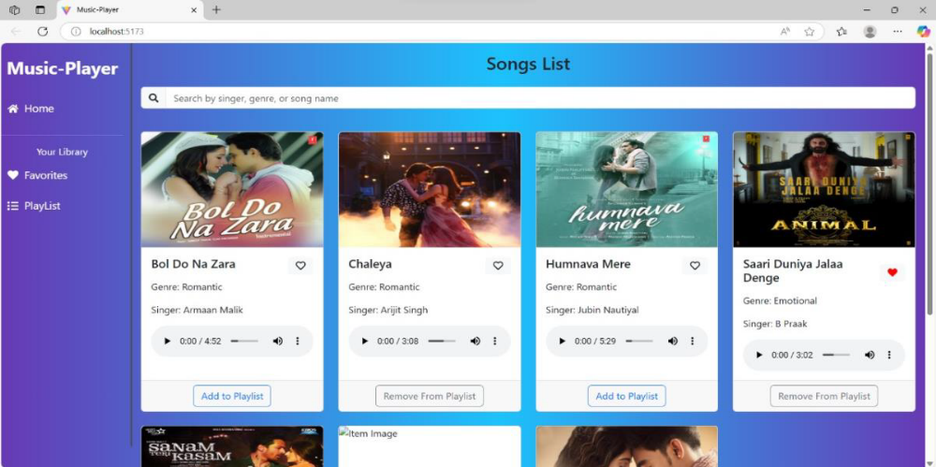

  - Search Page: Allows users to search for songs, albums, and artists.

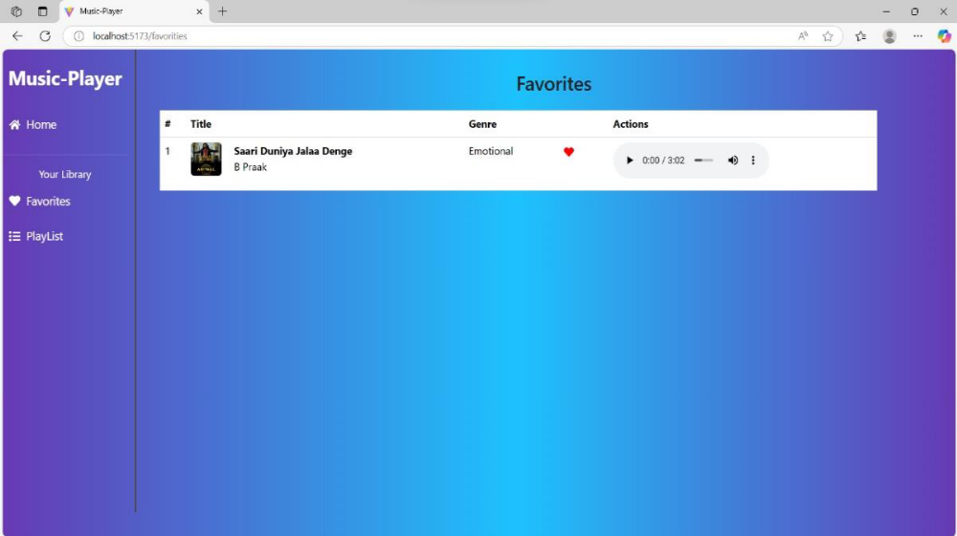

  - Playlist Page: Displays user-created playlists and allows playlist management
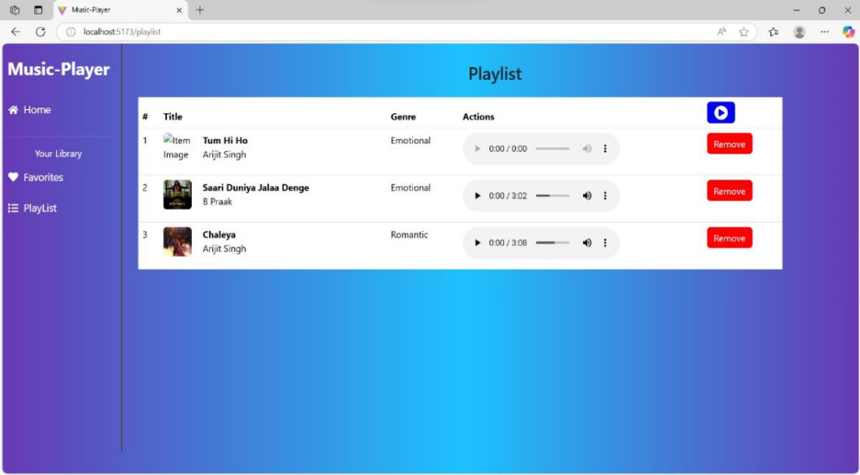

10. Styling
- CSS Frameworks/Libraries: The application uses Styled-Components for styling. This allows for modular and scoped CSS within components.
- Theming: A custom theme is implemented using Styled-Components, with support for light and dark modes.
11. Testing
  - Testing Strategy:
  - Unit Testing: Using Jest and React Testing Library.
  - Integration Testing: Is performed to ensure that components work together as expected.
  - End-to-End Testing: Cypress is used for end-to-end testing of user flows.
  - Code Coverage:
  - Code coverage is monitored using Jest’s built in coverage tool. The current coverage is 85%.

12.Screenshots or Demo
- Demo Link:
https://drive.google.com/file/d/1QsqGkYxHYcHPTgOZtdYyKb-2wwsL-J9H/view?usp=sharing

- Screenshots: See section 9 for UI screenshots.

13. Known Issues
- Issue 1: The music player sometimes skips tracks unexpectedly.
- Issue 2: The search functionality is slow with large datasets.

14. Future Enhancements
  - Future Features:
  - Add support for user profiles and social sharing.
  - Implement a recommendation engine for personalized music suggestions.
  - Add animations and transitions for a smoother user experience.

This documentation provides a comprehensive overview of the Rhythmic Tunes project, including its architecture, setup instructions, and future plans.

