***Operating System – Phase – 1***

Group – 10

Class – TY – CSA

Batch – B2

Members :

|  |  |  |
| --- | --- | --- |
| Roll Number | Prn No. | Name |
| 12 | 12010821 | Aditya Patil |
| 56 | 12010835 | Anuja Deshpande |
| 57 | 12011206 | Surabhi Deshpande |
| 59 | 12010283 | Dev Bohra |

Input File : -

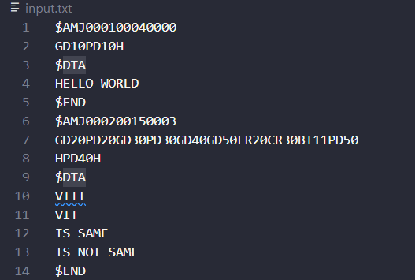

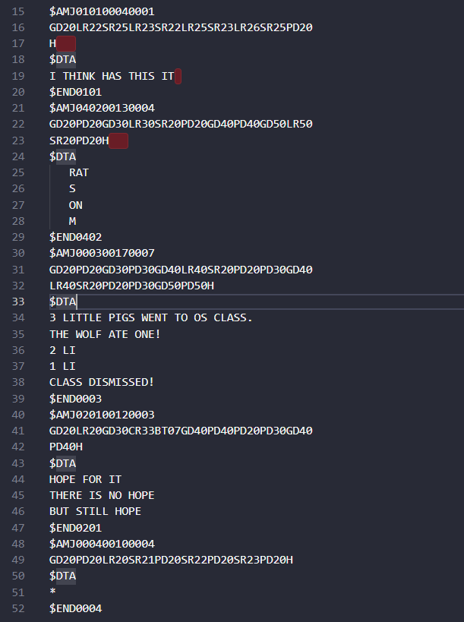

OUTPUT : 7 Programs run by Operating System which are being stored in output.txt file.

Combined Output : -

