***Operating System – Phase – 2***

Name : Aditya Patil

Class – TY – CSA

Batch – B2

Prn No. – 12010821

Roll no. – 12

Group - 10

**Design of a multiprogramming operating system - Phase 3**

**1. Input Spooling**

**2. Loading**

**3. Execution of GD & PD**

**4. Output Spooling**

**Output :**

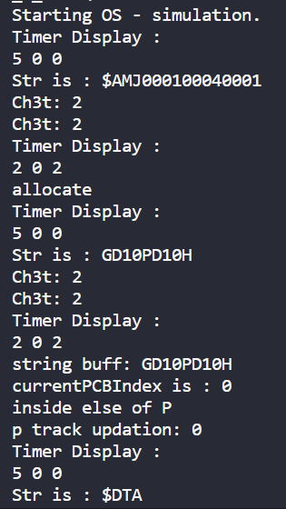

**Aux Memory :**

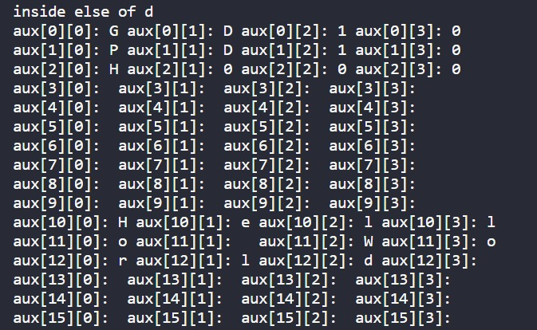

**Main Memory : (loading GD and PD).**

