***Operating System – Phase – 3***

Group – 10

Class – TY - CSA

Members :

|  |  |
| --- | --- |
| Roll Number | Name |
| 12 | Aditya Patil |
| 56 | Anuja Deshpande |
| 57 | Surabhi Deshpande |
| 59 | Dev Bohra |

**Design of a multiprogramming operating system - Phase 3**

**1. Input Spooling**

**2. Loading**

**3. Execution of GD & PD**

**4. Output Spooling**

**Output :**

**1] Channel Timers being updated:**

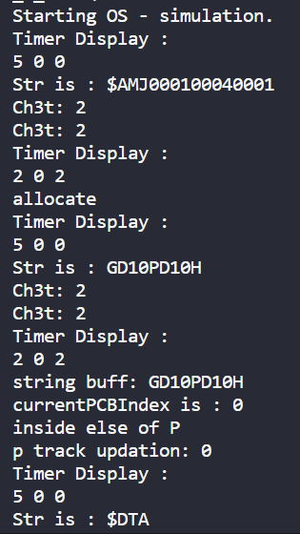

**2] Input Spooling performed by Channel 1 [Program and Data Card getting loaded from Card Reader to Auxillary Memory]**

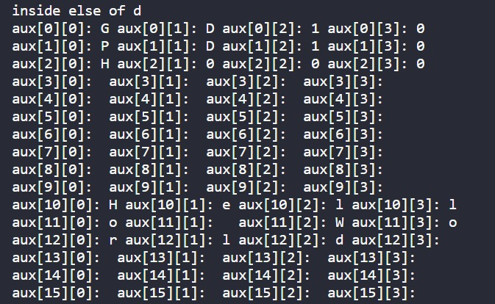

**3] Input Spooling performed by Channel 3 [Program and Data Card getting loaded from Auxillary Memory to Main Memory with Paging]**

**Page Table Initialised in Main Memory-**

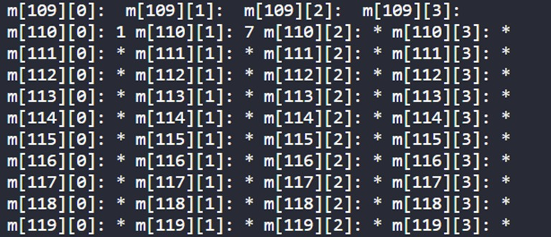

**Program Card Loaded in Main Memory-**

