**Background**

Congratulations! You’ve helped Seth and Tom submit the election audit results to the election commission. But wait! The election commission has requested some additional data to complete the audit:

* The voter turnout for each county
* The percentage of votes from each county out of the total count
* The county with the highest turnout

Working from this module’s election_results.csv file, use for loops and conditional statements with membership and logical operators to find the requested results. Then, print the results to the command line and save them to your election_results.txt file.

Finally, you’ll provide a written analysis of the election audit for the election commission, including the new results and a clearly written overview of your methods. As with all written analyses, this will help your audience understand what you did and what they might be able to do with the data you presented.

**What You're Creating**

This new assignment consists of two technical analysis deliverables and a written report to deliver your results. You will submit the following:

* Deliverable 1: The Election Results Printed to the Command Line
* Deliverable 2: The Election Results Saved to a Text File
* Deliverable 3: A written Analysis of the Election Audit (README.md)

**Files**

Use the following link to download the challenge starter code, which includes the Module 3 PyPoll solution.

[Download challenge starter code (Links to an external site.)](https://2u-data-curriculum-team.s3.amazonaws.com/dataviz-online/module_3/PyPoll_Challenge_starter_code.py)

**Deliverable 1: Election Results Printed to the Command Line (50 points)**

**Deliverable 1 Instructions**

Using repetition statements, conditional statements with logical operators, and print statements, print out the candidate and county election results to the command line.

**REWIND**

For this deliverable, you’ve already done the following in this module:

* [**Lesson 3.2.2:**](https://courses.bootcampspot.com/courses/755/pages/3-dot-2-2-execute-python-files) Run a Python file in the command line or VS Code.
* [**Lesson 3.2.4:**](https://courses.bootcampspot.com/courses/755/pages/3-dot-2-4-perform-calculations-using-python) Perform Calculations.
* [**Lesson 3.2.5:**](https://courses.bootcampspot.com/courses/755/pages/3-dot-2-5-data-structures-lists) Create and add to a list.
* [**Lesson 3.2.7:**](https://courses.bootcampspot.com/courses/755/pages/3-dot-2-7-data-structures-dictionaries) Create and add keys and values to a dictionary.
* [**Lesson 3.2.8:**](https://courses.bootcampspot.com/courses/755/pages/3-dot-2-8-decision-statements) Use decision statements to check a condition.
* [**Lesson 3.2.9:**](https://courses.bootcampspot.com/courses/755/pages/3-dot-2-9-membership-and-logical-operators) Apply membership and logical operators to decision statements.
* [**Lesson 3.2.10:**](https://courses.bootcampspot.com/courses/755/pages/3-dot-2-10-repetition-statements) Use repetition statements to iterate through a list or dictionary.
* [**Lesson 3.2.11:**](https://courses.bootcampspot.com/courses/755/pages/3-dot-2-11-printing-formats) Write print statements using f-strings.

1. Download the PyPoll_Challenge_starter_code.py file and rename it PyPoll_Challenge.py.
2. Use the step-by-step instructions below to add code where indicated by the numbered comments in the starter code file.

**Step 1:**

* Initialize a county list, like the candidate_options list, that will hold the names of the counties.
* Initialize a dictionary, like the candidate_votes dictionary, that will hold the county as the key and the votes cast for each county as the values.

**Step 2:**

* Initialize an empty string, like winning_candidate, that will hold the county name for the county with the largest turnout.
* Initialize a variable, like the winning_count variable, that will hold the number of votes of the county that had the largest turnout.

**Step 3:**

* While reading the election results from each row inside the for loop, write a script that gets the county name from each row.

**Step 4a:**

* Write a decision statement with a logical operator to check if the county name acquired in Step 3 is in the county list you created in Step 1.

**Step 4b:**

* If the county is not in the list created in Step 1, add it to the list of county names like you did when adding a candidate to the candidate_options list.

**Step 4c:**

* Write a script that initializes the county vote to zero, like you did when you began to track the vote counts for the candidates.

**Step 5:**

* Write a script that adds a vote to the county’s vote count as you are looping through all the rows, like you did for the candidate’s vote count.

**Step 6a:**

* Write a repetition statement to get the county from the county dictionary that was created in Step 1.

**Step 6b:**

* Initialize a variable to hold the county’s votes as they are retrieved from the county votes dictionary.

**Step 6c:**

* Write a script that calculates the county’s votes as a percentage of the total votes.

**Step 6d:**

* Write a print statement that prints the current county, its percentage of the total votes, and its total votes to the command line.

**Step 6e:** ***This step will be completed in Deliverable 2.***

**Step 6f:**

* Write a decision statement that determines the county with the largest vote count and then adds that county and its vote count to the variables created in Step 2.

**Step 7:**

* Write a print statement that prints out the county with the largest turnout.

After you run your solution to Deliverable 1, confirm that the output to the command line matches the following image:

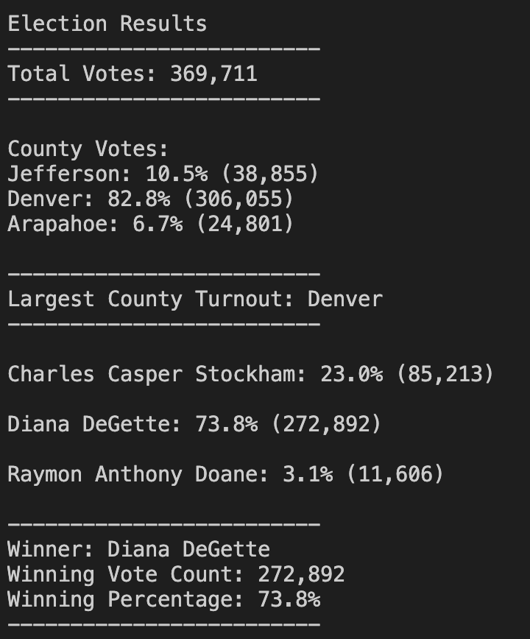

**Deliverable 1 Requirements**

You will earn a perfect score for Deliverable 1 by completing all requirements below:

**Candidate Results**

* Total Votes in the election are printed to the terminal. **(5 pt)**
* Each candidate’s total votes and percentage of votes are printed to the terminal. **(5 pt)**
* The winner of the election, winning vote count, and winning percentage of votes are printed to the terminal. **(5 pt)**

**County Results**

* Each county and its total vote count are printed to the terminal. **(15 pt)**
* Each county and its percentage of the total votes are printed to the terminal. **(10 pt)**
* The county with the largest number of voters is printed to the terminal. **(10 pt)**

**Deliverable 2: Election Results Saved to a Text File (30 points)**

**Deliverable 2 Instructions**

Using your knowledge of writing data to a text file, write the winning candidate results and the county election results to the election_results.txt file.

**REWIND**

For this deliverable, you’ve already done the following in this module:

* [**Lesson 3.2.2:**](https://courses.bootcampspot.com/courses/755/pages/3-dot-2-2-execute-python-files) Run a Python file in command line or VS Code.
* [**Lesson 3.2.10:**](https://courses.bootcampspot.com/courses/755/pages/3-dot-2-10-repetition-statements) Write data to a file.

Use the step-by-step instructions below to add code where indicated by the numbered comments in the starter code file.

**Step 6e:**

* Write a script that saves each county, the county’s total votes, and the county’s percentage of total votes to the election_results.txt file.

**Step 8:**

* Write a script that saves the county with the largest turnout to the election_results.txt file.

After you run your solution to Deliverable 2, confirm that your election_results.txt file matches the following image:

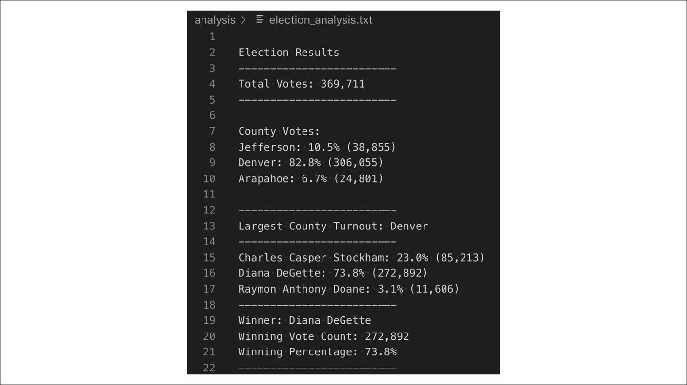

**Deliverable 2 Requirements**

You will earn a perfect score for Deliverable 2 by completing all requirements below:

**Candidate Results**

* Total Votes in the election are saved in the election_results.txt file. **(2 pt)**
* Each candidate’s total votes and percentage of votes are saved in the election_results.txt file. **(3 pt)**
* The winner of the election, winning vote count, and winning percentage of votes are saved in the election_results.txt file. **(5 pt)**

**County Results**

* Each county and its total vote count are saved in the election_results.txt file. **(10 pt)**
* Each county and its percentage of the total votes are saved in the election_results.txt file. **(5 pt)**
* The county with the largest number of voters is saved in the election_results.txt file. **(5 pt)**