# Klassediagram

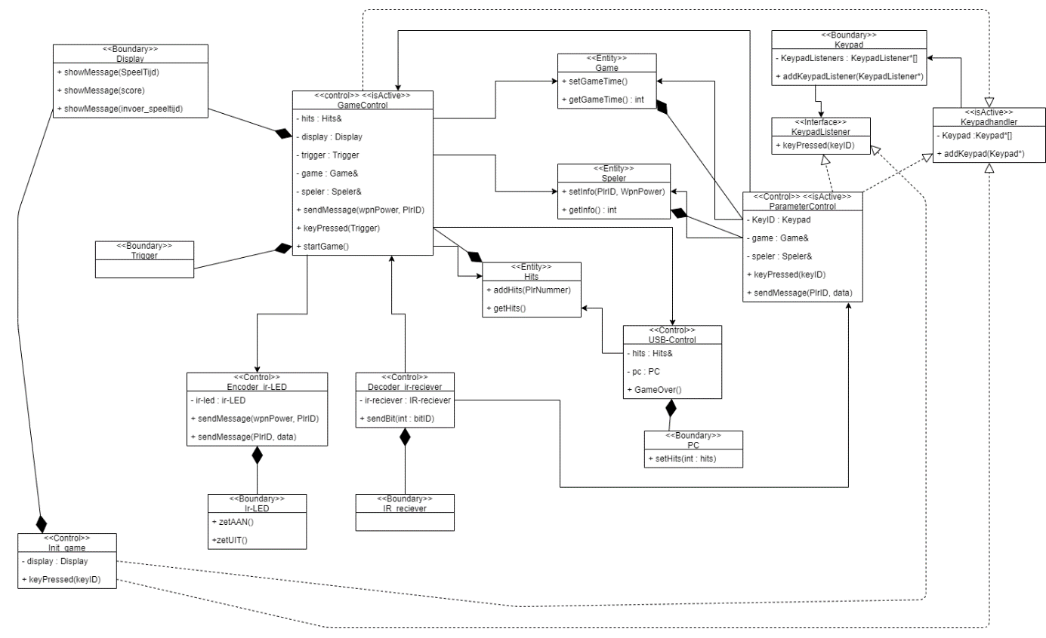

# Taakstructuring

|  |  |  |  |  |
| --- | --- | --- | --- | --- |
| Object | Taaksoort | Periode | Deadline | Prioriteit |
| Keypad | IO, event driven | - | 60ms | 2 |
| Display | IO, Demand driven | - | 200ms | 3 |
| Trigger | IO, Periodical | 50ms | 50ms | 2 |
| PCproxy | IO, Demand driven | - | 500ms | 3 |
| Game | - | - | - | - |
| Speler | - | - | - | - |
| Hits | - | - | - | - |
| Ir-LED | IO, Demand driven | - | 10us | 1 |
| Ir_receiver | IO, Periodiek | 10us | 100us | 1 |
| Encode_ir-LED | Intern, Demand driven | - | 10us | 1 |
| Decoder_ir-receiver | Intern, Periodiek | 10us | 100us | 1 |
| USB-control | Intern, Demand driven | - | 500ms | 4 |
| Init_game | Intern, Demand driven | - | 200ms | 3 |
| parameterControl | Intern, Demand driven | - | 200ms | 3 |
| gameControl | Intern, Demand driven |  | 200ms | 3 |

|  |  |  |  |  |  |
| --- | --- | --- | --- | --- | --- |
| Taak | Objecten | Taaksoort | Periode | Deadline | Prioriteit |
| Keytaak | Keypad | Intern, event driven |  | 60ms | 2 |
| Displaytaak | Display | IO, Demand driven | - | 200ms | 3 |
| Triggertaak | Trigger | IO, Periodical | 50ms | 50ms | 2 |
| Ir-sendtaak | Encode_ir-LED, Ir-LED, | Intern, Demand driven | - | 100us | 1 |
| Ir-recievetaak | Decoder_ir-receiver, Ir-receiver | Intern, Periodiek | 100us | 100us | 1 |
| USB-controltaak | USB-control, PC | Intern, Demand driven | - | 500ms | 4 |
| Init-gametaak | Init_game | Intern, Demand | - | 200ms | 3 |
| parameterControltaak | parameterControl | Intern, Demand | - | 500ms | 4 |
| gameControltaak | gameControl | Intern, Demand driven | - | 200ms | 3 |