2023

2023

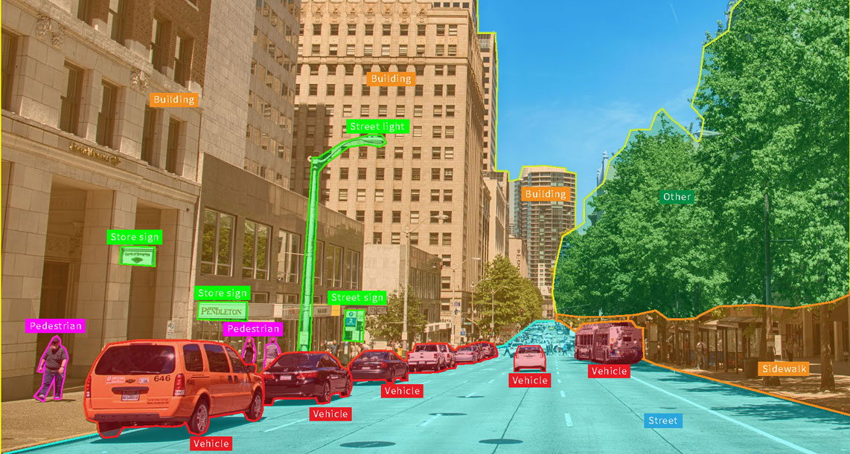

VISN | Eindopdracht

car object detection with custom vgg16-model

Ahmet Serdar Çanak

**Datum**: 28-11-2023

**Cursuscode**: TICT-TV2VISN1-20  
**Naam:** Ahmet Serdar Çanak

**Studierichting**: Technische Informatica

**Specialisatie**: Embedded Systems Engineering

**Studentennummer:** 1760039

Inhoud

Inleiding 2

# Inleiding