ENGINEERING HANDBOOK
Internal Team Design Document
Smart UV-C Sterilization Safety System
Using Multi-Layer Protection Mechanisms
Prepared for: Project Viva | Mentor Review | IEEE Paper | Patent Discussion | Final Presentation | Hackathons
Course: Bio Safety Standards and Ethics (BT242TC)
Department of Computer Science & Engineering
Team: A S Chirag | Parikshith B Bilchode | Ved U

How to Use This Handbook
This handbook explains our entire project from scratch in plain English. You do not need to know embedded systems to read it; every technical word is explained the first time it appears, and every idea comes with a real-world example or analogy.
Important — read this before the viva
This handbook describes a PROPOSED and PROTOTYPED design. Where our paper or report says the system was “fully tested” or achieved “sterilization,” this handbook uses more careful and more defensible language, because that is what an examiner will reward.
Two honesty rules we follow everywhere: (1) We say disinfection (surface, line-of-sight) rather than sterilization unless we have spore-kill data, because they mean different things. (2) We treat the safety interlock as something that must be made fail-safe — we explain both what we built and what a production-grade version needs.
Why this matters: a polished document that repeats every claim word-for-word is easy to attack. A document that already knows its own weak points and explains how to fix them is what wins vivas, reviews, and hackathons. Use the cheat sheets in Section 18 for last-minute revision.

Table of Contents

Section 1 — Project Overview

1.1 What problem are we solving?
Germs — bacteria, viruses, and fungi — live on the things we touch every day: medical tools, lab equipment, phones, door handles. In hospitals and labs, these germs can spread infection. So we need a fast, chemical-free way to clean surfaces.
UV-C light is the cleaner. UV-C is a special kind of invisible light (wavelength 200–280 nanometres). When it hits a germ, it damages the germ’s DNA so the germ can no longer multiply. No chemicals, no scrubbing, no leftover residue.
But UV-C is also dangerous to people. The same light that kills germs also burns human skin and eyes. A few seconds of direct exposure can cause a painful eye injury (like a sunburn on the eyeball). So the device is helpful and hazardous at the same time — exactly like a microwave oven.
The one-sentence problem
Build a low-cost machine that uses UV-C light to clean objects, while making it almost impossible for the light to ever shine on a person.

1.2 Why is safety the biggest problem?
Most cheap UV boxes already clean well. The hard part is not cleaning — it is making sure the light is OFF the instant a person could be exposed. A machine that is dangerous while it runs must switch its danger off automatically. We see this idea every day:
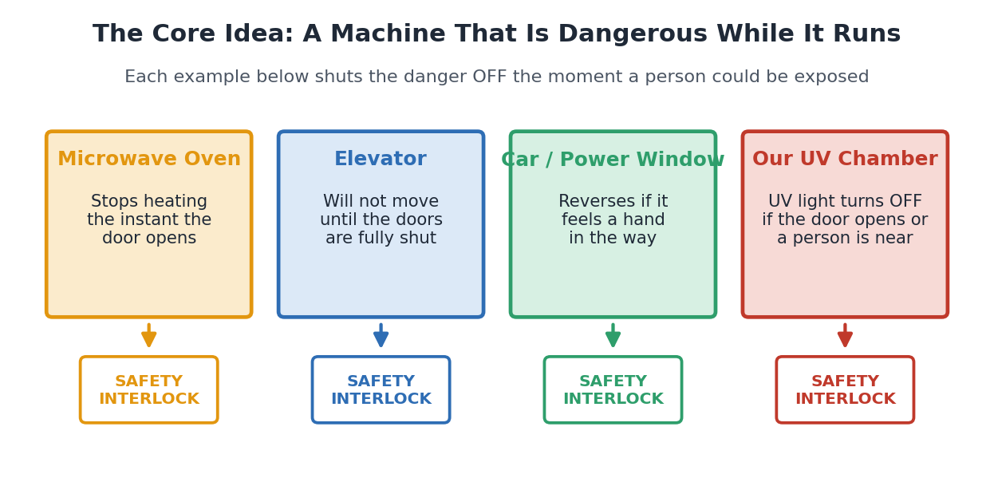
Figure 1. Everyday machines that switch their danger off the moment a person could be exposed. Our UV chamber copies this idea.
- Microwave oven: opens the door → heating stops immediately. You never get microwaved.
- Elevator: will not move until the doors are completely shut.
- Car power window: feels your hand and reverses so it cannot crush fingers.
Our UV chamber follows the same rule: UV light is allowed only when the door is shut and no person is nearby, and it shuts off instantly if anything changes.

1.3 Why are existing systems not enough?
Looking at existing low-cost UV products and research prototypes, we found a common weakness: most rely on a single safety feature — just a timer, or just one motion sensor. If that one feature fails or is bypassed, a person can be exposed. The expensive hospital robots are safer but cost lakhs of rupees, which puts them out of reach of small clinics, schools, and labs.
Our answer: stack several independent safety checks on top of each other (“multi-layer”), so that no single failure can expose a person, and keep the whole thing cheap by using common parts.

Section 2 — Complete System Architecture
The system has three kinds of parts: things that sense the world (inputs), one brain that decides (the controller), and things that act (outputs). Power feeds them all.
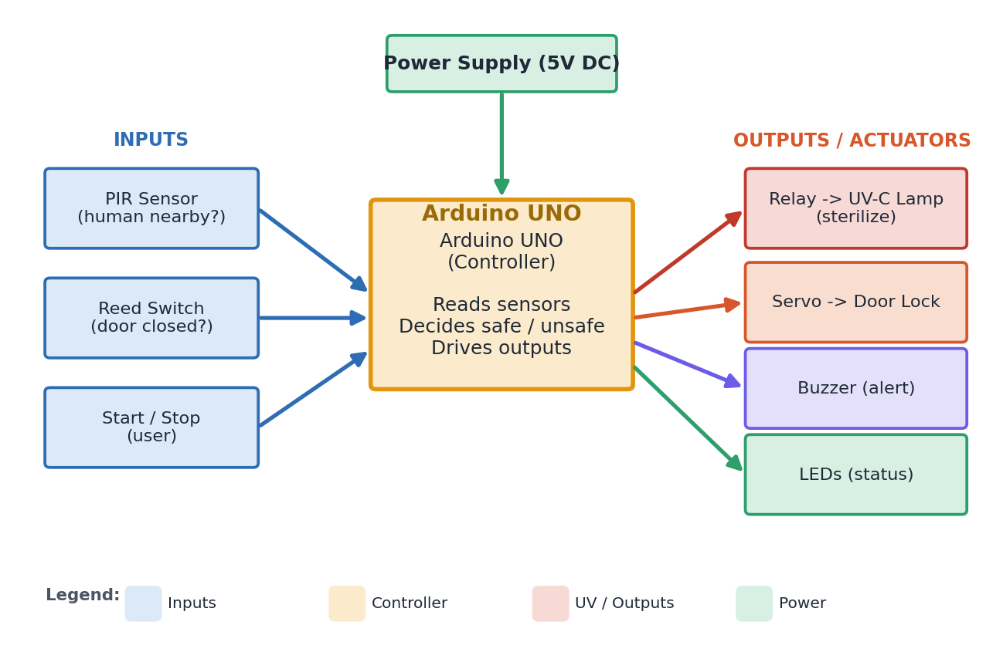
Figure 2. System architecture. Sensors feed the Arduino; the Arduino decides; actuators carry out the decision.

2.1 What goes in, what comes out, what is decided
Block | Type | Plain-English job
Power Supply (5V DC) | Power | Gives every part the energy it needs.
PIR Sensor | Input | “Is a person moving nearby?” Yes/No.
Reed Switch | Input | “Is the door fully closed?” Yes/No.
Start / Stop button | Input | The user’s command to begin or halt.
Arduino UNO | Controller | Reads inputs, checks safety rules, decides safe/unsafe, drives outputs.
Relay | Output | A switch the tiny Arduino uses to control the high-voltage UV lamp safely.
UV-C Lamp | Output | The actual germ-killing light.
Servo Motor | Output | Physically locks/unlocks the chamber door.
Buzzer | Output | Audible warning before and during UV.
LEDs | Output | Colour status: ready, running, done, emergency.
Table 1. Every block of the architecture and its job.
Analogy
Think of a car. The sensors are your eyes and ears, the Arduino is your brain, the relay/servo are your hands and feet, and the UV lamp is the engine. The brain only lets the engine run when it is safe to drive.

Section 3 — Multi-Layer Safety Framework
“Multi-layer” means several independent safety checks stacked together. UV runs only if every layer agrees it is safe. If even one layer says “unsafe,” UV stays off. This is the heart of our project.
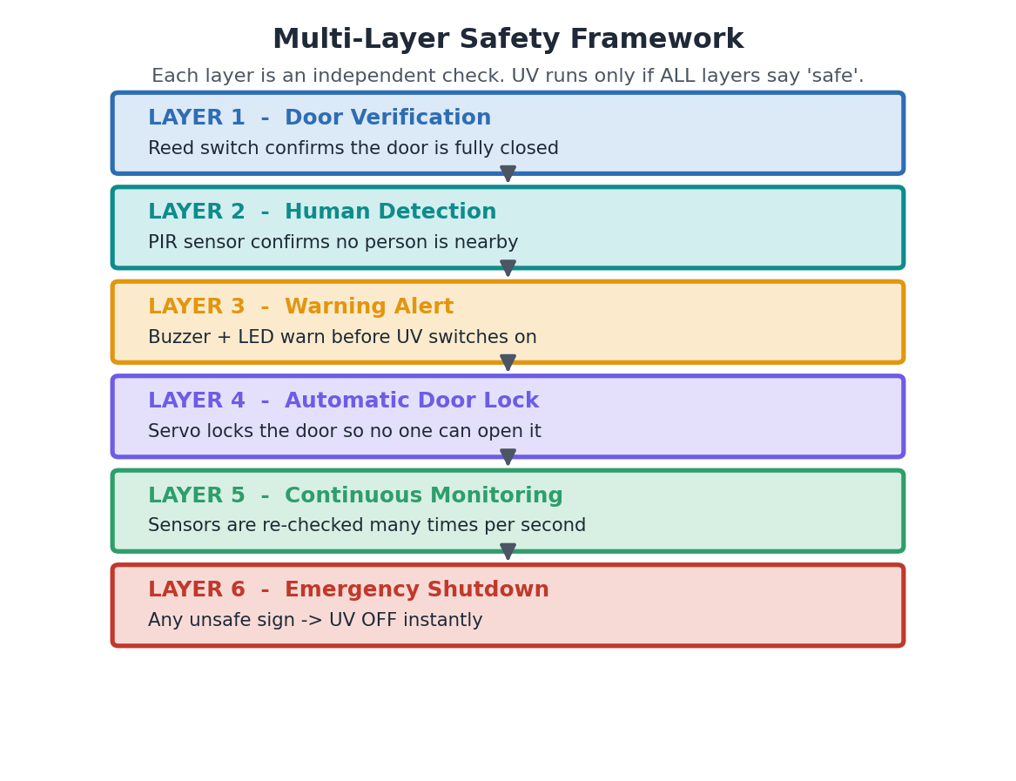
Figure 3. The six safety layers. Each is an independent check; all must pass before UV can run.

Layer 1 — Door Verification
Purpose | Why needed | How it works | Everyday example | If this layer is missing
Make sure the chamber is closed before any UV. | If the door is open, light could leak out onto people. | A reed switch (a magnet-operated contact) closes only when the door magnet is lined up. Door open → contact open → Arduino knows. | Same as a fridge: the inside light is tied to the door. | Without it, UV could fire with the door open and burn a bystander.

Layer 2 — Human Detection
Purpose | Why needed | How it works | Everyday example | If this layer is missing
Make sure no person is near the chamber. | People standing close could be exposed to stray or leaked light. | A PIR sensor detects the body heat of a moving person and reports “someone is here.” | Like the automatic light in a corridor that turns on when you walk past. | Without it, UV could start while someone is leaning over the chamber.

Layer 3 — Warning Alert
Purpose | Why needed | How it works | Everyday example | If this layer is missing
Give people a few seconds’ notice before UV switches on. | Sudden, silent UV is dangerous; a warning lets people step back. | Buzzer beeps and a red LED flashes for a short countdown before the lamp lights. | Like a reversing truck that beeps before it moves. | Without it, UV starts with no notice and someone may not realise.

Layer 4 — Automatic Door Lock
Purpose | Why needed | How it works | Everyday example | If this layer is missing
Stop anyone from opening the door while UV is on. | A curious user could open the chamber mid-cycle and look inside. | A servo motor turns a latch to lock the door before the lamp lights. | Like an aeroplane lavatory that locks the door when occupied. | Without it, a person can open the door during UV and get exposed.

Layer 5 — Continuous Monitoring
Purpose | Why needed | How it works | Everyday example | If this layer is missing
Keep checking safety many times every second — not just once at the start. | Conditions change: a door can pop open, a person can walk up after UV starts. | The Arduino re-reads all sensors in a fast loop the whole time UV is on. | Like a lifeguard who keeps watching the pool, not just glances once. | Without it, the system is “blind” after starting and cannot react to new danger.

Layer 6 — Emergency Shutdown
Purpose | Why needed | How it works | Everyday example | If this layer is missing
Cut UV instantly the moment anything looks unsafe. | When danger appears, even one second of delay can injure someone. | Any unsafe reading → relay opens → UV OFF, alarm ON, door unlocks when safe. | Like a treadmill’s red emergency cord that stops it at once. | Without it, the system might detect danger but fail to act on it.

Key safety principle
Layers are independent on purpose. One sensor failing should never expose a person, because the other layers still guard the danger. This is called defence in depth.

Section 4 — Component Explanation
Here we open up every part and explain it as if you had never seen it before.
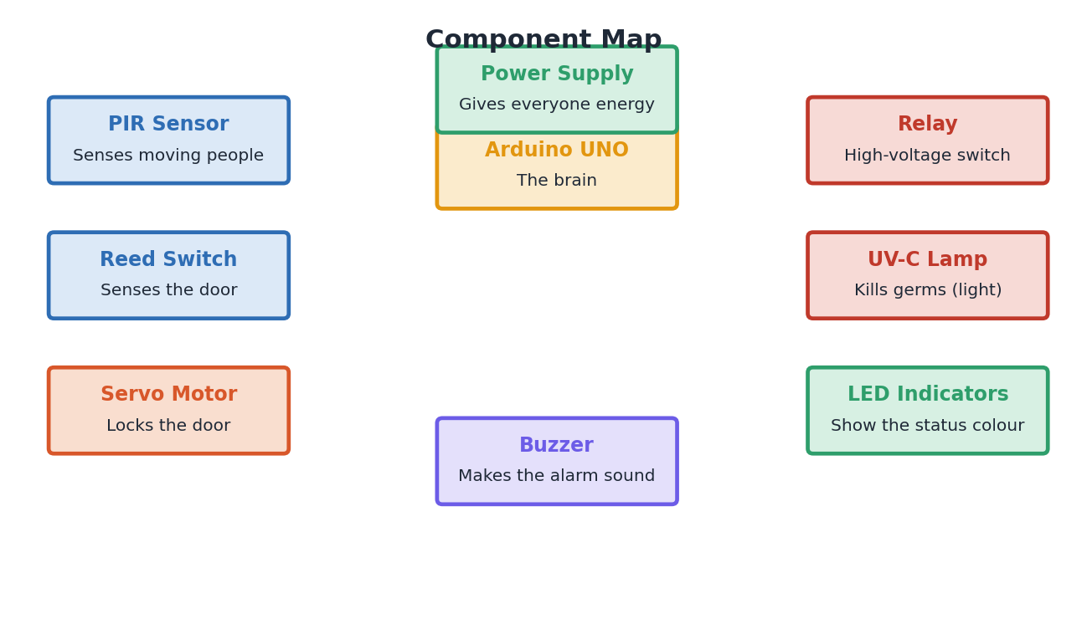
Figure 4. Component map — what each part is, at a glance.

Arduino UNO
Property | Detail
What it is | A small, cheap programmable circuit board — a tiny computer.
Why we use it | It is the brain: it reads sensors and decides what to do. Easy to program, lots of help online.
Input | Signals from PIR, reed switch, button.
Output | On/off commands to relay, servo, buzzer, LEDs.
Advantages | Cheap, simple, huge community, plenty of pins.
Limitations | Weak for heavy maths/AI; only basic safety on its own.
Real-world uses | Robotics kits, school projects, simple automation.
Simple analogy | The brain of the body.

PIR Sensor
Property | Detail
What it is | “Passive Infra-Red” sensor that detects the heat of a moving person.
Why we use it | To know if a human is near the chamber.
Input | Invisible body-heat changes.
Output | A simple HIGH/LOW “motion / no motion” signal.
Advantages | Very cheap, low power, easy.
Limitations | Misses a person standing perfectly still; can false-trigger on heat/sun.
Real-world uses | Corridor lights, burglar alarms, automatic doors.
Simple analogy | A motion-activated security light.

Reed Switch
Property | Detail
What it is | Two thin metal contacts in a glass tube that close when a magnet is near.
Why we use it | To check the door is fully shut.
Input | Nearness of the door magnet.
Output | “Closed / open” signal.
Advantages | Tiny, cheap, reliable, no power to sense.
Limitations | Can be fooled by any stray magnet; only senses position, not a real lock.
Real-world uses | Fridge doors, laptops, window alarms.
Simple analogy | The little switch that turns off your fridge light.

Relay
Property | Detail
What it is | An electrically-controlled switch that lets a small signal control a big load.
Why we use it | The Arduino is too weak to switch a mains UV lamp directly and safely.
Input | A small 5V control signal.
Output | Switches the high-voltage lamp circuit on/off.
Advantages | Isolates low and high voltage; simple.
Limitations | Mechanical contacts can wear out or weld shut.
Real-world uses | Home automation, appliances, industrial control.
Simple analogy | A light switch operated by a robot finger.

Servo Motor
Property | Detail
What it is | A small motor that turns to an exact angle on command.
Why we use it | To physically lock and unlock the door latch.
Input | An angle command from the Arduino.
Output | Precise rotation that moves the latch.
Advantages | Cheap, precise, easy to control.
Limitations | Hobby servos are weak and can be forced open; not a security lock.
Real-world uses | RC cars, robot arms, camera gimbals.
Simple analogy | A robot wrist that turns a key.

UV-C Lamp
Property | Detail
What it is | A lamp that emits germicidal ultraviolet light.
Why we use it | It is the actual cleaning tool.
Input | Electrical power via the relay.
Output | Germ-killing UV-C light (and heat).
Advantages | Chemical-free, fast surface cleaning.
Limitations | Dangerous to eyes/skin; only cleans line-of-sight; ages over time; mercury type can make ozone.
Real-world uses | Hospital chambers, water/air purifiers.
Simple analogy | Sunlight strong enough to sterilise — but only where it can reach.

LED Indicators
Property | Detail
What it is | Small coloured lights.
Why we use it | To show the system’s state at a glance.
Input | On/off signals from Arduino.
Output | Visible colour (e.g., green=ready, red=danger).
Advantages | Cheap, instant, intuitive.
Limitations | Only useful if someone is looking.
Real-world uses | Every electronic device.
Simple analogy | A traffic light for the machine.

Buzzer
Property | Detail
What it is | A small part that makes a beep.
Why we use it | To warn people by sound.
Input | On/off signal from Arduino.
Output | Audible beep/alarm.
Advantages | Cheap, attention-grabbing.
Limitations | Can be ignored in noisy rooms.
Real-world uses | Microwaves, alarms, reversing vehicles.
Simple analogy | A doorbell for danger.

Power Supply (5V DC)
Property | Detail
What it is | Converts wall power into safe low voltage for the electronics.
Why we use it | Everything needs clean, steady power.
Input | Mains AC.
Output | Steady 5V DC.
Advantages | Standard, reliable.
Limitations | If it fails, the system must fail to a safe state.
Real-world uses | Phone chargers, all electronics.
Simple analogy | The heart pumping energy to the body.

Section 5 — Complete Project Workflow
This is the full step-by-step story of one cleaning cycle, drawn as a flowchart. A flowchart is just a map of decisions: rectangles are actions, diamonds are yes/no questions.
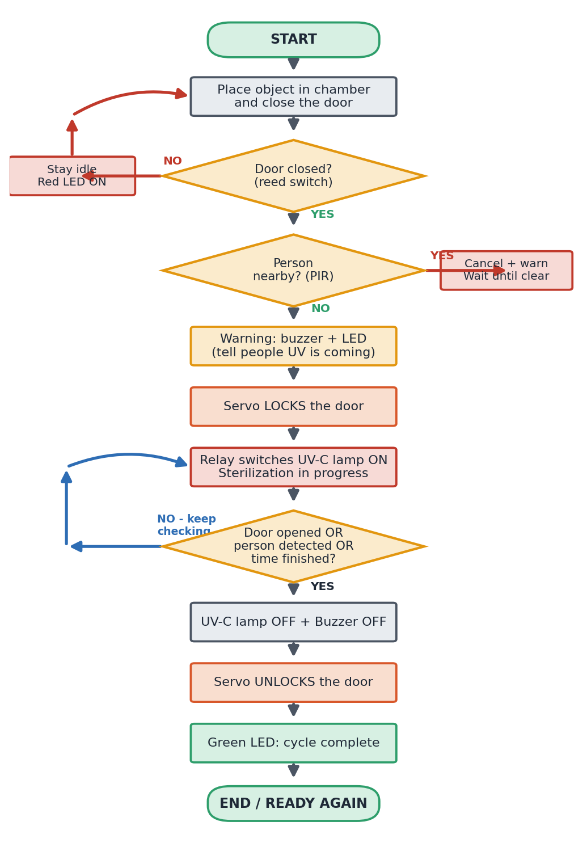
Figure 5. Complete workflow of one sterilization cycle, including the continuous-monitoring loop.

5.1 Step-by-step
- Object placed & door closed: the user loads items and shuts the door.
- Door verification: if the reed switch says “open,” the system stays idle with a red LED. UV never starts.
- Human detection: if the PIR senses someone, the cycle is cancelled and waits until clear.
- Warning: buzzer and LED announce that UV is about to begin.
- Door locking: the servo locks the door so nobody can open it mid-cycle.
- UV activation: the relay switches the lamp ON and cleaning begins.
- Continuous monitoring: while UV is on, the Arduino keeps re-checking the door and PIR (the loop on the left of the chart).
- Emergency shutdown: door opens or a person appears → UV OFF instantly, alarm on.
- Completion: when the set time/dose is reached safely, UV OFF, door unlocks, green LED shows “done.”

Section 6 — How the Code “Thinks” (no code shown)
You do not need to read code to understand the logic. The Arduino runs the same short routine over and over, extremely fast. Here are the only ideas you need:
Programming idea | Plain meaning | In our project
loop() | “Do this again and again, forever.” | Re-check all sensors continuously.
if ( ) … else | “If this is true do A, otherwise do B.” | If door open → keep UV off; else continue.
condition | A yes/no question. | “Is a person nearby?”
timer | A stopwatch the code watches. | Run UV for the needed time/dose, then stop.
state machine | The system is always in exactly one named “state” and moves between them by rules. | IDLE → CHECKING → WARNING/LOCK → STERILIZING → SHUTDOWN/DONE.
Table 17. The five coding ideas behind the whole system.
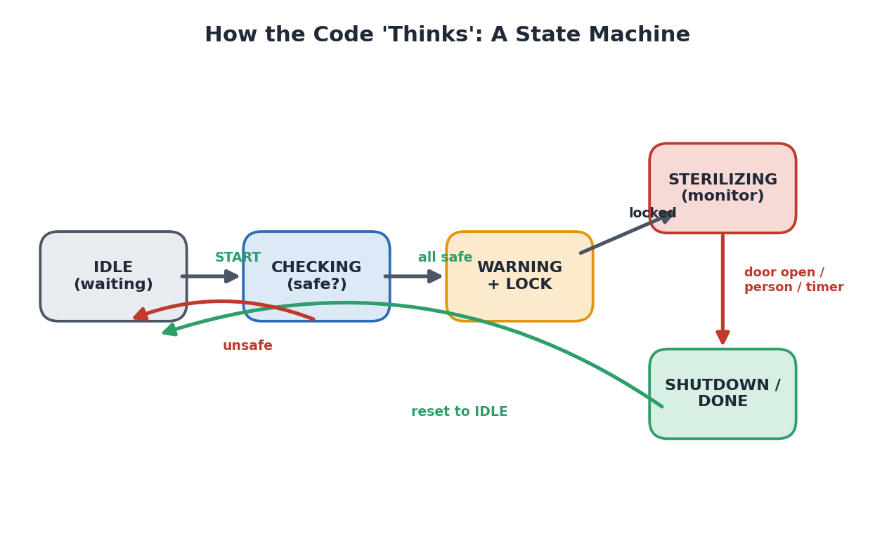
Figure 6. The control logic as a state machine. The system is always in one state and follows arrows when conditions are met.
Why a state machine?
It makes behaviour predictable and safe: from any state there is a defined, tested path to the safe state. There is no “undefined” situation where UV could be left on by accident — provided the default state is always the safe one (UV off).

Section 7 — Why Every Component Exists
The fastest way to prove a part is necessary is to imagine removing it and see what breaks.
Remove this… | …and this happens | Severity
PIR sensor | System can’t tell if a person is nearby → UV could start next to someone. | High
Reed switch | System can’t tell if the door is open → UV could leak onto people. | High
Relay | Arduino can’t switch the mains lamp safely → no controlled UV at all (and a fire/shock risk if bypassed). | High
Servo (lock) | Door can be opened during UV → mid-cycle exposure. | Medium
Buzzer | No audible warning → people get no notice before UV. | Medium
LEDs | No visible status → user can’t tell what the machine is doing. | Low
Table 18. Removing any component degrades safety or function.

Section 8 — Why Our Project Is Different
Honest comparison. We are not the most advanced — we are the safest design at the lowest price for small users. We also state where rivals beat us, because an examiner will ask.
System | What it does | What we add | Honest verdict
Normal UV box (consumer) | Timer + lamp, often no interlock at all. | Several independent safety layers + emergency stop. | We are clearly safer.
Commercial UV chamber | Door interlock + timer, certified. | Same safety idea, lower cost. | They have certification we lack; we win on price.
Hospital UV robot | Mobile, room-scale, validated, very expensive. | A fixed low-cost chamber for small users. | Different category, not a true rival.
IoT sterilizer | Cloud logging, app alerts. | We only propose IoT as future work. | They are ahead on connectivity.
AI sterilizer | Camera-based people detection, adaptive dose. | We use a simple PIR. | They are ahead on sensing.
Far-UV-C system | 222 nm light claimed safe around people. | We must exclude people entirely. | They beat us on the very axis we focus on — we must address this.
Table 19. Where we win, and where we honestly do not.
Viva-ready framing
Our niche is the low-cost, unoccupied, small-chamber segment — clinics, labs, schools — where we deliver layered safety at a price the expensive validated systems cannot match. Far-UV-C and AI systems target different, higher-cost segments.

Section 9 — The Research Gap
Research papers in this area fall into a few groups. Each group solves part of the problem but leaves a gap.
Research group | What they do well | What they miss
UV-C sterilization devices | Prove UV-C kills germs effectively. | Focus on cleaning power, weak on human safety.
Robotic UV systems | Move around rooms, cover large areas. | Expensive; safety often limited; not for small users.
Occupancy / human safety | Switch UV off when a person is detected. | Usually only ONE safety mechanism.
UV dose / monitoring | Measure how much UV is delivered. | Often need costly sensor networks; rarely combined with full interlocks.

The gap we target: no single low-cost embedded system combines door verification + human detection + warning + auto-lock + continuous monitoring + emergency shutdown together. Most have one or two of these. We integrate all six cheaply.
Be honest about the gap
“Integrating known safety features into one cheap box” is a useful systems contribution, but on its own it is not a scientific breakthrough. To make the gap strong, we must add something measured — a fail-safe interlock that is proven to fail to the safe state, or measured germ-kill data. See Sections 10, 11 and 14.

Section 10 — Failure Analysis (FMEA)
FMEA = Failure Modes and Effects Analysis. It is a simple, professional habit: list everything that can break, what it causes, and how we stop it from hurting anyone. The matrix below shows which failures are most dangerous.
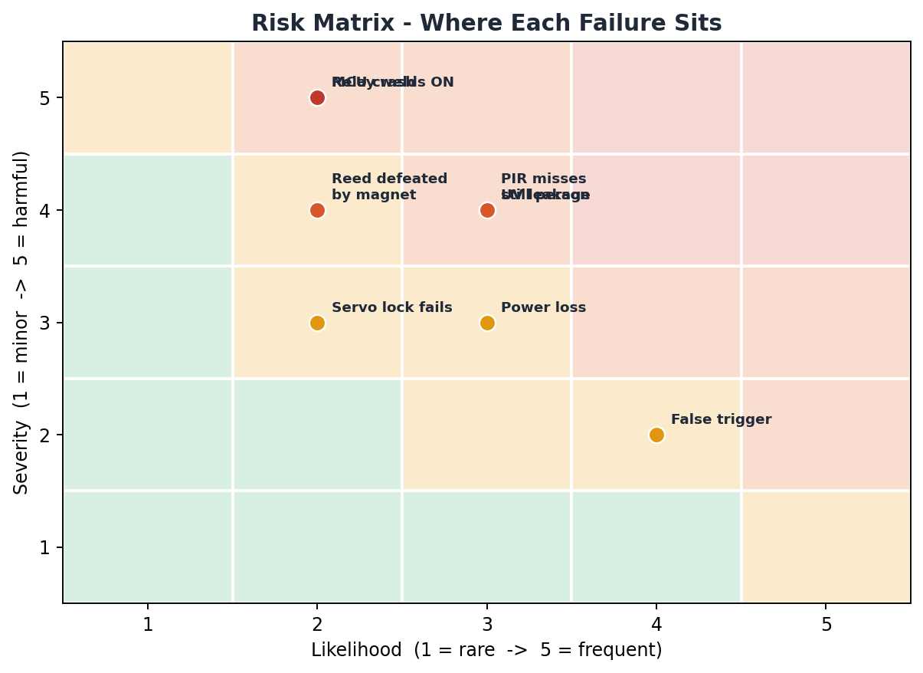
Figure 7. Risk matrix. Red zone = dangerous failures that must be designed out. The most dangerous ones leave UV ON.
Failure | Cause | Effect | Fix / mitigation | Severity
Relay welds closed | Arcing/aging — most common dangerous fault | UV stays ON after “off” command | Second relay in series + weld-detection; fuse | Critical
MCU (Arduino) crashes | Bug, brown-out | Outputs latch → UV may stay ON | Hardware watchdog forces UV OFF; safe default | Critical
PIR misses still person | PIR only senses motion | Person present but undetected | Add radar/thermal presence sensing | High
Reed switch defeated | Stray magnet held near switch | Door reads “closed” while open | Coded/RFID interlock (ISO 14119) | High
UV leakage | Gasket gap, viewport, vents | Slow operator exposure | Light-tight seals; measure leakage vs limits | High
Servo lock fails | Weak hobby servo, power loss | Door opens during UV | Real guard-locking device; lock holds without power | Medium
Power failure | Mains loss | Ambiguous state mid-cycle | Define safe power-loss state: lamp off, door safe | Medium
False PIR trigger | Sun, heat, drafts | Nuisance stops → user disables safety | Better sensing; make interlock non-defeatable | Medium
Animal enters area | Pet/pest near chamber | Undetected presence or exposure | Presence sensing for small bodies; sealed enclosure | Low
Human error | Wrong loading, forced door | Reduced cleaning or exposure attempt | Clear signage, training, lockout design | Medium
Table 21. FMEA of the main failure modes. Notice how many dangerous faults leave UV ON — that is why fail-safe design matters.
The pattern to notice
Almost every dangerous failure leaves the UV lamp ON or a person exposed. That is the single most important thing to fix — see the fail-safe design in Section 14/15.

Section 11 — Safety Standards (in plain words)
Standards are agreed rule-books that make products safe and trusted. You do not memorise them — you know what each one is for. These are the ones an examiner expects you to name.
Standard / body | What it covers | Why it matters to us
IEC 62471 | Photobiological safety of lamps — how much UV/light a lamp may safely emit; “risk groups.” | Tells us how to classify and contain our UV lamp.
IEC 60335 | Safety of household electrical appliances. | If we sell to homes/clinics, the box must meet this.
ISO 14119 | Interlocking devices for guards (e.g., door locks that stop a machine). | Our door interlock should follow this; a bare reed switch is too easy to defeat.
ISO 13849-1 | Safety-related parts of control systems; “Performance Level.” | How to prove our safety logic is reliable enough.
ACGIH / ICNIRP limits | Maximum safe human UV exposure over a work shift. | The number our leakage must stay below.
FDA | US medical-device rules (classification, clearance). | Needed only if marketed for medical use in the US.
WHO / ICMR | Health-authority guidance on disinfection & infection control. | Frames where and how UV disinfection should be used.
Biosafety (BSL levels) | Lab containment levels and safe handling of biological hazards. | The course context: our device assists, but does not replace, lab biosafety practice.
Table 22. Key standards and why each one matters.
Disinfection vs sterilization (say this correctly!)
Sterilization = kill everything, including tough spores. Disinfection = kill most germs on a surface. UV-C reaches only line-of-sight surfaces and struggles with spores and shadows, so what we really provide is surface disinfection. Using the right word protects you in viva.

Section 12 — User Personas
Who actually uses and buys this? Below are realistic users, strongest first. We lead with clinics and labs — real buyers with a real unmet need at our price.
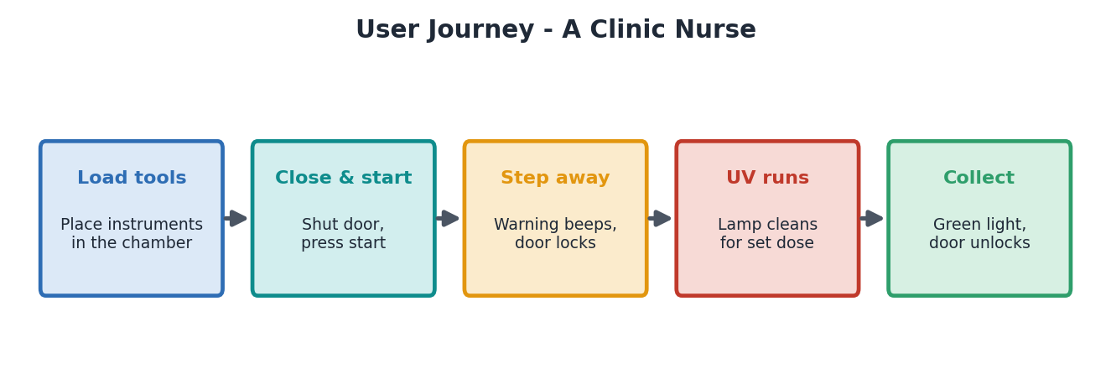
Figure 8. A typical user journey: a clinic nurse running one cleaning cycle.
User | Their problem | Why they’d buy ours | Fit
Small / dental clinics | Heat-sensitive tools an autoclave can’t take; no budget for big systems. | Cheap, chemical-free, safe by design. | Strong
Labs (BSL-1/2) | Quick surface decon between autoclave runs. | Low-cost, layered safety. | Strong
Schools / colleges | Shared equipment, tight budgets. | Cheapest credible safe option. | Good
Veterinary clinics | Small tools, no autoclave. | Affordable chemical-free cleaning. | Good
Electronics / pharma | Items that must stay dry/residue-free. | No moisture, no chemicals. | Moderate
Hotels / libraries | Disinfect high-touch shared items. | Branded “clean” signal. | Weak (saturated)
Households | Phones, keys, masks. | Peace of mind. | Weak (commodity)
Table 23. Target users, honestly ranked by fit.

Section 13 — Commercialization
How a real product would be made, sold, and supported.
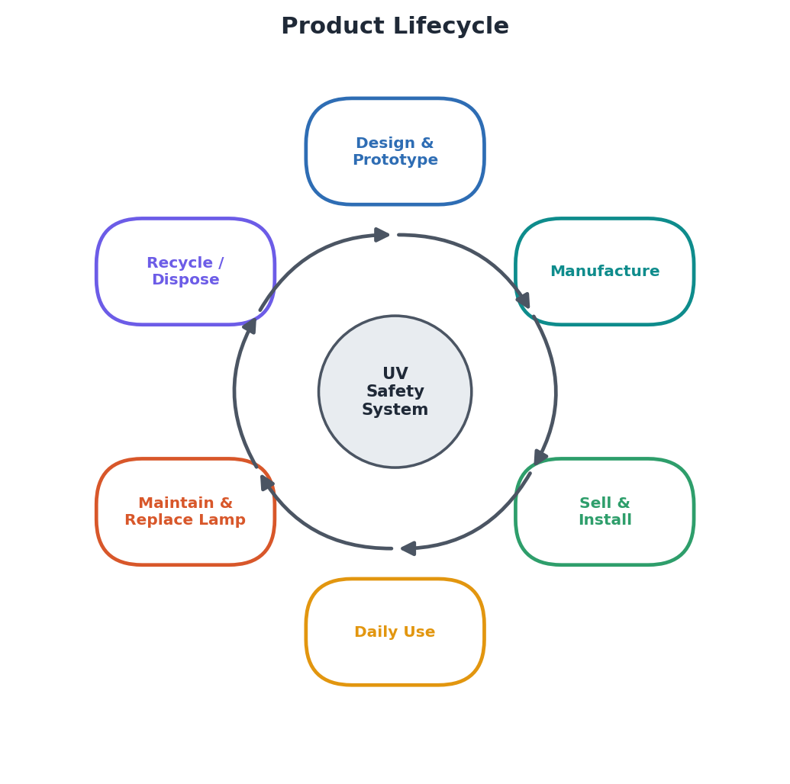
Figure 9. Product lifecycle, from design to recycling.
Stage | What happens | Rough cost / note
Manufacturing (parts) | Hobby build vs certifiable build differ a lot. | ≈ ₹1,500–3,000 (hobby) vs ₹6,000–12,000 (certifiable)
Selling price | Consumer race-to-bottom vs validated clinical. | ₹1,500–5,000 (consumer) vs ₹15,000–40,000 (validated)
Installation | Plug-in chamber; minimal setup. | Low — a key selling point.
Maintenance | Clean optics, check interlocks. | Periodic, low effort.
Lamp replacement | UV lamps lose output and must be replaced. | Recurring revenue (razor-and-blades model).
Annual maintenance | Calibration + lamp + checks. | Service contract opportunity.

Where the money really is
Margins are healthy ONLY in the validated clinical/lab segment, and that requires the safety + efficacy proof from Sections 10, 11 and 14. In the consumer segment we would be competing on price alone, which is a losing game. The business case depends on doing the engineering properly.

Section 14 — Patent Analysis
A patent protects something new and non-obvious. We must be honest: combining well-known safety parts is usually considered obvious, and door-interlocked UV cabinets already exist. So the basic system as-is is hard to patent.

14.1 Weaknesses in our novelty
- Door interlocks + occupancy cutoff on UV chambers are decades-old prior art.
- Putting several known safety features together is an “obvious combination.”
- Without dose/kill measurements we cannot even show the device performs as claimed.

14.2 Where real, patentable novelty could come from
Pick one or two of these, build them, and measure them — one genuine, working idea beats twenty shallow ones:
- Software-independent fail-safe interlock: a circuit where UV cannot energise unless two independent safety channels agree, and the Arduino can only ever CUT power, never supply it.
- Low-cost delivered-dose verification: a single UV photodiode plus a lamp-aging model that stops the cycle at the correct dose, compensating for an aging lamp.
- Relay-weld detection: a cheap way to detect the most dangerous fault (UV stuck ON) and cut a backup path.
- Defeat-resistant door interlock: a coded actuator that a stray magnet cannot fool — still at hobby budget.
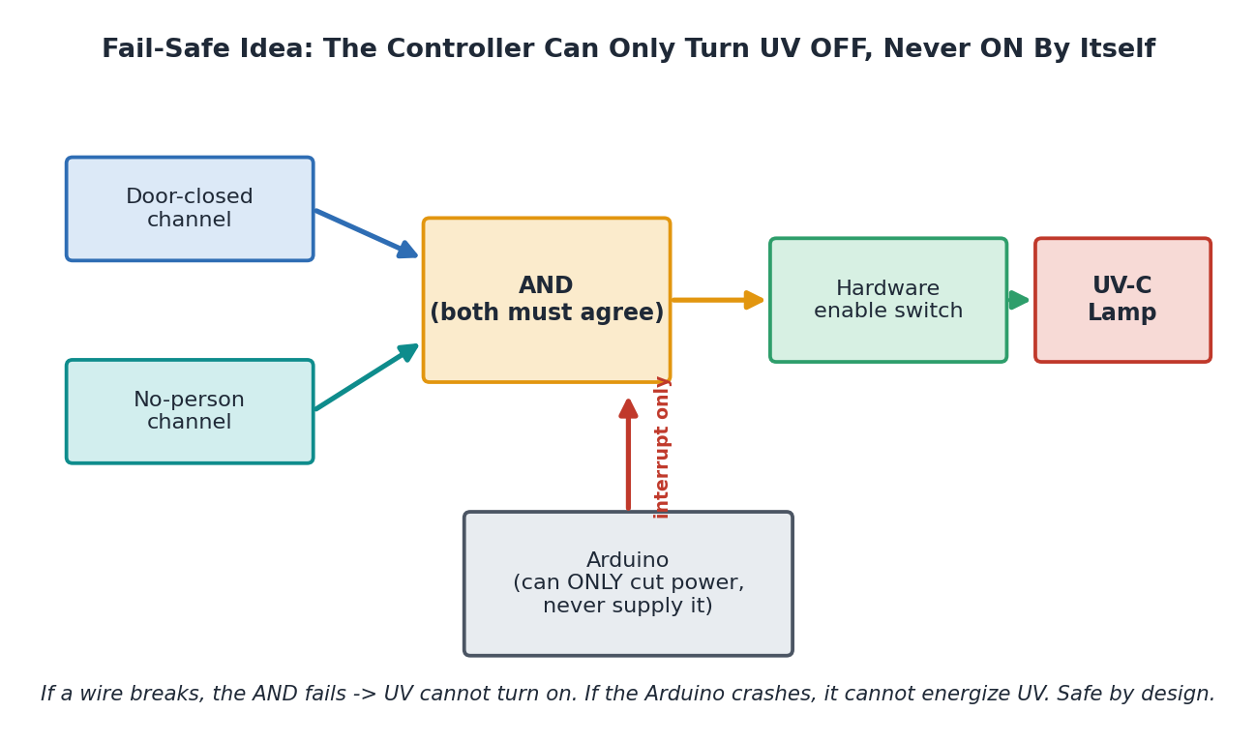
Figure 10. The strongest novelty idea: a fail-safe interlock where the controller can only turn UV OFF, never ON by itself.

Section 15 — Future Improvements & Roadmap
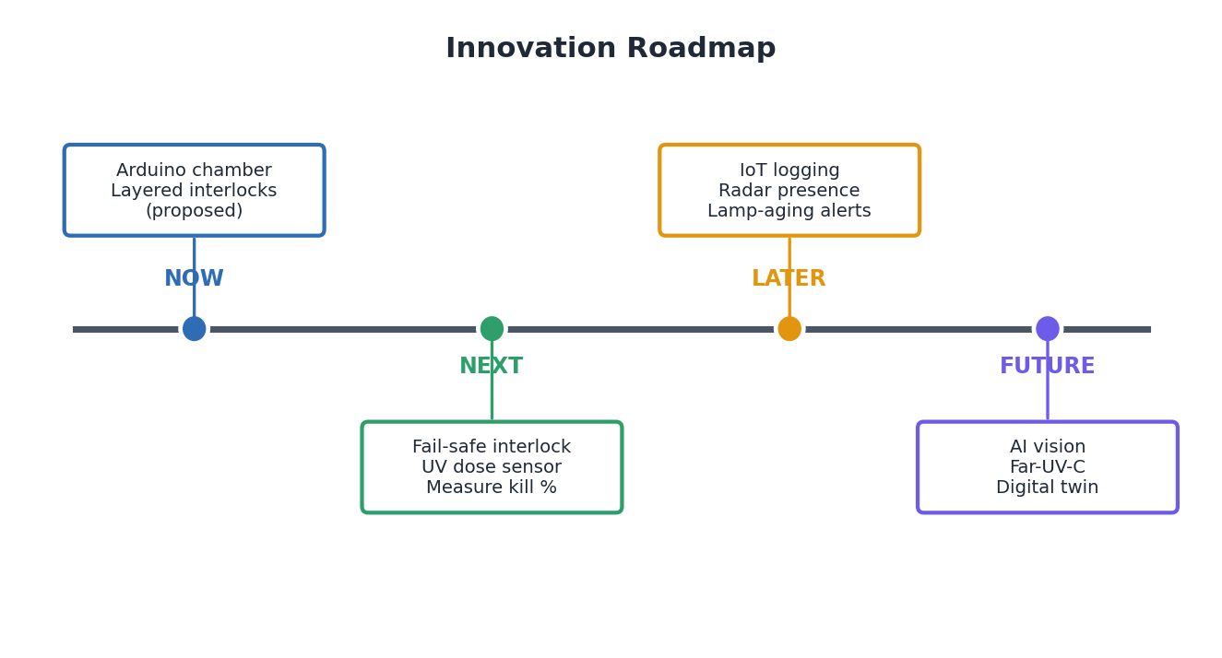
Figure 11. Innovation roadmap, from today’s proposed chamber to future intelligent systems.
Upgrade | What it adds | Why it matters
Fail-safe interlock | UV physically can’t fire unsafely. | Turns “claimed safe” into “provably safe.”
UV dose monitoring | Stop at correct dose, not fixed time. | Handles lamp aging; proves cleaning worked.
Radar presence sensing | Detects still people PIR misses. | Closes the biggest safety gap.
AI object/people detection | Smarter, fewer false alarms. | Better safety + adaptive dosing.
Thermal camera | Sees body heat directly. | Reliable human detection.
IoT + Cloud | Cycle logs, alerts, audit trail. | Compliance value for clinics.
Predictive maintenance | “Replace lamp soon” alerts. | Prevents silent under-dosing.
Far-UV-C (222 nm) | Potentially safe around people. | Could relax the “no people” rule.
Adaptive sterilization | Dose chosen per germ/load. | Saves energy and lamp life.
Digital twin | A live virtual copy for testing. | Test failures safely in software.
Table 25. The upgrade path. The first two rows are the highest-value, lowest-cost steps.
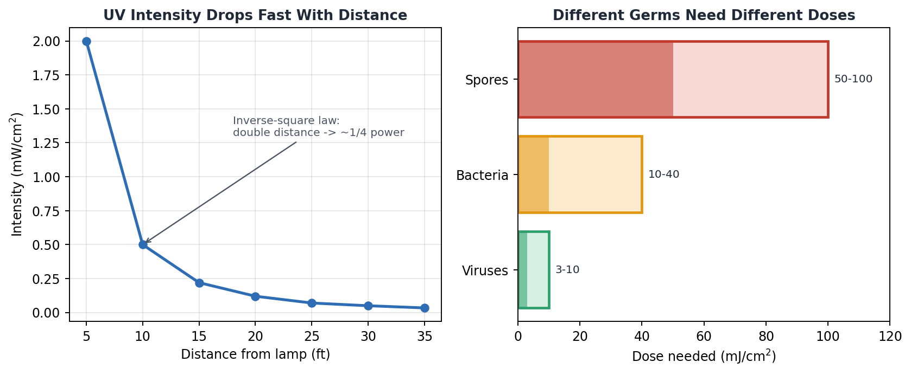
Figure 12. Two facts that drive future dosing work: UV weakens fast with distance, and different germs need different doses.

Section 16 — Viva Preparation
A focused set of the questions most likely to decide your viva, with simple, honest answers. These cover the basics, the tricky design choices, and the weak points examiners probe. (We have prioritised the highest-value questions over sheer quantity — ask the team lead if you want the list expanded further.)
Q1. What is UV-C and why does it clean?
A. Invisible light at 200–280 nm. It damages a germ’s DNA so it can’t multiply — no chemicals needed.
Q2. Is this sterilization or disinfection?
A. Honestly, surface disinfection. UV-C only reaches line-of-sight surfaces and struggles with spores and shadows. True sterilization kills everything including spores.
Q3. Did you build it or propose it?
A. Be straight: it is a proposed and prototyped design. Where our paper says “tested,” we mean the control logic was demonstrated; we have not yet measured germ kill. Do not claim more than you measured.
Q4. What UV dose does your chamber deliver?
A. We have not measured it yet. The correct way is irradiance (mW/cm²) × time = dose (mJ/cm²). Measuring this is our top next step.
Q5. What log reduction did you achieve?
A. None measured yet. To prove cleaning we’d run a plate-count test against an organism like E. coli or B. subtilis and report log₁₀ reduction.
Q6. Why multiple safety layers instead of one?
A. So no single failure exposes a person. If one sensor fails, the others still guard the danger. This is called defence in depth.
Q7. If the Arduino crashes mid-cycle, what happens to the lamp?
A. In the basic build it could stay on — a real weakness. The fix is a hardware watchdog that forces UV OFF, and a design where the Arduino can only cut power, never supply it.
Q8. Your relay welds shut. Then what?
A. UV stays ON — the most dangerous fault. Fix: a second relay in series plus weld detection, and a fuse.
Q9. Why PIR? It misses a still person.
A. PIR is cheap and detects movement, but yes, it misses a motionless person. The proper upgrade is radar or thermal sensing. We state this as a known limitation.
Q10. For a closed chamber, why do you even need PIR?
A. Sharp question. In a sealed chamber the real hazard is leakage, not bystanders, so PIR matters most for the room-scale version and as a backup. Be ready to say this.
Q11. Someone holds a fridge magnet to your reed switch — problem?
A. Yes: the door could read “closed” while open. A coded interlock (ISO 14119) cannot be fooled this way.
Q12. Which safety standards apply?
A. IEC 62471 (lamp UV safety), IEC 60335 (appliance safety), ISO 14119 (interlocks), ISO 13849-1 (safety control reliability), ACGIH/ICNIRP exposure limits.
Q13. Does your lamp make ozone? Is that bad?
A. A normal 254 nm mercury lamp can emit some 185 nm light that makes ozone, which is a breathing hazard. Use an ozone-free lamp or ventilation.
Q14. What about the mercury in the lamp?
A. If it breaks, mercury is toxic and must be contained and disposed of safely. A UV-C LED version removes mercury and ozone — a clean upgrade.
Q15. UV-C can’t reach shadows. How is the back of an object cleaned?
A. It isn’t, directly. Rotation, reflectors, or repositioning reduce shadows but can’t fully remove them. We state this honestly.
Q16. How does a fixed timer cope with an aging lamp?
A. Badly — an old lamp is weaker, so the same time gives less dose and may under-clean. A dose sensor + lamp-hour tracking fixes this.
Q17. What is truly novel here?
A. Be honest: it’s the integration of six safety features cheaply. For real novelty we’d build the fail-safe interlock or the low-cost dose-loop and measure them.
Q18. Why is the relay necessary?
A. The Arduino outputs tiny 5V signals and cannot safely switch a mains UV lamp. The relay isolates low and high voltage and switches the lamp.
Q19. Why a servo for the lock?
A. It turns to an exact angle to move a latch. But a hobby servo is weak — a production unit needs a proper guard-locking device.
Q20. What is a state machine and why use it?
A. The system is always in one named state (idle, checking, sterilizing…) and moves by rules. It makes behaviour predictable and gives a tested path to the safe state from anywhere.
Q21. What is the safe default state?
A. UV OFF. Any uncertainty, fault, or power loss must end with UV off and the door safe.
Q22. What is FMEA and why did you do one?
A. Failure Modes and Effects Analysis — listing what can break, its effect, and the fix. It shows we engineered for failure, not just success.
Q23. Far-UV-C is safe around people — doesn’t that beat you?
A. On the safety axis, partly yes. But Far-UV-C lamps cost more and their standards are still emerging. We target the low-cost unoccupied-chamber niche.
Q24. Why not just use chemicals?
A. Chemicals leave residue, take time, need handling, and can damage sensitive items. UV-C is fast, dry, and residue-free — for line-of-sight surfaces.
Q25. How fast is the emergency shutdown?
A. It should be within the control loop time — a fraction of a second. The relay opens and the lamp goes dark almost immediately.
Q26. What if two unsafe events happen at once?
A. Doesn’t matter — any single unsafe signal already forces shutdown, so multiple just reinforce it.
Q27. How do you stop nuisance trips making users disable safety?
A. Use more reliable sensing (radar) and make the interlock physically non-defeatable, so users can’t bypass it even if annoyed.
Q28. What’s your BOM cost?
A. Hobby build roughly ₹1,500–3,000; a certifiable build ₹6,000–12,000. “Low-cost” must be backed by a real parts list.
Q29. Who is your real customer?
A. Small clinics and labs first — they need heat-free cleaning, have tight budgets, and can’t afford big validated systems.
Q30. Why won’t you win in the consumer market?
A. It’s saturated with cheap UV boxes and is a price race. Our value (provable safety) is worth more to clinical buyers.
Q31. How would you prove the system is safe, not just claim it?
A. Measure enclosure UV leakage against ACGIH/ICNIRP limits, and rate the interlock against ISO 13849-1. Numbers, not adjectives.
Q32. What’s the difference between your paper’s chamber and the rotating-belt figure?
A. They are two different machines: a small chamber (what we built) and a room-scale rotating five-lamp concept (future work). We should not mix them — the belt belongs in ‘future scope.’
Q33. Can UV-C disinfect air too?
A. Yes, in principle (upper-room UVGI), but our device targets surfaces in a chamber. Air disinfection is a separate design.
Q34. What happens on power failure during a cycle?
A. Define it: lamp de-energises, and the door stays in a safe state. We must design this explicitly, not leave it to chance.
Q35. Why is continuous monitoring better than a single check?
A. Conditions change after the start — a door can open, a person can walk up. Checking once is blind; checking continuously can react.
Q36. What is ‘defence in depth’?
A. Multiple independent safeguards so that one failure never causes harm. Standard practice in aviation, nuclear, and medical devices.
Q37. How do LEDs improve safety?
A. They give instant, intuitive status (green=ready, red=danger) so a user can see the machine’s state at a glance.
Q38. Could a child operate or open this dangerously?
A. That’s why we add auto-lock, warnings, and (in a product) a child-resistant, non-defeatable interlock.
Q39. What material issues does UV cause?
A. UV-C degrades many plastics, rubber gaskets, and adhesives over time — including our own chamber. Use UV-resistant materials.
Q40. Why is your project more than a normal Arduino project?
A. Only once we add the fail-safe interlock and real measurements. As-is, it’s a good integration; the upgrades make it genuinely engineering-grade.
Q41. What is the single biggest weakness?
A. The safety system isn’t yet fail-safe — several faults can leave UV on. Fixing that is the most important improvement.
Q42. What would you do first with more time?
A. Make the interlock fail-safe, add a dose sensor, and measure leakage + germ kill. Those three turn claims into evidence.

Section 17 — The Project Story
Picture a busy clinic. A nurse, Anita, finishes a procedure and needs to clean a tray of small tools without an autoclave.
She opens our chamber and places the tools inside, then closes the door. A tiny magnet on the door lines up with the reed switch, and the system quietly notes: door closed. A green light says the machine is ready.
Anita presses Start. The PIR sensor sweeps the area — it feels her body heat and refuses to begin. “Good,” the machine is thinking, “someone is right here.” Anita steps back. Now the area is clear.
The buzzer beeps a friendly countdown and a red light blinks: UV is coming. The servo turns with a soft click and locks the door so no one can open it. Then the relay closes and the UV-C lamp lights up inside, bathing the tools in germicidal light.
All through the cycle, the Arduino is watching like a lifeguard — checking the door and the PIR again and again, many times each second. If Anita had pulled the door, or a colleague had wandered too close, the lamp would have snapped off instantly and the alarm would have sounded. Nothing does, so the cleaning continues safely.
When the set time is reached, the lamp switches off, the buzzer falls silent, and the servo unlocks the door. A steady green light says: done. Anita opens the chamber and collects her freshly cleaned tools — no chemicals, no waiting for an autoclave, and no risk to her eyes.
The moral of the story
Every dramatic moment in this story is a safety layer doing its job. The product’s real value is not the light — it is everything that keeps the light away from people.

Section 18 — Printable Cheat Sheets
One-page summaries for last-minute revision. Each starts on its own page so you can print just what you need.

Cheat Sheet 1 — One-Page Summary
Problem | UV-C cleans germs but burns people. Make it impossible for UV to hit a person.
Solution | Six independent safety layers + emergency shutdown on a cheap Arduino chamber.
Parts | Arduino, PIR, reed switch, relay, servo, UV-C lamp, LEDs, buzzer, 5V supply.
Status | Proposed + prototyped. Logic demonstrated; germ-kill not yet measured.
Niche | Low-cost safe disinfection for clinics, labs, schools.
Biggest weakness | Not yet fail-safe — some faults leave UV on. Top fix priority.
Say it right | Disinfection, not sterilization. Proposed, not fully tested.

Cheat Sheet 2 — Architecture

Figure 13. Architecture at a glance.
Inputs (PIR, reed, button) → Arduino decides → Outputs (relay/UV, servo lock, buzzer, LEDs). Power feeds all. Default state = UV OFF.

Cheat Sheet 3 — Workflow

Figure 14. One cycle, start to finish.

Cheat Sheet 4 — Component Map

Figure 15. Each part and its one-line job.
Part | One-line job
Arduino | Brain — decides
PIR | Senses moving people
Reed | Senses the door
Relay | Switches the mains lamp
Servo | Locks the door
UV-C lamp | Cleans (line-of-sight)
LEDs/Buzzer | Status + warning

Cheat Sheet 5 — Viva Notes (memorise these)
- Word discipline: disinfection (not sterilization); proposed (not fully tested).
- Why multi-layer: defence in depth — one failure must never expose a person.
- Default state: UV OFF on any fault, crash, or power loss.
- Standards: IEC 62471, IEC 60335, ISO 14119, ISO 13849-1, ACGIH/ICNIRP.
- Biggest weakness + fix: not yet fail-safe → make the Arduino able only to CUT UV; add watchdog, second relay, dose sensor.
- Novelty (honest): cheap integration of six safety features; real novelty = fail-safe interlock / low-cost dose loop, measured.
- Hazards to mention: eye/skin burns, ozone, mercury, shadowing, lamp aging.

Cheat Sheet 6 — Research Gap, Novelty & Patent
Topic | One-paragraph answer
Research gap | Existing low-cost UV systems use only one or two safety features. No single cheap embedded system combines door check + human detection + warning + auto-lock + continuous monitoring + emergency shutdown. We integrate all six.
Novelty (honest) | The contribution is integration at low cost. By itself this is a systems contribution, not a scientific breakthrough.
How to make it patentable | Build and measure ONE genuinely new mechanism: a software-independent fail-safe interlock, or a low-cost delivered-dose loop with lamp-aging compensation, or relay-weld detection.
Patent verdict | As-is: hard to patent (obvious combination, lots of prior art). With a measured fail-safe/dose mechanism: a real provisional is possible.

End of Handbook
Build it honestly, measure what you claim, and make the safety provable — that is what wins.

