**Relationship between QS Rankings, International Student Mobility, and National Economic indicators**

Chun-Heng Chien, 34902678, Applied 13

Teaching Associate: Ashwini Narasimhan & Michael Niemann

1. Introduction

In this Data Visualisation Project (DVP), I extended the topic from my previous Data Exploration Project (DEP), aiming to convey the key findings of the final critical question in the DEP: **What is the relationship between a country's economic and educational indicators and the volume of student net flow or inflow?**

This DVP targets a diverse audience, including **national governments, educational institutions, and students who are about to pursue or are currently pursuing higher education**. This is a challenging audience group due to the wide range of preferences and expertise. In this project, I hope to not only present my key findings but also enable various users to freely explore the data and potentially discover previously unnoticed patterns or correlations.

Upon revisiting the conclusion I drew in the DEP, I realized that my response to this question was still not sufficiently comprehensive. In the DEP, I examined the relationship between various QS and economic indicators and the student mobility of a given country. However, I overlooked the potential **regional differences** that may exist across different continents. Therefore, in this DVP, I incorporated an exploration of each continent, hoping to provide more precise insights from different perspectives.

This DVP project ultimately aims to convey three key data stories:

1. **QS Ranking Indicators**: In exploring the relationship between student mobility and QS ranking indicators, it was found that the number of QS-ranked universities is significantly and strongly positively correlated with the inflow of international students. Additionally, the International Student Ratio shows a clear positive correlation with student net flow in all regions except Asia.
2. **Economic Indicators**: Economic indicators, especially those related to GDP (such as PPPSH and NGDPD), are significantly positively correlated with a country’s student inflow. This pattern holds consistently across the globe.
3. **Comparison Between Continents**: In the comparison of student mobility and QS ranking indicators across continents, Europe and the Americas exhibit very similar distributions. While Asia also shows similar patterns, the presence of two major outliers — China and India — often causes more variability in the distribution.
4. Design Process

In the DVP proposal, I initially planned this project as a user-driven visualisation design. However, after revisiting the design approach, I realized that a mix-driven method would be more effective in conveying the insights I discovered in the data. Therefore, all five final design sheets were ultimately created using a mix-driven approach.

* 1. Sheet 1

At this stage, the focus was on generating as many ideas as possible, then filtering and categorizing them to create the initial versions of various designs. The goal was to ensure that these initial designs could effectively convey information to users.

In my Sheet 1, I listed 13 types of visualisation charts that might be used and eliminated 3 of them. I then categorized the remaining charts into five groups: 2D distributions, maps, heat maps, country-based bar/line graphs, and time-based bar/line graphs. Finally, I combined these five chart types and proposed three main design concepts

* The first design uses a bubble chart as the main visualisation to show the distribution of countries across a 2D space based on different indicators, with the bubble size providing additional information. This is complemented by a bar chart and line graph sharing a common x-axis, which display how specific indicators for a selected country change over time.
* The second design uses a symbol map as the main visualisation, where custom-designed symbols are used to compare different indicators. The map also allows for comparisons across different geographic regions. A grouped bar chart serves as a supplementary chart to compare indicator differences among regions (such as continents or countries), helping to address the limitation of symbols, which may not clearly convey subtle visual differences.
* The third design primarily uses multiple heat maps complemented by line graphs. In the heat maps, countries are shown on the y-axis, years on the x-axis, and the cells are color-filled based on indicator values. The line graphs display the trends of different indicators for a specific country, helping to overcome the difficulty of comparing values across different heat maps.

Finally, I reflected on the above designs through three key questions to ensure their effectiveness:

* **Is geographic information necessary?**
* **Do these designs effectively reveal the relationships between different indicators?**
* **Am I providing enough options for users to freely explore the data?**
  1. Sheet 2

At this stage, I focused on a more detailed discussion of my first design. This design centers on using a bubble chart to display the distribution of countries on a two-indicator plane, while a bar chart combined with a line graph shows the changes in specific indicators for a selected country over time.

This design follows a **mix-driven approach**, supporting free exploration while also effectively conveying my key findings. The narrative style adopts **a magazine format combined with a slide show**, allowing users to observe and trigger visual changes after reading each part.

For visualisation choices, my initial options were scatter plots and bubble charts, both of which intuitively show data point distributions in a 2D space and reveal correlations between the two axes. I ultimately chose the bubble chart because it offers an additional visual variable, size, which provides extra information and exploratory value. When unnecessary, it can easily be transformed into a scatter plot. For the secondary visualisations, I originally considered grouped bar charts, stacked bar charts, and line graphs. However, I chose the bar chart with line graph because it visually distinguishes two indicators more clearly. Compared to using different colored bars or lines alone, the shape difference helps users differentiate the indicators more effectively.

In terms of visual variables, the bubble chart uses 2D position to represent the values of the two axes, and size to represent a third indicator. The continent, being a categorical variable, is distinguished using color hue. The bar chart with line graph uses 2D position and bar length to display the values of the two Y-axis indicators over time.

For the layout, rather than emphasizing textual data storytelling, I want users to focus on the visualisations—especially the bubble chart. Therefore, I dedicated the top section to an interactive visualisation dashboard, allowing the bubble chart to occupy a larger space.

In terms of interactivity, to effectively present the data story, essential features include selecting the data story, choosing indicators for the X and Y axes and bubble size, filtering by continent, and displaying country names on the bubbles. Additionally, to encourage free exploration and uncover more potential correlations, I included features that allow users to select or query a specific country and visualize its data in the supplementary chart.

The main strength of this design lies in the bubble chart’s ability to clearly show the correlation between two indicators, with added value from the size variable and supplementary visualisations like the bar and line charts to enhance interactivity.

* 1. Sheet 3

This design focuses on using a symbol map to show differences in various indicators across countries or country groups, and a grouped bar chart to present indicator differences among the countries or groups shown on the map.

Like the previous design, this one follows a mix-driven approach. The narrative style is based primarily on a slideshow format, where selecting a specific data story will update all visualisations and display explanatory text in a pop-up.

Regarding visualisation choices, the symbol map offers more flexibility compared to prism maps and other types because symbols can be customized in shape. The grouped bar chart is effective in distinguishing indicators across countries or country groups. In terms of visual variables, the position of each element on the map indicates the geographic location of the corresponding country or group. The symbol is styled like bars, allowing the inclusion of two different indicators. I use color hue to represent different types of indicators and bar length to indicate indicator values. In the grouped bar chart, the x-axis position represents different countries or country groups, while the bar length indicates the value of each indicator.

In terms of layout, since both charts are equally important, I use a 50-50 split layout, with the symbol map on one half and the grouped bar chart on the other. The data story text is presented in a pop-up dialogue box.

For interactive design, selecting indicators and selecting country groups are essential for presenting the data story. Additional interactions such as sorting or filtering the bar chart are included to enhance user interactivity.

The main advantage of this design lies in the map’s geographic context, which helps users visually assess regional differences. However, even though the symbols are customizable, it remains difficult to compare relationships between different indicators. Also, in regions where countries are densely clustered, the symbols may reduce overall readability.

* 1. Sheet 4

The core of this design lies in using heat maps to compare the performance of countries across different years for a single indicator, and by adding multiple heat maps, it becomes possible to compare different indicators. The line graph focuses on a specific country to explore how various indicators change over time.

This design also adopts a mix-driven approach and uses both a magazine style and slideshow format as its narrative style, allowing users to trigger updates in the visualisations as they read through the data story.

Regarding visualisation choices, heat maps are selected as the primary visualisation because they can simultaneously display the most variables and allow for effective comparisons of indicator values within the same chart. Line graphs are commonly used to show how data changes over time. In terms of visual variables, the heat map uses 2D position to represent countries and years, while color value encodes the indicator value. It's worth noting that the color palette can be adapted based on the indicator type—for instance, diverging palettes for variables like student net flow, and sequential palettes for variables like student inflow. The line graph uses color hue to distinguish between indicators and 2D position to represent how each indicator changes over time.

In terms of layout, the main heat map occupies a larger portion of the screen to ensure sufficient space for visualization. The line graph is placed below the heat map as a secondary chart, while the narrative and data story description appear at the bottom, allowing users to scroll through them.

For interactivity, adding or switching heat maps and selecting indicators or countries are essential for presenting the data story. Additionally, allowing users to filter indicators in the line graph further enhances interactivity.

The strength of this design is that the heat map provides a detailed view of how data varies across countries and years for a single indicator, while the line graph complements the heat map by enabling comparisons across different indicators, which heat maps alone struggle to support. However, a potential limitation is that multiple heat maps may be constrained by screen space, or a single heat map may become too large and difficult to display effectively.

* 1. Sheet 5

Ultimately, I chose the first design (Sheet 2) as the final visualisation. The layout, visualisation choices, visual variables, genre and/or narrative style, and interactive features can be referred to in the Sheet 2 section.

Here, I want to focus on discussing why this design was selected as the final implementation. I believe the best way to answer this is by revisiting the three questions from Sheet 1:

First, although geographic information and location are important, they are not essential for conveying the main insights of this project. For this project, the most critical goal is to effectively communicate the relationships between different indicators, and among the three designs, the bubble chart performs the best in this regard.

Moreover, this design also provides the most interactive options for users, allowing for greater flexibility and freedom in data exploration.

1. Implementation
   1. Technical Implementation

Key features include:

* Dynamic Bubble Chart: Users can select indicators for X-axis, Y-axis, and bubble size across student mobility, QS, and economic indicators. Bubble size is scalable, and a regression line with Pearson's *r* is computed automatically.
* Linked Bar + Line Graph: Clicking a bubble or searching a country shows how the selected country's indicators change over time (2022–2024).
* Interactive Filters: Dropdowns and continent legend toggles enable deep, user-driven exploration.
* Narrative Tabs: Explain key findings, guiding both exploratory and narrative users.
* Tooltip System: Responsive, rich tooltips offer on-hover insights for both charts.
* Tour Guide: A step-by-step walkthrough helps new users understand dashboard interactions.

The regression line and Pearson’s r in the bubble chart were originally not part of the design. I later realized that including the regression line and correlation coefficient would help users better understand the degree of correlation between indicators.

Regarding the challenges in implementing this design:

First, handling the QS data was challenging. Unlike the other two datasets, the QS data required aggregation to create representative values for each country before it could be visualized.

Second, designing and positioning D3-rendered elements such as the regression line and legend was difficult. Although D3 provides many powerful features that reduce workload, as someone not very familiar with HTML and JavaScript, I still had to spend a significant amount of time ensuring all elements aligned with the design consistently.

Finally, the overall layout and user interaction design presented challenges. This project adopted a responsive design to ensure users have a consistent experience across different screen sizes. Additionally, designing the user tour took considerable effort. While not strictly necessary for a visualization project, I believe it is very important for enhancing the user experience.

* 1. Interactive Narrative Visualisation Implementation
     1. Final implementation
        1. Bubble chart

This chart will filter the displayed data based on the user’s current selections for the x-axis, y-axis, bubble size, continent filter, and other options, and will render the bubbles, xy-axes, regression line, and legend accordingly

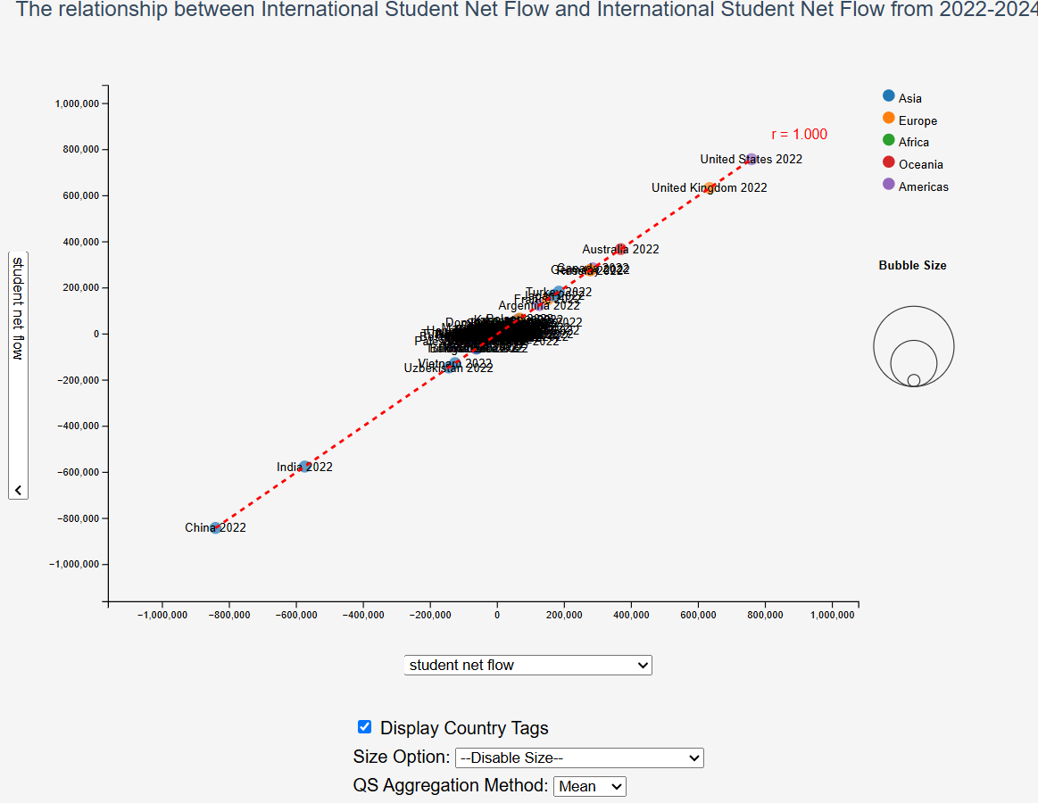

Figure 1 The screen of final implementation of Interactive Bubble Chart in DVP

* + - 1. Bar chart + Line Graph

This chart will plot the changes over the years between the two indicators for the selected country, based on the user’s current country selection (through clicking a bubble or searching for a specified country) and the indicators chosen for the x and y axes.

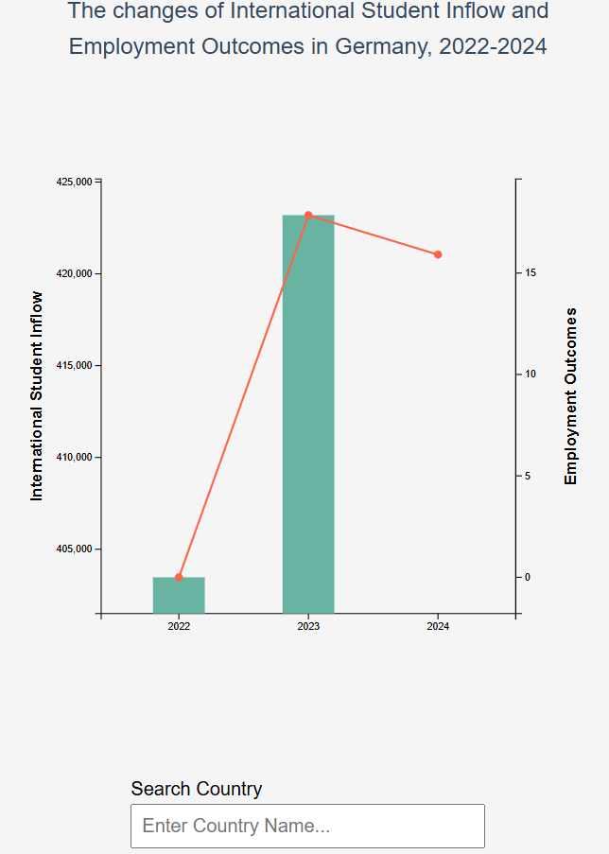

Figure 2 The screen of final implementation of Interactive Bar Chart with Line Graph in DVP

* + - 1. Interactable Elements

This section is located below the main visualisation (see below Figures 1 and 2) and allows control over features such as displaying country labels on the bubbles, selecting the bubble size indicator, adjusting the aggregation method for QS indicators, and searching/selecting target countries in the bar chart. This part is mainly implemented using native JavaScript and HTML, with D3 used to read the current state and update the visualisations in real time.

* + - 1. Description and data stories

This section is located at the very bottom of the screen and uses multiple selectable tabs to allow users to view the content they want, including the introduction, the three data story themes, data information, and a user guide. It is mainly implemented using native JavaScript and HTML, with functionalities such as updating text content, pop-up windows, and button toggling.

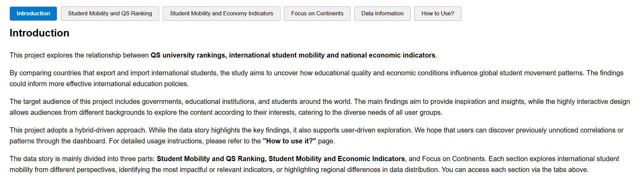

Figure 3 The screen of the Description part in DVP

* + 1. Data stories

When designing how to present the data stories, since the data stories I want to show focus on the relationships between different indicators—essentially a single snapshot on the bubble chart rather than changes over time—there is no need for additional animations or visualization transitions. When users click a button to display a data story, the visualization will present the required view based on pre-set states.

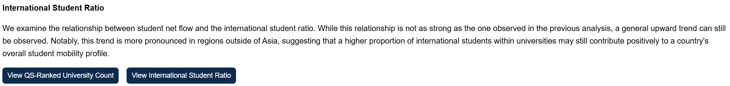

Figure 4 Illustrative diagram of a data story

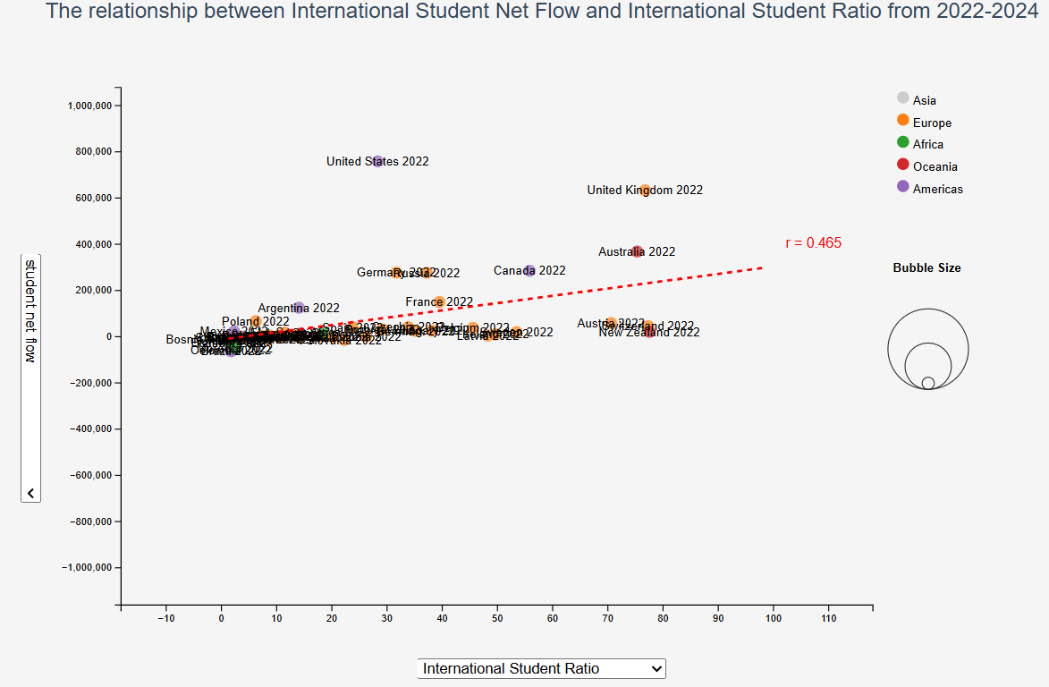

Figure 5 Bubble chart updated through the data story

* 1. Using the Implementation
     1. Bubble chart factor selection
        1. X-axis Selection
        2. Y-axis Selection
        3. Continent Filter (can be selected directly via legend)
        4. Size Selection
        5. Show Bubble Tags
        6. QS Indicator Aggregation Method Selection
     2. Bar chart country selection
        1. Update Target Country on Bar Chart by Clicking Bubble
        2. Select Target Country via Search Box
     3. Description Tabs
        1. Switch Tabs by Clicking Tab Buttons
        2. Update Visualisation by Clicking Data Story Buttons
        3. Show Visualisation Guide by Clicking "How to use?"

1. Conclusion

Through this Data Visualisation Project (DVP), I successfully deepened the insights from my previous Data Exploration Project (DEP), particularly regarding the relationship between international student mobility, QS ranking indicators, and national economic conditions. By transitioning from a primarily analytical approach to an interactive and narrative-driven visualisation, I was able to more effectively communicate these insights to a broad and diverse audience, including policymakers, educators, and prospective international students.

The final visualisation, built around a dynamic bubble chart and a linked bar-plus-line graph, demonstrated that countries with a higher number of QS-ranked universities and better GDP-related economic indicators tend to attract more international students. Importantly, the project revealed strong regional differences—particularly in Asia, where large outliers like China and India introduced distinct patterns that differed from trends seen in Europe and the Americas.

Throughout this project, I learned how to balance narrative storytelling with exploratory freedom, ultimately choosing a mix-driven approach that offers both guided insights and interactive exploration. I also gained valuable technical experience, especially in integrating regression analysis into D3.js and building a responsive, user-friendly dashboard. In hindsight, I would have allocated more time to learning D3 and JavaScript earlier in the project, which would have allowed me to implement advanced features more efficiently and explore more sophisticated design elements.

Looking forward, I would like to enhance this project by incorporating temporal animations to visualize how student mobility trends evolve year by year, and by exploring other influential variables such as visa policies, tuition fees, or cultural factors. Additionally, user testing with actual target users could provide valuable feedback to further improve the interactivity and accessibility of the dashboard.