Instructions for getting started with problem sets in GitHub

1. Get a Git account if you don’t have one already: <https://github.com/join>.
2. Once you have an account, you need to ‘fork’ the ‘parent’ repository. That’s Git speak for make your own copy of my main folder. To do that, first go to the main folder: <https://github.com/ASDS-TCD/StatsI_Fall2022>. Then, click the button in the top right that says ‘fork’.  
     
   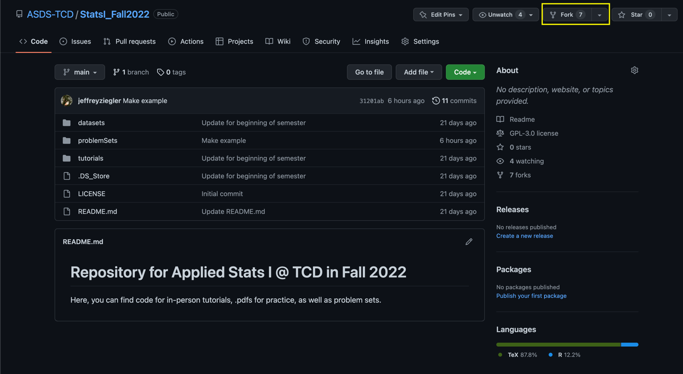
3. Now, you’ll have your own repository that you control online via your own GitHub account. Let’s make sure that you can sync the files on your online folder with the files you’ll be working on for your homework (likely on your local drive/computer). To do this, we’ll need to first download GitHub desktop to make it easier. You could do this manually through the command line or Terminal, but trust me, you’ll want to do it this way. You can download the program/app here: <https://desktop.github.com/>.
4. With the desktop version downloaded, let’s now link your online repository with your local repository. You’ll want to do this by click the green ‘Code’ button, and then selecting to open it in GitHub desktop.  
     
   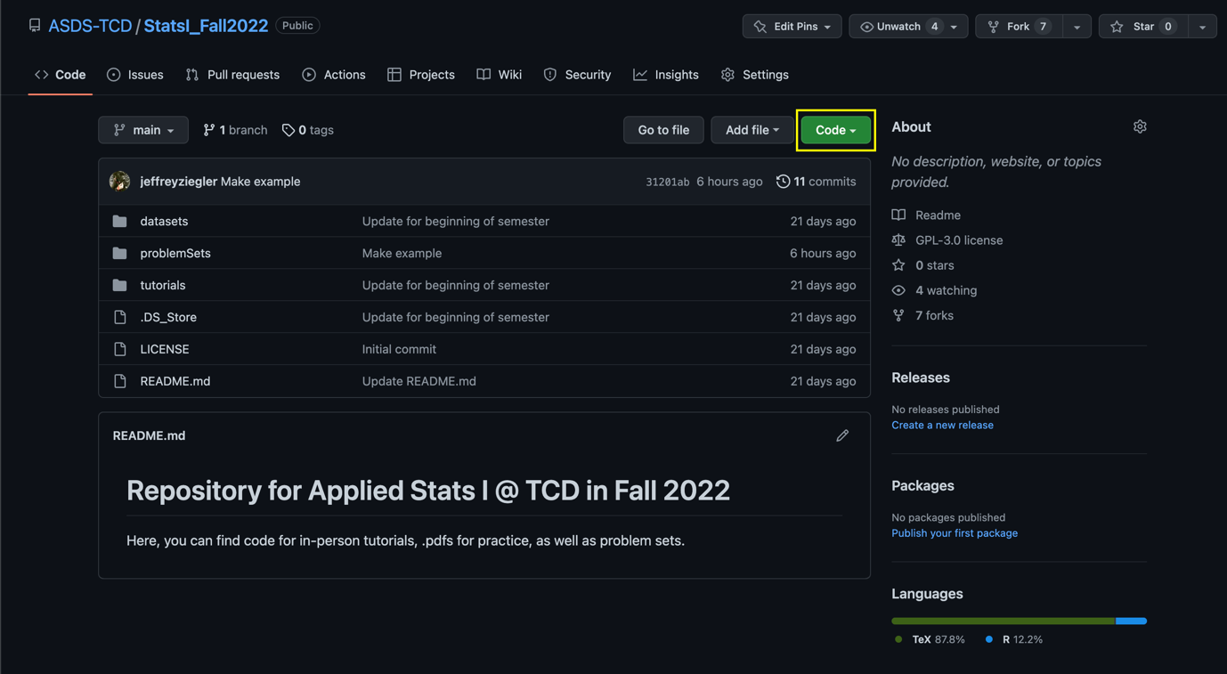
5. You’ll then be transferred over to GitHub desktop. You need to make sure that your folder is placed in “Documents > GitHub > StatsI_Fall2022”, which should be the default. Then click ‘clone’. Now you have a completely up-to-date version of my files from the parent directory, and a synchronized folder between your local files and your online repository.  
     
   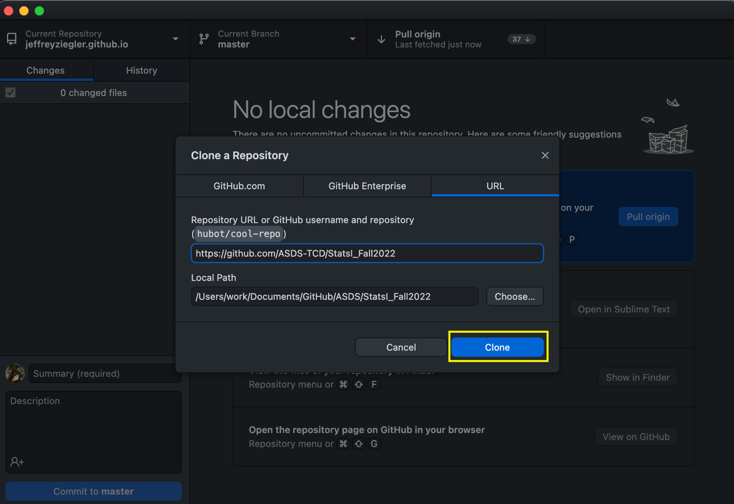
6. Let’s say you finish your homework, and you now want to post your answers to GitHub.