**Assignment 5**

**Submitted by: Geetalakshmi Javvadi, Jinal Patel and Supraja Raghavan.**

The Git Hub URL is: <https://github.com/ASE-Javvadi-Patel-Raghavan/PronunciationHelper.git>

The Project Website URL is: <http://170.224.163.107/aspnet_client/website2/CS.aspx>

Note: Assignment5 folder has all the code for the web service for Q3 and Lab5_Q4 has the android app for Q4.

Q1. Sample Website for our project using Jquery Mobile and HTML5:

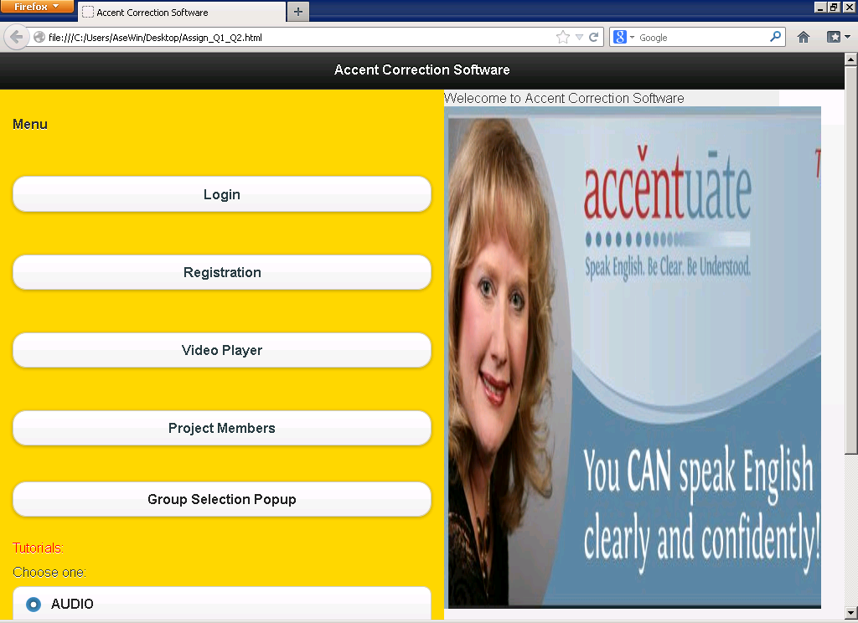

The Login Page:

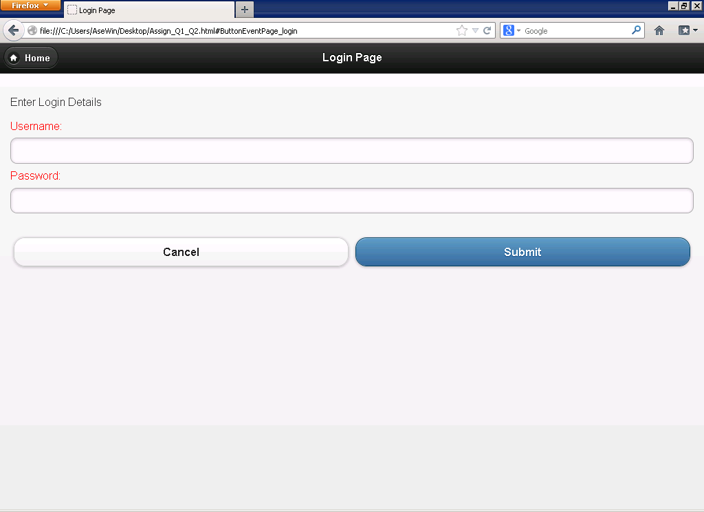

The Registration Page:

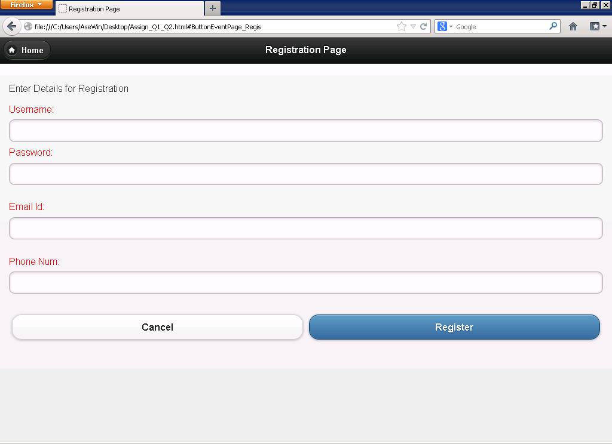

Q2. Screen Shot of a sample video for our website:

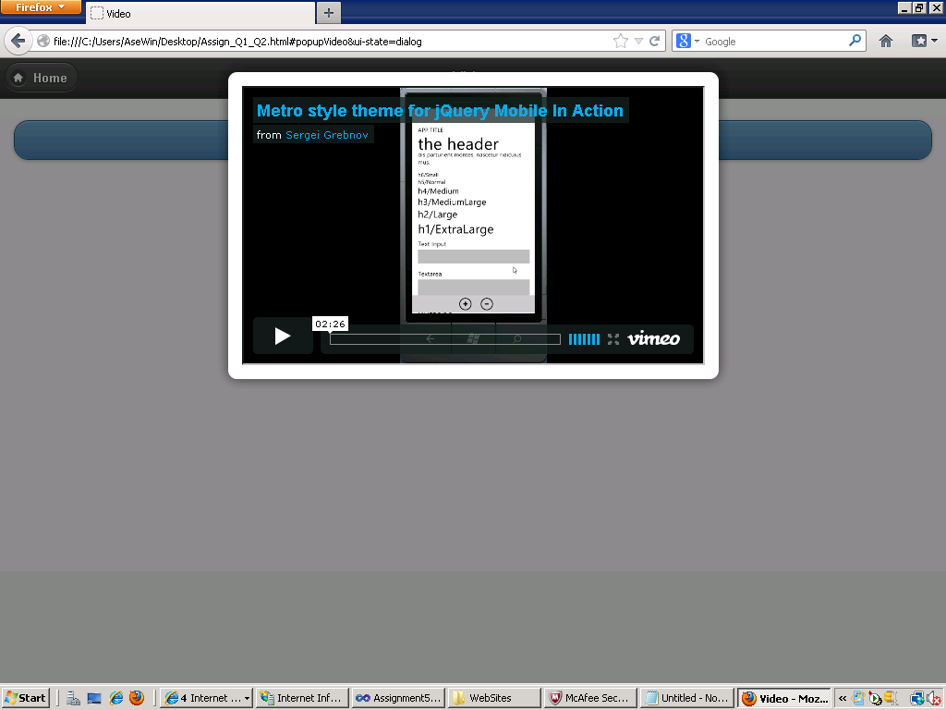

Q3. Screen shot of calling a web service that returns the project members:

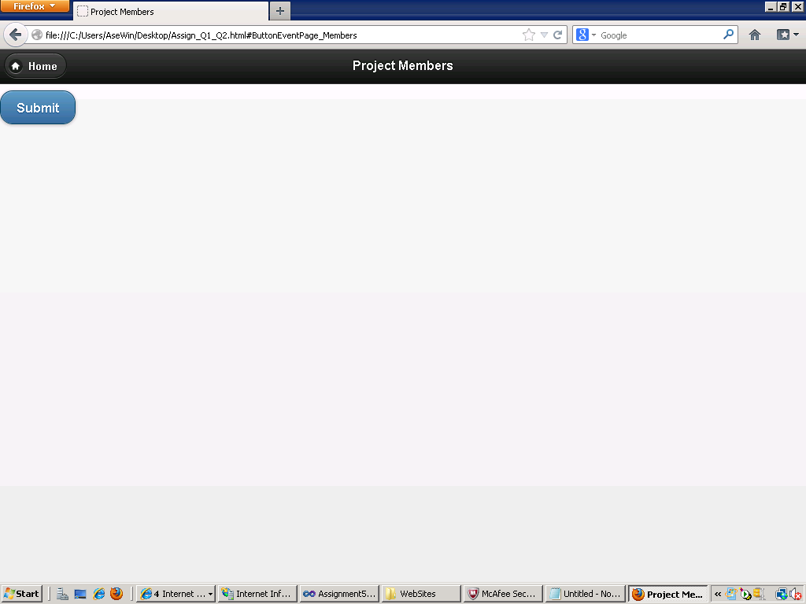

The members:

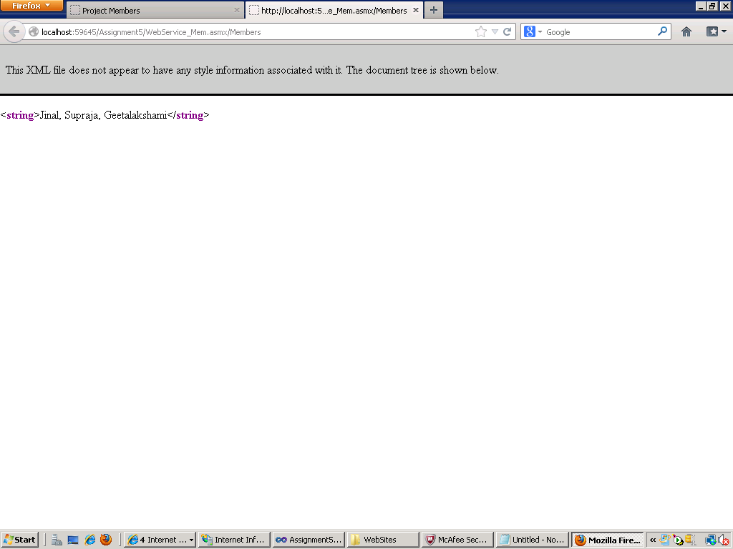

Language choices:

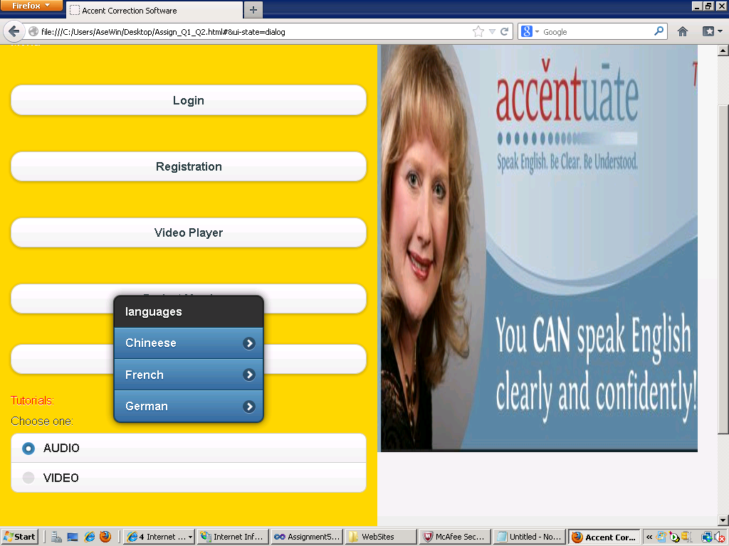

Q4 Add the same HTML page to create an interface in your mobile application.

