**CS5551 Advanced Software Engineering**

**Iteration II**

**Due Date: Mar. 27 (W) 2013, Midnight**

Team Members:

Geetalakshmi Javvadi

Jinal Patel

Supraja Raghavan

**Detail Design of Services - Iteration 2:**

For the Iteration II, Due to some technical issues at the IBM cloud, we had to recreate our instances and have been setting up our applications backend. We have recreated our database tables and created the web services for login, registration and group selection.

**Web Service for the application:**

For this Iteration we will design and implement the Web services that the user will use after he / she login to the application. This application homepage will have the details of the user’s group and account management information. From this the user can then select their respective group and check the list of words that will be shown to them according to their user type.

In this iteration we will design, implement and test the web service required for our users to choose their desired group for our application. We will also use the same NUnit client tool to test the proper working of our web service. In this iteration we will also ensure that the web service can access the database and retrieve the required group infrmation

**Web Service – Accent Mobile Application:**

After a user has registered and logged in to the mobile application, the user can access his/her group. This group contains the list of words for which the user would like to learn the accent for. When the user logs in subsequently they can access a list of most recently used words. When the user clicks on a word, the accent audio for the word would be played. Thus the user can listen to the words as many times as wanted to practice the correct accent of the word. The user can also manage their account with this application. The class diagram, sequence diagram and the service specification are as shown below.

For this Iteration we have recreated the user Registration, Login and have created the web service that the user can access after logging into the application. The web service that we created is used to allow the user to select his/her desired group. The users of our application need to specify a group to which he/she would have access to. The users can select from various groups such as Chinese, Spanish, India, African, etc. The user needs to provide his/her username and the group they would like to add. These details would be added to the user’s tables in the database. The class and sequence diagram of our application are as shown below.

**Service Specifications for Accent Mobile Application:**

**Manage Account**

* Description: Update account information and group
* Input: Account information
* Output: Confirmation
* Precondition: User is logged in successfully
* Post condition: Account information is updated
* Actors involved: User, Group, DBInterface, WordListWebService
* Object involved: User

**WordList**

* Description: Access the word list
* Input: username
* Output: Wordlist
* Precondition: User authenticated and has group selected
* Post condition: Wordlist for the user
* Actors involved: User
* Object involved: WordList, RecentWordList, GroupWordList, User



**Sequence Diagram:**



**Implementation**

We have created the required database tables and have reimplemented the web service for user registration and Login. For this iteration we have used the web page using HTML5 that allows a new user to add his/her group for the Speech Helper software. We have implemented the database and the tables to allow users to select the group. We have implemented and tested the code for the web service using NUnit.

**The various Screen Shots for the HTML page and the web services are attached below:**

**Screen shot of the HTML Page:**

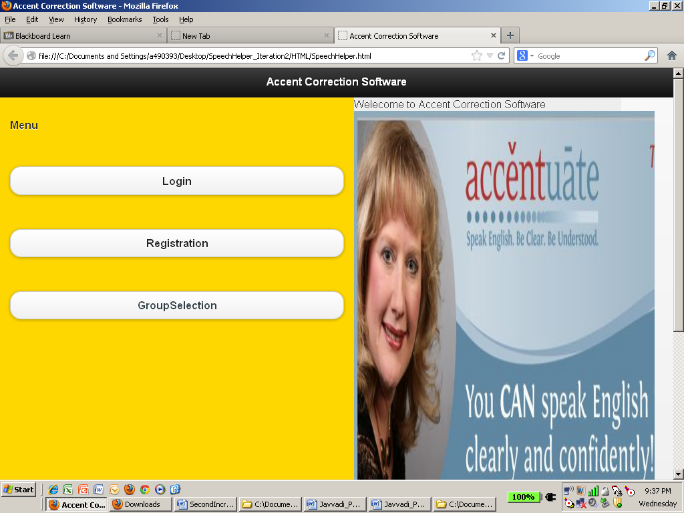

**Screen Shot for Group Selection:**

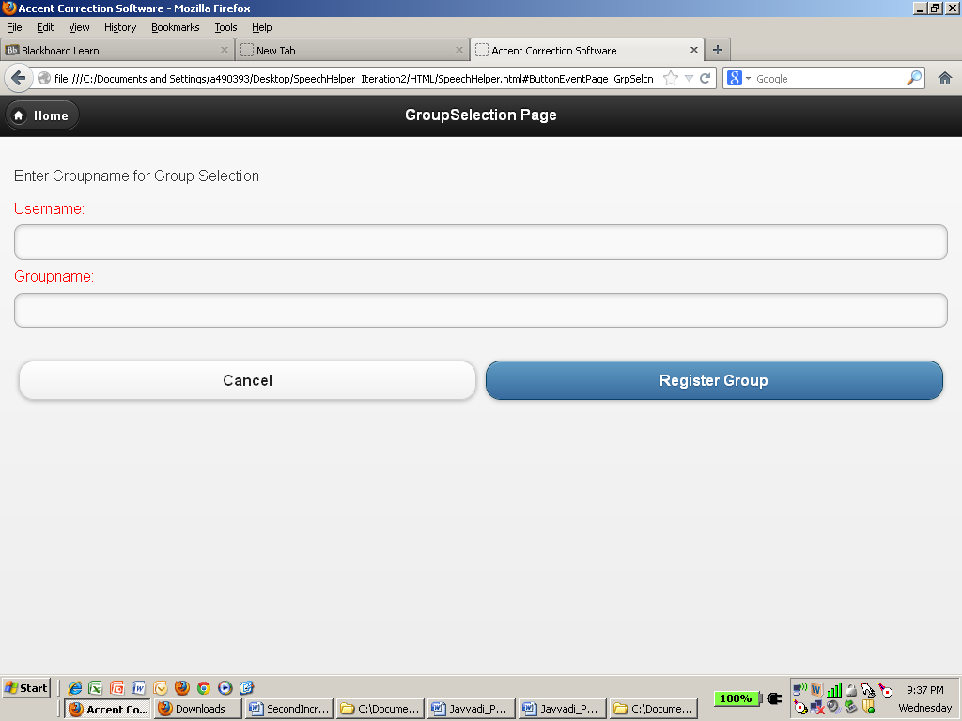

**Project Iteration II implementation Status:**

Work Completed:

Creating, Implementing and testing the webservices:

Geeta: 12 hrs.

Jinal: 12 hrs and

Supraja: 12 hrs.

**Internet Access:**

* 1. GitHub (URL):

We use GitHub for development version control. We have a GitHub account for the same. The URL is: <https://github.com/ASE-Javvadi-Patel-Raghavan/PronunciationHelper.git>