**CS5551 Advanced Software Engineering**

**Project Proposal & Plan**

**Due Date: Feb. 22 (F) 2013, Midnight**

Team Members:

Geetalakshmi Javvadi

Jinal Patel

Supraja Raghavan

1. **Project Goal and Objectives:**

* **Overall goal**

Speech recognition and accent correction is the main idea of the project. User is allowed to select for a particular group to which he/she belongs and our tool displays the correction of accent for the selected words. This project would be beneficial for the non-native speakers of English to correct their accent.

The globalization has taken the world to have an international language for cross culture communication. Pursuing higher education also requires English as most of the universities around the world offers course only in English. Good job opportunities require fluent accent in English.

Since the native speakers of other languages are influenced by the stress on syllables according to their native language and that would impact their accent in English. So communication is very important for fulfilling the aspirations and accent matters a lot in communication. The outcome of this tool is to provide training and improve the confidence levels of non-native speakers in communication.

* **Specific objectives** (problem statement)

This tool plays a significant role in the correction of accent for non-native speakers in English. Every ethnic group is influenced by the accent of their native language and becomes difficult to change the accent when they speak in English. This tool categorizes the person according to their native language and tells the person where to put stress on the syllable and where it is not required.

This tool would definitely help the person in recognizing the flaws in the pronunciation/accent and allows them to practice till they get used with the correct ones. Since none of the schools has this accent/ pronunciation correction in the schools definitely anyone would finding difficult in correcting the pronunciation/accent by their own.

Our objective is to facilitate the non-native speakers to correct their accent that would benefit them for proper communication.

* **Significance**

The significant part of this tool is the accent correction. This would enable a proper communication among the people in presenting the ideas and would also favor the listener in understanding the language easily. One of the fascinating aspects of this tool is it can be used by all the age group people, without any assistance from anyone as it is very simple to operate.

1. **Project Background and Related Work:**

* **Project Background**

People from different native language face the problems in communication as native language always dominates the secondary language. This causes a communication problem in education, searching a job or in cross cultural interaction. This has motivated us in taking this project which would assist non-native speakers in achieving their language goals efficiently.

When a non-English speaker presents an idea, although the idea may be very good but because of the proper accent/pronunciation, if the accent is not understood by the listeners the idea may not be taken into consideration and the person would lose points. This would cause frustration for the person but cannot help other than improving the eloquence of the speech and to stay abreast with the current pronunciation.

Most of the existing software gives emphasis on pronunciation rather than intonation. This kind of tool would definitely benefit umpteen number of language learners. There are only fewer listening and speaking software between 1990 and 2000. This indicates a need for new software and a research on that would certainly check its effectiveness. This language software has implications for artificial intelligence and human computer interaction. The futuristic idea is that artificial intelligence would detect the emotions based on the intonation pattern analysis.

* **Related work:**

1. <http://www.accentschool.com/run_software.html>
2. <http://www.accentmaster.com/individuals/software.htm>
3. <http://www.l2accent.com/accent-reduction-tools/index.php>

Work done by others (include the URLs in Bibliography): elaborate the similarities and differences between what you propose and each of the related projects)

1. This project presents an interactive tutorial, and tells the difficulties in accent. There is also a help document how to navigate to different windows of the tool.
2. Majority of the accent reduction software are not available for free. So our software is available for free.
3. This software just gives the clarity on the phonetics pronunciation. This helps people to refer to the intonation of phonetics in looking at the pronunciation. This software has the visuals of the mouth and the phonetic simulator.
4. **Proposed System:**
5. Requirement Specification

* Functional, Non-functional, Technical/business Requirements (prioritized)

**Functional:**

1. System allows the user to register.
2. User can log in into the system.
3. User is allowed to choose the group.
4. Then system will show the flaws of the accent made by the people in that group.
5. System will show the list of words and the accent that is followed.
6. User can practice as many times as wanted.
7. User log off the system.
8. User can use this tool at any point in time and is free software.

**Non-Functional:**

1. Usability: System is easy to use if the user has a login Id.
2. Availability: The Software tool will be available and accessible almost all the time.
3. Reliability and Robustness: The user is given only the read access to the software; user cannot change or add anything to the system. The software will perform well without a lot of downtime, hence the system is reliable.
4. Scalability and Extensibility: The administrator of the system is allowed to add more details to the existing tool to make more tutorials accessible for the user. The software is scalable and can be extended as required.
5. Privacy: Administrator cannot add the stuff when someone is using the tool. So whenever administrator wants to make some modification, a notification is sent to the users.
6. Fault tolerance: The system is not affected due to any issues associated with hardware and also with the software.
7. Security: The software tool is usable only by authenticated users; unauthenticated people cannot login into the system to use the tool.

**Technical/Business Requirements:**

1. User is allowed to choose his native language and training is based on that.
2. User should be allowed to use the tutorial as many times as required.
3. Administrator is allowed to add the additional tutorials.
4. Administrator is allowed to add the different categories of the native language.

* **Business Process/Workflow analysis:**

With the workflow analysis, we divide the system into various components are tasks and analyze the structure of the workflow for these tasks. This enables us to modify and improve the various tasks assigned for the iterations. For any project or system we need to specify the scope of the system, the stakeholders and the users of the system. We need to plan and design the various components, for our system we need to plan and design the various web services and their interactions. The different components that we use are the web services, android client and database.

Business Process/Workflow:

1. New user registration.
2. Administrator gives access to the user.
3. User login
4. User chooses one native language.
5. Tutorial for accent correction related to that language appears.
6. User uses the audio of the tutorials.
7. User logs out after the practice.

User Account

Exists

Does not exists

Register

Login

Access tutorials

Receive

Notification

Logout

User

Yes

No

Give permission

Add tutorials

Send Notification

Logout

Administrator

Check permission

Login

* **Technological and Architectural requirements**

Languages: ASP.net, C#, Java.

Front End: .NET framework; Android development framework.

Back End: On the cloud we need to have the IIS Server, Microsoft SQl Server.

Operating Systems: Microsoft Windows.

Protocols: HTTP, SOAP.

1. **Framework Specification:**

* **Assumptions and Principles**

This project is about accent learning for people from different walks of life. With this software tool, we assume the end users will be interested in using our mobile application for accent learning. It is also assumed the user will have access to the internet and to a smart android mobile phone in order to access our application at anytime and from anywhere. We also assumed that we can create and deploy our own instances on the IBM cloud for the IIS and Sql Server. These assumptions allow us to create the desired system that will be useable and available to the end user.

* **Methodologies and Algorithms:**

A software methodology is used to provide a framework for the development of the software system. For our project we are following the Service Oriented Architecture and the Agile Development Process. We use the incremental and iterative methodology that uses object oriented programming to develop our software system. With these methodologies and development process it makes it easy to keep track of the project development and progress. It also gives us the possibility to make changes to the initial scope of our project. Agile process gives us more flexibility in development and testing framework.

**System Architecture Diagram:**



**Database Design Diagram:**



1. **System Specification: Identify Primary Services**

* **New Services to be built:**

For this project we are going to design and implement 3 different web services which can be accessed using an android mobile application. These web services interact with the user and the also obtain the required user’s data from the database. The various services, their scenarios, use case diagrams, class diagrams, sequence diagrams and their service specification are given below.

**Use Case Diagram:**

The use case diagram for the entire project with the various actors and their interactions is given in the use case diagram which is attached below:

**Use Case Diagram:**

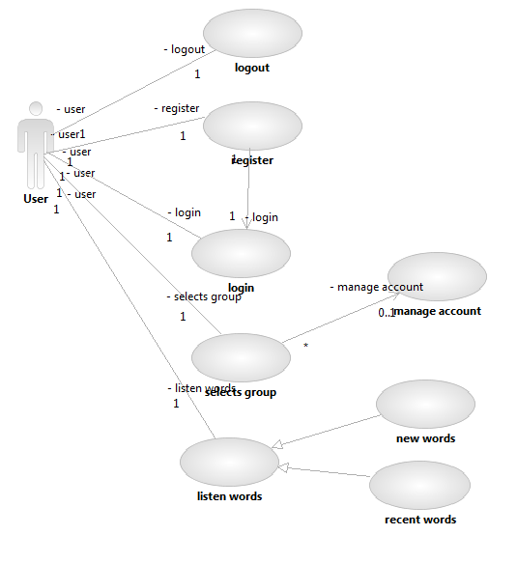

**Web Service - Registration:**

In this web service the user registers for access to the accent mobile application. They provide the required details such as the username, password and group.etc. The users are thus registered to the system after which they can login to the system. The class diagram, sequence diagram and the service specification are as shown below.

**Class Diagram:**



**Sequence Diagram:**



**Service Specifications for Registration:**

* Description: Register new user
* Input: User information
* Output: Confirmation
* Precondition: User must be interested in the accent mobile application
* Post condition: User account is created
* Actors involved: User, IIS Server and Database.
* Object involved: User, Group, DBInterface, RegisterWebService
* Constraint/Exception: Username does not exist

**Web Service - Login:**

After a user has registered for the mobile application, the user needs to Login to the application in order to access their group and the word list for their accent group. The user is authenticated and verified. If the user enters an authentic username and password he is allowed access to the application otherwise the access is denied. The class diagram, sequence diagram and the service specification are as shown below.

**Class Diagram:**



**Service Specifications for Login:**

* Description: Authenticate user
* Input: Username, password
* Output: authenticate pass
* Precondition: User has been registered
* Post condition: User is authenticated
* Actors involved: User, IIS Server, database
* Object involved: User, Group, DBInterface, LoginWebService
* Constraint/Exception: Username and password are correct

The sequence diagram below gives the sequence diagram for a user login. The diagram is for the user’s first time login and also for their subsequent login. For the first time login the sequence for RecentlyVieweWordList call will be not available.

**Sequence Diagram:**

**Web Service – Accent Mobile Application:**

After a user has registered and logged in to the mobile application, the user can access his/her group. This group contains the list of words for which the user would like to learn the accent for. When the user logs in subsequently they can access a list of most recently used words. When the user clicks on a word, the accent audio for the word would be played. Thus the user can listen to the words as many times as wanted to practice the correct accent of the word. The user can also manage their account with this application. The class diagram, sequence diagram and the service specification are as shown below.



**Sequence Diagram:**



**Service Specifications for Accent Mobile Application:**

**Manage Account**

* Description: Update account information and group
* Input: Account information
* Output: Confirmation
* Precondition: User is logged in successfully
* Post condition: Account information is updated
* Actors involved: User, Group, DBInterface, WordListWebService
* Object involved: User

**WordList**

* Description: Access the word list
* Input: username
* Output: Wordlist
* Precondition: User authenticated and has group selected
* Post condition: Wordlist for the user
* Actors involved: User
* Object involved: WordList, RecentWordList, GroupWordList, User

1. **Plan by Services**

* **Tentative schedules for the project and iterations:**

Our project has four iterations along with the project documentation; the tentative schedules for the four iterations are given below.

**Schedules:**

Project Proposal and Plan: Feb 22nd 2013.

Iteration 1: March 8th 2013.

Iteration 2: March 22nd 2013.

Iteration 3: April 12th 2013.

Iteration 4: May 3rd 2013.

Project Report: May 10th 2013.

* **Iteration 1:**

**Database Schema:**

For our first iteration we will design the Database Schema and implement the Database. Similarly we will design and implement the Login and Registration Web services. For this iteration we will create the necessary backend processing. We will create the necessary, user, group, word list tables that will be used. We will populate these tables with the required data.

**Web Services – Registration:**

We will also design and develop the Login and the Registration web services. The user who would like to have access to our accent web service will have to register for the service. The registration will have the details of the user’s username, password, group they belong to and other registration details.

**Web Services – Login:**

The Login page will ask the registered user to enter their login username and password. The user’s authenticity will be verified and validated. A validated user can then access our mobile application. For this iteration we plan to test the web services at the backend using the SOAP UI Web service client tool.

* **Iteration 2:**

**Web Service for the application:**

For this Iteration we will design and implement the Web services that the user will use after he / she login to the application. This application homepage will have the details of the user’s group and account management information. From this the user can the select their respective group and check the list of words that will be shown to them according to their user type.

In this iteration we will design, implement and test the web service required for application. We will also use the same SOAP UI Web service client tool to test the proper working of our web service. In this iteration we will also ensure that the web service can access the database and retrieve the required word list.

* **Iteration 3:**

**Android Based Web Application:**

For this iteration we will design and implement the Java based Android application development. In this we create the user interfaces and the navigation screens for the Registration and Login Web services.

We also implement the code required to access the Registration and Login Web Services. We create sample users and create various test scenarios to try to register and login to the web services. The users will enter their registration details which includes the username and password using the android application and register to the web service. The user then logins to the web service if he is authenticated.

* **Iteration 4:**

**End to End Integration and Testing of the Web Application:**

In this iteration we design, develop and implement the android accent application. We create the User interface and connect to the web service that gives the details of the group. From which the user can select the words to play the audio of the word for which they need the accent for.

The end to end integration of the entire mobile application and the testing of the proper function of the system can be done in this iteration. On successful integration of the system, with any time remaining we plan to implement some additional features such as the extensibility of the word list or multi group access to the users.

* **Project Timelines, Members, Task Responsibility (using tools such as wiggio, Agilefant):**

We are using Agilefant in order to manage our project. We are using the Wiggio tool for the effective communication and discussions about tasks, schedules or any difficulties that our team could confront. For the version control of the coding we are using the Git Hub. The details and the URL’s for these are given in section IV.

The various tasks and responsibilities of the team members are given using the Agilefant tool in the screen shots below.

**Screen Shots of Agilefant:**

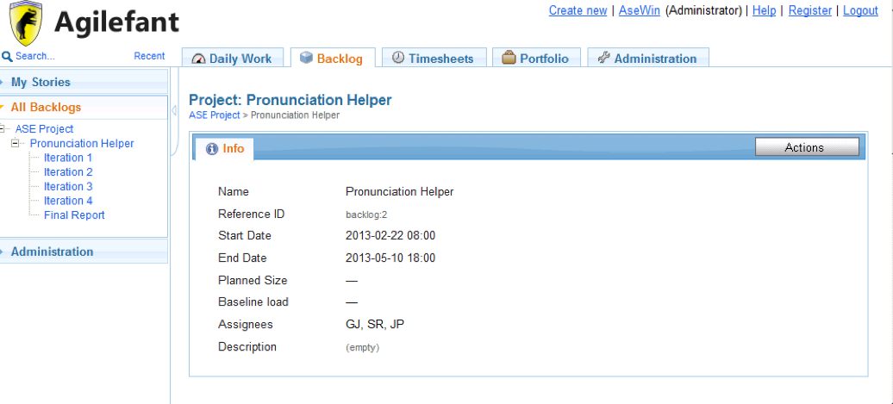

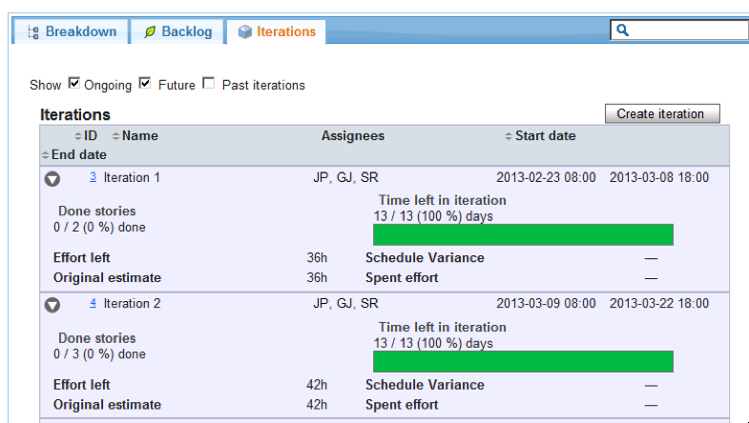

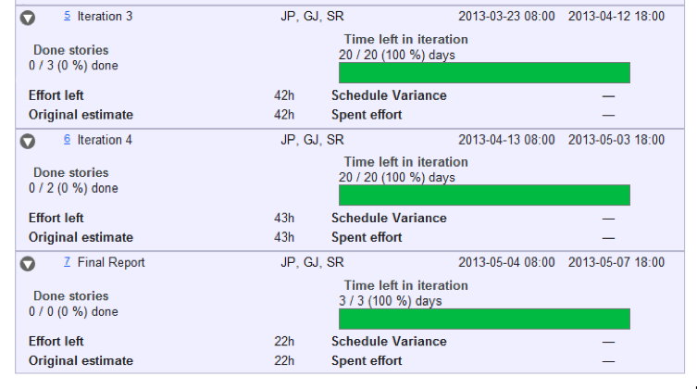

Iteration 1: Tasks and User story:

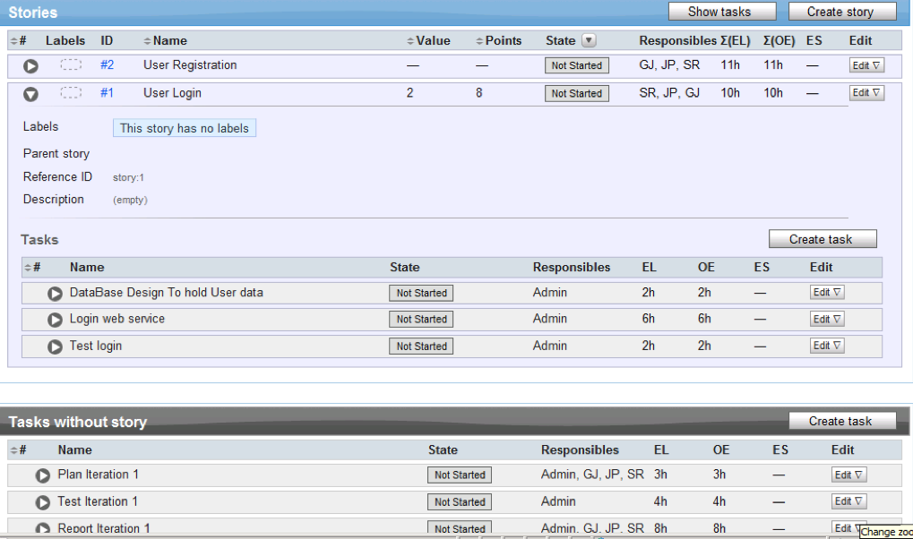

* **Risk management:**

For any project the Risks are always present. Certain risks can be avoided, some mitigated but some risks are unavoidable. Few of the risks that we could encounter in our project is the loss of access to the Cloud instance, which can be mitigated by having a readily available working back up instance. Similarly database crashes are unavoidable, hence redundant database can help to mitigate this risk. With a project the requirements and the design changes are possible, which could lead to not meeting project timelines we could avoid this by limiting the scope of the project to the scope of iteration and by managing the time and features implemented in each iteration.

1. **Internet Access:**
   1. Project Website (URL):

We created a website for the project on the cloud. The URL of the link is as given below.

<http://170.224.163.107/aspnet_client/website2/CS.aspx>

* 1. Wiggio (URL):

For the communication between the team members we use the Wiggio.

* 1. Afilefant (URL):

We use Agilefant for project management. We construct project plan, the team members and their responsibility using Afilefant.

* 1. GitHub (URL):

We use GitHub for development version control. We have created a GitHub account for the same. The URL is: <https://github.com/ASE-Javvadi-Patel-Raghavan/PronunciationHelper.git>

1. **Bibliography:**

<http://www.englishtalkshop.com/accent-reduction-software>

<http://esl.about.com/od/speakingenglish/a/accent_reduce.htm>

<http://www.accentmaster.com/>

<http://www.amazon.com/Accent-Reduction-Made-Easy-Discovery/dp/1560156600>

<http://theaccentlab.com/tools/>

<http://www.confidentvoice.com/blog/quiz-super-challenge-with-schwa-y-w/>

<http://www.prweb.com/releases/2013/1/prweb10376601.htm>

<http://www.nch.com.au/wavepad/index.html?gclid=CNvVoIm8y7UCFZE-MgodoEEASw>

<http://www.pronunciationworkshop.com/englishpronunciationvideo.htm?gclid=CN3F7Zm8y7UCFag7MgodQ0oATA>

<http://www.utilitychest.com/index.jhtml?spu=true&partner=ZOxdm003&gclid=CIKM26K8y7UCFag7MgodQ0oATA>

<http://www.howtodothings.com/computers-internet/how-to-find-accent-reduction-software>

<http://www.accentschool.com/run_software.html>

<http://www.accentmaster.com/individuals/software.htm>

<http://www.l2accent.com/accent-reduction-tools/index.php>