**ASE Project Increment1**

**Group# 12: Project “Ask UMKC “**

**Group Members:**

* Sravan Kumar Appana
* Vikesh Padarthi
* Architha Mukka
* Manikanta Maddula

**Objective**:

Create an android application which helps students of UMKC in clearing their doubts in all domains like fees, course, sports etc. and answers are replied by other students or any other registered user.

**Introduction:**

Name of the application “Ask UMKC”.

The App is about questionnaires which can be posted by any user and any registered user can answer the question. The questions need not to be in specific area like finance, course and sports etc., it can be of any topic related to university activities like events, career, etc. Any new student or a student who wants to join UMKC will have many doubts like ‘last date for paying fee’, ‘where is a particular event’, ‘Student associations ’etc. It is easy to drop a mail to the authorities asking for details but if answer is needed on weekends and on holidays, it’s difficult. But with this application answer can be found on any day and time.

Users can login to app using their Google account or they can sign up for the account. After successful login, home page will contain questions displayed as a list in reverse chronological order. User can scroll to different questions. Clicking on a question will display complete question and answers given to them or user has a feasibility to answer. There is an up vote option to decide the authenticity of an answer. In the menu, user has options to select a category: ‘Academic’, ‘Nonacademic ‘, ‘Admissions’, and ‘Career’. Menu also has ‘update profile’, ‘logout from application’, ‘My questions’ and FAQ. User can ask a question from home page by clicking ‘Ask’ button.

**Architecture:**

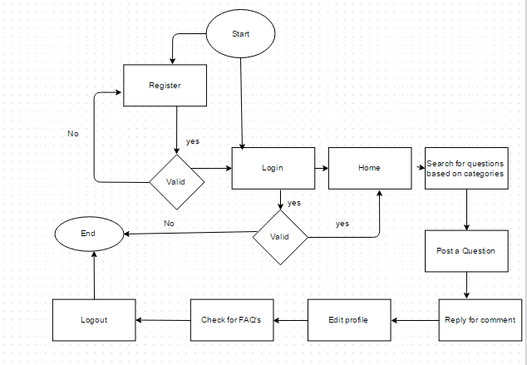

**Class Diagram:**

C:\Users\Manikanta\Downloads\class diagram.png

**Use Case Diagram:**

**C:\Users\Manikanta\Downloads\usecase (1).png**

**Sequence Diagram:**

**C:\Users\Manikanta\Downloads\sequence.png**

**Wireframes and Mockups:**

Login Screen:

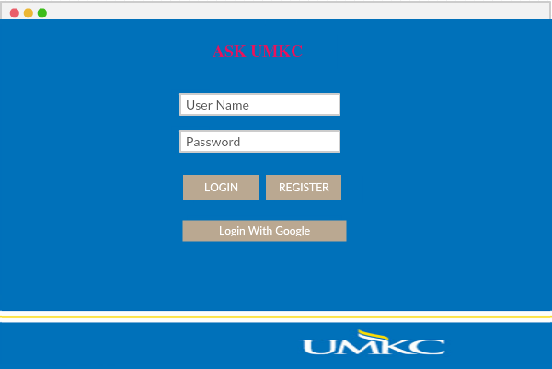

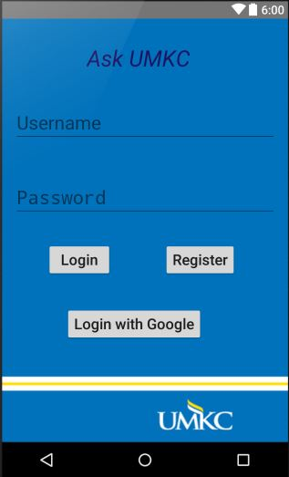

User can login using google account or with the username and password. New users can register themselves with Register button that is available.

**Register:**

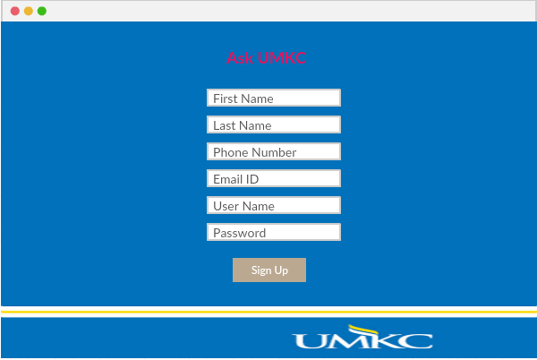

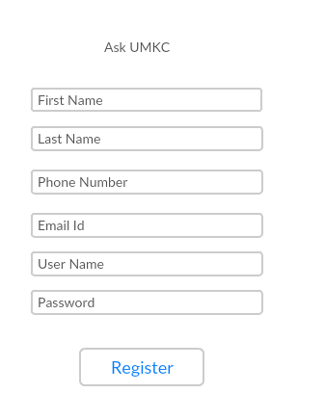 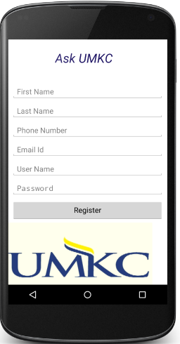

User who want to register, will have to fill a form containing basic information like, First Name, Last Name, Phone Number, Email Id, User Name, and Password. All the fields are mandatory to become a registered user. After successfully registering, user will be redirected to login page and user has to login to view home page.

**Home Page:**

After successful login user will be redirected to home page where user sees all questions in a list view. User can scroll down to several questions. Questions are presented in reverse chronological order. Home will have menu option as shown in below image. Questions are divided into several categories and presented in menu. Menu will have options to ‘update profile’, ‘My questions’, ‘FAQ’, ‘Logout’. User can ask a question by touching ‘Ask’ button on home page.

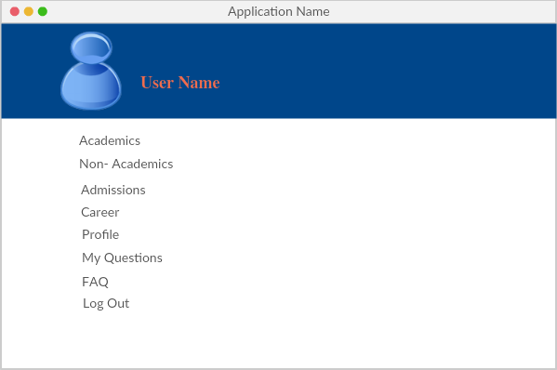

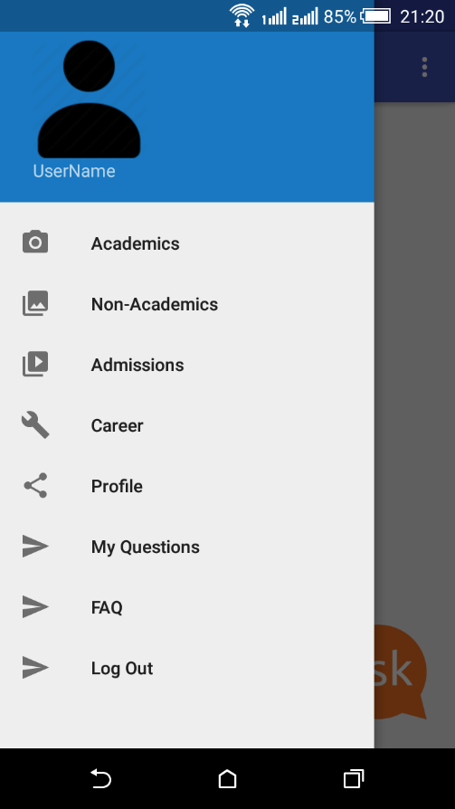

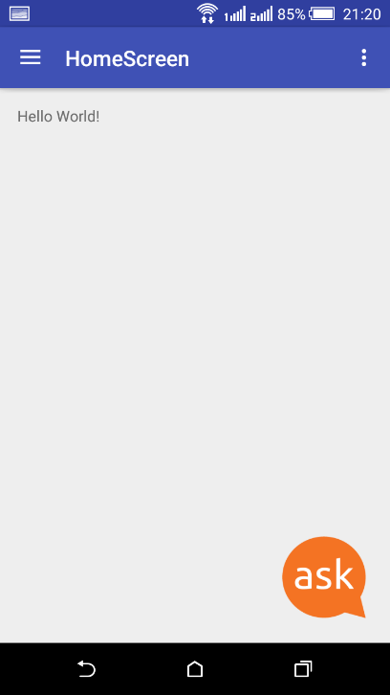

**Question:**

Selecting a question launches a screen where user can see question and answers given to them. User can add an answer here in same page. Here user will have option to up vote an answer. 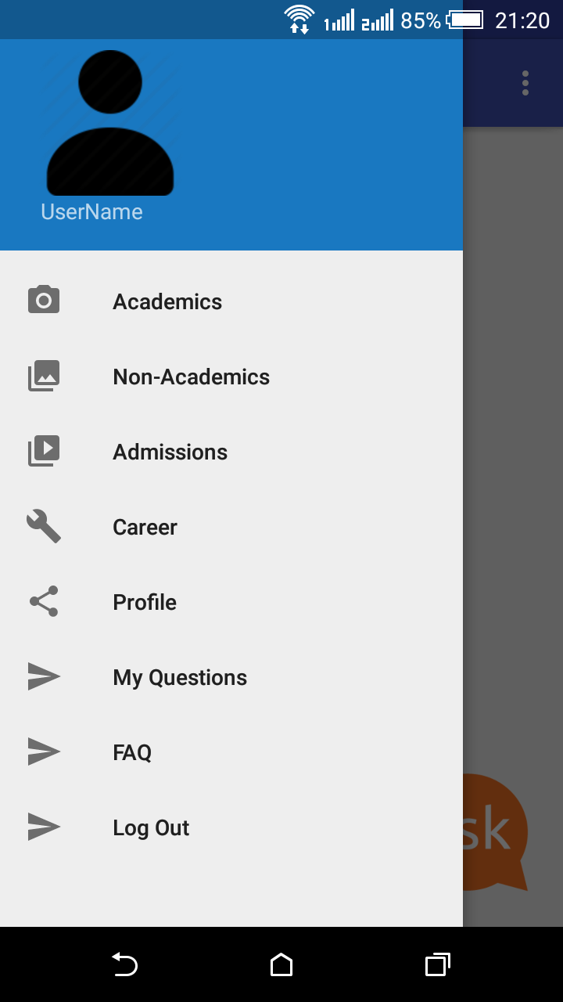 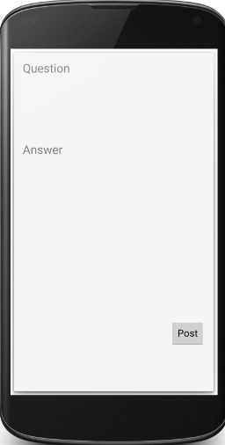

**Profile Update:**

User can update various details of his profile like photo, password etc as shown in below screens.

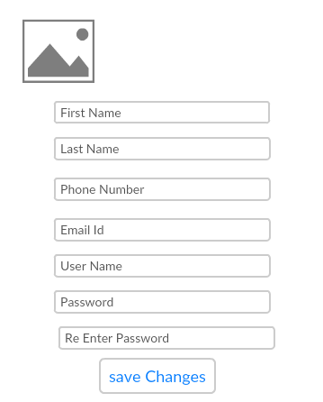 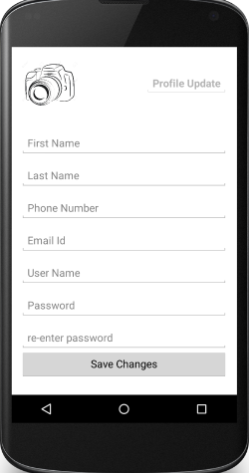

**Ask question:**

After touching ‘Ask’ button in home page, user will be redirected to ask question screen. Here user will have different views to add question, add category.

**System requirements:**

Operating System: Windows /Linux/Mac OS X

RAM: 2 GB RAM (takes lot of time to run, so 4 GB recommended)

Hard Disk: 400 MB hard disk

Data Base: Mongo DB (can alter depending upon future enhancements

Servers: Amazon Server (can alter depending upon availability of free online sources)

Software’s: Java Development kit (JDK) and Android SDK

Screen resolution: 1280 px * 800 px minimum

Additional: 1 GB space is required for android SDK, images and cache data

**Contribution of Team Members:**

Each and every team member contributed almost equally. Discussed the ideas and each and every person created one of the requirement documents- Architecture, Class Diagram, Use Case Diagram and sequence diagram. Each and every one created project and package with same names and developed wireframe and mockup screens. Those screens are integrated into single project.

**Concern:**

There must be a server to validate certain issues like forgot password and sending notifications.