Select *

From customers

Select number,

Count,

Quantity

From customers

Where quantity between 101 and 200

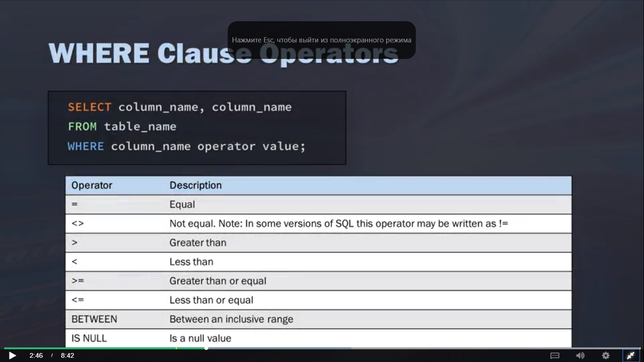

Select *

From customers

Where number in (1,2,3,4)

Where size like ‘_pizza’

Output:

‘spizza’

‘mpizza’

SELECT column_list

FROM tableAVG()ORDER BY

column_1 ASC,

column_2 DESC;

-----------------------------  
COUNT()  
MIN()  
MAX()  
SUM()

SELECT AVG(UnitPrice) AS avg_price

FROM products

SELECT SUM(UnitPrice*UnitsInstock)

AS total_price

FROM Products

WHERE SupplierID = 23;

SELECT COUNT(DISTINCT CustomerID) уникальные значения

FROM Products

SELECT

Region

, COUNT(CustomerID) AS total_customers

FROM Customers

GROUP BY Region;

SELECT SupplierID

, COUNT(*) AS Num_prod

FROM Products

WHERE UnitPrice >= 4

GROUP BY SuppliersID

HAVING COUNT(*) >= 2;

SELECT

CustomerID

,CompanyName

,Region

FROM Customers

WHERE customerID in (Select customerID

From Orders

Where Freight > 100);

Select Count (*) as orders

From Orders

Where customer_id = ‘143569’

Select customer_name

, customer_state

(Select Count (*) As orders

From Orders

Where Orders.customer_id = Customer.customer_id) As orders

From customers

Order by Customer_name

Select product_name

,unit_price

,company_name

From suppliers Cross Join products;

Select suppliers.CompanyName

,ProductName

,UnitPrice

From Suppliers Inner join Products

On Suppliers.suppliersID = Products.suppliersID

Select 0.Order, c.Company, e.LastName

From ((Orders o Inner Join Customers c On o.CustomersID = c.CustomersID)

Inner Join Empoyees e on o.EmployeeID = e.EmployeeID);

Сокращения

Select vendor_name

,product_name

,product_price

From Vendors As v, Products as p

Where v.VendorID = p.VendorID;

Left join

Select C.customerName, O.OrderID

From Customers C

Left Join Orders O on C.CustomerID = o.CustomerID

Order by C.CustomerName

Right join

All the same but ‘Right join’

Full join

All the same but ‘Full Outer Join’

Select Column_name(s) From table1

Union

Select column_name(s) From table2;

Select City, Country From Customers

Where Country=’Germany’

Union

Select City, Country From Suppliers

Where Country=’Germany’

Order by City

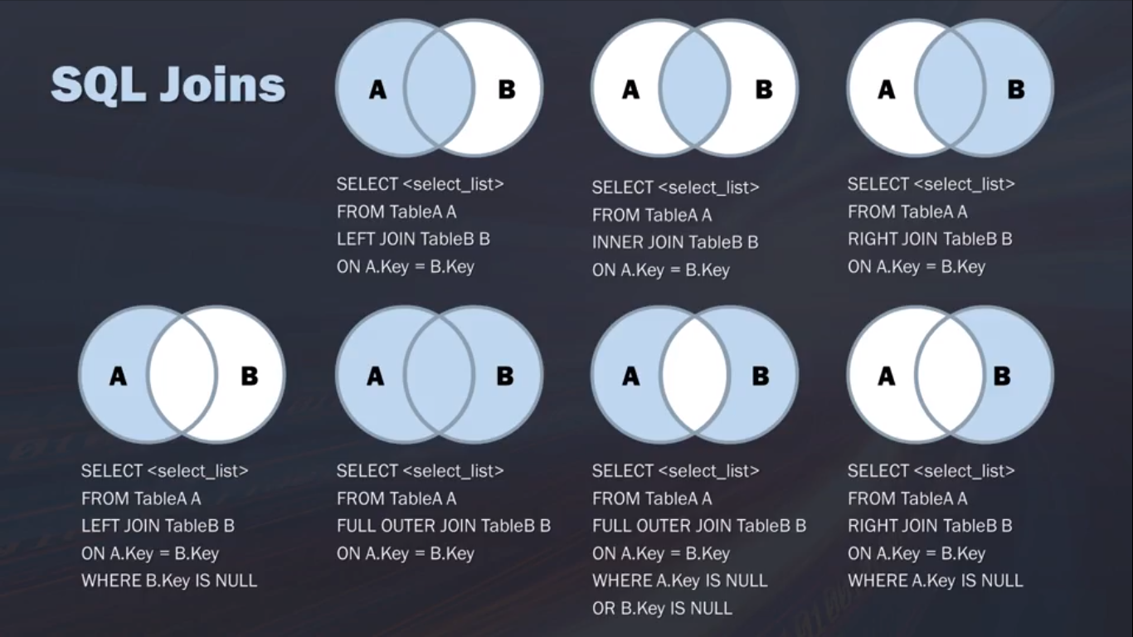

Select first_name, Substr(first_name, 2, 3) substr(строка, начало символа, кол симв.)

From employees substr(‘qwerty’, 2, 3) = wer

Where department_id=60;

Select Upper(column_name) From table_name;

Select Lower(column_name) From table_name;

Select Ucase(column_name) From table_name;

Select Birthdate

, Strftime(‘%Y’, Birthdate) As Year

, Strftime(‘%m’, Birthdate) As Year

, Strftime(‘%d’, Birthdate) As Year

, Date((‘now’)- Birthdate) As Age

From employees

Select Date(‘now’)

Select Strfime(‘%y %m %d’, ‘now’)

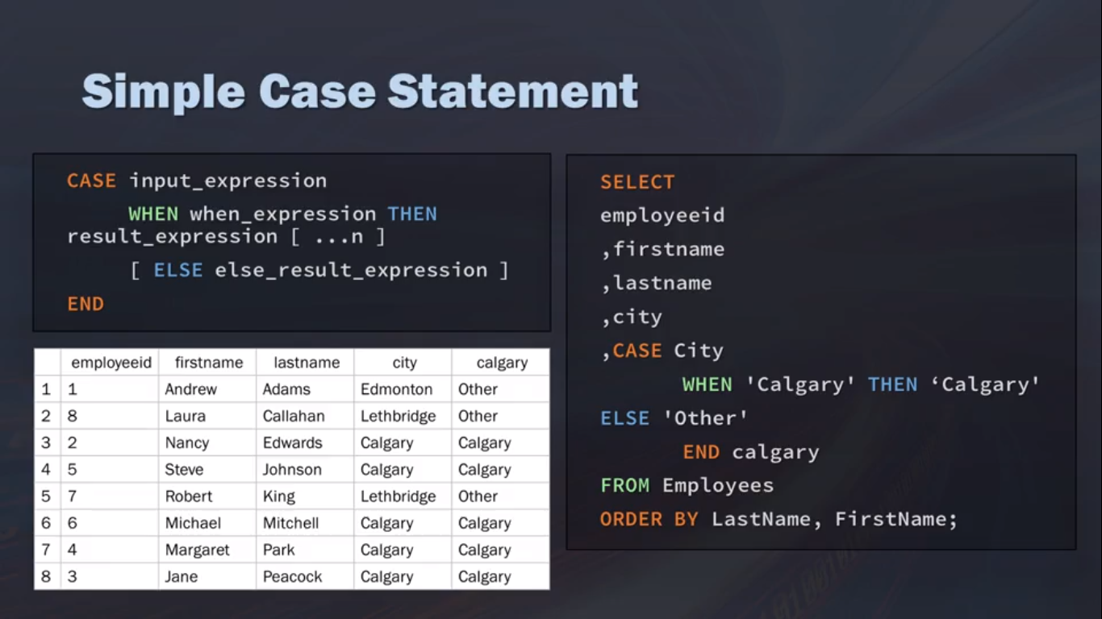

Select

trackId

, name

,bytes

,Case

When bytes < 3000 then ‘small’

When bytes >= 3001 and bytes <= 5000 then ‘medium’

When bytes >= 5001 then ‘large’

Else ‘Other’

End Bytescategory

From tracks;

Create view my_view

As Select

r.regindescription

,t.territorydescryption

,e.Lastname

,e.Hiredate

,e.Reportsto

From region r

Inner join Territories t on r.regionid = t.regionid

Inner join Employeeterritories et on t.territoriesID = et.territoriesID

Inner join Employees e on et.employeeid = e.Employeeid

Select count(territorydescription)

,Lastname

,Firstname

From my_view

Group by Lastname, Firstname

Drop View my_view;

**SPLITING**

SELECT *

FROM …

WHERE

RAND()<0.8

SELECT *

FROM …

WHERE

MOD(ABS(FARM_FINGERPRINT(date)), 10) < 8