**AWS ASSIGNMENT: -01**

========================================================================

* **Create 6 IAM Users:**

1. Alice

2. Bob

3. Charles

4. David

5. Edward

6. Fred

**SOLUTION: -**

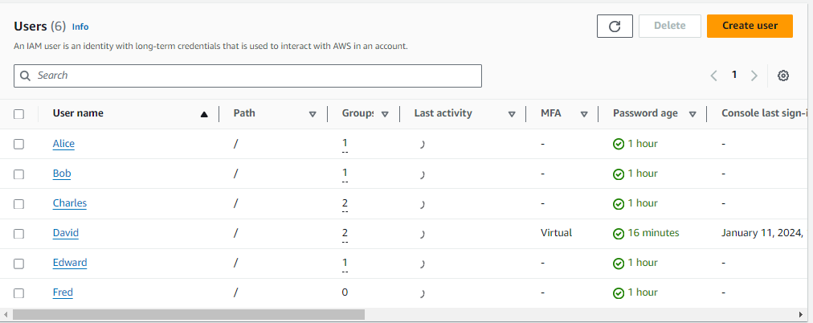

========================================================================

* **Create 3 groups:**

1. Developers

2. Operations

3. Audit-Team

**SOLUTION: -**

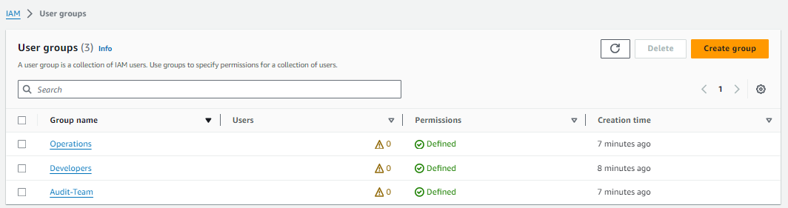

========================================================================

* **Developers group**

Assign the "IAMReadOnlyAccess" policy to the Developers group.

**SOLUTION: -**

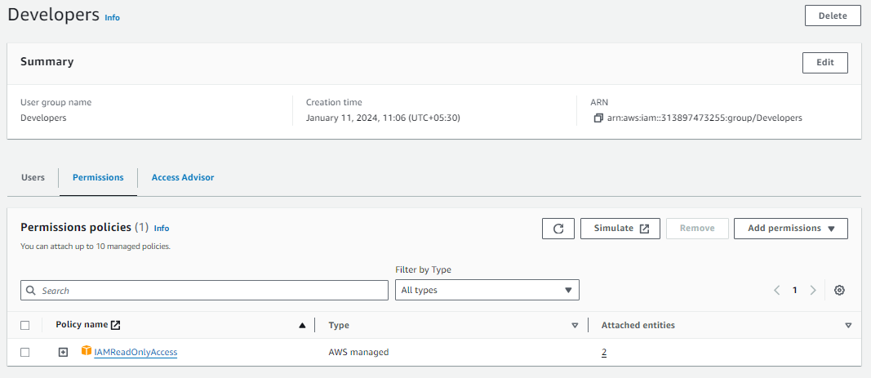

========================================================================

* **Operations group.**

Assign the "IAMReadOnlyAccess" policy to the Operations group.

**SOLUTION: -**

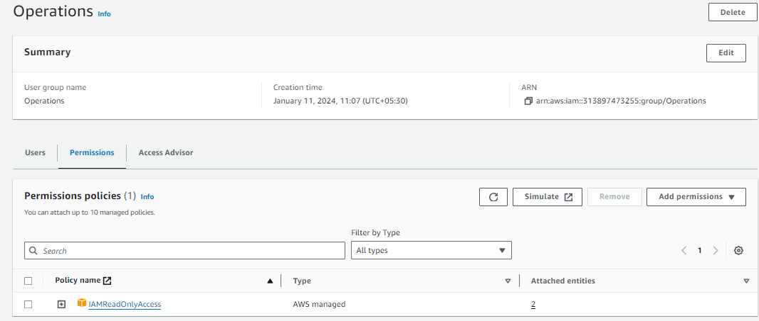

========================================================================

* **Audit-Team**

Assign the "IAMFullAccess" policy to the Audit-Team group.

**SOLUTION: -**

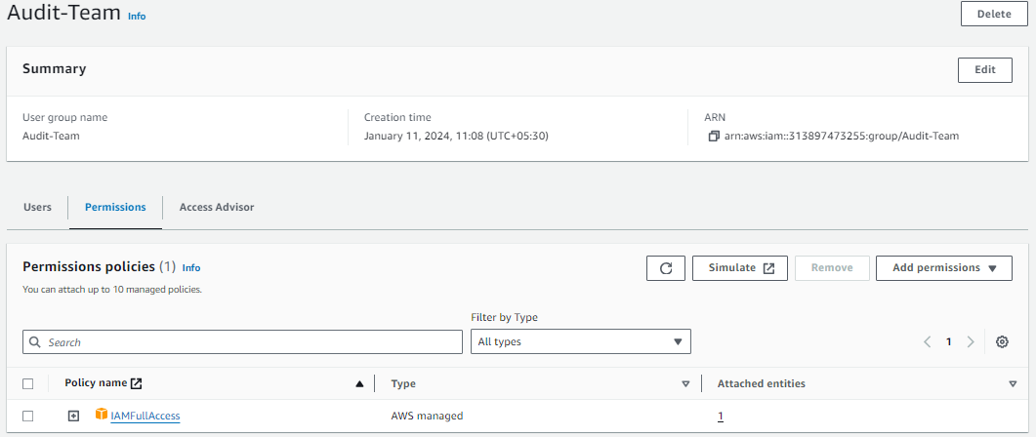

========================================================================

* **Developers group**

Add Alice, Bob, and Charles to the Developers group.

**SOLUTION: -**

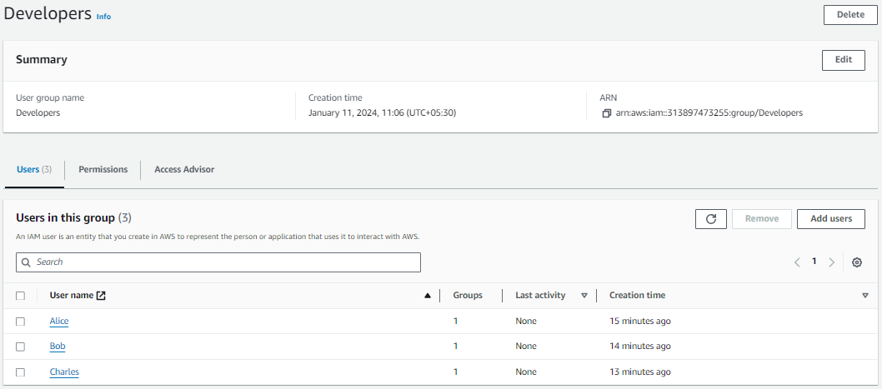

========================================================================

* **Operations group.**

Add David and Edward to the Operations group.

**SOLUTION: -**

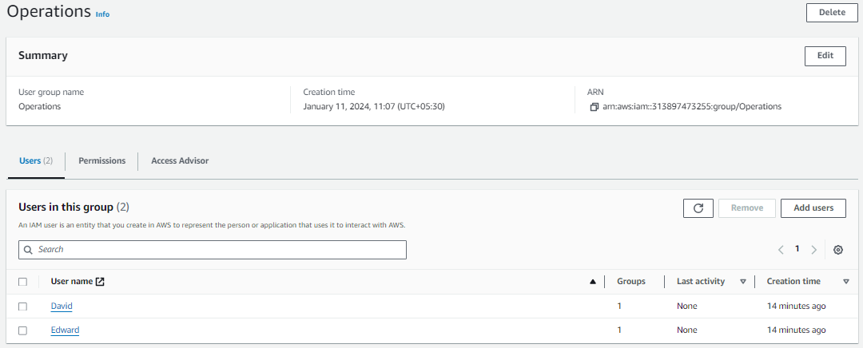

========================================================================

* **Audit-Team**

Add Charles and David to the Audit-Team group.

**SOLUTION: -**

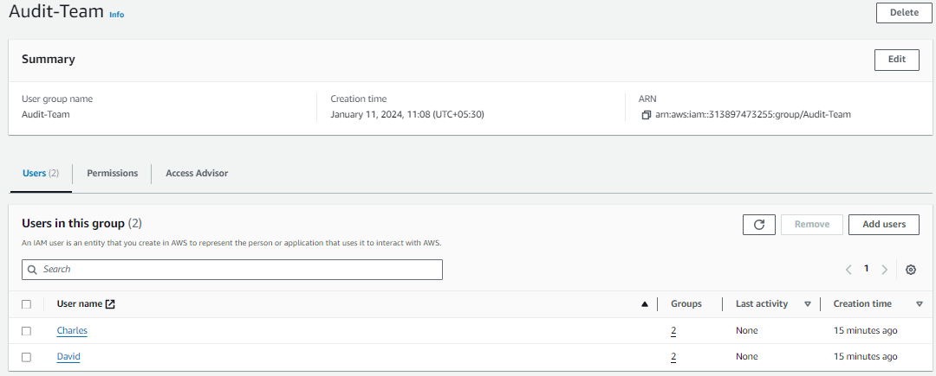

========================================================================

* **Assign an inline policy to Fred.**

**SOLUTION: -**

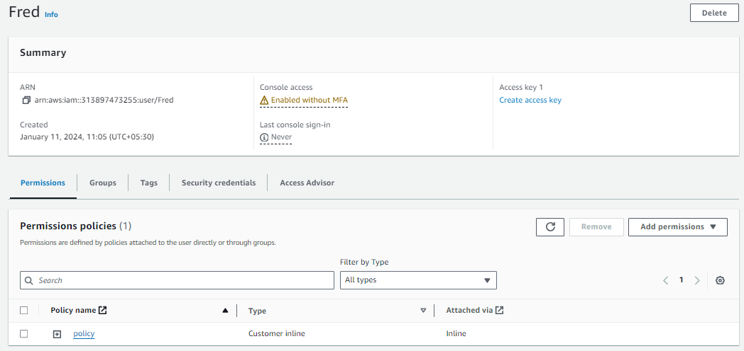

==================================================================================

**Log into the AWS account as an IAM user, add MFA, install AWS CLI, configure it in the terminal, and list IAM user actions using CLI command.**

**SOLUTION: -**

