NON-DISCLOSURE AGREEMENT (NDA)

This Non-Disclosure Agreement (“Agreement”) is made on {effectiveDate}, by and between:

GO-TO Friend Pvt. Ltd., a company incorporated under the laws of India, having its registered office at 3rd Floor, H.R. Vertex, Plot No 76, Behind Apollo Pharmacy, Sec - 3, Geetanjali Colony, Shankar Nagar, Raipur-492004 (hereinafter referred to as the “Company”),
and
{employeeName}, of {employeeAddress}, residing (hereinafter referred to as the “Employee”).

- Purpose
The Employee acknowledges that during the course of employment with the Company, they may have access to confidential and proprietary information belonging to the Company, its clients, and business partners. This Agreement ensures protection of such information.

- Definition of Confidential Information
“Confidential Information” includes, but is not limited to:
- Scripts, storylines, campaigns, advertisements, and unreleased media content.
- Client information, business plans, marketing strategies, financial data.
- Internal communications, operational processes, creative materials, and know-how.
- Any intellectual property, trade secrets, or proprietary knowledge created or accessed during employment.

Confidential Information does not include information that is:
(a) publicly available through no breach by the Employee;
(b) lawfully known to the Employee prior to disclosure;
(c) independently developed without use of Company information;
(d) required to be disclosed by law (with prior written notice to the Company).

- Employee’s Obligations
The Employee agrees to:
- Use confidential Information only for work assigned by the Company.
- Maintain confidentiality during and after employment.
- Not share, copy, reproduce, or disclose any confidential Information without prior written consent from the Company.
- Immediately return or delete all confidential documents/materials upon request or upon termination of employment.

- Non-Disclosure & Non-Use
The Employee shall not:
- Disclose confidential information to third parties (friends, family, competitors, media) without written consent.
- Use confidential information for personal benefit or to assist another party.

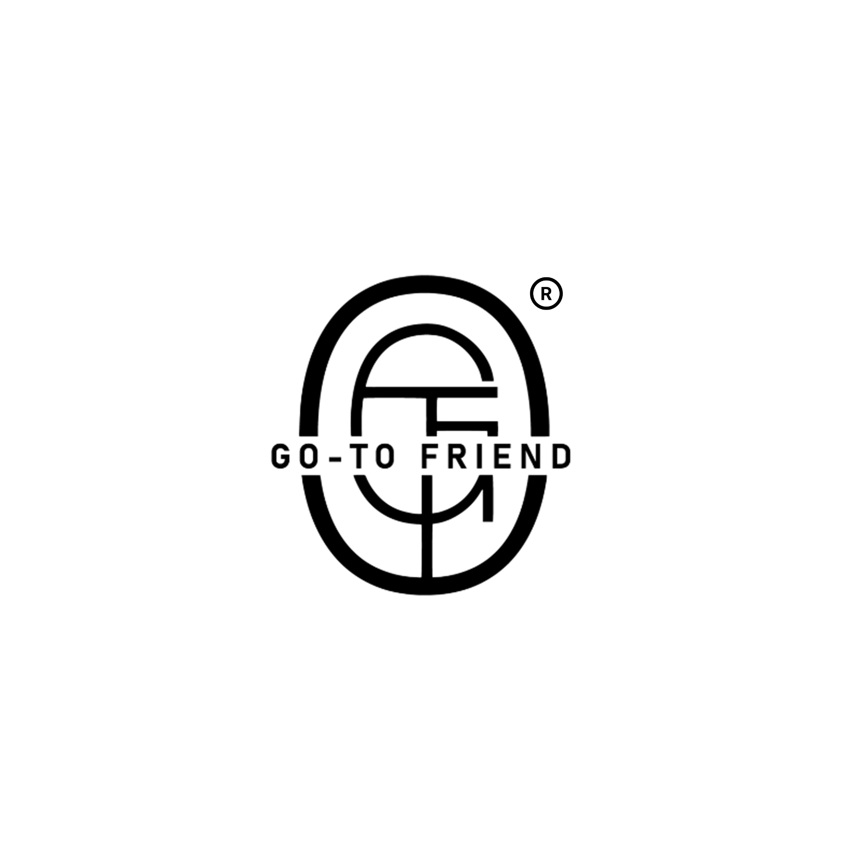
- Share project details or Company-related material on social media or public platforms before official release.

- Intellectual Property Rights
Any work (scripts, designs, edits, campaigns, videos, or other creative outputs) created by the Employee during employment shall be the exclusive property of the Company. The Employee shall have no claim of ownership unless specifically agreed in writing.

- Duration
This Agreement shall remain in effect for the entire duration of the Employee’s employment and shall continue for a period of 6 months after termination of employment, regardless of the reason for termination.

- Remedies for Breach
If the Employee breaches this Agreement, the Company shall be entitled to:
- Take disciplinary action, including termination of employment.
- Seek damages for financial or reputational loss caused.
- Initiate legal proceedings, including injunctive relief.

- Governing Law
This Agreement shall be governed by and construed in accordance with the laws of India, and disputes shall be subject to the exclusive jurisdiction of the courts of Raipur, Chhattisgarh.

- Entire Agreement
This Agreement constitutes the entire understanding between the Company and the Employee with respect to confidentiality and supersedes any prior agreements.

- Signatures

For GO-TO Friend Pvt. Ltd.,

Prakhar Agrawal,
CEO (Chief Executive Officer)
GO-TO Friend Pvt. Ltd.

For Employee:

Name: {employeeName}
Signature: ________________


