**TITLE:- COOKBOOK – THE VIRTUAL KITCHEN**

**INTRODUCTION:**

* Cook Book is a simple and user-friendly recipe website where users can find a wide variety of dishes — from vegetarian and non-vegetarian meals to breakfast items and starters. Each recipe provides ingredient details along with a YouTube video tutorial to guide users step by step in cooking the dish.
* This project is built using HTML, CSS, and JavaScript, focusing on providing an easy and interactive experience for learners and cooking enthusiasts.
* In the digital age, cooking has transcended the boundaries of traditional recipe books and entered the realm of intelligent, interactive platforms. *Cookbook: The Virtual Kitchen* is a cutting-edge web application designed to transform how individuals discover, organize, and create culinary masterpieces. Whether you're a novice home cook or a seasoned professional chef, this virtual assistant offers a seamless, personalized experience that caters to every taste and skill level.
* Built using modern technologies like React, the platform boasts a sleek, user-friendly interface that allows users to explore a vast library of recipes, filter by dietary preferences, and even save and share their own creations. With features like dynamic search, responsive design, and intuitive navigation, Cookbook empowers users to experiment with global cuisines from the comfort of their own kitchen.
* Inside, you'll find recipes crafted with love, tested with care, and flavoured with personal touches. From comforting classics to bold new experiments, each dish reflects the belief that cooking is not just about feeding the body—it’s about nourishing the soul.
* So tie on your apron, sharpen your knives, and let’s dive into the delicious adventure that awaits. May this cookbook become your trusted companion in the kitchen, sparking joy with every stir, sizzle, and serve.

**TEAM MEMBERS:**

* AISHWARYA V
* ANUGRAHA SS
* ASHA A – TEAM LEADER
* ASHIKA T

**FEATURES:**

* Recipe Collection – Includes veg, non-veg, breakfast, and starter recipes.
* Ingredient Details – Each recipe lists required ingredients clearly.
* YouTube Integration – Direct video tutorials for cooking guidance.
* Responsive Design – Accessible on desktop and mobile devices.
* Easy Navigation – Simple UI to quickly find recipes.

**TECHNOLOGY STACK:**

* Frontend: HTML, CSS, JavaScript
* Platform: Web Browser
* Media Integration: YouTube videos

**PROJECT STRUCTURE:**

* index.html Homepage of the website
* style.css Styling for the website
* scripts JavaScript functionality
* assets Images, icons, other resources
* videos Embedded YouTube links .

**USAGE / HOW TO RUN :**

1. Download or clone the project files.

2. Open index.html in any modern web browser (Chrome, Edge, Firefox).

3. Browse through recipe categories (veg, non-veg, breakfast, starter).

4. Click on a recipe to view ingredients and watch the cooking tutorial video.

**TARGET AUDIENCE:**

* Students – who want to cook by themselves.
* Housewives – looking for new dishes.
* Bachelors &amp; Working Professionals – living alone or away from family.
* Anyone Interested in Cooking – beginners or food lovers who want to learn new recipes.

**FUTURE ENHANCEMENT:**

* Add a search bar to find recipes quickly.
* Enable user-submitted recipes.
* Add a rating and review system.
* Convert into a mobile app version.

**JAVA SCRIPT**:

* JavaScript (JS) is a high-level, interpreted programming language primarily used to make
* web pages interactive, dynamic, and user-friendly. Along with HTML (structure) and
* CSS (style), JavaScript is one of the core technologies of the World Wide Web.
* It is often called the language of the web because nearly every website uses it to some
* extent, and all modern browsers.
* A **dynamic, interpreted programming language** used to create interactive and responsive web pages.
* Originally developed by **Brendan Eich** in 1995 and first appeared as **Live Script** before being renamed.

**KEY FEATURES :**

* Lightweight &amp; Interpreted – Runs directly inside the browser without compilation.
* Cross-platform – Works on any device with a browser (Windows, Mac, Linux, Android,
* iOS).
* Event-driven – Reacts to user actions like clicks, input, or page load.
* Object-oriented – Based on prototypes; supports classes since ES6.
* Dynamic typing – Variables don’t require explicit data type declarations.
* Asynchronous support – Handles tasks like API calls efficiently with callbacks, promises.

**HTML:**

* HTML (Hyper Text Markup Language) is the standard language for creating webpages.
* It defines the structure and content of a webpage using a system of tags (markup).
* Think of HTML as the skeleton of a webpage, while CSS adds style (appearance) and
* JavaScript adds interactivity (behaviour).

**KEY TAGS OF HTML:**

* <header>: Top section, often with site title or navigation
* <section>: Divides content into logical blocks
* <footer>: Bottom section with copyright or links
* <a h ref="#section-id">: Enables smooth scrolling between sections

**KEY FEATURES:**

* Simple and text-based – Easy to learn and read.
* Platform-independent – Runs on any device/browser.
* Hyperlinking – Connects documents through links.
* Media support – Embeds images, audio, video, and interactive content.
* Forms – Enables user input and interaction.
* Semantic elements – Provides meaningful structure (&it; header& ;, &it; article& ;, &it; footer&;).
* Integration with CSS &amp; JS – Works with styling and scripting to build full websites.

**CSS:**

* CSS (Cascading Style Sheets) is a stylesheet language used to control the
* appearance, layout, and design of HTML documents.
* If HTML is the skeleton, CSS is the skin, clothes, and colours that make a
* Website look appealing. It separates content (HTML) from presentation
* (CSS), allowing developers to style multiple pages consistently.

**KEY FEATURES:**

* Separation of style from content – HTML handles structure, CSS handles
* design.
* Selectors – Target HTML elements using tags, classes, IDs, or attributes.
* Box Model – Each element is treated as a rectangular box (content, padding,
* border, margin).
* Responsive Design – Media queries allow websites to adapt to different
* screen sizes.
* Flexbox &amp; Grid – Modern layout systems for building complex designs.
* Animations &amp; Transitions – Smooth effects without JavaScript

**USER INTERFACE:**

This webpage is a recipe web application built with React (as seen from the browser tab “React App” and the localhost URL).

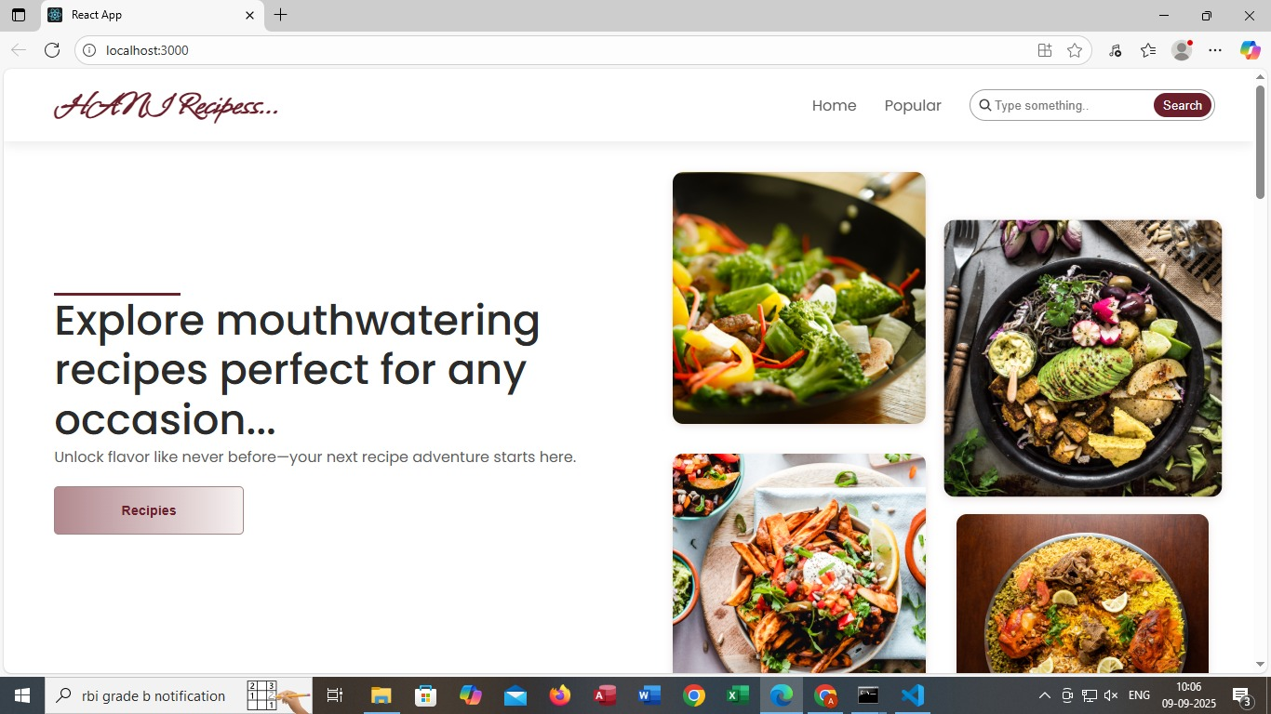

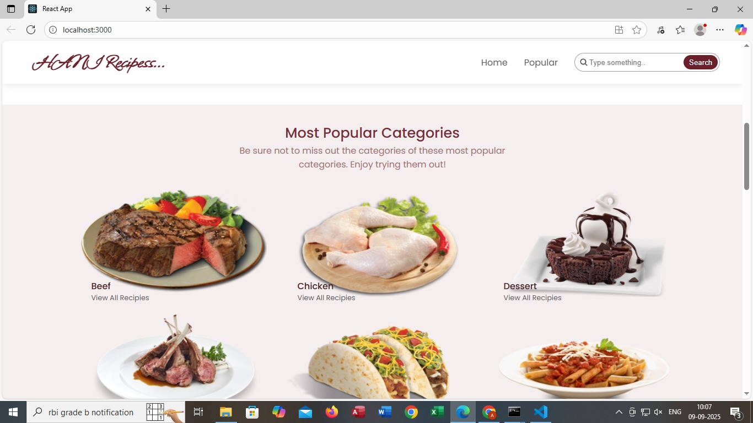

This page is for "H&M Recipes..." (though it seems like a typo and might be meant to be "Homemade Recipes"). It's a webpage showing "Most Popular Categories" of recipes. You've got Beef, Chicken, and Dessert categories displayed with images and a "View All Recipes" option for each. There's also a partial view of three more categories at the bottom: Lamb Chops, Tacos, and Pasta. The page has navigation options like Home, Popular, and a search bar. 😋

On this page, the Beef category shows an image of a grilled beef steak served with veggies on a plate. You can click "View All Recipes" under Beef to explore more beef-based recipes. Beef is one of the most popular categories highlighted on this Homemade Recipes webpage. 🍔🔥

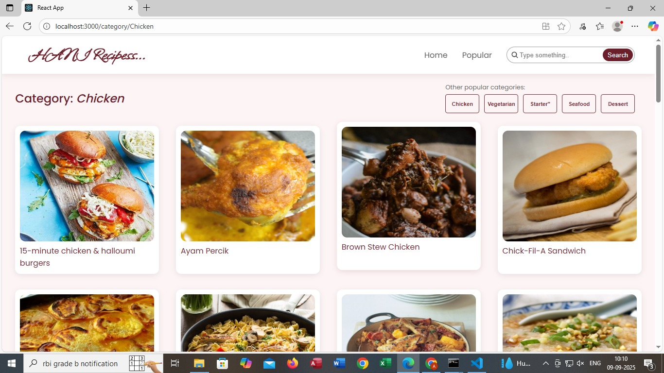

* Here’s a breakdown of the page:
* **Header Section (Top Bar):**
* Logo: "**HANI Recipes**..." styled in cursive.
* Navigation menu with links like Home and Popular.
* A search bar with placeholder text “Type something...” and a "Search" button to find recipes.
* **Hero Section (Main Highlight):**
* A large heading: “Explore mouthwatering recipes perfect for any occasion...”
* A subheading: “Unlock flavour like never before—your next recipe adventure starts here.”
* A button labelled “Recipes” to guide users toward the recipe collection.
* **Image Gallery (Right Side):**
* A grid of high-quality food images, showcasing different dishes such as salads, bowls, frie…

**OUR SIGNATURE RECIPES:**

**🧁 BATTERNBERG CAKE( PINK & YELLOW PATTERN)**

* Battenberg Cake is a classic British sponge cake known for its distinctive pink and yellow checkered pattern. Traditionally, it's made by baking two colored sponge cakes separately, then slicing and assembling them into a checkerboard layout. The pieces are glued together with apricot jam and wrapped in a smooth layer of marzipan, giving it a sweet almond finish.
* It’s believed to have been created in 1884 to celebrate the marriage of Princess Victoria (Queen Victoria’s granddaughter) to Prince Louis of Battenberg, hence the name. The cake quickly became a royal favorite and remains a charming centerpiece at British tea tables today.
* The Battenberg cake—an absolute British classic! 🇬🇧 I found some delightful images for you, and they should be showing up now.
* This charming sponge cake is known for its distinctive checkerboard pattern, typically pink and yellow squares, wrapped in a layer of marzipan. It’s held together with apricot jam and often served at tea time. The visual appeal is half the fun, but the almond flavor and soft texture make it a treat worth savoring.

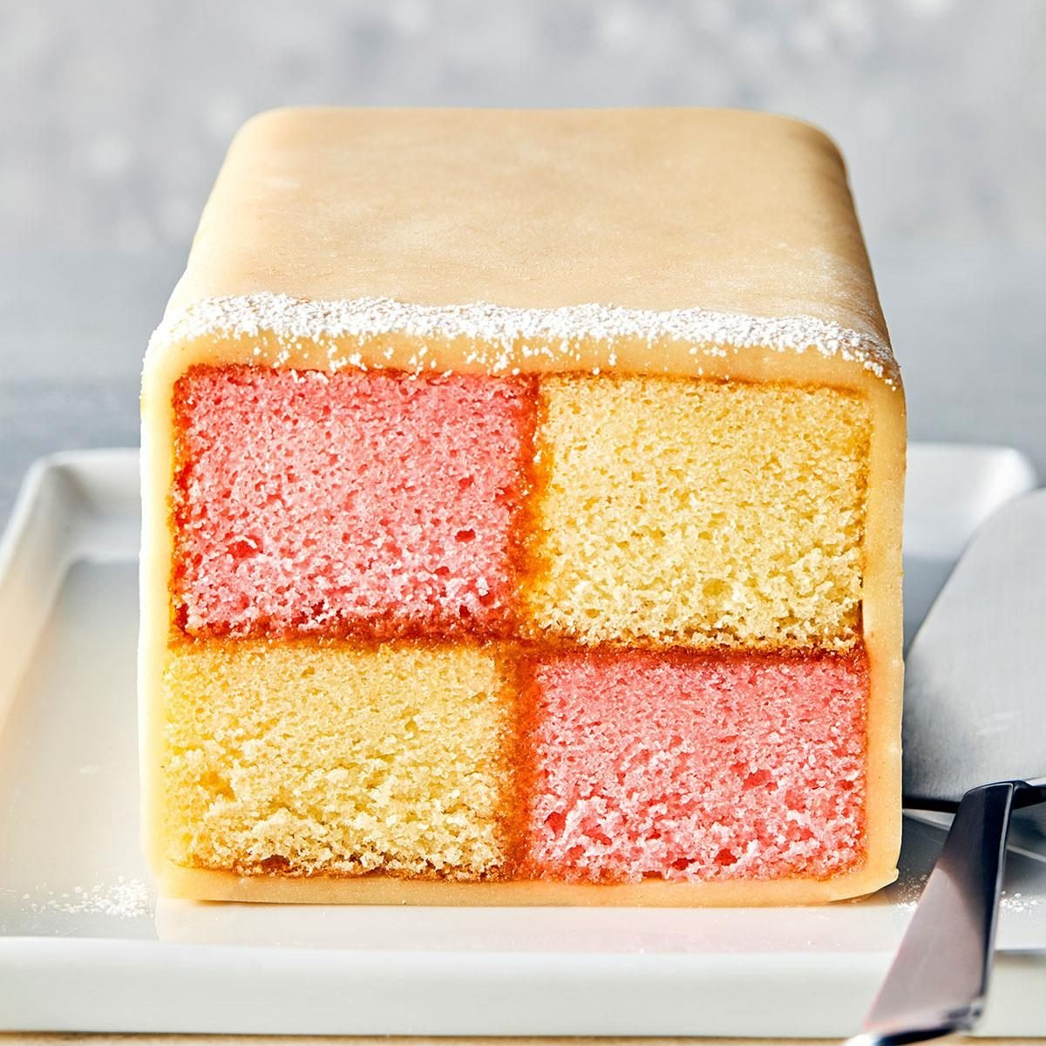

**INGREDIENTS:**

* 175g very soft butter
* 175g golden caster sugar
* 140g self-raising flour
* 50g ground almonds
* ½ tsp baking powder
* 3 medium eggs
* ½ tsp vanilla extract
* ¼ tsp almond extract
* Pink food colouring
* 200g apricot jam
* 2 blocks white marzipan
* Icing sugar (for dusting)

**🥣 INSTRUCTIONS:**

* Preheat Oven Heat oven to 180°C (160°C fan) or gas mark 4. Line a 20cm square tin with parchment paper, crossing two strips for easy removal.
* **Make the Almond Sponge** In a large bowl, beat butter, sugar, flour, ground almonds, baking powder, eggs, vanilla, and almond extract until smooth. Pour into the tin and bake for 25–30 minutes. Cool on a wire rack.
* **Make the Pink Sponge** Repeat the sponge-making process, omitting almond extract and adding pink food colouring. Bake and cool as above.
* **Cut and Assemble** Trim edges of both sponges. Measure the height and cut each sponge into four equal strips. Arrange two pink and two almond strips in a checkerboard pattern, using warmed and sieved apricot jam to stick them together.
* **Wrap in Marzipan** Roll out marzipan to 0.5cm thickness. Brush with jam and place the sponge checkerboard on top. Wrap marzipan around the cake, sealing the edges and trimming excess. Crimp edges with fingers or a fork.
* **Serve or Store** Mark slices with a fork if desired. Store in an airtight container for up to 3 days or freeze for up to a month.

**🍛 MATAR PANEER (PEAS & COTTAGE CHEESE CURRY)**

A classic North Indian vegetarian dish made with soft paneer cubes and green peas simmered in a spiced tomato-onion gravy. Comforting, flavorful, and perfect with roti or rice.

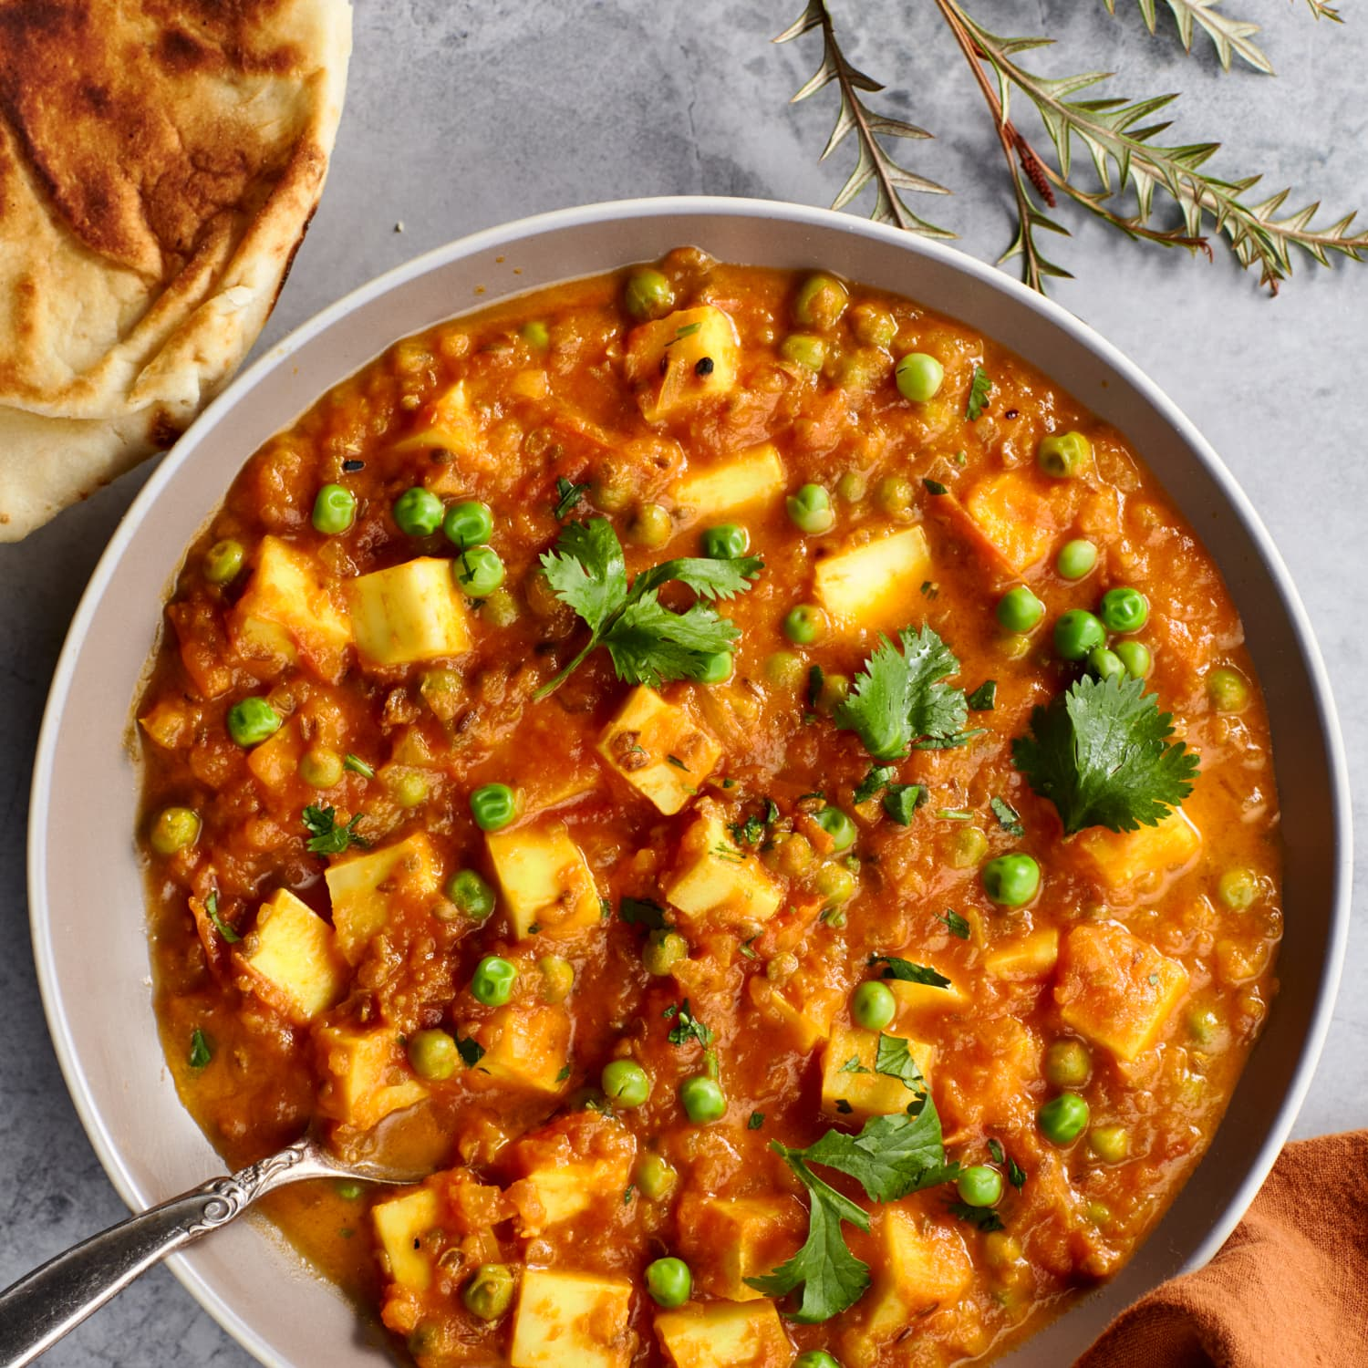

**🧾 Ingredients:**

* 250g paneer (cubed)
* 1 cup green peas (fresh or frozen)
* 2 medium onions (finely chopped)
* 1 cup tomato purée
* 1 tsp ginger-garlic paste
* ½ tsp turmeric powder
* 1 tsp cumin seeds
* 1 tsp coriander powder
* ½ tsp garam masala
* Salt to taste
* 2 tbsp oil or ghee
* Fresh coriander leaves (for garnish)

👨‍🍳 **Instructions:**

1. **Sauté spices**: Heat oil in a pan. Add cumin seeds and let them splutter. Add onions and sauté until golden.
2. **Cook the base**: Add ginger-garlic paste, tomato purée, turmeric, coriander powder, and salt. Cook until oil separates.
3. **Add peas & paneer**: Stir in green peas and paneer cubes. Add a splash of water and simmer for 10 minutes.
4. **Finish**: Sprinkle garam masala and garnish with chopped coriander. Serve hot.

**KNOWN ISSUES:**

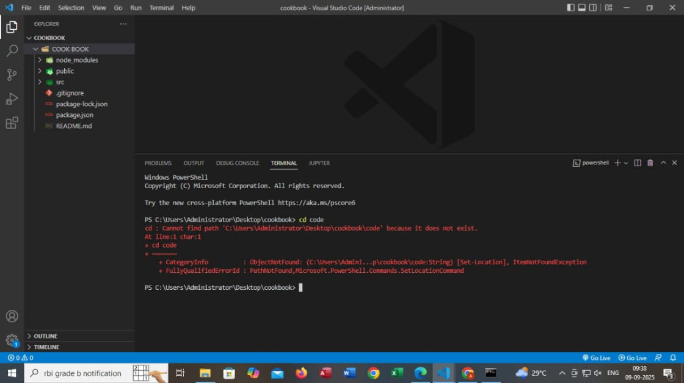

The error in this picture is a "PathNotFound" error in PowerShell.

Error message: cd : Cannot find path 'C:\Users\Administrator\Desktop\cookbook\code' because it does not exist.

Cause: The directory code does not exist within the cookbook directory.

CategoryInfo: ObjectNotFound

FullyQualifiedErrorId: PathNotFound,Microsoft.PowerShell.Commands.SetLocationCommand.

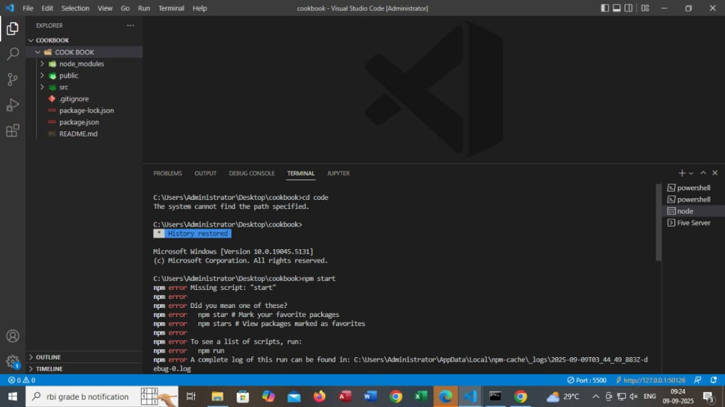

The error in the picture is due to running npm start in a directory where there's no script named "start" defined in package.json.

npm is suggesting alternatives like:

- npm star to mark favorite packages

- npm stars to view packages marked as favorites

**LINK TO A DEMO SHOWCASING:**

* https://drive.google.com/file/d/1H35nUerdu65UjTNtbnxVEU3nb6-