**Jamia Millia Islamia**

**Dept. Of Computer Science**

**LI & GD Assignment-2**

**Submitted By**:Wasit Shafi **Submitted To**: Dr.Shamsul Haq Ansari

**Roll no**: 18MCA054

**Q1) Define the term “Group”. Explain the types of Group.**

**Sol.**

Definition: A Group is basically an assemblage of people. It can be understood as a collection of individuals (two or more), who come together and interact with each other, so as to achieve the objectives of the organization.

**Formal Groups:** Groups that are formed consciously by the management, with an aim of serving an organizational objective. These are further classified as:

* **Self-directed teams:** The group of employees which are so authorised to make decisions, on their own, as it is independent and self-governing in nature.
* **Quality Circles:** A number of employees classed together belonging to the same field, who meet every week for an hour, to talk about their problems, identify the causes and find out solutions, to take necessary steps in this regard.
* **Committees:** An association of people created by the management for different matters to identify and discuss the issues of the company and arrive at a conclusion. It can be:
  + Standing Committee
  + Advisory Committee
  + Audit Committee
  + Grievance Committee
  + Adhoc Committee.
* **Task force :** It is a temporary committee, wherein people belonging to different fields are grouped together for the performance of the task.

**Informal Groups:** The social and psychological variables operating at the workplace, results in the formation of informal groups. The creation of these groups is spontaneous due to the common interest, social needs, physical proximity and mutual attraction.

**Q2) Differentiate between the terms “Group” and “Team”?**

**Sol**.

|  |  |  |
| --- | --- | --- |
|  | **Group** | **Team** |
| **Meaning** | A collection of individuals who work together in completing a task. | A group of persons having collective identity joined together, to accomplish a goal. |
| **Leadership** | Only one leader | More than one |
| **Members** | Independent | Interdependent |
| **Process** | Discuss, Decide and Delegate. | Discuss, Decide and Do. |
| **Work** **Products** | Individual | Collective |
| **Focus** **on** | Accomplishing individual goals. | Accomplishing team goals. |
| **Accountability** | Individually | Either individually or mutually |

**Q3) Discuss the different reasons to form groups or teams.**

## Sol.

**Reasons for Group Formation**

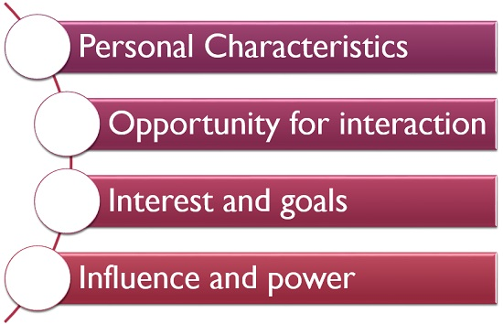

**Personal Characteristics:** Individuals with similar beliefs, attitudes and values are more likely to form groups.

**Opportunity for interaction:** If the employees of an organization, are given an opportunity to interact with one another, they find that they have many things similar, which also creates a group.

**Interest and goals:** When individuals share common interest and goals, it requires cooperation and coordination for its achievement, which also results in the formation of groups.

**Influence and power:** Last but not the least, a group has more influence and power, as compared to an individual, which also promotes its formation.

**Q4) Explain “group cohesiveness”.**

**Sol.**

Group cohesiveness (also called group cohesion and social cohesion) arises when bonds link members of a social group to one another and to the group as a whole. Although cohesion is a multi-faceted process, it can be broken down into four main components: social relations, task relations, perceived unity, and emotions. Members of strongly cohesive groups are more inclined to participate readily and to stay with the group.

Cohesion can be more specifically defined as the tendency for a group to be in unity while working towards a goal or to satisfy the emotional needs of its members. This definition includes important aspects of cohesiveness, including its multidimensionality, dynamic nature, instrumental basis, and emotional dimension. Its multidimensionality refers to how cohesion is based on many factors. Its dynamic nature refers to how it gradually changes over time in its strength and form from the time a group is formed to when a group is disbanded.

**Q5) Discuss main successive stages of group development given by Tuckman.**

**Sol.**

Bruce Tuckman presented a model of five stages Forming, Storming, Norming, and Performing in order to develop as a group:

* Orientation (Forming Stage)
* Power Struggle (Storming Stage)
* Cooperation and Integration (Norming Stage)
* Synergy (Performing Stage)
* Closure (Adjourning Stage)

1. **Orientation (Forming Stage)**

The first stage of group development is the forming stage. This stage presents a time where the group is just starting to come together and is described with anxiety and uncertainty.

Members are discreet with their behavior, which is driven by their desire to be accepted by all members of the group. Conflict, controversy, misunderstanding and personal opinions are avoided even though members are starting to form impressions of each other and gain an understanding of what the group will do together.

1. **Power Struggle (Storming Stage)**

The second stage of group development is the storming stage. The storming stage is where dispute and competition are at its greatest because now group members have an understanding of the work and a general feel of belongingness towards the group as well as the group members.

This is the stage where the dominating group members emerge, while the less confrontational members stay in their comfort zone.

1. **Cooperation and Integration (Norming Stage)**

In this stage, the group becomes fun and enjoyable. Group interaction are lot more easier, more cooperative, and productive, with weighed give and take, open communication, bonding, and mutual respect.

If there is a dispute or disruption, it’s comparatively easy to be resolved and the group gets back on track.

Group leadership is very important, but the facilitator can step back a little and let group members take the initiative and move forward together.

**4) Synergy (Performing Stage)**

Once a group is clear about its needs, it can move forward to the third stage of group development, the norming stage. This is the time where the group becomes really united.

At this stage, the morale is high as group members actively acknowledge the talents, skills and experience that each member brings to the group. A sense of belongingness is established and the group remains focused on the group's purpose and goal.

1. **Closure (Adjourning Stage)**

This stage of a group can be confusing and is usually reached when the task is successfully completed. At this stage, the project is coming to an end and the team members are moving off in different directions.

This stage looks at the team from the perspective of the well-being of the team instead of the perspective of handling a team through the original four stages of team growth.