Bitcoin-Candy (CDY) mining is supported by both Nvdia and AMD graphic card. Here is the Tutorial.

First of all, get your CDY address to receive payment：

Download the bitcoin-qt wallet, click ‘Receive’ button, and then click ‘Request payment’. You can click ‘Copy Address’ to copy the CDY address after the QR code page pops up.

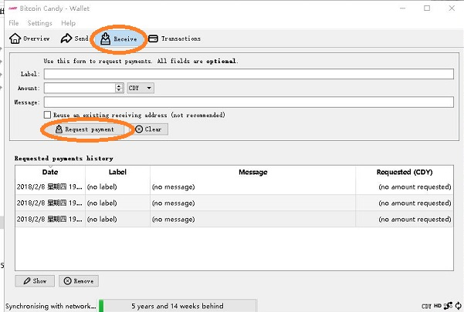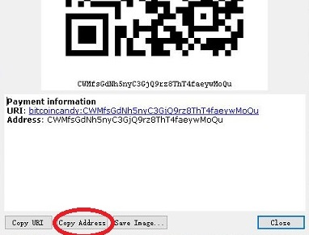

Or you can get CDY address in an online wallet. We use Bitpie wallet as an example.

Download the newest version of Bitpie wallet, switch your currency to **CDY**, and click ‘收币’, which means receiving payment. See the left figure.

There’ll pop up the QR code page, you can copy the character address below by clicking on the address.

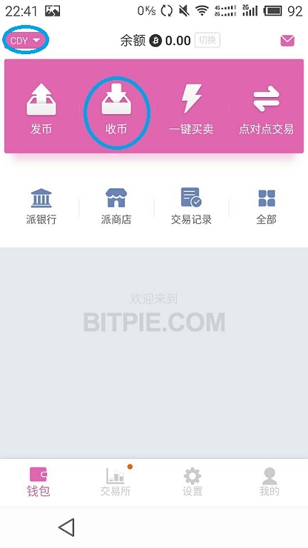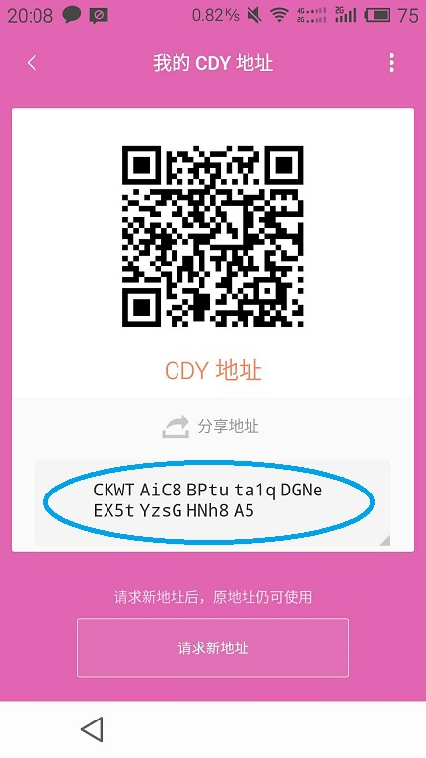

For Nvdia Card on Window Platform, download *BitcoinCandy-nVidia.miner.0.3.4b.windows*：

Step 1: open and edit file ***start-CDY.bat***, the original text should be：miner --server pool.cdy.one --user CPH3VKnSbSgYgyBi5gqm35phEBMDfVhnaF.MyWorker --pass x --port 3857. Change the address ‘CPH3VKnSbSgYgyBi5gqm35phEBMDfVhnaF’ with your CDY address. Save and close the file.

Step 2: open and edit file ***miner.cfg***. Fill main server address with ***pool.cdy.one***, and the additional server 1 with ***pool2.cdy.one***. Substitute the CDY address with yours after ‘user’. Save and close it.

Step 3: double click **start-CDY.bat** to start mining.

For Nvdia Card on Linux Platform, download *Bitcoin-Candy-nVidia.miner.0.3.4b.Linux.Bin*：

Step 1: open and edit file ***start-bitcoin-candy.sh***, the original text should be：./miner --server pool.cdy.one --user CPH3VKnSbSgYgyBi5gqm35phEBMDfVhnaF.MyWorker --pass x --port 3857. Change the address ‘CPH3VKnSbSgYgyBi5gqm35phEBMDfVhnaF’ with your CDY address. Save and close the file.

Step 2: open and edit file ***miner.cfg***. Fill main server address with ***pool.cdy.one***, and the additional server 1 with ***pool2.cdy.one***. Substitute the CDY address with yours after ‘user’. Save and close it.

Step 3: run ./***start-bitcoin-candy.sh*** in terminal.

For AMD card on Windows platform, download *Claymore.s.BitcoinCandy.AMD.GPU.Miner.v12.6*

Step 1: open and edit ***config.txt***, substitute the CDY address ‘CPH3VKnSbSgYgyBi5gqm35phEBMDfVhnaF’ after ‘user’ with your own one. Save and close it.

Step 2: open and edit ***epools.txt,*** Fill **POOL** address with ***pool.cdy.one***, and the **1POOL** address with ***pool2.cdy.one***. Substitute the CDY address with your own CDY address after ‘**WALLET**’. Save and close it.

Step 3: double click ***start.bat*** to run mining.

For AMD card on Linux platform, download *Claymore.s.BitcoinCandy.AMD.GPU.Miner.v12.6.-.LINUX*

Step 1: open and edit ***config.txt***, substitute the CDY address ‘CPH3VKnSbSgYgyBi5gqm35phEBMDfVhnaF’ after ‘user’ with your own one. Save and close it.

Step 2: open and edit ***epools.txt,*** Fill **POOL** address with ***pool.cdy.one***, and the **1POOL** address with ***pool2.cdy.one***. Substitute the CDY address with your own CDY address after ‘**WALLET**’. Save and close it.

Step 3: run ./***start.bash*** in terminal.