**DAILY ONLINE ACTIVITIES SUMMARY**

|  |  |  |  |  |  |  |  |  |  |
| --- | --- | --- | --- | --- | --- | --- | --- | --- | --- |
| **Date:** | **13-07-2020** | | | | **Name:** | | | **ASHIKA** | |
| **Sem & Sec** | **6th  Sem ‘A’ Sec** | | | | **USN:** | | | **4AL17CS016** | |
| **Online Test Summary** | | | | | | | | | |
| **Subject** | | **CNSC** | | | | | | | |
| **Max. Marks** | |  | | | | | **Score** | **-** | |
| **Pre-Placement Training Summary** | | | | | | | | | |
| **Course** | **-** | | | | | | | | |
| **Faculty** | | |  | | | **Duration** | | |  |
| **Coding Challenges** | | | | | | | | | |
| Problem Statement: | | | | | | | | | |
| **Status: done** | | | | | | | | | |
| **Uploaded the report in Github** | | | | **Yes** | | | | | |
| **If yes Repository name** | | | | <https://github.com/ASHIKA-05/DAILY-REPORT> | | | | | |
| **Uploaded the report in slack** | | | | **Yes** | | | | | |

**Coding Challenge:**

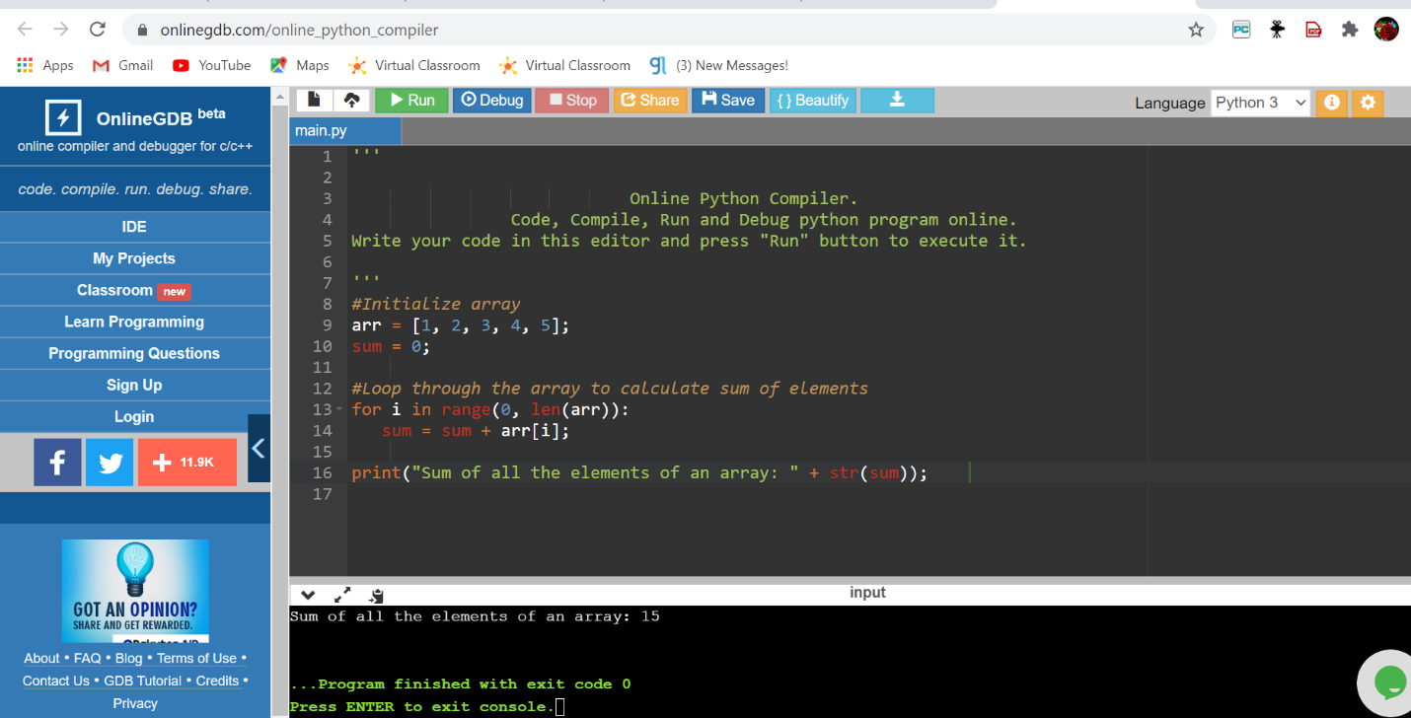

**Course**

