**Brand Name**: Crystal spark

**Brand Category**: Jewellery

**Target Audience**: All(Men, Women, and Kids)

**Email**: [crystalsparkjewellery@gmail.com](mailto:crystalsparkjewellery@gmail.com)

**Steps involved in brand promo video**

**Step 1:** selecting the template from canva for the brand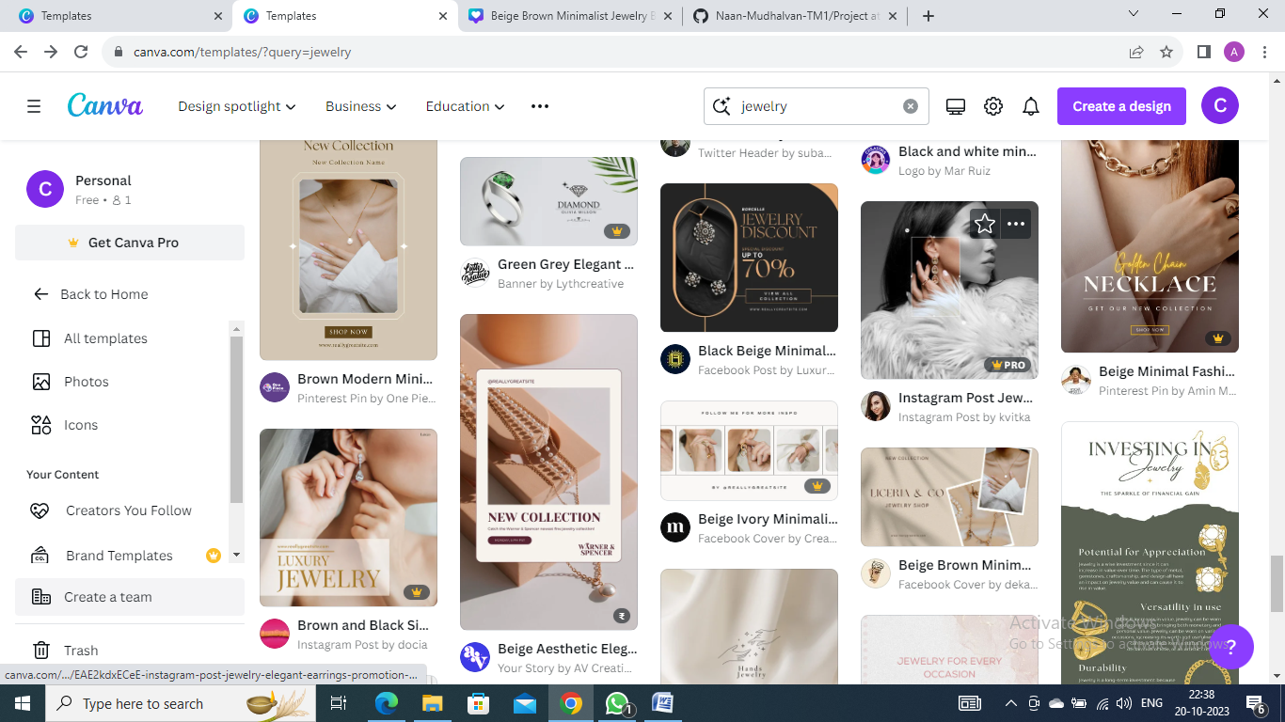

**Step2:** Editing based on our logo design and brand 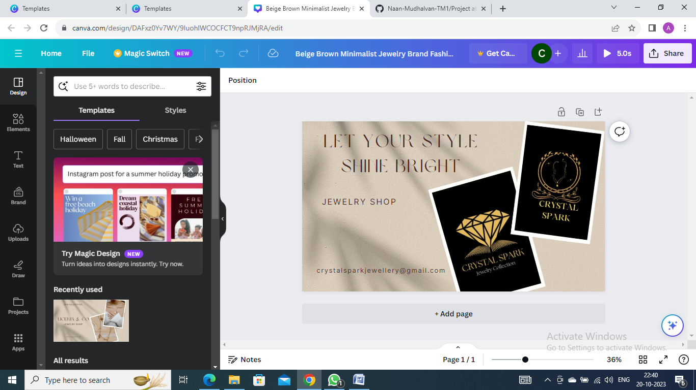

**Step 3:** Creating the final canva video promo with 60 sec by merging all the templates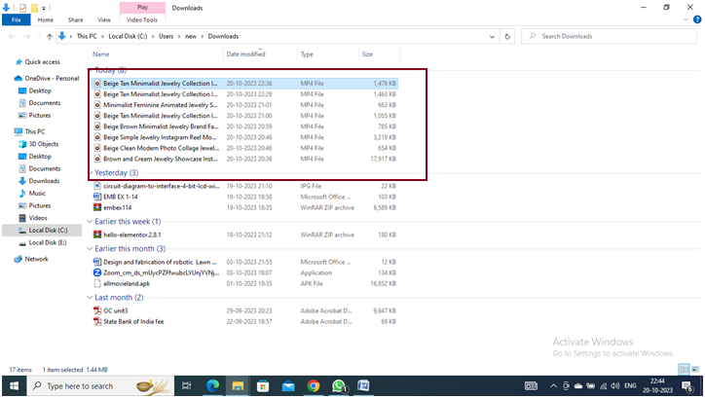

**Step 4:**Canva promo video is finally created

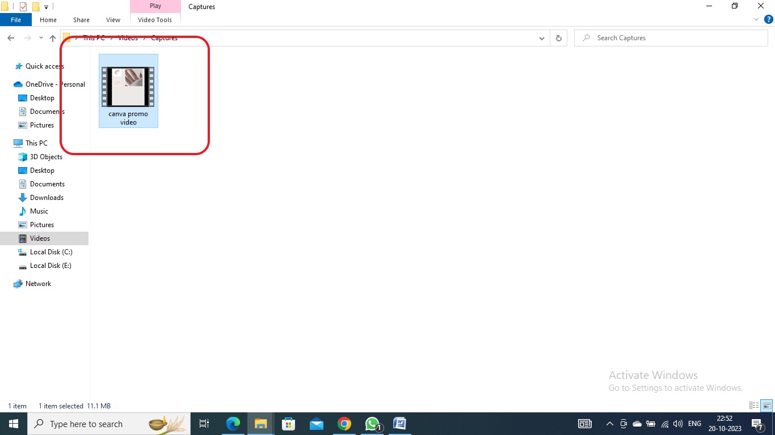

**Step 5: upload the canva promo video in youtube or social media website like FB, Insta and share the links.**

**Canva promo link:**

**Link:** https://www.facebook.com/61552573293830/posts/pfbid02qt7gtsNZGkVe2psdJrujX2z5VhQ4Z8wD7DyxiZRdnwn2Ho2rBHtpi7FApjHrt7SNl/

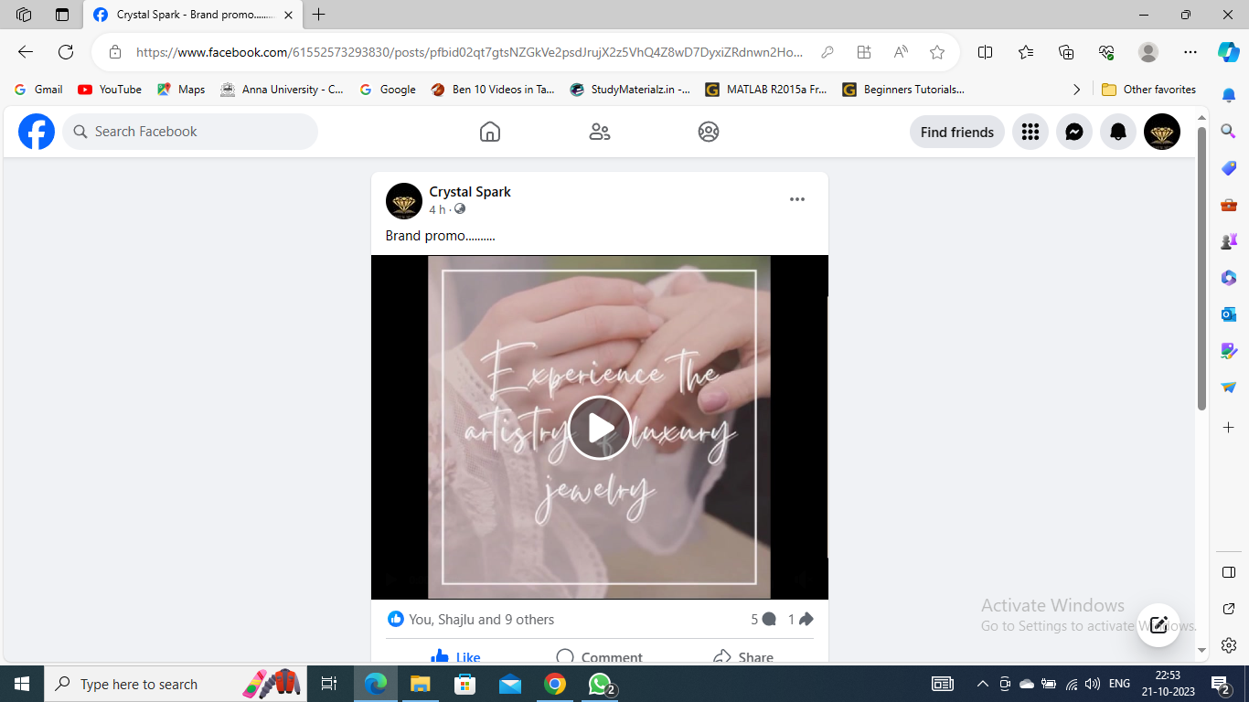

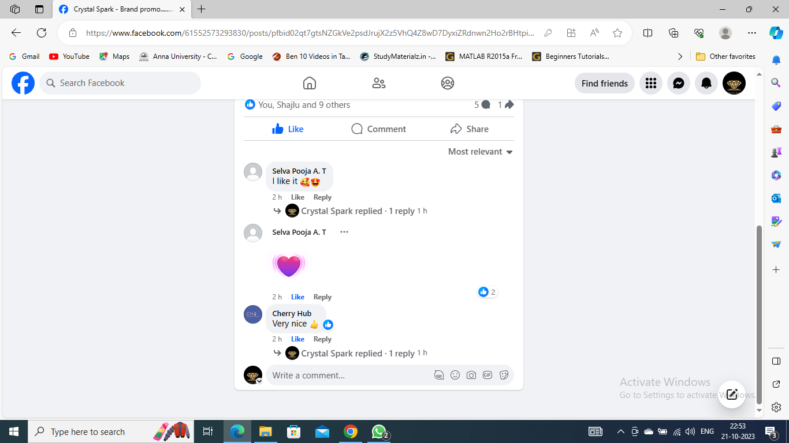

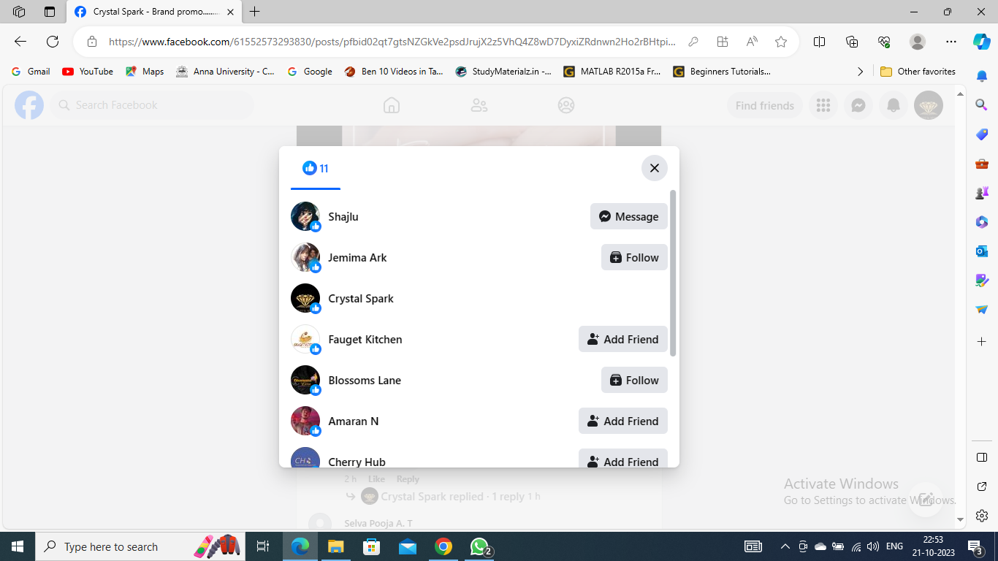

**Step 6:** upload the demo video link

**Link:**

https://drive.google.com/file/d/1EKkOR-6zupAPCUIcHFB0gFKDF4JfarZT/view?usp=drivesdk