**File named ‘tech’ in HDFS**

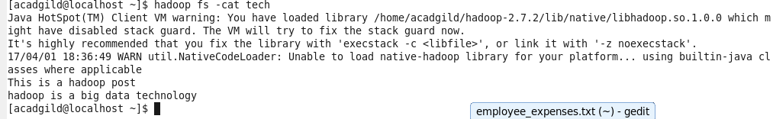

**Load the data from HDFS**

**lines = load ‘/user/acadgild/tech’ AS (line:chararray);**

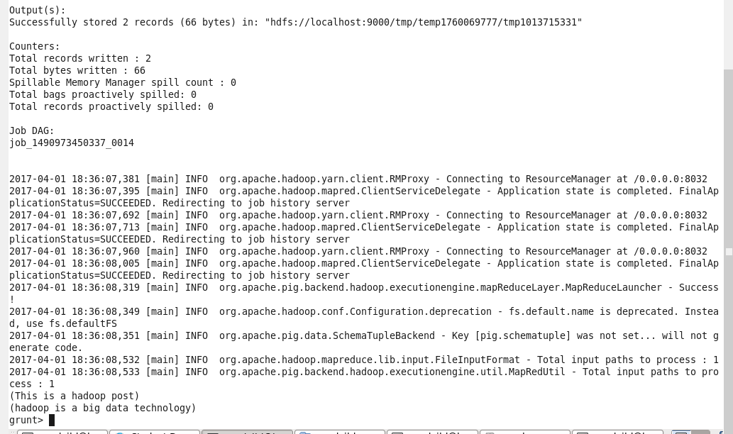

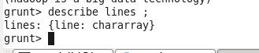

**Convert the sentence into words**

**words = FOREACH lines GENERATE FLATTEN (TOKENIZE(LINE)) as word ;**

**output**

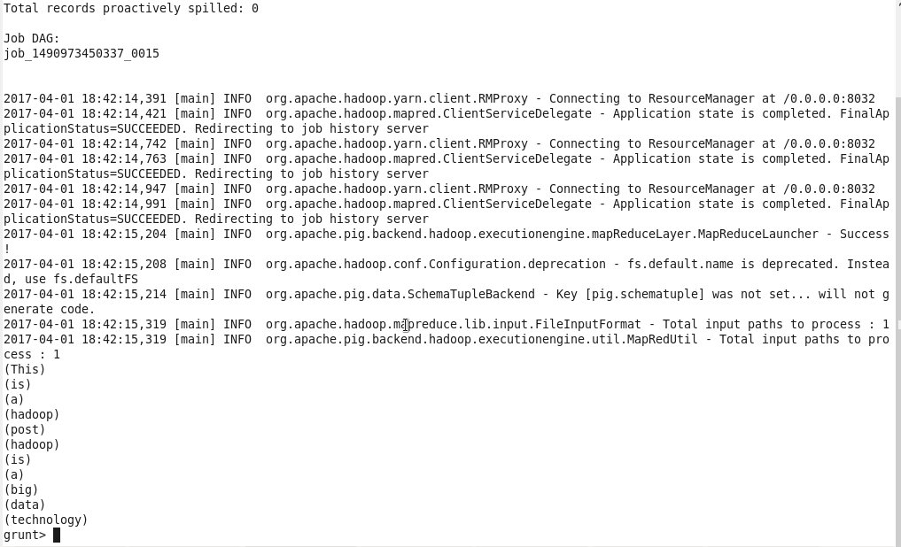

**Apply GROUP BY**

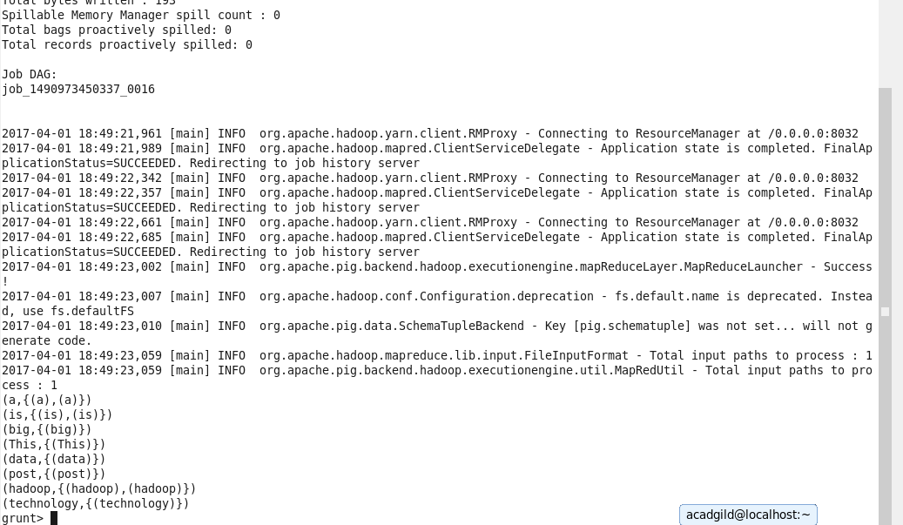

**Generate word count**

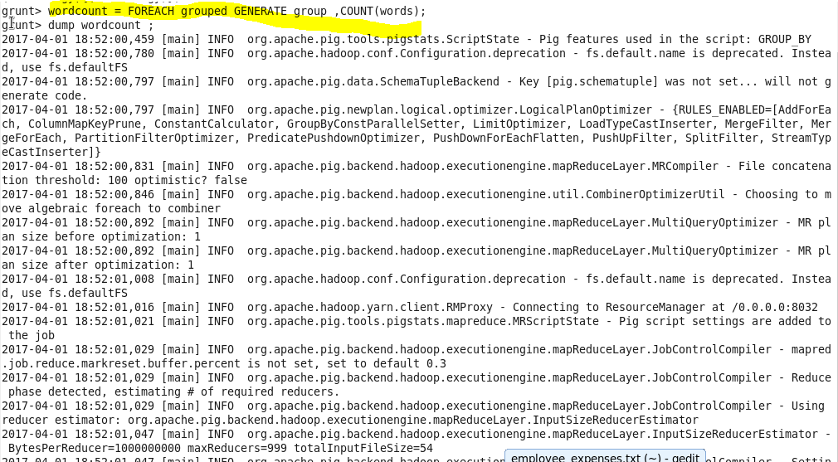

**Print the wordcount**

**Dump wordcount**

