# **USA Crime Analysis**

**This dataset contains attributes related to crimes taking place in various areas like type of crime, FBI code related to that criminal case, arrest frequency, location of crime etc.**

**Using Flume to load the data in HDFS**

**Data file in below path**

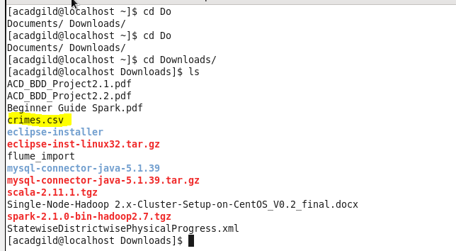

**Run the flume agent**

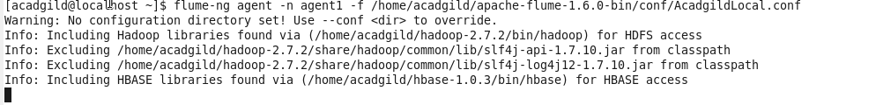

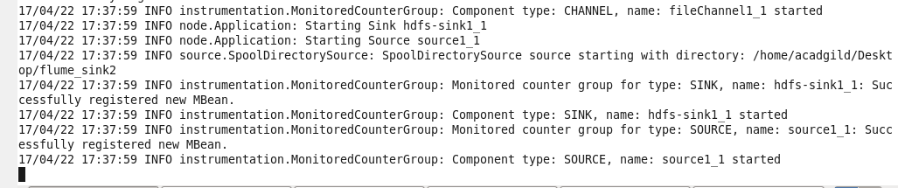

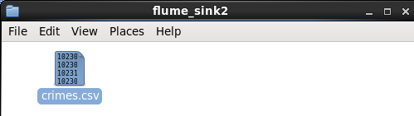

**After complete loading**

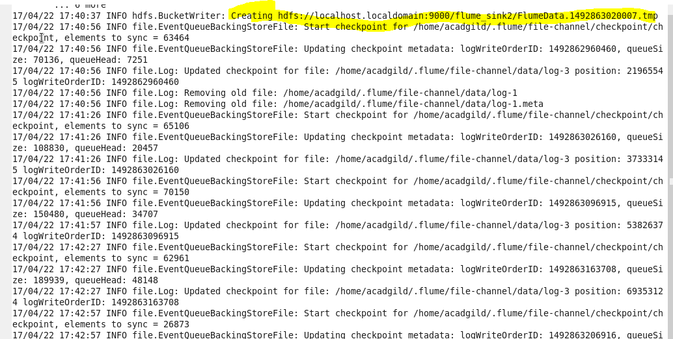

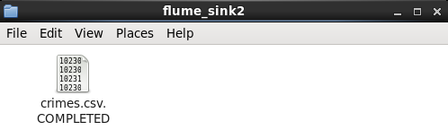

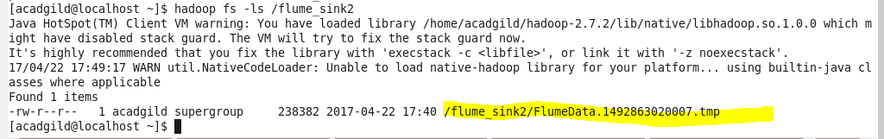

**Creating pig relation**



# **1.Write a mapreduce/pig program to calculate the number of cases investigated under each FBI code**





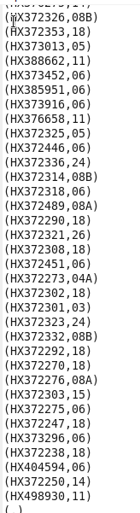





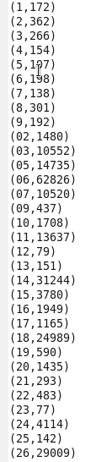

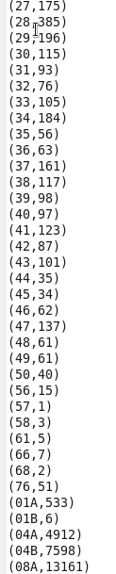



# **2.Write a mapreduce/pig program to calculate the number of cases investigated under FBI code 32.**



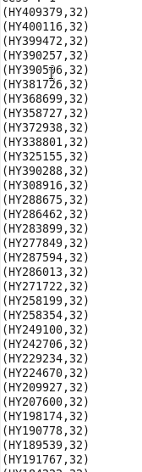



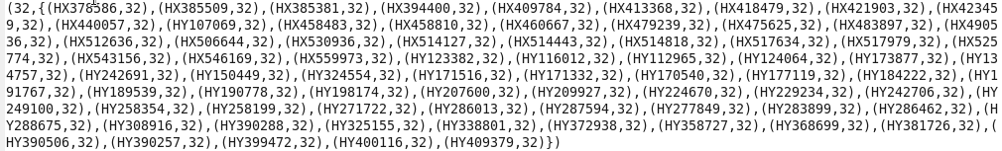



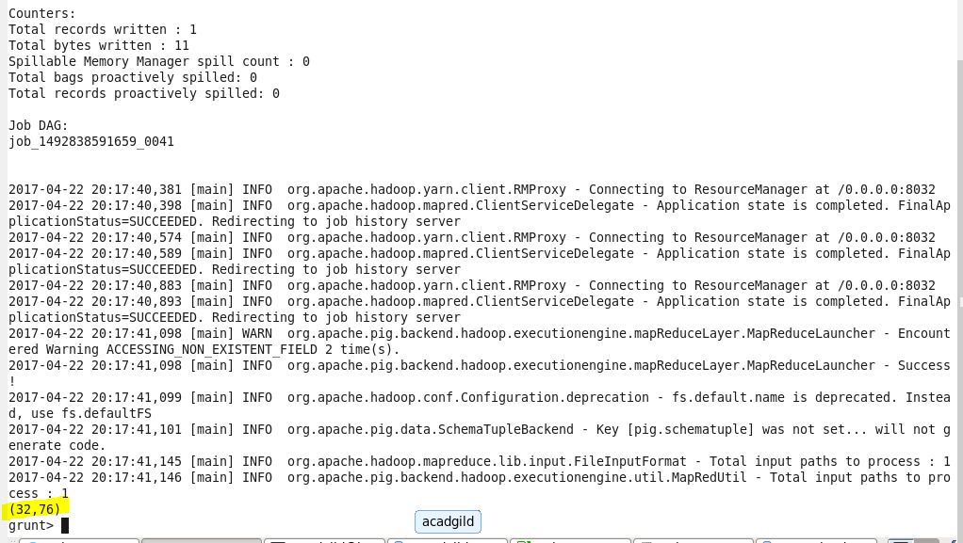

# **3.Write a mapreduce/pig program to calculate the number of arrests in theft district wise.**



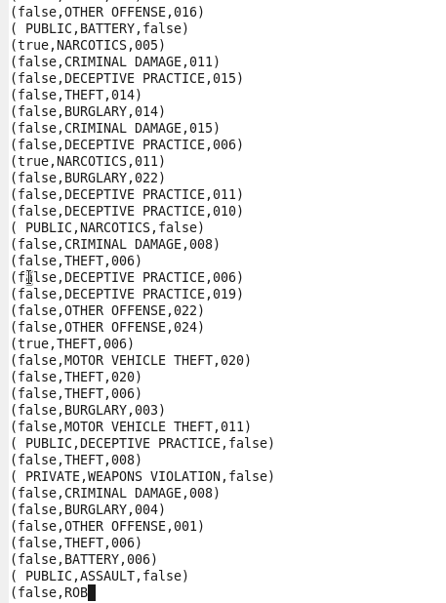

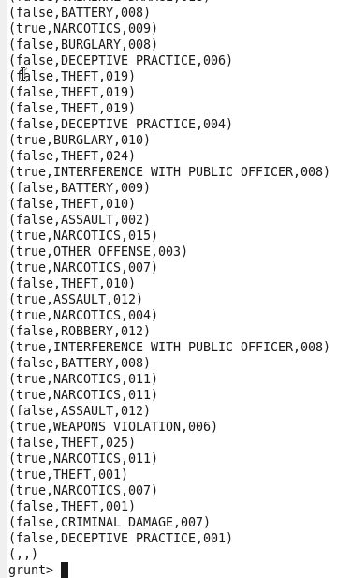



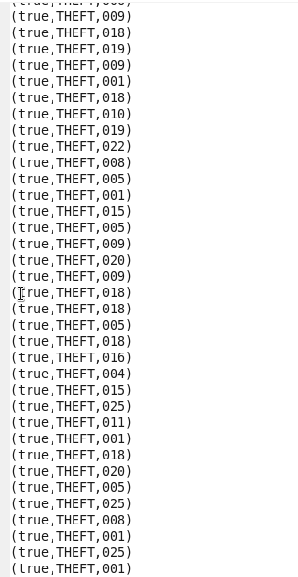



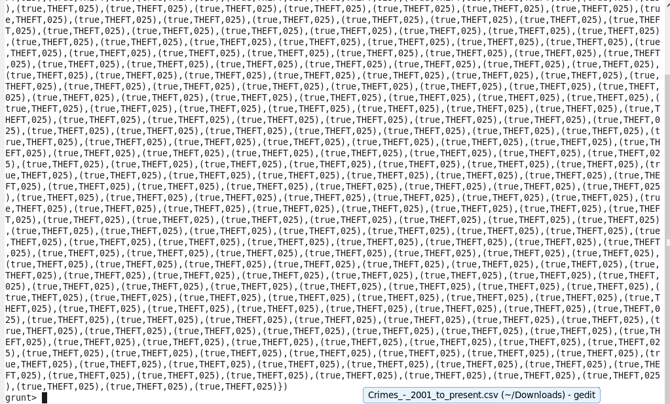



**Final output: district and total cases as required for theft**

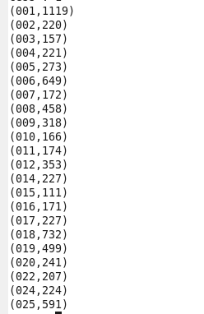

# **4.Write a mapreduce/pig program to calculate the number of arrests done between october 2014 and october 2015.**





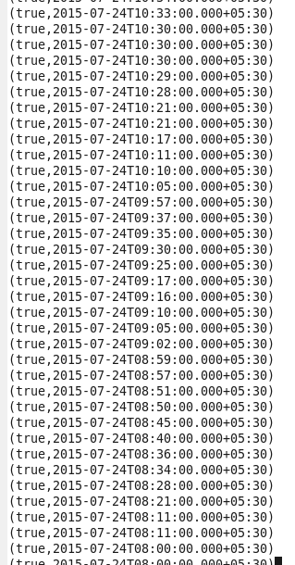

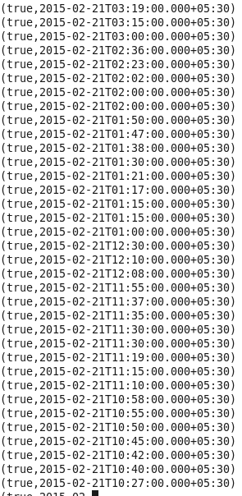

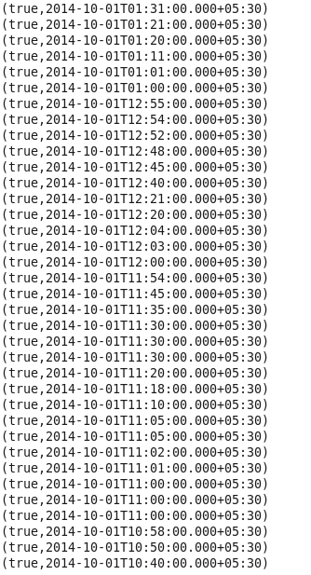



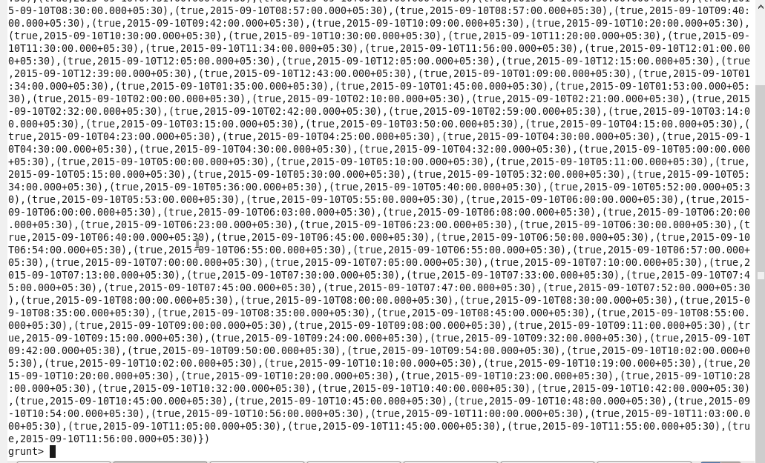



**True here means arrested**

**So total number of arrests between oct 2014 and oct 2015 = 63173**

