**Performance Analysis of AODV Protocol in MANETs: Impact of Node Density and Transmission Range on Packet Delivery Ratio and Throughput using NS-3**

Completed by:

Ashish Chauhan(121CS0156)

Pranav Prakash Ranjan (121CS0212)

Ashutosh Dalai(121CS0157)

Adaysha Kiran Dash(121CS0163)

Aakash Kumar Biswal(121CS0152)

**Network Simulation Laboratory**

**Submitted on:5th November 2024**



**CONTENT**

Page No.

1. Introduction 3
   1. Background 3

2. Workflow and Algorithm 4

2.1. Flowchart 4

2.2. Algorithm 6

3. Simulation Results and Analysis 7

3.1. Simulation and Configuration 7

3.2. Performance Analysis 8

3.2.1. Throughput 8

3.2.2. End to End Delay 9

3.3.3. Packet Loss 10

4. Conclusion 11

5. Manual 12

6. Learnings 13

1. **Introduction**
   1. **Background**

The Ad hoc On-Demand Distance Vector (AODV) protocol is widely used in Mobile Ad hoc Networks (MANETs) due to its efficient route discovery and maintenance. Unlike traditional protocols, AODV dynamically establishes routes only when requested by source nodes, minimizing network overhead. In this project, using the ns-3 simulator, we explore AODV’s performance across a network of 100 nodes with positions set by the manet.csv file. By adjusting transmission ranges and node densities, we aim to measure packet delivery ratio and throughput, analysing the network's response to changing parameters.

**2. Flowchart and Algorithm**

**2.1. Flowchart:**

**The flowchart is as follows:**

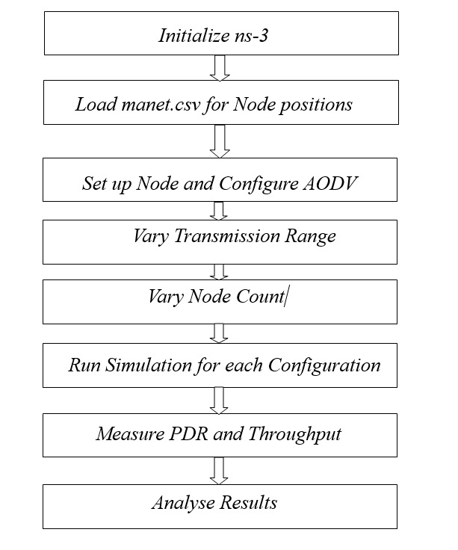

**Flowchart and Algorithm**

The flowchart can be given as follows:

**Initialize ns-3:** Set up the environment for the ns-3 simulator. It includes simulating parameters such as simulation time and initial set-up for the usage of the AODV protocol.

1. **Initialize NS-3**: Begin by initializing the NS-3 simulation environment, which provides the framework to model network behaviors and interactions.
2. **Load “manet.csv” for Node Positions**: Load the file manet.csv, which contains the X-Y coordinates of the 100 nodes for this simulation. These positions will dictate the spatial organization of nodes within the network, providing the foundation for the simulation by establishing node locations and initial configurations.
3. **Set Up Nodes and Configure AODV**: After loading the node positions, simulate the network with each node actively involved, and configure AODV as the routing protocol. Using AODV ensures that this protocol will handle the routing process for packet transmission and manage route discovery across nodes, maintaining dynamic paths for efficient data delivery.
4. **Vary Transmission Range**: Adjust the transmission range to define the maximum distance over which each node can send data. This variation affects the connectivity between nodes, as larger ranges enable wider connections, while smaller ranges limit node reachability. These adjustments in transmission range will show how connectivity changes impact network structure and AODV performance.
5. **Vary Node Count**: Modify the network’s node density by changing the number of active nodes for different simulation runs. Increasing or decreasing node count will allow observation of AODV’s performance under varying network loads, helping identify how node density impacts route stability and data transmission efficiency.
6. **Run Simulations for Each Configuration**: Conduct simulations for every possible combination of transmission range and node count. Each unique configuration simulates a different network condition, requiring multiple runs to capture the performance of AODV under varied settings and to ensure results accurately reflect the protocol's behavior in diverse environments.
7. **Measure PDR and Throughput**: Utilize :Flow Monitor within NS-3 to monitor Packet Delivery Ratio (PDR) and throughput for each simulation run. PDR will measure the efficiency of packet delivery, while throughput will indicate data transmission capacity. These metrics are essential for assessing AODV’s performance across configurations.
8. **Analyse Results**: After all simulations are complete, analyse the collected data to identify trends in PDR and throughput across different transmission ranges and node densities. This analysis will reveal insights into how AODV performs under changing network conditions, allowing evaluation of its strengths and weaknesses in terms of connectivity, stability, and data handling efficiency.

**2.2. Algorithm**

**a. Route Discovery (On-Demand)**

* Initiates route discovery only when a source node requires a path to a destination.
* Sends a Route Request (RREQ) packet to neighbouring nodes.

**b. Broadcasting RREQ**

* Each node receiving the RREQ forwards it to its neighbors if it doesn’t have a valid route to the destination.
* RREQ propagation continues until it reaches the destination or a node with a fresh route to the destination.

**c. Route Reply (RREP)**

* The destination node, or an intermediate node with a fresh route, sends a Route Reply (RREP) back to the source.
* RREP traverses back along the path established by RREQs, updating routing tables en route.

**d. Route Maintenance**

* Routes remain active as long as they are being used.
* If a link break occurs, the affected node sends a Route Error (RERR) to inform upstream nodes.

**e. Sequence Numbers for Freshness**

* AODV uses sequence numbers to ensure routes are loop-free and up-to-date, allowing nodes to select the most recent route.

**f. Periodic Hello Messages**

* Nodes broadcast hello messages periodically to maintain connectivity with neighbours.

This algorithm ensures efficient, on-demand routing in dynamic, decentralized networks, minimizing routing overhead and adapting quickly to network topology changes.

**3. Results and Discussion**

**3.1. Simulation and Configuration**

* **Version of ns3**: ns-3.35
* **Total Source Nodes**: 1 (assuming a total of 100 nodes)
* 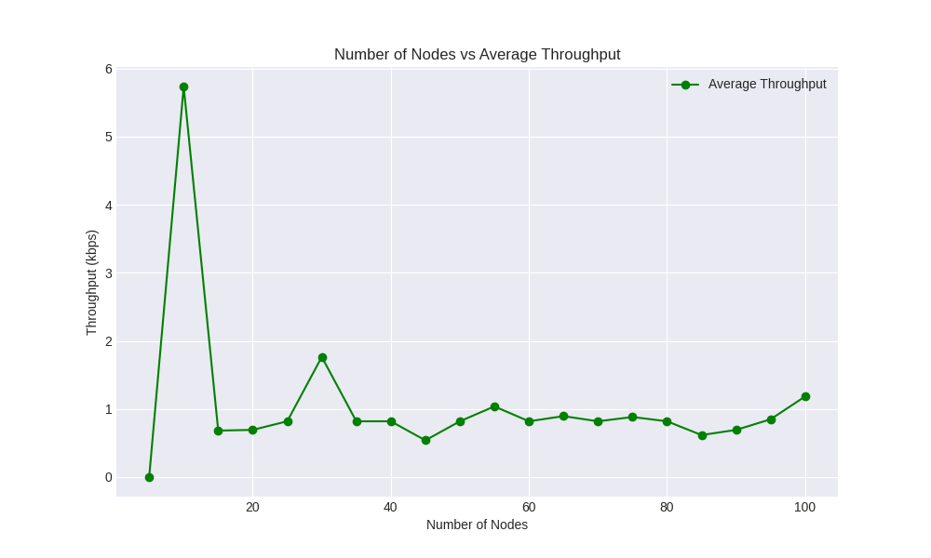**Total Destination Nodes**: 99 (assuming a total of 100 nodes)
* **Number of Routers**: 100
* **Queue Management**: DropTailQueue.
* **Link Management**: **YansWifiChannel** and **RangePropagationLossModel.**
* **Bandwidth: 500 Mbps.**
* **Delay: No Explicit Delay is given.**

**3.2. Performance Analysis**

**3.2.1. Average Throughput**

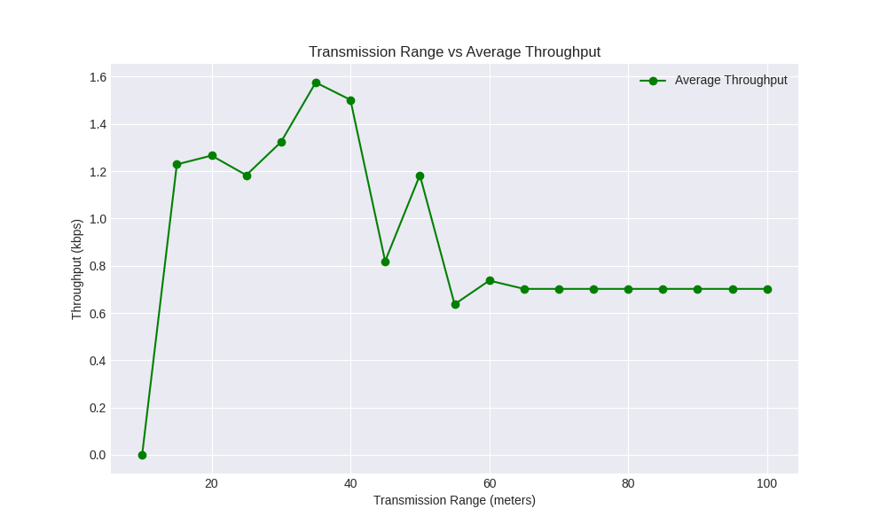

The graphs illustrate the relationship between average throughput (kbps) and two key network parameters: the number of nodes and transmission range. In the "Number of Nodes vs Average Throughput" graph, throughput initially spikes with fewer nodes, likely due to minimal contention, but stabilizes as node count increases, indicating network congestion. In the "Transmission Range vs Average Throughput" graph, throughput rises up to an optimal range, possibly due to better connectivity, but decreases as range continues to increase, potentially due to interference or signal attenuation.

**3.2.2 End to End Delay**

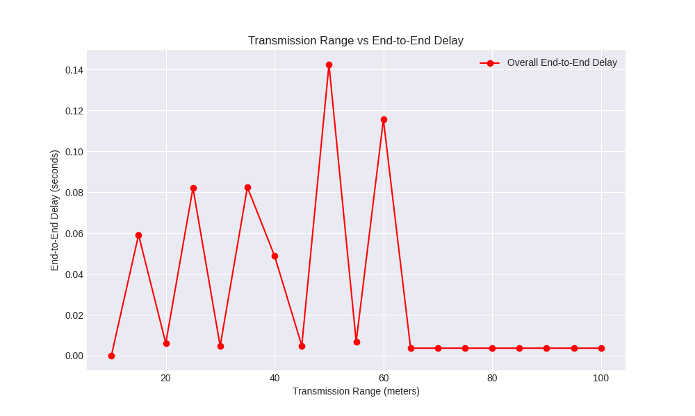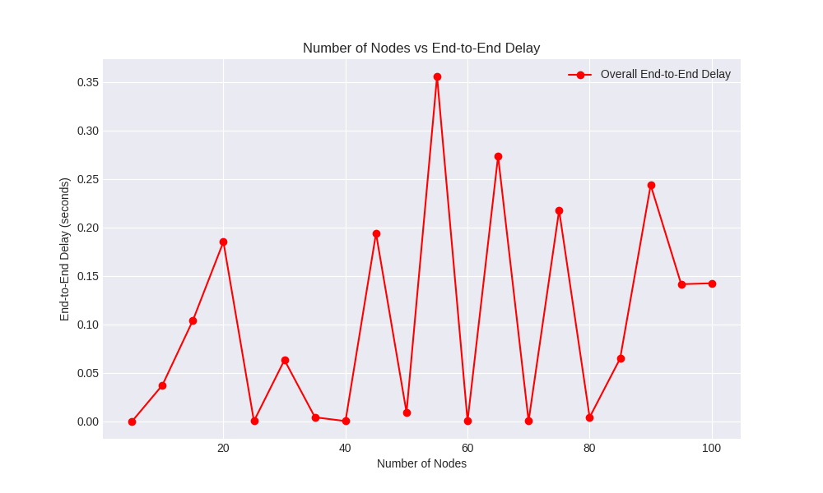

The first graph shows fluctuating end-to-end delay with increasing node numbers, while the second graph indicates decreasing delay as transmission range increases, improving connectivity.

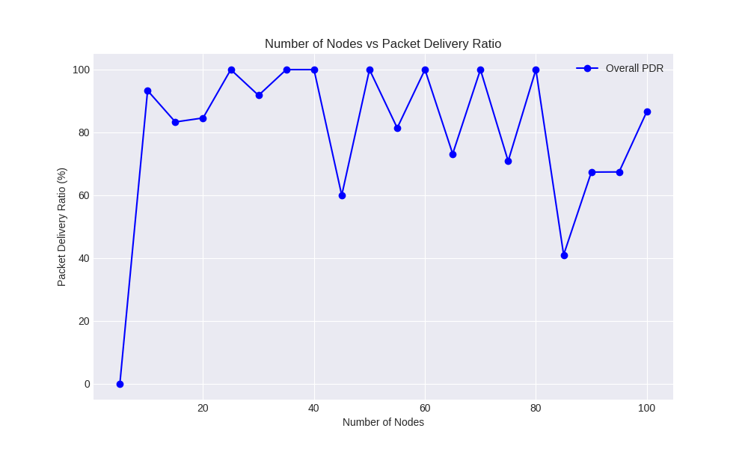**3.2.3 Packet delivery Ratio**

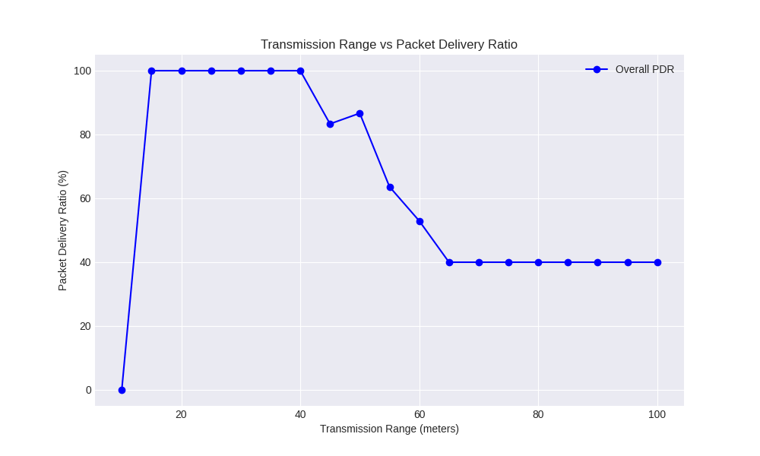

The first graph shows the relationship between the number of nodes and the packet delivery ratio (PDR), indicating stable performance up to 100 nodes with occasional dips. The second graph illustrates how the transmission range affects PDR, with optimal performance up to around 40 meters before significant drops.

**4. Conclusion**

We can arrive at the following conclusions after the completion of the project:

* + **Optimal Transmission Range**: Transmission ranges of **15-40 meters** yielded high packet delivery ratios (PDR) with low delay. Beyond 45 meters, PDR and throughput declined due to increased interference.
  + **Node Density Impact**: The network performed best with **10-40 nodes,** maintaining high PDR and stable throughput. **Densities above 50 nodes** led to reduced PDR and higher delays, showing AODV’s limitations in highly dense networks.
  + **AODV’s Suitability**: AODV is effective for **small to medium-sized networks** with moderate node density but struggles with scalability and performance in larger, denser environments.
  + **Protocol Limitations**: AODV’s on-demand routing mechanism is prone to increased overhead and latency in large or dense networks, impacting its scalability.

**5. Manual**

Prerequisites

a. NS-3 Installation: Ensure NS-3 (version 3.35 or a compatible version) is installed on your system. The latest version can be downloaded from the official NS-3 website, along with installation instructions.

b. Environment Setup:

* Place all necessary experiment files (such as aodv_m_test.cc) and the manet.csv file containing node positions in the scratch directory within your NS-3 installation.
* Verify that the manet.csv file is correctly formatted, containing columns for node IDs, x-coordinates, and y-coordinates to ensure proper positioning of nodes in the simulation.

Experiment Files

* Simulation File: aodv_m_test.cc - This is the main source code file for the AODV protocol simulation.
* Node Position File: manet.csv - A CSV file that specifies X-Y coordinates for each node in the network.

Steps to Run the Experiment

a. Navigate to NS-3 Directory: Open a terminal and navigate to the root directory of your NS-3 installation.

b. Place Files in the Scratch Directory: Ensure both aodv_m_test.cc and manet.csv are in the scratch directory for easy access by the simulator.

c. Build the Simulation File: Compile and run the simulation code by entering the following command:

./waf build --run scratch/aodv_m_test

* If the build completes successfully, the simulation will automatically start.
* In case of any errors, check for missing dependencies or syntax issues within the code.

d. Configure Command-Line Parameters: Optional parameters for the simulation can be adjusted directly in the command line, as shown below:

./waf --run "scratch/aodv_m_test --size=100 -- transmissionRange=50 --time=10"

* Available Parameters:
  + --size: Specifies the number of nodes (default is 100).
  + --transmissionRange: Sets the transmission range in meters (default is 50).
  + --time: Defines the total simulation time in seconds (default is 10).

e. Output Files: Upon completion, the simulation generates several output files:

* PCAP Traces (if enabled): Stored as aodv-xx.pcap files for packet capture analysis.
* NetAnim File: aodv_simulation.xml, which can be used for network visualization in NetAnim.
* Flow Monitor XML: flow-monitor-results.xml, containing detailed flow statistics.
* CSV Results: results.csv, which includes metrics like Packet Delivery Ratio (PDR), average throughput, and end-to-end delay.

f. Analysed Results: After the simulation ends, open the results.csv file to review key performance metrics. This file provides a summary of PDR, throughput, and delay, enabling you to analyse the AODV protocol's effectiveness.

g. Run Simulation with Varying Parameters:

Vary Node Count:

* + Place simul.py in the NS-3.35 directory, then run the following command:

python3 simul.py

* + This generates a file named results.csv with results from varying node counts. Rename it to results_by_varying_nodes.csv for clarity and future reference.

Vary Transmission Range:

* + Place simul1.py in the NS-3.35 directory, then run it with:

python3 simul1.py

* + This creates transmission_range_results.csv, containing data from simulations with different transmission ranges.

h. Generate Graphs:

* To create visualizations for Node Count vs. PDR, Node Count vs. Average Throughput, and Node Count vs. End-to-End Delay, run the ns3_results_1.py script.
* For graphs depicting Transmission Range vs. PDR, Transmission Range vs. Average Throughput, and Transmission Range vs. End-to-End Delay, use the ns3_results_2.py script.

6. Learnings

* **Technical Insights**: Discuss specific technical concepts or skills you developed, such as understanding the AODV protocol in-depth, working with NS-3, or analysing network performance metrics.
* **Challenges and Problem-Solving**: Reflect on any challenges you faced (e.g., debugging simulation code, adjusting network parameters) and how you overcame them.
* **Impact of Parameters on Performance**: Summarize key findings on how parameters like node density and transmission range impact network metrics, connecting back to the experiment’s objective.
* **Future Applications**: Mention how the knowledge gained might apply to future projects, particularly in fields like network engineering, wireless communication, or protocol optimization.
* **Collaboration and Teamwork (if applicable)**: Highlight any collaborative skills developed through working with team members, if the report is a group project.

Thanks & Regards