**The Dynamics of Social Equity and GDP Growth**

**A Global Outlook**

**Introduction:**

Social inequality and GDP growth are crucial aspects of a nation's well-being, and understanding their relationship is vital for informed policymaking and international cooperation. This project investigates the dynamics between social inequality, as measured by various indicators like the Gini coefficient and access to education, and GDP growth rates across diverse countries over several decades. By analyzing historical and current data, we seek to identify trends, patterns, and correlations and gain insights into how these dynamics have evolved. This research will provide valuable knowledge for fostering inclusive and sustainable economic development on a global scale.

**Objective questions:**

1. How have economic inequality and GDP growth been related in various countries over the past few decades, and how have these relationships changed?
2. What can historical data tell us about the expected changes in poverty, literacy, and unemployment rates for high-economic countries?

**Methodologies:**

1. HTML/CSS: Create a user-friendly web interface using HTML/CSS for data presentation and interactivity.
2. JavaScript: Implement JavaScript for dynamic and interactive elements within the web application.
3. Visualization Tools: Use Leaflet or Plotly for data visualization and interactive charting.
4. Database Integration: Utilize a database (SQL, MongoDB, SQLite, etc.) for efficient data storage and retrieval.
5. Python Flask-Powered API: Develop a Flask-powered API to facilitate data retrieval and manipulation.

**Datasets:**

GDP:

<https://www.imf.org/external/datamapper/api/v1/NGDP_RPCH>

Poverty:

<https://data.worldbank.org/topic/11?end=2023&start=2000>

Literacy:

<https://ourworldindata.org/literacy>

Unemployment rate:

<https://www.imf.org/external/datamapper/LUR@WEO/OEMDC/ADVEC/WEOWORLD>

Gini index:

<https://ourworldindata.org/what-is-the-gini-coefficient>

**Dashboard design:**

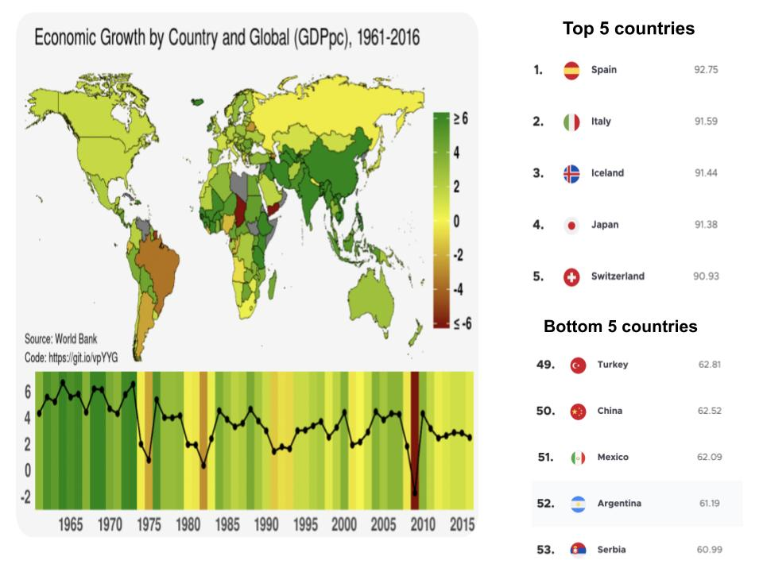

**Poverty, Unemployment, Literacy, Gini Index:**

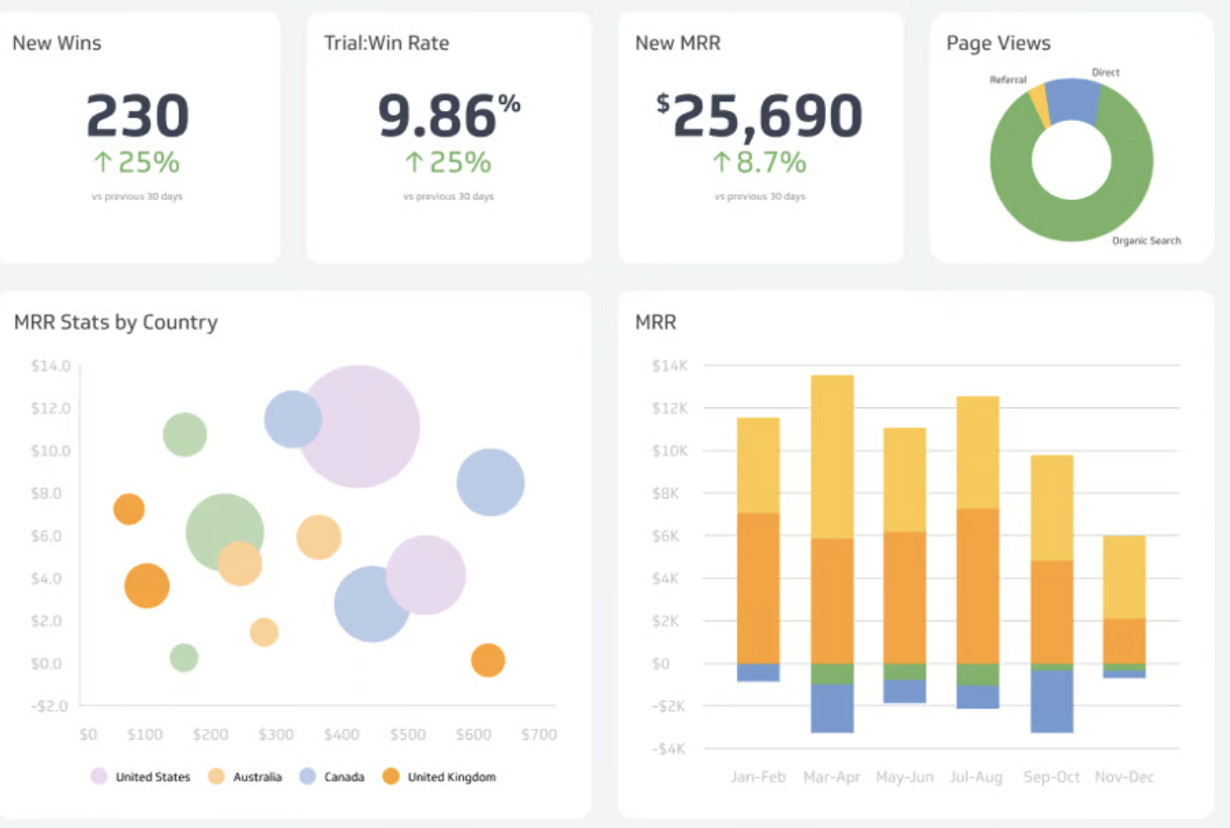

**Sketch:**

