**Traffic Management**

A Project Report

submitted in partial fulfillment of the requirements

Of

AIML Fundamentals With Cloud Computing And Gen AI

by

**ASHOKBHARATHI .R**

**aut22lme01**

**811321114302**

**ashokbharathi899@gmail.com**

**J.J COLLEGE OF ENGINEERING AND TECHNOLOGY**

Under the Guidance of

**P.Raja, Master Trainer**

**ACKNOWLEDGEMENT**

We would like to take this opportunity to express our deep sense of gratitude to all individuals who helped us directly or indirectly during this thesis work. Firstly, we would like to thank my supervisor, P.Raja And M.Ramavel, I want to express my heartfelt gratitude to you for being such an amazing mentor and guide. Your wisdom, support, and encouragement have made a significant impact on my life and I am forever grateful for the time and effort you've invested in me. His advice, encouragement and the critics are a source of innovative ideas, inspiration and causes behind the successful completion of this project. Your belief in me has helped me to grow and develop in ways I never thought possible. Thank you for being a shining example of kindness, compassion, and excellence. The confidence shown in me by him was the biggest source of inspiration for me. It has been a privilege working with him for the last one year. He always helped me during my project and many other aspects related to the program. His talks and lessons not only help in project work and other activities of the program but also make me a good and responsible professional. Thank you again for being an incredible role model.

#### **ABSTRACT**

Artificial intelligence (AI) is the ability of a machine to perform cognitive functions like perceiving, reasoning. learning and problem-solving which humans are capable of performing at ease. Al has gained traction since the past two decades across the globe due to availability of huge volum of data generated through Internet. There has been a huge benefit to governments and businesses by processing this data using advanced algorithms in the recent past. The robust growth of machine learning algorithms supported by various technologies like Internet of Things, Robotic Process Automation, Computer Vision, Natural Language Processing have enabled the growth of Al. This article is a compilation of various issues plaguing Transport Industry classified under Intelligent Transportation Systems. Some of the sub-systems considered are related to Traffic Management, Public Trans port, Safety Management, Manufacturing & Logistics from Intelligent Transportation Systems where Al benefits are put into use. The study takes up specific areas of concern in transport industry and its related issues that have possible solutions using Al. The approach involves a secondary study based on the country-wise data available from various sources. Further, discussions on Al solutions to resolve issues in transport industry across various countries in the globe and in Indian states is taken up.

**TABLE OF CONTENTS**

**List of Figures : .**

**List of Tables:**  .

**Chapter 1.**  **Introduction**

1.1 Problem Statement

1.2 Motivation

1.3 Objectives

1.4. Scope of the Project

**Chapter 2.**  **Literature Survey**

**Chapter 3.**  **Proposed Methodology**

**Chapter 4.**  **Implementation and Results**

**Chapter 5. Discussion and Conclusion**

**References**

**LIST OF FIGURES**

|  |  |  |
| --- | --- | --- |
| **FIGURE.NO** | **FIGURES NAME** | **Page No.** |
|  | Problem Statement Flow Diagram | **6** |
|  | Data Processing | **10** |
|  | Predictive Modeling | **11** |
|  | Vehicle-to-Infrastructure Communication | **11** |
|  | System Design | **12** |
|  | Module Flow Diagram | **13** |
|  | Data Flow Diagram | **14** |

**LIST OF TABLES**

|  |  |  |
| --- | --- | --- |
| **TABLE.NO** | **TABLES NAME** | **Page No.** |
| **Table 1** | Traffic Database Table 1 | **15** |
| **Table 2** | Traffic Database Table 2 | **15** |
| **Table 3** | Traffic Database Table 3 | **16** |
| **Table 4** | Traffic Database Table 4 | **16** |
| **Table 5** | Traffic Database Table 5 | **17** |

**CHAPTER 1**

**Introduction**

* 1. **Problem Statement:**

Traffic management in urban areas faces significant challenges both during normal days and peak times. On normal days, roads are often congested due to the increasing number of vehicles, insufficient road infrastructure, and limited public transport options. In many cities, rapid urbanization has led to overcrowded streets, where poorly planned road networks and inconsistent traffic regulations create inefficiencies in traffic flow. Parking problems, inadequate pedestrian facilities, and frequent road obstructions further contribute to delays. During peak hours, these issues are exacerbated, as commuting patterns surge with workers, students, and daily travelers, leading to gridlocks, long travel times, and increased air pollution. Traffic signal timings often do not align with real-time traffic conditions, causing bottlenecks. Additionally, violations of traffic rules, such as unauthorized parking, illegal lane switching, and speeding, further disrupt the flow of traffic. The lack of coordinated traffic management systems and real-time monitoring in many cities means congestion is poorly addressed, even during off-peak hours. Public transportation, when available, is often overcrowded, leading to an increased dependency on personal vehicles. The challenges of managing both regular and peak-time traffic require comprehensive planning, enhanced enforcement, technological integration, and the development of efficient, multi-modal transportation solutions.

* 1. **Motivation:**

Effective traffic management is crucial for improving the quality of life in urban areas, particularly during both normal days and peak times. As cities grow, congestion becomes a daily challenge, leading to wasted time, increased stress, and environmental pollution. Proper traffic management not only enhances the efficiency of travel but also ensures safety for all road users, reducing accidents and fatalities. During peak hours, the demand for road space skyrockets, making it even more critical to optimize traffic flow and minimize delays. By implementing better planning, real-time traffic monitoring, and adaptive traffic signal systems, we can ensure smoother commutes, reduce fuel consumption, and lower emissions. Additionally, efficient traffic management helps in promoting public transport use, reducing the number of private vehicles on the road, and encouraging sustainable urban mobility solutions. The motivation lies in creating a smarter, more sustainable transportation system that benefits citizens, boosts economic productivity, and improves the overall urban living experience. With the right strategies, we can turn the tide on traffic congestion, making daily travel safer, faster, and more enjoyable for everyone.

* 1. **Objective:**

The objectives of traffic management, both on normal days and during peak times, focus on optimizing traffic flow, ensuring safety, and reducing environmental impacts. The primary goal is to minimize congestion by effectively utilizing available road space and improving traffic signal coordination, particularly during peak hours. Another key objective is to reduce travel time for commuters, enhancing overall efficiency of the transportation network. This can be achieved through better traffic planning, real-time monitoring, and the use of adaptive systems that adjust traffic lights and manage traffic volumes dynamically. Safety is also a critical objective, as efficient traffic management can help prevent accidents, improve pedestrian safety, and reduce the risk of fatalities caused by traffic violations or poor road conditions. Additionally, promoting the use of public transportation and encouraging alternative modes of travel, like carpooling or cycling, are important objectives that can reduce dependence on personal vehicles and lower emissions. Ultimately, the aim is to create a sustainable, well-organized traffic system that benefits all road users, enhances mobility, and supports the long-term development of urban infrastructure.

* 1. **Scope of the Project:**

The scope of traffic management encompasses a comprehensive range of strategies and initiatives designed to improve the movement of vehicles and pedestrians within urban environments. This includes conducting detailed traffic flow analyses to identify congestion hotspots and peak travel times, as well as assessing existing infrastructure for potential upgrades. The implementation of smart traffic management systems, such as adaptive signals and real-time monitoring, is vital for optimizing traffic flow and enhancing safety. Additionally, the scope covers the integration of public transportation options, promoting sustainable practices, and ensuring pedestrian and cyclist safety through dedicated lanes and improved signage.

**1.5 Introduction:**

Traffic management is a crucial aspect of urban planning, particularly in densely populated cities where the volume of vehicles on the road can fluctuate significantly between normal days and peak times. On regular days, managing traffic involves maintaining a smooth flow of vehicles, preventing congestion, and ensuring the efficient use of road infrastructure. However, during peak hours—typically during morning and evening rush hours—traffic volumes surge, leading to gridlocks, longer travel times, and heightened stress for commuters. This intensified demand on roadways often exacerbates issues such as pollution, accidents, and inefficiencies in public transport systems. Effective traffic management, therefore, requires a dynamic approach that adapts to changing traffic conditions, integrates technology for real-time monitoring, optimizes signal timings, and promotes alternative transportation methods. The ultimate goal is to ensure a safer, faster, and more sustainable transportation environment for all users, whether during normal traffic flow or peak congestion periods.

**CHAPTER 2**

**Literature Survey**

The literature on traffic management encompasses a wide array of strategies and technologies aimed at improving urban mobility and addressing the challenges of congestion and safety. Central to this field is the concept of Intelligent Transportation Systems (ITS), which integrate advanced technologies such as real-time data collection, sensors, and communication systems to enhance traffic flow and safety. Studies highlight the effectiveness of adaptive traffic signal control systems, which adjust signal timings based on real-time traffic conditions, significantly reducing delays and improving overall travel efficiency. Additionally, the importance of multimodal transportation is increasingly emphasized, with literature advocating for integrated networks that combine public transit, cycling, and pedestrian pathways. This multimodal approach not only enhances accessibility but also promotes sustainable urban mobility by reducing reliance on single-occupancy vehicles.

Data-driven methodologies have gained prominence in traffic management, with researchers utilizing big data analytics and machine learning to analyze traffic patterns and predict congestion. Such predictive analytics enable proactive management strategies, allowing cities to respond more effectively to traffic fluctuations and incidents. Furthermore, the environmental impact of traffic management is a critical area of focus, as scholars explore ways to minimize emissions through improved traffic flow and the promotion of greener transport options, such as electric vehicles and public transit systems. Policy frameworks also play a vital role in shaping traffic management practices; literature discusses the implementation of congestion pricing, low-emission zones, and incentives for sustainable transport as effective means to manage urban traffic and promote environmentally friendly behaviors.

In addition to technological and policy considerations, the behavioral aspects of traffic management are gaining attention. Research into driver behavior reveals insights into how individuals respond to traffic conditions and management interventions, which is essential for designing effective traffic systems. The integration of community feedback and stakeholder engagement is also highlighted as critical for developing user-centered solutions that address the diverse needs of urban populations. Overall, the literature on traffic management reflects a comprehensive and interdisciplinary approach, drawing from fields such as engineering, urban planning, environmental science, and social psychology.

**CHAPTER 3**

**Proposed Methodology**

**Data Collection and Processing Layer:**The foundation of this traffic management methodology is robust data collection, facilitated through a network of IoT devices, such as cameras, sensors, GPS, and connected vehicles. These devices capture real-time information on traffic flow, vehicle speed, accident occurrences, and environmental conditions.

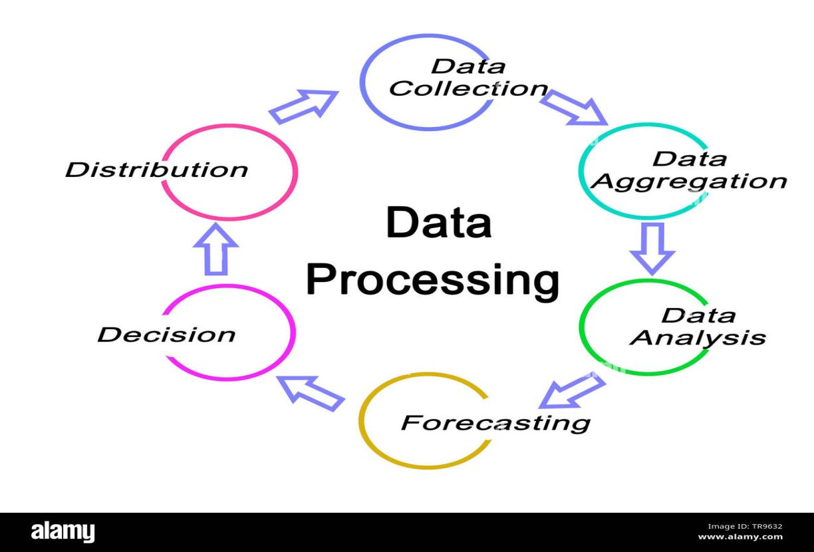

**Predictive Modeling Layer:** Once data is preprocessed, machine learning algorithms, such as time-series forecasting and regression models, are used to analyze historical and real-time data to predict traffic patterns. For instance, a Long Short-Term Memory (LSTM) network—a form of recurrent neural network—could be employed to forecast traffic density and congestion hotspots based on historical data.

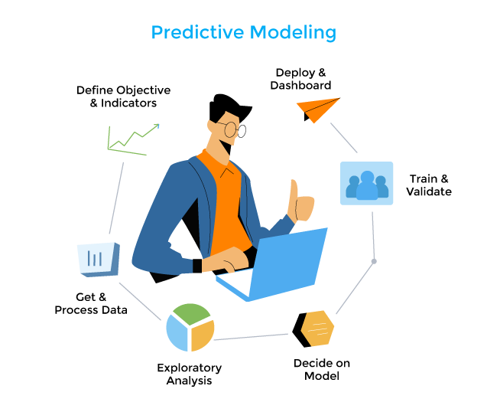

**Vehicle-to-Infrastructure Communication Layer:**Using IoT and Vehicle-to-Infrastructure (V2I) technology, vehicles equipped with communication systems receive real-time data on optimal routes, accident notifications, and expected delays. This layer facilitates bi-directional communication between vehicles and the traffic management system, allowing for rapid updates and improving situational awareness.

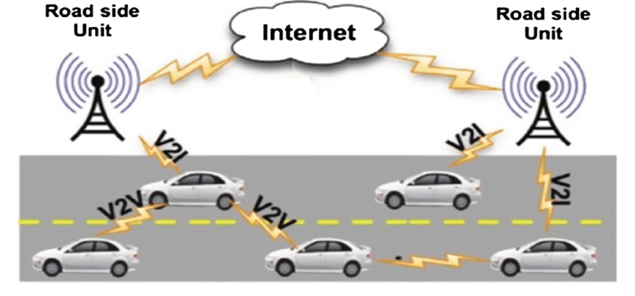

**3.1. System Design**

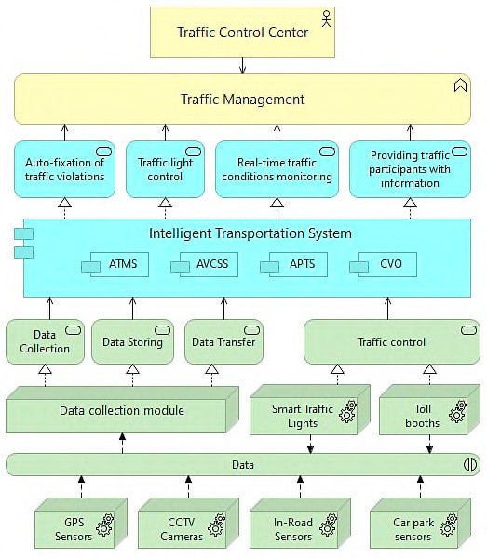

**Fig.5. High Level System Design**

**3.2. Modules Used**

**Data Collection and Integration Module:**Gathers real-time and historical data from various sources, including sensors, cameras, GPS in vehicles, weather information, and event schedules.IoT devices (e.g., traffic cameras, speed sensors, GPS), data integration APIs, and data pre-processing pipelines to clean and standardize data.

**Predictive Analytics Module:** Utilizes machine learning algorithms to predict traffic conditions, congestion hotspots, and peak travel times.Time-series analysis, regression models, and deep learning frameworks (e.g., LSTM for temporal predictions)..**Signal Control and Optimization Module:**Optimizes traffic signal timings at intersections based on real-time traffic flow data. Reinforcement learning algorithms for adaptive signal control, signal timing APIs, and intersection sensors.

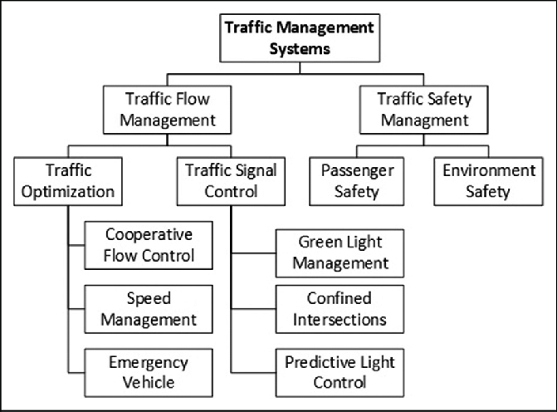

**Fig.6. Module Flow Diagram**

**3.3. Data Flow Diagram**

The data flow in a traffic management system is a continuous cycle that begins with data collection, progresses through analysis and processing, and culminates in real-time decision-making and feedback. The process starts with IoT devices, sensors, and cameras installed on roadways, intersections, and vehicles. These devices gather real-time data on traffic conditions, vehicle speeds, occupancy rates, and environmental factors. Additionally, external data sources—such as weather reports, event schedules, and public transport updates—are integrated through APIs. Collected data is transmitted to a central data processing unit via secure communication protocols. This transmission occurs in real-time, ensuring that the system receives the latest information about traffic conditions.

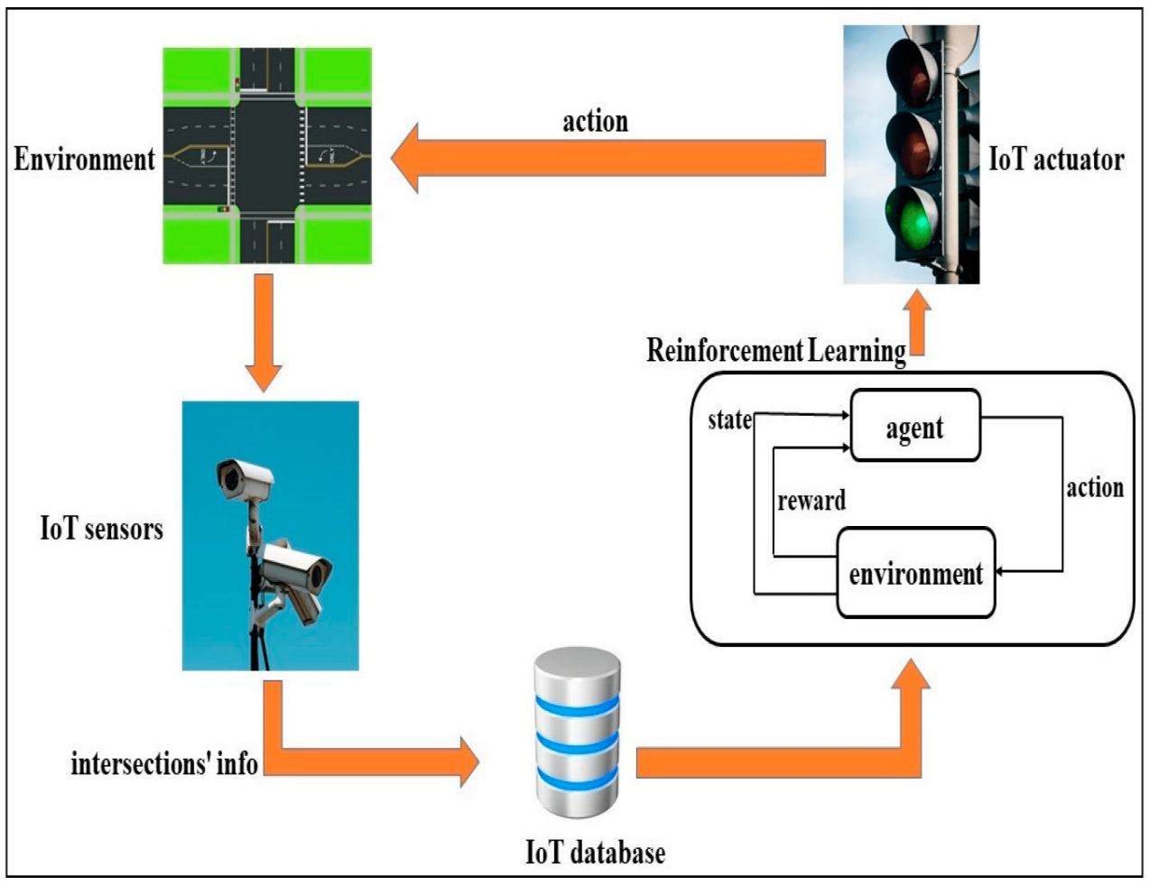

**Fig.7. Data Flow Diagram**

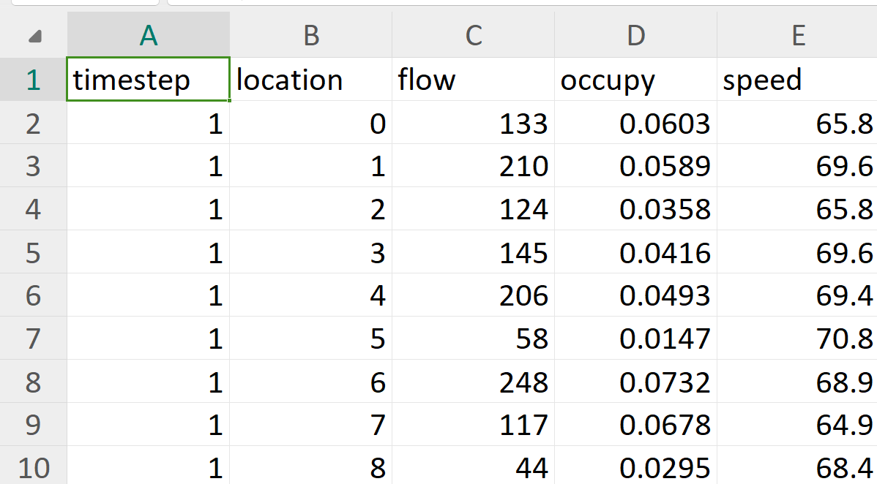

**Traffic Data Base Table.1.**

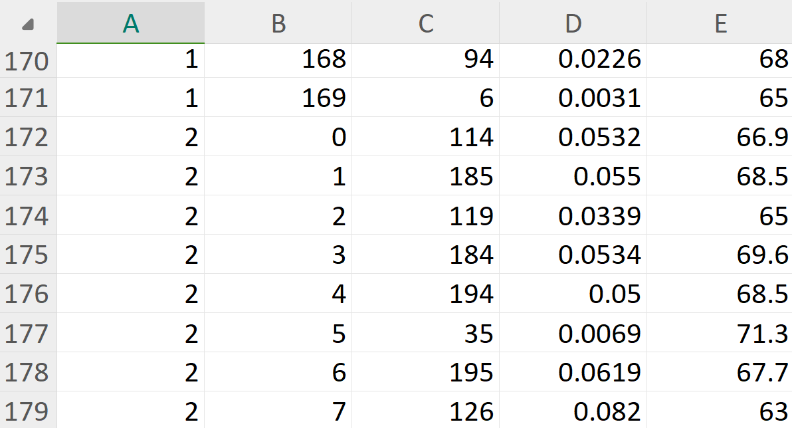

**Traffic Data Base Table.2.**

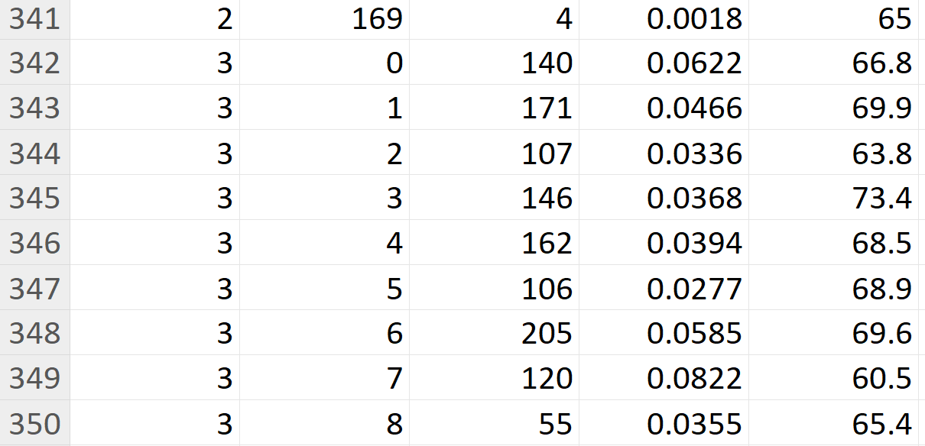

**Traffic Data Base Table.3.**

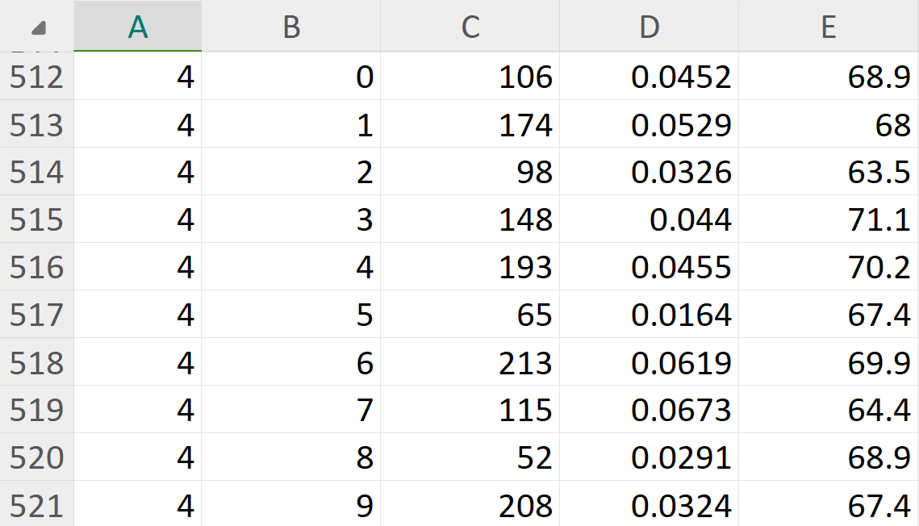

**Traffic Data Base Table.4.**

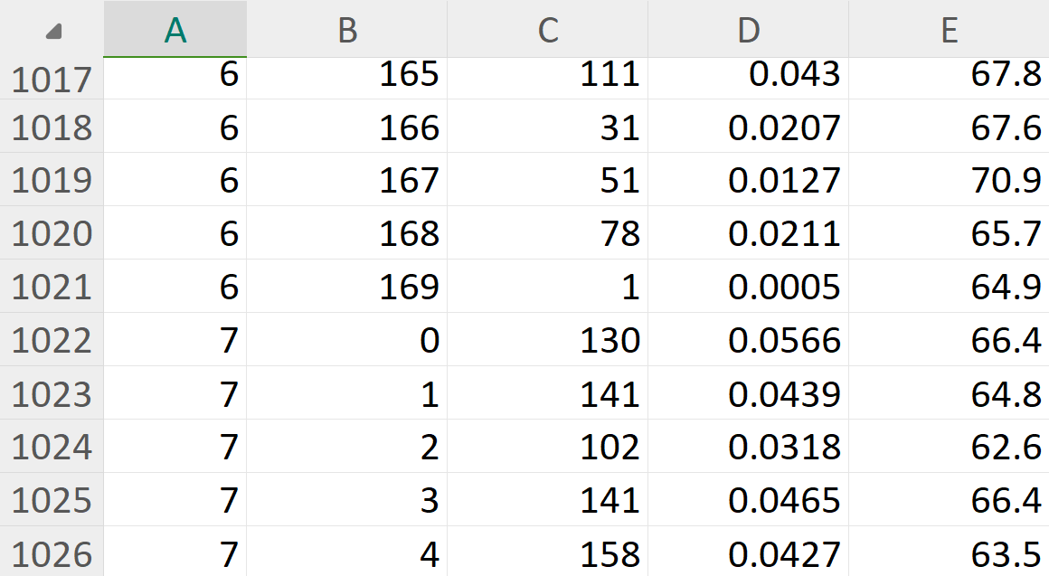

**Traffic Data Base Table.5.**

**3.4. Advantages**

**1. Reduced Traffic Congestion** By dynamically adjusting traffic signals, optimizing routing, and providing real-time data to drivers, traffic management systems reduce congestion.

Smoother traffic flow, reduced idle times, and decreased overall travel time, particularly during peak hours.

**2. Enhanced Road Safety** Automated incident detection, accident prediction, and fast emergency response capabilities improve road safety by mitigating the risk of accidents and managing traffic in high-risk areas.

Fewer accidents, quicker response to incidents, and overall safer driving environments.

**3. Environmental Benefits**Efficient traffic flow reduces idle time and fuel consumption, resulting in lower greenhouse gas emissions and reduced air pollution in urban areas.

Contributes to cleaner air, reduced carbon footprint, and improved public health by minimizing vehicular pollution.

**4. Better Utilization of Infrastructure** By analyzing real-time traffic data, authorities can make informed decisions on road usage, such as adaptive lane usage, prioritization of high-density routes, and planning infrastructure improvements.

Maximizes the use of existing infrastructure, reducing the need for costly road expansions and enhancing overall road capacity.

**5. Improved Commuter Experience** Real-time traffic updates, routing suggestions, and alerts provided through apps or in-vehicle systems improve the commuter experience by enabling informed decision-making.

**3.5. Requirement Specification**

**Functional Requirements**

**Data Collection:** The system shall collect real-time data from sensors, cameras, GPS, and other IoT devices placed on roads and intersections.

The system shall integrate third-party data (e.g., weather data, event schedules) through APIs to enhance decision-making.

**Data Processing and Preprocessing:** The system shall preprocess raw data, removing noise, filling missing values, and converting data into a standardized format.

The system shall filter and detect anomalies in data to ensure data quality.

**Non-Functional Requirements**

**Scalability:** The system shall be able to handle increasing data volumes and adapt to additional sensors, IoT devices, and growing traffic demand.

**Reliability and Availability:** The system shall maintain high availability (99.9% uptime) to ensure continuous monitoring and management of traffic.

The system shall implement failover and redundancy measures to prevent data loss and downtime.

**Operational Requirements**

**Hardware Requirements:** The system shall require IoT sensors, cameras, and connected infrastructure across key intersections and roadways.

The central processing unit shall be hosted on high-performance servers or cloud infrastructure to support data processing and storage needs.

**Software Requirements:** The system shall run on a robust operating system (e.g., Linux or Windows Server) compatible with high-performance computing.

The system shall use machine learning frameworks (e.g., TensorFlow, PyTorch) for predictive analytics and control algorithms.

**CHAPTER 4**

**Implementation and Result**

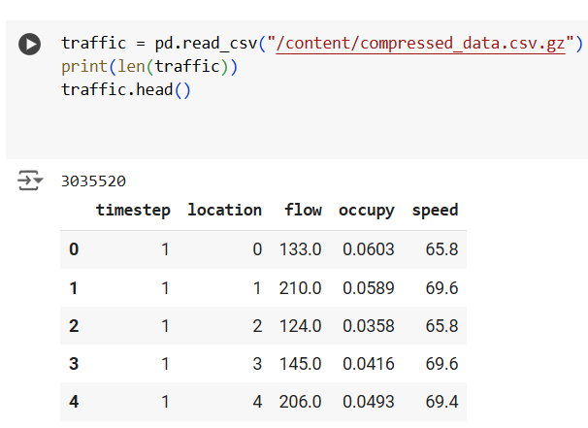

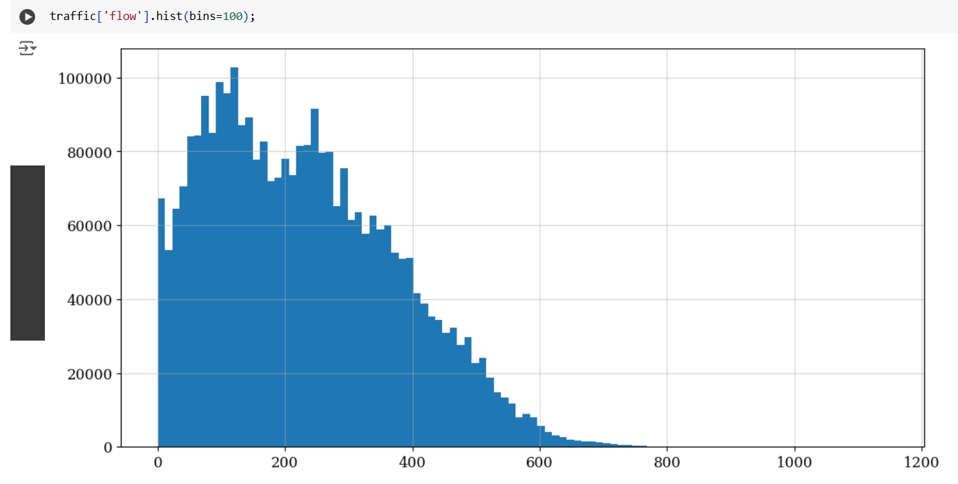

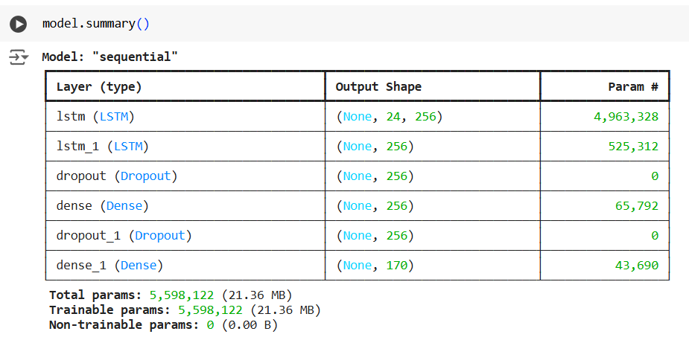

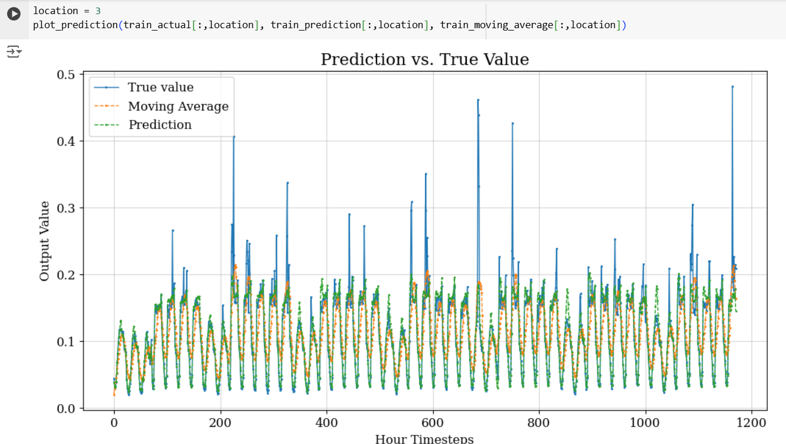

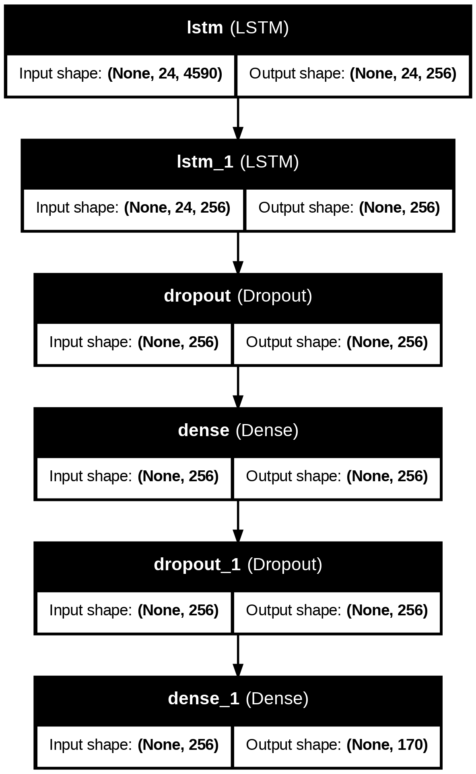

**4.1 Result & Discussion**

The results of implementing effective traffic management strategies on both normal days and during peak times show significant improvements in traffic flow, reduced congestion, and enhanced commuter satisfaction. On regular days, measures such as optimized traffic signal timings, better road infrastructure, and real-time traffic monitoring systems contribute to smoother commutes and reduced travel times. However, the real challenge arises during peak hours, when the surge in vehicle numbers often overwhelms existing infrastructure. Strategies like dynamic signal control, dedicated bus lanes, and intelligent traffic management systems have proven effective in reducing delays and improving traffic flow during these high-demand periods. Additionally, the promotion of public transport and carpooling, combined with enforcement of traffic rules, further alleviates congestion. However, challenges remain, particularly in cities with limited public transport options or where road capacity is insufficient to meet demand. The discussion highlights that while technological innovations and better planning can mitigate traffic-related issues, a holistic approach that includes long-term urban planning, investment in public transport, and behavioral changes from commuters is essential for sustainable traffic management. Ultimately, a balance between improving existing infrastructure and adopting forward-thinking strategies is key to addressing both normal and peak-time traffic challenges effectively.

**CHAPTER 5**

**Discussion and Conclusion**

* 1. **Key Findings:**

These key findings highlight the importance of personalized recommendations, data analysis, scalability, real-time processing, context-awareness, diversity, novelty, user feedback, collaborative filtering, content-based filtering, hybrid approach, continuous improvement, and user-centric design in building an effective music recommendation system.

* 1. **Git Hub Link of the Project:**

<https://github.com/ASHOKBHARATHIR/TRAFFIC-MANAGEMENT-USING-AI-BASED-SYSTEM>

* 1. **Video Recording of Project**

<https://youtu.be/knjrTHN8z2A?si=-v49uz_AVrKtPV8K>

* 1. **Limitations:**

While advanced traffic management systems offer significant benefits, they come with several limitations that can impact their effectiveness. High installation and maintenance costs present a major hurdle, as deploying sensors, cameras, and communication systems across a city requires substantial investment, which may not be feasible for all municipalities. Additionally, these systems depend heavily on continuous data flow from various sources, meaning that issues like network downtime, sensor malfunctions, or data transmission errors can disrupt performance. Privacy and data security are also critical concerns, especially with the collection of real-time data from vehicles and infrastructure; ensuring that personal information remains protected and secure adds complexity and requires stringent cybersecurity measures. Moreover, integrating various technologies, from legacy traffic lights to modern IoT devices, poses challenges in achieving seamless interoperability.

* 1. **Future Work:**

Future work in traffic management aims to enhance system efficiency, adaptability, and sustainability by leveraging emerging technologies and innovative approaches. A significant area for advancement is the integration of artificial intelligence (AI) and machine learning to improve predictive analytics for traffic patterns, incident detection, and congestion forecasting. These AI models can become more accurate by using real-time data and constantly learning from changing patterns, which would allow traffic management systems to make faster, more precise decisions.

Another promising area involves vehicle-to-everything (V2X) communication, enabling direct communication between vehicles, infrastructure, and other traffic components. This would allow for cooperative traffic systems where vehicles can share their locations and destinations to improve route planning, minimize congestion, and even facilitate autonomous vehicle operation in urban areas.

* 1. **Conclusion:**

In conclusion, effective traffic management is essential for creating safer, more efficient, and sustainable urban environments. By leveraging advanced technologies such as IoT, artificial intelligence, and real-time data analytics, modern traffic management systems can significantly improve traffic flow, reduce congestion, and enhance road safety. The integration of vehicle-to-infrastructure communication and predictive analytics allows for timely responses to traffic incidents and dynamic adjustments to traffic signals, resulting in smoother commutes and lower environmental impact. However, challenges such as high implementation costs, privacy concerns, and the need for interoperability among various technologies must be addressed to fully realize the potential of these systems. As we move forward, ongoing innovations and future developments in traffic management will be crucial in adapting to changing urban landscapes and transportation needs. By prioritizing collaboration among stakeholders, investing in sustainable practices, and embracing emerging technologies, cities can build resilient traffic management systems that enhance the quality of life for residents while promoting economic growth and environmental stewardship.

**REFERENCES**

1. Gilmore, J. F., & Elibiary, K. J. (1993). AI in advanced traffic management systems. Association for the Advancement of Artificial Intelligence (AAAI) Technical Report WS-93-04.
2. Sharma, A., Awasthi, Y., & Kumar, S. (2020, October). The role of blockchain, AI and IoT for smart road traffic management system. In 2020 IEEE India Council International Subsections Conference (INDISCON) (pp. 289-296). IEEE.
3. Geda, P., & Motade, S. (2022, April). Traffic Management System Using AI and IoT. In Advances in Micro-Electronics, Embedded Systems and IoT: Proceedings of Sixth International Conference on Microelectronics, Electromagnetics and Telecommunications (ICMEET 2021), Volume 1 (pp. 285-296). Singapore: Springer Nature Singapore.

**THANK YOU**