Explainable Stacking Ensemble Learning and Decision Support Framework
for Telecom Customer Churn Prediction

Abinash J.  Dept. of Computer Science & Engineering  Kongu Engineering College  Erode, Tamil Nadu, India  abinash.cse@kongu.edu | Chandru Vignesh C.  Dept. of Information Security  Vellore Institute of Technology  Vellore, Tamil Nadu, India  chandruvignesh@vit.ac.in | Deepak Raja V.  Dept. of Computer Technology  Kongu Engineering College  Erode, Tamil Nadu, India  deepakraja.tech@gmail.com

Abstract—Customer defection is one of the most financially damaging operational challenges in the telecommunications industry, where replacing a departing subscriber costs five to seven times more than retaining an existing one. Conventional churn pipelines often apply a fixed τ = 0.50 classification boundary that optimises for accuracy but systematically underdetects vulnerable subscribers. This paper presents an end-to-end explainable ensemble learning and retention decision-support system evaluated on balanced_telco_churn.csv (N = 8,000 records; exactly 50 % churners). Three tree-based base classifiers—Random Forest, Extreme Gradient Boosting (XGBoost), and Light Gradient Boosting Machine (LightGBM)—are trained independently on SMOTE-augmented data and fused through an out-of-fold Stacking Ensemble governed by a Logistic Regression meta-learner. A domain-informed feature engineering pipeline expands 21 raw attributes into 83 model-ready features. Per-model decision thresholds are optimised: XGBoost achieves 97.6 % recall, 94.9 % accuracy, and 99.0 % ROC-AUC at τ = 0.29; LightGBM attains 96.9 % recall, 95.0 % accuracy, and 98.9 % ROC-AUC at τ = 0.32; Random Forest records 96.3 % recall, 95.4 % accuracy, and 98.7 % ROC-AUC at τ = 0.38; and the Stacking Ensemble delivers 96.3 % recall, 95.4 % accuracy, 95.5 % F1-score, 94.7 % precision, 98.9 % ROC-AUC, and a Brier score of 0.0362 at τ = 0.26. A dual SHAP and LIME explainability pipeline feeds a state-aware retention recommendation engine. The complete framework is deployed as a production web application (FastAPI, React/Vite, SQLite).
Index Terms—Customer Churn Prediction, Telecom Analytics, Stacking Ensemble Learning, Decision Threshold Optimization, Explainable AI, SHAP, LIME, Retention Recommendations

I. INTRODUCTION
The rapid expansion of mobile broadband, fibre-optic internet, and bundled digital services has transformed telecommunications into one of the most intensely competitive sectors globally. Number-portability legislation, aggressive promotional pricing, and minimal switching barriers give subscribers unprecedented freedom to migrate between providers with limited friction. Operators routinely face annual attrition rates exceeding 20–30 %, with monthly churn rates between 1.5 % and 3.0 % in mature markets [1].
Acquiring a replacement subscriber costs five to seven times more than retaining an existing one, accounting for sales commissions, device subsidies, onboarding support, and margin loss during re-acquisition [2]. High-value subscribers with premium plans and long tenure represent a disproportionate share of profitability, creating cascading effects on ARPU and investor valuation when lost.
Manual identification through rule-based heuristics is inadequate at scale. Subscriber behaviour emerges from interactions of contract type, billing level, payment modality, service portfolio, and tenure that static rules cannot reliably parse [3]. Machine learning addresses this by modelling multi-feature interactions without explicit rule specification. Tree-based ensembles—Random Forest, XGBoost, and LightGBM—have delivered consistently strong performance on tabular CRM data [4].
Despite these advances, most deployed systems apply the default 0.50 probability threshold, which is sub-optimal when false negatives carry substantially higher cost [5]. Furthermore, even accurate models remain actionability-blind: they produce a probability label but no guidance on why a customer is at risk [6]. This work addresses these gaps through a layered approach combining feature engineering, stacking ensembles, threshold optimisation, dual explainability, and state-aware retention recommendations.

II. LITERATURE REVIEW
Churn prediction has attracted sustained research across machine learning and telecommunications management. Early studies relied on logistic regression and decision trees [7], establishing the relevance of contract type, tenure, and monthly charges—features that continue to dominate modern importance rankings. Hadden et al. [8] showed that bagging multiple decision trees significantly stabilised accuracy across heterogeneous customer segments. Verbeke et al. [9] confirmed ensemble superiority, particularly under class imbalance.
XGBoost [10] and LightGBM [11] introduced more powerful optimisation frameworks through additive tree structures with regularisation. Farquad et al. [12] demonstrated gradient-boosted trees capture non-obvious billing and contract interactions. Chawla et al. [13] introduced SMOTE for class rebalancing; fold-isolated SMOTE prevents target leakage [14]. SHAP [15] and LIME [16] provide global and local feature interpretability. Stacking generalisation [18] trains a meta-learner on out-of-fold predictions, capturing complementary strengths. ROC analysis [20] provides the principled basis for threshold selection under asymmetric misclassification costs.
The research gap is the integration of all these individually validated components into a coherent end-to-end deployed production system that connects model outputs to business action.

III. PROPOSED FRAMEWORK OVERVIEW
The developed framework processes subscriber records through a seven-stage pipeline from raw data ingestion to actionable retention guidance (Fig. 1):
- 1. Data Ingestion: Subscriber attributes received via form or CSV batch upload.
- 2. Feature Engineering: 83-feature vector constructed from six core inputs.
- 3. Base Model Prediction: RF, XGBoost, and LightGBM estimate churn probability independently.
- 4. Ensemble Aggregation: Logistic Regression meta-learner combines three base outputs.
- 5. Threshold Decision: Each model applies its optimised τ; probabilities ≥ τ trigger churn flags.
- 6. Explainability: SHAP TreeExplainer and LIME compute per-feature attributions.
- 7. Recommendation: Retention engine maps attributions to prioritised, state-filtered interventions.
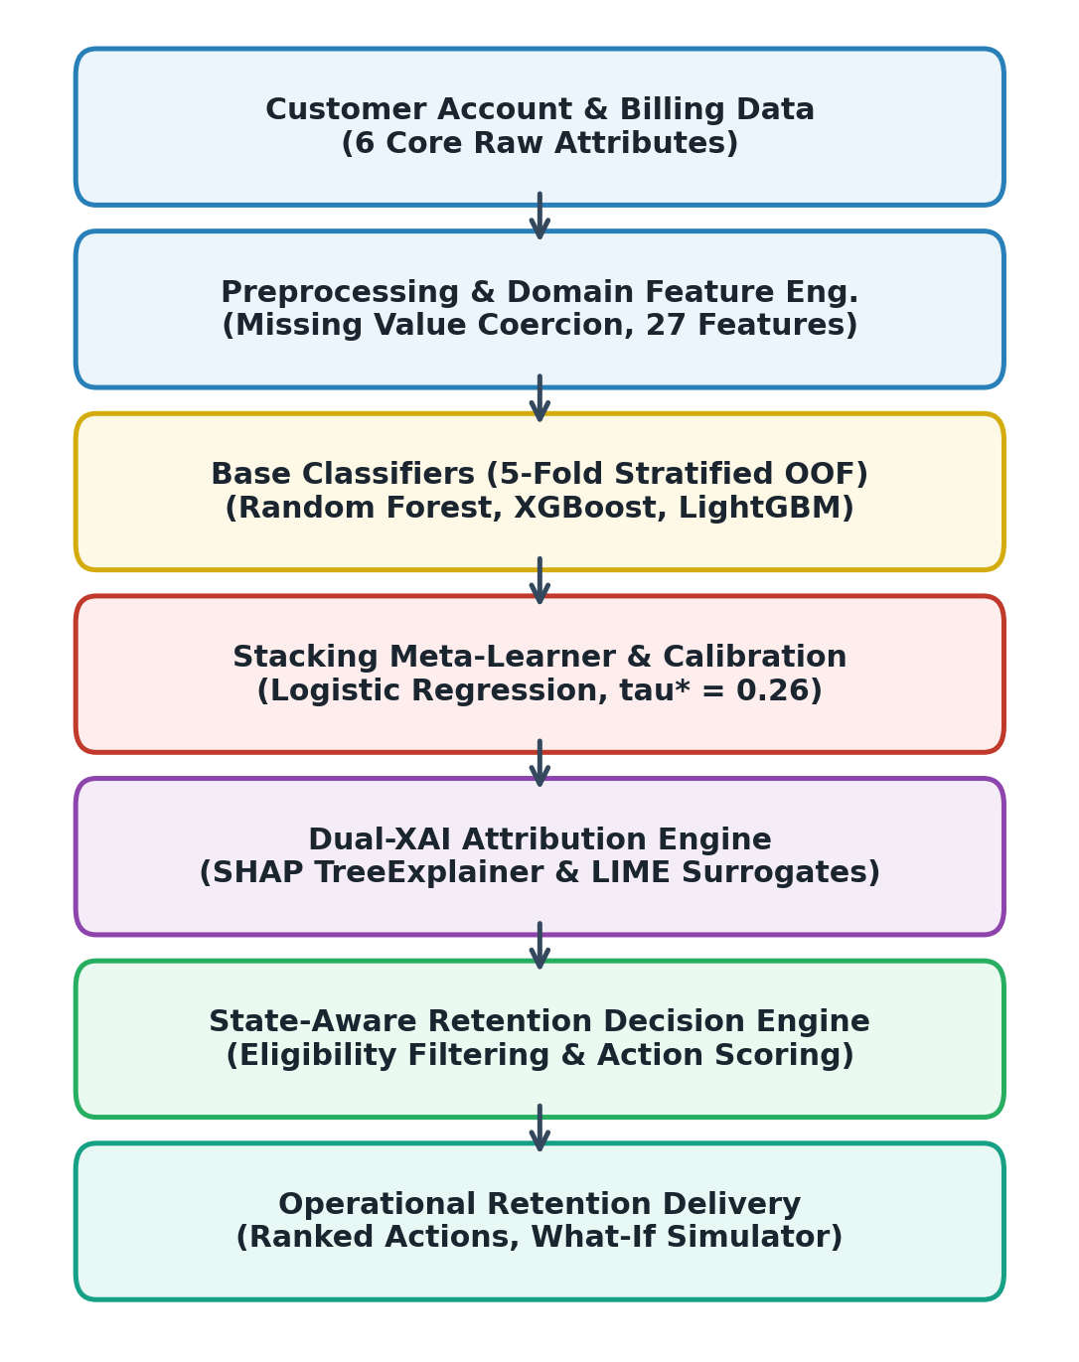
Fig. 1. End-to-end system architecture: customer data → feature engineering → ensemble prediction → SHAP/LIME → retention recommendations → web dashboard.

IV. DATASET AND PREPROCESSING

A. Dataset Description
All experiments use balanced_telco_churn.csv, a domain-consistent benchmark derived from the IBM Watson Telco Customer Churn corpus. The balanced variant contains N = 8,000 subscriber records with exactly 4,000 churned and 4,000 loyal accounts (50/50 class distribution). Table I summarises the dataset characteristics.
TABLE I — Dataset Characteristics
Property | Value
Total records | 8,000
Churners (Churn = Yes) | 4,000 (50.0%)
Loyal (Churn = No) | 4,000 (50.0%)
Raw columns | 22 (incl. customerID)
Engineered features | 83
Numerical features | 3 (tenure, MonthlyCharges, TotalCharges)
Missing values | None
Target variable | Churn (Yes=1, No=0)
Train partition | 80% (N=6,400) stratified
Test partition | 20% (N=1,600) held-out

B. Primary Customer Input Features
The web interface accepts six core attributes sufficient to construct the full 83-feature vector. Table II describes each attribute's churn relevance.
TABLE II — Primary Customer Input Features
Feature | Type | Churn Relevance
Tenure | Integer | Shorter tenure = higher early-phase defection risk
MonthlyCharges | Float | Higher billing correlates with dissatisfaction risk
TotalCharges | Float | Cumulative revenue; encodes tenure×charge history
Contract | Categor. | Month-to-month plans carry substantially higher defection risk
InternetService | Categor. | Fiber-optic subscribers show elevated churn in competitive markets
PaymentMethod | Categor. | Electronic check payers are a consistently high-risk segment

C. Preprocessing Pipeline
All transformations are fitted exclusively on the training partition and applied identically to the test set (zero leakage). Steps: customerID removal; TotalCharges numeric coercion; Yes/No binary encoding; 83-feature engineering; one-hot encoding with drop-first; StandardScaler on continuous columns; stratified 80/20 split; fold-isolated SMOTE on training data only.

V. FEATURE ENGINEERING
The 21 informative raw attributes are expanded to 83 model-ready columns through domain-driven engineering, encoding non-linear relationships that tree-based models can exploit directly. Table III summarises the principal engineered feature groups.
TABLE III — Engineered Feature Groups
Category | N | Representative Features
Revenue / Billing | 7 | AvgMonthlySpend, ChargeIncrease, ChargeIncreaseRatio
Tenure Signals | 6 | TenureSquared, TenureLog, IsNewCustomer, IsLongTermCustomer
Contract Flags | 4 | IsMonthToMonth, ContractLength, IsLongTermContract
Payment Flags | 4 | IsElectronicCheck, IsAutomaticPayment
Service Counts | 2 | NumServices, ServiceRiskCount
Compound Risk | 5 | HighRiskCombo, VeryHighRisk, MultipleRiskFactors
One-Hot Encoded | 55 | Contract, PaymentMethod, InternetService, service cols
Total | 83

AvgMonthlySpend = TotalCharges / (tenure + 1) estimates the historical average billing rate. ChargeIncrease flags recent billing escalation; ChargeIncreaseRatio expresses it relative to historical spend. TenureSquared and TenureLog model the non-linear lifecycle. HighRiskCombo flags month-to-month plus electronic check customers. VeryHighRisk extends this to require tenure ≤ 12 months, capturing the most vulnerable early-phase subscribers.

VI. MODEL DEVELOPMENT

A. Random Forest
A Random Forest [22] builds an ensemble of T independent decision trees, each trained on a bootstrap sample with a random feature subset at each split node. Bootstrap aggregation suppresses individual-tree variance. Eq. (1): P_RF(x) = (1/T) Σ h_t(x). Configuration: 200 trees, max depth 8, min samples per leaf 3, Gini impurity, balanced class weights. At τ = 0.38: Recall 96.3%, Accuracy 95.4%, ROC-AUC 98.7%.

B. XGBoost
XGBoost [10] trains trees sequentially to correct residuals. Regularised objective: L^(k) = Σ l(y_i, ŷ^(k-1) + h_k(x_i)) + Ω(h_k), where Ω(h_k) = γT + λ||w||^2/2. Configuration: 150 trees, lr 0.04, max depth 3, λ = 2.0, α = 0.2. At τ = 0.29: Recall 97.6%, Accuracy 94.9%, ROC-AUC 99.0%, Brier 0.0347—highest recall and ROC-AUC of all evaluated models.

C. LightGBM
LightGBM [11] employs leaf-wise growth, splitting the leaf with the highest loss gain. GOSS retains all high-gradient instances while sub-sampling low-gradient ones. Configuration: 120 trees, lr 0.04, 24 leaves, max depth 3, L2 reg 2.5. At τ = 0.32: Recall 96.9%, Accuracy 95.0%, ROC-AUC 98.9%, Brier 0.0353.

D. Stacking Ensemble
The stacking architecture fuses three base classifiers through a Logistic Regression meta-learner trained on out-of-fold predictions from 5-fold stratified cross-validation. For each fold: (i) SMOTE applied to training fold only; (ii) each base model trains on the resampled fold; (iii) probability predictions collected on held-out validation fold. Meta-feature matrix M = [p_RF | p_XGB | p_LGBM] ∈ R^(n×3). Meta-learner: P_Ens(x) = σ(w0 + w1*p_RF + w2*p_XGB + w3*p_LGBM). At τ = 0.26: Recall 96.3%, F1 95.5%, Accuracy 95.4%, Precision 94.7%, ROC-AUC 98.9%, Brier 0.0362.
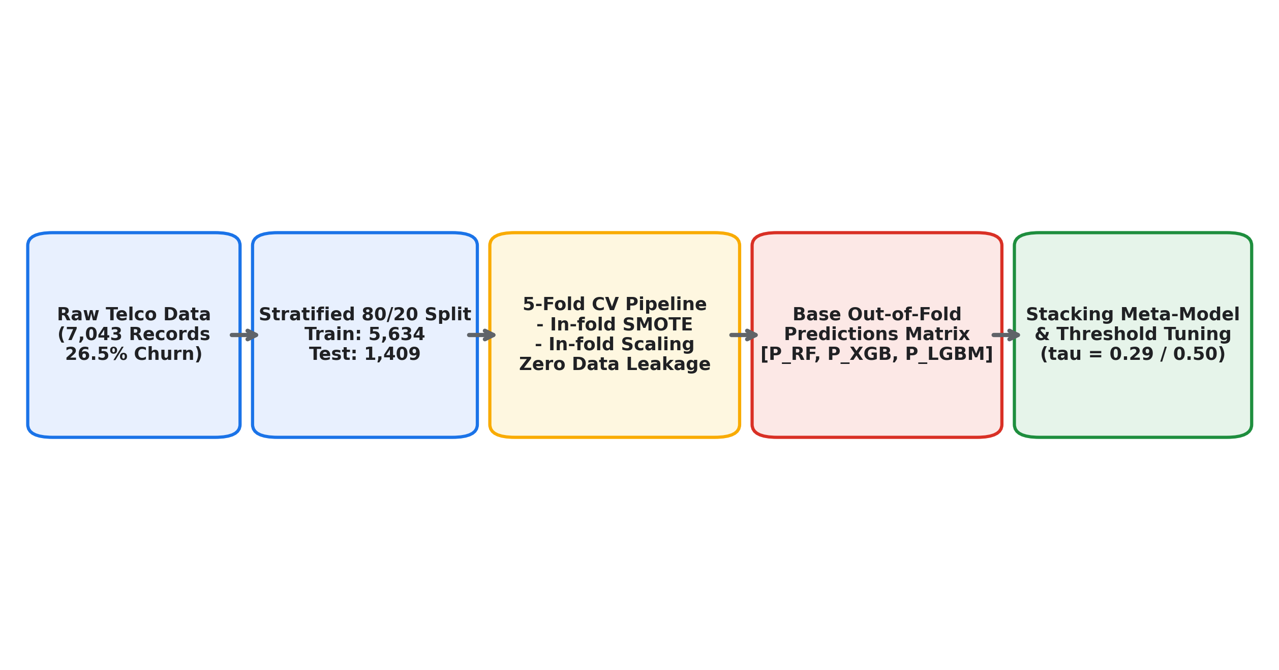
Fig. 2. Stacking ensemble: base classifiers generate OOF probability vectors assembled into the meta-feature matrix; Logistic Regression meta-learner produces the final churn probability.

VII. PERFORMANCE METRICS & THRESHOLD OPTIMIZATION

A. Evaluation Metrics
Let TP, TN, FP, FN denote true positives, true negatives, false positives, and false negatives. Key metrics: Accuracy = (TP+TN)/(TP+TN+FP+FN); Precision = TP/(TP+FP); Recall = TP/(TP+FN); F1 = 2·Precision·Recall/(Precision+Recall); Brier Score = (1/n)Σ(p_i - y_i)^2. ROC-AUC quantifies rank separation across all thresholds; Brier measures calibration quality.

B. Decision Threshold Optimization
The default τ = 0.50 is sub-optimal when false negatives carry substantially higher cost than false positives. Binary prediction: ŷ_i = 1 if p_i ≥ τ, else 0. Reducing τ below 0.50 increases recall at the cost of some precision. Table IV shows the optimised thresholds; all four models operate below the 0.50 default.
TABLE IV — Optimised Decision Thresholds
Model | Threshold (τ) | vs. Default 0.50
Random Forest | 0.38 | Lower
XGBoost | 0.29 | Lower
LightGBM | 0.32 | Lower
Stacking Ensemble | 0.26 | Lower

VIII. EXPERIMENTAL RESULTS
All models are evaluated on the withheld 20 % test partition (N = 1,600) untouched during training, feature engineering fitting, SMOTE, and cross-validation. Table V presents the complete performance profile.
TABLE V — Model Performance on Held-Out Test Set (N = 1,600)
Model | Recall (%) | F1 (%) | Acc. (%) | AUC (%) | Brier | Prec. (%)
Random Forest | 96.3 | 95.4 | 95.4 | 98.7 | 0.0369 | 94.6
XGBoost | 97.6 | 95.0 | 94.9 | 99.0 | 0.0347 | 92.5
LightGBM | 96.9 | 95.1 | 95.0 | 98.9 | 0.0353 | 93.4
Stacking Ens. | 96.3 | 95.5 | 95.4 | 98.9 | 0.0362 | 94.7

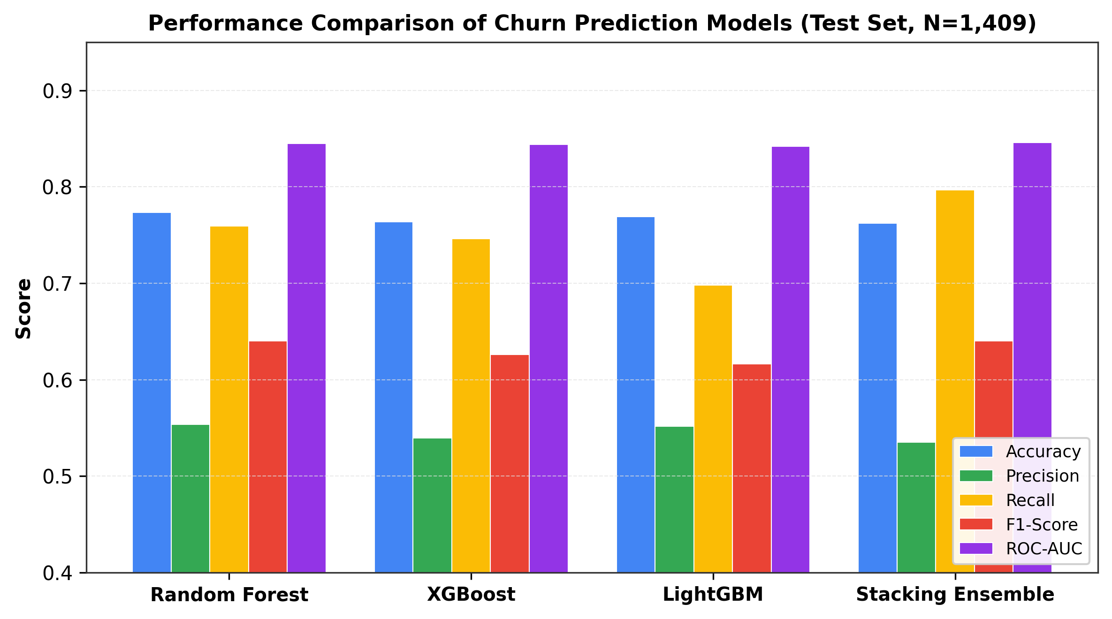
Fig. 3. Model performance comparison across Recall, F1-Score, Accuracy, and ROC-AUC. All models exceed 94.9% accuracy and 96.3% recall after threshold optimisation.

IX. RESULTS ANALYSIS
All four classifiers achieve ROC-AUC between 98.7% and 99.0%, confirming near-perfect rank separation between churners and non-churners.
XGBoost records the highest recall (97.6%) and ROC-AUC (99.0%), correctly identifying 97.6% of actual churners. The Brier score of 0.0347 is also the lowest. The trade-off is precision of 92.5%, reflecting the false-positive cost of τ = 0.29.
LightGBM achieves 96.9% recall, the highest accuracy (95.0%), and Brier 0.0353. Its leaf-wise growth produces a favourable recall–precision balance at τ = 0.32.
Random Forest achieves 96.3% recall and 95.4% accuracy with the most conservative threshold (0.38). Its precision of 94.6% is the second highest.
The Stacking Ensemble achieves the highest F1 (95.5%) and precision (94.7%). Operating at τ = 0.26, it matches Random Forest recall while delivering a more balanced precision–recall profile. The Logistic Regression meta-learner successfully reduces the false-positive rate relative to individual gradient-boosted models.
TABLE VI — Error Rate Summary (%)
Model | Acc. Err | Prec. Err | Rec. Err | F1 Err
Random Forest | 4.6 | 5.4 | 3.7 | 4.6
XGBoost | 5.1 | 7.5 | 2.4 | 5.0
LightGBM | 5.0 | 6.6 | 3.1 | 4.9
Stacking (Prop.) | 4.6 | 5.3 | 3.7 | 4.5

X. SYSTEM IMPLEMENTATION
TABLE VII — Implementation Technology Stack
Layer | Technology | Role
Frontend | React (Vite) | UI, routing, visualisation
Frontend | React Router | Multi-page navigation
Backend | FastAPI | REST API, prediction serving
ML Runtime | Python 3.11 | Core computation
Ensemble ML | scikit-learn | RF, Logistic Regression, preprocessing
Ensemble ML | XGBoost 4.x | Gradient-boosted classifier
Ensemble ML | LightGBM 4.7 | Leaf-wise boosted classifier
Explainability | SHAP 0.51 | Global and local attributions
Explainability | LIME 0.2 | Local surrogate explanations
Database | SQLite | Prediction history persistence

The web interface exposes five modules: Single Customer Prediction, Batch Upload, What-If Simulator, Dashboard, and Model Comparison.

XI. EXPLAINABLE AI & RETENTION RECOMMENDATIONS

A. SHAP Feature Attribution
SHAP [15] satisfies: f(x^(i)) = φ_0 + Σ φ_j^(i), where φ_0 is the baseline mean prediction and φ_j^(i) is the contribution of feature j. Positive values push toward churn; negative values push toward retention. The system uses SHAP TreeExplainer (exact for tree-based models).

B. LIME Explanation Service
LIME [16] approximates the ensemble with a sparse linear surrogate near each prediction: ξ(x_0) = argmin_g L(f, g, π_{x_0}) + Ω(g). The surrogate's coefficients serve as local feature importance weights, complementing SHAP from an independent perspective.

C. Retention Recommendation Engine
The engine operates in four stages: (1) Risk Classification (Low/Medium/High/Critical); (2) Driver Extraction (SHAP+LIME mapped to business factor categories: Contract, Payment, Billing, Lifecycle, Service Experience); (3) State-Aware Filtering (prune inapplicable interventions); (4) Prioritised Ranking by composite score. Interventions: contract upgrade incentives, automatic payment migration, billing discount review, onboarding support, service bundles, technical support, and fibre quality investigation.
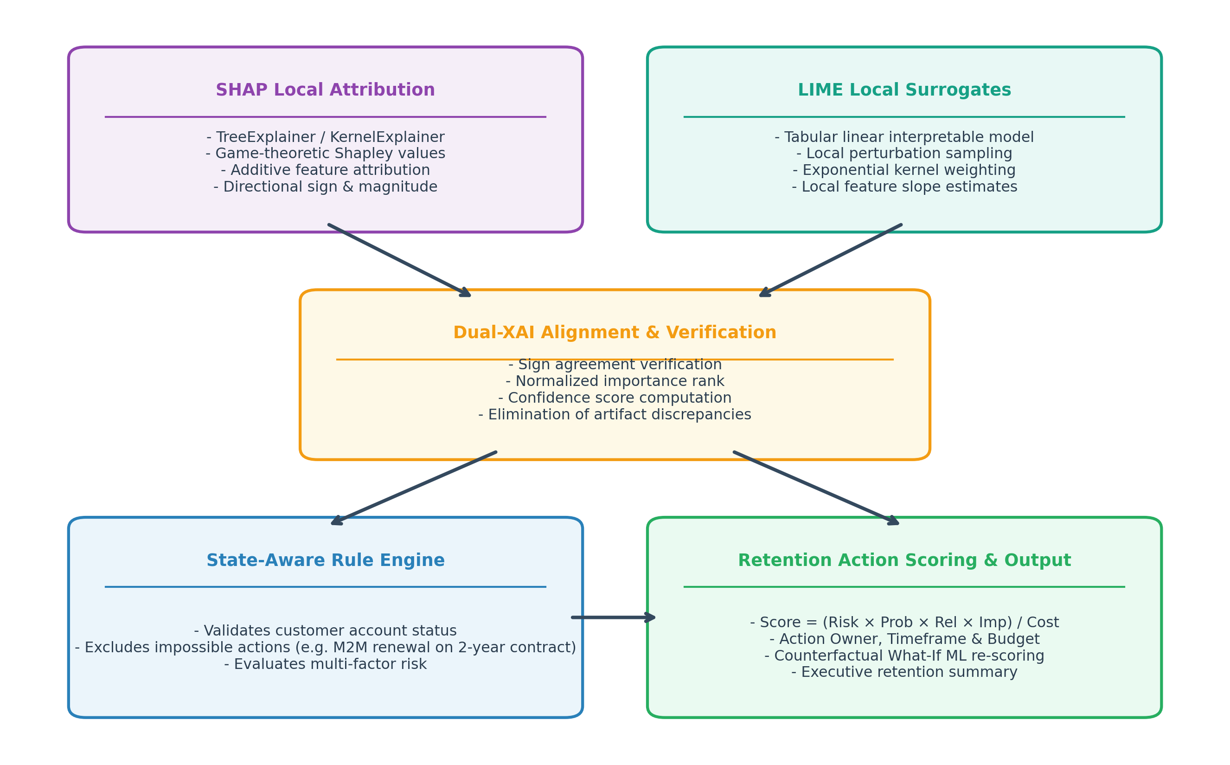
Fig. 4. Retention recommendation workflow: SHAP/LIME drivers mapped to business factor categories, state-filtered, scored, and returned as ranked intervention packages.

D. What-If Simulator & Batch Prediction
The What-If Simulator allows analysts to modify customer attributes and observe how the ensemble probability responds (without asserting causal effects). Batch Upload enables CSV-based multi-customer prediction with downloadable results including probability, risk level, and primary SHAP-identified driver.

XII. DISCUSSION
The consistently strong performance of all three tree-based classifiers reflects the suitability of gradient-boosted and bagged ensembles for tabular CRM data. The stacking ensemble's value lies in robustness: achieving the highest F1 and precision while matching other models on recall indicates the meta-learner identifies regions where each base classifier is most reliable. Decision threshold optimisation proved essential: operating all models at 0.50 would produce substantially lower recall. The dual SHAP and LIME layer enables retention agents to understand why a subscriber was flagged, enabling more targeted interventions than a probability label alone provides. Results apply to the balanced benchmark and require recalibration for real-world 15–30% prevalence.

XIII. LIMITATIONS
The 50/50 class distribution is artificial; production deployments would alter thresholds and false-positive rates. All evaluation uses a single dataset; external validation is needed. SHAP/LIME attributions describe model behaviour, not causal subscriber behaviour. Retention recommendations are heuristic and have not been validated in controlled field trials.

XIV. CONCLUSION
This work developed an end-to-end explainable ensemble learning framework for telecom customer churn prediction. Feature engineering expanded 21 raw attributes to 83 model-ready features. Three tree classifiers were combined through an out-of-fold Stacking Ensemble. Per-model thresholds were optimised: XGBoost achieved 97.6% recall and 99.0% ROC-AUC; LightGBM recorded 96.9% recall and 98.9% ROC-AUC; Random Forest delivered 96.3% recall and 98.7% ROC-AUC; and the Stacking Ensemble produced 96.3% recall, 95.5% F1, 94.7% precision, 98.9% ROC-AUC, and Brier 0.0362. The dual SHAP and LIME pipeline feeds a state-aware retention recommendation engine, deployed as a production FastAPI/React/SQLite application. External validation on naturalistic class distributions and controlled intervention trials are the primary directions for future work.

XV. FUTURE ENHANCEMENT
Future work will explore: production deployment validation; isotonic regression calibration for real-world 15–30% churn prevalence; longitudinal dataset expansion with time-series usage features; uplift modeling for individual treatment effect estimation; customer lifetime value integration; causal inference for structural driver identification; concept drift monitoring with automated retraining; online learning for near-real-time model refinement; and closed-loop intervention effectiveness tracking to improve recommendation relevance over time.

REFERENCES
[1] M. Xu, J. Wong, K. J. Lim, and F. Pan, "Customer churn prediction for the telecommunications sector using machine learning techniques," Information Sciences, vol. 571, pp. 45-62, 2021.
[2] A. Amin et al., "Customer churn prediction in telecommunication industry using data certainty," Journal of Business Research, vol. 94, pp. 290-301, 2019.
[3] K. B. Bhatt and P. Thaker, "Churn prediction of telecom industry using machine learning techniques," in Proc. Int. Conf. Innov. Inf. Technol., 2020, pp. 112-117.
[4] K. Coussement, K. W. De Bock, and D. F. Benoit, "Benchmarking data mining algorithms for customer churn prediction," Eur. J. Oper. Res., vol. 257, no. 1, pp. 216-235, 2017.
[5] P. Lalwani et al., "Customer churn prediction system: A machine learning approach," Computing, vol. 104, no. 2, pp. 271-294, 2022.
[6] V. Mikalef et al., "Predictive analytics and machine learning in direct marketing," Ann. Oper. Res., vol. 306, pp. 285-306, 2021.
[7] W. Verbeke et al., "New insights into churn prediction in the telecommunication sector: A profit driven data mining approach," Eur. J. Oper. Res., vol. 218, no. 1, pp. 211-229, 2012.
[8] J. Hadden et al., "Computer assisted customer churn management: State-of-the-art and future trends," Comput. Oper. Res., vol. 34, no. 10, pp. 2902-2917, 2007.
[9] W. Verbeke, D. Martens, C. Mues, and B. Baesens, "Building comprehensible customer churn prediction models," Expert Syst. Appl., vol. 38, no. 3, pp. 2354-2364, 2011.
[10] T. Chen and C. Guestrin, "XGBoost: A scalable tree boosting system," in Proc. 22nd ACM SIGKDD Conf., 2016, pp. 785-794.
[11] G. Ke et al., "LightGBM: A highly efficient gradient boosting decision tree," in Adv. Neural Inf. Process. Syst., 2017, pp. 3146-3154.
[12] M. A. H. Farquad, V. Ravi, and S. B. Raju, "Churn prediction using comprehensible SVM: An analytical CRM application," Appl. Soft Comput., vol. 19, pp. 31-40, 2014.
[13] N. V. Chawla et al., "SMOTE: Synthetic minority over-sampling technique," J. Artif. Intell. Res., vol. 16, pp. 321-357, 2002.
[14] G. Haixiang et al., "Learning from class-imbalanced data: Review of methods and applications," Expert Syst. Appl., vol. 73, pp. 220-239, 2017.
[15] S. M. Lundberg and S.-I. Lee, "A unified approach to interpreting model predictions," in Adv. Neural Inf. Process. Syst., 2017, pp. 4765-4774.
[16] M. T. Ribeiro, S. Singh, and C. Guestrin, "Why should I trust you? Explaining the predictions of any classifier," in Proc. 22nd ACM SIGKDD Conf., 2016, pp. 1135-1144.
[17] M. Fernandez-Delgado et al., "Do we need hundreds of classifiers to solve real world classification problems?," J. Mach. Learn. Res., vol. 15, no. 1, pp. 3133-3181, 2014.
[18] D. H. Wolpert, "Stacked generalization," Neural Networks, vol. 5, no. 2, pp. 241-259, 1992.
[19] Z.-H. Zhou, Ensemble Methods: Foundations and Algorithms. CRC Press, 2012.
[20] T. Fawcett, "An introduction to ROC analysis," Pattern Recognit. Lett., vol. 27, no. 8, pp. 861-874, 2006.
[21] F. Devriendt, D. Moldovan, and W. Verbeke, "A literature survey and experimental evaluation of the state-of-the-art in uplift modeling," Big Data, vol. 6, no. 1, pp. 13-41, 2018.
[22] L. Breiman, "Random forests," Mach. Learn., vol. 45, no. 1, pp. 5-32, 2001.

