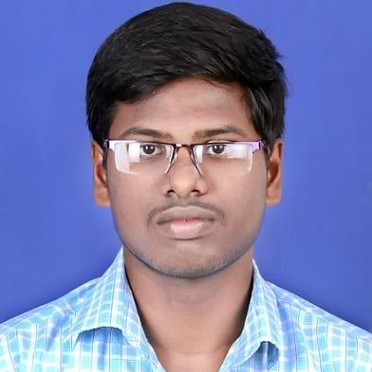

+91 6382040562

ashokkumark.citeee2017@gmail.com

**ASHOK KUMAR K**

[](https://github.com/ASHOKKUMAR-K)[](mailto:ashokkumark.citeee2017@gmail.com)

github.com/ASHOKKUMAR-K

**ASPIRING DATA SCIENTIST**



youtube.com



medium.com

Explored on Machine Learning, Exploratory Data Analysis, Data collection and cleaning, Data pre-processing, Visualization, Full Stack Development, etc...,

[](https://data-scientist-ashok.herokuapp.com/)

data-scientist-ashok.herokuapp.com/

[](https://www.kaggle.com/ashokkumar1085)[](https://www.linkedin.com/in/ashok-kumar-k-6641bb16a)

linkedin.com/in/ashok-kumar-k-6641bb16a

kaggle.com/ashokkumar1085

SKILLS

INTERNSHIPS

Seaborn

SQL

1. RESCUE THE DORAEMON (Jul 02, 2019 – Jul 20, 2019)

1. GENDER CLASSIFICATION (Feb 03, 2020 – Feb 18, 2020)

* Created hints for various kind of problems in their online platform.
* Sample 1
* Sample 2
* Sample 3
* Sample 4

WORK SAMPLES

2. The 365 Data Science Program (Mar 20, 2020 – Apr 15, 2020)

1. Python for Data Science (Apr 27, 2020 – Jun 05, 2020)

CERTIFICATES

*81.14%*

*08/2017 - Present*

English

*Professional Working Proficiency*

Tamil

*Native or Bilingual Proficiency*

LANGUAGES

**Electrical and Electronics Engineering**

**Higher Secondary Certificate**

*06/2011 – 04/2015*

*97.40%*

Government High School, Alapakkam

Chennai Higher Secondary School,

Virugambakkam

**Secondary School Leaving Certificate**

*06/2015 – 04/2017*

*90.41%*

Chennai Institute of Technology

EDUCATION

Sublime Text

Visual Studio Code

PyCharm

Spyder

Jupyter Notebook

TOOLS / IDE

* Rescue Doraemon from rats which tries to attack Doraemon
* Frameworks – Pygame
* GitHub Repository -
* Me and my team under the guidance of our seniors have developed website for our college techno-cultural event 'TAKSHASHILA' in order gather students from various colleges.
* Team Size – 6
* My role – Front End Development
* GitHub Repository -

**GAMING PROJECTS**

1. TAKSHASHILA 3.0 (Jan 02, 2019 – Mar 03, 2019)

**WEB DEVELOPMENT PROJECTS**

* Data Source – Kaggle
* Frameworks – Scikit-Learn, Flask, Git, Heroku
* Machine Learning Algorithm – Linear Regression (SVC)
* GitHub Repository -

2. WEIGHT PREDICTION (Jan 02, 2020 – Jan 27, 2020)

* Data Source – Kaggle
* Frameworks – NumPy, Pandas, Scikit-Learn, Flask, Git, Heroku
* Machine Learning Algorithm – Support Vector Machine (SVC)
* GitHub Repository -

**DATA SCIENCE PROJECTS**

PROJECTS

**GUVI –** PROBLEM SETTER(June 26, 2020 - Present)

Excel

PowerPoint

Word

**MS - OFFICE**

Tableau

Heroku

Pivotal Web Services

**CLOUD DEPLOYMENT**

Git

PHP

jQuery

MongoDB

SASS

Ajax

Bootstrap

Flask

MySQL

HTML5

CSS3

Java Script

Node

**WEB DEVELOPMENT**

Feature Engineering & Selection

EDA

Unsupervised Learning

Statistics

Probability

Supervised Learning

NumPy

Pandas

Pre-processing

**DATA SCIENCE**

**PROGRAMMING LANGUAGES**

Matplotlib

**DASH BOARD PRESENTATION**

Visualization

C

Java

Python