Raspberry Pi 3 64 bit build on kernel 4.9 Jignesh Patel : Emp ID 902 :
Date : 16/07/2017
The Raspberry Pi 3 ships with a Broadcom BCM2837 64bit ARMv8 quad core Cortex A53 processor, which is a 64-bit CPU.

The boot sequence of the Raspberry Pi is basically this:
- Stage 1 boot is in the on-chip ROM. Loads Stage 2 in the L2 cache
- Stage 2 is bootcode.bin. Enables SDRAM and loads Stage 3
- Stage 3 is loader.bin. It knows about the .elf format and loads start.elf
- start.elf loads kernel.img. It then also reads config.txt, cmdline.txt and bcm2835.dtb If the dtb file exists, it is loaded at 0×100 & kernel @ 0×8000 If disable_commandline_tags is set it loads kernel @ 0×0 Otherwise it loads kernel @ 0×8000 and put ATAGS at 0×100
- kernel.img is then run on the ARM.
Everything is run on the GPU until kernel.img is loaded on the ARM.
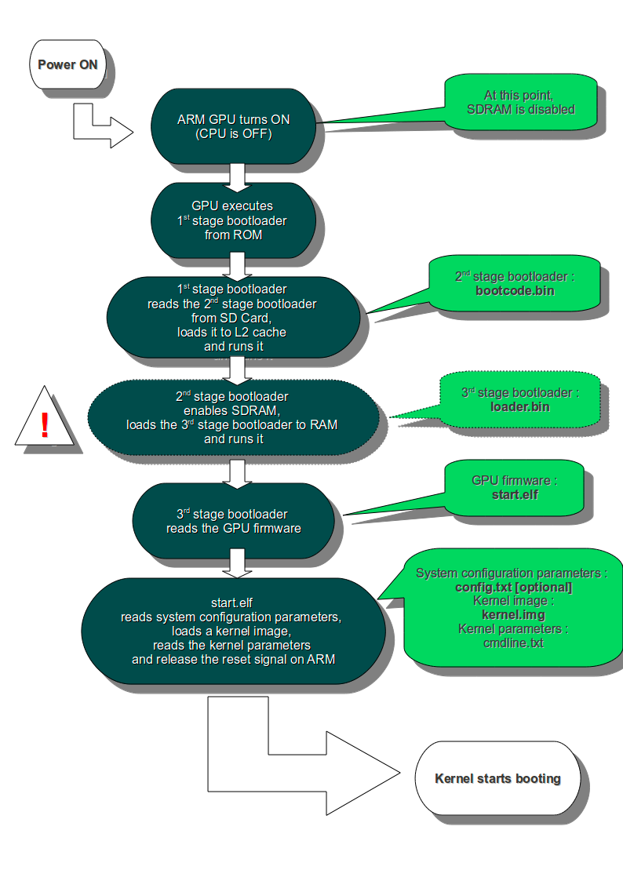

- First, we need a few build tools and the aarch64 cross-compiler :
- apt-get update
- apt-get install -y bc build-essential gcc-aarch64-linux-gnu git unzip
OR we can download from Linaro Releases
- https://releases.linaro.org/components/toolchain/binaries/latest/aarch64-linux-gnu/gcc-linaro-6.3.1-2017.05-x86_64_aarch64-linux-gnu.tar.xz
Add path to current linux dir.
$ export PATH=/home/to/aarch64-linux-gnu/bin:$PATH

- Then we can download the Linux Kernel sources :
- git clone –depth=1 -b rpi-4.9.y https://github.com/raspberrypi/linux.git
OR by default it sync stable branch
- git clone https://github.com/raspberrypi/linux.git

- In order to build it, run the following commands :
- make ARCH=arm64 CROSS_COMPILE=aarch64-linux-gnu- bcmrpi3_defconfig
- make -j3 ARCH=arm64 CROSS_COMPILE=aarch64-linux-gnu-
- make -j3 ARCH=arm64 CROSS_COMPILE=aarch64-linux-gnu- dtbs (Optional)
- make -j3 ARCH=arm64 CROSS_COMPILE=aarch64-linux-gnu- modules (Optional)
-j flag depending on your number of CPUs (nproc * 1.5)

SD card Partition using a GUI with GParted
GParted can be installed using:
- sudo apt-get install gparted
follow this steps -> https://www.acmesystems.it/microsd_format
Get the latest Raspberry Pi firmware (git://github.com/raspberrypi/firmware.git) Transfer the following files from the firmware/boot directory to the Raspberry Pi /boot directory:
- bootcode.bin
- fixup.dat
- start.elf
Once the Kernel build is finished, the last steps involve copying the Linux Kernel and the device tree to the boot partition :
- cp arch/arm64/boot/Image /mnt/boot/kernel.img
- cp arch/arm64/boot/dts/broadcom/bcm2837-rpi-3-b.dtb /mnt/boot/
- sudo make ARCH=arm64 CROSS_COMPILE=aarch64-linux-gnu INSTALL_MOD_PATH=mnt/ext4 modules_install

