
CCP6224 OOAD

Assignment Report:
Title
Tutorial: TT5L
Group: 5
Lecturer: Dr. Shahid

Prepared by:
Name | Student ID
AL-SALOUL, ASHRAF ALI HUSSEIN | 1221303805
Mohamed Mustafa Mohamed Salih | 242UC241G7
MAHMOUD M M ALSAQQA | 1231302839
ABDELRAHMAN MOHAMED HUSSEIN ABDELRAHMAN | 242UC2430Z

Table of Contents
1 Introduction 3
2 System Overview 3
2.1 Primary Roles 3
2.2 Layered Architecture 3
3 Organisation of Key Files 4
3.1 Key Files Table 4
3.2 Detailed File Descriptions 4
3.3 Data Files 5
4 User Interface Screens 5
4.1 Role Selection and Login Screen 5
4.2 Student Dashboard 6
4.3 Coordinator Dashboard 6
4.4 Evaluator Dashboard 6
4.5 Persistent Storage Evidence 6
5 Usage Scenarios 6
5.1 Logging In 6
5.2 Student Scenario 7
5.3 Coordinator Scenario 7
5.4 Evaluator Scenario 7
6 Diagrams 7
6.1 UML Class Diagram 8
6.2 Sequence Diagram 1 – Login and Seminar Retrieval 9
6.3 Sequence Diagram 2 – Student Enrolment Flow 10
6.4 Sequence Diagram 3 – Evaluator Evaluation Flow 11
7 Conclusion 12

Introduction
This project implements a Seminar Management System using Java and the Swing user interface library. The system supports management of postgraduate seminar presentations through three roles: Student, Coordinator, and Evaluator. The design follows object‑oriented principles and a clean separation of layers: core entities reside in the model package, the business logic lives in a service layer, and each role has its own graphical interface. Data is persisted to simple CSV files.
The system is designed to be elegant and extensible, providing clear workflows for each user with input validation and helpful feedback.

System Overview

Primary Roles
The system defines three primary roles as outlined in the class diagram:
- Student: represents the presenter or student who registers for seminars.
- Evaluator: the academic who evaluates seminars against specific criteria.
- Coordinator: the person responsible for creating seminars, assigning presenters, and monitoring participants.
The Role enumeration in the model package restricts roles to STUDENT, EVALUATOR, and COORDINATOR. Another enumeration SeminarStatus defines the seminar’s state (DRAFT, OPEN, CLOSED, COMPLETED).

Layered Architecture
The system is divided into four logical layers:
- Models: core data entities such as Seminar, User, Evaluation and Enrollment. For example, Seminar stores properties including an ID, title, presentation date, venue and status. Enrollment holds the enrolment ID, seminar ID, student ID and status, while Evaluation keeps evaluator and seminar IDs alongside four scores and a comment.
- Repositories: handle reading and writing CSV files for each model (Users, Seminars, Enrolments, Evaluations).
- Services: implement business rules such as creating and updating seminars, enrolling students, saving evaluations and authenticating users.
- User Interface: Swing frames for each role: a RoleSelectionFrame for choosing role and logging in, and the dashboards StudentDashboard, CoordinatorDashboard and EvaluatorDashboard to present each role’s functions.
Overall, data flows from the user interface through services to repositories and then to CSV storage. This design makes it easy to swap the persistence layer in future without changing the UI or business logic.
- Organisation of Key Files

Key Files Table
Path | Brief Purpose
model/Seminar.java | Defines the Seminar entity (ID, title, date, venue, status)
model/Enrollment.java | Defines a student’s enrolment (ID, student, seminar, status)
model/Evaluation.java | Defines a seminar evaluation (ID, evaluator, scores, comment)
model/User.java | Defines a user (ID, name, role, password)
service/SeminarService.java | Business logic for creating, updating and retrieving seminars
service/EnrollmentService.java | Business logic for enrolling students and updating enrolment status
service/EvaluationService.java | Business logic for saving and retrieving evaluations and computing averages
service/AuthService.java | Validates login credentials and matches roles
repository/*Repository.java | Reads and writes data to CSV files
ui/RoleSelectionFrame.java | GUI for selecting role and logging in
ui/StudentDashboard.java | Student dashboard for viewing seminars and enrolling
ui/CoordinatorDashboard.java | Coordinator dashboard for creating/editing seminars and monitoring participants
ui/EvaluatorDashboard.java | Evaluator dashboard for scoring seminars

Note: Long explanations are avoided in the table above. Detailed descriptions for each file are provided in the following paragraphs.

Detailed File Descriptions

Model Files
- Seminar.java: represents a seminar and contains fields such as id, title, presenterId, date, venue and status. It is used to pass seminar information between layers.
- Enrollment.java: records a student’s participation in a specific seminar with fields id, seminarId, studentId and a status (e.g., registered, accepted).
- Evaluation.java: stores a seminar evaluation with a seminar ID, evaluator ID, four scores from 1‑5 and a free‑text comment.
- User.java: represents a user with id, name, role (from the Role enum) and a password for authentication.

Service Files
- SeminarService.java: provides functions to create, modify and retrieve seminars and manage their status. It relies on SeminarRepository for storage and uses the SeminarStatus enumeration to manage states.
- EnrollmentService.java: allows students to enrol in seminars and ensures no duplicate enrolments occur. It returns an Enrollment object with the updated status and calls loadEnrollments() in the student dashboard to display the current registrations.
- EvaluationService.java: enables evaluators to create or update a seminar evaluation and computes the average of the scores. The average is shown in a message when saved.
- AuthService.java: handles login validation and ensures the selected role matches the user’s role.

Repository Files
Each model has a corresponding repository that maps to a CSV file. These repositories read data from CSV files, convert them into model objects, and write them back when modified. This separation allows the persistence layer to be swapped for a database later without changing the business logic.

User Interface Files
- RoleSelectionFrame.java: enables the user to choose a role and enter credentials. When the login button is pressed, the service validates the inputs and opens the corresponding dashboard.
- StudentDashboard.java: displays a table of available seminars with columns: ID, title, date, venue and status. A student can select a seminar and click Enroll to register; if no row is selected the system shows a warning, and if successful it saves the enrolment and refreshes the list. A second table shows the student’s current enrolments.
- CoordinatorDashboard.java: provides three buttons: Create Seminar, Edit Seminar and Refresh. The coordinator can view a table of seminars and a participant table with enrolment ID, student name, seminar ID and status. When creating or editing a seminar, a form appears with fields such as title, presenter ID, abstract, supervisor, presentation type, venue, date and status, and after clicking Save the data are stored and tables are updated.
- EvaluatorDashboard.java: lists available seminars with an Evaluate button. Selecting a seminar opens an evaluation dialog with four spinner fields (problem clarity, methodology, results, presentation) and a text field for comments. Saving the evaluation computes the average score and displays it to the evaluator.

Utility Files
- IdGenerator.java: generates unique IDs for various objects.
- FileUtils.java: provides helper functions for reading and writing CSV files and ensuring resources are closed correctly.

Data Files
The system stores its data in the data/ directory as CSV files:
users.csv, seminars.csv, enrollments.csv and evaluations.csv. Users can remove these files to reset the seed data easily.
- User Interface Screens
The system provides several Swing‑based screens. Below is a description of each screen along with where to insert the corresponding screenshot:

Role Selection and Login Screen
- Image location: [Insert the role‑selection and login screen image here – Figure 1]
- Figure description: This figure shows the RoleSelectionFrame where the user selects their role from a drop‑down list (Student, Evaluator or Coordinator) and enters their user ID and password. When the Login button is pressed, the credentials are sent to AuthService for verification. If they are valid, the appropriate dashboard for the role is opened.

Student Dashboard
- Image location: [Insert the student dashboard image here – Figure 2]
- Figure description: The StudentDashboard displays a table of available seminars with columns (ID, Title, Date, Venue, Status). There is an Enroll button to register for the selected seminar; if the student fails to select a row a warning message is shown, and on success a new row is added to the enrolments table and a confirmation is displayed. The Refresh button updates the lists, and the bottom table shows the student’s current registrations.

Coordinator Dashboard
- Image location: [Insert the coordinator dashboard image here – Figure 3]
- Figure description: The CoordinatorDashboard contains a seminar table and a participant table. The Create Seminar and Edit Seminar buttons open forms for adding a new seminar or modifying an existing one. The form includes fields such as title, presenter ID, abstract, supervisor, presentation type, venue, date and status, and after clicking Save the data are written and the tables are updated.

Evaluator Dashboard
- Image location: [Insert the evaluator dashboard image here – Figure 4]
- Figure description: The EvaluatorDashboard lists seminars with an Evaluate button. When a seminar is selected and the button is pressed, an evaluation dialog opens consisting of four spinner fields for scores (each between 1 and 5) and a text area for comments. After pressing Save Evaluation the average score is computed and displayed in a confirmation message.

Persistent Storage Evidence
- Image location: [Insert an image demonstrating that data persist after restarting the application – Figure 5]
- Figure description: This image should show how seminar, enrolment and evaluation data remain after closing and relaunching the application, demonstrating successful persistence to CSV files. You can capture a screenshot of the tables after restarting and compare them with previous sessions.
- Usage Scenarios
This section explains how to operate the system from start to finish for each role.

Logging In
- The user starts the application and the role selection screen appears.
- They select their role (Student, Evaluator or Coordinator) from the list and enter their user ID and password.
- When Login is pressed, AuthService validates the credentials and role.
- If the credentials are correct, the login screen closes and the appropriate dashboard opens; otherwise, an error message is displayed.

Student Scenario
- The student opens the StudentDashboard and sees the table of available seminars.
- They select a seminar, review its details and click Enroll. If they forget to select a row the system displays a warning.
- Upon enrolment the system saves the Enrollment and shows a confirmation with the enrolment status.
- The enrolments table is refreshed to show the student’s current records.
- The student can use the Refresh button at any time to update the tables.

Coordinator Scenario
- The coordinator opens the CoordinatorDashboard, viewing tables of seminars and participants.
- To create a new seminar, they click Create Seminar and a form appears with fields for title, presenter, abstract, supervisor, presentation type, venue, date and status.
- After filling in the details they click Save to store the seminar and refresh the tables.
- To modify an existing seminar, they select a row in the seminar table and click Edit Seminar; the form shows the current values and allows editing.
- The Refresh button updates the seminars and participants tables with the latest data.

Evaluator Scenario
- The evaluator sees a list of seminars in EvaluatorDashboard and selects a seminar to assess.
- They click Evaluate, which opens an evaluation window containing four scores (each between 1 and 5) and a comments field.
- If an evaluation already exists, the scores and comment are pre‑loaded.
- After entering their scores and comment, they click Save Evaluation to save the evaluation and see the average score in a confirmation message.
- The evaluator can assess all seminars one after another; each evaluation is saved to a CSV file.

Diagrams
This section contains the UML class diagram and sequence diagrams required for the assignment. The diagrams illustrate the structure and interactions of key components in the system.

UML Class Diagram
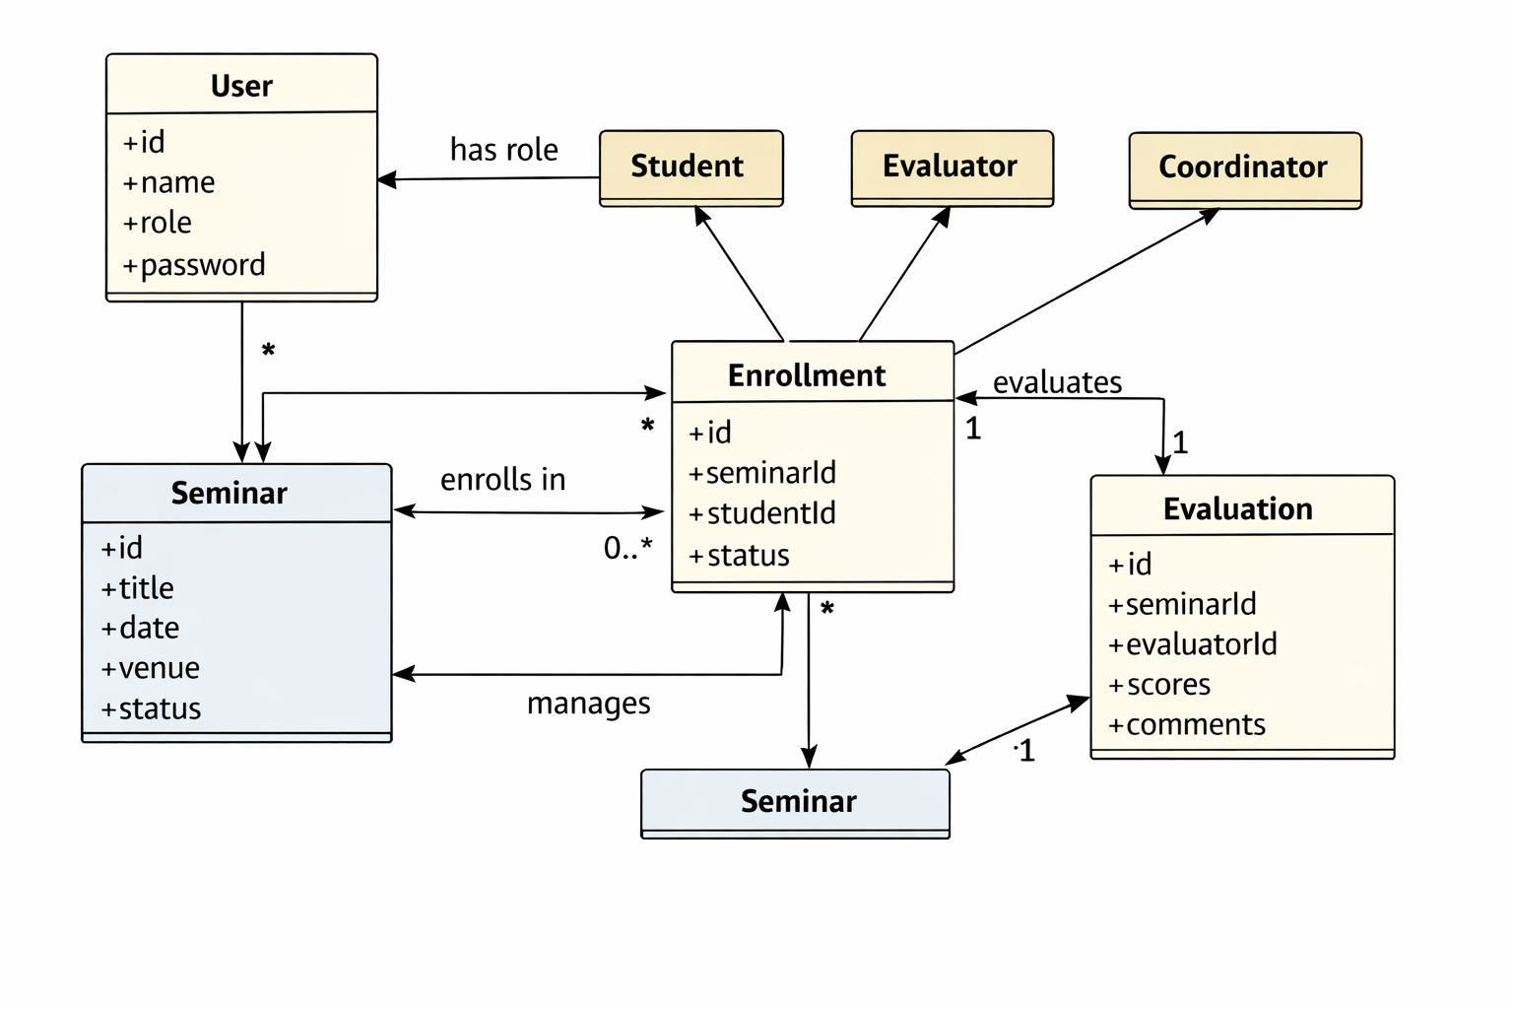
UML Class Diagram
Figure 6: A class diagram showing the major classes (User, Seminar, Enrollment, Evaluation) and the roles Student, Evaluator and Coordinator, with associations and multiplicities. User has a role, a student enrols in a seminar via an Enrollment, and an evaluator evaluates a seminar via an Evaluation.

Sequence Diagram 1 – Login and Seminar Retrieval
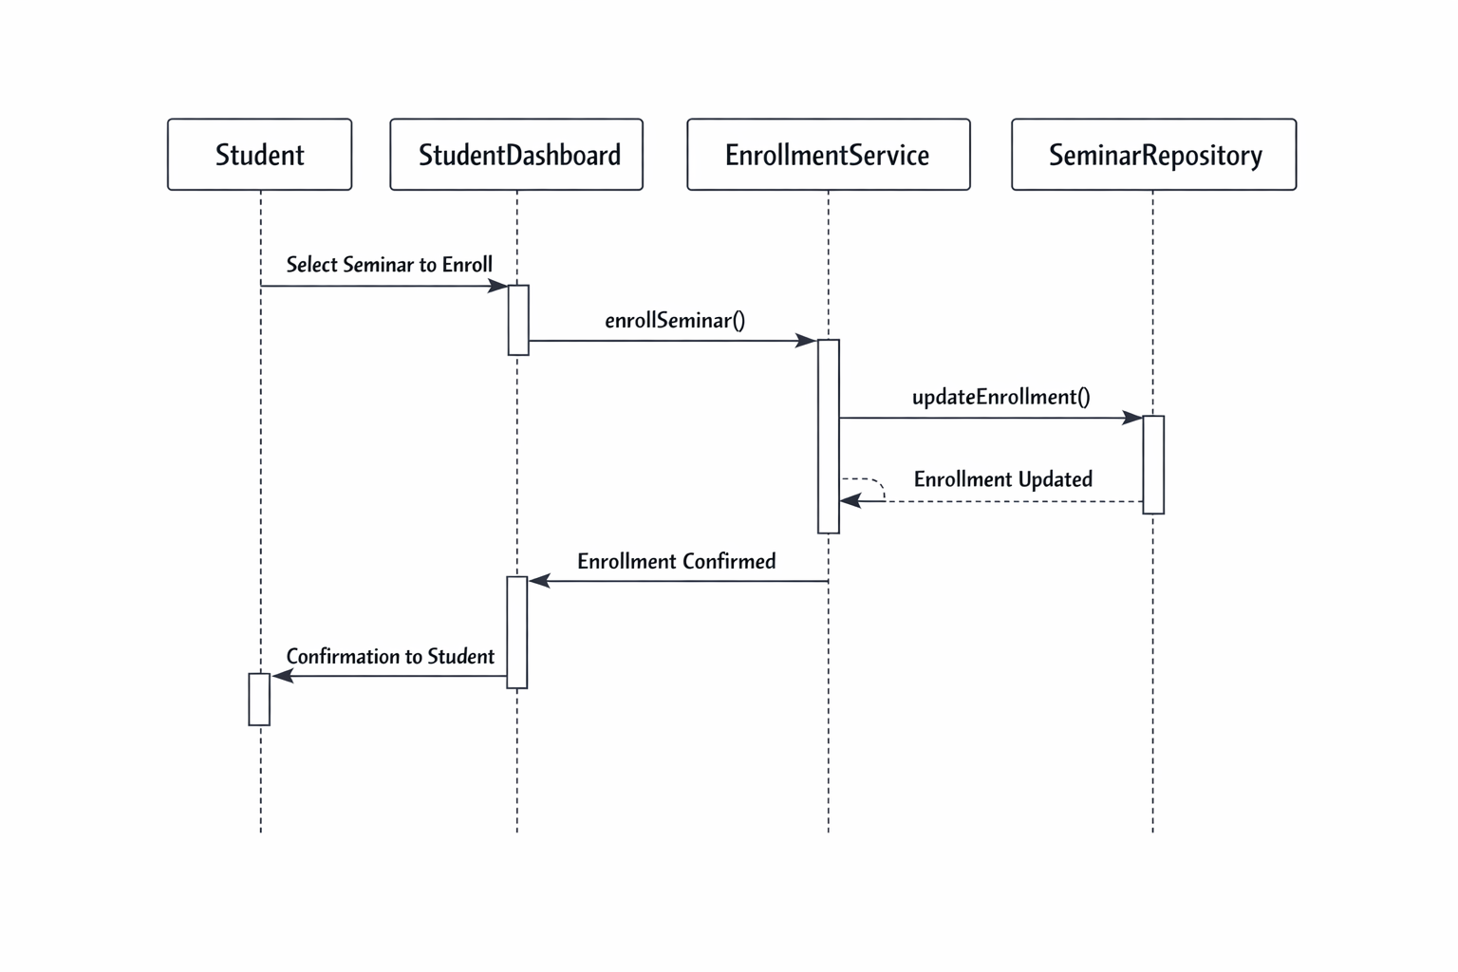
Sequence Diagram 1
Figure 7: Sequence of interactions when a student logs in, selects the Student role, and the dashboard retrieves the list of seminars from the service.

Sequence Diagram 2 – Student Enrolment Flow
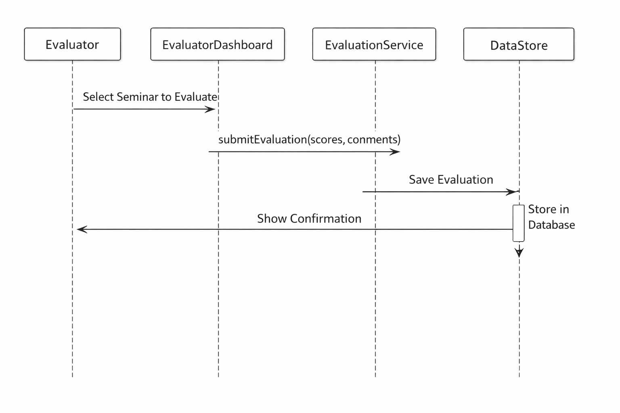
Sequence Diagram 2
Figure 8: Sequence of interactions when a student enrols in a seminar: the student selects a seminar, the dashboard calls the enrolment service to create an enrolment, the service writes to CSV, and the dashboard refreshes the enrolment list.

Sequence Diagram 3 – Evaluator Evaluation Flow
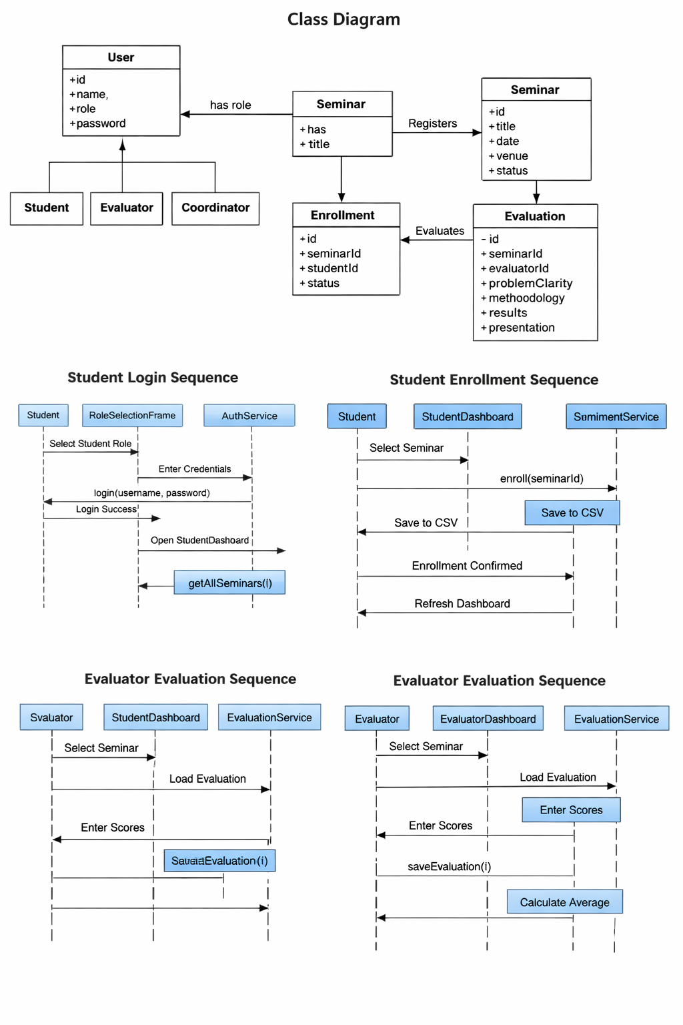
Sequence Diagram 3
Figure 9: Sequence of interactions when an evaluator evaluates a seminar: the evaluator selects a seminar, the dashboard loads any existing evaluation, the evaluator enters scores, the evaluation is saved via the service, and the average score is shown.

Conclusion
The Seminar Management System has been designed to provide an integrated environment supporting students, coordinators and evaluators through a simple graphical interface. This report describes the file structure and system layers, provides descriptions of each screen with guidance on where to insert the required screenshots, includes UML class and sequence diagrams illustrating key relationships and interactions, and breaks down each role’s workflow into clear steps. The system also demonstrates how data are preserved using CSV files so they can be reloaded after restarting.
This flexible structure ensures the system can be extended with new features or roles in the future while maintaining its current organisation.

