FINAL YEAR PROJECT INTERIM REPORT

985

Machine Learning-Based System for Cardiopulmonary Sound Separation

1221303805

AL-SALOUL, ASHRAF ALI HUSSEIN

Supervisor: Arshad Jamal

BACHELOR OF COMPUTER SCIENCE B.CS (HONS) SOFTWARE ENGINEERING

MAY 2026

985

Machine Learning-Based System for Cardiopulmonary Sound Separation

BY

1221303805 AL-SALOUL, ASHRAF ALI HUSSEIN
PROJECT INTERIM REPORT SUBMITTED IN PARTIAL FULFILMENT OF THE REQUIREMENT FOR THE DEGREE OF

BACHELOR OF COMPUTER SCIENCE B.CS (HONS) SOFTWARE ENGINEERING

Supervisor: Arshad Jamal
in the
Faculty of Computing and Informatics

MULTIMEDIA UNIVERSITY

MALAYSIA

MAY 2026

Copyright
- 2026 Universiti Telekom Sdn. Bhd. ALL RIGHTS RESERVED.
Copyright of this report belongs to Universiti Telekom Sdn. Bhd. as qualified by Regulation 7.2 (c) of the Multimedia University Intellectual Property and Commercialisation Policy. No part of this publication may be reproduced, stored in or introduced into a retrieval system, or transmitted in any form or by any means, or for any purpose, without the express written permission of Universiti Telekom Sdn. Bhd. Due acknowledgement shall always be made of the use of any material contained in, or derived from, this report.

Declaration
I hereby declare that the work has been done by myself and no portion of the work contained in this report has been submitted in support of any application for any other degree or qualification of this or any other university or institution of learning.
Name of candidate: AL-SALOUL, ASHRAF ALI HUSSEIN
Faculty of Computing & Informatics
Multimedia University
Date:

Acknowledgements
In the name of Allah, the Most Gracious, the Most Merciful.
I would like to express my sincere gratitude to my supervisor, Arshad Jamal, for his guidance, patience, and continuous support throughout the development of this project. His advice helped shape both the technical and academic direction of this work.
I am also grateful to Multimedia University and the Faculty of Computing and Informatics for providing the academic environment, resources, and support necessary to complete this project.
Finally, I would like to thank my family, friends, and colleagues for their encouragement, patience, and moral support throughout this journey.

Abstract
Cardiopulmonary sound recordings often contain heart sounds, lung sounds, sensor contact noise, and environmental artefacts in the same audio signal. Because these components can overlap, simple filtering may not be enough to produce clear heart and lung outputs. This Final Year Project, titled Machine Learning-Based System for Cardiopulmonary Sound Separation, focuses on designing a software prototype that accepts mixed cardiopulmonary audio, applies suitable preprocessing, separates the recording into heart sound and lung sound outputs, and plans evaluation using suitable datasets and metrics.
The report follows an application-based prototype approach. The literature review discusses cardiopulmonary sound characteristics, traditional signal processing methods, machine learning and deep learning methods, available datasets, evaluation metrics, and software-prototype gaps. The report then defines the requirements analysis, system design, and implementation plan for a proof-of-concept workflow covering audio upload, validation, preprocessing, model selection, separation, output management, and planned evaluation. The project does not focus on disease diagnosis or clinical decision-making; its contribution is a structured software workflow for cardiopulmonary sound separation research and experimentation.

Table of Contents
Right-click and update field to generate the table of contents.

List of Tables
Table 1: Summary literature review matrix for key cardiopulmonary sound separation studies
Table 2: Questionnaire structure for user requirements analysis
Table 3: Questionnaire analysis mapping
Table 4: Functional requirements for the cardiopulmonary sound separation prototype
Table 5: Non-functional requirements for the cardiopulmonary sound separation prototype
Table 6: User requirements for the proposed prototype
Table 7: Main use case description for the proposed prototype
Table 8: Main system modules and responsibilities
Table 9: Planned separation strategy options for model selection
Table 10: Planned database entities for prototype traceability
Table 11: Planned interface areas for the prototype
Table 12: Planned backend API responsibilities
Table 13: Full literature review matrix for selected Chapter 2 papers
Table 14: PRISMA screening summary for the literature review
Table 15: System design diagram summary
Table 16: Planned test cases and evaluation checks
Table 17: Planned evaluation metrics for FYP2 prototype testing

List of Figures
Figure 1: PRISMA flow diagram for the literature search and screening process
Figure 2: Perceived difficulty of separating heart and lung sounds
Figure 3: Problems affecting cardiopulmonary sound processing
Figure 4: Usefulness of the proposed heart-lung sound separation prototype
Figure 5: Preferred system features
Figure 6: Preferred output after sound separation
Figure 7: Importance of previewing separated heart and lung sounds
Figure 8: Preferred interface style
Figure 9: Preferred first information after separation is completed
Figure 10: Importance of evaluation metrics for separated output
Figure 11: Willingness to use the cardiopulmonary sound separation prototype
Figure 12: Context diagram for the proposed cardiopulmonary sound separation prototype
Figure 13: Use case diagram for the proposed cardiopulmonary sound separation prototype
Figure 14: Activity diagram for the sound separation workflow
Figure 15: Class diagram for the planned prototype modules
Figure 16: Component-level architecture for the proposed prototype
Figure 17: Sequence diagram for uploading and separating a cardiopulmonary recording
Figure 18: FYP1 Gantt chart for the cardiopulmonary sound separation report schedule

List of Abbreviations/Symbols
Abbreviation | Description
FYP | Final Year Project
ML | Machine Learning
DL | Deep Learning
PCG | Phonocardiogram
HLS-CMDS | Heart and Lung Sounds Dataset Recorded from a Clinical Manikin using Digital Stethoscope
SNR | Signal-to-Noise Ratio
SDR | Signal-to-Distortion Ratio
SI-SDR | Scale-Invariant Signal-to-Distortion Ratio
STFT | Short-Time Fourier Transform
NMF | Non-negative Matrix Factorization
VMD | Variational Mode Decomposition
CNN | Convolutional Neural Network
PESQ | Perceptual Evaluation of Speech Quality
STOI | Short-Time Objective Intelligibility
API | Application Programming Interface
UI | User Interface
UML | Unified Modeling Language
PRISMA | Preferred Reporting Items for Systematic Reviews and Meta-Analyses

List of Appendices
Appendix A: Gantt Chart
Appendix B: FYP1 Meeting Logs
Appendix C: Turnitin Similarity Index Page
Appendix D: Full Literature Review Matrix
Appendix E: PRISMA Screening Summary
Appendix F: System Design Diagrams
Appendix G: Planned Test Cases and Evaluation Metrics
Appendix H: Full User Requirements Questionnaire

CHAPTER 1: INTRODUCTION

1.1 Overview
Cardiopulmonary auscultation records sounds from the heart, lungs, airways, chest wall, and the surrounding environment. A single chest recording can contain heart sounds, lung sounds, breathing artefacts, body movement, sensor noise, and background sound at the same time. This becomes a problem when the required output is not the mixed recording, but two separate audio files: one for the heart sound and one for the lung sound. This project focuses on that software problem by designing a reusable prototype for cardiopulmonary sound separation.
The project is titled Machine Learning-Based System for Cardiopulmonary Sound Separation. It is an application-based FYP1 project, and the contribution is a prototype or proof of concept rather than a finished medical product. This report covers the background study, literature review, requirements analysis, system design, and implementation plan needed before continuing with FYP2 development and evaluation.

1.2 Problem Statement
- Noise and recording artefacts reduce the quality of cardiopulmonary sound recordings, making the signals harder to process accurately. In a practical recording, the useful heart and lung components may be mixed with background sound, sensor noise, breathing artefacts, body movement, and device limitations before the file reaches the software system. This matters for the project because the separation model can only work with the signal it receives. If the input is dominated by unwanted noise, the model may learn patterns that are not actually heart or lung sounds. Studies on noisy neonatal chest sounds, blind denoising, and lung sound enhancement show that preprocessing is still needed before later analysis or separation can be trusted (Grooby et al., 2023; Fattahi et al., 2022; Ali et al., 2023). For this FYP, the problem is partly about model choice, but it is also about building a workflow that validates and preprocesses the uploaded audio before separation starts.
- Heart and lung sounds can overlap in time and frequency when they are recorded together, so separating them is not as simple as cutting the signal into two frequency bands. A mixed cardiopulmonary recording may contain short heart sound events and longer respiratory patterns at the same time. Their frequency ranges can also partially overlap, which means a fixed filter may remove useful information or leave part of the unwanted source in the output. This is more difficult when the prototype receives only one mixed recording and does not have direct access to the original heart and lung sources. Recent work on neonatal heart and lung sound separation, decomposition-based approaches, and compact learning models shows that the separation task needs more than a basic filtering rule (Poh et al., 2024; Sun et al., 2024; Wang et al., 2023a). This FYP addresses the problem by planning a machine learning-based separation workflow instead of depending only on a fixed signal processing pipeline.
- Many existing studies focus on diagnosis, classification, or algorithm-level experiments, while fewer works describe a reusable software prototype for the separation workflow itself. Review and analysis studies show that cardiopulmonary sound research often discusses clinical interpretation, automated classification, or model performance, which is useful but does not always provide a complete student-usable application (Roy et al., 2024; Zhao et al., 2024; Torabi et al., 2025a). For this project, the required workflow is more practical: upload one mixed recording, validate it, preprocess it, select or run a separation model, and obtain separate heart and lung audio outputs. As a Software Engineering FYP, the algorithm is only one part of the work. The system around it also has to be designed. The prototype needs clear requirements, module responsibilities, interface flow, storage planning, and evaluation planning so it can be implemented and tested consistently in FYP2.

1.3 Project Objectives
- To study and apply suitable preprocessing techniques to reduce noise and improve the quality of cardiopulmonary sound recordings.
- To design and implement a machine learning-based approach for separating mixed cardiopulmonary recordings into heart and lung sound outputs.
- To develop a reusable software prototype and evaluate its separation performance using public datasets and suitable performance metrics.

1.4 Project Scope
This project is limited to a software prototype for cardiopulmonary sound separation. The intended prototype accepts one mixed cardiopulmonary audio file, validates the input, applies preprocessing, runs a separation workflow, and returns separate heart and lung sound outputs for preview and download.
The work focuses on public or otherwise permissible datasets, reproducible preprocessing, model integration, and evaluation planning using suitable signal-level metrics. It does not include disease detection, treatment recommendation, real-time bedside deployment, or replacement of professional medical assessment. The system is designed as a research and learning prototype for sound separation only.

1.5 Project Limitations
The current work is limited by the FYP1 stage. At this stage, the focus is background study, requirements analysis, system design, and implementation planning. Full model training, completed implementation results, user acceptance outcomes, and final performance scores are left for later implementation work.
The prototype also depends on the availability and quality of public cardiopulmonary sound datasets. Recordings collected using different devices, body positions, sampling rates, or noise conditions may behave differently. The questionnaire analysis in Chapter 3 is based on 53 responses, but the respondents are still a small academic sample. Their feedback is useful for FYP1 requirements analysis, not a replacement for full user acceptance testing after implementation.

1.6 Methodology
The project follows an application-based workflow. The first step is to study cardiopulmonary sound characteristics, separation techniques, public datasets, and evaluation metrics. The second step is to define requirements from the literature review, existing system observation or benchmarking, supervisor consultation, and the completed questionnaire analysis. The third step is to prepare system design artefacts such as the context diagram, use case diagram, activity diagram, class diagram, and sequence diagram. The final FYP1 step is to prepare the implementation plan for the front end, back end, machine learning integration, storage, testing, deployment, documentation, and maintenance.
This methodology keeps the FYP1 report aligned with the expected application-based structure while avoiding unsupported claims about completed implementation, completed user studies, or final test results.

1.7 Target Audience
The target users are students, researchers, and project evaluators who need a simple workflow for separating mixed cardiopulmonary recordings into heart and lung audio outputs. The system also supports the student developer by giving a clear prototype structure that can be implemented, tested, and improved during FYP2.

1.8 Summary
Mixed cardiopulmonary recordings can contain noisy and overlapping heart and lung components, and many existing works do not provide a complete reusable software workflow for separation. This chapter defined the project problem, objectives, scope, limitations, methodology, and target audience. The next chapter reviews the studies that support the project direction.

CHAPTER 2: LITERATURE REVIEW

2.1 Overview
This review focuses on the studies that shape the cardiopulmonary sound separation prototype. It covers sound characteristics, separation techniques, datasets, evaluation metrics, existing systems, and the connection between prior work and this application-based project. The main purpose is to explain why the prototype needs preprocessing, model-based separation, output handling, and a clear evaluation plan.
Across the selected studies, one issue appears repeatedly: heart sounds, lung sounds, and recording noise can exist in the same signal. Traditional signal processing is still useful for preprocessing and explainable decomposition, but recent machine learning and deep learning methods are more relevant when the separation task becomes too complex for fixed rules alone.

2.2 Literature Search and Screening Process
The search focused on cardiopulmonary sound separation, heart sound removal, lung sound separation, denoising, public auscultation datasets, evaluation metrics, and prototype-related cardiopulmonary sound systems. In total, 96 records were considered. After unsuitable and out-of-scope papers were removed, 49 records remained eligible. From these eligible records, 35 studies were selected for the Chapter 2 synthesis and the full literature review matrix. The selected set contains 18 core separation studies and 17 background or supplementary studies. Fourteen eligible backup records were kept for reference but are not cited in this report.
The review uses a PRISMA-style summary so the search and screening decisions are clear. The final counts are 96 records considered, 47 records excluded, 49 eligible records after screening, and 35 studies selected and used in the current literature review. Excluded papers are not used as evidence in this report.
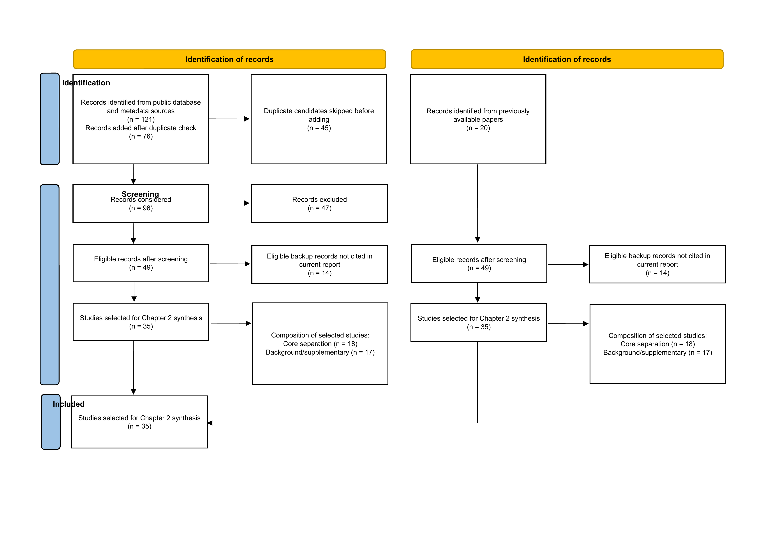
Figure 1: PRISMA flow diagram for the literature search and screening process

2.3 Cardiopulmonary Sound Characteristics
Cardiopulmonary sound recordings contain acoustic components from cardiac activity, respiratory airflow, chest wall transmission, and the recording environment. Heart sounds usually appear as short repeated events such as S1 and S2. Lung sounds are linked to breathing airflow and can change between inspiration and expiration. When both are recorded from the chest surface, the two sources can occur at the same time and may overlap in frequency.
This overlap matters because simple fixed-band filtering may not separate the sources cleanly. Studies on respiratory sound analysis and cardiopulmonary signal characteristics show that a useful system must consider noise, source overlap, and recording variability (Roy et al., 2024; Zhao et al., 2024; Grooby et al., 2023). For this reason, the prototype needs preprocessing and consistent model input preparation before separation.

2.4 Heart and Lung Sound Separation Techniques
Heart and lung sound separation has been studied using traditional signal processing methods and machine learning-based methods. No single method is suitable for every recording condition. The better choice depends on the recording source, noise level, available training data, and the metric used to judge the output.

2.4.1 Traditional Signal Processing Methods
Traditional approaches include filtering, adaptive filtering, blind source separation, non-negative matrix factorization, empirical mode decomposition, variational mode decomposition, and related decomposition techniques. These methods are useful because their behaviour is easier to inspect and they can be tested even when large training datasets are not available. Blind denoising and decomposition-based separation studies show how signal structure can be used to reduce interference between heart and lung components (Fattahi et al., 2022; Sun et al., 2024; Ullah and Zhang, 2024).
Their limitation is that fixed rules may struggle when the sources overlap strongly or when the recording contains changing noise. A method that works for one subject, device, body position, or recording condition may not behave the same way in another case. In this project, traditional methods are therefore better treated as preprocessing, baseline, or comparison strategies rather than the only separation solution.

2.4.2 Machine Learning and Deep Learning Methods
Machine learning and deep learning approaches learn a mapping from a mixed cardiopulmonary input to separated output components. Recent studies use neural networks, source separation models, compact architectures, and data-driven enhancement methods for separation or related cardiopulmonary sound tasks (Poh et al., 2024; Wang et al., 2023a; Zhang et al., 2025; Ali et al., 2023). These studies are relevant because this FYP needs a repeatable workflow that can take one mixed recording, prepare it, run a model, and return heart and lung outputs.
The advantage of machine learning is that it can learn source patterns that are difficult to describe using fixed rules. The limitation is that the result depends on training data quality, preprocessing consistency, evaluation design, and available computing resources. In this project, the model is treated as one part of the prototype, not as a standalone experiment.

2.5 Datasets for Cardiopulmonary Sound Separation
Public datasets are needed because they allow the prototype to be tested in a consistent way. The reviewed literature includes dataset and dataset-oriented studies related to heart sounds, lung sounds, and combined cardiopulmonary recordings. These resources can support preprocessing, model training, benchmarking, and output evaluation (Torabi et al., 2025a; Grooby et al., 2022; Ali et al., 2026; Rocha et al., 2023).
For this project, the dataset choice must match the separation objective. The preferred data should support heart and lung sound separation directly, or provide recordings and labels that can be used to construct or evaluate mixed inputs. Restricted or unavailable sources should be avoided because the FYP2 work needs data that can realistically be accessed and used within the project timeline.

2.6 Evaluation Metrics
A sound separation prototype needs more than a visual check of the waveform. The evaluation should reflect whether the heart and lung outputs are closer to the intended sources, whether interference is reduced, and whether the output is usable for later analysis. Processing time and resource use may also matter because the prototype is intended for student and research use.
Model-level metrics, source separation measures, and audio quality indicators are needed to compare outputs consistently (Torabi et al., 2025a; Roy et al., 2024; Zhao et al., 2024). For this FYP, the evaluation is planned around suitable public datasets and metrics that can be applied honestly after implementation and testing are completed.

2.7 Existing Systems and Prototype Relevance
Many existing works demonstrate algorithms for cardiopulmonary sound analysis, denoising, classification, or separation. They are useful because they identify possible preprocessing and modelling strategies. However, they do not always show the full software workflow needed for this project: audio upload, validation, preprocessing, model execution, output generation, download, and processing history in one reusable prototype.
This gap matters for a Software Engineering FYP. The contribution should not stop at choosing an algorithm. It also has to show requirements analysis, system design, interface planning, implementation planning, and evaluation planning. Review and dataset studies support this direction by showing the need for reproducible data handling and structured evaluation (Roy et al., 2024; Torabi et al., 2025a; Zhao et al., 2024).

2.8 Literature Review Matrix
Table Table 1 summarizes representative studies used in this project. The short matrix shows how each study supports the report direction. The full literature review matrix is provided in Appendix D.
Table 1: Summary literature review matrix for key cardiopulmonary sound separation studies
Study | Focus | Method or contribution | Relevance to this project
Grooby et al. (2023) | Noisy neonatal chest sounds | Examines noisy chest sound recordings and processing needs | Supports the need for preprocessing and noise-aware input handling
Fattahi et al. (2022) | Blind denoising | Denoising approach for respiratory or cardiopulmonary recordings | Supports preprocessing and separation preparation
Poh et al. (2024) | Neonatal separation | Machine learning-based heart and lung sound separation | Supports the core separation direction
Sun et al. (2024) | Decomposition-based separation | NMF and VMD-oriented separation strategy | Provides a traditional method baseline direction
Ullah and Zhang (2024) | Unsupervised separation | Unsupervised separation of heart and lung sounds | Supports alternatives when labels are limited
Wang et al. (2023a) | Compact learning model | Efficient model for cardiopulmonary sound processing | Supports prototype-oriented model integration
Zhang et al. (2025) | Joint separation approach | Deep learning sound separation architecture | Supports machine learning separation design
Torabi et al. (2025a) | Dataset and benchmarking | Heart and lung sound dataset or benchmark support | Supports dataset and evaluation planning
Roy et al. (2024) | Review study | Reviews processing and analysis of cardiopulmonary sounds | Supports problem framing and research gaps
Zhao et al. (2024) | Heart sound analysis | Reviews or analyses heart sound processing methods | Supports evaluation and system relevance

2.9 Research Gaps
The review identifies three main gaps. First, noise and recording artefacts remain a challenge because mixed cardiopulmonary recordings may contain background sound, sensor limitations, movement, and breathing-related interference. Second, heart and lung components may overlap in time and frequency, which makes separation difficult when the system receives only one mixed recording. Third, many studies focus on diagnosis, classification, or isolated model experiments, while fewer studies provide a reusable software prototype that connects preprocessing, separation, output generation, and planned evaluation.
These gaps support the application-based direction of this project. The prototype should not diagnose disease or replace clinical assessment. Its role is narrower: provide a structured sound separation workflow that can be implemented and evaluated using public datasets and suitable metrics.

2.10 Summary
The selected studies show why the prototype needs noise-aware preprocessing, a separation model, accessible data, and an evaluation plan that can be applied after implementation. The next chapter turns this literature review into project requirements.

CHAPTER 3: REQUIREMENTS ANALYSIS

3.1 Overview
The requirements for the Machine Learning-Based System for Cardiopulmonary Sound Separation come from the project scope, literature and document review, existing system observation or benchmarking, supervisor consultation, and a structured questionnaire. The questionnaire is a required fact-finding method because the prototype should reflect practical user needs rather than technical assumptions alone.
The Google Form collected 53 responses. Section A is summarized in text because it is mainly used to describe the respondent profile. Sections B to E are represented through 10 main requirement-focused charts so the report does not repeat all 24 questionnaire questions one by one. The final part of the chapter defines the functional, non-functional, and user requirements for the proposed prototype.

3.2 Questionnaire
The questionnaire is used as a required fact-finding technique to check user needs for the prototype. It asks about practical requirements instead of broad theoretical opinions. The questions cover respondent background, experience with audio or biomedical signal processing, problems in cardiopulmonary audio separation, preferred features, interface style, output presentation, and evaluation needs.
The full questionnaire contains 24 questions and is included in Appendix H. Chapter 3 analyzes only 10 main requirement-focused items so the report body does not repeat every Google Form question. The full questionnaire still supports traceability between the questions and the resulting requirements.

3.2.1 Questionnaire Design
The questionnaire was used to collect practical requirements for the cardiopulmonary sound separation prototype. The target respondents were Software Engineering or Computer Science students, AI or Machine Learning students, Biomedical Engineering or health-related students, researchers or students interested in biomedical audio or signal processing, and supervisors or evaluators where appropriate.
The questionnaire was distributed using Google Forms and collected 53 responses. Its introduction stated that the responses were collected for academic purposes, that there were no right or wrong answers, and that responses would remain confidential. The question types included multiple choice, checkbox, Likert-style scale, and paragraph response items.
Table Table 2 summarizes the questionnaire structure.
Table 2: Questionnaire structure for user requirements analysis
Section | Purpose | Example question focus | Question type
Section A: Respondent Background | Identify respondent profile and relevant experience. | Age group, study area, signal processing familiarity, biomedical audio experience. | Multiple choice
Section B: Current Challenges in Cardiopulmonary Audio Processing | Identify problems users associate with cardiopulmonary audio processing. | Separation difficulty, noise, source overlap, recording quality, lack of tools. | Multiple choice, checkboxes, Likert-style scale
Section C: System Feature Preferences | Prioritize prototype features. | Upload, preprocessing, separation, preview, download, history, evaluation results. | Multiple choice, Likert-style scale
Section D: Interface and Output Preferences | Guide interface design and result presentation. | Audio player, waveform, spectrogram, metrics, interface simplicity, error messages. | Multiple choice, Likert-style scale
Section E: Evaluation and Improvement | Identify evaluation needs and improvement ideas. | Metrics, processing information, willingness to use the prototype, improvement suggestions. | Multiple choice, Likert-style scale, paragraph response

Table Table 3 maps the questionnaire sections to the 10 main analysis items used in this chapter.
Table 3: Questionnaire analysis mapping
Report item | Main chart used | Related questions used only for discussion | Requirement area supported
Respondent Background and Experience | Section A, Q2-Q5 | Section A, Q1 when needed | Respondent profile
Difficulty of Separating Heart and Lung Sounds | Section B, Q1 | None | Separation requirement
Problems Affecting Cardiopulmonary Sound Processing | Section B, Q2 | Section B, Q3 | Preprocessing and separation requirements
Usefulness of Prototype | Section B, Q4 | None | System relevance
Preferred System Features | Section C, Q1 | Section C, Q6 | Functional requirements
Preferred Output After Separation | Section C, Q2 | Section D, Q1 | Output design
Importance of Audio Preview Function | Section C, Q3 | Section C, Q4 | Preview and download requirements
Preferred Interface Style | Section D, Q2 | Section D, Q3 and Q5 | Usability requirements
First Information Shown After Separation | Section D, Q4 | Section C, Q5 and Q6 | Result page design
Importance of Evaluation Metrics | Section E, Q1 | Section E, Q2 | Evaluation requirements
Willingness to Use Prototype | Section E, Q3 | Section E, Q4 | User acceptance and improvements

3.2.2 Respondent Background and Experience
Section A collected respondent background information, including age group, respondent category, familiarity with audio or signal processing, biomedical audio experience, and audio-related task experience. This section is used mainly to describe the respondent profile, so it is summarized in text instead of being shown as separate figures.
Among the 53 respondents, 39 respondents (73.6%) were in the 18-25 age group, 8 respondents (15.1%) were under 18, and 6 respondents (11.3%) were in the 26-35 age group. The largest respondent groups were Software Engineering or Computer Science students with 20 responses (37.7%), AI or Machine Learning students with 15 responses (28.3%), Biomedical Engineering or health-related students with 8 responses (15.1%), and researchers with 7 responses (13.2%). Smaller numbers came from a lecturer or supervisor and other backgrounds.
For technical familiarity, 29 respondents (54.7%) reported a basic level of audio or signal processing knowledge, 15 respondents (28.3%) were not familiar, 6 respondents (11.3%) were intermediate, and 3 respondents (5.7%) were advanced. A total of 30 respondents (56.6%) had worked with biomedical audio before, while 22 respondents (41.5%) had not. The most common audio-related experiences were audio recording, audio editing, audio classification, audio separation, and machine learning model testing. This respondent profile is suitable for a requirements analysis because it includes both users with relevant technical exposure and users who may need a clearer, easier prototype interface.

3.2.3 Question 1: Difficulty of Separating Heart and Lung Sounds
This question asks respondents how difficult they think it is to separate heart and lung sounds from a mixed cardiopulmonary recording. It checks whether users see the separation task as a real technical challenge.
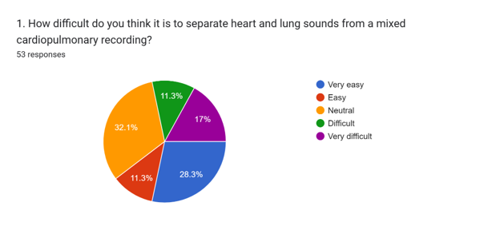
Figure 2: Perceived difficulty of separating heart and lung sounds
Finding: Based on 53 responses, the largest group selected neutral with 17 respondents (32.1%). A total of 15 respondents (28.3%) selected very easy, 6 respondents (11.3%) selected easy, 6 respondents (11.3%) selected difficult, and 9 respondents (17.0%) selected very difficult. The result is mixed rather than one-sided. Some respondents may see the task as easy at a user level, while others recognize it as technically difficult. This supports the need for a prototype that hides unnecessary processing complexity from the user.
Requirement implication: The system needs a clear separation workflow that processes mixed cardiopulmonary audio and produces separate heart and lung sound outputs without requiring the user to handle the technical separation steps manually.

3.2.4 Question 2: Problems Affecting Cardiopulmonary Sound Processing
This question asks users to identify the main problems that affect cardiopulmonary sound processing. The options focus on practical issues such as background noise, overlap between heart and lung sounds, low recording quality, and lack of simple software tools.
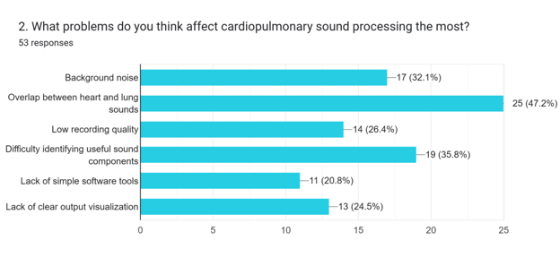
Figure 3: Problems affecting cardiopulmonary sound processing
Finding: This was a checkbox question, so respondents could select more than one problem. The most selected issue was overlap between heart and lung sounds, chosen by 25 respondents (47.2%). Other common issues were difficulty identifying useful sound components with 19 selections (35.8%), background noise with 17 selections (32.1%), low recording quality with 14 selections (26.4%), lack of clear output visualization with 13 selections (24.5%), and lack of simple software tools with 11 selections (20.8%). The related noisy-audio question also showed that 27 respondents (50.9%) agreed or strongly agreed that noisy recordings can reduce the quality of machine learning-based sound processing.
Requirement implication: The prototype needs audio validation, preprocessing support, and a separation workflow that considers source overlap and noisy or low-quality recordings. The result also supports simple output visualization so users can inspect the separated results more easily.

3.2.5 Question 3: Usefulness of a Heart-Lung Sound Separation Prototype
This question checks whether respondents think a simple heart-lung sound separation prototype would be useful for students, researchers, or users working with biomedical audio. It helps show whether the application has practical value.
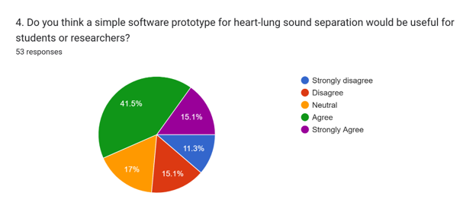
Figure 4: Usefulness of the proposed heart-lung sound separation prototype
Finding: A total of 22 respondents (41.5%) agreed and 8 respondents (15.1%) strongly agreed that a simple prototype would be useful for students or researchers. This gives 30 positive responses out of 53 (56.6%). Another 9 respondents (17.0%) selected neutral, while 14 respondents (26.4%) selected disagree or strongly disagree. The result supports the project direction, although it also shows that the prototype should be practical and easy to understand to convince users who are unsure.
Requirement implication: The system should remain application-based and focused on a usable prototype. It should describe the algorithm direction, but it also needs a basic workflow for uploading mixed audio, running separation, previewing the outputs, and downloading the separated files.

3.2.6 Question 4: Preferred System Features
This question collects user preferences on the most important system features. The listed features include uploading mixed cardiopulmonary audio, preprocessing noisy audio, separating heart and lung sounds, previewing separated audio, downloading outputs, viewing history, and viewing evaluation results.
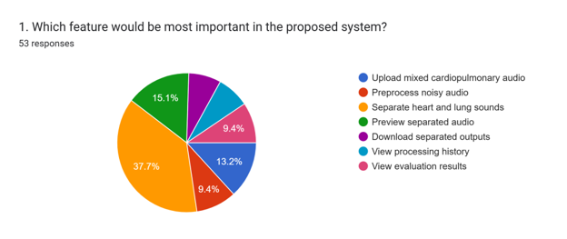
Figure 5: Preferred system features
Finding: The most selected feature was separating heart and lung sounds, chosen by 20 respondents (37.7%). The next selected features were preview separated audio with 8 responses (15.1%) and upload mixed cardiopulmonary audio with 7 responses (13.2%). Viewing evaluation results and preprocessing noisy audio each received 5 responses (9.4%), while downloading separated outputs and viewing processing history each received 4 responses (7.5%). A related history-page question showed stronger support for history when asked directly, with 44 respondents (83.0%) selecting yes.
Requirement implication: The core function is separation. Upload, preprocessing, preview, download, evaluation display, and history features support that main flow. The history feature can be included if the prototype storage layer supports it without distracting from the separation workflow.

3.2.7 Question 5: Preferred Output After Separation
This question asks what users prefer to receive after sound separation. The options include audio files only, waveform visualization, spectrogram visualization, evaluation metrics, or a combination of these outputs. The related result-display question from Section D will be discussed in text only.
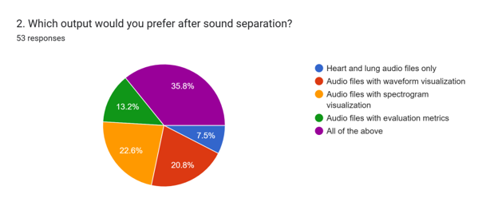
Figure 6: Preferred output after sound separation
Finding: The largest group, 19 respondents (35.8%), preferred all listed outputs: audio files, waveform visualization, spectrogram visualization, and evaluation metrics. Another 12 respondents (22.6%) preferred audio files with spectrogram visualization, 11 respondents (20.8%) preferred audio files with waveform visualization, 7 respondents (13.2%) preferred audio files with evaluation metrics, and 4 respondents (7.5%) preferred heart and lung audio files only. The related result-display question also showed that 21 respondents (39.6%) preferred an audio player with waveform, spectrogram, and metrics.
Requirement implication: The result page should not stop at download links only. The prototype should prioritize separated audio outputs and, where feasible, include waveform, spectrogram, and evaluation information to help users inspect the separated heart and lung sounds.

3.2.8 Question 6: Importance of Audio Preview Function
This question asks whether previewing the separated heart and lung sounds is important before downloading them. The related download-importance question from Section C will be mentioned in the discussion only.
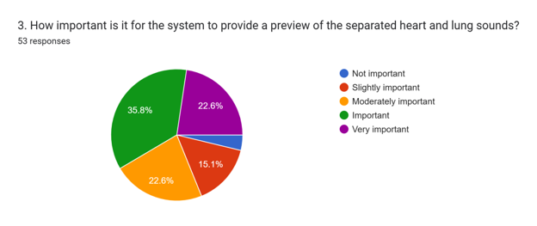
Figure 7: Importance of previewing separated heart and lung sounds
Finding: Previewing the separated sounds was rated important by 19 respondents (35.8%), very important by 12 respondents (22.6%), and moderately important by 12 respondents (22.6%). Only 8 respondents (15.1%) selected slightly important and 2 respondents (3.8%) selected not important. The related download question also showed strong support: 44 respondents (83.0%) rated downloading separated outputs as moderately important, important, or very important.
Requirement implication: Audio preview should be treated as a core result-page function. Download support is also needed so users can keep the separated heart and lung sound files for review, reporting, or later analysis.

3.2.9 Question 7: Preferred Interface Style
This question checks whether respondents prefer a simple interface, a detailed technical interface, or a balanced interface with simple controls and optional advanced details. Related ease-of-use and error-message questions from Section D will be discussed in text only.
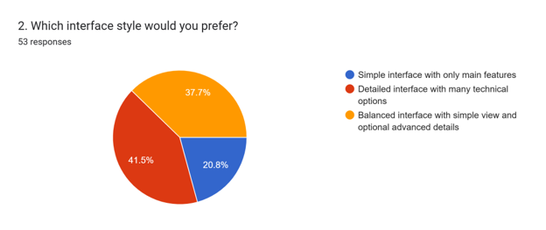
Figure 8: Preferred interface style
Finding: The most selected option was a detailed interface with many technical options, chosen by 22 respondents (41.5%). A balanced interface with a simple view and optional advanced details was close behind with 20 responses (37.7%), while 11 respondents (20.8%) preferred a simple interface with only main features. The related non-expert usability question still matters because 33 respondents (62.3%) rated ease of use as moderately important, important, or very important. For invalid uploads, 29 respondents (54.7%) preferred an error message that explains the problem and suggests a fix.
Requirement implication: The interface should support both basic and technical users. A practical design is to show the upload and separation flow clearly, while keeping details such as selected model, preprocessing status, metrics, waveform, and spectrogram available without crowding the first screen.

3.2.10 Question 8: First Information Shown After Separation
This question asks what information users want to see first after separation is completed. The choices include download buttons, audio preview players, waveform or spectrogram visualization, evaluation metrics, and processing status summary.
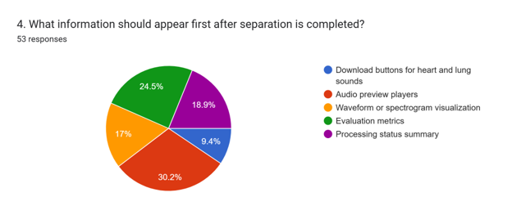
Figure 9: Preferred first information after separation is completed
Finding: Audio preview players were the most selected first item after separation, with 16 responses (30.2%). Evaluation metrics followed with 13 responses (24.5%), processing status summary with 10 responses (18.9%), waveform or spectrogram visualization with 9 responses (17.0%), and download buttons with 5 responses (9.4%). The related processing-information question showed that 48 respondents (90.6%) rated file name, processing status, and completion time as moderately important, important, or very important.
Requirement implication: The result page should show audio preview players near the top, followed by evaluation metrics, status summary, waveform or spectrogram display, and download buttons. This order matches the way respondents expect to review the separated outputs.

3.2.11 Question 9: Importance of Evaluation Metrics
This question asks how important evaluation metrics are for the separated output. The related question about useful evaluation information from Section E will be discussed in text only.
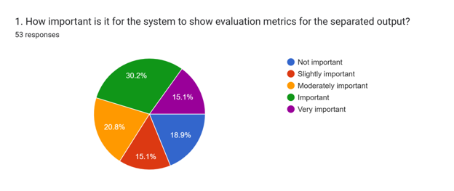
Figure 10: Importance of evaluation metrics for separated output
Finding: Evaluation metrics were rated important by 16 respondents (30.2%), moderately important by 11 respondents (20.8%), and very important by 8 respondents (15.1%). Overall, 35 respondents (66.0%) rated metrics as moderately important, important, or very important. Another 8 respondents (15.1%) selected slightly important and 10 respondents (18.9%) selected not important. In the related evaluation-information question, the largest group selected all listed information, while other respondents selected separation accuracy score, processing time, noise reduction information, or signal quality score.
Requirement implication: The prototype should display evaluation information when valid evaluation data is available. For FYP1, this remains a planned evaluation requirement, not completed model performance. Suitable information may include processing time, signal quality, separation quality, and noise reduction information depending on the available dataset and reference signals.

3.2.12 Question 10: Willingness to Use the Prototype
This question asks whether respondents would use a prototype that separates mixed cardiopulmonary audio into heart and lung sound outputs. The related open-ended question is discussed in text only because it supports improvement ideas rather than a separate chart.
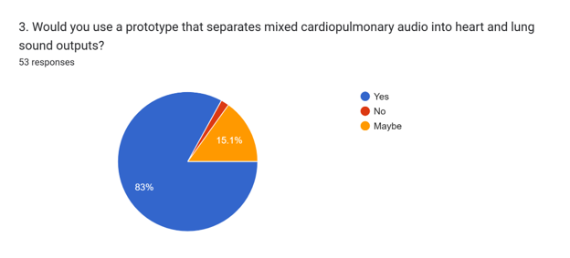
Figure 11: Willingness to use the cardiopulmonary sound separation prototype
Finding: A total of 44 respondents (83.0%) answered yes when asked whether they would use a prototype that separates mixed cardiopulmonary audio into heart and lung sound outputs. Another 8 respondents (15.1%) answered maybe, and 1 respondent (1.9%) answered no. The open-ended improvement question received 18 non-empty responses. Some responses were general or unclear, but the useful comments mentioned easier use for non-technical users, waveform and spectrogram visualization, audio preview, download options, evaluation metrics, clearer explanation of results, improved noise reduction, and better separation quality. A few comments mentioned diagnosis-related ideas, but those are outside the scope of this FYP because the project focuses only on sound separation.
Requirement implication: The high willingness-to-use response supports continuing with the prototype design. The system should stay focused on cardiopulmonary sound separation, while later work can refine usability, visualization, evaluation feedback, and separation quality.

3.3 Functional Requirements
Table Table 4 lists the preliminary functional requirements for the prototype.
Table 4: Functional requirements for the cardiopulmonary sound separation prototype
Req ID | Requirement | Description
F1 | Upload Audio File | The system shall allow the user to upload a mixed cardiopulmonary audio file for processing.
F2 | Validate Audio Format | The system shall validate the uploaded file type, file size, and basic audio readability before processing starts.
F3 | Preprocess Audio | The system shall apply suitable preprocessing steps such as resampling, normalization, segmentation, or noise reduction according to the selected workflow.
F4 | Run Cardiopulmonary Sound Separation | The system shall execute the selected machine learning-based separation pipeline on the validated and preprocessed recording.
F5 | Generate Heart Sound Output | The system shall produce a separated heart sound output from the mixed cardiopulmonary input.
F6 | Generate Lung Sound Output | The system shall produce a separated lung sound output from the mixed cardiopulmonary input.
F7 | Preview Separated Outputs | The system shall allow users to preview the separated heart and lung outputs before downloading them.
F8 | Download Separated Outputs | The system shall allow users to download the separated heart and lung sound files.
F9 | Display Processing Status | The system shall show processing status information such as validation result, processing progress, completion state, or failure message.
F10 | Display Evaluation Metrics | The system shall display suitable evaluation metrics when reference signals or valid evaluation data are available.
F11 | View Processing History | The system shall provide a processing history showing previous uploads and separation results when storage support is enabled.

3.4 Non-Functional Requirements
Table Table 5 lists the preliminary non-functional requirements for the prototype.
Table 5: Non-functional requirements for the cardiopulmonary sound separation prototype
Req ID | Category | Requirement
NF1 | Usability | The interface shall be understandable for users with different levels of technical experience.
NF2 | Performance | The system shall process reasonable audio file sizes within an acceptable time for prototype demonstration and evaluation.
NF3 | Reliability | The system shall handle invalid files, failed preprocessing, failed separation, and missing outputs with clear feedback.
NF4 | Maintainability | The system shall separate interface, validation, preprocessing, model, storage, and result management logic to support future updates.
NF5 | Security and Privacy | The system shall handle uploaded audio files carefully and avoid exposing or retaining files unnecessarily.
NF6 | Compatibility | The system shall support common audio formats where feasible and document any input limitations.
NF7 | Data Integrity | The system shall avoid overwriting outputs incorrectly and shall preserve the association between uploaded files, processing status, and generated outputs.
NF8 | Scalability | The system design shall allow future expansion, such as additional models, output visualizations, or evaluation metrics, without major restructuring.

3.5 User Requirements
Table Table 6 summarizes the preliminary user requirements for the prototype.
Table 6: User requirements for the proposed prototype
User Requirement ID | User Need | Description
UR1 | Easy audio upload | The user needs to upload mixed cardiopulmonary audio easily through a clear interface.
UR2 | File validity feedback | The user needs to understand whether the uploaded file is valid before processing begins.
UR3 | Separated heart and lung outputs | The user needs separated heart and lung sound outputs after the separation process is completed.
UR4 | Output preview | The user needs to preview separated outputs before downloading them.
UR5 | Simple visual feedback | The user needs simple visual feedback such as waveform or spectrogram displays when these are supported by the prototype.
UR6 | Clear status and errors | The user needs clear processing status and error messages when validation or separation fails.
UR7 | Downloadable results | The user needs to download separated output files for review, reporting, or further analysis.
UR8 | Basic metrics or processing information | The user needs basic metrics or processing information when evaluation support is included.

3.6 Summary
This chapter used the completed Google Form responses to define the prototype requirements. The questionnaire collected 53 responses. Section A was summarized as respondent profile information, while Sections B to E were represented through 10 main requirement-focused charts. The findings support a prototype that can upload mixed cardiopulmonary audio, validate and preprocess the file, run separation, preview the separated heart and lung outputs, provide download options, show useful processing information, and support evaluation where valid data is available. The functional, non-functional, and user requirements were defined based on the project scope, literature review, supervisor consultation, and questionnaire analysis.

CHAPTER 4: SYSTEM DESIGN

4.1 Overview
This design is for the Machine Learning-Based System for Cardiopulmonary Sound Separation. It is an application-based prototype, not a finished clinical product. The intended workflow is direct: the user uploads a mixed cardiopulmonary WAV file, selects a separation model when more than one model is available, runs the separation process, previews the separated heart and lung outputs, downloads the files, and checks recent processing history.
The design also takes direction from the existing local Software Design prototype. That prototype uses a simple web interface, a backend API, service-layer modules, SQLite metadata storage, filesystem audio storage, and model selection. In this report, those ideas are adapted to the cardiopulmonary sound separation project. The design shows what should be built in FYP2; it does not claim that final separation performance has already been achieved.

4.2 Context Diagram
Figure Figure 12 shows the system context. The main external actor is the student or researcher user. The user provides a mixed cardiopulmonary audio recording and receives separated heart and lung sound outputs. Public datasets are not part of the normal user workflow, but they support model development, baseline comparison, and planned evaluation during FYP2.
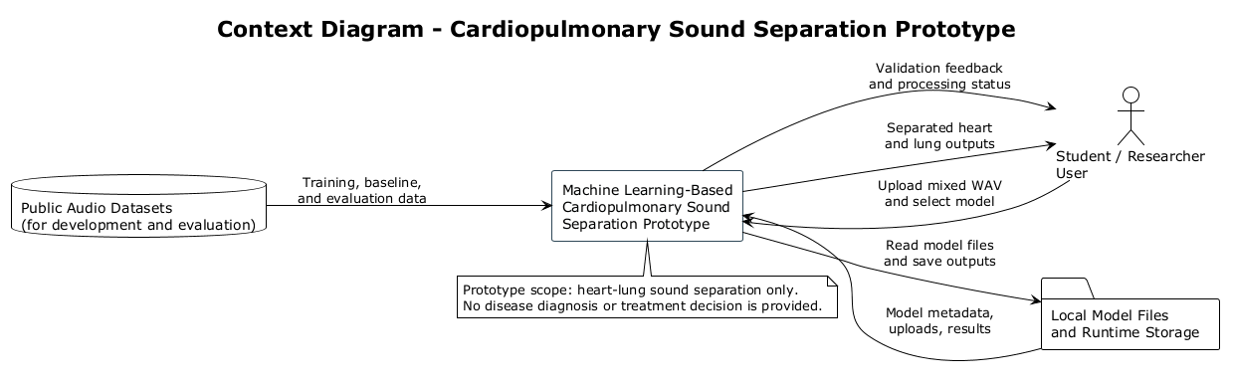
Figure 12: Context diagram for the proposed cardiopulmonary sound separation prototype
At the system boundary, the prototype is responsible for audio validation, model selection, preprocessing, separation execution, result storage, output preview, and download. The design remains limited to sound separation and does not provide disease diagnosis, clinical interpretation, or treatment recommendation.
Preprocessing and noise-aware input handling are included because mixed cardiopulmonary recordings can be affected by recording artefacts, source overlap, and signal quality variation (Grooby et al., 2023; Fattahi et al., 2022; Roy et al., 2024).

4.3 Use Case Diagram
Figure Figure 13 shows the main user interactions supported by the prototype. The design includes Select separation model instead of only an upload-and-run flow. This is needed because the first version may start with one active model, while later FYP2 work can register additional strategies or model versions.
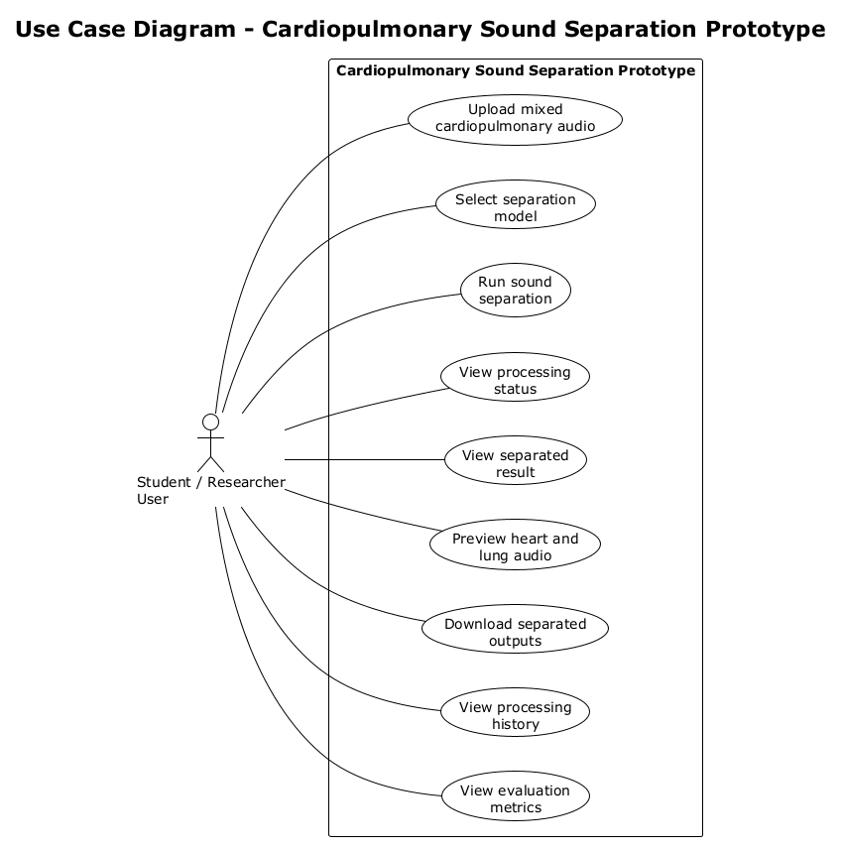
Figure 13: Use case diagram for the proposed cardiopulmonary sound separation prototype

4.3.1 Use Case Description
Table Table 7 describes the main use case for separating a mixed cardiopulmonary recording.
Table 7: Main use case description for the proposed prototype
Item | Description
Use case name | Separate cardiopulmonary sound recording
Primary actor | Student or researcher user
Goal | Obtain separated heart and lung sound outputs from one mixed cardiopulmonary recording
Trigger | The user uploads a supported audio file, selects a model where available, and starts processing
Main output | Heart sound output file, lung sound output file, processing status, and optional metric summary

4.3.1.1 Actors
The primary actor is the student or researcher user. The user interacts with the prototype through the interface by uploading an audio file, selecting a separation model when more than one model is available, starting processing, viewing outputs, and downloading results.
The internal system elements include the user interface, upload controller, model service, audio validation module, preprocessing module, separation service, algorithm strategy module, result service, database, and filesystem storage. They are shown in the design diagrams to explain the prototype architecture, but they are not treated as separate human actors.

4.3.1.2 Preconditions
The user must have a cardiopulmonary audio file in a supported format, preferably WAV for the first prototype version. The prototype must be running, the database or metadata store must be initialized, and at least one separation model or baseline strategy must be configured. If model selection is enabled, the interface loads the available model list before separation starts. If the user does not select a model, the backend uses the active default model.

4.3.1.3 Normal Flow
- The user opens the prototype interface.
- The system loads the available separation model list.
- The user selects a mixed cardiopulmonary WAV file.
- The user selects a separation model or keeps the active default model.
- The user starts the separation process.
- The system validates the file extension, audio header, size, and basic metadata.
- The system stores the uploaded audio file and records its metadata.
- The system preprocesses the audio by converting it to a model-ready waveform.
- The system creates a processing job and records the selected model.
- The separation algorithm factory resolves the selected model into the correct strategy.
- The separation engine runs the selected strategy and generates heart and lung outputs.
- The result service stores output paths, timing information, and status.
- The interface displays the result summary, audio preview controls, and download links.
- The user previews or downloads the separated heart and lung audio files.

4.3.1.4 Postconditions
After successful processing, the user receives separated heart and lung sound output files. The system stores the upload metadata, selected model, job status, output paths, processing time, and optional evaluation metrics when reference signals are available. If processing history is enabled, the user can reopen recent results without uploading the same file again.

4.3.1.5 Alternative Flows and Exceptions
If the uploaded file is unsupported or unreadable, the system rejects it before creating a separation job and displays a clear message. If the model list cannot be loaded, the system may continue with the active default model if it is configured. If the selected model is missing a checkpoint, configuration file, or supported strategy, the system marks the job as failed and explains the model configuration problem. If preprocessing fails, the system stops before inference. If the algorithm fails to generate both outputs, the system must not present incomplete files as successful results.

4.3.1.6 Non-Functional Requirements
The use case must support usability, reliability, maintainability, performance, privacy, compatibility, and traceability. The interface needs clear status messages because users may not understand backend or machine learning errors. The backend keeps file handling, model selection, strategy execution, result storage, and evaluation as separate responsibilities so FYP2 development can improve one part without rewriting the whole prototype.

4.4 Activity Diagram
Figure Figure 14 shows the planned activity flow. The flow loads the available models before the user starts separation. This makes the workflow suitable for a prototype where the first working model may be NeoSSNet, while later versions may include baseline or alternative strategies for comparison.
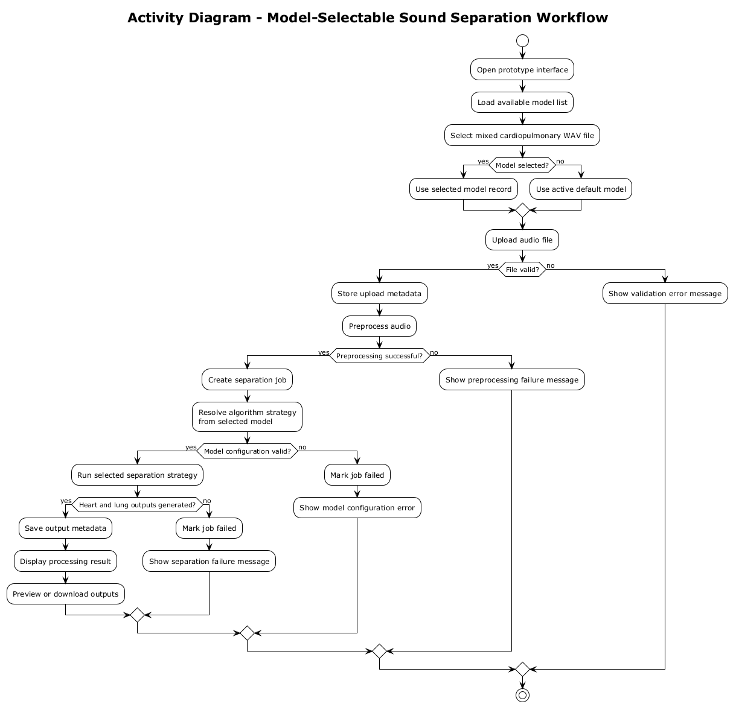
Figure 14: Activity diagram for the sound separation workflow
The activity diagram also shows where the system should stop safely. Invalid audio, missing model configuration, preprocessing failure, and separation failure should be reported as controlled errors instead of being hidden from the user.

4.5 Class Diagram
Figure Figure 15 shows the planned class-level design. The structure is service-oriented and follows the same general idea as the existing prototype. The user interface communicates with route or controller classes, while the main processing logic is handled by services. The separation algorithm is accessed through a common strategy interface, so additional algorithms can be added without changing the whole workflow.
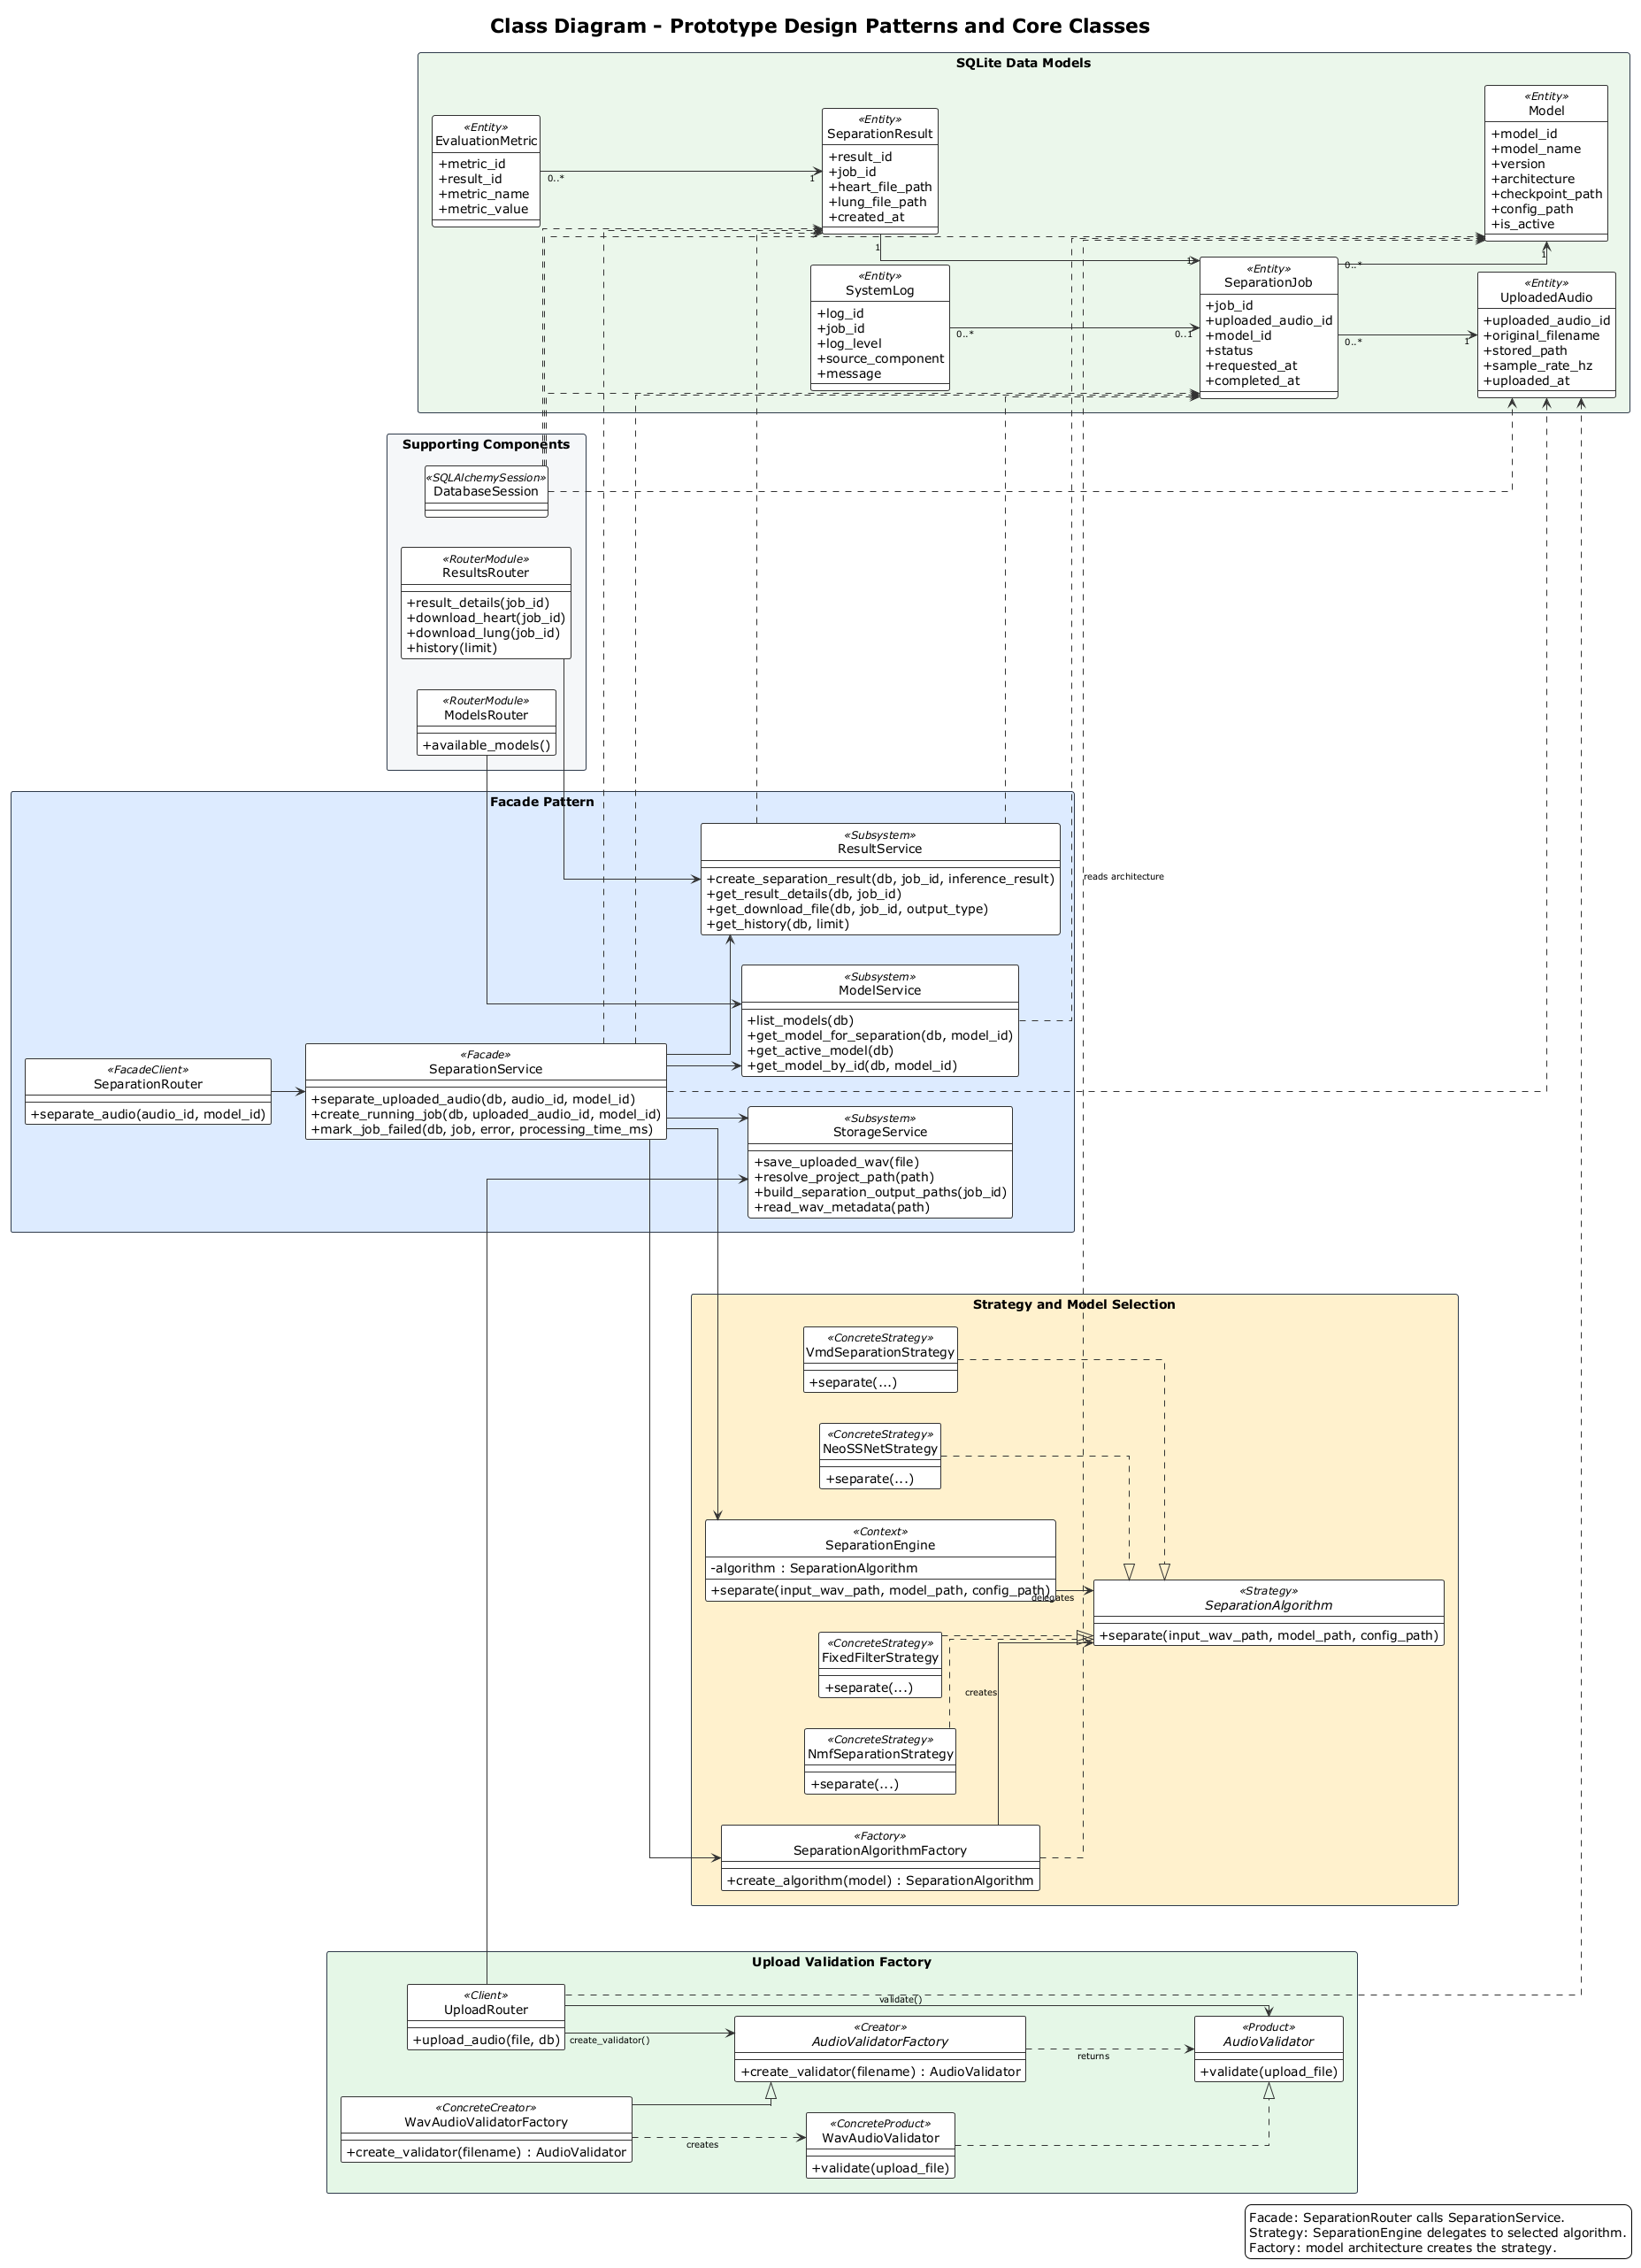
Figure 15: Class diagram for the planned prototype modules

4.5.1 Component-Level Architecture
Figure Figure 16 shows the component-level architecture. The design separates the browser interface, backend API, service layer, model registry, separation strategies, database, and filesystem storage. This structure is suitable for a student prototype because each part has a clear responsibility and can be tested separately.
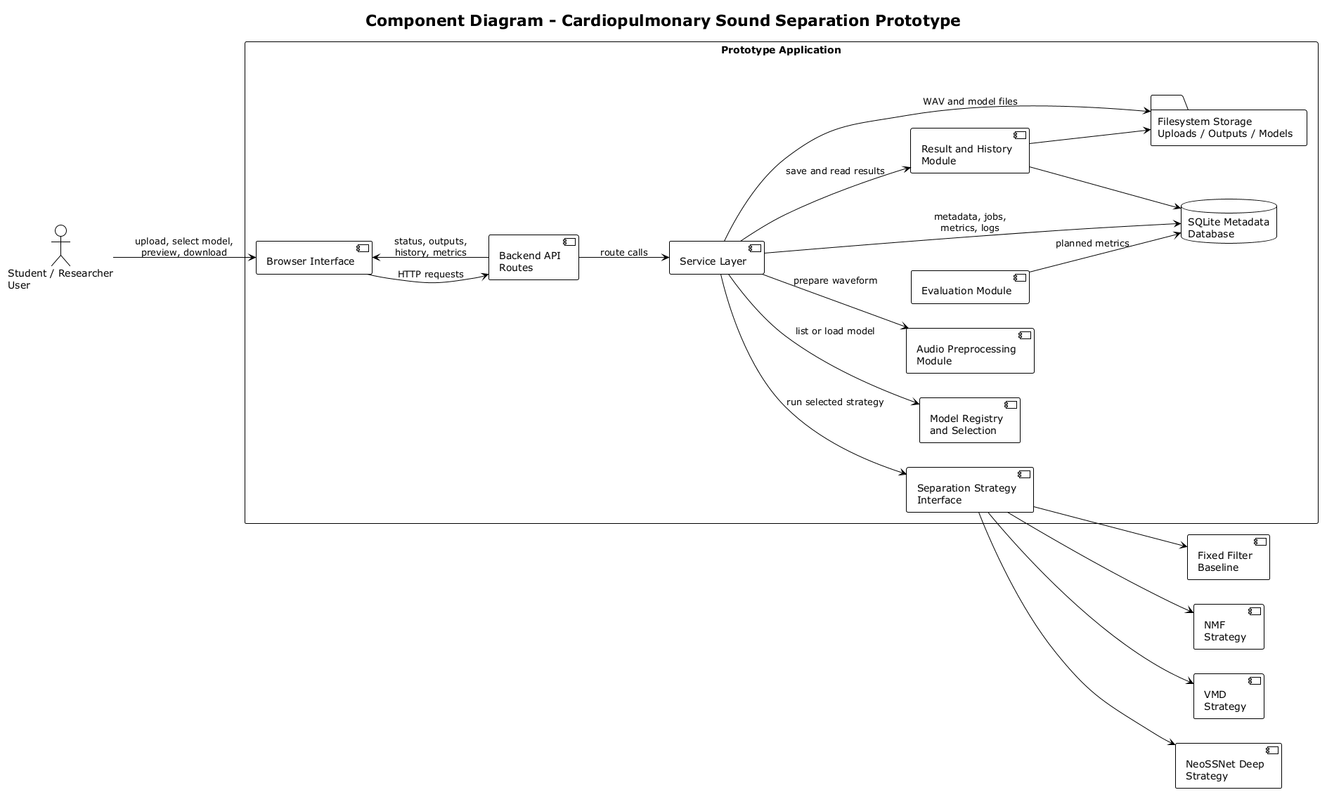
Figure 16: Component-level architecture for the proposed prototype
Table Table 8 summarizes the main system modules and responsibilities.
Table 8: Main system modules and responsibilities
Module | Responsibility
User interface | Provides upload controls, model selection, processing status, result display, preview controls, downloads, and history view.
Upload and validation module | Checks supported WAV input, validates the audio header, extracts metadata, and prevents invalid files from entering the pipeline.
Model service | Lists configured models, identifies the active default model, and validates model checkpoint and configuration paths.
Preprocessing module | Converts uploaded audio into a model-ready signal through mono conversion, resampling, normalization, segmentation, and optional time-frequency transformation.
Separation service | Coordinates the full workflow from uploaded audio to completed or failed separation job.
Algorithm factory | Converts the selected model architecture into the correct separation strategy.
Separation strategies | Provide interchangeable algorithm implementations such as baseline filtering, NMF/VMD decomposition, and NeoSSNet-style deep separation.
Result service | Stores output metadata, exposes download paths, retrieves result details, and returns recent processing history.
Database module | Stores upload records, model records, job state, result metadata, evaluation metrics, and system logs.
Filesystem storage | Stores uploaded WAV files, generated heart and lung WAV files, model files, temporary files, and local logs.

4.5.2 Algorithm and Model Selection Design
Each separation method is planned as a strategy with the same input-output contract. A mixed waveform enters the strategy, and the strategy returns two output files or two output waveforms: one for heart sound and one for lung sound. This design is practical because the project can start with one working model and later add baselines without changing the upload, result, and history workflow.
The planned strategy set is based on the reviewed literature on noisy cardiopulmonary recordings, decomposition-based separation, unsupervised separation, and NeoSSNet-style deep separation (Grooby et al., 2023; Fattahi et al., 2022; Sun et al., 2024; Ullah and Zhang, 2024; Poh et al., 2024). Table Table 9 lists the algorithm strategies planned for FYP2. The table describes why each strategy is included; it does not report completed performance.
Table 9: Planned separation strategy options for model selection
Strategy | Planned role in prototype | Reason for inclusion
Fixed filter baseline | Simple baseline for checking whether the pipeline can process, save, and return separated outputs. | Easy to implement and useful for comparison, but limited when heart and lung components overlap.
NMF separation strategy | Traditional matrix-factorization baseline or fallback strategy. | Supports explainable decomposition and comparison with deep learning.
VMD separation strategy | Traditional mode-decomposition baseline or fallback strategy. | Provides another interpretable decomposition route for separating mixed signal components.
NeoSSNet deep separation strategy | Main machine learning-based strategy for heart-lung sound separation. | Matches the project title and supports the selected machine learning direction.
Future model versions | Optional FYP2 extension through the same model registry. | Allows new checkpoints or architectures to be added without redesigning the whole system.

The model selection feature is planned as a model registry. Each model record stores a model name, version, architecture, framework, checkpoint path, configuration path, description, and active status. When the user selects a model, the backend records that choice in the separation job. If the user does not select a model, the active default model is used.

4.5.3 Database and Storage Design
The planned database design follows the same principle as the Software Design prototype: keep structured metadata in SQLite and keep large WAV files on the filesystem. This avoids storing binary audio inside the database and makes the prototype easier to inspect during demonstration.
Table Table 10 summarizes the main planned entities.
Table 10: Planned database entities for prototype traceability
Entity | Purpose
uploaded_audio | Stores metadata for each uploaded mixed WAV file, including filename, stored path, sample rate, channels, duration, and upload time.
model | Stores available model or algorithm configuration, including model name, architecture, checkpoint path, config path, and active status.
separation_job | Tracks each processing request, selected model, status, timestamps, processing time, parameters, and error message.
separation_result | Stores output metadata and paths for generated heart and lung sound files.
evaluation_metric | Stores optional metric values when reference signals are available.
system_log | Stores structured log records for upload, processing, completion, or failure events.

The filesystem uses separate folders for uploaded audio, temporary files, generated heart outputs, generated lung outputs, model files, and logs. This separation makes cleanup easier and prevents runtime demo files from being mixed with public dataset files.

4.6 Sequence Diagram
Figure Figure 17 shows the planned interaction sequence between the user interface and the main system modules. The sequence includes model retrieval before upload, model selection during the separation request, strategy creation through the factory, and result retrieval after the job completes.
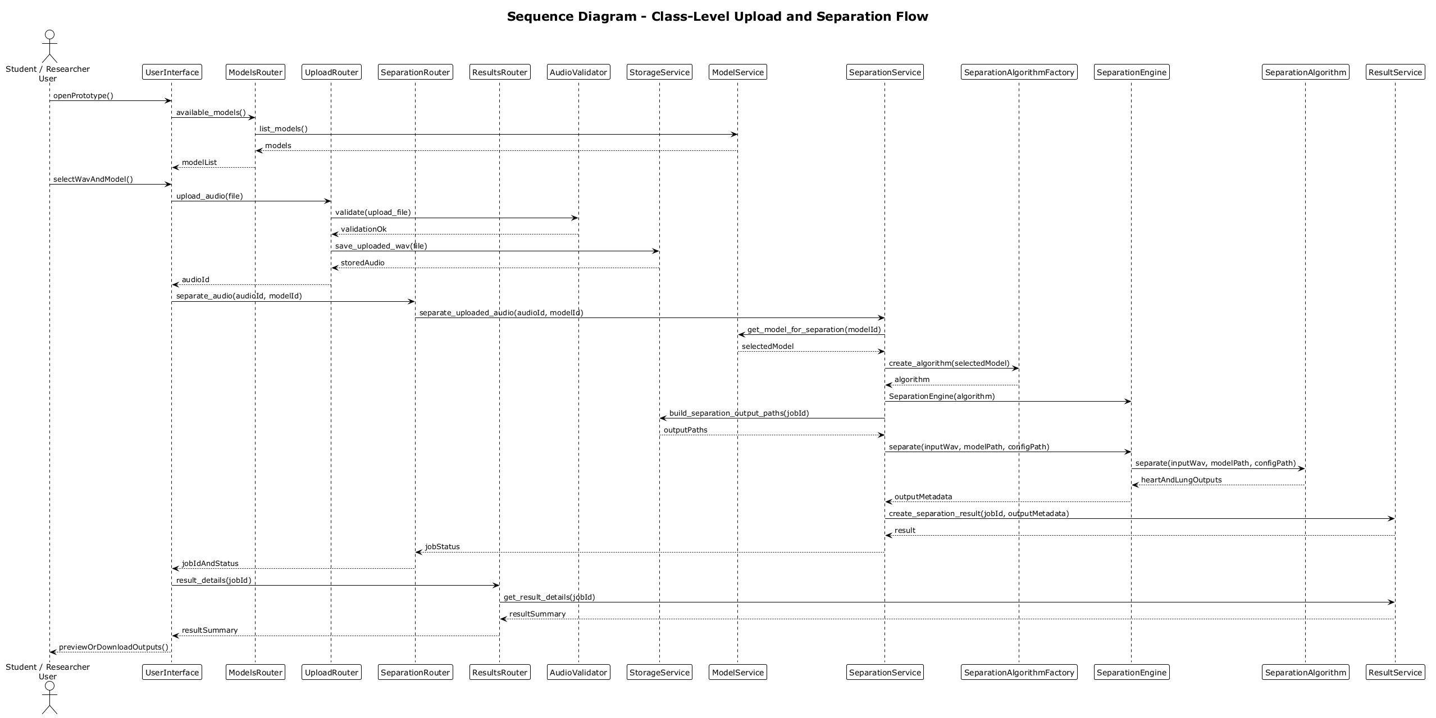
Figure 17: Sequence diagram for uploading and separating a cardiopulmonary recording
The sequence is intentionally kept close to a small prototype workflow. It can run synchronously for FYP demonstration, but the class and component design still leaves room for a future background job queue if longer recordings make synchronous processing too slow.

4.7 Interface Design
The interface supports the main workflow without exposing unnecessary implementation details. The first screen lets the user select a WAV file, select a model if multiple models are configured, and start processing. The processing area shows upload, validation, model selection, separation, and result status messages. The result view provides separate heart and lung output sections with audio players and download controls.
Table Table 11 summarizes the planned interface areas.
Table 11: Planned interface areas for the prototype
Interface area | Planned content
Upload area | WAV file selector, accepted format note, selected filename, and start processing control.
Model selection area | Dropdown list of available separation models, default active model indicator, and short model description.
Status area | API status, validation status, preprocessing status, model execution status, completion time, and clear error messages.
Result area | Heart sound preview, lung sound preview, output download controls, and optional metric summary.
History area | List of recent processing jobs with filename, status, processing time, and links to reopen or download results.

No final interface screenshots are included in this FYP1 report because final implementation and testing belong to FYP2. The questionnaire results in Chapter 3 will guide the first interface version, especially the result preview, download, status-message, and evaluation-display areas.

4.8 Summary
The planned design gives the prototype a clear upload, model selection, processing, preview, download, and history workflow. It also separates the service layer, model registry, algorithm strategies, database records, and filesystem storage so FYP2 implementation can be built in manageable parts. The next chapter explains the implementation and testing plan without claiming final results at the FYP1 stage.

CHAPTER 5: IMPLEMENTATION PLAN

5.1 Development Phase
The development phase will turn the requirements and design from FYP1 into a working prototype during FYP2. The planned prototype will be a web-based application with a simple browser interface, a backend API, service-layer processing modules, a lightweight database, local file storage, and model selection. This chapter describes planned work only. It does not report completed separation accuracy, completed user testing, or final implementation results.
The implementation follows one practical principle: the software workflow should still be usable while the separation algorithm is being improved. Upload, validation, model selection, job tracking, output storage, preview, download, and history are treated as reusable application features. Separation algorithms can then be added or improved through the shared strategy interface.

5.1.1 Front-End Development
The front end will provide the interface for uploading cardiopulmonary audio, selecting the separation model, viewing validation messages, monitoring processing status, reviewing separated outputs, and downloading results. The interface needs to stay simple because the target users are students and researchers who need a clear workflow, not a complex clinical system.
The planned front-end views are:
- Upload workspace, where the user selects a WAV file and starts processing.
- Model selection control, where the user selects the active separation model or keeps the default model.
- Processing status area, where the system reports upload, validation, model execution, completion, or failure.
- Result view, where the user previews heart and lung outputs and downloads the generated files.
- History view, where recent processing jobs can be reopened.
The front end must keep the prototype scope clear. It should describe the output as separated audio, not medical diagnosis. It also needs understandable errors for unsupported file type, missing model configuration, failed preprocessing, failed separation, or missing output files.

5.1.2 Back-End Development
The back end will handle uploaded files, validate audio input, retrieve the selected model, call preprocessing functions, run the selected separation strategy, manage output files, and return status information to the front end. The planned structure follows a thin-controller and service-layer approach. Route modules receive requests and return responses, while services handle file management, model lookup, job coordination, and result retrieval.
The planned API responsibilities are shown in Table Table 12.
Table 12: Planned backend API responsibilities
Endpoint or function | Planned purpose
GET /health | Check whether the API and local database are available.
GET /models | Return available separation models and identify the active default model.
POST /upload | Accept and validate a mixed WAV file, then store upload metadata.
POST /separate/{audio_id} | Run separation using the selected model or active default model.
GET /result/{job_id} | Return job status, uploaded audio metadata, output paths, timing, and optional metrics.
GET /download/{job_id}/heart | Download the separated heart sound output.
GET /download/{job_id}/lung | Download the separated lung sound output.
GET /history | Return recent separation jobs for the history view.

The back end keeps model execution separate from routing. This allows FYP2 development to replace a baseline strategy with a stronger model without changing the upload and result workflow.

5.1.3 Machine Learning Model Integration
The machine learning component will be integrated through a strategy interface. Each separation strategy will receive a mixed input waveform and return separated heart and lung outputs using the same contract. This allows the prototype to support baseline filtering, traditional decomposition methods, and a machine learning method under one workflow. These planned strategies are derived from the reviewed separation, denoising, and model-based cardiopulmonary sound studies (Fattahi et al., 2022; Sun et al., 2024; Ullah and Zhang, 2024; Poh et al., 2024).
The mixed cardiopulmonary signal can be represented as:
$$x[n]=h[n]+l[n]+r[n],$$
where (x[n]) is the recorded mixed signal, (h[n]) is the heart sound component, (l[n]) is the lung sound component, and (r[n]) represents noise, recording artefacts, or residual interference. The prototype goal is to estimate ([n]) and ([n]) from (x[n]).

5.1.3.1 Input Preparation
Before separation, the audio will be converted into a consistent format because noisy recordings, recording artefacts, and inconsistent signal preparation can affect separation quality (Grooby et al., 2023; Fattahi et al., 2022). A practical preparation flow is:
- Read the uploaded WAV file.
- Convert stereo input to mono if needed.
- Resample to the model sample rate.
- Normalize the amplitude.
- Segment or transform the signal if required by the selected model.
Amplitude normalization can be written as:
$$\tilde{x}[n]=\frac{x[n]}{\max_{n}|x[n]|+ϵ},$$
where () is a small value used to avoid division by zero. For methods that use a time-frequency representation, the short-time Fourier transform (STFT) can be computed as:
$$X(k,m)=\sum_{n=0}^{N−1}{\tilde{x}}[n]w[n−mH]e^{−j2πkn/N},$$
where (w[]) is the analysis window, (H) is the hop size, (N) is the FFT size, (k) is the frequency bin, and (m) is the frame index.

5.1.3.2 Algorithm 1: Fixed Filter Baseline
The fixed filter baseline will be used as a simple comparison method and as an early pipeline test. Filtering is not expected to solve all overlap problems, but it gives the prototype a transparent baseline before stronger decomposition or neural methods are evaluated (Roy et al., 2024; Zhao et al., 2024). The baseline applies frequency-domain masks or filters to produce rough heart and lung estimates:
$$\hat{H}(k,m)=M_{h}(k)X(k,m),$$
$$\hat{L}(k,m)=M_{l}(k)X(k,m),$$
where (M_h(k)) and (M_l(k)) are fixed masks or filters for heart-dominant and lung-dominant frequency regions. The time-domain estimates are obtained using inverse STFT:
$$\hat{h}[n]=iSTFT(\hat{H}(k,m)), \hat{l}[n]=iSTFT(\hat{L}(k,m)).$$
This method is not expected to solve strong overlap between heart and lung sounds. Its value is practical: it helps verify that upload, preprocessing, output writing, preview, and download functions work correctly before a stronger model is integrated.

5.1.3.3 Algorithm 2: NMF and VMD-Based Decomposition
Non-negative matrix factorization (NMF) and variational mode decomposition (VMD) will be considered as two concrete traditional strategies. Decomposition-based work remains relevant because it gives explainable baselines for heart-lung separation and comparison (Sun et al., 2024; Ullah and Zhang, 2024). In the implementation design, these can be represented as NmfSeparationStrategy and VmdSeparationStrategy classes that implement the same separation interface.
For the NMF strategy, if (V = |X|) is the non-negative magnitude spectrogram, NMF approximates it as:
$$V≈WH,$$
where (W) contains spectral basis patterns and (H) contains their time activations. A common optimization objective is:
$$\min_{W,H≥0}D(V||WH)+λR(W,H),$$
where (D()) measures reconstruction difference and (R()) is an optional regularization term. If separate heart and lung estimates are represented as (V_h) and (V_l), soft masks can be formed as:
$$M_{h}=\frac{V_{h}}{V_{h}+V_{l}+ϵ}, M_{l}=\frac{V_{l}}{V_{h}+V_{l}+ϵ}.$$
The separated spectrograms are then:
$$\hat{H}=M_{h}⊙X, \hat{L}=M_{l}⊙X,$$
where () represents element-wise multiplication.
For the VMD strategy, the signal is decomposed into modes (u_k(t)) with center frequencies (_k):
min{uk},{ωk}k​∂tδ(t)+jπt*uk(t)e−jωkt22
subject to:
k​uk(t)=x(t).
The implementation can then group modes that are more likely to represent heart-dominant or lung-dominant components. This approach is useful for comparison because it is more explainable than a deep model, but it may still struggle with noisy and strongly overlapping recordings.

5.1.3.4 Algorithm 3: NeoSSNet Deep Separation Strategy
The main machine learning strategy will be a NeoSSNet-style deep separation model because NeoSSNet is directly related to heart and lung sound separation and supports the machine learning direction of this project (Poh et al., 2024). The model receives a prepared mixed waveform or representation and estimates two output channels:
$$[\hat{h},\hat{l}]=f_{θ}(\tilde{x}),$$
where (f_{}) is the neural model with parameters (). If the model uses time-frequency masks, the separation can be represented as:
$$[M_{h},M_{l}]=g_{θ}(X),$$
$$\hat{H}=M_{h}⊙X, \hat{L}=M_{l}⊙X.$$
If paired reference signals are available during training or evaluation, a simple reconstruction loss can be written as:
$$L_{rec}=∥h−\hat{h}∥_{1}+∥l−\hat{l}∥_{1}.$$
For evaluation, a scale-invariant signal-to-distortion ratio (SI-SDR) direction may be used when suitable reference signals exist, together with other metrics selected according to the available dataset and evaluation design (Torabi et al., 2025a; Zhao et al., 2024). For one estimated source () and reference source (s):
$$s_{target}=\frac{⟨\hat{s},s⟩}{∥s∥^{2}}s,$$
$$e_{noise}=\hat{s}−s_{target},$$
$$SI-SDR=10\log_{10}\frac{∥s_{target}∥^{2}}{∥e_{noise}∥^{2}}.$$
The first FYP2 target is a working inference path from upload to separated output files. After that, training, fine-tuning, or model replacement can be attempted depending on dataset availability, hardware limits, and supervisor approval.

5.1.3.5 Model Selection Strategy
The model-selection feature will allow the user to select from configured model records. The backend will use the selected model ID if provided; otherwise, it will use the active default model. The factory method will map the model architecture to the correct strategy:
$$\text{strategy}=Factory(\text{model.architecture}).$$
For example, a model record with architecture NeoSSNet should create a NeoSSNet strategy, while FixedFilter, NMF, and VMD architecture names can create their corresponding concrete strategies. This design keeps extension manageable: adding a new algorithm should require a new strategy class and a model registry entry, not a rewrite of the whole application.

5.1.4 Database and Storage Integration
The prototype will use lightweight database storage for metadata and filesystem storage for audio files. The database should store upload metadata, model metadata, selected model ID, job status, output paths, processing time, optional evaluation metrics, and system logs. Audio files, model files, and generated outputs should remain on the filesystem.
The planned storage folders are:
storage/uploads/raw/
storage/uploads/temp/
storage/outputs/heart/
storage/outputs/lung/
storage/ml_models/
storage/logs/
This design is practical for a local academic prototype because it keeps the database small while maintaining traceability between uploaded files, selected model records, processing jobs, and generated outputs.

5.2 Testing Phase
The testing phase will check whether the prototype functions correctly and whether each algorithm strategy behaves safely inside the application workflow. Testing is presented as planned work because completed test execution belongs to FYP2.

5.2.1 Unit Testing
Unit testing will focus on individual modules. Planned unit tests include WAV validation, metadata extraction, path handling, model lookup, active model fallback, strategy factory resolution, preprocessing output shape, output file writing, result retrieval, and error handling.
For algorithm modules, unit tests should not imply that separation quality is already final. Early tests need to verify that each strategy accepts valid input, rejects missing configuration, returns heart and lung output paths, and does not mark a failed job as completed.

5.2.2 Integration Testing
Integration testing will verify that the front end, API, database, storage, preprocessing, model selection, strategy factory, separation engine, and result service work together. Planned integration tests include:
- Upload a valid WAV file and confirm metadata is stored.
- Load available models and confirm the active model is selected by default.
- Submit a separation request with a selected model ID.
- Confirm that the job records the selected model.
- Confirm that successful processing creates both heart and lung output paths.
- Confirm that result and download endpoints return the expected job information.
- Confirm that missing model files or unsupported model architecture produce controlled failure messages.

5.2.3 System Testing
System testing will check the complete prototype from the user perspective. Planned system tests include valid upload, unsupported file upload, invalid WAV header, model list loading, selected model execution, default model fallback, successful output preview, output download, history retrieval, and failure recovery.
System testing should also check usability details: progress messages, failed-job display, disabled download buttons before outputs exist, and wording that avoids diagnosis claims.

5.2.4 User Acceptance Testing
User acceptance testing may be conducted with students, researchers, or project evaluators after the prototype is implemented. The purpose will be to check whether the workflow is understandable, whether model selection is clear, whether the separated outputs can be accessed easily, and whether the result page provides enough information for academic use. No user acceptance results are included in this FYP1 report because the prototype has not yet reached that stage.

5.3 Deployment Phase
The deployment phase will prepare the prototype for demonstration and evaluation. The first deployment target is a local development environment because the system handles uploaded audio files, model files, and generated outputs. The deployment package should include setup instructions, dependency notes, database initialization, model file placement, sample input guidance, and output folder handling.
The planned deployment steps are:
- Create and activate the Python environment.
- Install backend and machine learning dependencies.
- Initialize the database schema.
- Confirm required storage folders exist.
- Place model checkpoint and configuration files in the expected folder.
- Start the backend server.
- Open the browser interface.
- Run a smoke test using a short WAV file.
- Confirm that heart and lung output files are created or that failures are reported clearly.
If the prototype is later deployed outside the local laptop, additional work will be needed for authentication, storage cleanup, secure file handling, background processing, and deployment monitoring. These items are outside the minimum FYP1 plan but can be listed as future improvements.

5.4 Documentation and Maintenance Plan
Documentation will include setup instructions, dependency notes, usage steps, system limitations, model configuration notes, testing notes, and evaluation guidance. The report and repository should make clear which parts are implemented, which parts are planned, and which results are still pending.
Maintenance activities may include updating dependencies, improving error handling, adding separation strategies, replacing the model checkpoint, improving preprocessing, adding waveform or spectrogram visualization, adding evaluation metrics, and improving cleanup of temporary files. These activities must preserve the project scope as sound separation only.

5.5 Summary
This implementation plan keeps the FYP2 work concrete without pretending that the prototype has already been completed. It covers front-end development, back-end development, model selection, algorithm strategy integration, database and storage integration, testing, deployment, documentation, and maintenance. The planned algorithms include a fixed filter baseline, an NMF separation strategy, a VMD separation strategy, and a NeoSSNet-style deep learning strategy. The chapter remains FYP1-appropriate because it explains what will be implemented in FYP2 without inventing final separation results, testing results, model scores, or user evaluation findings.

CHAPTER 6: CONCLUSION

6.1 Overview
This chapter closes the FYP1 report for the machine learning-based cardiopulmonary sound separation project. The report has prepared the background study, literature review, requirements analysis, system design, and implementation plan needed before FYP2 development.

6.2 Project Summary
The project addresses the problem of separating mixed cardiopulmonary recordings into heart and lung sound outputs. The literature review shows that these recordings may contain noise, artefacts, and overlapping source components, so simple filtering alone may not be enough. Machine learning-based methods are relevant because they can learn more complex source patterns when suitable data and evaluation procedures are available.
The FYP1 work defines a prototype workflow that includes audio upload, validation, preprocessing, model selection, sound separation, result viewing, and output download. Requirements analysis and system design give the later implementation a clearer direction.

6.3 Expected Contributions
The expected contribution is a reusable software prototype for cardiopulmonary sound separation. The prototype is intended to help a student or researcher process mixed cardiopulmonary audio and obtain separated heart and lung sound outputs.
For FYP1, the contribution is the preparation work: a structured literature review, an application-based requirements analysis, system design artefacts, and an implementation plan that can guide prototype development and evaluation in FYP2.

6.4 Limitations
The current report is limited to the FYP1 stage. It includes questionnaire-based requirements analysis, but it does not include completed implementation results, completed testing results, final model scores, or user acceptance testing. The project is also limited by dataset availability, recording quality, model selection, and the time available for FYP2 implementation.
The proposed system is not intended for clinical diagnosis or treatment recommendation. It is a sound separation prototype and should be evaluated only within that scope.

6.5 Future Work
Future work will focus on implementing the planned prototype, selecting or preparing suitable public datasets, integrating the separation model, generating separated outputs, and evaluating the results using appropriate metrics. The questionnaire findings in Chapter 3 can also be used to guide interface details such as preview, download, status messages, and result presentation.
Additional future improvements may include interface refinement, expanded audio format support, improved preprocessing, better model selection, output visualization, and more detailed comparison with baseline methods.

6.6 Summary
The FYP1 report provides the foundation for developing and evaluating the cardiopulmonary sound separation prototype in the next project stage. The remaining work is mainly implementation, dataset preparation, model integration, testing, and final evaluation.

References
S. N. Ali, S. B. Shuvo, M. I. S. Al-Manzo, A. Hasan, and T. Hasan. (2023). An end-to-end deep learning framework for real-time denoising of heart sounds for cardiac disease detection in unseen noise. IEEE Access. https://doi.org/10.1109/ACCESS.2023.3292551.
S. N. Ali, A. Zahin, S. B. Shuvo, N. B. Nizam, S. I. S. K. Nuhash, S. S. Razin, S. M. S. Sani, F. Rahman, N. B. Nizam, F. B. Azam, R. Hossen, and S. Ohab. (2026). BUET multi-disease heart sound dataset: A comprehensive auscultation dataset for developing computer-aided diagnostic systems. Computer Methods and Programs in Biomedicine Update. https://doi.org/10.1016/j.cmpbup.2026.100237.
Y. Arjoune, T. N. Nguyen, T. Salvador, A. Telluri, J. C. Schroeder, R. L. Geggel, J. W. May, D. K. Pillai, S. J. Teach, S. J. Patel, R. W. Doroshow, and R. Shekhar. (2023). StethAid: A digital auscultation platform for pediatrics. Sensors. https://doi.org/10.3390/s23125750.
R. Baeyens, D. Ragusa, T. Stas, K. Ides, E. Marenzi, F. Leporati, W. Daems, and J. Steckel. (2025). Compressed sensing of acoustic cardiopulmonary signals using a CNN-based reconstruction method. 2025 47th Annual International Conference of the IEEE Engineering in Medicine and Biology Society (EMBC). https://doi.org/10.1109/embc58623.2025.11253482.
S. Behera, P. K. Jain, and S. Bakshi. (2026). Adaptive thresholding of DWT coefficients using UNet for denoising real-life respiratory sounds. Biomedical Signal Processing and Control. https://doi.org/10.1016/j.bspc.2025.108232.
D. Fattahi, R. Sameni, E. Grooby, K. Tan, L. Zhou, A. King, A. Ramanathan, A. K. Malhotra, and F. Marzbanrad. (2022). A blind filtering framework for noisy neonatal chest sounds. IEEE Access. https://doi.org/10.1109/access.2022.3170052.
E. Grooby, C. Sitaula, D. Fattahi, R. Sameni, K. Tan, L. Zhou, A. King, A. Ramanathan, A. Malhotra, G. A. Dumont, and F. Marzbanrad. (2022). Real-time multi-level neonatal heart and lung sound quality assessment for telehealth applications. IEEE Access. https://doi.org/10.1109/access.2022.3144355.
E. Grooby, C. Sitaula, D. Fattahi, R. Sameni, K. Tan, L. Zhou, A. King, A. Ramanathan, A. Malhotra, G. Dumont, and F. Marzbanrad. (2023). Noisy neonatal chest sound separation for high-quality heart and lung sounds. IEEE Journal of Biomedical and Health Informatics. https://doi.org/10.1109/JBHI.2022.3215995.
B. Han and W. Quan. (2025). Cardiorespiratory sound separation using singular spectrum analysis. 2025 17th International Conference on Signal Processing Systems (ICSPS). https://doi.org/10.1109/icsps66615.2025.11347745.
V. T. Hoang, Q. Nguyen, Q. C. Nguyen, X. P. Nguyen, and H. Nguyen. (2023). Sound-dr: Reliable sound dataset and baseline artificial intelligence system for respiratory illnesses. PHM Society Asia-Pacific Conference. https://doi.org/10.36001/phmap.2023.v4i1.3604.
M. Jakubec, E. Lieskovska, and P. Pocta. (2025). A robust deep learning based model for denoising phonocardiogram signals in clinical environments. Engineering Applications of Artificial Intelligence. https://doi.org/10.1016/j.engappai.2025.112286.
E. Mutlu, V. Hüseyin, and G. Serbes. (2024). Bridging auscultation and tiny machine learning: A digital stethoscope leveraging convolutional neural networks on an embedded device for organ sound analysis. Traitement du Signal. https://doi.org/10.18280/ts.410521.
R. Pal and A. Barney. (2024). Automatic breathing phase identification based on the second derivative of the recorded lung sounds. Biomedical Signal Processing and Control. https://doi.org/10.1016/j.bspc.2024.106315.
Y. Y. Poh, E. Grooby, K. Tan, A. Malhotra, M. Harandi, and F. Marzbanrad. (2026). Reprogramming automatic speech recognition models for neonatal chest sound separation. IEEE journal of biomedical and health informatics. https://doi.org/10.1109/jbhi.2026.3669531.
Y. Y. Poh, E. Grooby, K. Tan, L. Zhou, A. King, A. Ramanathan, A. Malhotra, M. Harandi, and F. Marzbanrad. (2024). NeoSSNet: Real-time neonatal chest sound separation using deep learning. IEEE Open Journal of Engineering in Medicine and Biology. https://doi.org/10.1109/OJEMB.2024.3401571.
M. F. Pouyani, M. Vali, and M. A. Ghasemi. (2022). Lung sound signal denoising using discrete wavelet transform and artificial neural network. Biomedical Signal Processing and Control. https://doi.org/10.1016/j.bspc.2021.103329.
M. A. Reyna, Y. Kiarashi, A. Elola, J. Oliveira, F. Renna, A. Gu, E. A. P. Alday, N. Sadr, A. Sharma, J. Kpodonu, S. Mattos, M. T. Coimbra, R. Sameni, A. B. Rad, and G. D. Clifford. (2023). Heart murmur detection from phonocardiogram recordings: The george b. Moody PhysioNet challenge 2022. PLOS Digital Health. https://doi.org/10.1371/journal.pdig.0000324.
B. Rocha, D. Pessoa, A. Marques, P. Carvalho, and R. P. Paiva. (2023). Automatic wheeze segmentation using harmonic-percussive source separation and empirical mode decomposition. IEEE Journal of Biomedical and Health Informatics. https://doi.org/10.1109/jbhi.2023.3248265.
T. S. Roy, J. K. Roy, N. Mandal, and S. C. Mukhopadhyay. (2024). Recent advances in PCG signal analysis using AI: A review. International Journal on Smart Sensing and Intelligent Systems. https://doi.org/10.2478/ijssis-2024-0012.
S. B. Shuvo, S. S. Alam, and T. Hasan. (2026). A self-attention-driven deep denoiser model for real time lung sound denoising in noisy environments. Biomedical Signal Processing and Control. https://doi.org/10.1016/j.bspc.2025.108818.
P. Somarathne, S. Herath, G. Gargiulo, P. Breen, N. Anderson, Y. Yao, T. Liu, and A. Withana. (2026). A dual classifier-regressor architecture for heart sound onset/offset detection. IEEE transactions on bio-medical engineering. https://doi.org/10.1109/tbme.2026.3654558.
W. Sun, Y. Zhang, and F. Chen. (2024). Research on heart and lung sound separation method based on DAE-NMF-VMD. EURASIP Journal on Advances in Signal Processing. https://doi.org/10.1186/s13634-024-01152-0.
Y. Torabi, S. Shirani, and J. P. Reilly. (2023). A new non-negative matrix factorization approach for blind source separation of cardiovascular and respiratory sound based on the periodicity of heart and lung function. arXiv (Cornell University). https://doi.org/10.48550/arxiv.2305.01889.
Y. Torabi, S. Shirani, and J. P. Reilly. (2025a). Descriptor: Heart and lung sounds dataset recorded from a clinical manikin using digital stethoscope (HLS-CMDS). IEEE Data Descriptions, 2, 133–140. https://doi.org/10.1109/IEEEDATA.2025.3566012.
Y. Torabi, S. Shirani, and J. P. Reilly. (2025b). Large language model-based nonnegative matrix factorization for cardiorespiratory sound separation. arXiv.org. https://doi.org/10.48550/arxiv.2502.05757.
T.-S. Tsai, C.-C. Hsu, C.-L. Hsieh, and Y. Liu. (2023). Separation of heart and lung sounds by a deep network-based model. https://doi.org/10.1109/ickii58656.2023.10332660.
R. Ullah and S. Zhang. (2024). Unsupervised framework for single channel heart and lung sounds separation in data constrained environments. Applied Acoustics. https://doi.org/10.1016/j.apacoust.2024.110076.
W. Wang, D. Qin, S. Wang, Y. Fang, and Y. Zheng. (2023a). A multi-channel UNet framework based on SNMF-DCNN for robust heart-lung-sound separation. Computers in Biology and Medicine. https://doi.org/10.1016/j.compbiomed.2023.107282.
W. Wang, S. Wang, D. Qin, Y. Fang, and Y. Zheng. (2023b). Heart-lung sound separation by nonnegative matrix factorization and deep learning. Biomedical Signal Processing and Control. https://doi.org/10.1016/j.bspc.2022.104180.
Y. Wang, H. Yang, Z. Gao, Z. Dai, K. Yu, T. Song, H. Yang, Y. Wang, and J. Zhang. (2025). A phase-enhanced neural network with dual-path transformer for single-channel chest sound separation. IEEE journal of biomedical and health informatics. https://doi.org/10.1109/jbhi.2025.3631643.
B. Zhang, J. Wang, Z. Ye, L. Zhou, D. Xiong, X. Wang, and L. Guo. (2025). JASSNet: Heart and lung sound separation network based on joint attention mechanism and semi-supervised learning. Biomedical Signal Processing and Control. https://doi.org/10.1016/j.bspc.2025.107525.
L. Zhang, F. He, H. Tan, W. Wang, and S. Wang. (2026). An efficient lung sound separation algorithm base on GIHO-VMD. Computer methods and programs in biomedicine. https://doi.org/10.1016/j.cmpb.2025.109124.
Q. Zhao, S. Geng, B. Wang, Y. Sun, W. Nie, B. Bai, C. Yu, F. Zhang, G. Tang, D. Zhang, Y. Zhou, J. Liu, and S. Hong. (2024). Deep learning in heart sound analysis: From techniques to clinical applications. Health Data Science. https://doi.org/10.34133/hds.0182.
J. Zheng, Y. Wang, J. Niu, Y. Shi, and F. Xie. (2025). Identifying the respiratory sound based on single-channel separation and hyperdimensional computing. IEEE Sensors Journal. https://doi.org/10.1109/jsen.2025.3557909.
R. Zheng and S. Sanei. (2024). Separation of cardiopulmonary sound signals for classification of respiratory diseases. Asia pacific signal and information processing association annual summit and conference (APSIPA ASC). https://doi.org/10.1109/APSIPAASC63619.2025.10848841.

Appendix A: Gantt Chart
Figure Figure 18 shows the planned FYP1 report schedule for the project. The schedule follows the CPT6314 Teaching Plan T2610 sequence and the current report workflow, from the initial FYP1 briefing through final interim report submission and oral presentation preparation.
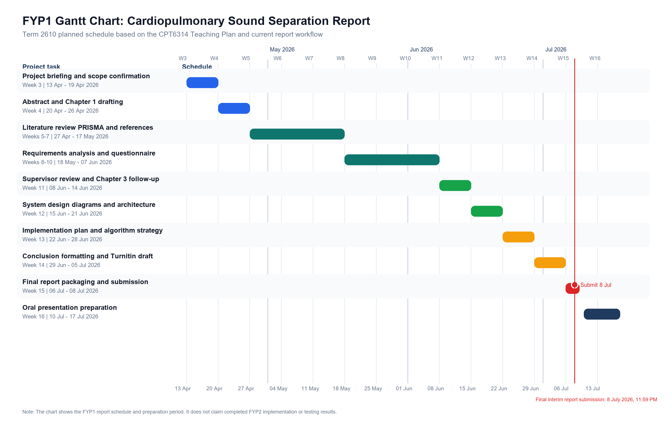
Figure 18: FYP1 Gantt chart for the cardiopulmonary sound separation report schedule

Appendix B: FYP1 Meeting Logs
The FYP1 meeting logs will be inserted or checked in the final document package. The local meeting log files are retained separately in the repository and should not be modified unless the supervisor requires changes.

Appendix C: Turnitin Similarity Index Page
The Turnitin similarity index page will be inserted after the similarity report is generated and accepted for submission.

Appendix D: Full Literature Review Matrix
The complete literature review matrix below summarizes the selected papers used in the Chapter 2 synthesis. It supports the comparison of research focus, methods, datasets, findings, limitations, and relevance to the proposed cardiopulmonary sound separation system.
Table 13: Full literature review matrix for selected Chapter 2 papers
No. | Research Title | Author(s) & Year | Journal / Conference / Database | Research Problem / Objective | Algorithm / Framework Used | Dataset Used | Results / Findings | Research Gap | Limitation | How It Helps This Project
1 | An End-to-End Deep Learning Framework for Real-Time Denoising of Heart Sounds for Cardiac Disease Detection in Unseen Noise | Ali et al. (2023) (Ali et al., 2023) | IEEE Access | Improve noisy heart sound recordings before later analysis. | LU-Net encoder-decoder denoiser. | PCG data mixed with breathing and hospital noise. | Reported SNR and real-time denoising improvements. | Denoising is related but does not separate heart and lung outputs. | Focuses on heart sound denoising and diagnosis support. | Supports preprocessing and noise-reduction choices.
2 | Noisy Neonatal Chest Sound Separation for High-Quality Heart and Lung Sounds | Grooby et al. (2023) (Grooby et al., 2023) | IEEE Journal of Biomedical and Health Informatics | Separate noisy neonatal chest recordings into heart and lung sounds. | NMF and NMCF. | Neonatal artificial mixtures and noisy chest sounds. | Improved signal quality and vital-sign estimation support. | Robust separation remains difficult under noisy neonatal conditions. | Dataset is neonatal and not clearly public. | Provides a classical separation baseline.
3 | NeoSSNet: Real-Time Neonatal Chest Sound Separation Using Deep Learning | Poh et al. (2024) (Poh et al., 2024) | IEEE Open Journal of Engineering in Medicine and Biology | Perform real-time neonatal chest sound separation. | 1D encoder-decoder with transformer mask generation. | Neonatal chest recordings with heart and lung references. | Reported SDR and SI-SDR improvement with real-time relevance. | Reproducibility is limited by private clinical data. | Performance depends on noise and recording quality. | Main deep learning reference for the prototype.
4 | Recent Advances in PCG Signal Analysis using AI: A Review | Roy et al. (2024) (Roy et al., 2024) | International Journal on Smart Sensing and Intelligent Systems | Review AI methods for PCG preprocessing and analysis. | Review of preprocessing, segmentation, features, and AI models. | PCG datasets from prior studies. | Summarizes common PCG processing stages and AI approaches. | Review is not focused on heart-lung source separation. | Mainly classification and PCG analysis oriented. | Supports background on PCG preprocessing.
5 | Research on Heart and Lung Sound Separation Method Based on DAE-NMF-VMD | Sun et al. (2024) (Sun et al., 2024) | EURASIP Journal on Advances in Signal Processing | Improve heart-lung sound separation using a hybrid method. | Deep autoencoder, NMF, and VMD. | Heart-lung sound mixtures. | Reported SDR, PESQ, STOI, and separation metrics. | Reproducible public data access is limited. | Data and code access may require request. | Shows how ML and decomposition can be combined.
6 | Unsupervised Framework for Single Channel Heart and Lung Sounds Separation in Data Constrained Environments | Ullah and Zhang (2024) (Ullah and Zhang, 2024) | Applied Acoustics | Separate single-channel heart and lung sounds with limited data. | MCRA, OMLSA, and NMF-HMM. | Heart and lung sound mixtures. | Reported SDR, SAR, and separation performance. | Data-constrained separation needs methods with limited labels. | Dataset availability is unclear. | Supports feasible low-data separation options.
7 | A Multi-Channel UNet Framework Based on SNMF-DCNN for Robust Heart-Lung-Sound Separation | Wang et al. (2023) (Wang et al., 2023a) | Computers in Biology and Medicine | Improve robust heart-lung sound separation. | SNMF-DCNN-MCUNet. | Heart-lung mixtures with different lung sound types. | Reported SNR, SDR, SIR, SAR, and correlation improvements. | Constructed mixtures affect generalizability. | Public dataset details are limited. | Guides U-Net-style model design and metrics.
8 | Heart-Lung Sound Separation by Nonnegative Matrix Factorization and Deep Learning | Wang et al. (2023) (Wang et al., 2023b) | Biomedical Signal Processing and Control | Combine NMF and deep learning for separation. | MCNMF, clustering, and ECNet. | Heart-lung sound mixtures. | Reported SNR, SDR, SIR, SAR, and correlation. | Separation depends on mixture assumptions. | Public dataset details are limited. | Supports hybrid baseline and evaluation planning.
9 | JASSNet: Heart and Lung Sound Separation Network Based on Joint Attention Mechanism and Semi-Supervised Learning | Zhang et al. (2025) (Zhang et al., 2025) | Biomedical Signal Processing and Control | Improve separation using attention and semi-supervision. | Joint attention and semi-supervised network. | Simulated and clinical cardiopulmonary recordings. | Reported SDR, SIR, SAR, and rate-estimation improvement. | Advanced models can be difficult to reproduce. | Clinical data and disease context reduce general reuse. | Defines a recent advanced comparison method.
10 | Deep Learning in Heart Sound Analysis: From Techniques to Clinical Applications | Zhao et al. (2024) (Zhao et al., 2024) | Health Data Science | Review deep learning for heart sound analysis. | Review of CNN, RNN, transformer, denoising, and segmentation methods. | Common heart sound datasets. | Summarizes heart sound AI methods and dataset issues. | Not focused on heart-lung source separation. | Clinical analysis focus may not match this project scope. | Supports ML background and dataset discussion.
11 | Separation of Cardiopulmonary Sound Signals for Classification of Respiratory Diseases | Zheng and Sanei (2024) (Zheng and Sanei, 2024) | APSIPA ASC | Separate cardiopulmonary signals before respiratory analysis. | Singular spectrum analysis with kurtosis optimization. | Auscultated cardiopulmonary recordings. | Separation improved downstream respiratory classification. | Separation quality is secondary to classification. | Diagnostic objective differs from this FYP. | Shows separation value without shifting project scope to diagnosis.
12 | Reprogramming Automatic Speech Recognition Models for Neonatal Chest Sound Separation | Poh et al. (2026) (Poh et al., 2026) | IEEE Journal of Biomedical and Health Informatics | Adapt speech models for neonatal chest sound separation. | Whisper model reprogramming. | Neonatal chest mixtures and supporting PCG data. | Reported separation, segmentation, and rate-estimation results. | Foundation-model adaptation is complex. | Small neonatal source set and artificial mixtures limit generalization. | Identifies an advanced ML direction beyond the first prototype.
13 | A Phase-Enhanced Neural Network With Dual-Path Transformer for Single-Channel Chest Sound Separation | Wang et al. (2025) (Wang et al., 2025) | IEEE Journal of Biomedical and Health Informatics | Improve single-channel chest sound reconstruction. | Phase-enhanced dual-path transformer. | Constructed heart and lung sound mixtures. | Reported SI-SDR-based and phase-aware improvements. | Phase reconstruction is often under-addressed. | Relies on constructed mixtures. | Supports time-frequency and reconstruction design choices.
14 | Large Language Model-based Nonnegative Matrix Factorization For Cardiorespiratory Sound Separation | Torabi et al. (2025) (Torabi et al., 2025b) | arXiv | Use language-model feedback to tune NMF separation. | LingoNMF with LLaMA-based feedback. | Synthetic and manikin heart-lung recordings. | Reported SNR, SDR, SIR, and SAR improvements. | LLM-assisted separation adds system complexity. | Preprint and synthetic/manikin data limit claims. | Helps compare explainable NMF extensions.
15 | A New Non-Negative Matrix Factorization Approach for Blind Source Separation of Cardiovascular and Respiratory Sound Based on the Periodicity of Heart and Lung Function | Torabi et al. (2023) (Torabi et al., 2023) | arXiv | Use periodicity to separate cardiovascular and respiratory sounds. | Periodicity-guided NMF. | Synthetic heart and lung sound mixtures. | Reported SDR, SIR, and SAR. | Real-world validation remains limited. | Mainly synthetic evaluation. | Supports physiological periodicity as a separation cue.
16 | Separation of Heart and Lung Sounds by A Deep Network-Based Model | Tsai et al. (2023) (Tsai et al., 2023) | International Conference on Knowledge Innovation and Invention | Separate generated heart-lung mixtures using a deep model. | Deep network-based model. | Public heart and lung sounds used to generate mixtures. | Reported correlation-based separation results. | Evaluation needs stronger metrics and real recordings. | Synthetic mixtures and limited method detail. | Provides a feasible student-level ML reference.
17 | An efficient lung sound separation algorithm base on GIHO-VMD | Zhang et al. (2026) (Zhang et al., 2026) | Computer Methods and Programs in Biomedicine | Separate lung sounds from mixed heart-lung signals. | GIHO-VMD. | Pre-simulated mixed heart and lung sound signals. | Reported SNR, NCC, spectrogram, and runtime comparisons. | Decomposition methods remain sensitive to simulation assumptions. | Real-world application pipeline is not fully shown. | Provides a recent decomposition comparator.
18 | Identifying the Respiratory Sound Based on Single-Channel Separation and Hyperdimensional Computing | Zheng et al. (2025) (Zheng et al., 2025) | IEEE Sensors Journal | Use separation before respiratory sound identification. | Encoder-decoder separation, hyperdimensional computing, and LightGBM. | ICU respiratory recordings and benchmark data. | Reported respiratory identification improvements. | Separation is used mainly for classification. | Standalone separation quality is not the main objective. | Shows how separation can support later audio analysis.
19 | Descriptor: Heart and Lung Sounds Dataset Recorded from a Clinical Manikin using Digital Stethoscope (HLS-CMDS) | Torabi et al. (2025) (Torabi et al., 2025a) | IEEE Data Descriptions | Provide paired recordings for separation research. | Dataset descriptor. | HLS-CMDS manikin heart, lung, mixed, and source recordings. | Provides mixed recordings with corresponding source signals. | Public paired source datasets remain limited. | Manikin data may not represent full patient variability. | Main public dataset candidate for training and evaluation.
20 | Automatic Wheeze Segmentation Using Harmonic-Percussive Source Separation and Empirical Mode Decomposition | Rocha et al. (2023) (Rocha et al., 2023) | IEEE Journal of Biomedical and Health Informatics | Segment wheezes from respiratory recordings. | HPSS and EMD. | Respiratory sound datasets. | Reported wheeze segmentation performance. | Respiratory preprocessing is not heart-lung separation. | Full real-world wheeze segmentation remains difficult. | Supports preprocessing and respiratory signal handling.
21 | A Blind Filtering Framework for Noisy Neonatal Chest Sounds | Fattahi et al. (2022) (Fattahi et al., 2022) | IEEE Access | Filter noisy neonatal chest sounds. | Wavelet transform, PCA, periodic component analysis, and SOBI. | Neonatal chest sound recordings. | Improved quality assessment and rate estimation. | Traditional filtering needs careful component selection. | Severe artefacts may still reduce reliability. | Supports preprocessing and baseline separation design.
22 | A Dual Classifier-Regressor Architecture for Heart Sound Onset/Offset Detection | Somarathne et al. (2026) (Somarathne et al., 2026) | IEEE Transactions on Biomedical Engineering | Detect heart sound onset and offset. | Classifier-regressor PCG architecture. | PhysioNet/CinC heart sound data. | Reported timing and segmentation metrics. | Segmentation is not source separation. | Requires PCG/ECG-style context. | Supports timing and evaluation considerations.
23 | BUET multi-disease heart sound dataset: A comprehensive auscultation dataset for developing computer-aided diagnostic systems | Ali et al. (2026) (Ali et al., 2026) | Computer Methods and Programs in Biomedicine Update | Provide a public heart sound dataset. | Dataset descriptor. | BUET multi-disease heart sound recordings. | Provides labelled heart sound data for AI research. | Dataset is diagnosis-oriented, not paired separation data. | No lung source or mixed-source separation target. | Helps distinguish background datasets from separation datasets.
24 | Cardiorespiratory Sound Separation Using Singular Spectrum Analysis | Han and Quan (2025) (Han and Quan, 2025) | International Conference on Signal Processing Systems | Separate cardiac and respiratory components. | Multi-stage singular spectrum analysis. | Digital stethoscope cardiorespiratory recordings. | Presents a recent direct separation approach. | Detailed evaluation evidence remains limited at this reporting stage. | Full implementation details need further confirmation. | Adds a recent non-deep-learning comparator.
25 | StethAid: A Digital Auscultation Platform for Pediatrics | Arjoune et al. (2023) (Arjoune et al., 2023) | Sensors | Support pediatric digital auscultation workflow. | Digital auscultation platform. | Pediatric auscultation use context. | Demonstrates platform-oriented auscultation support. | Platform design is not separation-specific. | Does not provide heart-lung separation output. | Supports software workflow and interface thinking.
26 | Sound-Dr: Reliable Sound Dataset and Baseline Artificial Intelligence System for Respiratory Illnesses | Hoang et al. (2023) (Hoang et al., 2023) | PHM Society Asia-Pacific Conference | Provide respiratory audio dataset and baseline AI. | Dataset and baseline AI system. | Sound-Dr respiratory recordings. | Supports respiratory sound dataset context. | Respiratory illness focus differs from source separation. | No paired heart-lung source targets. | Provides supplementary dataset background.
27 | Compressed Sensing of Acoustic Cardiopulmonary Signals Using a CNN-based Reconstruction Method | Baeyens et al. (2025) (Baeyens et al., 2025) | IEEE EMBC | Reconstruct acoustic cardiopulmonary signals. | Compressed sensing with CNN reconstruction. | Acoustic cardiopulmonary signals. | Shows reconstruction quality can affect later processing. | Reconstruction is not heart-lung source separation. | Dataset and deployment details need confirmation. | Supports acquisition and reconstruction context.
28 | Real-Time Multi-Level Neonatal Heart and Lung Sound Quality Assessment for Telehealth Applications | Grooby et al. (2022) (Grooby et al., 2022) | IEEE Access | Assess neonatal heart and lung sound quality. | Real-time multi-level quality assessment. | Neonatal heart and lung sound recordings. | Supports input quality assessment before analysis. | Quality assessment is separate from source separation. | Does not generate separated outputs. | Supports input-quality checks for the prototype.
29 | Bridging Auscultation and Tiny Machine Learning: A Digital Stethoscope Leveraging Convolutional Neural Networks on an Embedded Device for Organ Sound Analysis | Mutlu et al. (2024) (Mutlu et al., 2024) | Traitement du Signal | Process organ sounds on constrained devices. | CNN-based TinyML digital stethoscope system. | Organ sound recordings. | Demonstrates embedded auscultation processing. | Organ classification is not source separation. | Hardware direction is outside this software prototype. | Provides implementation context for practical systems.
30 | Heart murmur detection from phonocardiogram recordings: The George B. Moody PhysioNet Challenge 2022 | Reyna et al. (2023) (Reyna et al., 2023) | PLOS Digital Health | Benchmark heart murmur detection from PCG. | Challenge dataset and scoring framework. | CirCor DigiScope pediatric PCG data. | Provides benchmark context for heart sound analysis. | Detection task is not source separation. | Does not include lung source separation targets. | Supports dataset and evaluation background.
31 | A robust deep learning based model for denoising phonocardiogram signals in clinical environments | Jakubec et al. (2025) (Jakubec et al., 2025) | Engineering Applications of Artificial Intelligence | Denoise PCG signals in noisy environments. | Deep learning denoising model. | PCG datasets. | Supports robust PCG noise reduction. | Denoising does not produce both heart and lung outputs. | Dataset and metric details require later confirmation. | Supports preprocessing design.
32 | A self-attention-driven deep denoiser model for real time lung sound denoising in noisy environments | Shuvo et al. (2026) (Shuvo et al., 2026) | Biomedical Signal Processing and Control | Denoise lung sounds in real time. | Self-attention deep denoiser. | Noisy lung sound recordings. | Shows attention-based denoising potential. | Lung denoising is not heart-lung separation. | Does not output separated cardiac sound. | Supports respiratory preprocessing choices.
33 | Adaptive thresholding of DWT coefficients using UNet for denoising real-life respiratory sounds | Behera et al. (2026) (Behera et al., 2026) | Biomedical Signal Processing and Control | Denoise real-life respiratory recordings. | DWT coefficient thresholding with UNet. | Real-life respiratory sounds. | Supports multiscale denoising for noisy respiratory data. | Focuses on respiratory denoising rather than source separation. | No paired heart-lung outputs. | Supports wavelet and UNet preprocessing ideas.
34 | Lung sound signal denoising using discrete wavelet transform and artificial neural network | Pouyani et al. (2022) (Pouyani et al., 2022) | Biomedical Signal Processing and Control | Improve noisy lung sound quality. | DWT and artificial neural network. | Lung sound signals. | Supports classical and ML-based lung denoising. | Does not address cardiopulmonary source separation. | Dataset details need confirmation. | Supports preprocessing and denoising background.
35 | Automatic breathing phase identification based on the second derivative of the recorded lung sounds | Pal et al. (2024) (Pal and Barney, 2024) | Biomedical Signal Processing and Control | Identify breathing phases from lung sounds. | Second-derivative based phase identification. | Heterogeneous lung sound recordings. | Reported breathing phase identification metrics. | Phase identification is not source separation. | Focuses only on respiratory signal structure. | Supports lung sound segmentation and evaluation context.

Appendix E: PRISMA Screening Summary
The PRISMA screening process used in Chapter 2 is summarized below. The summary separates eligible papers used in the literature synthesis from eligible backup records that were not cited in the current report.
Table 14: PRISMA screening summary for the literature review
Screening item | Count | Report interpretation
Records considered | 96 | Records reviewed for relevance to cardiopulmonary sound separation and supporting topics.
Records excluded | 47 | Records removed because they were outside scope, inaccessible for supporting use, duplicated, or weakly related to the project.
Eligible records after screening | 49 | Records remaining after screening and access checking.
Studies selected for Chapter 2 synthesis | 35 | Papers used in the Chapter 2 narrative, summary matrix, or full matrix.
Core separation studies | 18 | Studies directly related to cardiopulmonary, heart-lung, or chest sound separation.
Background/supplementary studies | 17 | Studies related to datasets, preprocessing, machine learning methods, evaluation metrics, or supporting context.
Eligible backup records not cited | 14 | Eligible records retained for future reference but not used as evidence in this report.

Appendix F: System Design Diagrams
The main system design diagrams are presented in Chapter 4. They summarize the prototype context, use cases, activity flow, planned class structure, component-level architecture, and audio processing sequence. The diagrams are included to support the design explanation without adding unsupported implementation details.
Table 15: System design diagram summary
Diagram | Purpose
Context diagram | Shows the external relationship between the user, public datasets, and the proposed prototype.
Use case diagram | Shows the user-facing functions of the cardiopulmonary sound separation system.
Activity diagram | Shows the planned workflow from upload to output download.
Class diagram | Shows the planned module responsibilities for implementation.
Component diagram | Shows the browser interface, backend API, service layer, model registry, separation strategies, database, and storage components.
Sequence diagram | Shows the expected processing flow when a user uploads an audio file.

Appendix G: Planned Test Cases and Evaluation Metrics
The following planned tests will guide the FYP2 implementation and evaluation phase. Actual results should be recorded only after the prototype has been implemented and tested.
Table 16: Planned test cases and evaluation checks
Test area | Planned check | Expected evidence
Audio upload | Accept a valid cardiopulmonary audio file. | Successful upload status and saved input metadata.
File validation | Reject unsupported file type, missing file, or oversized file. | Clear validation message without processing failure.
Preprocessing | Convert audio to the required sampling rate, channel format, and segment length. | Stored preprocessing metadata and consistent model input.
Model inference | Run the selected separation method on a valid mixed input. | Generated heart and lung output files.
Output review | Allow separated outputs to be played, inspected, or downloaded. | Accessible result view and downloadable audio files.
Metric calculation | Compute relevant metrics when reference source signals are available. | Evaluation table containing valid metric values.
Error handling | Handle corrupted or invalid audio input safely. | User-facing error message and no corrupted output record.

Table Table 17 summarizes the evaluation metrics that may be used when suitable reference signals are available.
Table 17: Planned evaluation metrics for FYP2 prototype testing
Evaluation area | Planned metric or evidence | Purpose
Source separation quality | SDR, SI-SDR, SIR, or SAR where reference sources are available. | Measure how well the separated output matches the target source.
Noise reduction | SNR or related signal quality indicator. | Check whether preprocessing and separation improve output quality.
Audio reconstruction | Correlation, waveform inspection, or spectrogram comparison. | Compare separated output structure with reference or expected patterns.
System usability | Task completion feedback and user comments if user testing is approved. | Check whether users can upload, process, and download outputs clearly.
Processing reliability | Success and failure records from test cases. | Verify that the prototype handles valid and invalid inputs consistently.

Appendix H: Full User Requirements Questionnaire
The full questionnaire below supports traceability between the Google Form questions and the requirements analysis in Chapter 3. Chapter 3 analyzes 10 main requirement-focused items, while this appendix preserves the full 24-question instrument for reference.

6.7 Section A: Respondent Background
Q1. What is your age group?
- Type: Multiple choice
- Required: Yes
- Options: Under 18; 18-25; 26-35; 36 and above
Q2. What best describes you?
- Type: Multiple choice
- Required: Yes
- Options: Software Engineering / Computer Science student; AI / Machine Learning student; Biomedical Engineering / Health-related student; Researcher; Lecturer / Supervisor; Other
Q3. How familiar are you with audio processing or signal processing?
- Type: Multiple choice
- Required: Yes
- Options: Not familiar; Basic; Intermediate; Advanced
Q4. Have you worked with biomedical audio before?
- Type: Multiple choice
- Required: Yes
- Options: Yes; No; Not sure
Q5. Which type of audio-related task are you most familiar with?
- Type: Multiple choice
- Required: Yes
- Options: Audio recording; Audio editing; Audio classification; Audio separation; Machine learning model testing; I have not worked with audio tasks before

6.8 Section B: Current Challenges in Cardiopulmonary Audio Processing
Q6. How difficult do you think it is to separate heart and lung sounds from a mixed cardiopulmonary recording?
- Type: Multiple choice
- Required: Yes
- Options: Very easy; Easy; Neutral; Difficult; Very difficult
Q7. What problems do you think affect cardiopulmonary sound processing the most?
- Type: Checkboxes
- Required: Yes
- Options: Background noise; Overlap between heart and lung sounds; Low recording quality; Difficulty identifying useful sound components; Lack of simple software tools; Lack of clear output visualization; Other
Q8. Do you think noisy audio recordings can reduce the quality of machine learning-based sound processing?
- Type: Linear scale or Likert multiple choice
- Required: Yes
- Options: Strongly disagree; Disagree; Neutral; Agree; Strongly agree
Q9. Do you think a simple software prototype for heart-lung sound separation would be useful for students or researchers?
- Type: Linear scale or Likert multiple choice
- Required: Yes
- Options: Strongly disagree; Disagree; Neutral; Agree; Strongly agree

6.9 Section C: System Feature Preferences
Q10. Which feature would be most important in the proposed system?
- Type: Multiple choice
- Required: Yes
- Options: Upload mixed cardiopulmonary audio; Preprocess noisy audio; Separate heart and lung sounds; Preview separated audio; Download separated outputs; View processing history; View evaluation results
Q11. Which output would you prefer after sound separation?
- Type: Multiple choice
- Required: Yes
- Options: Heart and lung audio files only; Audio files with waveform visualization; Audio files with spectrogram visualization; Audio files with evaluation metrics; All of the above
Q12. How important is it for the system to provide a preview of the separated heart and lung sounds?
- Type: Linear scale or Likert multiple choice
- Required: Yes
- Options: Not important; Slightly important; Moderately important; Important; Very important
Q13. How important is it for the system to allow users to download separated audio outputs?
- Type: Linear scale or Likert multiple choice
- Required: Yes
- Options: Not important; Slightly important; Moderately important; Important; Very important
Q14. How important is it for the system to show basic processing information, such as file name, processing status, and completion time?
- Type: Linear scale or Likert multiple choice
- Required: Yes
- Options: Not important; Slightly important; Moderately important; Important; Very important
Q15. Should the system include a history page showing previously uploaded files and separation results?
- Type: Multiple choice
- Required: Yes
- Options: Yes; No; Not sure

6.10 Section D: Interface and Output Preferences
Q16. How would you prefer the separated results to be displayed?
- Type: Multiple choice
- Required: Yes
- Options: Simple audio player only; Audio player with waveform; Audio player with spectrogram; Audio player with waveform, spectrogram, and metrics; Not sure
Q17. Which interface style would you prefer?
- Type: Multiple choice
- Required: Yes
- Options: Simple interface with only main features; Detailed interface with many technical options; Balanced interface with simple view and optional advanced details
Q18. How important is it for the system interface to be easy for non-expert users?
- Type: Linear scale or Likert multiple choice
- Required: Yes
- Options: Not important; Slightly important; Moderately important; Important; Very important
Q19. What information should appear first after separation is completed?
- Type: Multiple choice
- Required: Yes
- Options: Download buttons for heart and lung sounds; Audio preview players; Waveform or spectrogram visualization; Evaluation metrics; Processing status summary
Q20. What type of error message would be most helpful if the uploaded file is invalid?
- Type: Multiple choice
- Required: Yes
- Options: Short message only; Message explaining the problem; Message explaining the problem and suggested fix; Not sure

6.11 Section E: Evaluation and Improvement
Q21. How important is it for the system to show evaluation metrics for the separated output?
- Type: Linear scale or Likert multiple choice
- Required: Yes
- Options: Not important; Slightly important; Moderately important; Important; Very important
Q22. Which evaluation information would be most useful?
- Type: Multiple choice
- Required: Yes
- Options: Signal quality score; Separation accuracy score; Noise reduction information; Processing time; All of the above
Q23. Would you use a prototype that separates mixed cardiopulmonary audio into heart and lung sound outputs?
- Type: Multiple choice
- Required: Yes
- Options: Yes; No; Maybe
Q24. What improvement or feature would you like to see in a cardiopulmonary sound separation system?
- Type: Paragraph answer
- Required: No unless supervisor requires complete written feedback
- Options: Open-ended written response

