**BRAIN TUMOR DETECTION FRPM MRI IMAGES WITH IBM WATSON STUDIO**

A Mini Project report submitted to

**JAWAHARLAL NEHRU TECNOLOGICAL UNIVERSITY, HYDERABAD**

In partial fulfillment of the requirements for the award of the degree of

**BACHELOR OF TECHNOLOGY**

In

**COMPUTER SCIENCE AND ENGINEERING**

Submitted By

**P. ASHRITHA 18UK1A05L5**

**K. SUSMITHA 18UK1A05F0**

**S. CHANDANA 18UK1A05N1**

**MD. SHAKIL UR RAHMAN 18UK1A05L1**

Under the guidance of

**Mr. A. ASHOK KUMAR**

Assistant Professor



**DEPARTMENT OF COMPUTER SCIENCE AND ENGINEERING**

**VAAGDEVI ENGINEERING COLLEGE**

Affiliated to JNTUH, HYDERABAD

BOLLIKUNTA, WARANGAL (T.S) – 506005

**DEPARTMENT OF COMPUTER SCIENCE AND ENGINEERING**

**VAAGDEVI ENGINEERING COLLEGE**

**WARANGAL**



**CERTIFICATE**

This is to certify that the Mini project report entitled **“BRAIN TUMOR DETECTION FRPM MRI IMAGES WITH IBM WATSON STUDIO”** is being submitted by **P. ASHRITHA (18UK1A05L5), K. SUSMITHA (18UK1A05F0), S. CHANDANA (18UK1A05N1), MD. SHAKIL UR RAHMAN (18UK1A05L1)** in partial fulfillment of the requirements for the award of the degree of Bachelor of Technology in Computer Science & Engineering to Jawaharlal Nehru Technological University Hyderabad during the academic year 2021- 2022.

**Project Guide HOD**

**Ms. P. Swetha Dr. R. NAAVEN KUMAR**

**EXTERNAL**

**ACKNOWLEDGEMENT**

We wish to Jake this opportunity to express our sincere gratitude and deep sense of respect to our beloved **Dr. P. Prasad Rao**, Principal, Vaagdevi Engineering College for making us available all the required assistance and for his support and inspiration to carry out this mini project in the institute.

We extend our heartfelt thanks to **Dr. R. Naveen Kumar**, Head of the Department of CSE, Vaagdevi Engineering College for providing us necessary infrastructure and thereby giving us freedom to carry out the mini project.

We express heartfelt thanks to the Mini Project Coordinator, **Dr. J. Srikanth**, Assistant Professor, Department of CSE for his constant support and giving necessary guidance for completion of this mini project.

We express heartfelt thanks to the guide, **Mr. A. Ashok Kumar**, Assistant Professor, Department of CSE for his constant support and giving necessary guidance for completion of this mini project.

Finally, we express our sincere thanks and gratitude to our family members, friends for their encouragement and outpouring their knowledge and experiencing throughout thesis.

**ABSTRACT**

A Brain tumor is considered as one of the aggressive diseases, among children and adults. Brain tumors account for 85 to 90 percent of all primary Central Nervous System(CNS) tumors. Every year, around 11,700 people are diagnosed with a brain tumor. The 5-year survival rate for people with a cancerous brain or CNS tumor is approximately 34 percent for men and36 percent for women. Brain Tumors are classified as: Benign Tumor, Malignant Tumor, Pituitary Tumor, etc. Proper treatment, planning, and accurate diagnostics should be implemented to improve the life expectancy of the patients. The best technique to detect brain tumors is Magnetic Resonance Imaging (MRI). A huge amount of image data is generated through the scans. These images are examined by the radiologist. A manual examination can be error-prone due to the level of complexities involved in brain tumors and their properties.

Application of automated classification techniques using Machine Learning(ML) andArtificial Intelligence(AI)has consistently shown higher accuracy than manual classification. Hence, proposing a system performing detection and classification by using Deep Learning Algorithms using Convolution Neural Network (CNN), Artificial Neural Network (ANN), and Transfer Learning (TL) would be helpful to doctors all around the world.

**TABLE OF CONTENTS**

1. **INTRODUCTION…………………………………………………. 1**
   1. **OVERVIEW……………………………………………………………………………… 1**
   2. **PURPOSE………………………………………………………………………………… 1**
2. **LITERATURE SURVEY………………………………………….. 2**
   1. **EXISTING PROBLEM…………………………………........... 2**
   2. **PROPOSED SOLUTION……………………………………… 2**
3. **THEORITICAL ANALYSIS……………………………………… 3**
   1. **BLOCK DIAGRAM………………………………………...3**
4. **EXPERIMENTAL INVESTIGATION……………………............. 4**
   1. **METHODOLOGY………………………………………........4**
   2. **IMAGE ACQUISITION……………………………………...4**
   3. **IMAGE PROCESSING…………………………………….....4**
   4. **SEGMENTATION…………………………………..................... 5**
   5. **FEATURE EXTRACTION……………………………………... 5**
   6. **CLASSIFICATION……………………………………………… 5**
5. **METHODS OF DETECTING BRAIN TUMOR FROM MRI…… .....6**
6. **FLOW CHART……………………………………………………….....10**
7. **ADVANTAGES ……………………………………………………….......11**
8. **DISADVANTAGES …………………………………………………........ 12**
9. **APPLICATIONS ……………………………………………………....... 13**
10. **CONCLUSION………………………………………………………...... 14**
11. **FUTURE SCOPE……………………………………………………......16**
12. **BIBILOGRAPHY……………………………………………………......17**

**1. INTRODUCTION**

1. **OVERVIEW:**

Brain tumor identification is a really challenging task in the early stages of life. These days the issue of brain tumor automatic identification is of great interest. A tumor is the unusual growth of the tissues. A brain tumor is a number of unnecessary cells growing in the brain or central spinal canal. It is the unrestrained progress of cancer cells in any portion of the body.

The structure and function of brain can be studied non-invasively by doctors and researchers using Magnetic Resonance Imaging. It is tedious even for experienced doctors to identify the tumors, especially in its initial stages. In order to both speed up the process and maintain the quality of classification we need a very high quality classification system. By applying the SIFT technique and providing the proper image dataset, it would be easier for doctors to detect the tumors so that the treatment could be started soon enough and precious human lives can be saved.

**b. PURPOSE:**

Deep learning techniques can be used in order to detect the brain tumor of a patient using the MRI images of a patient’s brain. In this application, we are helping the doctors and patients to classify the type of scan for the specific image given with the help of Neural Networks and store the patient's data.

**2.** **LITERATURE SURVEY**

# a. EXISTING PROBLEM:

Today’s recent medical imaging research faces the challenge of detecting brain tumour through magnetic resonance image(MRI). Broadly, to produce images of soft tissue of human body, MRI images are used by experts. For brain tumor detection, image segmentation is required. Mechanizing this process is a tricky task because of the high diversity in the appearance of tumor tissue among different patients and in many cases similarly with the usual tissues Physical segmentation of medical image by the radiologist is a monotonous and prolonged process. MRI is a highly developed medical imaging method providing rich information about the person soft-tissue structure. There are varied brain tumor recognition and segmentation methods to detect and segment a brain tumor from MRI images. This is well thought-out to be one of the most significant but tricky part of the process of detecting brain tumor. A variety of algorithms were developed for segmentation of MRI images by using different tools and methods. Alternatively this paper presents a comprehensive review of the methods and techniques and used to detect brain tumor through MRI images.

**b. PROPOSED SOLUTION:**

A brain tumor is a mass or development of atypical cells inside the skull region of the brain. The growth of such malignancy in a confined space leads to a cohort of problems, like the malfunctioning of the brain. The tumor can be malignant or benign, and early detection might turn out to be a savior. For this purpose, computerized tomography (CT) scans and magnetic resonance imaging (MRI) scans are examined. In recent decades’ image processing, computer vision and deep learning approaches have gained substantial recognition. However, straightforward approaches using image enhancement techniques and morphological operations are also much efficient in this regard, such an image processing approach is compared to the state-of-the-art deep learning techniques in this paper for detecting a tumor in the MRI scans of the brain. The straightforward system is incorporated into four steps. First, the scan is pre-processed for adjustment of its quality. Second, the image is enhanced using image enhancement approaches. Third, edge detection approaches are applied to it. Fourth, image segmentation with morphological operators is applied to detect the tumor region. The findings are then compared with the results of previous deep learning techniques. The purpose of this study is to present that advanced deep learning algorithms can generate better results and perform multiple classifications of brain tumor detection in MRI images.

**3. THEORITICAL ANALYSIS**

**BLOCK DIAGRAM:**

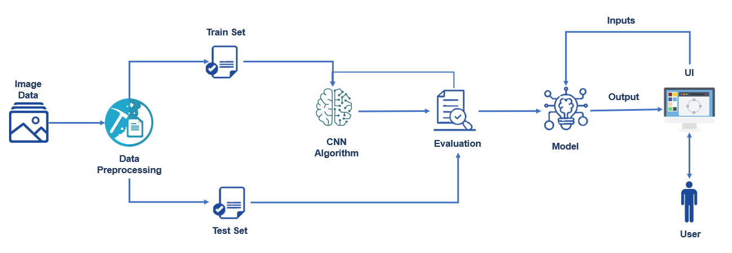

# 4. EXPERIMENTAL INVESTIGATIONS

1. MRI is a technique that uses powerful magnets, radio waves, and a computer to make detailed pictures inside our body.
2. MRIs can be done on different parts of our body
3. It is useful for looking at soft tissues and the nervous system
4. Information technology and e-health care system in the medical field helps clinical experts to provide effective diagnosis, treatment and monitoring of the disease for better health care to the patient
5. **METHODOLOGY:**

The image processing techniques are applied to the dataset that we have acquired then we have extracted the useful features that are necessary for further analysis

1. Image Aquisition
2. Image Preprocessing
3. Segmentation
4. Feature extraction
5. Classifiaction
   1. **IMAGE AQUISITION**

This brain tumor dataset containing 3064 T1-weighted contrast-inhanced images from 233 patients with three kinds of brain tumor.

* 1. **IMAGE PREPROCESSING**

1. Image de-noising is an important task in any type of image processing
2. The aim of pre-processing is an improvement of the image data that suppresses unwanted distortions or enhances some image features important for further processing
3. Most enhancement and noise reduction techniques are used to get better results
4. Enhancement will bring about more prominent edges and noise will be reduced and so the blurring of image is decreased.

# SEGMENTATION

1. In image segmentation the image is divided into regions.
2. Image segmentation is used for measuring and visualizing the brain’s anatomical structures, for analyzing brain changes, and for better diagnosis
3. Brain MRI segmentation is an essential task in many clinical applications because it influences the outcome of the entire analysis. This is because different processing steps rely on accurate segmentation of anatomical regions be after used.

The data is being downloaded from Kaggle, below is the link. It has two folders labeled as **Yes** and **No**, the “Yes” folder contains the image of the brain which has a tumor, and the “No” folder contains the image of the brain which does not have a tumor. I’ve separated out 10 images from each folder to test our model..

The detection of brain tumors means identifying not only the affected part of the brain but alsoto the tumor shape, size, boundary, and position. Different imaging technologies such as magneticresonance image (MRI), computed tomography (CT), positron emission tomography (PET), etc. areused for imaging the brain. Most frequently, the anatomy of the brain tumor can be tested by MRI scan or CT scan. However, the CT scan contains radiation that is detrimental to human body, whereas MRI gives accurate visualization of the anatomical formation of tissues of the brain. The MRI is adevice that conducts a magnetic field and radio waves for generating detailed images of the organs andtissues. Processing of MR images are extremely complicated and constantly scrutinized by researchersto give pathologists an improved experience to diagnose the patients.

**5.METHODS OF DETECTING BRAIN TUMOR FROM MRI**

Methods that we use to detect brain tumor from MRI images (figure 1) are watershed segmentation and contour of the image [2]. Before we start the segmentation we have to filter the MRI image noise. We use in this step the digital filter from Matlab (“Sobel edge masks”) which will show the gradient is high at the borders of the MRI objects and low (mostly) inside the image as shown in figure(1).

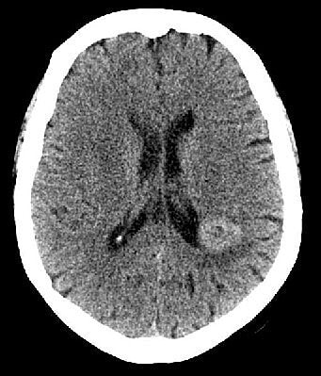

Figure:1 Original MRI images for brain tumor

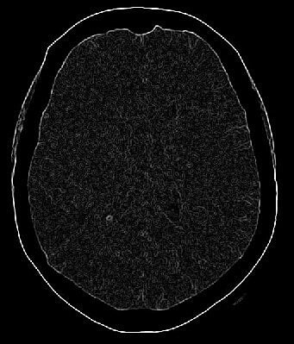

Figure:2 Showing MRI image after using of “Sobel” edge mask

Next step is using the contour program to see the contour of the objects in the MRI image As can be seen in figure

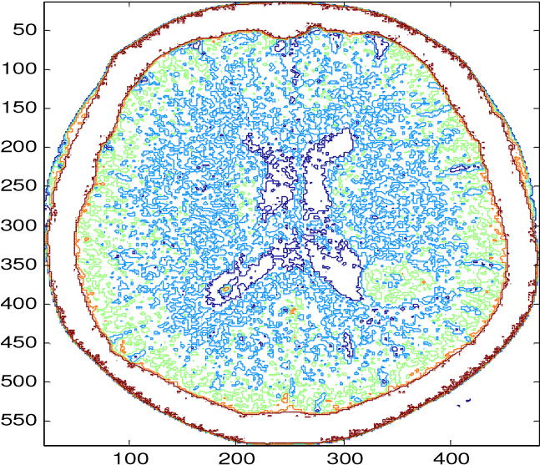

Figure:3. Contour of the MRI image

After we have filtered the noise of the MRI image the next step is finding the gradient magnitude in this step we will find the different in the pixels of the image as shown in figure.

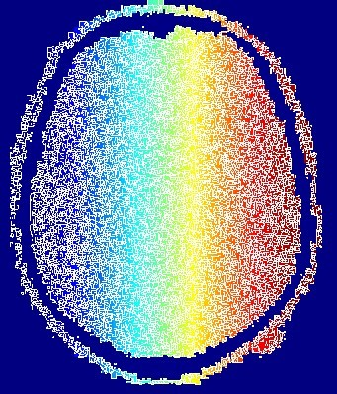

Figure:4 Gradient magnitude of MRI image

Compute the Watershed Transform of the Segmentation Function as clear segmentation for the MRI image. We use the watershed method starting with the transform of gradient Magnitude as can be seen. Now we have to make the different pixels as in different region in the MRI image in this way we can detect the region of the tumor as it can be seen .

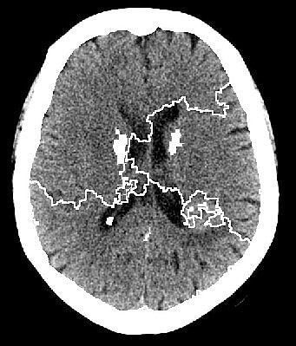

Figure:5 MRI image region’s using watershed segmentation

**6. FLOW CHART**

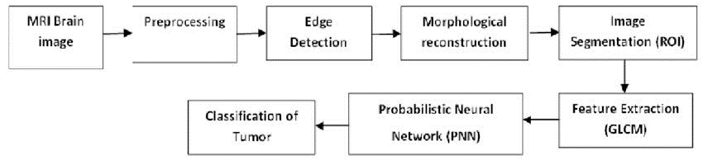

**7. ADVANTAGES**

1. Brain recoverytumor detection at early stages can increase the chances of the patient'safter treatment. In the last decade, we have noticed a substantial development in the medical imaging technologies, and they are now becoming an integral part in the diagnosis and treatment processes.

2. Independent of atlas registration.

3. Independent of prior anatomy knowledge.

4. Independent of bias correlation.

5. using single-spectral MRI.

6. This approach does not rely of registration and the prior anatomy knowledge.

7. Simplicity,better noise suppression.

8. Make simpler as compared to sobel.

9. Detection or edges and their orientations,having fixed characteristics in all directions.

10. simplicity,accuracy of zero crossing locations.

11. low error rate,single edge point response.

Brain tumor detection at early stages can increase the chances of the patient's recovery after treatment. In the last decade, we have noticed a substantial development in the medical imaging technologies, and they are now becoming an integral part in the diagnosis and treatment processes. In this study, we generalize the concept of entropy difference defined in terms of Marsaglia formula (usually used to describe two different figures, statues, etc.) by using the quantum calculus..

**8.DISADVANTAGES**

1.No edge detection.

2.High computational complexity.

3.Discontinuity in edges,not accurate in result.

4.Discontinuity in edges.

5.Noise sensitive.

6.No edge detection at corners.

7.High complexity little time consuming compared to others.

**9. APPLICATIONS**

Magnetic resonance imaging (MRI) and computed tomography (CT) scan**s** are used most often to look for brain diseases. These scans will almost always show a brain tumor, if one is present

· The main aim of the application is tumor identification.

· The main reason behind the development of this application is to provide proper treatment as soon as possible and protect the human life which is in danger.

· This application is helpful to doctors as well as patient.

· The manual identification is not fast, accurate and efficient. to overcome those problem this application is design.

application is design.

The medical field needs fast, automated, efficient and reliable technique to detect tumor like brain tumor. ... In this medical application using **K-mean** and FCM segmentation algorithm System detects the proper shape and size accurately. It works accurately in small time. It accepts MRI and CT images as a input.

Some of the most common symptoms of a brain tumor include:

* headaches
* seizures
* changes in personality
* vision problems
* memory loss
* mood swings
* tingling or stiffness on one side of the body
* loss of balance
* nausea
* fatigue
* anxiety or depression
* difficulty concentrating
* difficulty communicating as usual
* feeling confused or disorientated
* loss of coordination
* muscle weakness

Primary brain tumors are tumors that begin in the brain.

**10. CONCLUSION**

Brain tumor detection is done by preprocessing which is first step in that median filter and by using diagonal, anti-diagonal masks segmented images get preprocessed and skull masking is done here. After skull masking fatty tissues and other unwanted details get smoothen. Preprocessed image is segmented with the K-Mean segmentation and Object Labeling with HOG, HOG is friendly with feature extraction. So the texture feature and color feature are extracted here in the system which is use to find out the region of interest and SVM is use for pattern mapping and pattern matching process. Also use to learn Neural Network.

Image processing has become a very important task in today’s world. Today applications of image processing can be originate in number of areas like medical, remote sensing, electronics and so on. If we focus on medical applications, and image segmentation is widely used for diagnosis purpose. In this paper, we have proposed a system that can be used for segmentation of brain MR Images for Detection and identification of brain tumor. We find area of tumor and its type of tumor.

Future scope for detection and segmentation of brain tumor is that if we obtained the three dimensional image of brain with tumor then we can also find out its tumor size and also can evaluate its tumor type and also its stage of tumor.

To remove a noise and smoothen the image, preprocessing is used which also results in the improvement of signal-to-noise ratio. Next, we have used discrete wavelet transform that decomposes the images and textural features were extracted from gray-level co-occurrence matrix (GLCM) followed by morphological operation. Probabilistic neural network (PNN) classifier is used for the classification of tumors from brain MRI images.

In identification and classification into normal and abnormal tumors from brain MR images, accuracy of nearly 100% was achieved for trained dataset because the statistical textural features were extracted from LL and HL subbands wavelet decomposition and 95% was achieved for tested dataset. With the above results, we conclude that our proposed method clearly distinguishes the tumor into normal and abnormal which helps in taking clear diagnosis decisions by clinical experts.

From the observation results, it can be clearly expressed that the detection of brain tumor is fast and accurate when compared to the manual detection carried out by clinical experts. The performance factors evaluated also shows that it gives better outcome by improving PSNR and MSE parameters. The proposed methodology results in accurate and speedy detection of tumor in brain along with identification of precise location of the tumor.

In this article, we made a classification model with the help of custom CNN layers to classify whether the patient has a brain tumor or not through MRI images. With a few no of training samples, the model gave 86% accuracy. If we increase the training data may be by more MRI images of patients or perform [data augmentation](https://analyticsindiamag.com/image-data-augmentation-impacts-performance-of-image-classification-with-codes/) techniques we can achieve higher classification accuracy. Also, we can make use of pre-trained architectures like Vgg16 or [Resnet 34](https://analyticsindiamag.com/mobilenet-vs-resnet50-two-cnn-transfer-learning-light-frameworks/) for improving the model performance.

**11. FUTURE SCOPE**

1.In the future, this technique can be developed to classify the tumours based on feature extraction.

2.This technique can be applied for ovarian,breast,lung,skin tumours.

3.Instead of rectangular boxes,can work with general boundaries level set based framework.

4.As medical imagebsegmentation plays a very important role in the field of image guide surgeries.

5.By creating three dimensional anatomical models from individual patients,training,planning,and computer guidance during surgery is improved.

**12. BIBILOGRAPHY**

1. Bahadure NB, Ray AK, Thethi HP (2017) Image analysis for MRI based brain tumor detection and feature extraction using biologically inspired BWT and SVM. Int J Biomed Imaging 2017, Article ID 9749108, 12 pages
2. 1.Alfonse M, Salem M (2016) An automatic classification of brain tumors through MRI using support vector machine. Egypt Comput Sci J 40:11–21
3. Demirhan A, Toru M, Guler I (2015) Segmentation of tumor and edema along with healthy tissues of brain using wavelets and neural networks. IEEE J Biomed Health Inform 19(4):1451–1458
4. Haralick RM, Shanmugam K, Dinstein I (1973) Textural features for image classification. IEEE Trans Syst Man Cybern 3(6):610–621
5. Sawakare S, Chaudhari D (2014) Classification of brain tumor using discrete wavelet transform, principal component analysis and probabilistic neural network. Int J Res Emerg Sci Technol 1(6), E-ISSN: 2349-7610
6. Dubey RB, Hanmandlu M, Gupta K (2009) Region growing for MRI brain tumor volume analysis. Indian J Sci Technol 2(9), ISSN: 0974-6846
7. [8] T. Logeswari, M. Karnan, An improved implementation of brain tumor detection using segmentation based on soft computing, Page(s): 006-014, Journal of Cancer Research and Experimental Oncology Vol. 2(1), March
8. Kharat KD, Kulkarni PP, et al. (2012) Brain tumor classification using neural network based methods. Int J Comput Sci Inform 1(4), ISSN (PRINT): 2231-5292
9. Jadhav C et al (2014) Study of different brain tumor MRI image segmentation techniques. Int J Comput Sci Eng Technol (IJCSET) 4(4):133–136
10. Madhikar GV, Lokhande SS (2014) Detection and classification of brain tumour using modified region growing and neural network in MRI images. Int J Sci Res (IJSR) 3(12):5
11. Dubey RB, Hanmandlu M, Gupta K (2009) Region growing for MRI brain tumor volume analysis. Indian J Sci Technol 2(9), ISSN: 0974-684
12. [14] S.Koley and A.Majumder, “Brain MRI segmentation for
13. tumor detection using cohesion based self-merging
14. algorithm,” in Proceedings in IEEE-3rd International
15. Conference on Communication Software and Networks,
16. pp. 781-785, 2011.
17. [14] S.Koley and A.Majumder, “Brain MRI segmentation for
18. tumor detection using cohesion based self-merging
19. algorithm,” in Proceedings in IEEE-3rd International
20. Conference on Communication Software and Networks,
21. pp. 781-785, 2011.