Title: [Farther Yet Closer]

By: [Joaquin Germar] (artist), [Mio Lopez] (writer)

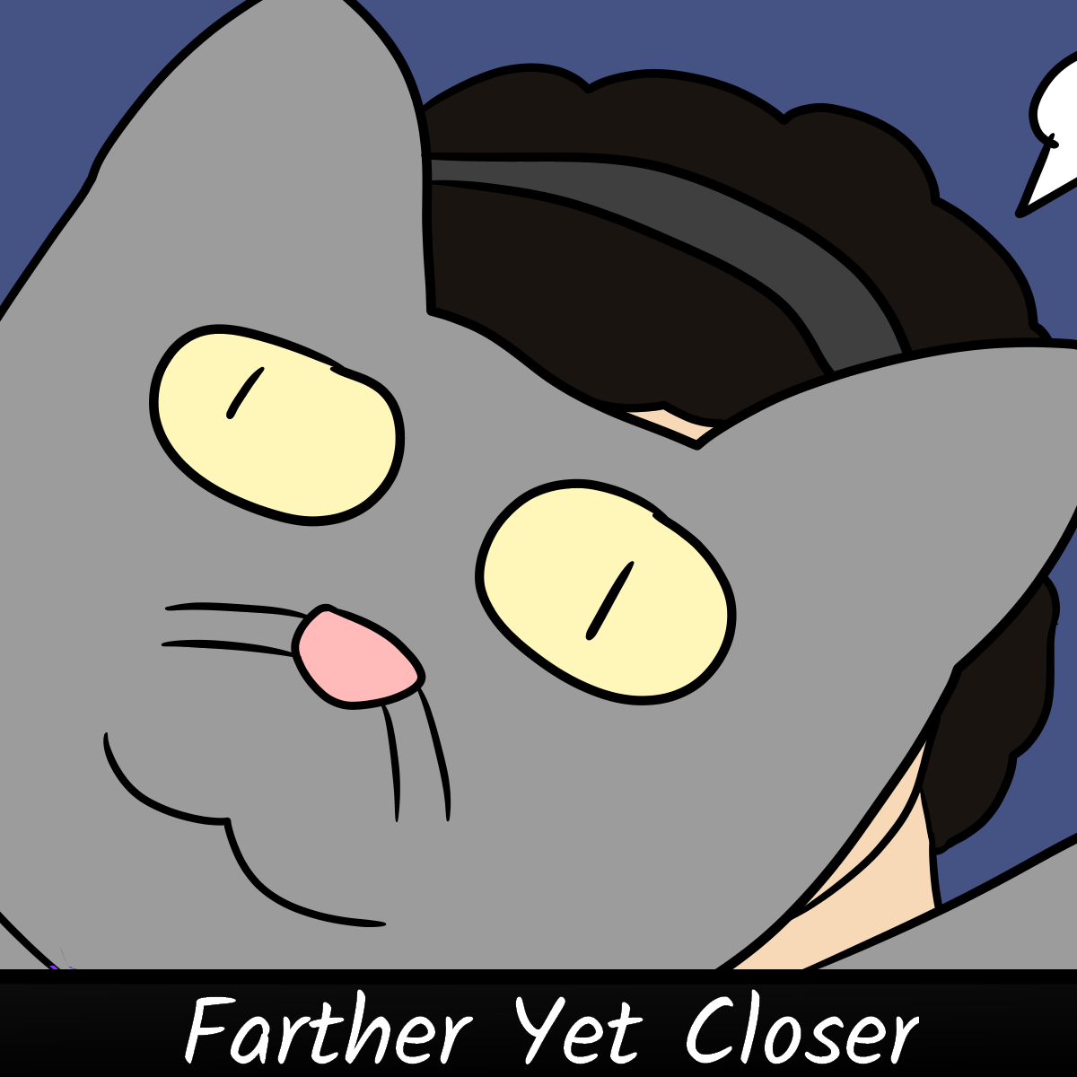

Every friend group has people who are only connected via their mutual friend. Since you're less close to that person, conversation becomes difficult. However, despite two such people being farther than ever from each other because of the lockdown, they end up becoming closer to each other. This is the story of how two people connected only by a mutual friend are able to bond during a time when doing so is even more difficult than usual.