Lab Brief

Course: Cloud Computing on AWS Storage I Volumes, S3, CLI

(Add volumes to EC2 instance, migrate data from one volume to the other, write a CLI to upload documents to S3 from local machine)

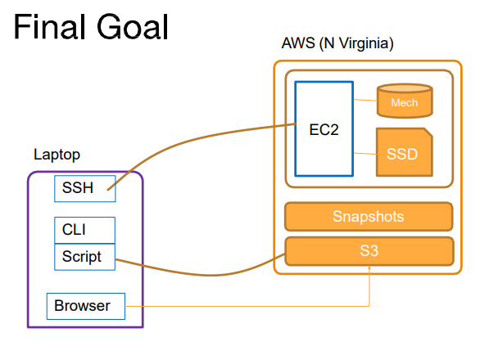

Part1- EBS

**Step-1:** Set region to North Virginia

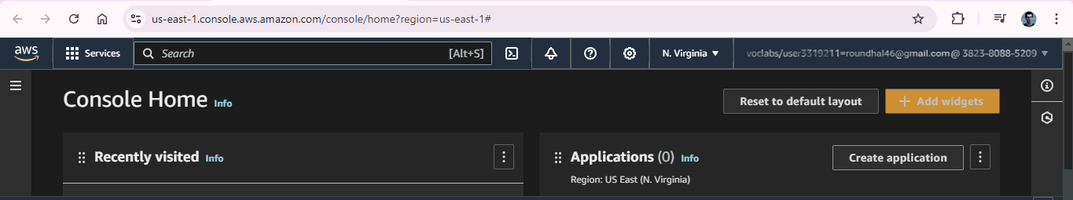

**Step-2:** Instance creation using 7 step work-flow

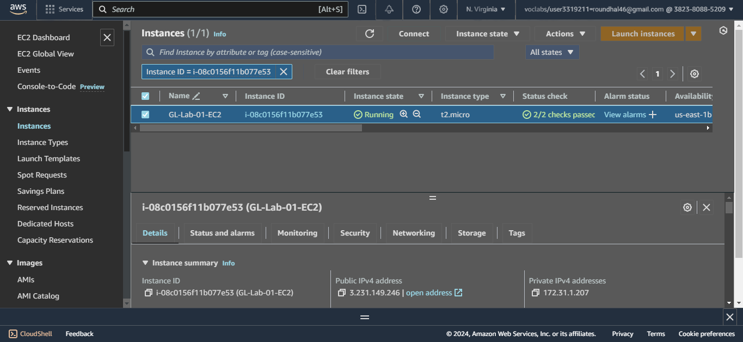

* Use Amazon Linux AMI in AZ1
* Download new PEM file and SSH to the instance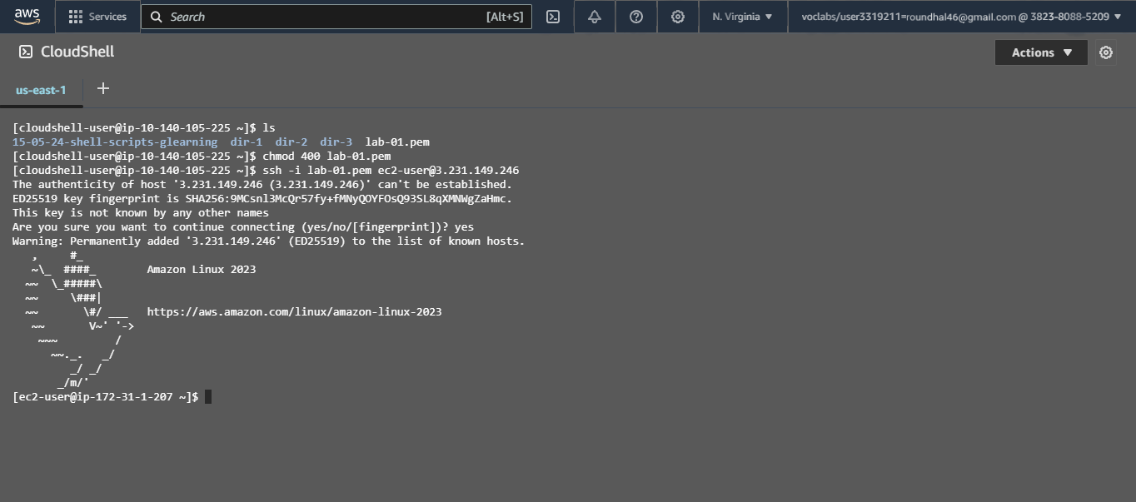

**Step-3:** Volumes

* Get 10G Magnetic volume in the same AZ1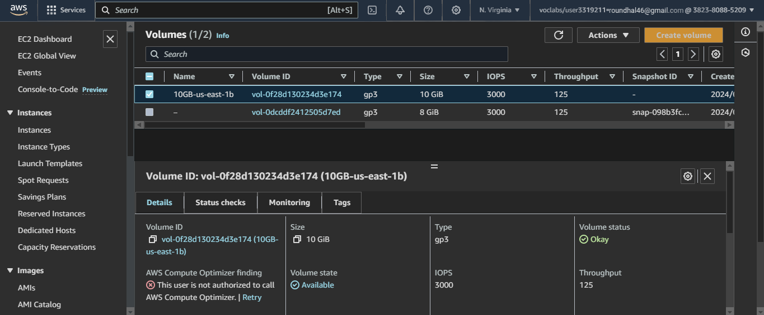
* Attach Volume to the instance

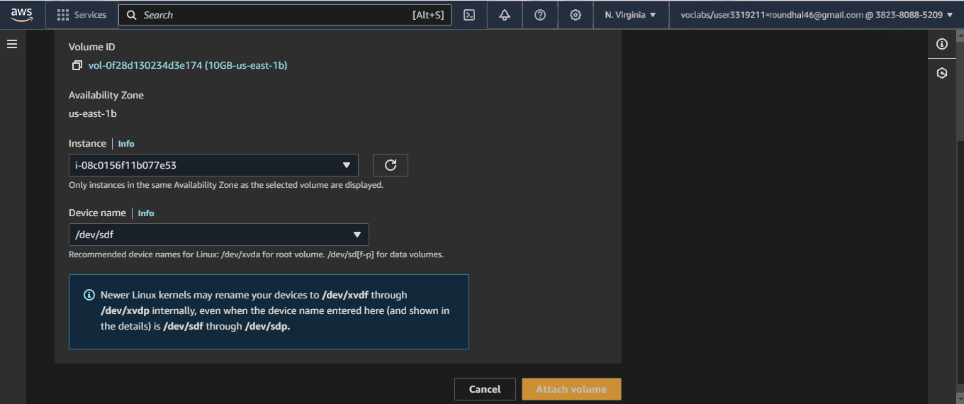

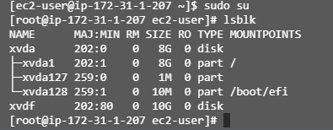

Lsblk Outcome



File System not available

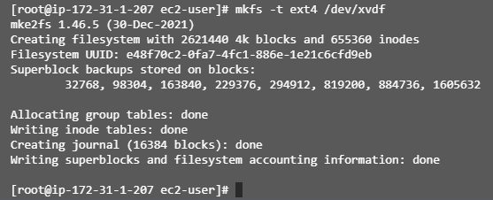

File System Creation



File System Available

* Volume Mounted

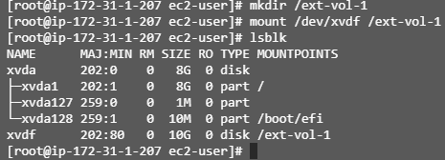

* Create a sample text file in the volume to simulate data creation

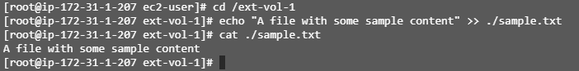

* Unmount, detach the volume

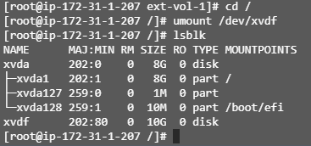

Volume Unmounted

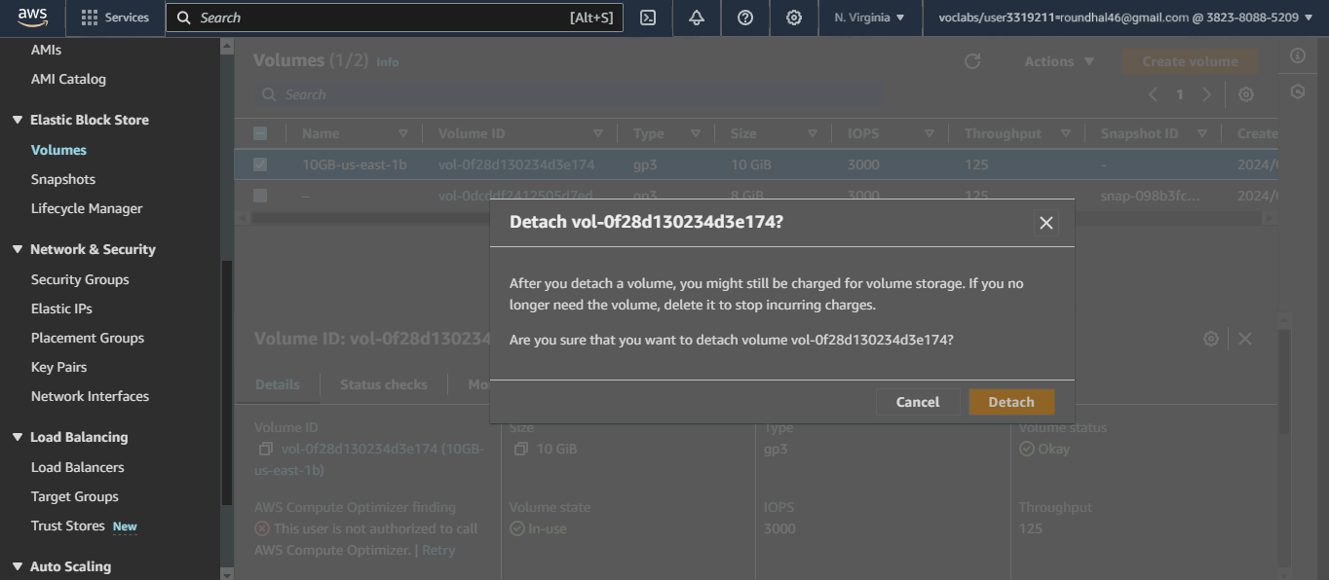

Volume Detached

**Step-4:** Snapshot

* Create a snapshot of the detached volume

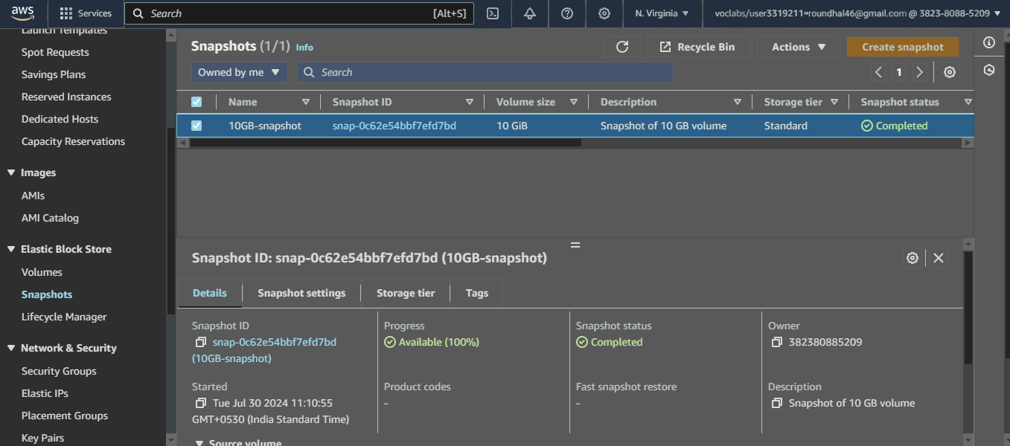

* Create a new SSD volume of 15G and apply the snapshot to it

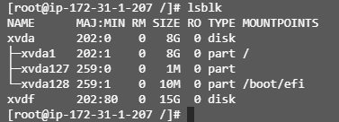

Snapshot Created

* Attach, mount and check if the data is there



15GB volume attached

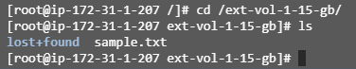

Sample file found



File Contents Available

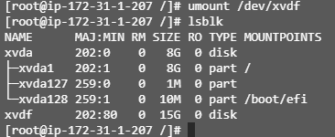

Unmounted

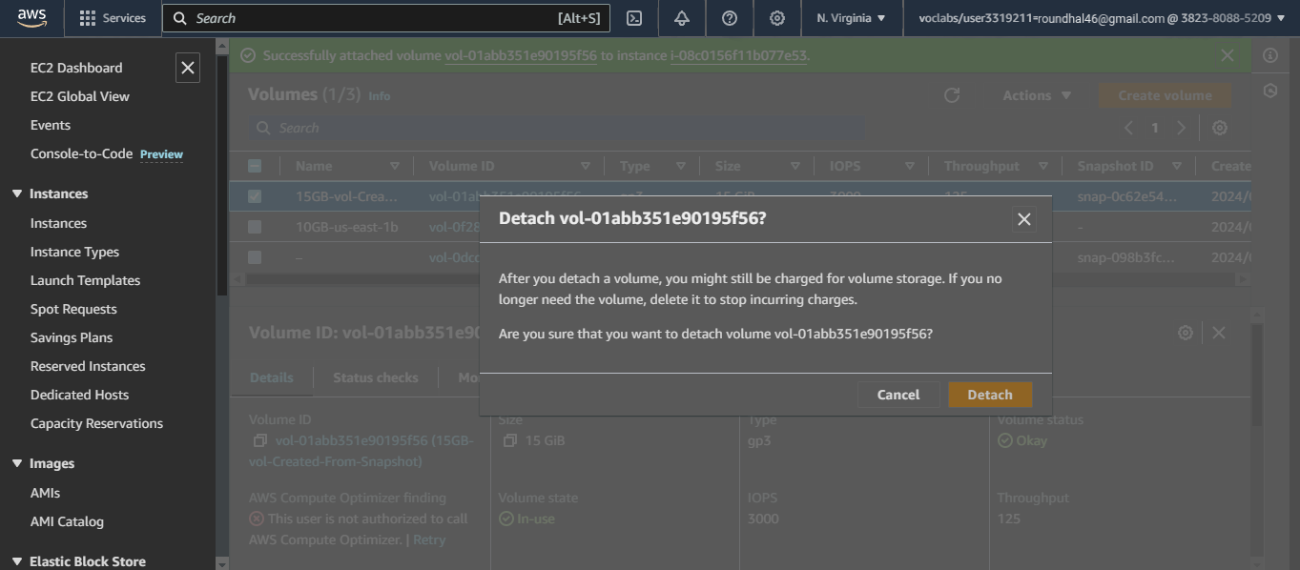

Detatched Volume

Part 2- S3

**Step-1:** Use the S3 browser console to create a bucket that’s unique to the region

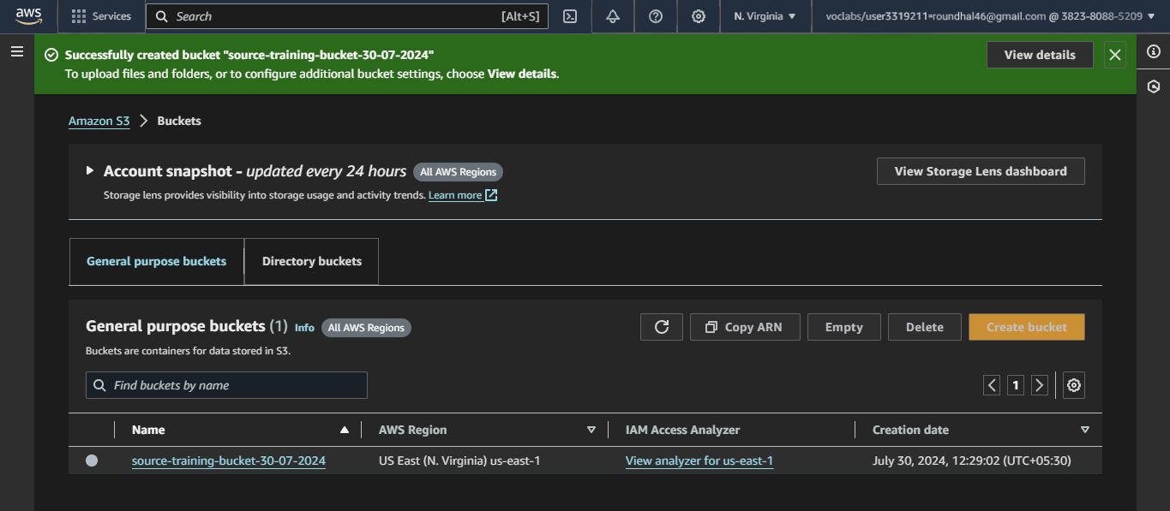

Source Bucket Creation

**Step-2:** Use the CLI to

* Upload a few (non-sensitive) files from your local machine to S3 bucket

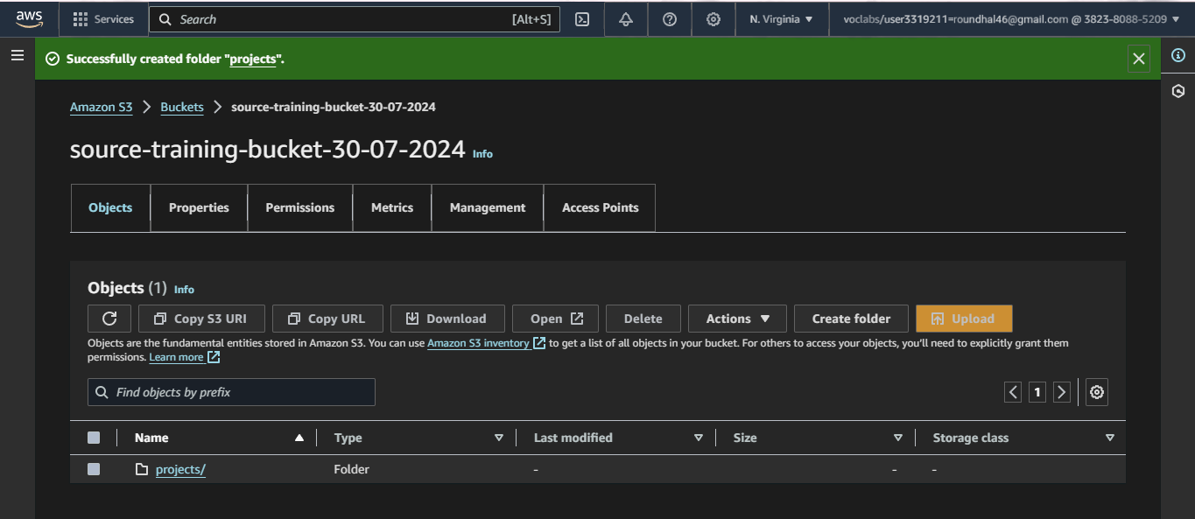

Folder created

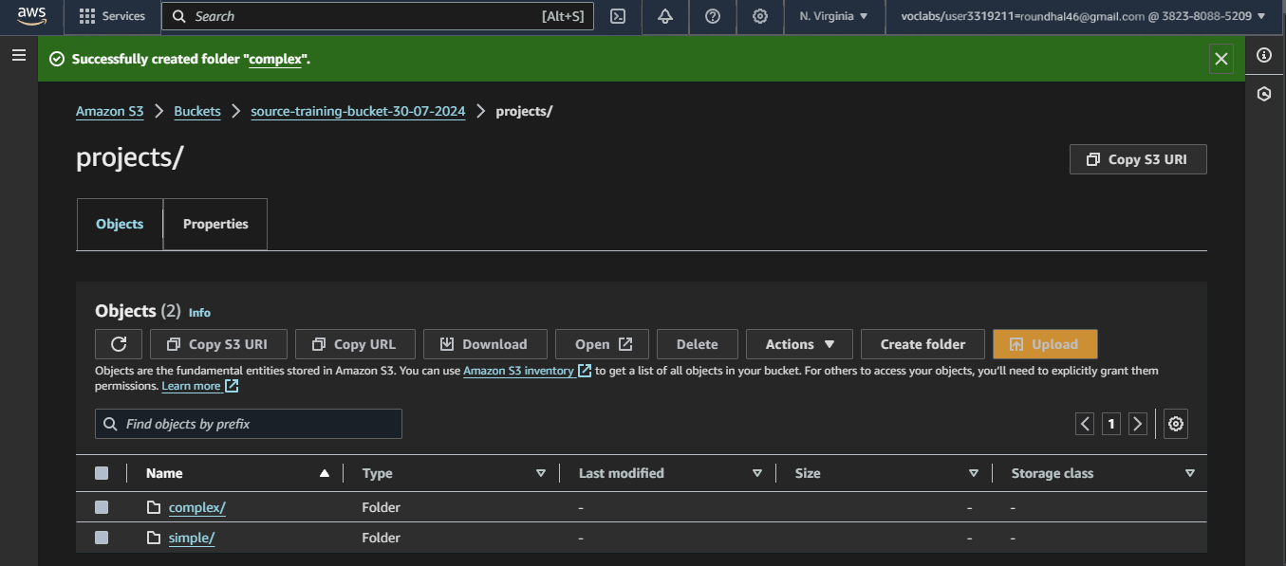

Subfolders created

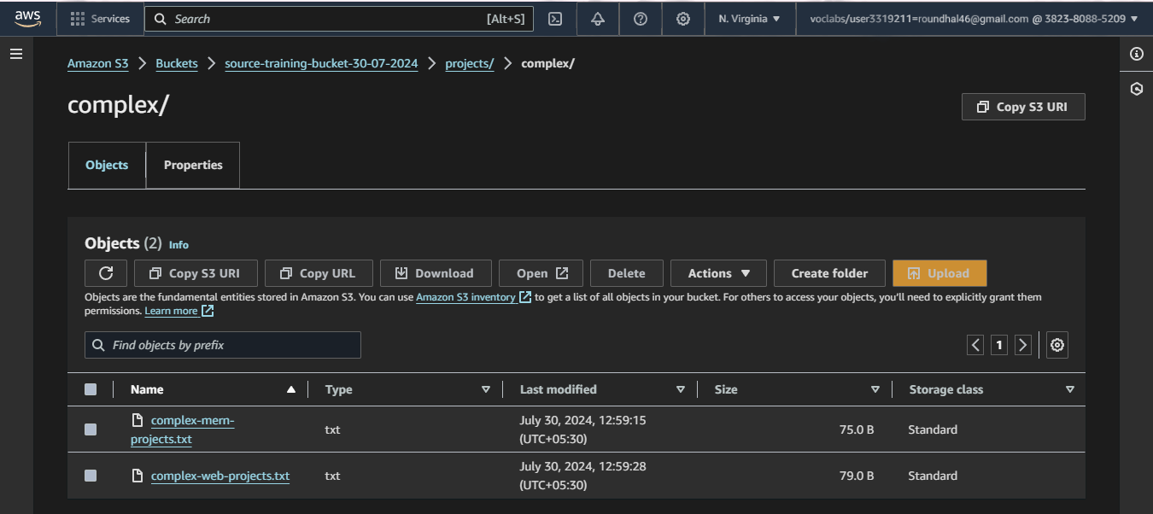

File Added

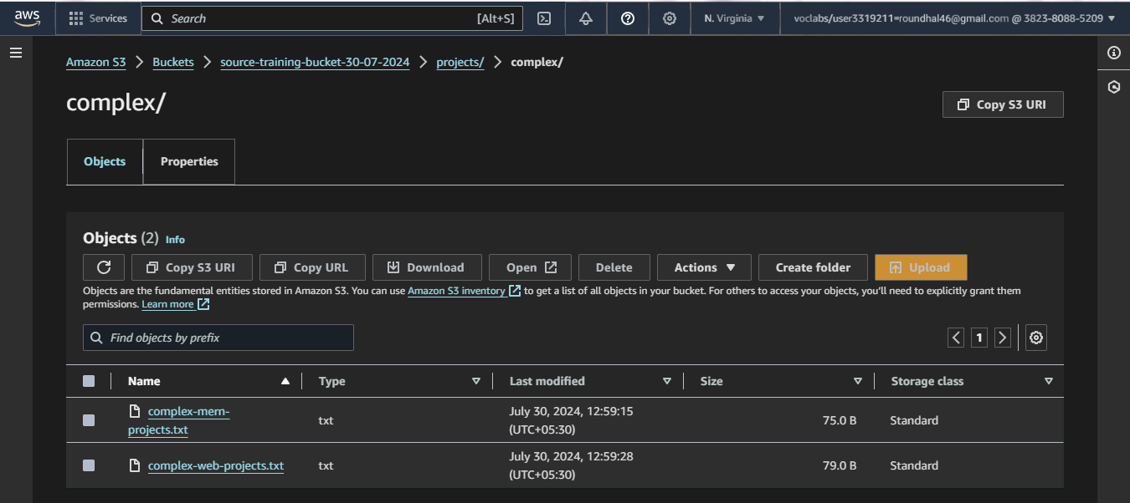

Multiple files added

* List the contents of a bucket



File display

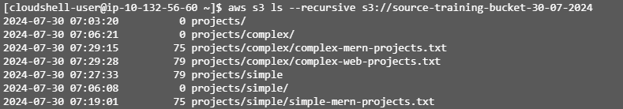

List of Files (Recursive)

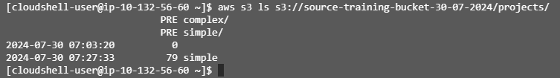

List with specified prefix

* List the buckets

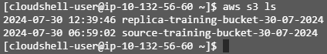

Both Buckets Available

**Step-3:** Enable versioning of the bucket

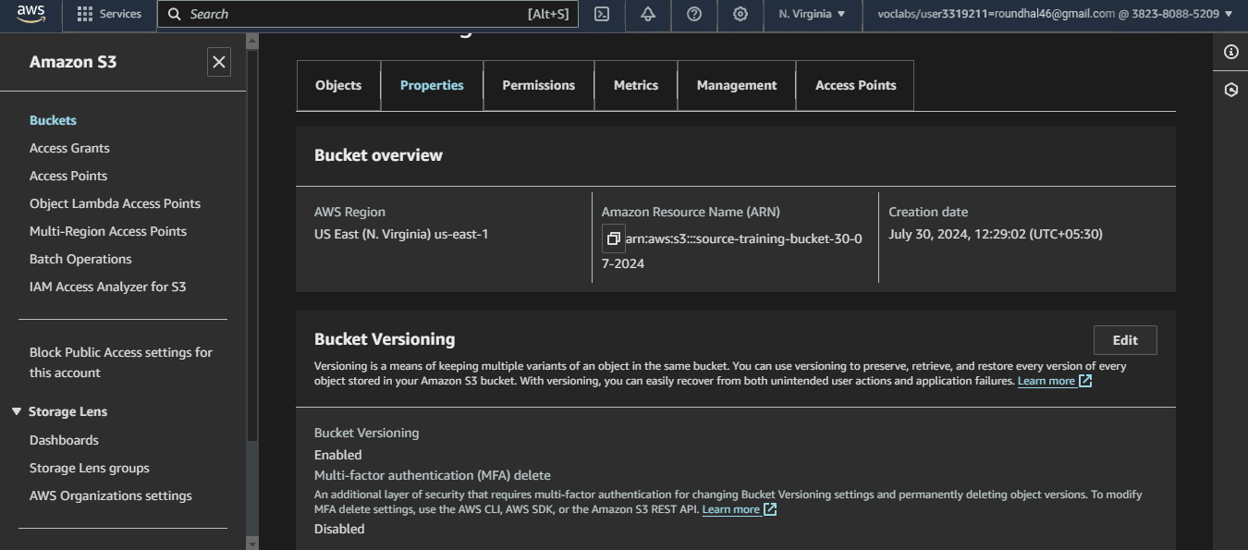

Source bucket versioning enabled

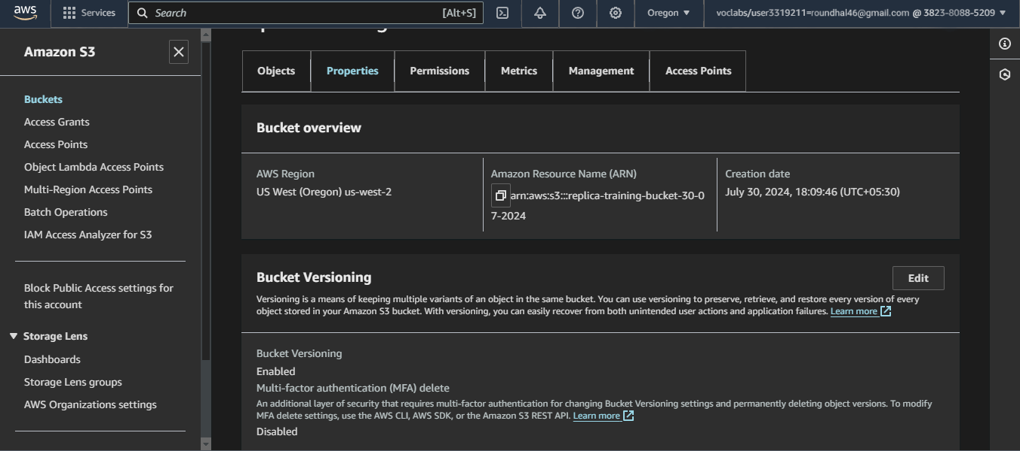

Replication bucket versioning enabled

**Step-4:** Enable cross region application

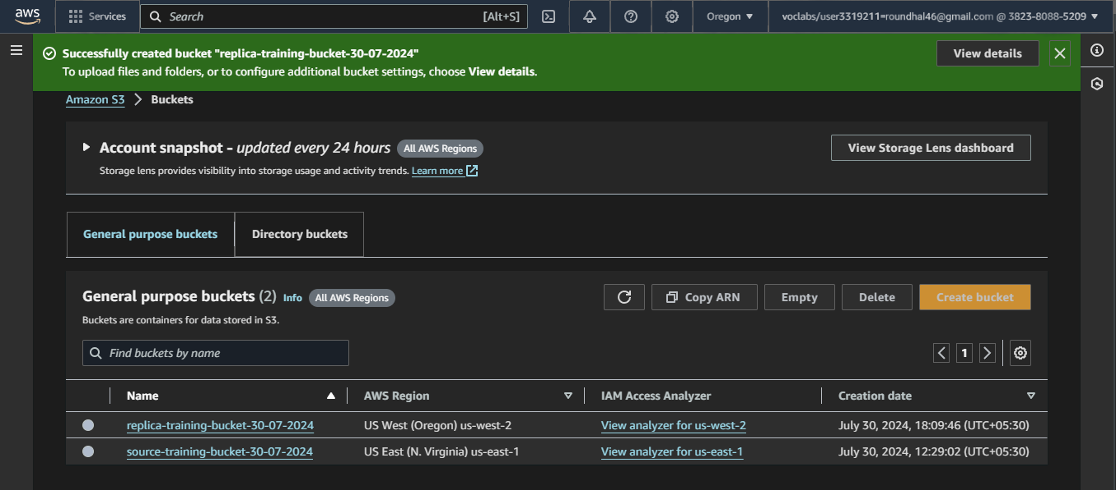

Replica bucket created in Oregon (us-west-2)

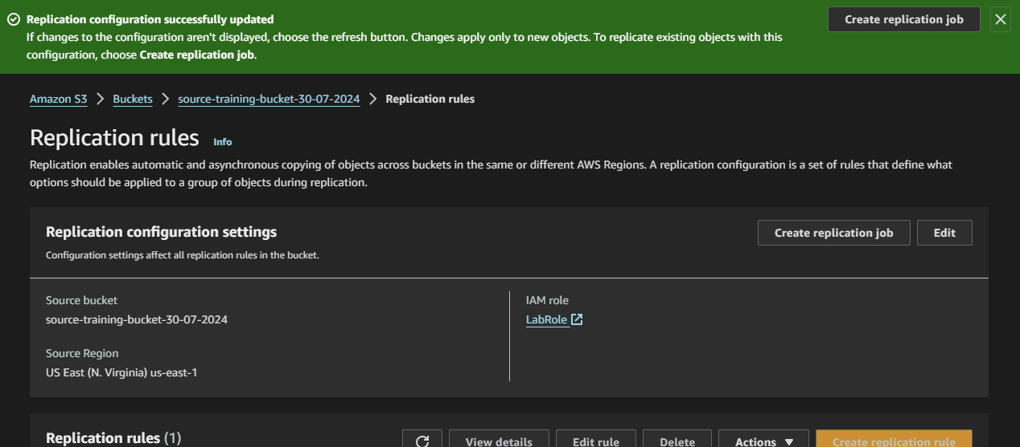

Replication Rule Set-up

**Step-5:** observation of replication of existing objects

As we selected at the moment of replication bucket creation, no prior file was copied to the existing source bucket.

**Step-6:** Use the CLI, upload new files to the same bucket

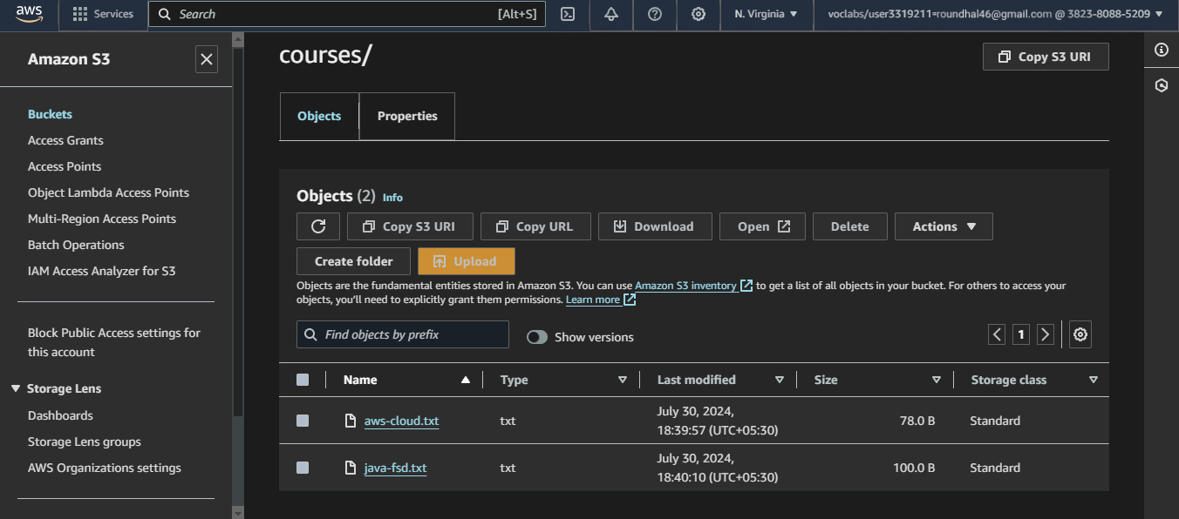 Files Uploaded

**Step-7:** Observation of the new objects

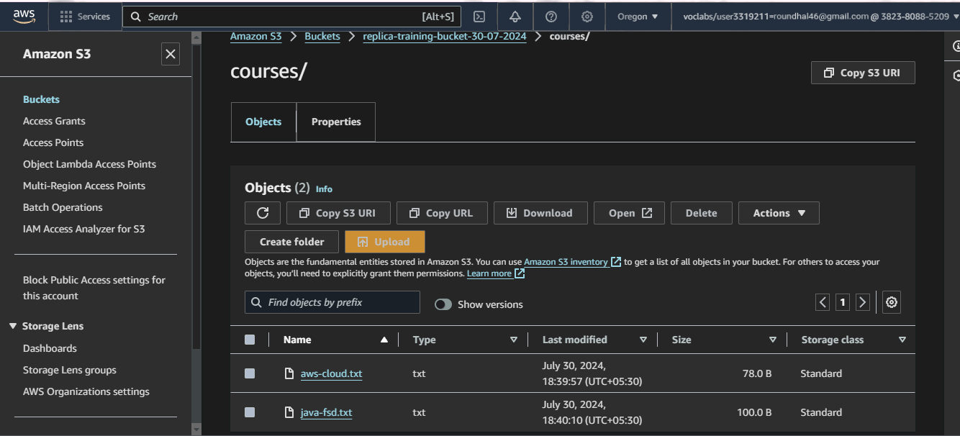

Replication Successful

New items has been replicated in the bucket.

**Step-7:** File Removal



Single file removal

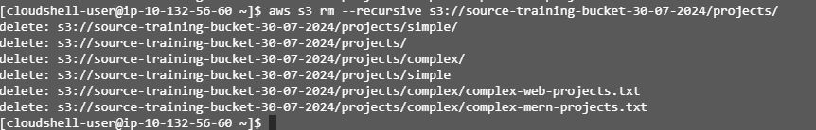

Recursive (multiple) file removal

**Step-8:** Termination of Instance

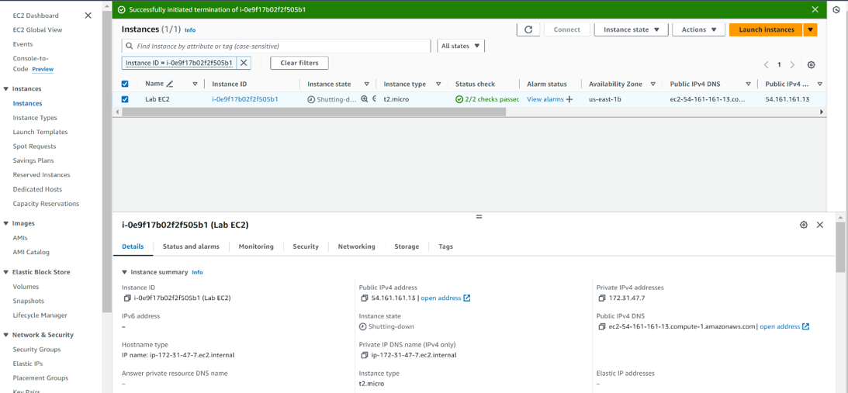

Instance Terminated