**A TECHNICAL SEMINAR REPORT**

**ON**

**RED-TACTON TECHNOLOGY**

*for the degree of*

**Bachelor of Technology**

in

**Electronics and Communication Engineering**

*Submitted by*

**Ashritha Sunkara (19B81A0407)**

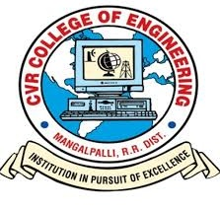

**DEPARTMENT OF ELECTRONICS & COMMUNICATION ENGINEERING**

**CVR COLLEGE OF ENGINEERING**

**(An autonomous Institution)**

**(Approved by AICTE, Accredited by NBA, NAAC - A & Affiliated by JNTU, Hyderabad)**

**Jawaharlal Nehru Technological University, Hyderabad**

**2022-23**

**CVR COLLEGE OF ENGINEERING**

**BONAFIDE CERTIFICATE**

Certified that this technical seminar report **“RedTacton Technology”** is the bonafide work of “**Ashritha Sunkara**”who carried out the seminar presentation under my supervision.

**Signature**: **Signature** :

Dr. K. Lalithendra Dr.Humaira Nishat

Head of Department Ms. M. Santhoshi

Dept. of ECE Faculty In charge

Dept. of ECE

**CVR COLLEGE OF ENGINEERING**

**(An autonomous Institution)**

**(Approved by AICTE, Accredited by NBA, NAAC - A & Affiliated by JNTU, Hyderabad)**

**Jawaharlal Nehru Technological University, Hyderabad**

**(2022-23)**