**­­­MODULE – 4(Advance PHP)**

**OOPS**

**• What Is Object Oriented Programming?**

**-> Object-oriented programming (OOP) is a computer programming model that organizes software design around data, or objects, rather than functions and logic. An object can be defined as a data field that has unique attributes and behavior.**

**­­­­­­**

**• What Are Properties Of Object Oriented Systems?**

**-> 1) class**

**2) Object**

**3) Encapsulation**

**4) Abstraction**

**5) Inheritance**

**6) Polymorphism**

**• What Is Difference Between Class And Interface?**

**->**

**Class:**

**A class can be instantiated i.e.,**

**Objects of a class can be created.**

**Classes does not support multiple inheritance.**

**Interface:**

**A Interface cannot be instantiated i.e.,**

**Objects cannot be created.**

**Interface supports multiple inheritance.**

**• What Is Overloading?**

**-> Overloading in PHP provides means to dynamically create properties and methods. These dynamic entities are processed via magic methods one can establish in a class for various action types.**

**• What Is T_PAAMAYIM_NEKUDOTAYIM (Scope Resolution Operator (::) with Example**

**->** **The scope resolution operator also known as *Paamayim Nekudotayim* or more commonly known as the double colon is a token that allows access to static, constant, and overridden properties or methods of a class.**

**It is used to refer to blocks or codes in context to classes, objects, etc. An identifier is used with the scope resolution operator.**

**The most common example of the application of the scope resolution operator in PHP is to access the properties and methods of the class.**

**Example:**

**<?php**

**class democlass {**

**const PI = 3.14;**

**}**

**echo democlass::PI;**

**?>**

**• What are the differences between abstract classes and interfaces?**

**->**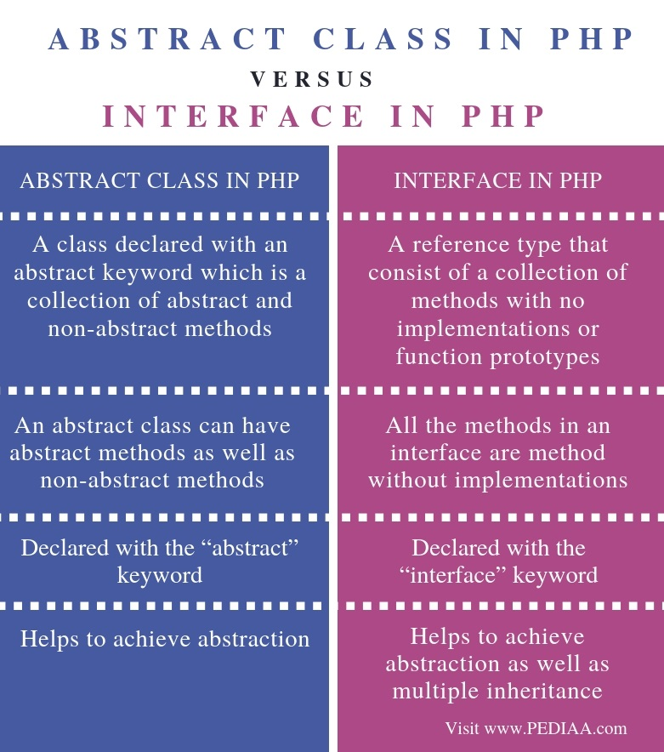

**• Define Constructor and Destructor?**

**->**

**Constructors :**

**Constructors are the blueprints for object creation providing values for member functions and member variables. Once the object is initialized, the constructor is automatically called.**

**Destructors :**

**Destru­­­ctors are for destroying objects and automatically called at the end of execution. In this article, we are going to learn about object-oriented concepts of constructors and destructors.**

**Syntax:**

* **__construct():**

**function __construct()**

**{**

**// initialize the object and its properties by assigning**

**}**

* **__destruct():**

**function __destruct()**

**{**

**// destroying the object or clean up resources here**

**}**

**• How to Load Classes in PHP?**

**->**

**PHP load classes are used for declaring its object etc. in object oriented applications.**

**PHP parser loads it automatically, if it is registered**

**With spl_autoload_register() function.**

**PHP parser gets the least chance to load class/interface before emitting an error.**

**Before using a class, you need to:**

* **First, define the class in a file.**
* **Second, load it using the require, require_once, include, or include_once statement.**

**Syntax:**

**spl_autoload_register(function ($class_name)**

**{**

**include $class_name . '.php';**

**});**

**Example:**

**<?php**

**class Contact**

**{**

**private $email;**

**public function __construct(string $email)**

**{**

**$this->email = $email;**

**}**

**public function getEmail()**

**{**

**return $this->email;**

**}**

**}**

**• How to Call Parent Constructor?**

**-> A constructor allows you to initialize an object's properties upon creation of the object.**

**If you create a __construct() function, PHP will automatically call this function when you create an object from a class.**

**Notice that the construct function starts with two underscores (__)!**

**We see in the example below, that using a constructor saves us from calling the set_name() method which reduces the amount of code:**

**<?php  
class Fruit {  
  public $name;  
  public $color;  
  
  function __construct($name) {  
    $this->name = $name;  
  }  
  function get_name() {  
    return $this->name;  
  }  
}  
  
$apple = new Fruit("Apple");  
echo $apple->get_name();  
?>**

**• Are Parent Constructor Called Implicitly When Create An Object Of Class?**

**->Parent constructors are not called implicitly if the child class defines a constructor. In order to run a parent constructor, a call to parent::__construct() within the child constructor is required.**

**• What Happen, If Constructor Is Defined As Private Or Protected?**

**->** **The constructor may be made private or protected to prevent it from being called externally.**

**If so, only a static method will be able to instantiate the class.**

**Because they are in the same class definition they have access to private methods, even if not of the same object instance.**

**Public, private and protected are called access modifiers.**

**Just like C++, PHP also have three access modifiers such as public, private and protected.**

**The visibility of a property, a method or a constant can be defined by prefixing the declaration with these keywords.**

* **If the class member declared as public then it can be accessed everywhere.**
* **If the class members declared as protected then it can be accessed only within the class itself and by inheriting child classes.**
* **If the class members declared as private then it may only be accessed by the class that defines the member.**

**• What are PHP Magic Methods/Functions? List them Write program for Static Keyword in PHP?**

**->**

**Magic methods are special methods which override PHP's default's action when certain actions are performed on an object. Caution.**

**All methods names starting with __ are reserved by PHP.**

**Therefore, it is not recommended to use such method names unless overriding PHP's behavior.**

**The following method names are considered magical:**

**__construct(), __destruct(), __call(), __callStatic(), __get(), __set(), __isset(), __unset(), __sleep(), __wakeup(), __serialize(), __unserialize(), __toString(), __invoke(), __set_state(), __clone(), and __debugInfo().**

**Example:**

**<?php  
class MyClass {  
  public static $str = "Hello World!";  
  
  public static function hello() {  
    echo MyClass::$str;  
  }  
}  
  
echo MyClass::$str;  
echo "<br>";  
echo MyClass::hello();  
?>**

**• Create multiple Traits and use it in to a single class ?**

**->**

**Traits are used to declare methods that can be used in multiple classes.**

**Traits can have methods and abstract methods that can be used in multiple classes, and the methods can have any access modifier. (public, private, or protected).**

**• Write PHP Script of Object Iteration?**

**->**

**it is possible to iterate through list of all visible items of an object.**

**Iteration can be performed using foreach loop as well as iterator interface.**

**There is also IteratorAggregate interface in PHP, that can be used for this purpose**

**Example:**

**<?php**

**class myclass**

**{**

**private $var;**

**protected $var1;**

**public $x, $y, $z;**

**public function __construct()**

**{**

**$this->var="private variable";**

**$this->var1=TRUE;**

**$this->x=100;**

**$this->y=200;**

**$this->z=300;**

**}**

**public function iterate()**

**{**

**foreach ($this as $key => $value)**

**{**

**print "$key => $value\n";**

**}**

**}**

**}**

**$obj = new myclass();**

**foreach($obj as $key => $value)**

**{**

**print "$key => $value\n";**

**}**

**echo "\n";**

**$obj->iterate();**

**?>**

**• Use of The $this keyword**

**->**

**$this is a reserved keyword in PHP that refers to the calling object.**

**It is usually the object to which the method belongs, but possibly another object if the method is called statically from the context of a secondary object.**

**This keyword is only applicable to internal methods.**

**Example :**

|  |
| --- |
| **<?php**  **class simple**  **{**  **public $k = 9;**  **public function display()**  **{**  **return $this->k;**  **}**  **}**  **$obj = new simple();**  **echo $obj->display();**  **?>**  •**TASK :**   * **Consider the exercise11and add a edit link near delete link e.g. Clicking up on edit button a particular row should be open in** * **editing mode** * **e.g. on the Particular row there should be filled text box with data and on the option column there should be a confirm button clicking upon it arrow should be updated.** * **Create Hotel Room Booking System User can book room by 3 ways** * **Full day** * **Half day** * **Custom** * **If user select for the full day than user only have selection for the checking checkout date** * **If user select Half day than user have option of date and slot option(like user want to book room for first half – Morning (8AM to 6PM) if user select for second halfit‟s for evening (7PM to Morning 7AM)). Do proper validation like if user can book only available slot. (have touse jQuery -> Ajax, validation, Json passing).** |