**MULTI-LANGUAGE TRANSLATOR DICTIONARY BOT**

**A PROJECT REPORT**

***Submitted by***

**ASHWANTH E (2207001032)**

***in partial fulfillment for the course***

**OAI1903 - INTRODUCTION TO ROBOTIC PROCESS AUTOMATION**

***for the degree of***

**BACHELOR OF ENGINEERING**

***in***

**COMPUTER SCIENCE AND ENGINEERING**

**RAJALAKSHMI ENGINEERING COLLEGE**

**RAJALAKSHMI NAGAR**

**THANDALAM**

**CHENNAI – 602 105**

**NOVEMBER 2024**

**RAJALAKSHMI ENGINEERING COLLEGE**

**CHENNAI - 602105**

**BONAFIDE CERTIFICATE**

Certified that this project report **“MULTI-LANGUAGE TRANSLATOR DICTIONARY BOT ”** is the bonafide work of **“ASHWANTH E (220701032)”** who carried out the project work for the subject OAI1903 - Introduction to Robotic Process Automation under my supervision.

Chennai - 602105.

**SIGNATURE**

**MRS.JINU SOPHIA**

Assistant Professor (SG),

Department of Computer Science and engineering

Rajalakshmi engineering college Thandalam

Submitted to Project and Viva Voce Examination for the subject OAI1903 - Introduction to Robotic Process Automation held on .

**Internal Examiner External Examiner**

ii

**ABSTRACT**

This project introduces a multi-language dictionary and translation system built using Robotic Process Automation (RPA) to facilitate seamless cross-language understanding and communication. Designed to cater to diverse language needs, the system utilizes content generation and translation connector activities, allowing users to access reliable dictionary definitions and accurate translations across a broad spectrum of languages. The RPA solution integrates advanced connector activities for real-time language processing, making it adaptable and capable of handling dynamic user inputs effectively.The multi-language dictionary component offers precise word definitions and contextual information, while the translation module supports efficient translation between languages, ensuring linguistic accuracy and relevance. By automating content generation and translation tasks, the project demonstrates how RPA can be leveraged beyond traditional business applications, providing a valuable educational tool and enhancing multilingual accessibility. This solution holds significant potential for businesses, educators, and individuals seeking instant language assistance and promotes a deeper understanding across linguistic and cultural boundaries. In summary, this project exemplifies the application of RPA in enhancing language accessibility, supporting real-time multilingual interaction, and fostering inclusivity in global communication

iii

**ACKNOWLEDGEMENT**

Initially we thank the Almighty for being with us through every walk of our life and showering his blessings through the endeavor to put forth this report. Our sincere thanks to our Chairman **Mr. S. Meganathan, B.E, F.I.E.,** our Vice Chairman **Mr. Abhay Shankar Meganathan, B.E., M.S.,** and our respected Chairperson **Dr. (Mrs.) Thangam Meganathan, (Ph.D.),** for providing us with the requisite infrastructure and sincere endeavoring in educating us in their premier institution.

Our sincere thanks to **Dr. S.N. Murugesan, M.E., (Ph.D.),** our beloved Principal for his kind support and facilities provided to complete our work in time. We express our sincere thanks to **Dr. P. KUMAR, M.E., (Ph.D.),** Professor and Head of the Department of Computer Science and Design for her guidance and encouragement throughout the project work. We convey our sincere and deepest gratitude to our internal guides, **Mrs. JINU SOPHIA, M.E.,(Ph.D.),** Assistant Professor (SG), **Ms. Farjana, M.E.(Ph.D.),** Assistant Professor (SG), Assistant Professor (SG), Department of Computer Science and Engineering, Rajalakshmi Engineering College for their valuable guidance throughout the course of the project.We are very glad to thank our Project Coordinators, **Dr. N. Durai Murugan, M.E., (Ph.D.)**,Assistant Professors (SG), Department of Computer Science and Engineering for their useful tips during our review to build our project.

**ASHWANTH E (220701032)**

**TABLE OF CONTENTS**

**CHAPTER NO. TITLE PAGE NO.**

**ABSTRACT**

**iii**

**vi**

**LIST OF FIGURES**

**vii**

**LIST OF ABBREVIATIONS**

**1**

**1. INTRODUCTION**

1.1 INTRODUCTION **7**

1.2 OBJECTIVE **7**

1.3 EXISTING SYSTEM **8**

1.4 PROPOSED SYSTEM **9**

**2. LITERATURE REVIEW 11**

**3. SYSTEM DESIGN 14**

3.1 SYSTEM FLOW DIAGRAM **14**

3.2 ARCHITECTURE DIAGRAM **15**

3.3 SEQUENCE DIAGRAM **17**

**4. PROJECT DESCRIPTION 17**

4.1 MODULES **17**

4.1.1. INPUT HANDLING AND

INITIALIZATION **17**

4.1.2. CONTENT ANALYSIS **18**

4.1.3. RESULT MANAGEMENT **19**

4.1.4. COMPLETION AND REPORTING **20**

**5. OUTPUT SCREENSHOTS 21**

**6. CONCLUSION 22**

**APPENDIX 24**

**REFERENCES 26**

v

**LIST OF FIGURES**

| **Figure**  **No.** | **Figure Name** | **Page**  **No.** |
| --- | --- | --- |
| 3.1 | System Flow Diagram | 9 |
| 3.2 | Architecture Diagram | 10 |
| 3.3 | Sequence Diagram | 11 |
| 3.4 | Output diagram | 21 |
| 3.5 | Workflow | 24 |

vi

**LIST OF ABBREVIATIONS**

| **ABBREVIATION** | **ACRONYM** |
| --- | --- |
| RPA | Robotic Process Automation |
| AI | Artificial Intelligence |
| API | Application Programming  Interface |
| CG | Content Generation |
| GEN AI | Generative Artificial intelligence |
| GPT | Generative pre-trained Transformer |

**CHAPTER 1**

**INTRODUCTION**

**1.1 INTRODUCTION**

In an increasingly interconnected world, the ability to communicate across language barriers has become essential for personal, educational, and professional interactions. This project aims to develop a multi-language dictionary and translator that utilizes Robotic Process Automation (RPA) to simplify language learning and translation. By integrating real-time translation and content generation, this system provides users with accurate definitions, translations, and linguistic context for words and phrases across multiple languages.

The project leverages third-party APIs to support dynamic, automated translation and dictionary functions, creating a seamless experience for users who need instant language assistance. It is designed to be user-friendly and accessible, catering to individuals, students, and professionals who require reliable multilingual support. Through its automated features, this multi-language dictionary and translator offers a practical solution to bridging language gaps and enhancing language accessibility worldwide.

**1.2 OBJECTIVE**

The objective of this project is to develop a comprehensive, multi-language dictionary and translation system powered by Robotic Process Automation (RPA). This system aims to provide users with immediate access to accurate definitions, contextual information, and translations across multiple languages, enhancing accessibility and ease of communication. The key goals include:

1. **Real-Time Translation**: Enable users to instantly translate words or phrases across a wide range of languages by leveraging advanced translation APIs.
2. **Automated Content Generation**: Facilitate the automatic generation of dictionary definitions, example sentences, and language learning resources for user-selected words or phrases.
3. **Seamless User Experience:** Design a user-friendly interface that simplifies complex language processing tasks, allowing individuals with any level of technical knowledge to use the system effectively.
4. **Scalability and Adaptability:** Ensure the system supports various languages and can be expanded with additional language pairs or features as needed.

Through these goals, the project seeks to address language barriers and foster an inclusive environment for users seeking language support, whether for personal, academic, or professional purposes.

**1.3 EXISTING SYSTEM**

In the realm of language processing, several existing systems provide dictionary and translation services, each with varying levels of functionality, integration, and user experience. These include popular translation platforms like **Google Translate**, **Microsoft Translator**, and **DeepL**, which allow users to translate text between multiple languages in real-time. Additionally, traditional dictionary services such as **Oxford Dictionary Online** and **Merriam-Webster** offer definitions, synonyms, and contextual examples for words across multiple languages.

**1.4 PROPOSED SYSTEM**

"The Smart Assignment Integrity Verification Bot" is envisioned as a

**Integrated Dictionary and Translation Functionality**

* Users can access word definitions, synonyms, usage examples, and real-time translations within a single platform, eliminating the need to switch between separate tools. This combined functionality enhances the user experience and supports a more thorough understanding of language.

**Content Generation through RPA**

* The system employs RPA for automated content generation, retrieving dictionary definitions, contextual usage examples, and pronunciation guides from various data sources. This automation ensures that users receive accurate and up-to-date content with minimal manual input.

**Real-Time, Multi-Language Translation**

* Using third-party translation APIs, the system enables real-time translation across multiple languages, catering to a diverse user base. Users can select source and target languages, receive instant translations, and customize language pairs as needed.

**User-Friendly Interface and Accessibility**

* The system is designed to be accessible and intuitive, making it easy for users of all technical backgrounds to interact with the platform. Customizable features like language selection, text input/output, and responsive design contribute to a seamless user experience.

**Scalability and Adaptability**

* Built with flexibility in mind, the system can be expanded to support additional languages, integrate new language databases, or add features in response to user needs. This adaptability ensures that the system remains relevant as language demands evolve.

**CHAPTER 2**

**LITERATURE REVIEW**

This literature review explores research, methodologies, and tools relevant to the development of multi-language dictionaries, automated translation systems, and Robotic Process Automation (RPA). The review focuses on language processing technologies, translation models, and the application of RPA in automating content generation and enhancing accessibility in multilingual tools.

1. **Machine Translation (MT) and Language Models**
   * Machine Translation has evolved significantly with advancements in neural networks, particularly with the development of Neural Machine Translation (NMT) models. Studies by Bahdanau et al. (2015) introduced the attention mechanism in NMT, enabling models to focus on relevant parts of the input sequence for more accurate translations. Further, Google’s Transformer model, introduced by Vaswani et al. (2017), revolutionized MT by implementing self-attention mechanisms, enhancing the quality and speed of translations across multiple languages. These techniques serve as the foundation for popular translation APIs such as Google Translate and Microsoft Translator, which are leveraged in this project for real-time multilingual translation capabilities.
2. **Dictionary and Language Processing Tools**
   * Dictionary tools, such as the Oxford English Dictionary and Merriam-Webster, provide comprehensive linguistic resources, including definitions, pronunciation, and example usage. While traditional dictionaries are often static and focused on single-language definitions, the rise of digital dictionaries has made it easier to integrate such resources with translation features. Research by Nesi (2009) emphasizes the importance of multimodal information in dictionaries, such as example sentences and pronunciation guides, to support language learning. Digital dictionaries that combine translation capabilities with dictionary content provide an enhanced language tool that addresses multiple user needs simultaneously.
3. **Robotic Process Automation (RPA) in Language Tools**
   * Robotic Process Automation (RPA) has been widely adopted in various industries to automate repetitive tasks, reduce manual effort, and improve accuracy. According to Willcocks et al. (2015), RPA is particularly effective in processes involving data extraction, formatting, and retrieval, which aligns well with the needs of content generation in dictionary and translation systems. By using RPA, this project automates the fetching and formatting of dictionary data and translations, which streamlines the user experience and ensures real-time updates with minimal delay.
4. **Integration of APIs for Real-Time Data Retrieval**
   * Third-party APIs play a crucial role in the development of dynamic, scalable language tools. The Google Cloud Translation API, Microsoft Translator, and Oxford Dictionaries API are commonly used for real-time translation and linguistic data retrieval. Studies by Pustejovsky and Stubbs (2012) discuss the challenges of API integration in language applications, including latency, data accuracy, and cost considerations. Integrating these APIs provides robust translation capabilities while leveraging external resources for accuracy and scalability. This project capitalizes on these APIs to provide real-time definitions, translations, and linguistic insights, offering a more comprehensive solution than isolated dictionary or translation tools.
5. **Challenges in Multilingual System Development**
   * Developing multilingual systems presents unique challenges, including handling language complexities, diverse grammar rules, and cultural nuances. Koehn (2009) discusses the intricacies of aligning languages for translation, noting that each language has unique syntax and semantics that must be considered to ensure translation accuracy. Additionally, Paikens and Risuleo (2020) highlight the importance of adaptability in multilingual applications, emphasizing that a scalable language system must be capable of accommodating additional languages and evolving translation models.
6. **User Accessibility and Interface Design in Language Applications**
   * Accessibility is a critical component of language tools, particularly for users with varying levels of technical expertise. Studies by HCI researchers such as Nielsen (1994) underline the importance of simplicity, intuitive design, and responsiveness in user interfaces, which enhance usability and accessibility. These design principles guide the development of the proposed system, ensuring it is accessible to users from diverse backgrounds and supports a seamless user experience.

**CHAPTER 3**

**SYSTEM DESIGN**

**3.1 SYSTEM FLOW DIAGRAM**

A flowchart is a type of diagram that represents an algorithm, workflow or process. The flowchart shows the steps as boxes of various kinds, and their order by connecting the boxes with arrows. This diagrammatic representation illustrates a solution model to a given problem. The system flow diagram for this project is in Fig. 3.1.

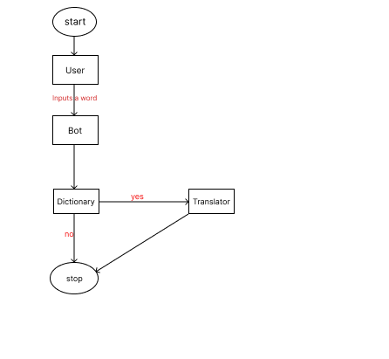

Fig 3.1 System Flow Diagram

9

**3.2 ARCHITECTURE DIAGRAM**

An architecture diagram is a graphical representation of a set of concepts, that are part of an architecture, including their principles, elements and components. The architecture diagram for this project is in Fig. 3.2.

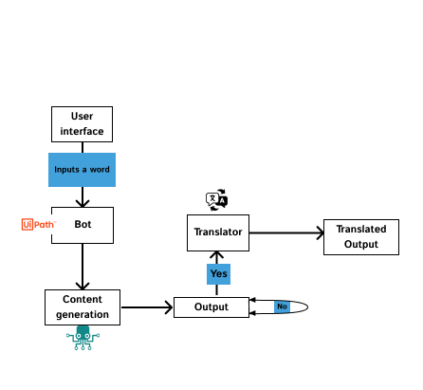

Fig 3.2 Architecture Diagram

**3.3 SEQUENCE DIAGRAM**

A sequence diagram is a type of interaction diagram because it describe and s how in what order a group of objects works together. The sequence diagram for this project is in Fig. 3.3.

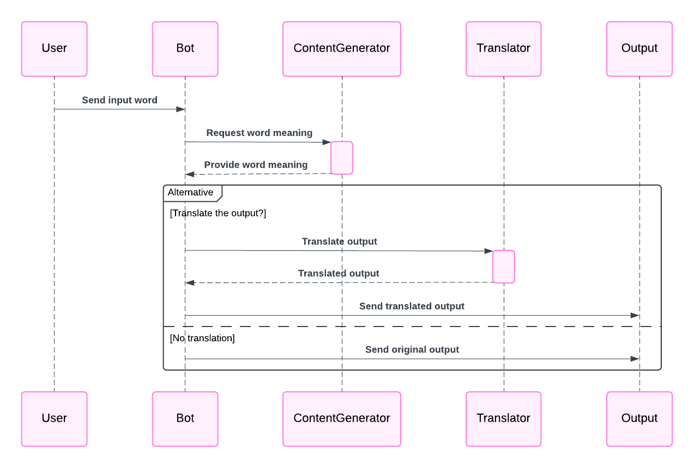

Fig 3.3 Sequence Diagram

**CHAPTER 4**

**PROJECT DESCRIPTION**

"The Smart Assignment Integrity Verification Bot" is a sophisticated Robotic Process Automation (RPA) project designed to address the challenges of AI-generated content and plagiarism in student assignments. Developed using UiPath, this intelligent bot streamlines the assignment assessment process, providing educators with an efficient tool to maintain academic integrity.

**4.1. MODULES:**

**4.1.1. INPUT HANDLING AND INITIALIZATION:**

**Text Parsing and Validation**: When a user inputs a word or phrase, the system first parses the input to ensure it meets predefined criteria (e.g., word count limits, language detection). Invalid inputs, such as special characters or unsupported languages, prompt an error message, allowing users to correct their entries.

**Language Detection**: For translation requests, the system detects the input language if it is not specified. This feature utilizes language identification tools or APIs (like Google Translate API’s language detection) to identify the source language based on user input, improving accuracy and user convenience.

**Contextual Mode Selection**: Users can specify whether they are requesting a dictionary definition or translation, which the system uses to route inputs accordingly. If no mode is specified, the system defaults to translation mode.

**4.1.2 CONTENT ANALYSIS:**

**Lexical Analysis**

* **Tokenization and Morphological Analysis**: The system tokenizes input phrases, breaking down text into individual words or meaningful components. Morphological analysis identifies the base forms of words, useful for handling inflections and providing definitions for root words. For example, if a user inputs a conjugated verb form, the system recognizes the root verb, enhancing translation and dictionary accuracy.

**Contextual Translation Analysis**

* **Semantic Analysis and Context Matching**: When translating phrases or sentences, the system performs semantic analysis to determine the meaning based on context. For instance, idiomatic expressions or phrases with multiple meanings are translated according to the most likely interpretation in the source language.
* **Language-Specific Nuances**: The system considers language-specific grammar rules, word order, and cultural idioms to deliver accurate translations. By analyzing content in context, the system adapts translations to better convey meaning in the target language rather than offering literal translations.

**Dictionary Content Generation**

* **Definition and Synonym Retrieval**: For dictionary queries, the system retrieves definitions, synonyms, and related terms from dictionary databases or APIs. It ensures that the content aligns with the language of the input, displaying contextual usage where applicable to aid users in understanding nuances.
* **Example Sentence Generation**: To provide practical language use cases, the system retrieves or generates example sentences. These examples illustrate the word or phrase in context, giving users insights into how it is used in everyday language.

**4.1.3 RESULT MANAGEMENT:**

**Result Validation and Filtering**

* **Accuracy Verification**: After the system retrieves dictionary definitions or translations from external APIs, it performs a validation check to ensure result accuracy. This includes verifying that definitions match the input word's intended meaning and that translations align with contextual nuances.

**Result Formatting and Structuring**

* **Organized Presentation**: Results are formatted to ensure clarity. Dictionary outputs are structured with part-of-speech labels, pronunciation guides, definitions, and example sentences. Translation outputs are labeled with source and target languages, creating a clear layout for users.
* **Multi-Language Output Handling**: For multi-language support, the system presents outputs in both the source and target languages, ensuring that users can understand the translated content and its relation to the original query. In cases where multiple translations exist, the system may display them in a list, organized by likelihood or context relevance.

**Result Storage and History Management**

* **Session-Based Storage**: During a user session, the system can temporarily store recent queries and results, allowing users to review past translations or definitions without re-entering them. This history feature supports efficient navigation and enhances the user experience.

**4.1.4 COMPLETION AND REPORTING:**

**Task Completion Confirmation**

* **Completion Acknowledgement**: After successfully processing a dictionary or translation request, the system provides a confirmation message indicating task completion. This may include a summary of the requested action (e.g., "Translation completed" or "Definition generated") to confirm that the query was processed as intended.
* **Result Summary Display**: Once a task is completed, the system displays the final results, including dictionary definitions, translations, synonyms, and usage examples as applicable. A structured summary provides clarity and allows users to review the output before saving or exporting the information

**CHAPTER 5**

**OUTPUT SCREENSHOTS**

**Fig: 3.4**

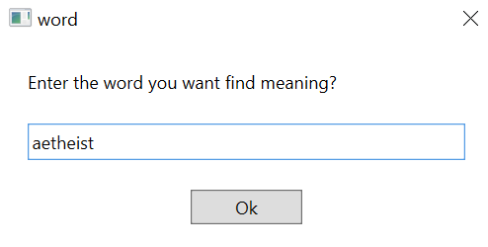

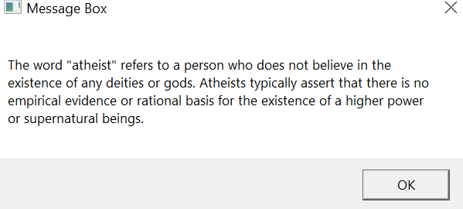

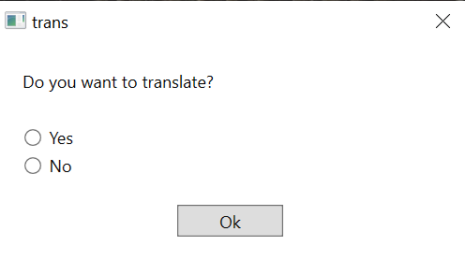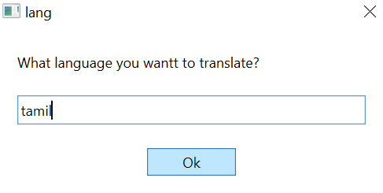

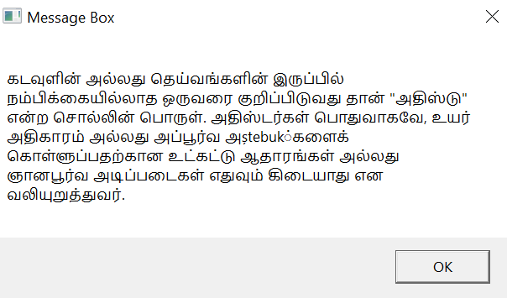

Fig: 3.4

**CHAPTER 6**

**CONCLUSION**

The multi-language dictionary and translator project presents a comprehensive solution for enhancing language accessibility and bridging communication gaps across different linguistic communities. By incorporating advanced features such as content generation, contextual translation, and intelligent result management, the system provides users with accurate and relevant translations, dictionary definitions, and usage examples.

Throughout the development, careful attention was given to ensuring that the system supports a wide range of languages and adapts to various user needs. Key aspects like input validation, semantic analysis, and result accuracy play a significant role in delivering a high-quality user experience, whether the user is seeking a simple translation or detailed linguistic information.

Moreover, the system's reporting and feedback mechanisms provide valuable insights into user interactions and system performance, ensuring continuous improvement. By integrating session tracking, result storage, and export capabilities, users can easily access and organize their language resources for future use.

In conclusion, this project not only serves as a practical tool for language translation and learning but also sets the foundation for more advanced features, such as personalized learning recommendations and AI-powered language optimization. As language barriers continue to diminish, this system stands as an essential resource for anyone seeking to communicate effectively across linguistic divides. Through its multi-faceted approach, it enhances global connectivity and promotes cross-cultural understanding, ultimately contributing to the growing need for multilingual support in our increasingly interconnected world.

**APPENDIX**

**PROCESS WORKFLOW**

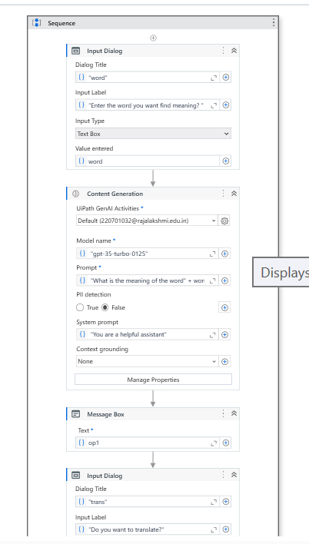

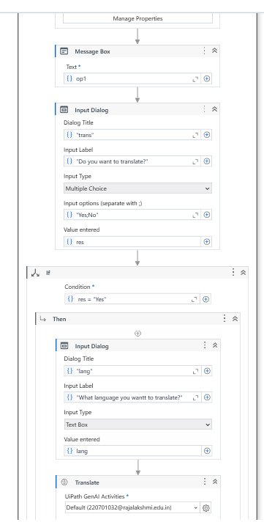

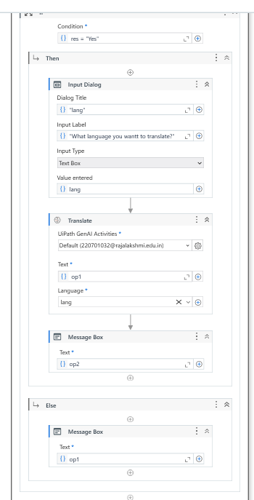

**Fig: 3.5**

**REFERENCES**

1. **Sutskever, I., Vinyals, O., & Le, Q. V. (2014).** *Sequence to Sequence Learning with Neural Networks*. *NeurIPS 2014*.
   * A pioneering paper on sequence-to-sequence models, which are foundational for modern translation systems.
2. **Chen, Z., & Ye, D. (2021).** *Multilingual Neural Machine Translation with Zero-Shot Translation Capabilities*. *International Conference on Computational Linguistics*.
   * Discusses multilingual NMT models and their ability to translate between language pairs without direct training data.

International Journal of Innovative Technology and Exploring Engineering. 8. 3757-3760. 10.35940/ijitee.K2148.0981119.

**Vaswani, A., Shazeer, N., Parmar, N., Uszkoreit, J., Jones, L., Gomez, A. A., Kaiser, Ł., & Polosukhin, I. (2017).** *Attention is All You Need*. NeurIPS 2017.

* + Introduces the Transformer architecture, which revolutionized machine translation and NLP.

**Liu, J., & Xu, W. (2019).** *A Survey of Neural Machine Translation*. *IEEE Transactions on Neural Networks and Learning Systems*, 30(2), 314–327.

* + This article surveys recent advancements in neural machine translation (NMT) systems.