**EX.NO:**

**4**

**DATE:**

**23**

**/**

**10**

**/2024**

**Reg.no:220701518**

**MINIMAX ALGORITHM**

•

A simple example can be used to explain how the minimax algorithm

works. We've included an example of a game

-

tree below, which represents a

two

-

player game.

•

There are two

players in this scenario, one named Maximizer and the

other named Minimizer.

•

Maximizer will strive for the highest possible score, while Minimizer will

strive for the lowest possible score.

•

Because this algorithm uses DFS, we must go all the way through the

leaves to reach the terminal nodes in this game

-

tree.

•

The terminal values are given at the terminal node, so we'll compare them

and retrace the tree till we reach the original state.

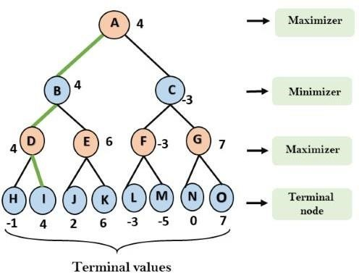

**OUTPUT:** 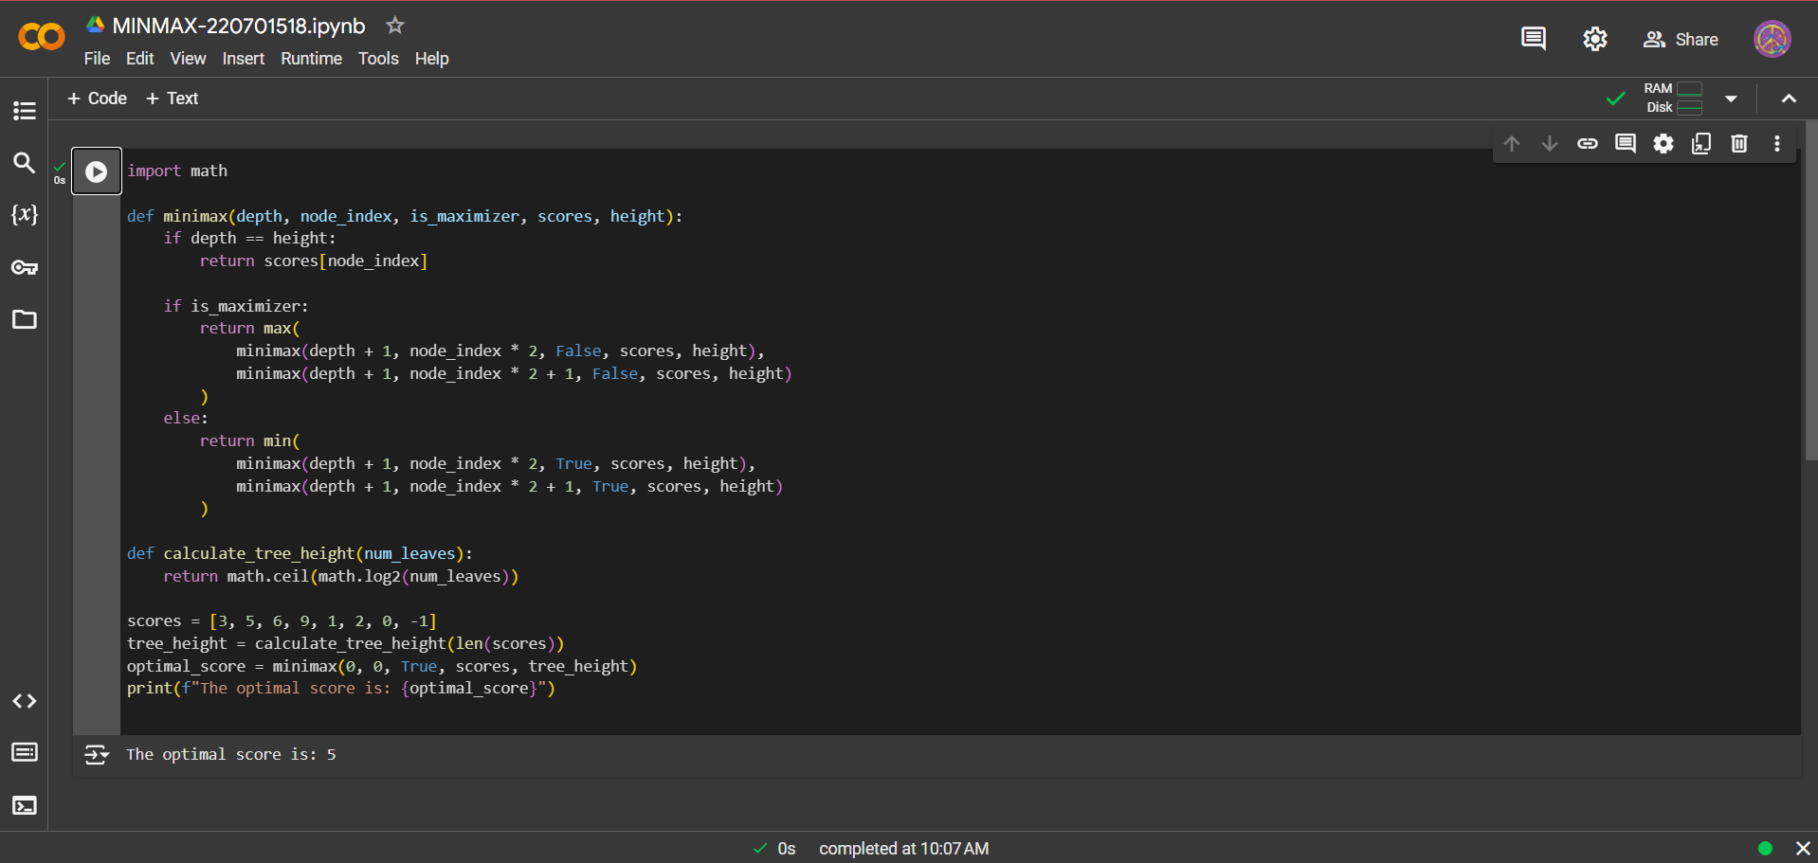

**AIM:**

To

implement

minimax algorithm using python

**CODE:**

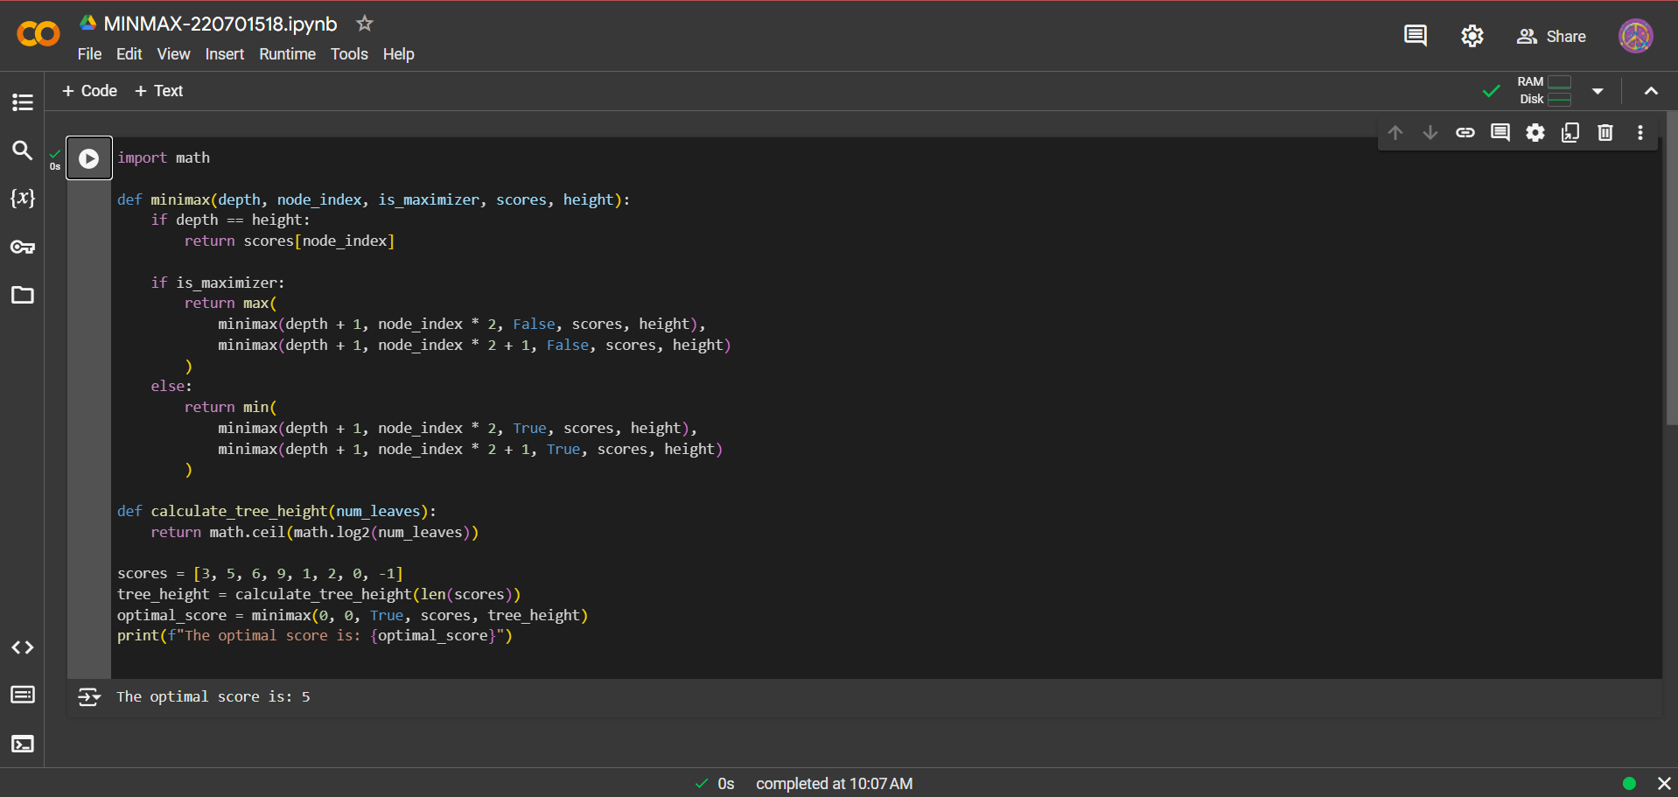

**RESULT**

**:**

Thus, the

minimax algorithm

has been implemented successfully.

