Department of Computer Science and Engineering
(AI & ML)
B. Tech. CSE - 5th Semester
Aug – Dec 2026

UE23CS351A
DATABASE MANAGEMENT SYSTEMS (DBMS)

PROJECT REPORT on

GymFlow: Gym Membership and Workout Progress Tracker

Submitted by:
PES1UG24AM021 | Akarsh Kumar Gupta | 5<sec>
PES1UG24AM055 | Aryan Arora | 5<sec>
PES1UG24AM057 | Ashwin Anand | 5<sec>

Class of Prof. [NAME]
[Lab Faculty]

Abstract

Small gyms usually run on paper registers, spreadsheets and messages, so expired members keep training, renewals get mixed up, trainers get overloaded and nobody can see whether a member is making progress. GymFlow is a web application that brings memberships, attendance, trainer allocation and workout tracking into one system, for three roles: admin, trainer and member.
The project uses two databases, each chosen for the shape of its data. PostgreSQL stores users, plans, memberships, payments, check-ins and trainer assignments, where money and rules need ACID transactions, foreign keys and constraints. Business rules are enforced inside the database through triggers, a stored procedure, functions, views and indexes. For example, a check-in without a valid membership is refused by a trigger, whichever screen sent it. MongoDB stores workout sessions and trainer-written plans, where each exercise has a different shape and a session is always read as a whole. $jsonSchema validators keep this data clean, and aggregation pipelines produce the progress charts and personal records.
The interface is built with Next.js, with Route Handlers as the API layer, bcrypt password hashing, JWT sessions in httpOnly cookies and role-based access control. The system was tested with 38 automated tests and 16 manual test cases, all of which pass.
Repository: https://github.com/ASHWINANAND19/gymflow
Table of Contents
Sl. No | Topic | Page No.
 | Introduction  - Problem Statement  - Objectives and Scope | 4
 | User Requirements Specification- Tech Stack | 6
 | E-R Model  - List of Entities [labeling Weak ones]  - List non-simple Attributes  - ER Diagram Snapshot  - ERD from tool like draw.io | 8
 | Relational Model  - List of Relations that are not Entities in ER Model  - Schema Diagram  - Data Dictionary and Normalisation | 12
 | SQL DDL Statements | 17
 | SQL DML Statements | 26
 | NoSQL/ Vector Database Commands | 30
8. | Results  - Resulting Tables’ Screenshots  - Testing Results | 37
9. | Next.js-Project Tree Structure | 47
10. | Few sample Screenshots of application code and demo | 50
11. | Evaluation Rubrics- Completion Status | 59
12. | Team Contribution | 60
13. | Conclusion and Future Enhancements | 61

1. Introduction

a) Problem Statement
Small and mid-sized gyms usually run on paper registers, spreadsheets and WhatsApp messages. This causes real problems:
- Lapsed members keep training. Nobody checks at the door whether a membership is still valid.
- Renewals get mixed up. A member who renews early either loses days or gets an overlapping plan.
- Trainers get overloaded. Clients are handed out without tracking how many each trainer already has.
- No one can see progress. Workout notes are scattered or lost, so members and trainers cannot tell whether training is working.
- Owners lack numbers. Monthly revenue, expiring memberships and low-attendance members are hard to find.
GymFlow puts all of this into one system. Rules such as "no check-in without a valid membership" or "a trainer cannot exceed their capacity" are enforced by the database itself, so no screen or API bug can bypass them.

b) Objectives and Scope
Objectives
- Design a normalised relational schema for members, plans, memberships, payments, attendance and trainer assignments, with proper keys and constraints.
- Enforce business rules at the database level using constraints, triggers, a stored procedure and transactions.
- Store flexible, nested workout data in MongoDB with schema validation, and analyse it with aggregation pipelines.
- Provide role-based access for three roles (admin, trainer and member), with secure authentication.
- Build a Next.js web interface that shows the database features in action through dashboards, filters, charts and forms.
- Justify the use of each database through the shape of its data.
In scope
- Member self-registration, login and role-based access
- Plans, purchase and renewal with queued start dates, and payment records
- Gym check-in and check-out with membership validation
- Trainer capacity, assignment rules and weekly workout plans
- Workout logging (strength, cardio, flexibility), progress charts and personal records
- Admin dashboard, member search, payment reports and an audit log
Out of scope
- Real online payment processing (payments are recorded, not charged)
- Email or SMS notifications, mobile apps, and biometric or QR check-in hardware
- Multi-branch gyms and class or slot booking

2. User Requirements Specification

a) Functional Requirements
ID | Requirement | Role
FR1 | Users log in with email and password. Passwords are stored hashed. | All
FR2 | A visitor can sign up as a member. Members must be 14 or older. | Public
FR3 | A member can buy a plan. If a plan is still running, the new one starts the day after it ends. | Member, Admin
FR4 | A purchase creates a membership and its payment together, or neither. | System
FR5 | A member can check in only on a day covered by an active membership, and only once until checking out. | Member
FR6 | A member can log a workout with any mix of strength, cardio and flexibility exercises. | Member
FR7 | A member can see weekly training volume, sessions per week and personal records. | Member, Trainer
FR8 | A trainer can see only their own clients and write a weekly workout plan for each. | Trainer
FR9 | An admin can assign a trainer only if the trainer has capacity and the member's plan includes a trainer. | Admin
FR10 | An admin can manage plans. Plans that have been bought cannot be deleted, only deactivated. | Admin
FR11 | An admin can search and filter members by name, membership status and plan. | Admin
FR12 | An admin can filter payments by date and method and see totals per method. | Admin
FR13 | Memberships whose end date has passed are marked expired automatically. | System
FR14 | Every membership creation and status change is recorded in an audit log. | System
FR15 | An admin can deactivate a member account, which blocks login immediately. | Admin

b) Tech Stack and Justification
Layer | Technology | Why it fits this problem
Interface and API | Next.js 16 (App Router, Route Handlers), React 19, Tailwind CSS, Recharts | One project holds the pages for all three roles and the API routes they call. Recharts draws the progress and revenue charts.
Relational database | PostgreSQL 17 with the pg driver and raw parameterised SQL | Memberships and payments involve money, so they need ACID transactions. Triggers and procedures keep the gym's rules next to the data.
Document database | MongoDB 7 with the official driver | Workout logs are nested and differ by exercise type (see below).
Authentication | bcrypt password hashing, signed JWT in an httpOnly cookie | Passwords are never stored in plain text and the browser's scripts cannot read the session.
Testing and version control | Node.js test runner, Git and GitHub | Tests run against separate databases, so the demo data is never touched.

Raw SQL was used instead of an ORM so that every query, join and transaction is visible in the code and can be explained directly.

c) Why MongoDB for This Problem
Reason | Explanation
Different shapes | One session holds a list of exercises, and each has a different shape: strength has a nested list of sets (reps, kg), cardio has minutes and distance, and flexibility has minutes. In SQL this would need three or more extra tables or many nullable columns.
Access pattern | A session is always written and read as a whole. One document read replaces a three-table join.
Growth | Logs are append-heavy and form the largest dataset, so they are kept out of the transactional database.
Analysis | Aggregation pipelines ($unwind, $group, $dateTrunc) compute weekly volume and personal records directly from the nested data.
Trainer plans | A plan is a nested week, day and exercise structure that is replaced as a whole when the trainer edits it.

Flexibility does not mean no rules. Both collections have a $jsonSchema validator, so MongoDB itself rejects a strength exercise with no sets, a negative weight or an unknown category.
How the two databases connect
MongoDB documents store PostgreSQL ids (memberId, trainerId, exerciseId). No foreign key can span two databases, so the API keeps them consistent:
- Every workout write runs after requireRole('member'), which checks in PostgreSQL that the account exists and is active.
- Exercise names and categories are looked up in PostgreSQL and copied into the document. The server never trusts names sent by the browser.
- A trainer can write a plan only after isTrainerOfMember() confirms an active assignment in PostgreSQL.
- Because names are copied into the documents, deleting an exercise from the catalog never breaks old workout history.

d) System Architecture
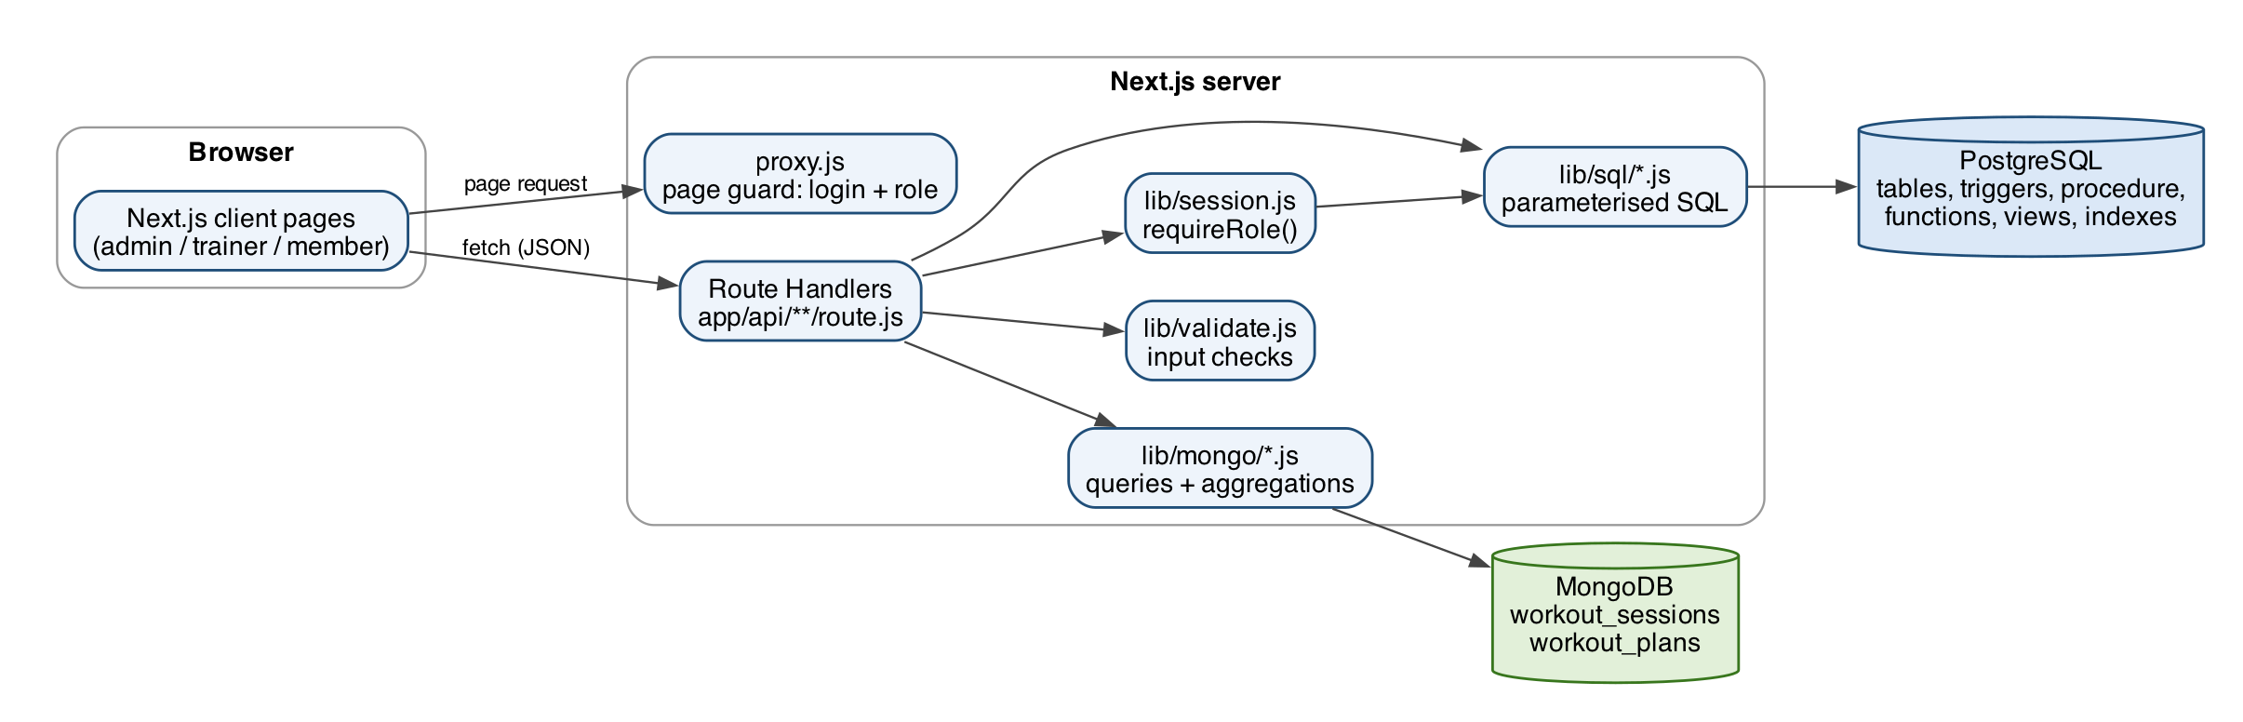
Figure 1: System architecture

3. E-R Model

a) List of Entities (Weak Entities Highlighted)
Entity | Type | Key | Description
USER | Strong (supertype) | user_id | Any account: admin, trainer or member
MEMBER | Subtype of USER | member_id | Personal details of a gym member
TRAINER | Subtype of USER | trainer_id | Specialization and client capacity
PLAN | Strong | plan_id | A plan the gym sells, such as Monthly Basic
MEMBERSHIP | Strong | membership_id | One purchase of a plan by a member, with its dates and status
EXERCISE | Strong | exercise_id | Exercise catalog, referenced by MongoDB documents
CHECK_IN | Weak (owner: MEMBER) | Partial key: check_in_time | One gym visit. It has no meaning without the member, and is identified by the member plus the time.
PAYMENT | Weak (owner: MEMBERSHIP) | Identified by its membership (1:1) | The payment for one membership. It cannot exist without that membership.

In the physical schema, CHECK_IN and PAYMENT also get a surrogate primary key (check_in_id, payment_id) to make them easier to reference from code. Their dependence on the owner stays enforced by a NOT NULL foreign key with ON DELETE CASCADE.
Relationships
Relationship | Between | Cardinality | Notes
ISA | USER, MEMBER / TRAINER | 1 : 0..1 | A user is at most one member or one trainer. The subtypes share the user's key.
HOLDS | MEMBER, MEMBERSHIP | 1 : N | Full history of plans
OF_PLAN | PLAN, MEMBERSHIP | 1 : N | ON DELETE RESTRICT, so a sold plan cannot be deleted
PAID_BY (identifying) | MEMBERSHIP, PAYMENT | 1 : 1 | payments.membership_id is UNIQUE
MAKES (identifying) | MEMBER, CHECK_IN | 1 : N | Every visit belongs to one member
ASSIGNED_TO | MEMBER, TRAINER | M : N | Has attributes assigned_on and ended_on. At most one active assignment per member.

b) List of Non-Simple Attributes
Attribute | Entity | Kind | How it is handled
validity_period {start_date, end_date} | MEMBERSHIP | Composite | Flattened into two columns, start_date and end_date
age | MEMBER | Derived | Computed from date_of_birth. The rule age ≥ 14 is enforced by the CHECK constraint chk_member_min_age.
days_remaining | MEMBERSHIP | Derived | Computed by the function days_remaining(member_id)
active_clients | TRAINER | Derived | Counted in the view v_trainer_workload
visit_duration | CHECK_IN | Derived | Not stored. It is check_out_time - check_in_time.

Multivalued attributes: there are none left in the relational model. The only multivalued data in the project is the list of exercises in a workout and the list of sets in an exercise. These are stored as arrays inside MongoDB documents, which is one of the reasons for using a document database.

c) ER Diagram Snapshot
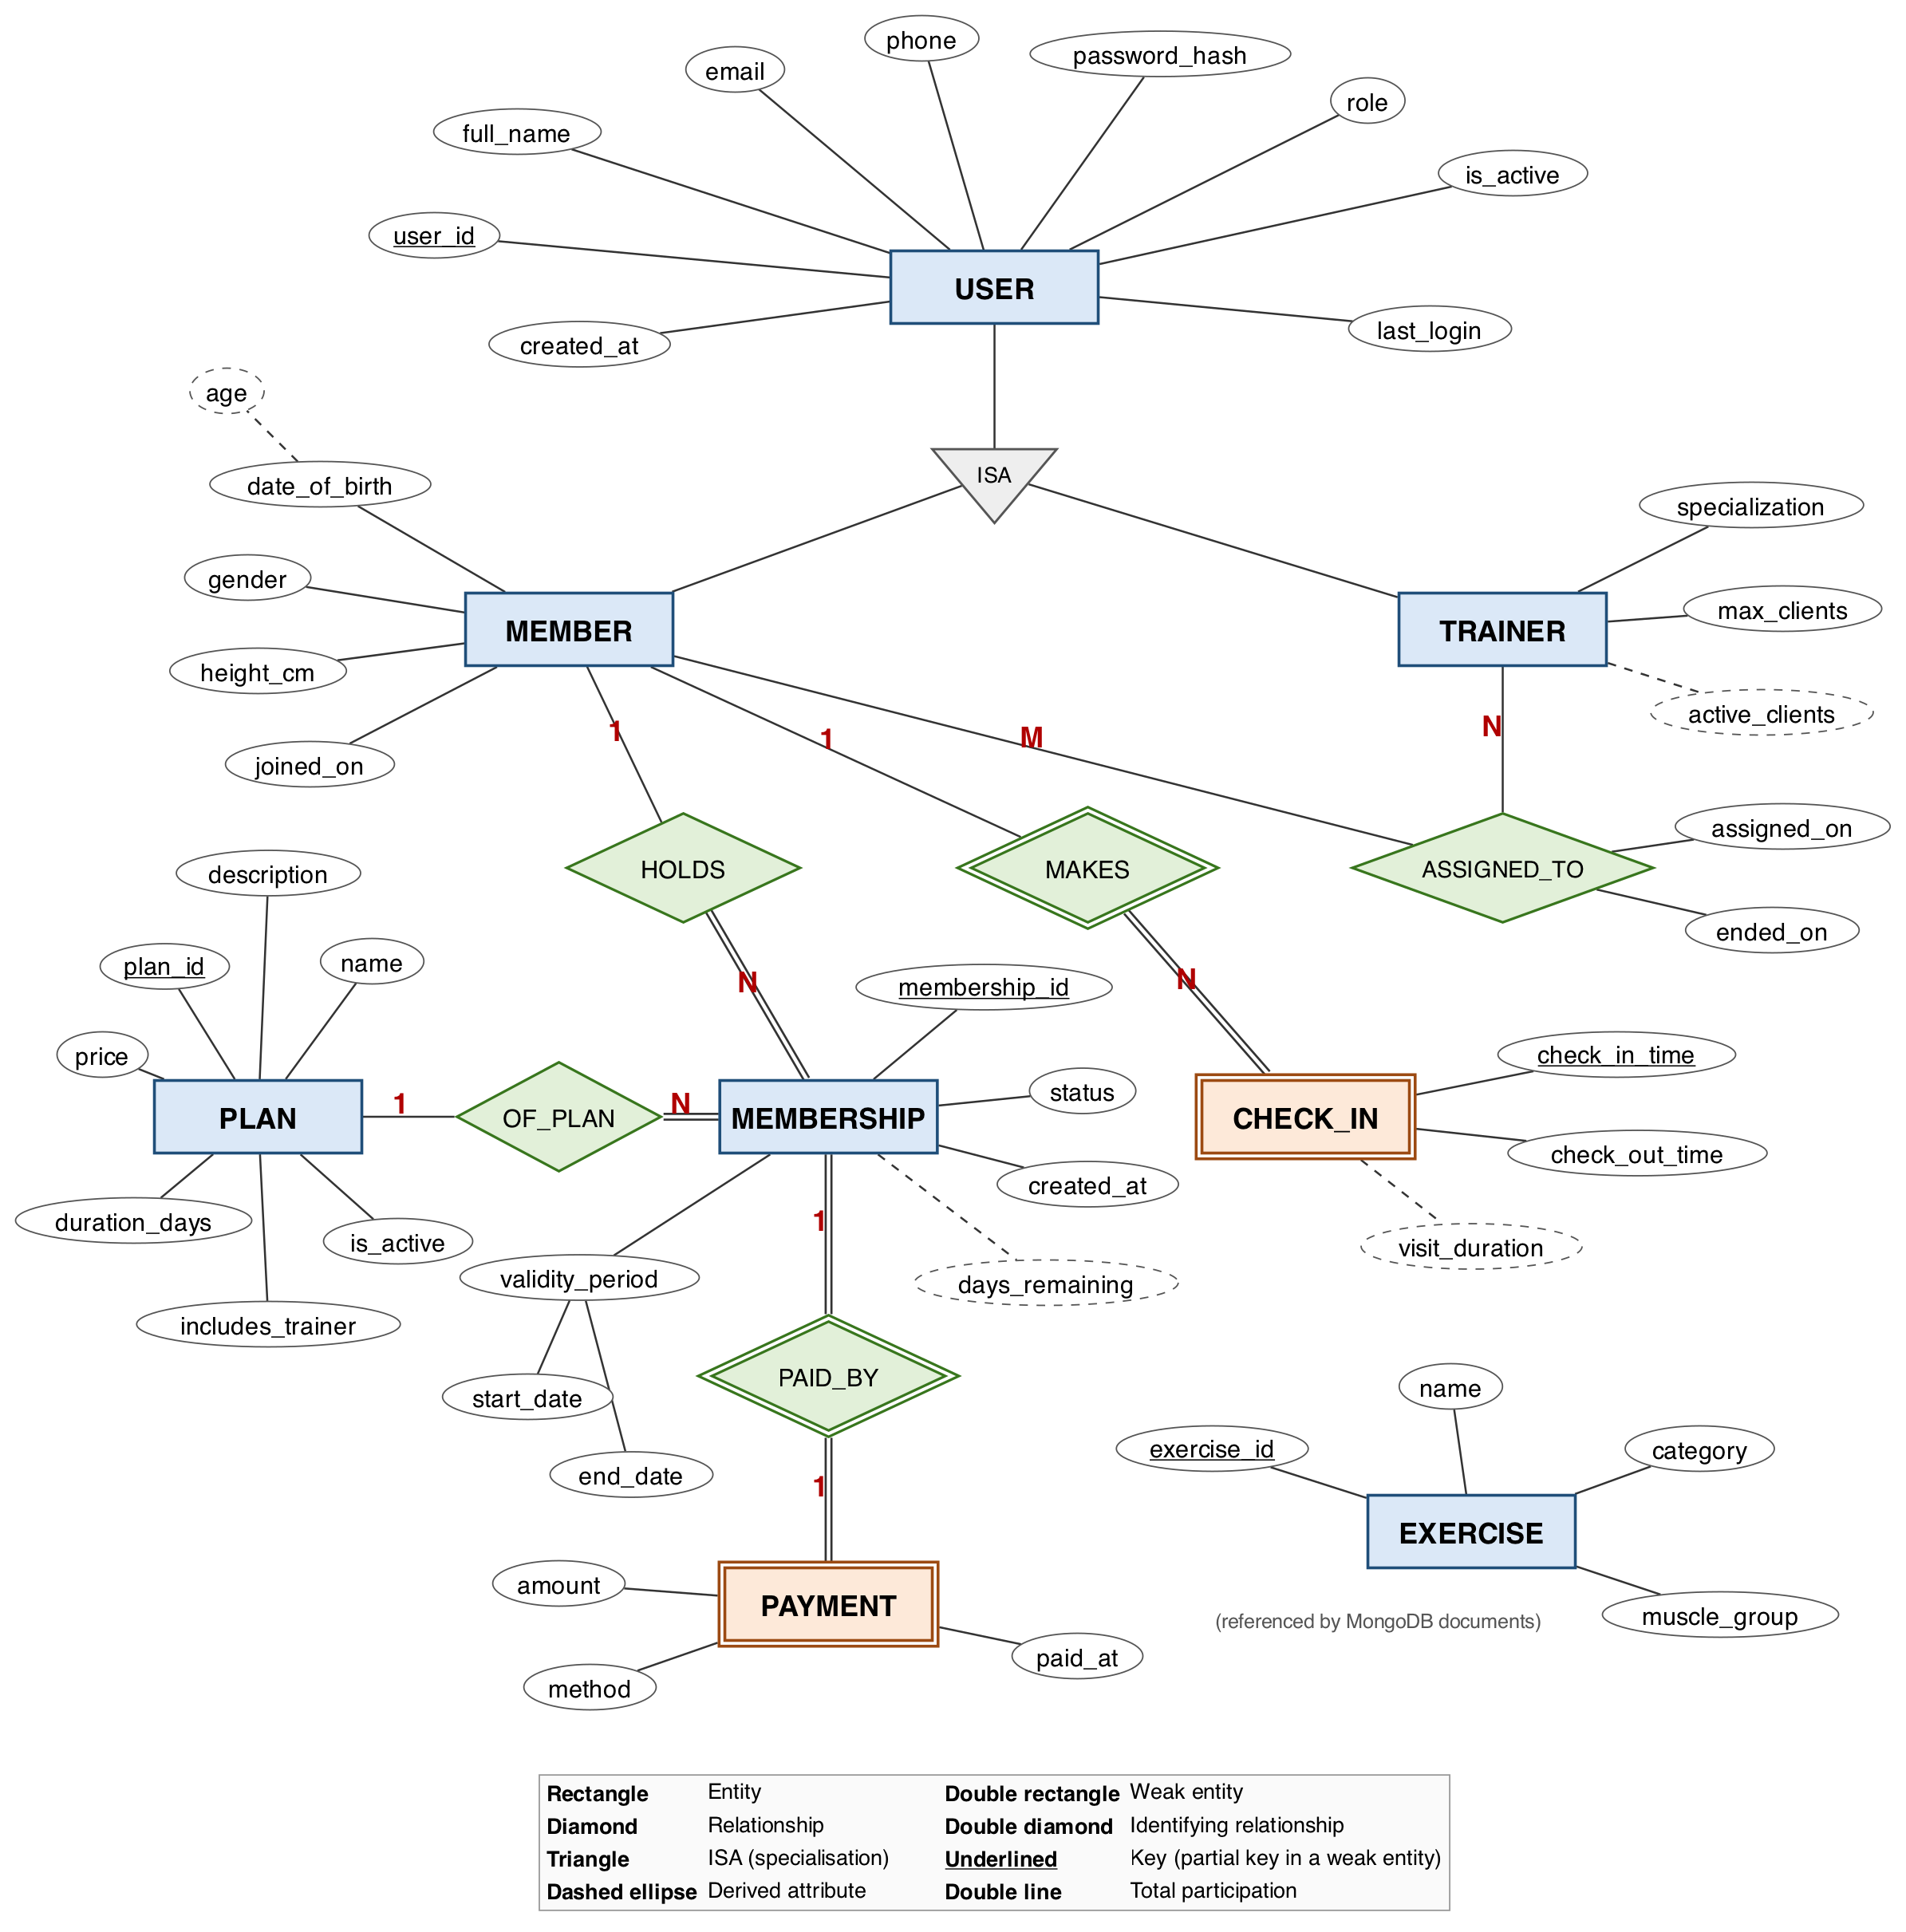
Figure 2: ER diagram in Chen notation, generated with Graphviz

d) ERD from a Diagramming Tool
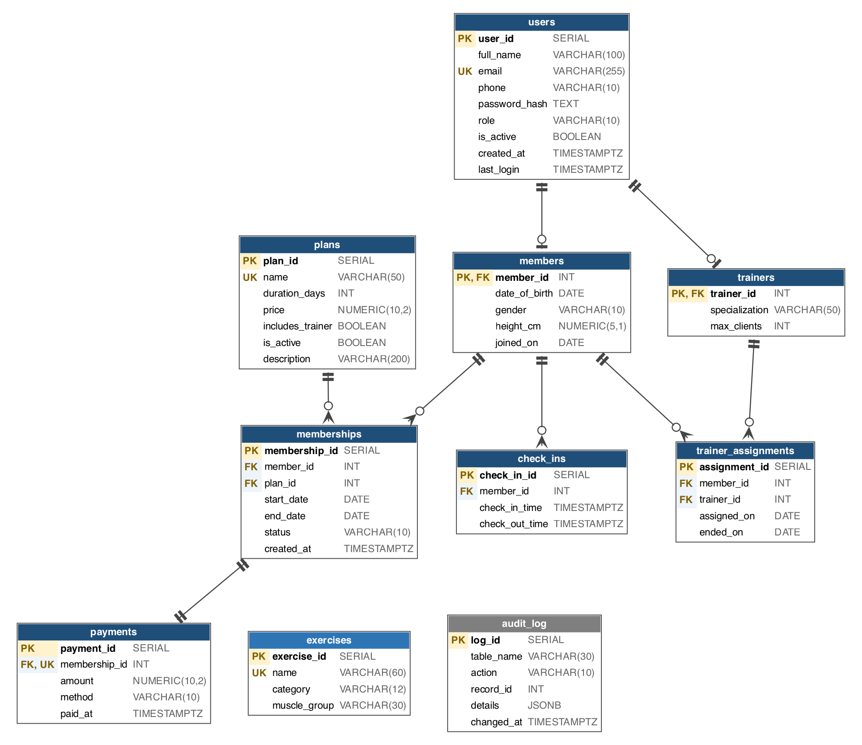
Figure 3: Entity-relationship diagram in crow's-foot notation with all attributes, keys and types, generated with Graphviz

4. Relational Model

a) List of Relations (Those That Are Not ER Entities Labelled)
Primary keys are underlined. Foreign keys are marked with an arrow to the table they reference.
Relation | Attributes | Source in the ER model
users | user_id, full_name, email, phone, password_hash, role, is_active, created_at, last_login | Entity USER
members | member_id → users, date_of_birth, gender, height_cm, joined_on | Entity MEMBER (ISA)
trainers | trainer_id → users, specialization, max_clients | Entity TRAINER (ISA)
plans | plan_id, name, duration_days, price, includes_trainer, is_active, description | Entity PLAN
memberships | membership_id, member_id → members, plan_id → plans, start_date, end_date, status, created_at | Entity MEMBERSHIP
payments | payment_id, membership_id → memberships (unique), amount, method, paid_at | Weak entity PAYMENT
check_ins | check_in_id, member_id → members, check_in_time, check_out_time | Weak entity CHECK_IN
exercises | exercise_id, name, category, muscle_group | Entity EXERCISE
trainer_assignments | assignment_id, member_id → members, trainer_id → trainers, assigned_on, ended_on | Not an entity. Comes from the M:N relationship ASSIGNED_TO.
audit_log | log_id, table_name, action, record_id, details, changed_at | Not an entity. A system table written only by a trigger.

b) Schema Diagram
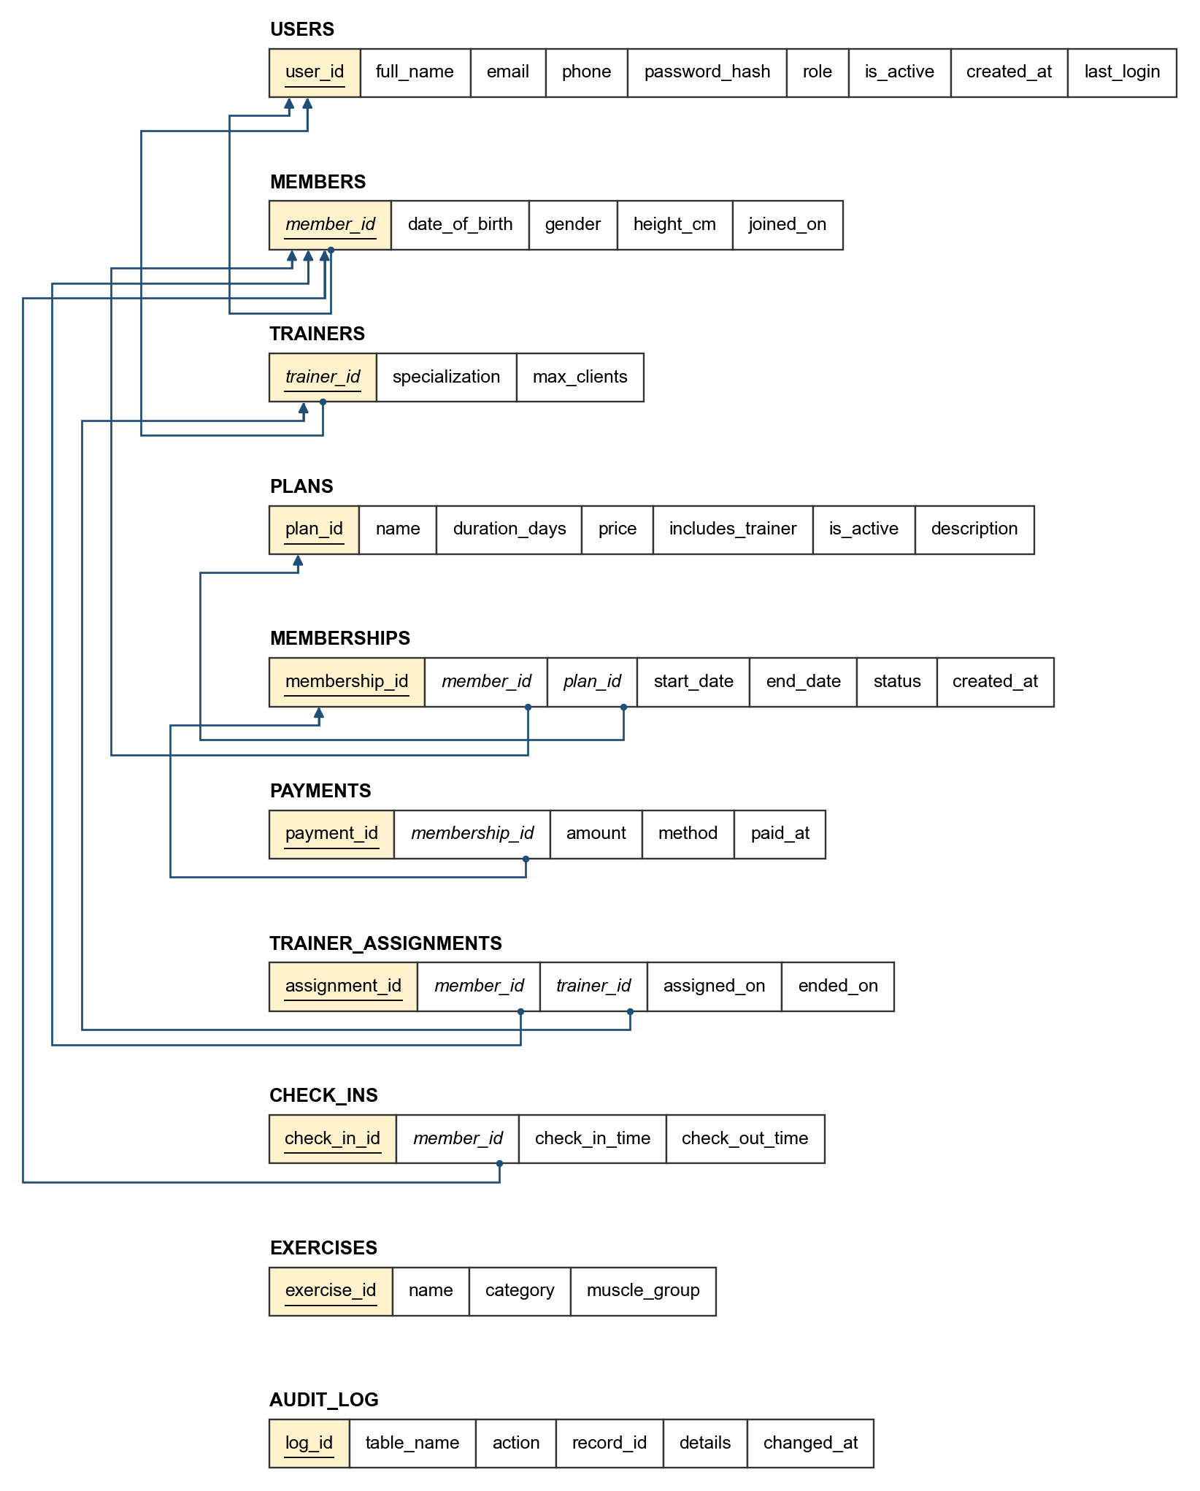
Figure 4: Relational schema. Primary keys are underlined, foreign keys are in italics, and each arrow runs from a foreign key to the primary key it references.

c) Data Dictionary and Normalisation
users
Column | Type | Constraints | Description
user_id | SERIAL | PK | Account id
full_name | VARCHAR(100) | NOT NULL, CHECK length ≥ 2 | Display name
email | VARCHAR(255) | NOT NULL, UNIQUE, CHECK email pattern | Login id (stored lowercase)
phone | VARCHAR(10) | CHECK exactly 10 digits | Optional
password_hash | TEXT | NOT NULL | bcrypt hash (cost 10), never plain text
role | VARCHAR(10) | NOT NULL, CHECK IN (admin, trainer, member) | Access level
is_active | BOOLEAN | NOT NULL, DEFAULT TRUE | FALSE blocks login
created_at | TIMESTAMPTZ | NOT NULL, DEFAULT now()
last_login | TIMESTAMPTZ | Added by ALTER | Updated on each login

members
Column | Type | Constraints | Description
member_id | INT | PK, FK → users ON DELETE CASCADE | Same id as the user
date_of_birth | DATE | NOT NULL, CHECK age ≥ 14 (added by ALTER)
gender | VARCHAR(10) | CHECK IN (male, female, other) | Optional
height_cm | NUMERIC(5,1) | CHECK 100 to 250 | Optional
joined_on | DATE | NOT NULL, DEFAULT current_date

trainers
Column | Type | Constraints | Description
trainer_id | INT | PK, FK → users ON DELETE CASCADE | Same id as the user
specialization | VARCHAR(50) | NOT NULL | e.g. Weight Loss
max_clients | INT | NOT NULL, DEFAULT 10, CHECK 1 to 30 | Capacity checked by trigger

plans
Column | Type | Constraints | Description
plan_id | SERIAL | PK
name | VARCHAR(50) | NOT NULL, UNIQUE
duration_days | INT | NOT NULL, CHECK > 0
price | NUMERIC(10,2) | NOT NULL, CHECK > 0 | Rupees
includes_trainer | BOOLEAN | NOT NULL, DEFAULT FALSE | Required for trainer assignment
is_active | BOOLEAN | NOT NULL, DEFAULT TRUE | FALSE hides it from members
description | VARCHAR(200) | Added by ALTER

memberships
Column | Type | Constraints | Description
membership_id | SERIAL | PK
member_id | INT | NOT NULL, FK → members ON DELETE CASCADE
plan_id | INT | NOT NULL, FK → plans ON DELETE RESTRICT
start_date | DATE | NOT NULL | First valid day
end_date | DATE | NOT NULL, CHECK end_date > start_date | Last valid day (inclusive)
status | VARCHAR(10) | NOT NULL, DEFAULT 'active', CHECK IN (active, expired, cancelled)
created_at | TIMESTAMPTZ | NOT NULL, DEFAULT now()

payments
Column | Type | Constraints | Description
payment_id | SERIAL | PK
membership_id | INT | NOT NULL, UNIQUE, FK → memberships ON DELETE CASCADE | 1:1 with membership
amount | NUMERIC(10,2) | NOT NULL, CHECK > 0 | Price at time of purchase
method | VARCHAR(10) | NOT NULL, CHECK IN (cash, card, upi)
paid_at | TIMESTAMPTZ | NOT NULL, DEFAULT now()

trainer_assignments
Column | Type | Constraints | Description
assignment_id | SERIAL | PK
member_id | INT | NOT NULL, FK → members ON DELETE CASCADE | Partial UNIQUE where ended_on IS NULL
trainer_id | INT | NOT NULL, FK → trainers ON DELETE CASCADE
assigned_on | DATE | NOT NULL, DEFAULT current_date
ended_on | DATE | CHECK ended_on ≥ assigned_on | NULL means still running

check_ins
Column | Type | Constraints | Description
check_in_id | SERIAL | PK
member_id | INT | NOT NULL, FK → members ON DELETE CASCADE | Validated by trigger
check_in_time | TIMESTAMPTZ | NOT NULL, DEFAULT now()
check_out_time | TIMESTAMPTZ | CHECK > check_in_time | NULL means still in the gym

exercises
Column | Type | Constraints | Description
exercise_id | SERIAL | PK | Referenced from MongoDB documents
name | VARCHAR(60) | NOT NULL, UNIQUE
category | VARCHAR(12) | NOT NULL, CHECK IN (strength, cardio, flexibility) | Decides which fields a workout entry needs
muscle_group | VARCHAR(30)

audit_log
Column | Type | Constraints | Description
log_id | SERIAL | PK
table_name | VARCHAR(30) | NOT NULL | Always 'memberships'
action | VARCHAR(10) | NOT NULL | INSERT or UPDATE
record_id | INT | NOT NULL | membership_id
details | JSONB |  | Dates and plan for inserts, old and new status for updates
changed_at | TIMESTAMPTZ | NOT NULL, DEFAULT now()

Normalisation
Every table is in Third Normal Form (3NF):
- Every non-key attribute depends only on its table's key.
- Plan details are not copied into memberships, and member details are not copied into payments. The exception is payments.amount, which stores the price at the time of purchase. That is a historical fact and not a duplicate, because a plan's price can change later.
- Role-specific attributes live in the subtype tables, so users has no columns that are always NULL for one role.

5. SQL DDL Statements
All SQL is in db/sql/ and runs in order with npm run db:setup.
File | Contents | DDL shown
00_drop.sql | Removes every view, table, function and procedure | DROP
01_schema.sql | 10 tables with PK, FK, UNIQUE, NOT NULL and CHECK | CREATE TABLE
02_alter.sql | Age constraint, last_login, description | ALTER TABLE
03_functions.sql | days_remaining, expire_memberships, purchase_membership | CREATE FUNCTION, CREATE PROCEDURE
04_triggers.sql | 3 trigger functions and their triggers | CREATE TRIGGER
05_views.sql | 4 views | CREATE VIEW
06_indexes.sql | 4 indexes and 1 partial unique index | CREATE INDEX

db/sql/00_drop.sql
-- =============================================================
-- 00_drop.sql
-- Removes every GymFlow object so the schema can be rebuilt.
-- Views go first because they depend on the tables.
-- =============================================================

DROP VIEW IF EXISTS v_member_attendance_30d;
DROP VIEW IF EXISTS v_trainer_workload;
DROP VIEW IF EXISTS v_monthly_revenue;
DROP VIEW IF EXISTS v_active_members;

-- CASCADE also removes the triggers attached to these tables
DROP TABLE IF EXISTS audit_log CASCADE;
DROP TABLE IF EXISTS check_ins CASCADE;
DROP TABLE IF EXISTS trainer_assignments CASCADE;
DROP TABLE IF EXISTS payments CASCADE;
DROP TABLE IF EXISTS memberships CASCADE;
DROP TABLE IF EXISTS exercises CASCADE;
DROP TABLE IF EXISTS plans CASCADE;
DROP TABLE IF EXISTS trainers CASCADE;
DROP TABLE IF EXISTS members CASCADE;
DROP TABLE IF EXISTS users CASCADE;

DROP PROCEDURE IF EXISTS purchase_membership(INT, INT, VARCHAR, INT);
DROP FUNCTION IF EXISTS days_remaining(INT);
DROP FUNCTION IF EXISTS expire_memberships();
DROP FUNCTION IF EXISTS fn_checkin_requires_membership();
DROP FUNCTION IF EXISTS fn_trainer_assignment_rules();
DROP FUNCTION IF EXISTS fn_audit_memberships();

db/sql/01_schema.sql
-- =============================================================
-- 01_schema.sql
-- Tables, primary keys, foreign keys and constraints.
--
-- users is the supertype; members and trainers are subtypes that
-- share the same id (ISA / specialization).
-- =============================================================

CREATE TABLE users (
user_id SERIAL PRIMARY KEY,
full_name VARCHAR(100) NOT NULL CHECK (length(trim(full_name)) >= 2),
email VARCHAR(255) NOT NULL UNIQUE
CHECK (email ~* '^[^@\s]+@[^@\s]+\.[^@\s]+$'),
phone VARCHAR(10) CHECK (phone ~ '^[0-9]{10}$'),
password_hash TEXT NOT NULL,
role VARCHAR(10) NOT NULL CHECK (role IN ('admin', 'trainer', 'member')),
is_active BOOLEAN NOT NULL DEFAULT TRUE,
created_at TIMESTAMPTZ NOT NULL DEFAULT now()
);

CREATE TABLE members (
member_id INT PRIMARY KEY REFERENCES users(user_id) ON DELETE CASCADE,
date_of_birth DATE NOT NULL,
gender VARCHAR(10) CHECK (gender IN ('male', 'female', 'other')),
height_cm NUMERIC(5,1) CHECK (height_cm BETWEEN 100 AND 250),
joined_on DATE NOT NULL DEFAULT current_date
);

CREATE TABLE trainers (
trainer_id INT PRIMARY KEY REFERENCES users(user_id) ON DELETE CASCADE,
specialization VARCHAR(50) NOT NULL,
max_clients INT NOT NULL DEFAULT 10 CHECK (max_clients BETWEEN 1 AND 30)
);

CREATE TABLE plans (
plan_id SERIAL PRIMARY KEY,
name VARCHAR(50) NOT NULL UNIQUE,
duration_days INT NOT NULL CHECK (duration_days > 0),
price NUMERIC(10,2) NOT NULL CHECK (price > 0),
includes_trainer BOOLEAN NOT NULL DEFAULT FALSE,
is_active BOOLEAN NOT NULL DEFAULT TRUE
);

-- A membership is valid from start_date to end_date (both inclusive)
CREATE TABLE memberships (
membership_id SERIAL PRIMARY KEY,
member_id INT NOT NULL REFERENCES members(member_id) ON DELETE CASCADE,
plan_id INT NOT NULL REFERENCES plans(plan_id) ON DELETE RESTRICT,
start_date DATE NOT NULL,
end_date DATE NOT NULL,
status VARCHAR(10) NOT NULL DEFAULT 'active'
CHECK (status IN ('active', 'expired', 'cancelled')),
created_at TIMESTAMPTZ NOT NULL DEFAULT now(),
CONSTRAINT chk_membership_dates CHECK (end_date > start_date)
);

-- Exactly one payment per membership (UNIQUE makes this 1:1)
CREATE TABLE payments (
payment_id SERIAL PRIMARY KEY,
membership_id INT NOT NULL UNIQUE REFERENCES memberships(membership_id) ON DELETE CASCADE,
amount NUMERIC(10,2) NOT NULL CHECK (amount > 0),
method VARCHAR(10) NOT NULL CHECK (method IN ('cash', 'card', 'upi')),
paid_at TIMESTAMPTZ NOT NULL DEFAULT now()
);

-- ended_on IS NULL means the assignment is still running
CREATE TABLE trainer_assignments (
assignment_id SERIAL PRIMARY KEY,
member_id INT NOT NULL REFERENCES members(member_id) ON DELETE CASCADE,
trainer_id INT NOT NULL REFERENCES trainers(trainer_id) ON DELETE CASCADE,
assigned_on DATE NOT NULL DEFAULT current_date,
ended_on DATE,
CONSTRAINT chk_assignment_dates CHECK (ended_on IS NULL OR ended_on >= assigned_on)
);

CREATE TABLE check_ins (
check_in_id SERIAL PRIMARY KEY,
member_id INT NOT NULL REFERENCES members(member_id) ON DELETE CASCADE,
check_in_time TIMESTAMPTZ NOT NULL DEFAULT now(),
check_out_time TIMESTAMPTZ,
CONSTRAINT chk_checkout_after_checkin
CHECK (check_out_time IS NULL OR check_out_time > check_in_time)
);

-- Exercise catalog. Workout logs in MongoDB refer to these ids.
CREATE TABLE exercises (
exercise_id SERIAL PRIMARY KEY,
name VARCHAR(60) NOT NULL UNIQUE,
category VARCHAR(12) NOT NULL CHECK (category IN ('strength', 'cardio', 'flexibility')),
muscle_group VARCHAR(30)
);

-- Written only by triggers
CREATE TABLE audit_log (
log_id SERIAL PRIMARY KEY,
table_name VARCHAR(30) NOT NULL,
action VARCHAR(10) NOT NULL,
record_id INT NOT NULL,
details JSONB,
changed_at TIMESTAMPTZ NOT NULL DEFAULT now()
);

db/sql/02_alter.sql
-- =============================================================
-- 02_alter.sql
-- Changes made after the first version of the schema.
-- =============================================================

-- Members must be at least 14 years old
ALTER TABLE members
ADD CONSTRAINT chk_member_min_age
CHECK (date_of_birth <= current_date - INTERVAL '14 years');

-- Track when each user last logged in
ALTER TABLE users ADD COLUMN last_login TIMESTAMPTZ;

-- Short marketing description shown on the plans page
ALTER TABLE plans ADD COLUMN description VARCHAR(200);

db/sql/03_functions.sql
-- =============================================================
-- 03_functions.sql
-- Stored functions and procedures.
-- =============================================================

-- Days of paid membership a member has left (0 if none).
-- Renewals are stacked, so this counts to the end of the last one.
CREATE OR REPLACE FUNCTION days_remaining(p_member_id INT)
RETURNS INT
LANGUAGE sql STABLE
AS $$
SELECT COALESCE(MAX(end_date) - current_date, 0)
FROM memberships
WHERE member_id = p_member_id
AND status = 'active'
AND end_date >= current_date;
$$;

-- Marks every active membership whose end date has passed as expired.
-- Returns how many rows were changed. Called when the admin dashboard loads.
CREATE OR REPLACE FUNCTION expire_memberships()
RETURNS INT
LANGUAGE plpgsql
AS $$
DECLARE
v_count INT;
BEGIN
UPDATE memberships
SET status = 'expired'
WHERE status = 'active'
AND end_date < current_date;

GET DIAGNOSTICS v_count = ROW_COUNT;
RETURN v_count;
END;
$$;

-- Buys (or renews) a plan for a member: inserts the membership and its
-- payment. The caller runs this inside a transaction, so if the payment
-- insert fails the membership insert is rolled back too.
CREATE OR REPLACE PROCEDURE purchase_membership(
p_member_id INT,
p_plan_id INT,
p_method VARCHAR,
INOUT p_membership_id INT DEFAULT NULL
)
LANGUAGE plpgsql
AS $$
DECLARE
v_duration INT;
v_price NUMERIC(10,2);
v_start DATE;
BEGIN
-- Lock the member row so two purchases for the same member cannot
-- run at the same time and compute the same start date
PERFORM 1
FROM members m
JOIN users u ON u.user_id = m.member_id
WHERE m.member_id = p_member_id AND u.is_active
FOR UPDATE OF m;

IF NOT FOUND THEN
RAISE EXCEPTION 'Member not found or inactive';
END IF;

SELECT duration_days, price INTO v_duration, v_price
FROM plans
WHERE plan_id = p_plan_id AND is_active;

IF NOT FOUND THEN
RAISE EXCEPTION 'Plan is not available';
END IF;

-- A renewal starts the day after the last active membership ends
SELECT GREATEST(current_date, COALESCE(MAX(end_date) + 1, current_date))
INTO v_start
FROM memberships
WHERE member_id = p_member_id AND status = 'active';

INSERT INTO memberships (member_id, plan_id, start_date, end_date)
VALUES (p_member_id, p_plan_id, v_start, v_start + v_duration - 1)
RETURNING membership_id INTO p_membership_id;

INSERT INTO payments (membership_id, amount, method)
VALUES (p_membership_id, v_price, p_method);
END;
$$;

db/sql/04_triggers.sql
-- =============================================================
-- 04_triggers.sql
-- Business rules enforced inside the database.
-- =============================================================

-- Rule 1: a member can only check in on a day covered by an active
-- membership, and cannot check in twice without checking out.
CREATE OR REPLACE FUNCTION fn_checkin_requires_membership()
RETURNS TRIGGER
LANGUAGE plpgsql
AS $$
BEGIN
IF NOT EXISTS (
SELECT 1 FROM memberships
WHERE member_id = NEW.member_id
AND status = 'active'
AND NEW.check_in_time::date BETWEEN start_date AND end_date
) THEN
RAISE EXCEPTION 'Check-in refused: no active membership for this date';
END IF;

IF EXISTS (
SELECT 1 FROM check_ins
WHERE member_id = NEW.member_id
AND check_out_time IS NULL
AND check_in_time::date = NEW.check_in_time::date
) THEN
RAISE EXCEPTION 'Check-in refused: already checked in';
END IF;

RETURN NEW;
END;
$$;

CREATE TRIGGER trg_checkin_requires_membership
BEFORE INSERT ON check_ins
FOR EACH ROW EXECUTE FUNCTION fn_checkin_requires_membership();

-- Rule 2: a trainer cannot take more clients than max_clients, and only
-- members whose current plan includes a trainer can be assigned one.
CREATE OR REPLACE FUNCTION fn_trainer_assignment_rules()
RETURNS TRIGGER
LANGUAGE plpgsql
AS $$
DECLARE
v_active INT;
v_max INT;
BEGIN
SELECT max_clients INTO v_max FROM trainers WHERE trainer_id = NEW.trainer_id;

SELECT COUNT(*) INTO v_active
FROM trainer_assignments
WHERE trainer_id = NEW.trainer_id AND ended_on IS NULL;

IF v_active >= v_max THEN
RAISE EXCEPTION 'Trainer is at full capacity (% of % clients)', v_active, v_max;
END IF;

IF NOT EXISTS (
SELECT 1
FROM memberships ms
JOIN plans p ON p.plan_id = ms.plan_id
WHERE ms.member_id = NEW.member_id
AND ms.status = 'active'
AND current_date BETWEEN ms.start_date AND ms.end_date
AND p.includes_trainer
) THEN
RAISE EXCEPTION 'Member''s current plan does not include a personal trainer';
END IF;

RETURN NEW;
END;
$$;

CREATE TRIGGER trg_trainer_assignment_rules
BEFORE INSERT ON trainer_assignments
FOR EACH ROW EXECUTE FUNCTION fn_trainer_assignment_rules();

-- Rule 3: every new membership and every status change is written to
-- audit_log automatically.
CREATE OR REPLACE FUNCTION fn_audit_memberships()
RETURNS TRIGGER
LANGUAGE plpgsql
AS $$
BEGIN
IF TG_OP = 'INSERT' THEN
INSERT INTO audit_log (table_name, action, record_id, details)
VALUES ('memberships', 'INSERT', NEW.membership_id,
jsonb_build_object('member_id', NEW.member_id,
'plan_id', NEW.plan_id,
'start_date', NEW.start_date,
'end_date', NEW.end_date));
ELSIF OLD.status IS DISTINCT FROM NEW.status THEN
INSERT INTO audit_log (table_name, action, record_id, details)
VALUES ('memberships', 'UPDATE', NEW.membership_id,
jsonb_build_object('member_id', NEW.member_id,
'old_status', OLD.status,
'new_status', NEW.status));
END IF;

RETURN NEW;
END;
$$;

CREATE TRIGGER trg_audit_memberships
AFTER INSERT OR UPDATE ON memberships
FOR EACH ROW EXECUTE FUNCTION fn_audit_memberships();

db/sql/05_views.sql
-- =============================================================
-- 05_views.sql
-- Saved queries used by the dashboards.
-- =============================================================

-- Members whose membership covers today, with plan and trainer
CREATE OR REPLACE VIEW v_active_members AS
SELECT
u.user_id AS member_id,
u.full_name,
u.email,
u.phone,
p.name AS plan_name,
ms.start_date,
ms.end_date,
ms.end_date - current_date AS days_left,
tu.full_name AS trainer_name
FROM memberships ms
JOIN users u ON u.user_id = ms.member_id
JOIN plans p ON p.plan_id = ms.plan_id
LEFT JOIN trainer_assignments ta ON ta.member_id = ms.member_id AND ta.ended_on IS NULL
LEFT JOIN users tu ON tu.user_id = ta.trainer_id
WHERE ms.status = 'active'
AND current_date BETWEEN ms.start_date AND ms.end_date
AND u.is_active;

-- Revenue per month per plan
CREATE OR REPLACE VIEW v_monthly_revenue AS
SELECT
date_trunc('month', pay.paid_at)::date AS month,
p.name AS plan_name,
COUNT(*) AS payments,
SUM(pay.amount) AS revenue
FROM payments pay
JOIN memberships ms ON ms.membership_id = pay.membership_id
JOIN plans p ON p.plan_id = ms.plan_id
GROUP BY date_trunc('month', pay.paid_at), p.name;

-- How full each trainer's client list is
CREATE OR REPLACE VIEW v_trainer_workload AS
SELECT
t.trainer_id,
u.full_name,
t.specialization,
t.max_clients,
COUNT(ta.assignment_id) AS active_clients,
ROUND(100.0 * COUNT(ta.assignment_id) / t.max_clients, 1) AS utilisation_pct
FROM trainers t
JOIN users u ON u.user_id = t.trainer_id
LEFT JOIN trainer_assignments ta ON ta.trainer_id = t.trainer_id AND ta.ended_on IS NULL
GROUP BY t.trainer_id, u.full_name, t.specialization, t.max_clients;

-- Gym visits per member over the last 30 days
CREATE OR REPLACE VIEW v_member_attendance_30d AS
SELECT
m.member_id,
u.full_name,
COUNT(c.check_in_id) AS visits_30d,
MAX(c.check_in_time) AS last_visit
FROM members m
JOIN users u ON u.user_id = m.member_id
LEFT JOIN check_ins c
ON c.member_id = m.member_id
AND c.check_in_time >= now() - INTERVAL '30 days'
GROUP BY m.member_id, u.full_name;

db/sql/06_indexes.sql
-- =============================================================
-- 06_indexes.sql
-- Indexes for the queries the app runs most often.
-- (Primary keys and UNIQUE columns already get an index automatically.)
-- =============================================================

-- "What is this member's current membership?" (dashboard, check-in trigger)
CREATE INDEX idx_memberships_member_end ON memberships (member_id, end_date);

-- Attendance history and the 30-day attendance view
CREATE INDEX idx_checkins_member_time ON check_ins (member_id, check_in_time);

-- Revenue reports filter and group payments by date
CREATE INDEX idx_payments_paid_at ON payments (paid_at);

-- Login and admin screens filter users by role
CREATE INDEX idx_users_role ON users (role);

-- Partial unique index: a member can have only ONE running trainer
-- assignment, but any number of finished ones.
CREATE UNIQUE INDEX uq_one_active_trainer_per_member
ON trainer_assignments (member_id)
WHERE ended_on IS NULL;

Execution log
Output of running the files in order against an empty scratch database:
$ psql -d gymflow_report_tmp -f db/sql/00_drop.sql
DROP VIEW (x4)
DROP TABLE (x10)
DROP PROCEDURE
DROP FUNCTION (x5)
$ psql -d gymflow_report_tmp -f db/sql/01_schema.sql
CREATE TABLE (x10)
$ psql -d gymflow_report_tmp -f db/sql/02_alter.sql
ALTER TABLE (x3)
$ psql -d gymflow_report_tmp -f db/sql/03_functions.sql
CREATE FUNCTION (x2)
CREATE PROCEDURE
$ psql -d gymflow_report_tmp -f db/sql/04_triggers.sql
CREATE FUNCTION
CREATE TRIGGER
CREATE FUNCTION
CREATE TRIGGER
CREATE FUNCTION
CREATE TRIGGER
$ psql -d gymflow_report_tmp -f db/sql/05_views.sql
CREATE VIEW (x4)
$ psql -d gymflow_report_tmp -f db/sql/06_indexes.sql
CREATE INDEX (x5)

6. SQL DML Statements

a) INSERT, UPDATE and DELETE
This is the log of a real session against the demo data. It signs up a member, buys a plan through the stored procedure, checks in and out, changes a price, and adds and deletes a plan. It runs inside a transaction that is rolled back at the end, so the demo data stays unchanged.
BEGIN;
BEGIN
-- INSERT: sign up a new member (users row + members row in one transaction)
INSERT INTO users (full_name, email, phone, password_hash, role)
VALUES ('Neha Sharma', 'neha@example.com', '9876543210', '$2b$10$examplehashexamplehashexamplehashexampleha', 'member')
RETURNING user_id, full_name, role;
user_id | full_name | role
---------+-------------+--------
46 | Neha Sharma | member
(1 row)

INSERT 0 1
INSERT INTO members (member_id, date_of_birth, gender, height_cm)
VALUES (currval('users_user_id_seq'), '2001-04-12', 'female', 162)
RETURNING *;
member_id | date_of_birth | gender | height_cm | joined_on
-----------+---------------+--------+-----------+------------
46 | 2001-04-12 | female | 162.0 | 2026-11-03
(1 row)

INSERT 0 1
-- INSERT through the stored procedure: membership + payment together
CALL purchase_membership(currval('users_user_id_seq')::int, 1, 'upi', NULL);
p_membership_id
-----------------
96
(1 row)

SELECT ms.membership_id, ms.start_date, ms.end_date, ms.status, p.amount, p.method
FROM memberships ms JOIN payments p USING (membership_id)
WHERE ms.member_id = currval('users_user_id_seq');
membership_id | start_date | end_date | status | amount | method
---------------+------------+------------+--------+---------+--------
96 | 2026-11-03 | 2026-12-02 | active | 1500.00 | upi
(1 row)

-- INSERT a check-in: allowed by the trigger because the membership is active
INSERT INTO check_ins (member_id) VALUES (currval('users_user_id_seq')) RETURNING check_in_id, member_id, check_in_time;
check_in_id | member_id | check_in_time
-------------+-----------+----------------------------------
1807 | 46 | 2026-11-03 11:20:25.585449+05:30
(1 row)

INSERT 0 1
-- UPDATE: check out
UPDATE check_ins SET check_out_time = now() + INTERVAL '75 minutes'
WHERE member_id = currval('users_user_id_seq') AND check_out_time IS NULL
RETURNING check_in_id, check_in_time, check_out_time;
check_in_id | check_in_time | check_out_time
-------------+----------------------------------+----------------------------------
1807 | 2026-11-03 11:20:25.585449+05:30 | 2026-11-03 12:35:25.585449+05:30
(1 row)

UPDATE 1
-- UPDATE: change a plan's price (old payments keep the old amount)
UPDATE plans SET price = 1650 WHERE name = 'Monthly Basic' RETURNING plan_id, name, price;
plan_id | name | price
---------+---------------+---------
1 | Monthly Basic | 1650.00
(1 row)

UPDATE 1
-- DELETE: an unused plan can be deleted
INSERT INTO plans (name, duration_days, price) VALUES ('Weekend Pass', 2, 300) RETURNING plan_id, name;
plan_id | name
---------+--------------
6 | Weekend Pass
(1 row)

INSERT 0 1
DELETE FROM plans WHERE name = 'Weekend Pass' RETURNING plan_id, name;
plan_id | name
---------+--------------
6 | Weekend Pass
(1 row)

DELETE 1
ROLLBACK;
ROLLBACK

b) Rules Enforced by the Database
Each of these statements is refused by a trigger, foreign key or CHECK constraint. The application shows the trigger messages to the user unchanged.
-- Expired member (member2, id 7) tries to check in
INSERT INTO check_ins (member_id) VALUES (7);
psql:refusals.sql:2: ERROR: Check-in refused: no active membership for this date
CONTEXT: PL/pgSQL function fn_checkin_requires_membership() line 9 at RAISE
-- Meera Pillai (id 5) already has 3 of 3 clients
INSERT INTO trainer_assignments (member_id, trainer_id) VALUES (43, 5);
psql:refusals.sql:4: ERROR: Trainer is at full capacity (3 of 3 clients)
CONTEXT: PL/pgSQL function fn_trainer_assignment_rules() line 13 at RAISE
-- A plan that has been sold cannot be deleted (FK ON DELETE RESTRICT)
DELETE FROM plans WHERE name = 'Monthly Basic';
psql:refusals.sql:6: ERROR: update or delete on table "plans" violates foreign key constraint "memberships_plan_id_fkey" on table "memberships"
DETAIL: Key (plan_id)=(1) is still referenced from table "memberships".
-- CHECK constraints
INSERT INTO plans (name, duration_days, price) VALUES ('Free Plan', 30, 0);
psql:refusals.sql:8: ERROR: new row for relation "plans" violates check constraint "plans_price_check"
DETAIL: Failing row contains (7, Free Plan, 30, 0.00, f, t, null).
INSERT INTO users (full_name, email, password_hash, role) VALUES ('Test', 'not-an-email', 'x', 'member');
psql:refusals.sql:9: ERROR: new row for relation "users" violates check constraint "users_email_check"
DETAIL: Failing row contains (47, Test, not-an-email, null, x, member, t, 2026-11-03 11:20:25.642088+05:30, null).

c) Important Queries
All of these are in db/sql/queries.sql. Their output is in Section 8.
Q1. JOIN (4 tables): each member's current plan, trainer and days left
SELECT u.full_name AS member, p.name AS plan, ms.end_date,
ms.end_date - current_date AS days_left,
COALESCE(tu.full_name, '-') AS trainer
FROM memberships ms
JOIN users u ON u.user_id = ms.member_id
JOIN plans p ON p.plan_id = ms.plan_id
LEFT JOIN trainer_assignments ta ON ta.member_id = ms.member_id AND ta.ended_on IS NULL
LEFT JOIN users tu ON tu.user_id = ta.trainer_id
WHERE ms.status = 'active' AND current_date BETWEEN ms.start_date AND ms.end_date
ORDER BY days_left
LIMIT 10;

Q2. GROUP BY and HAVING: active members with fewer than 8 visits in 30 days
SELECT am.full_name, COUNT(c.check_in_id) AS visits_30d
FROM v_active_members am
LEFT JOIN check_ins c
ON c.member_id = am.member_id
AND c.check_in_time >= now() - INTERVAL '30 days'
GROUP BY am.member_id, am.full_name
HAVING COUNT(c.check_in_id) < 8
ORDER BY visits_30d;

Q3. Aggregates: revenue, number of payments and average amount per method
SELECT method, COUNT(*) AS payments, SUM(amount) AS revenue, ROUND(AVG(amount), 2) AS avg_amount
FROM payments
GROUP BY method
ORDER BY revenue DESC;

Q4. Nested subquery: members whose total spend is above the average
SELECT u.full_name, member_spend.total
FROM (
SELECT ms.member_id, SUM(pay.amount) AS total
FROM payments pay
JOIN memberships ms ON ms.membership_id = pay.membership_id
GROUP BY ms.member_id
) AS member_spend
JOIN users u ON u.user_id = member_spend.member_id
WHERE member_spend.total > (
SELECT AVG(t.total) FROM (
SELECT SUM(pay2.amount) AS total
FROM payments pay2
JOIN memberships ms2 ON ms2.membership_id = pay2.membership_id
GROUP BY ms2.member_id
) AS t
)
ORDER BY member_spend.total DESC;

Q5. Correlated NOT EXISTS: members who have never had a trainer
SELECT u.full_name, u.email
FROM members m
JOIN users u ON u.user_id = m.member_id
WHERE NOT EXISTS (SELECT 1 FROM trainer_assignments ta WHERE ta.member_id = m.member_id)
ORDER BY u.full_name
LIMIT 10;

Q6. Correlated NOT EXISTS: memberships ending within 7 days with no renewal queued
SELECT am.full_name, am.plan_name, am.end_date
FROM v_active_members am
WHERE am.end_date <= current_date + 7
AND NOT EXISTS (
SELECT 1 FROM memberships nxt
WHERE nxt.member_id = am.member_id
AND nxt.status = 'active'
AND nxt.start_date > am.end_date
)
ORDER BY am.end_date;

Q7. EXTRACT, GROUP BY and LIMIT: busiest hours of the day
SELECT EXTRACT(HOUR FROM check_in_time) AS hour, COUNT(*) AS check_ins
FROM check_ins
GROUP BY hour
ORDER BY check_ins DESC
LIMIT 5;

Q8. Window function: how often each plan was bought and its share of sales
SELECT p.name, COUNT(ms.membership_id) AS times_bought,
ROUND(100.0 * COUNT(ms.membership_id) / SUM(COUNT(ms.membership_id)) OVER (), 1) AS share_pct
FROM plans p
LEFT JOIN memberships ms ON ms.plan_id = p.plan_id
GROUP BY p.plan_id, p.name
ORDER BY times_bought DESC;

Q9. UPDATE with a subquery: deactivate members with no membership in the last 90 days
BEGIN;
UPDATE users u
SET is_active = FALSE
WHERE u.role = 'member'
AND u.is_active
AND NOT EXISTS (
SELECT 1 FROM memberships ms
WHERE ms.member_id = u.user_id AND ms.end_date >= current_date - 90
);
ROLLBACK;

Q10. DELETE: remove an exercise from the catalog (rolled back)
BEGIN;
DELETE FROM exercises WHERE name = 'Jump Rope' RETURNING exercise_id, name;
ROLLBACK;

Q11. EXPLAIN ANALYZE: the query plan for a member's attendance lookup
EXPLAIN ANALYZE
SELECT * FROM check_ins
WHERE member_id = 10 AND check_in_time >= now() - INTERVAL '30 days';

Q12. CTE (WITH): revenue per month and the change from the month before
WITH monthly AS (
SELECT date_trunc('month', paid_at)::date AS month_start, SUM(amount) AS revenue
FROM payments
GROUP BY 1
)
SELECT to_char(month_start, 'Mon YYYY') AS month, revenue,
revenue - LAG(revenue) OVER (ORDER BY month_start) AS change
FROM monthly
ORDER BY month_start;

Q13. Recursive CTE: check-ins on each of the last 7 days, including days with none
WITH RECURSIVE last_7_days(day) AS (
SELECT current_date - 6
UNION ALL
SELECT day + 1 FROM last_7_days WHERE day < current_date
)
SELECT d.day, to_char(d.day, 'Dy') AS weekday, COUNT(c.check_in_id) AS check_ins
FROM last_7_days d
LEFT JOIN check_ins c ON c.check_in_time::date = d.day
GROUP BY d.day
ORDER BY d.day;

7. NoSQL / Vector Database Commands
The project uses MongoDB as its NoSQL database (Option 1 in the project requirements). No vector database is used. Collection setup is in db/mongo/setup.js and application queries are in lib/mongo/.

a) Data Model
Collection workout_sessions
{
"_id": "ObjectId",
"memberId": 6,
"date": "2026-10-31T15:23:00Z",
"durationMin": 81,
"notes": "Felt strong today",
"exercises": [
{ "exerciseId": 1, "name": "Bench Press", "category": "strength",
"sets": [ { "reps": 10, "weightKg": 35 }, { "reps": 8, "weightKg": 35 } ] },
{ "exerciseId": 13, "name": "Treadmill Run", "category": "cardio",
"durationMin": 20, "distanceKm": 3.2 },
{ "exerciseId": 17, "name": "Yoga Flow", "category": "flexibility", "durationMin": 25 }
],
"createdAt": "2026-10-31T16:44:00Z"
}

Field | Type | Validation
memberId | int | Required (PostgreSQL member id)
date | date | Required
durationMin | number | 1 to 300
notes | string | Up to 500 characters
exercises | array | Required, at least 1 item
exercises[].category | enum | strength, cardio or flexibility
exercises[].sets | array | Required for strength, at least 1 item; reps is an int from 1 to 100, weightKg from 0 to 500
exercises[].durationMin | number | Required for cardio and flexibility, 1 to 300
exercises[].distanceKm | number | Optional, 0 to 100

Index: { memberId: 1, date: -1 }, which serves "this member's sessions, newest first".
Collection workout_plans
{
"memberId": 6, "trainerId": 2, "title": "Strength & Conditioning - 4 week block", "active": true,
"days": [
{ "day": "Mon", "items": [ { "exerciseId": 1, "name": "Bench Press", "targetSets": 4, "targetReps": 10 } ] }
],
"updatedAt": "2026-11-01T07:10:00Z"
}

Validation: day must be Mon to Sun, targetSets 1 to 10, targetReps 1 to 100, with at least one day holding at least one item. Index: { memberId: 1, active: 1 }. When a plan is edited, the old document is kept with active: false as history.

b) Collection Creation and Validators
// MongoDB data model: two collections, each protected by a $jsonSchema
// validator so bad documents are rejected by the database itself.

const NUMBER = ['int', 'long', 'double', 'decimal'];
const INTEGER = ['int', 'long'];

// One exercise inside a workout session. The required fields depend on
// the category: strength needs sets, cardio and flexibility need minutes.
const exerciseEntry = {
bsonType: 'object',
required: ['exerciseId', 'name', 'category'],
properties: {
exerciseId: { bsonType: INTEGER },
name: { bsonType: 'string', minLength: 1 },
category: { enum: ['strength', 'cardio', 'flexibility'] },
sets: {
bsonType: 'array',
minItems: 1,
items: {
bsonType: 'object',
required: ['reps', 'weightKg'],
properties: {
reps: { bsonType: INTEGER, minimum: 1, maximum: 100 },
weightKg: { bsonType: NUMBER, minimum: 0, maximum: 500 },
},
},
},
distanceKm: { bsonType: NUMBER, minimum: 0, maximum: 100 },
durationMin: { bsonType: NUMBER, minimum: 1, maximum: 300 },
},
anyOf: [
{ properties: { category: { enum: ['strength'] } }, required: ['sets'] },
{ properties: { category: { enum: ['cardio', 'flexibility'] } }, required: ['durationMin'] },
],
};

const workoutSessionSchema = {
bsonType: 'object',
required: ['memberId', 'date', 'exercises', 'createdAt'],
properties: {
memberId: { bsonType: INTEGER },
date: { bsonType: 'date' },
durationMin: { bsonType: NUMBER, minimum: 1, maximum: 300 },
notes: { bsonType: 'string', maxLength: 500 },
exercises: { bsonType: 'array', minItems: 1, items: exerciseEntry },
createdAt: { bsonType: 'date' },
},
};

const workoutPlanSchema = {
bsonType: 'object',
required: ['memberId', 'trainerId', 'title', 'days', 'active', 'updatedAt'],
properties: {
memberId: { bsonType: INTEGER },
trainerId: { bsonType: INTEGER },
title: { bsonType: 'string', minLength: 1, maxLength: 100 },
active: { bsonType: 'bool' },
days: {
bsonType: 'array',
minItems: 1,
items: {
bsonType: 'object',
required: ['day', 'items'],
properties: {
day: { enum: ['Mon', 'Tue', 'Wed', 'Thu', 'Fri', 'Sat', 'Sun'] },
items: {
bsonType: 'array',
minItems: 1,
items: {
bsonType: 'object',
required: ['exerciseId', 'name', 'targetSets', 'targetReps'],
properties: {
exerciseId: { bsonType: INTEGER },
name: { bsonType: 'string' },
targetSets: { bsonType: INTEGER, minimum: 1, maximum: 10 },
targetReps: { bsonType: INTEGER, minimum: 1, maximum: 100 },
},
},
},
},
},
},
updatedAt: { bsonType: 'date' },
},
};

export async function setupMongo(db) {
const existing = (await db.listCollections({}, { nameOnly: true }).toArray()).map((c) => c.name);
for (const name of ['workout_sessions', 'workout_plans']) {
if (existing.includes(name)) await db.collection(name).drop();
}

await db.createCollection('workout_sessions', {
validator: { $jsonSchema: workoutSessionSchema },
validationLevel: 'strict',
validationAction: 'error',
});
await db.createCollection('workout_plans', {
validator: { $jsonSchema: workoutPlanSchema },
validationLevel: 'strict',
validationAction: 'error',
});

// Most reads are "this member's sessions, newest first"
await db.collection('workout_sessions').createIndex({ memberId: 1, date: -1 });
await db.collection('workout_plans').createIndex({ memberId: 1, active: 1 });
}

c) Commands and Output (mongosh)
This is the log of a real mongosh session on the demo data. The test document is removed again by the delete step.
Collections, document count and indexes
gymflow> show collections
workout_plans
workout_sessions
gymflow> db.workout_sessions.countDocuments()
843
gymflow> db.workout_sessions.getIndexes()
[
{ v: 2, key: { _id: 1 }, name: '_id_' },
{ v: 2, key: { memberId: 1, date: -1 }, name: 'memberId_1_date_-1' }
]

Read: a member's latest session
gymflow> db.workout_sessions.find(
{ memberId: 6 },
{ _id: 0, date: 1, durationMin: 1, "exercises.name": 1, "exercises.sets": 1 }
).sort({ date: -1 }).limit(1)
[
{
date: ISODate('2026-11-02T15:23:00.000Z'),
durationMin: 81,
exercises: [
{
name: 'Barbell Row',
sets: [
{ reps: 10, weightKg: 30 },
{ reps: 11, weightKg: 30 },
{ reps: 8, weightKg: 30 }
]
},
{
name: 'Bench Press',
sets: [
{ reps: 8, weightKg: 35 },
{ reps: 11, weightKg: 35 },
{ reps: 10, weightKg: 35 },
{ reps: 7, weightKg: 35 }
]
},
{
name: 'Lat Pulldown',
sets: [
{ reps: 7, weightKg: 30 },
{ reps: 11, weightKg: 30 },
{ reps: 10, weightKg: 30 },
{ reps: 12, weightKg: 30 }
]
},
{
name: 'Incline Dumbbell Press',
sets: [
{ reps: 12, weightKg: 12.5 },
{ reps: 8, weightKg: 12.5 },
{ reps: 6, weightKg: 12.5 },
{ reps: 12, weightKg: 12.5 }
]
}
]
}
]

Create: a valid session with two kinds of exercise
gymflow> db.workout_sessions.insertOne({
memberId: 6, date: new Date(), durationMin: 45, notes: "Report demo",
exercises: [
{ exerciseId: 1, name: "Bench Press", category: "strength",
sets: [ { reps: 10, weightKg: 40 }, { reps: 8, weightKg: 42.5 } ] },
{ exerciseId: 13, name: "Treadmill Run", category: "cardio", durationMin: 15, distanceKm: 2.4 }
],
createdAt: new Date()
})
{
acknowledged: true,
insertedId: ObjectId('6ae97622d4547dbaa47f7a1e')
}

Validator: a strength exercise with no sets is rejected
gymflow> db.workout_sessions.insertOne({
memberId: 6, date: new Date(),
exercises: [ { exerciseId: 1, name: "Bench Press", category: "strength" } ],
createdAt: new Date()
})
Uncaught:

MongoServerError: Document failed validation
Additional information: {
failingDocumentId: ObjectId('6ae97622d4547dbaa47f7a1f'),
details: {
... (rest of the error omitted; it reports missingProperties: [ 'sets' ])

Update, then read it back
gymflow> db.workout_sessions.updateOne(
{ notes: "Report demo" },
{ $set: { notes: "Report demo (edited)", durationMin: 50 } }
)
{
acknowledged: true,
insertedId: null,
matchedCount: 1,
modifiedCount: 1,
upsertedCount: 0
}
gymflow> db.workout_sessions.find({ notes: /Report demo/ }, { _id: 0, notes: 1, durationMin: 1 })
[ { durationMin: 50, notes: 'Report demo (edited)' } ]

Delete
gymflow> db.workout_sessions.deleteOne({ notes: "Report demo (edited)" })
{ acknowledged: true, deletedCount: 1 }

Read: the active plan a trainer wrote for a member
gymflow> db.workout_plans.findOne(
{ memberId: 6, active: true },
{ _id: 0, title: 1, trainerId: 1, "days.day": 1, "days.items.name": 1 }
)
{
trainerId: 2,
title: 'Strength & Conditioning - 4 week block',
days: [
{
day: 'Mon',
items: [
{ name: 'Bench Press' },
{ name: 'Back Squat' },
{ name: 'Overhead Press' }
]
},
{
day: 'Wed',
items: [
{ name: 'Deadlift' },
{ name: 'Overhead Press' },
{ name: 'Barbell Row' }
]
},
{
day: 'Fri',
items: [ { name: 'Barbell Row' }, { name: 'Pull-up' }, { name: 'Pull-up' } ]
}
]
}

Aggregation: weekly training volume for one member
gymflow> db.workout_sessions.aggregate([
{ $match: { memberId: 6, date: { $gte: new Date(Date.now() - 28*864e5) } } },
{ $unwind: "$exercises" },
{ $unwind: { path: "$exercises.sets", preserveNullAndEmptyArrays: true } },
{ $group: {
_id: { $dateTrunc: { date: "$date", unit: "week", startOfWeek: "monday", timezone: "Asia/Kolkata" } },
volumeKg: { $sum: { $multiply: [ { $ifNull: ["$exercises.sets.reps", 0] },
{ $ifNull: ["$exercises.sets.weightKg", 0] } ] } },
sessions: { $addToSet: "$_id" } } },
{ $project: { _id: 0, week: "$_id", volumeKg: 1, sessions: { $size: "$sessions" } } },
{ $sort: { week: 1 } }
])
[
{
volumeKg: 10875,
week: ISODate('2026-10-04T18:30:00.000Z'),
sessions: 4
},
{
volumeKg: 5997.5,
week: ISODate('2026-10-11T18:30:00.000Z'),
sessions: 2
},
{
volumeKg: 9327.5,
week: ISODate('2026-10-18T18:30:00.000Z'),
sessions: 2
},
{
volumeKg: 15387.5,
week: ISODate('2026-10-25T18:30:00.000Z'),
sessions: 4
},
{
volumeKg: 3805,
week: ISODate('2026-11-01T18:30:00.000Z'),
sessions: 1
}
]

Aggregation: personal records for one member
gymflow> db.workout_sessions.aggregate([
{ $match: { memberId: 6 } },
{ $unwind: "$exercises" },
{ $match: { "exercises.category": "strength" } },
{ $unwind: "$exercises.sets" },
{ $group: { _id: "$exercises.name", maxKg: { $max: "$exercises.sets.weightKg" } } },
{ $sort: { maxKg: -1 } },
{ $limit: 5 }
])
[
{ _id: 'Leg Press', maxKg: 67.5 },
{ _id: 'Deadlift', maxKg: 50 },
{ _id: 'Back Squat', maxKg: 42.5 },
{ _id: 'Bench Press', maxKg: 35 },
{ _id: 'Barbell Row', maxKg: 30 }
]

Aggregation: most logged exercises across the gym
gymflow> db.workout_sessions.aggregate([
{ $unwind: "$exercises" },
{ $group: { _id: "$exercises.name", timesLogged: { $sum: 1 } } },
{ $sort: { timesLogged: -1 } },
{ $limit: 5 }
])
[
{ _id: 'Bench Press', timesLogged: 255 },
{ _id: 'Leg Press', timesLogged: 225 },
{ _id: 'Incline Dumbbell Press', timesLogged: 197 },
{ _id: 'Barbell Row', timesLogged: 183 },
{ _id: 'Lat Pulldown', timesLogged: 173 }
]

8. Results

a) Resulting Tables' Screenshots
The images below are the real psql output on the demo data, drawn on a light background so they print clearly. Each base table shows a sample of its rows.
Row counts
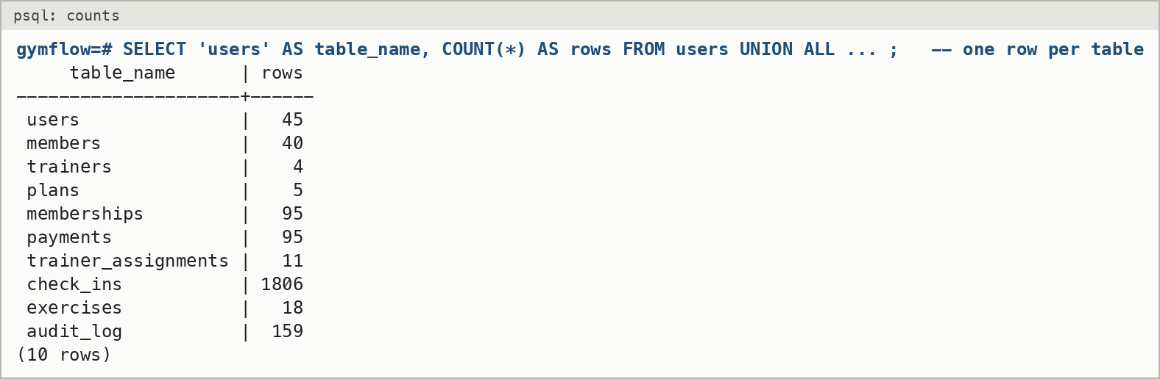
Figure 5: Rows in each table after loading the demo data. MongoDB holds a further 843 workout sessions and 11 workout plans.
Base tables
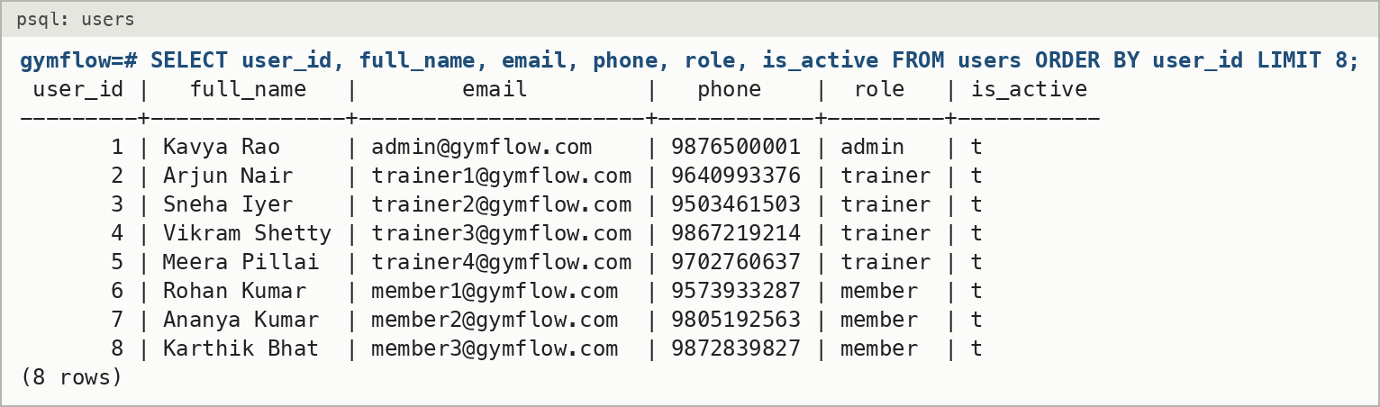
Figure 6: users (first 8 rows; password_hash is left out)
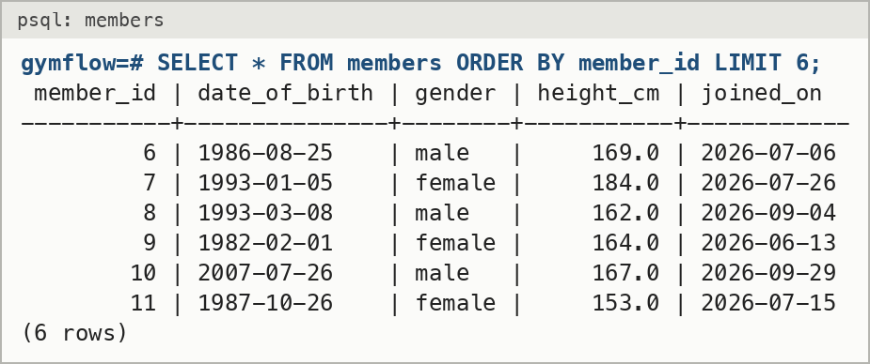
Figure 7: members
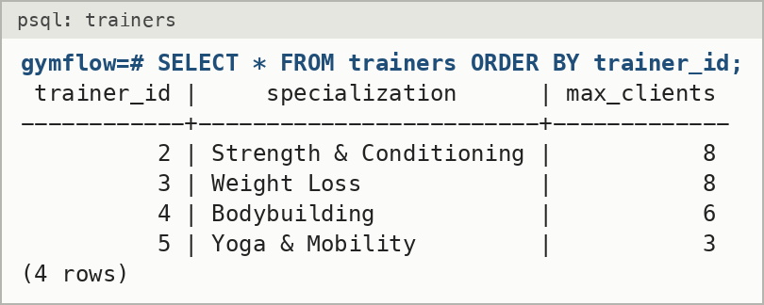
Figure 8: trainers
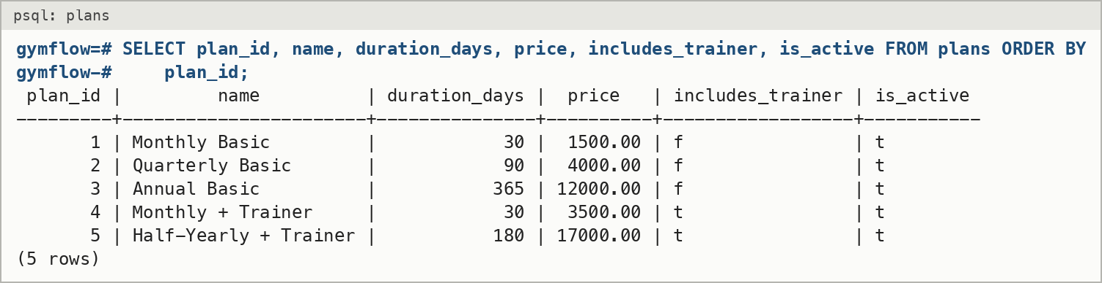
Figure 9: plans
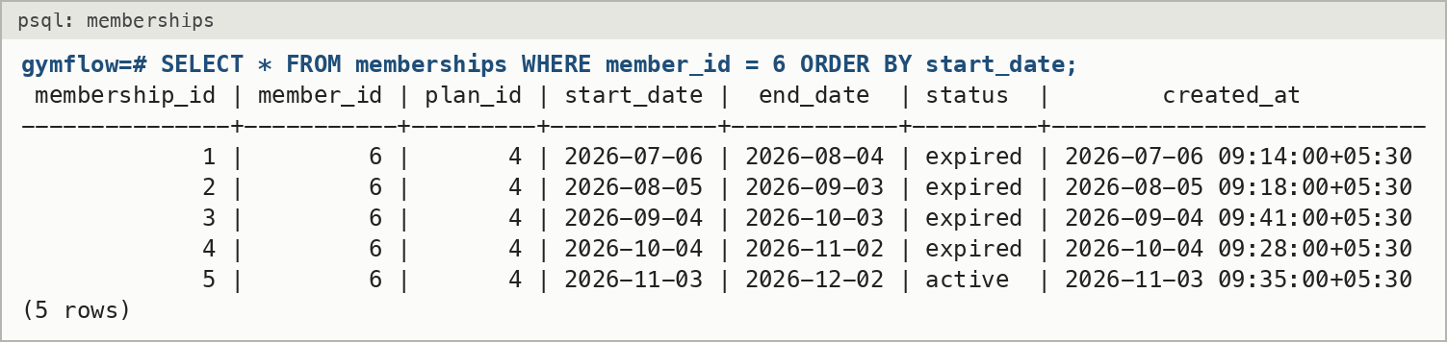
Figure 10: memberships for member 6, showing stacked renewals
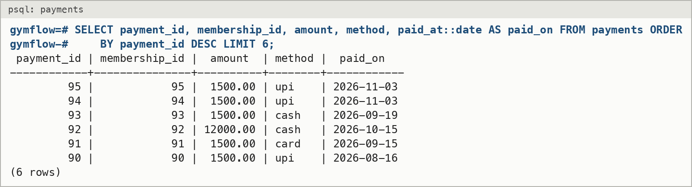
Figure 11: payments (latest 6)
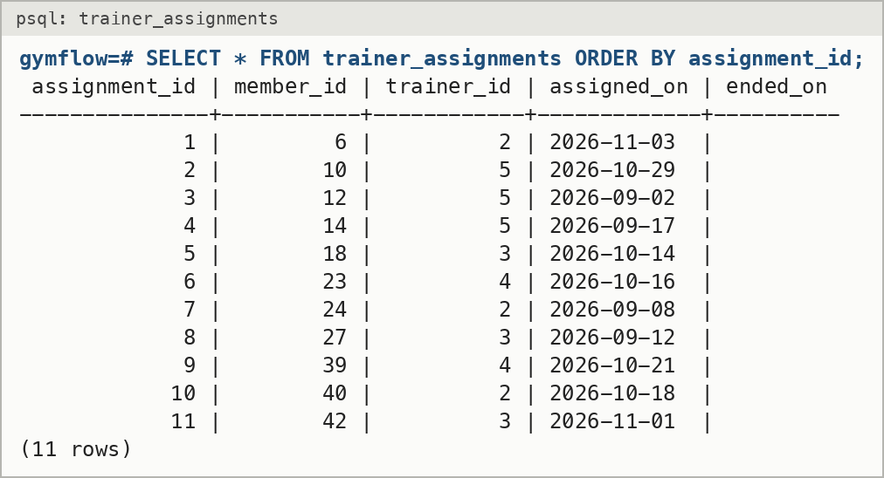
Figure 12: trainer_assignments
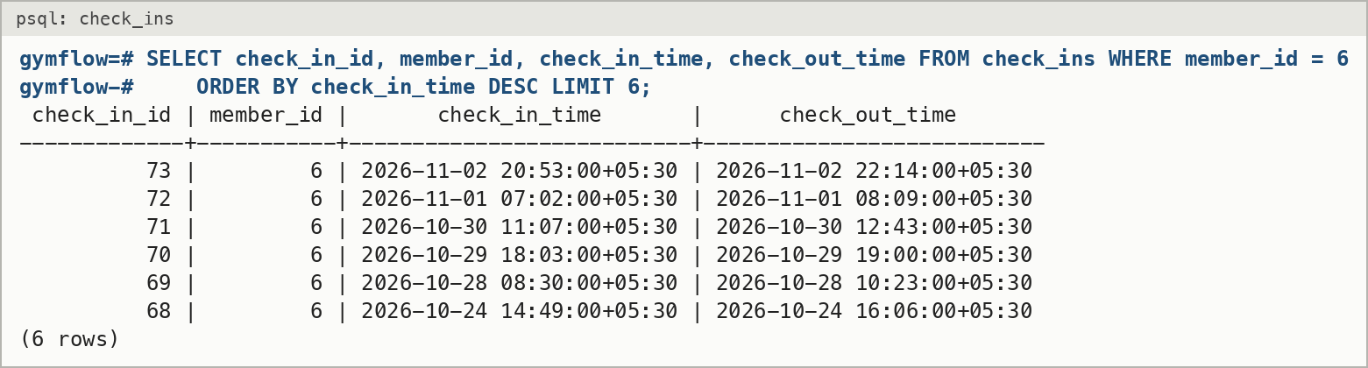
Figure 13: check_ins for member 6 (latest 6)
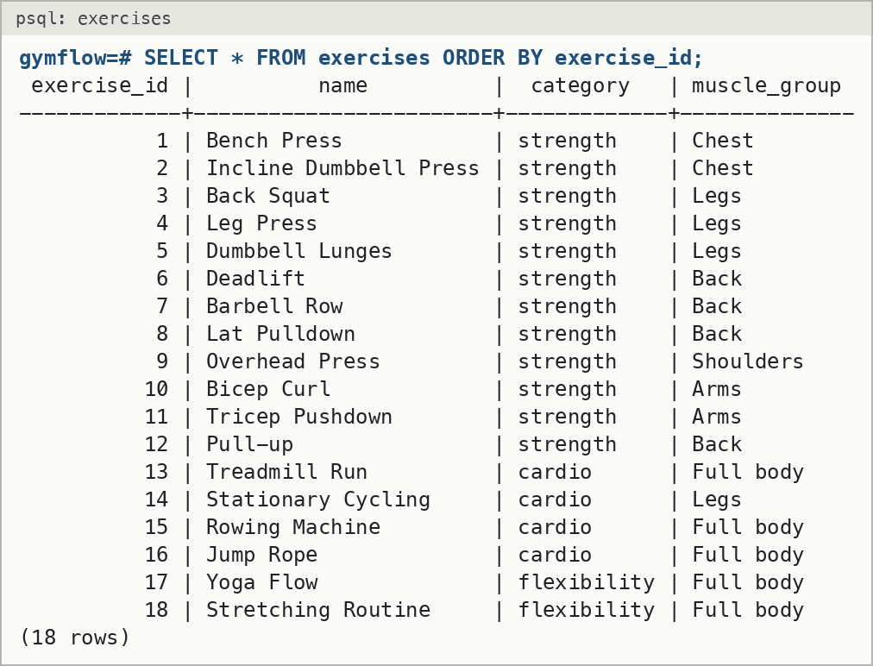
Figure 14: exercises
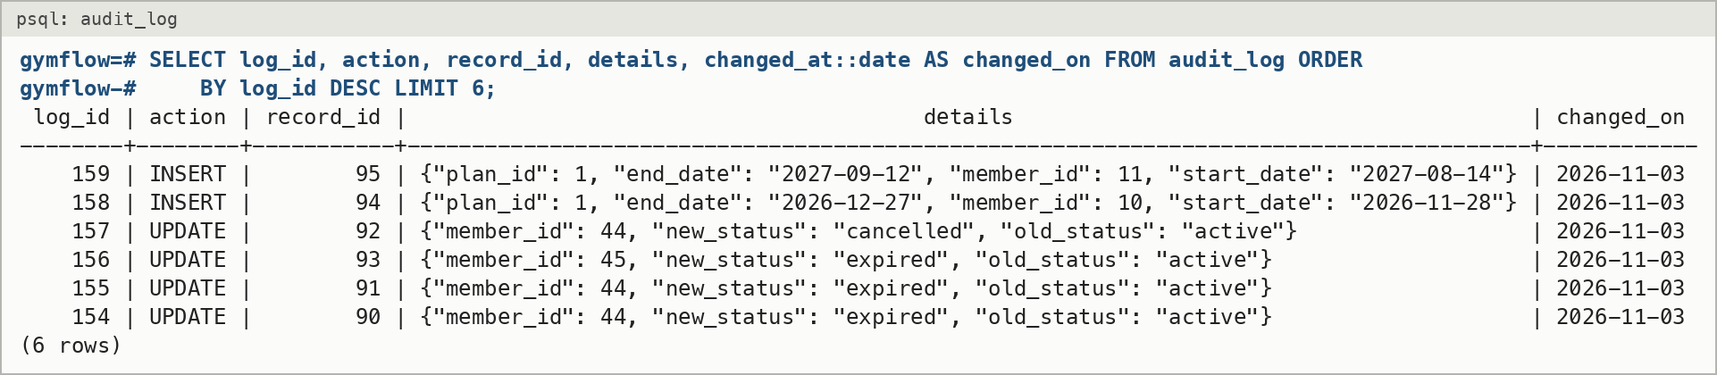
Figure 15: audit_log, written by the trigger (latest 6)
Views and functions
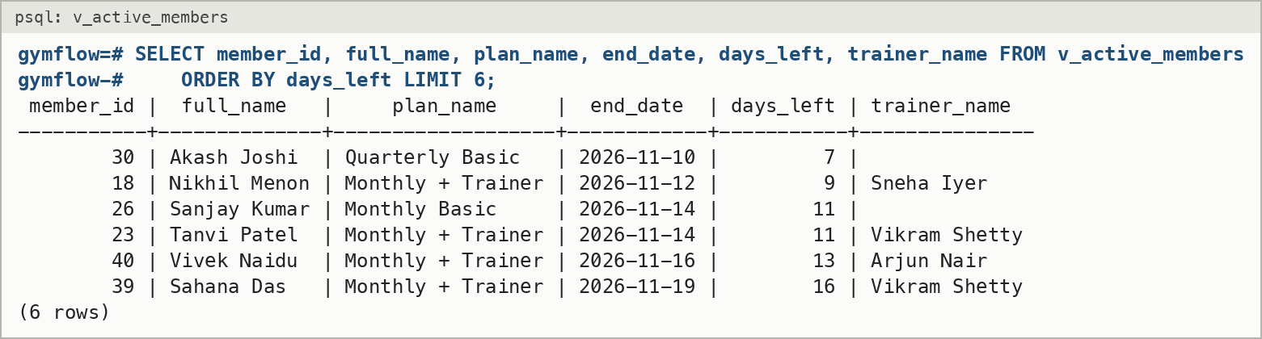
Figure 16: View v_active_members
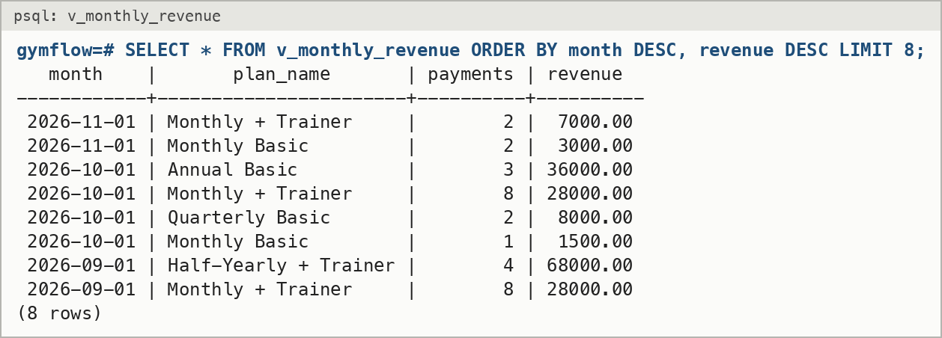
Figure 17: View v_monthly_revenue
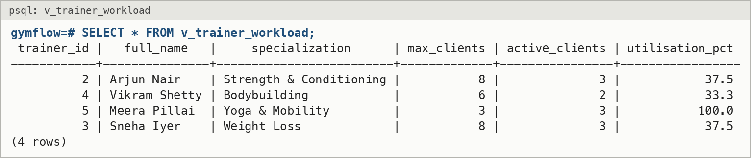
Figure 18: View v_trainer_workload. Meera Pillai is full (3 of 3), which is why the capacity trigger refuses her.
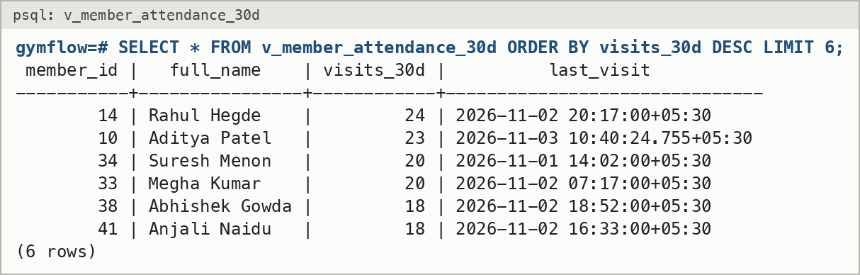
Figure 19: View v_member_attendance_30d
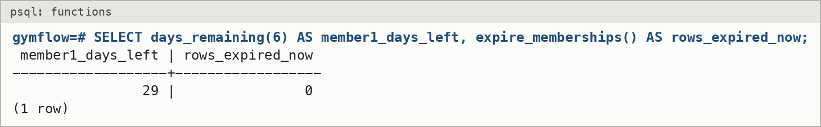
Figure 20: Functions days_remaining and expire_memberships
Query output
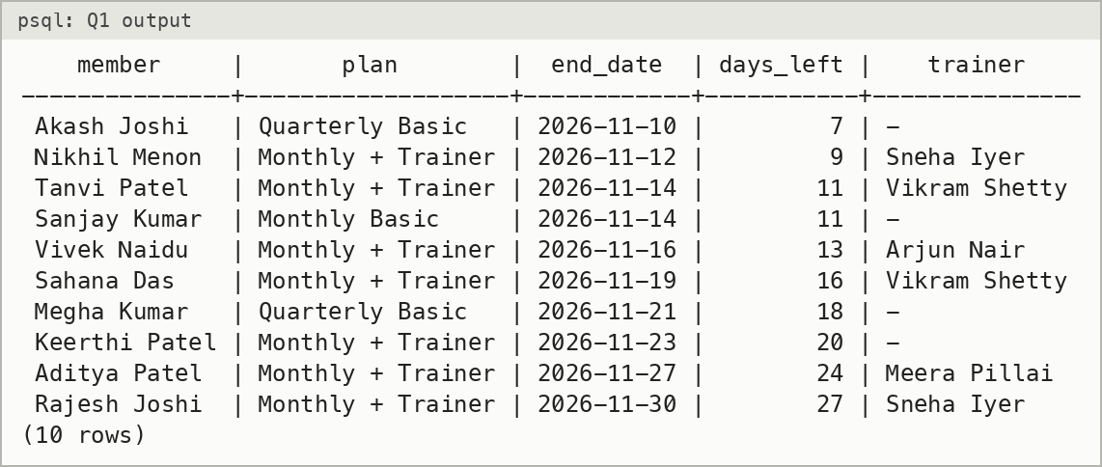
Figure 21: Q1 output: JOIN across 4 tables
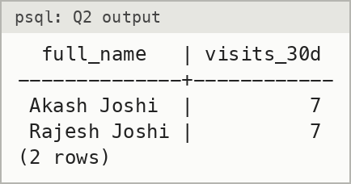
Figure 22: Q2 output: GROUP BY and HAVING
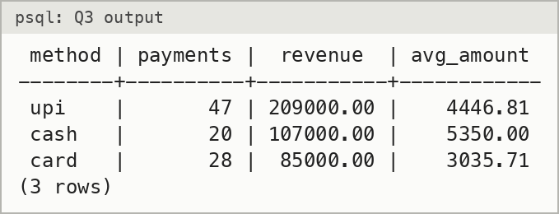
Figure 23: Q3 output: aggregates per payment method
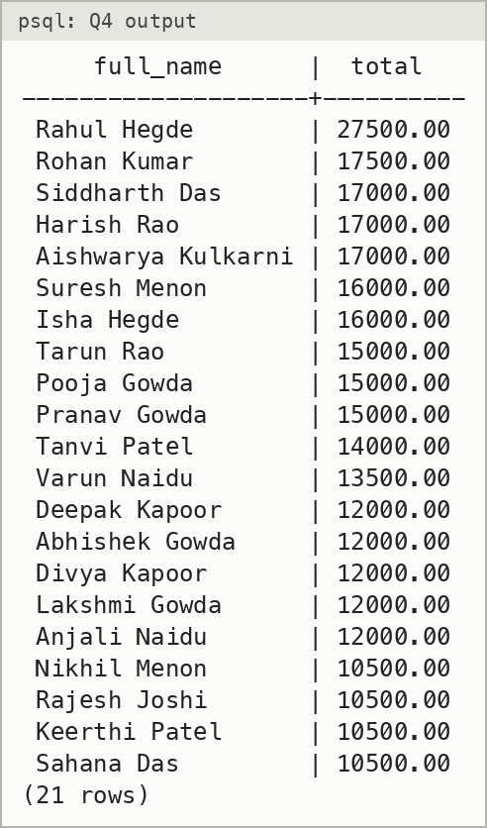
Figure 24: Q4 output: nested subquery
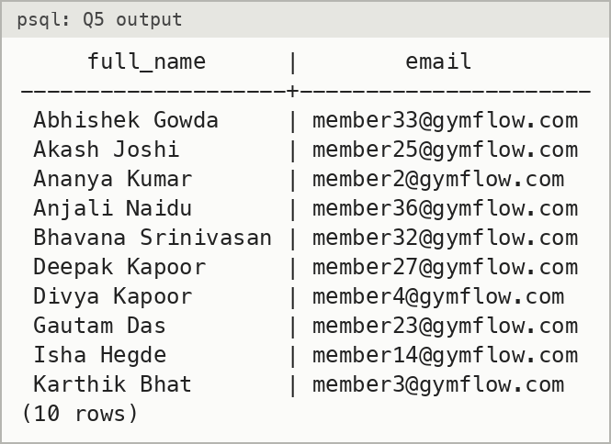
Figure 25: Q5 output: correlated NOT EXISTS
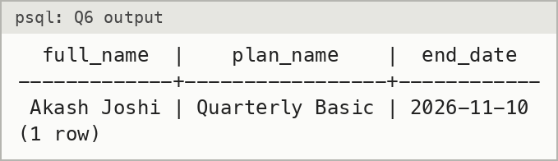
Figure 26: Q6 output: correlated NOT EXISTS
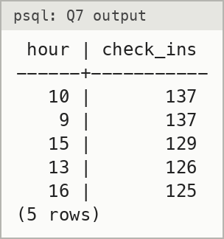
Figure 27: Q7 output: busiest hours
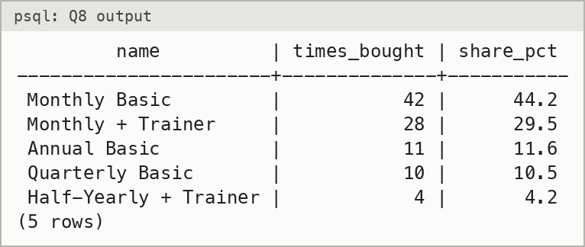
Figure 28: Q8 output: window function
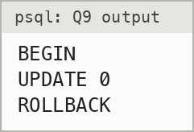
Figure 29: Q9 output: no rows match on this data, because no member's last membership ended more than 90 days ago. The statement ran inside a transaction that was rolled back.
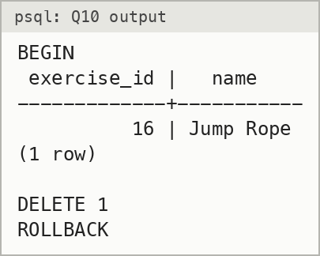
Figure 30: Q10 output: DELETE ... RETURNING, rolled back
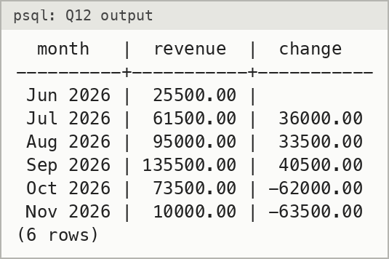
Figure 31: Q12 output: CTE
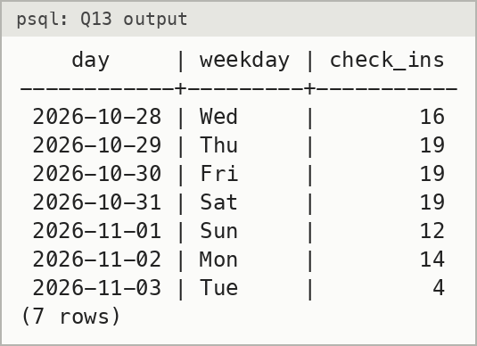
Figure 32: Q13 output: recursive CTE
Q11: effect of an index
The same query was run with idx_checkins_member_time dropped and then with it in place. Without the index, PostgreSQL reads all 1,806 rows and throws away 1,783 of them. With it, PostgreSQL goes straight to the 23 matching rows in 2 blocks. The estimated cost falls from 49.68 to 11.87, and with a warm cache the execution time falls from 0.390 ms to 0.023 ms. The gap grows with the size of the table.
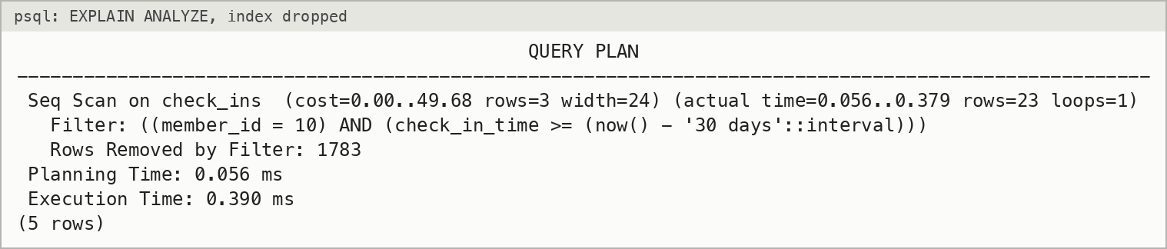
Figure 33: Query plan without the index: sequential scan
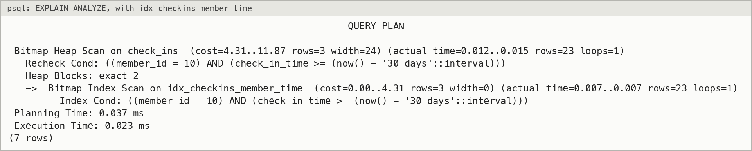
Figure 34: Query plan with the index: bitmap index scan

b) Testing Results
Automated tests
Run with npm test. The tests use separate gymflow_test databases, which are rebuilt before each test file, so the demo data is never touched.
File | What it covers | Tests
tests/db-rules.test.js | Triggers, procedure, transactions, views, constraints | 15
tests/mongo.test.js | $jsonSchema validators, input parsing, aggregation pipelines | 9
tests/auth.test.js | Hashing, JWT, tampered tokens, atomic sign-up | 6
tests/api-logic.test.js | Dashboard, check-in and check-out, trainer ownership, cancellation, search, delete | 8
Total | 38 passed, 0 failed | 38

ok 1 - purchaseMembership returns the new id and records the payment
ok 2 - getMemberDashboard shows upcoming-only member
ok 3 - check in then check out; checkOut without open check-in throws 400
ok 4 - isTrainerOfMember false for another trainer's client
ok 5 - cancelling a trainer plan releases the trainer
ok 6 - capacity cannot go below current client count
ok 7 - searchMembers filters by status
ok 8 - deletePlan in use is refused; unused plan is deleted
ok 9 - hash and verify password
ok 10 - session token round-trips userId and role
ok 11 - tampered token returns null
ok 12 - registerMember stores a hashed password and a member profile
ok 13 - registerMember rejects a duplicate email
ok 14 - registerMember is atomic: a bad profile leaves no user row behind
ok 15 - check-in refused without active membership
ok 16 - check-in refused when membership has expired
ok 17 - check-in refused when the only membership starts in the future
ok 18 - second open check-in same day refused
ok 19 - purchase creates membership and payment at plan price
ok 20 - renewal starts the day after current membership ends
ok 21 - failed payment rolls back the membership
ok 22 - purchase of an inactive plan is refused
ok 23 - trainer at capacity is refused
ok 24 - trainer requires a plan that includes one
ok 25 - member cannot have two active trainers
ok 26 - expire_memberships flips stale rows and audit_log records it
ok 27 - days_remaining counts stacked memberships
ok 28 - v_trainer_workload counts active clients
ok 29 - check constraints reject bad email and zero price
ok 30 - validator rejects strength exercise without sets
ok 31 - validator rejects negative weight
ok 32 - parseWorkoutInput rejects empty exercises and NaN reps
ok 33 - parseWorkoutInput fills name and category from the catalog
ok 34 - weeklyVolume sums reps x weight
ok 35 - personalRecords returns max weight per exercise
ok 36 - topExercises counts how often each exercise is logged
ok 37 - aggregations return [] for a member with no sessions
ok 38 - deleteSession only deletes the member's own session
# tests 38
# pass 38
# fail 0

Manual test cases (through the web interface and API)
ID | Steps | Expected | Result
TC1 | Log in with a wrong password | 401 "Invalid email or password" | Pass
TC2 | Open /api/member/dashboard without logging in | 401 "Please log in" | Pass
TC3 | Member opens /api/admin/dashboard | 403 "You do not have access to this" | Pass
TC4 | member1 clicks Check in, then Check in again | First succeeds; second "Check-in refused: already checked in" | Pass
TC5 | member1 checks out twice | Second "You are not checked in" | Pass
TC6 | member2 (expired) clicks Check in | "Check-in refused: no active membership for this date" | Pass
TC7 | Log a workout with empty reps | 400 "Exercise 1 set 1 reps must be a number" | Pass
TC8 | Log a workout dated in the future | 400 "Workout date cannot be in the future" | Pass
TC9 | Buy a plan with method "bitcoin" through the API | 400 "Payment method must be cash, card or upi"; nothing saved | Pass
TC10 | Trainer opens another trainer's client page | 403 "This member is not one of your clients" | Pass
TC11 | Admin assigns a member to Meera Pillai (3 of 3) | "Trainer is at full capacity (3 of 3 clients)" | Pass
TC12 | Admin deletes "Monthly Basic" (already sold) | 409 "This plan has been bought before..." | Pass
TC13 | Sign up with a date of birth in 2020 | 400 "Members must be at least 14 years old"; no user created | Pass
TC14 | New member opens Progress and Dashboard | Empty states, no errors | Pass
TC15 | Trainer saves a workout plan; member opens My workout plan | Plan visible to the member | Pass
TC16 | Admin filters payments by method = cash | Only cash rows; totals recomputed | Pass

9. Next.js Project Tree Structure
Repository: https://github.com/ASHWINANAND19/gymflow
gymflow/
├── app/
│ ├── admin/
│ │ ├── audit/page.js
│ │ ├── exercises/page.js
│ │ ├── members/
│ │ │ ├── [id]/page.js
│ │ │ └── page.js
│ │ ├── payments/page.js
│ │ ├── plans/page.js
│ │ ├── trainers/page.js
│ │ ├── layout.js
│ │ └── page.js
│ ├── api/
│ │ ├── admin/
│ │ │ ├── assignments/
│ │ │ │ ├── [id]/route.js
│ │ │ │ └── route.js
│ │ │ ├── audit/route.js
│ │ │ ├── dashboard/route.js
│ │ │ ├── exercises/
│ │ │ │ ├── [id]/route.js
│ │ │ │ └── route.js
│ │ │ ├── members/
│ │ │ │ ├── [id]/route.js
│ │ │ │ └── route.js
│ │ │ ├── memberships/
│ │ │ │ ├── [id]/cancel/route.js
│ │ │ │ └── route.js
│ │ │ ├── payments/route.js
│ │ │ ├── plans/
│ │ │ │ ├── [id]/route.js
│ │ │ │ └── route.js
│ │ │ └── trainers/
│ │ │ ├── [id]/route.js
│ │ │ └── route.js
│ │ ├── auth/
│ │ │ ├── login/route.js
│ │ │ ├── logout/route.js
│ │ │ └── register/route.js
│ │ ├── exercises/route.js
│ │ ├── me/route.js
│ │ ├── member/
│ │ │ ├── check-in/route.js
│ │ │ ├── check-out/route.js
│ │ │ ├── dashboard/route.js
│ │ │ ├── memberships/route.js
│ │ │ ├── progress/route.js
│ │ │ ├── workout-plan/route.js
│ │ │ └── workouts/
│ │ │ ├── [id]/route.js
│ │ │ └── route.js
│ │ ├── plans/route.js
│ │ └── trainer/clients/
│ │ ├── [id]/
│ │ │ ├── plan/route.js
│ │ │ └── route.js
│ │ └── route.js
│ ├── login/page.js
│ ├── member/
│ │ ├── plans/page.js
│ │ ├── progress/page.js
│ │ ├── workout-plan/page.js
│ │ ├── workouts/page.js
│ │ ├── layout.js
│ │ └── page.js
│ ├── register/page.js
│ ├── trainer/
│ │ ├── clients/[id]/page.js
│ │ ├── layout.js
│ │ └── page.js
│ ├── favicon.ico
│ ├── globals.css
│ ├── layout.js
│ └── page.js
├── components/
│ ├── Charts.js
│ ├── PlanEditor.js
│ ├── PlanView.js
│ ├── ProgressCharts.js
│ ├── Shell.js
│ ├── WorkoutSummary.js
│ └── ui.js
├── db/
│ ├── mongo/setup.js
│ └── sql/
│ ├── 00_drop.sql
│ ├── 01_schema.sql
│ ├── 02_alter.sql
│ ├── 03_functions.sql
│ ├── 04_triggers.sql
│ ├── 05_views.sql
│ ├── 06_indexes.sql
│ └── queries.sql
├── docs/
│ ├── screenshots/(13 application screenshots)
│ └── REPORT.md
├── lib/
│ ├── mongo/
│ │ ├── plans.js
│ │ └── workouts.js
│ ├── sql/
│ │ ├── audit.js
│ │ ├── checkins.js
│ │ ├── dashboard.js
│ │ ├── exercises.js
│ │ ├── members.js
│ │ ├── memberships.js
│ │ ├── payments.js
│ │ ├── plans.js
│ │ ├── trainers.js
│ │ └── users.js
│ ├── auth.js
│ ├── client.js
│ ├── db.js
│ ├── http.js
│ ├── mongo.js
│ ├── session.js
│ └── validate.js
├── scripts/
│ ├── seed.js
│ └── setup-db.js
├── tests/
│ ├── api-logic.test.js
│ ├── auth.test.js
│ ├── db-rules.test.js
│ ├── helpers.js
│ └── mongo.test.js
├── .env.example
├── .gitignore
├── README.md
├── eslint.config.mjs
├── jsconfig.json
├── next.config.mjs
├── package.json
└── proxy.js

Folder | Purpose
app/api/ | Route Handlers, the backend API
app/admin/, app/trainer/, app/member/ | Pages for each role
components/ | Shared UI: layout shell, tables, charts, workout views
lib/ | Database connections, sessions, error handling, validation
lib/sql/, lib/mongo/ | All SQL queries and all MongoDB queries and pipelines
db/sql/, db/mongo/ | Schema, routines, views, indexes, validators
scripts/, tests/ | Database setup and seed scripts; automated tests
proxy.js | Page-level login and role guard

Running the project
npm install
cp .env.example .env.local # then set JWT_SECRET and the database URLs
npm run db:reset # creates and seeds both databases
npm run dev # http://localhost:3000

Database URLs and the JWT secret are read from environment variables in .env.local, which is git-ignored. Only .env.example is committed.

10. Sample Screenshots of Application Code and Demo

a) Application Code
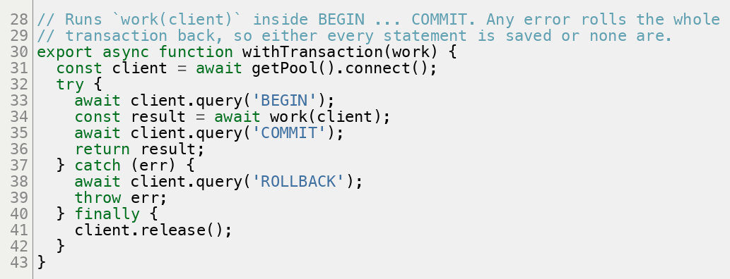
Figure 35: lib/db.js: every statement inside withTransaction is saved, or none are
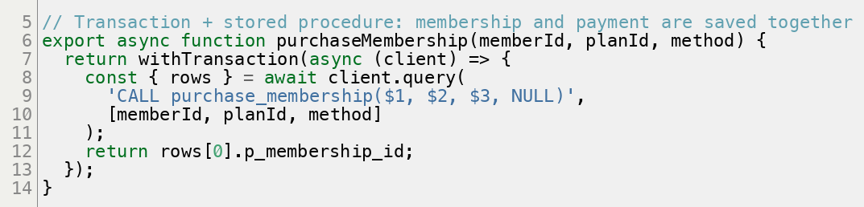
Figure 36: lib/sql/memberships.js: purchase through the stored procedure inside a transaction
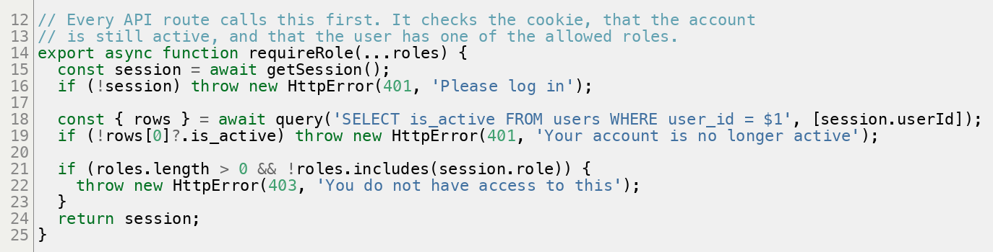
Figure 37: lib/session.js: login, active-account and role checks on every API route
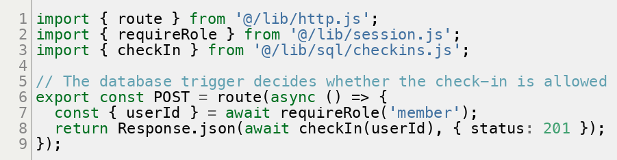
Figure 38: app/api/member/check-in/route.js: an API route; the database trigger decides whether the check-in is allowed
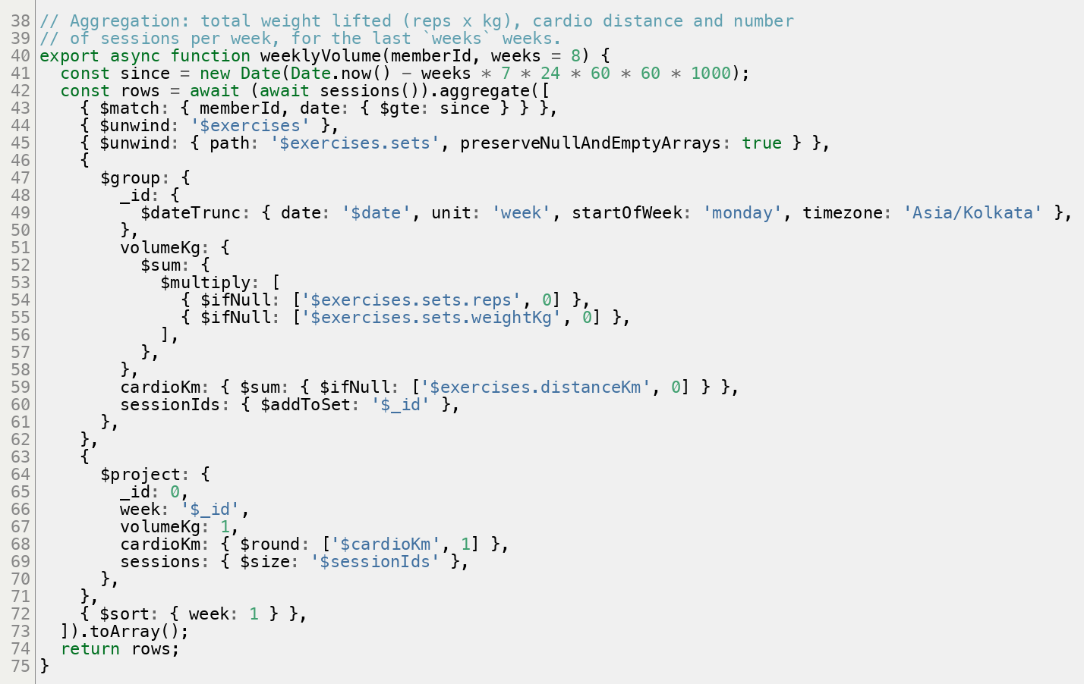
Figure 39: lib/mongo/workouts.js: the weekly volume aggregation pipeline
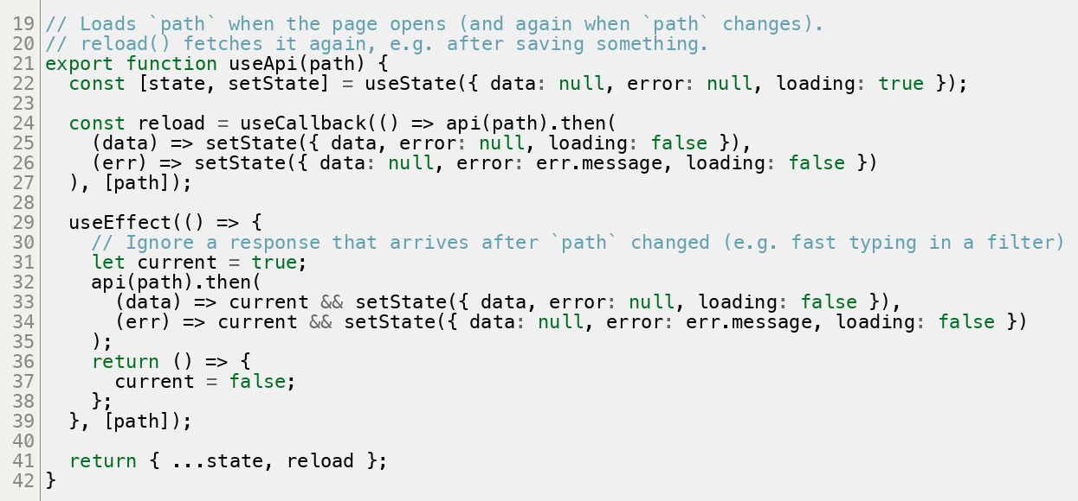
Figure 40: lib/client.js: the React hook that pages use to load data from the API

b) Application Demo
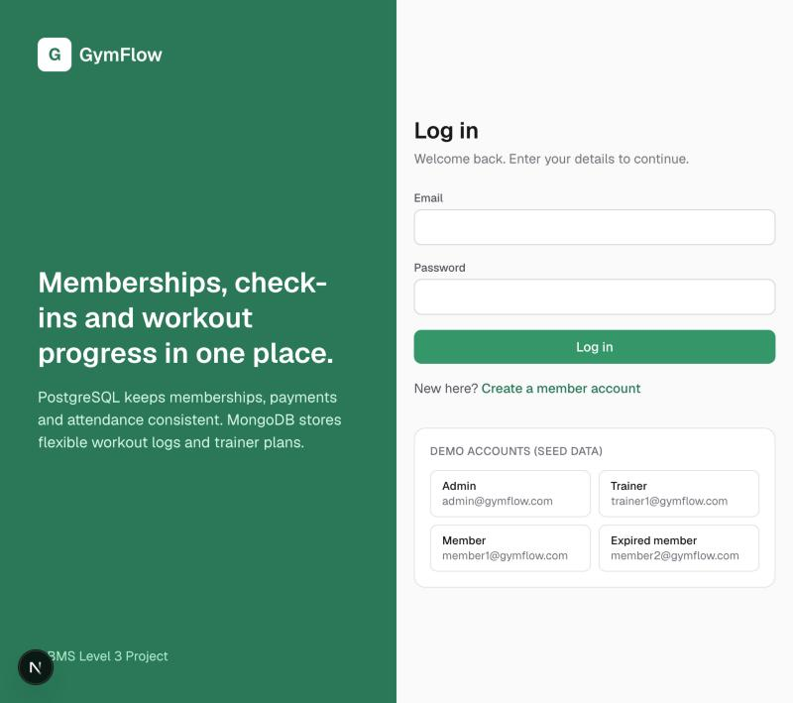
Figure 41: Login page with demo accounts
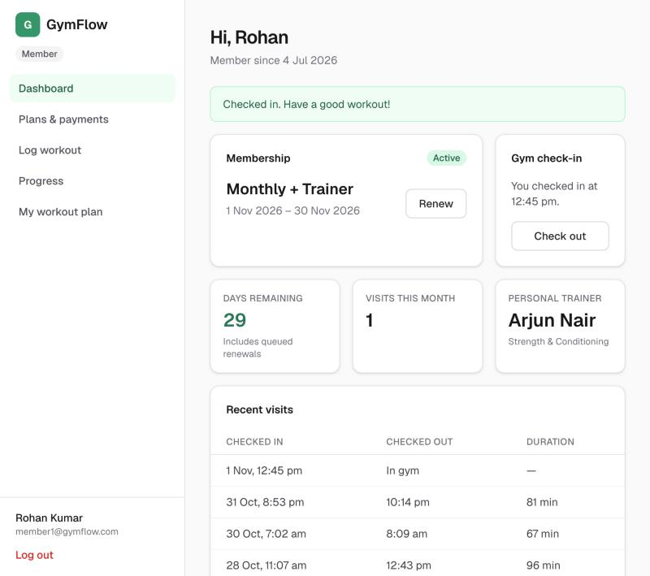
Figure 42: Member dashboard after checking in
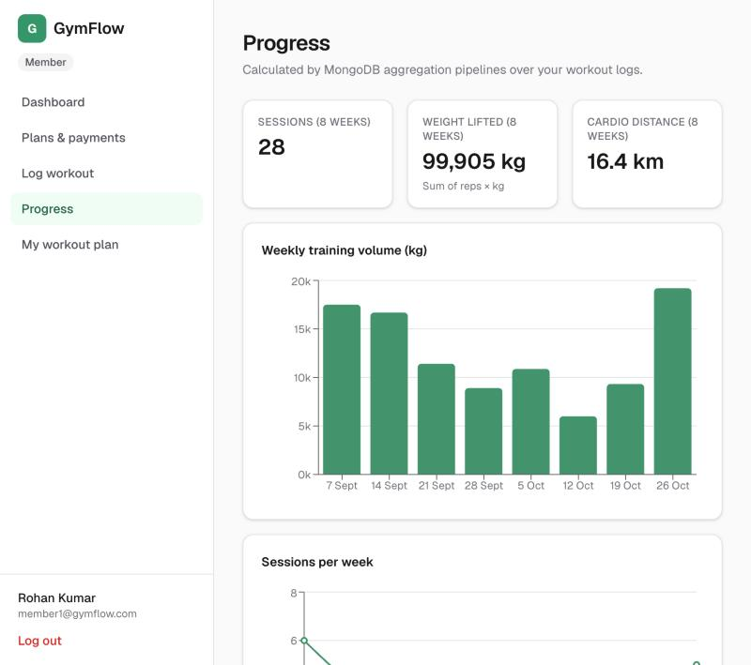
Figure 43: Progress charts from MongoDB aggregation
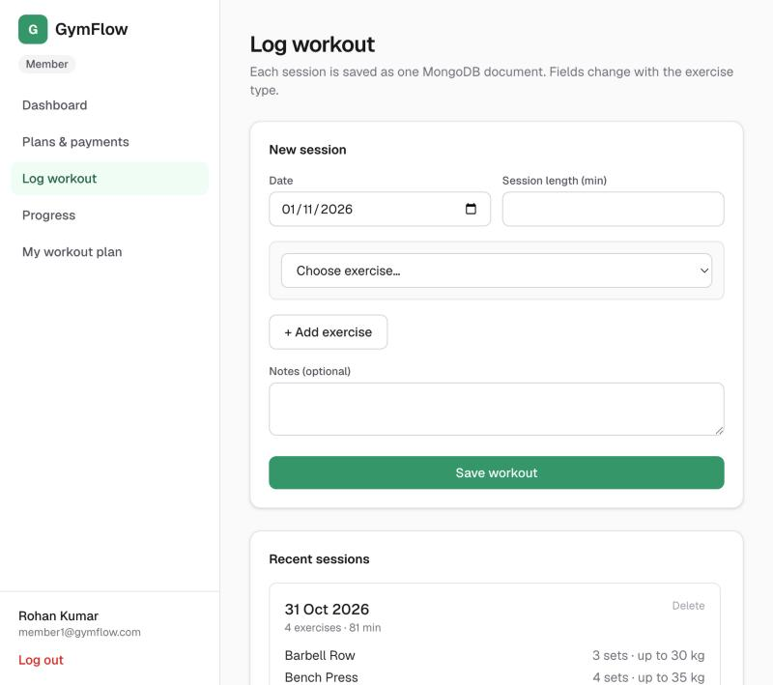
Figure 44: Workout logger: fields change with the exercise type
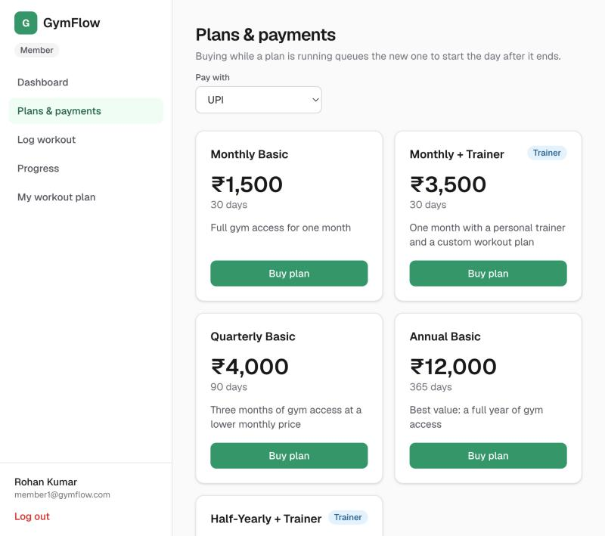
Figure 45: Plans and purchase
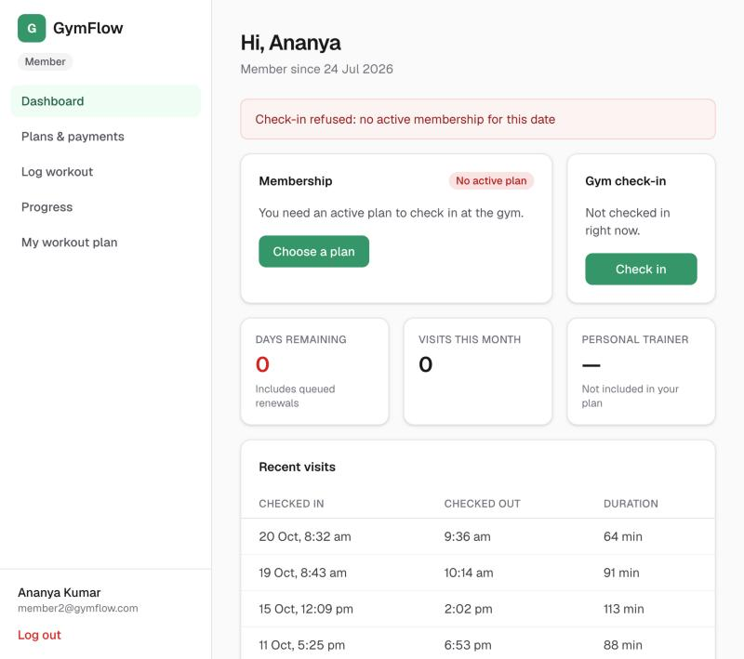
Figure 46: An expired member's check-in refused by the trigger
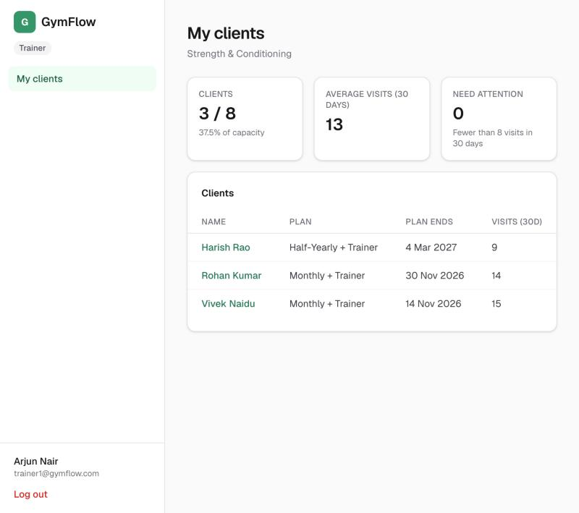
Figure 47: Trainer's client list
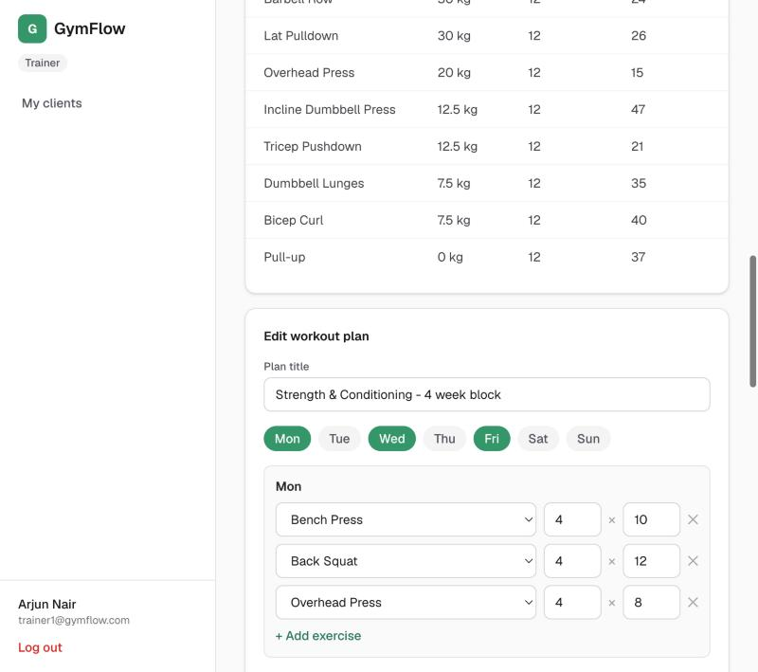
Figure 48: Trainer editing a workout plan
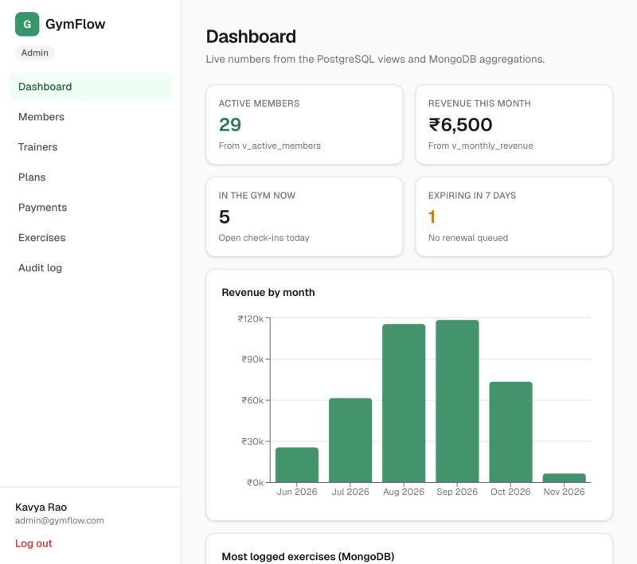
Figure 49: Admin dashboard, built on the views
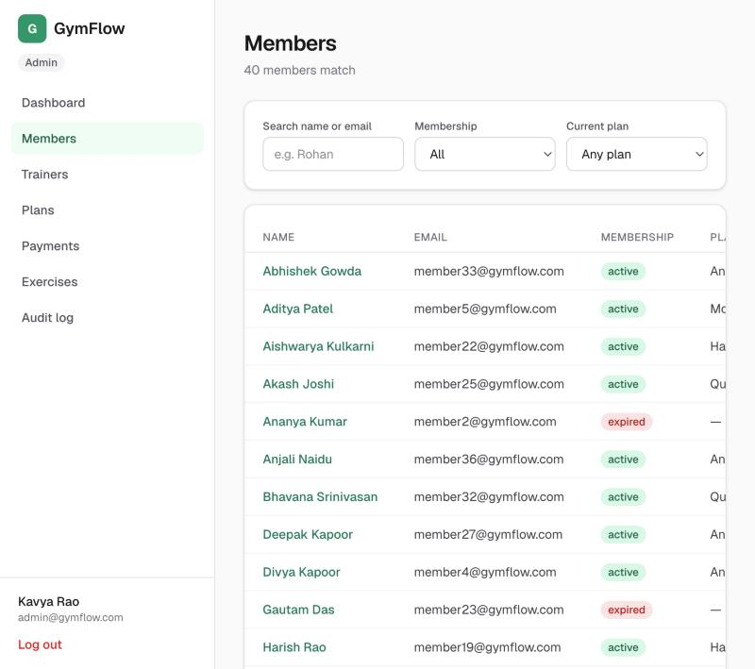
Figure 50: Member search and filters
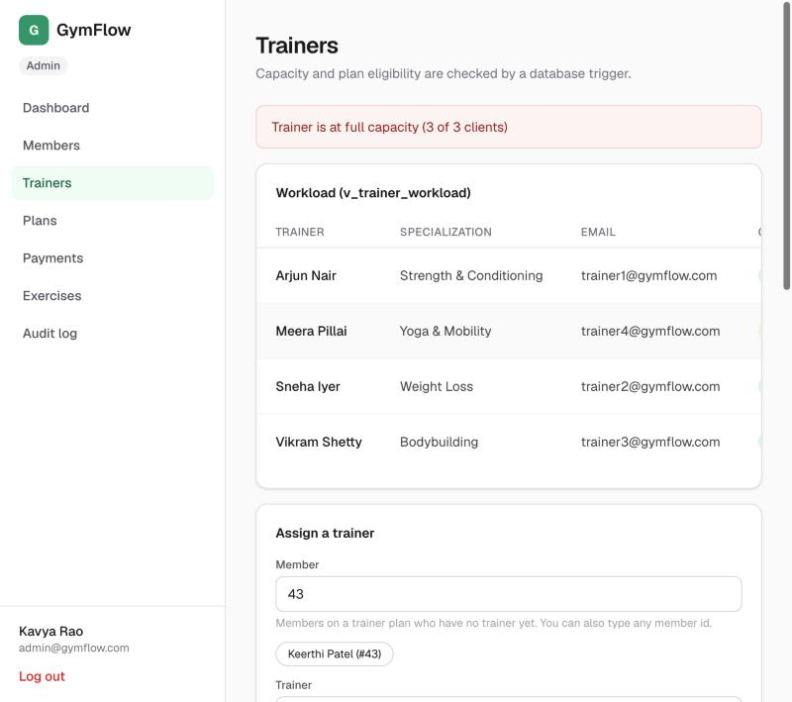
Figure 51: A full trainer refused by the trigger
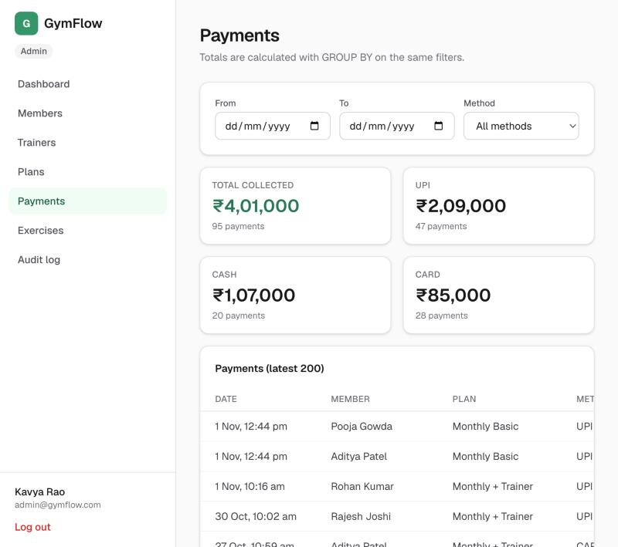
Figure 52: Payments report with GROUP BY totals
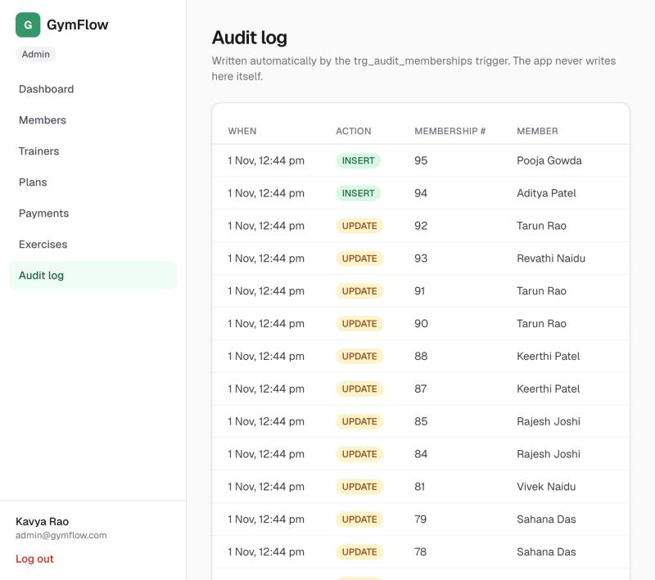
Figure 53: Audit log written by the trigger

11. Evaluation Rubrics - Completion Status
# | Criteria | Distribution | Status
1 | Database Design | ER diagram , relational schema with keys, relationships, and constraints | Completed
2 | Database Creation | SQL database implementation - DDL with constraints , NoSQL/Vector database creation , Technology justification | Completed
3 | SQL Operations and Queries | DML operations , Nested/correlated/Recursive SQL queries, Join SQL queries | Completed
4 | Advanced Database Concepts | Advanced database concepts (Procedure/function, trigger, CTE) , NoSQL/Vector feature RUD | Completed
5 | Web Application and Database Integration | Next.js interface , Backend/API and database integration | Completed
6 | Authentication and Authorization | Authentication implementation (front end and backend) and minimum two roles and role-based access control in database | Completed
7 | Documentation, Git/GitHub, Demonstration, Testing, and Originality | Documentation, Git/GitHub , Originality and individual contribution | Completed

Where each criterion is shown in this report
# | Evidence
1 | ER diagrams (Section 3); relational schema, keys, relationships and constraints (Section 4)
2 | DDL with constraints (Section 5); MongoDB collections and validators (Section 7); technology justification (Section 2)
3 | DML session, joins, nested, correlated and recursive queries (Section 6); their output (Section 8)
4 | Procedure and functions, triggers (Section 5); CTE and recursive CTE (Q12, Q13 in Section 6); MongoDB read, update, delete and aggregation (Section 7)
5 | Next.js interface and API routes (Sections 9 and 10); database integration (Section 2d)
6 | Login, hashed passwords, JWT sessions, three roles and role checks (Sections 2 and 10); access tests (Section 8b)
7 | This report; README and public GitHub repository (Section 9); test results (Section 8b); team contribution (Section 12)

12. Team Contribution
The work was split into three areas. Each member owns both database work and the application screens built on it.
Member | Area | Database work | Application work
Akarsh Kumar Gupta PES1UG24AM021 | Relational design and reporting | ER diagram, relational schema, normalisation, data dictionary; tables, keys and constraints; views; indexes and the EXPLAIN ANALYZE study; important queries | Admin dashboard, member search and detail, plans, payments report, audit log
Aryan Arora PES1UG24AM055 | Business rules and security | purchase_membership procedure, days_remaining and expire_memberships functions; the three triggers; transactions | Password hashing, JWT sessions and role checks; member dashboard and check-in; plan purchase; trainer assignment
Ashwin Anand PES1UG24AM057 | MongoDB workout module and UI | MongoDB data model, $jsonSchema validators, indexes and aggregation pipelines; exercise catalog table and the PostgreSQL to MongoDB link; setup and seed scripts | Workout logger, progress charts, workout plan views, trainer client page and plan editor, app layout and shared components; README and report

Files owned by each member
Akarsh Kumar Gupta | Aryan Arora | Ashwin Anand
db/sql/00_drop.sql | db/sql/03_functions.sql | db/mongo/setup.js
db/sql/01_schema.sql | db/sql/04_triggers.sql | lib/mongo.js, lib/mongo/workouts.js, lib/mongo/plans.js
db/sql/02_alter.sql | lib/db.js (transactions) | lib/sql/exercises.js, lib/validate.js
db/sql/05_views.sql | lib/auth.js, lib/session.js, proxy.js | scripts/setup-db.js, scripts/seed.js
db/sql/06_indexes.sql | lib/sql/users.js, memberships.js, checkins.js, trainers.js | app/api/member/workouts, progress, workout-plan; app/api/trainer/clients/[id]; app/api/exercises
db/sql/queries.sql | lib/http.js (error handling) | app/member/workouts, progress, workout-plan
lib/sql/dashboard.js, members.js, payments.js, plans.js, audit.js | app/api/auth/*, app/api/member/{dashboard,check-in,check-out,memberships} | app/trainer/**, components/PlanEditor.js, ProgressCharts.js, WorkoutSummary.js, PlanView.js
app/api/admin/{dashboard,members,plans,payments,audit} | app/api/admin/{memberships,trainers,assignments} | app/login, app/register, components/Shell.js, ui.js, Charts.js, lib/client.js
app/admin/{page,members,plans,payments,audit} | app/member/page.js, app/member/plans, app/admin/trainers | app/admin/exercises, README.md, docs/
Tests: views, constraints, member search, plan delete | Tests: triggers, procedure, transactions, auth, check-in and check-out, cancellation | Tests: tests/mongo.test.js

13. Conclusion and Future Enhancements
GymFlow shows how the choice of database follows from the shape of the data:
- PostgreSQL holds money, identity and rules. Its constraints, triggers, stored procedure and transactions guarantee that no membership exists without its payment, that nobody checks in without a valid plan, and that no trainer is overbooked.
- MongoDB holds nested, varied workout logs. Its validators keep that flexible data clean, and its aggregation pipelines turn it into progress charts.
- The Next.js interface makes each database feature visible. The errors users see for these rules are the database's own messages.
Future enhancements
- Online payments (Razorpay or Stripe) with webhook-confirmed transactions
- QR-code check-in at the gym entrance
- Email or SMS reminders for memberships about to expire, using the "ending soon" query
- Class and slot booking with capacity limits, as another use for triggers
- Semantic search over workout notes with vector embeddings (pgvector)
- Multi-branch support, with a branches table and per-branch revenue views
- Scheduled expire_memberships() with pg_cron, instead of running it when the dashboard loads

