5 Why Analysis

Description:
5 Why Analysis is a root cause analysis technique used to explore the underlying cause of a problem by asking “Why” five times (or as many times as needed). Each answer forms the basis of next “Why” question, helping dig deeper into the issue.

Example Diagram:
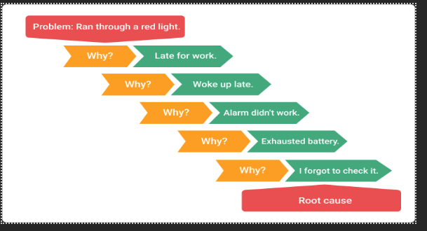

How to use it in Problem Solving:
- State the problem clearly.
- Ask “Why?” the problem happened.
- Record the answer.
- Ask “Why?” again based on the previous answer.
- Repeat up to five times or until the root cause is found.
- Take corrective action based on the root cause.

Example scenario 1: A user cannot log into the website.

1. Why?
🔹 Because the login form throws an error.

2. Why?
🔹 Because the server returned a 500 internal server error.

3. Why?
🔹 Because the database connection failed.

4. Why?
🔹 Because the configuration file has the wrong database password.

5. Why?
🔹 Because it was overwritten during the last deployment without testing.



Example scenario 2: A web application crashed during peak usage.

1. Why?
🔹 Because the server ran out of memory.

2. Why?
🔹 Because too many requests were consuming memory without being released.

3. Why?
🔹 Because there was a memory leak in the code.

4. Why?
🔹 Because objects were being stored in a global array and never removed.

5. Why?
🔹 Because the developer didn’t implement proper cleanup logic, and there was no code review to catch it.

Understanding and applying the 5W & 1H Framework in Real-Time Problem Solving

INTRODUCTION:
The 5W1H method is a structured approach to problem-solving and information gathering. It involves asking six key questions to analyse a situation thoroughly. The acronym stands for:
- What?
- Why?
- Who?
- When?
- Where?
- How?
This technique helps in breaking down complex problems, identifying root causes, and developing effective solutions.
1. What?
- Definition: Identifies the problem, event, or situation.
- Purpose: Clarifies the exact issue at hand.
- Example:
- "What is the problem?"
- "What happened?"
2. Why?
- Definition: Explores the reason or cause behind the problem.
- Purpose: Helps in root cause analysis.
- Example:
- "Why did this happen?"
- "Why is this important?"
3. Who?
- Definition: Identifies the people or stakeholders involved.
- Purpose: Determines responsibility and impact.
- Example:
- "Who is affected by this?"
- "Who is responsible for solving it?"
4. When?
- Definition: Examines the timing of the problem.
- Purpose: Helps in understanding urgency and scheduling solutions.
- Example:
- "When did this issue occur?"
- "When should it be resolved?"
5. Where?
- Definition: Locates the problem's origin or impact area.
- Purpose: Helps in pinpointing the exact location for intervention.
- Example:
- "Where did the problem occur?"
- "Where should we focus our efforts?"
6. How?
- Definition: Analyzes the process or method involved.
- Purpose: Helps in developing actionable solutions.
- Example:
- "How did this happen?"
- "How can we prevent it in the future?"

Description:
The 5W & 1H framework — Who, What, When, Where, Why, and How — is a fundamental method used for gathering complete information and breaking down problems systematically. It's widely used in journalism, project management, root cause analysis, and strategic planning. This approach ensures that all essential aspects of a situation are addressed, leading to better understanding, decision-making, and communication.

How to Use in Problem Solving:
When faced with a problem or task, ask the following structured questions:
- Who is involved or affected?
  - Identify stakeholders, users, or responsible teams.
- What is the issue, task, or objective?
  - Define the core problem or the requirement clearly.
- When did it happen, or when is it needed?
  - Establish timelines, deadlines, and time-based triggers.
- Where is it happening?
  - Understand the context or location (physical or system-based).
- Why is this happening?
  - Analyze causes, goals, or reasons behind the issue or request.
- How can it be solved, or how does it function?
  - Identify the method, solution, or process needed.
By answering these questions, a clearer picture emerges, allowing for more accurate root cause identification and better planning.

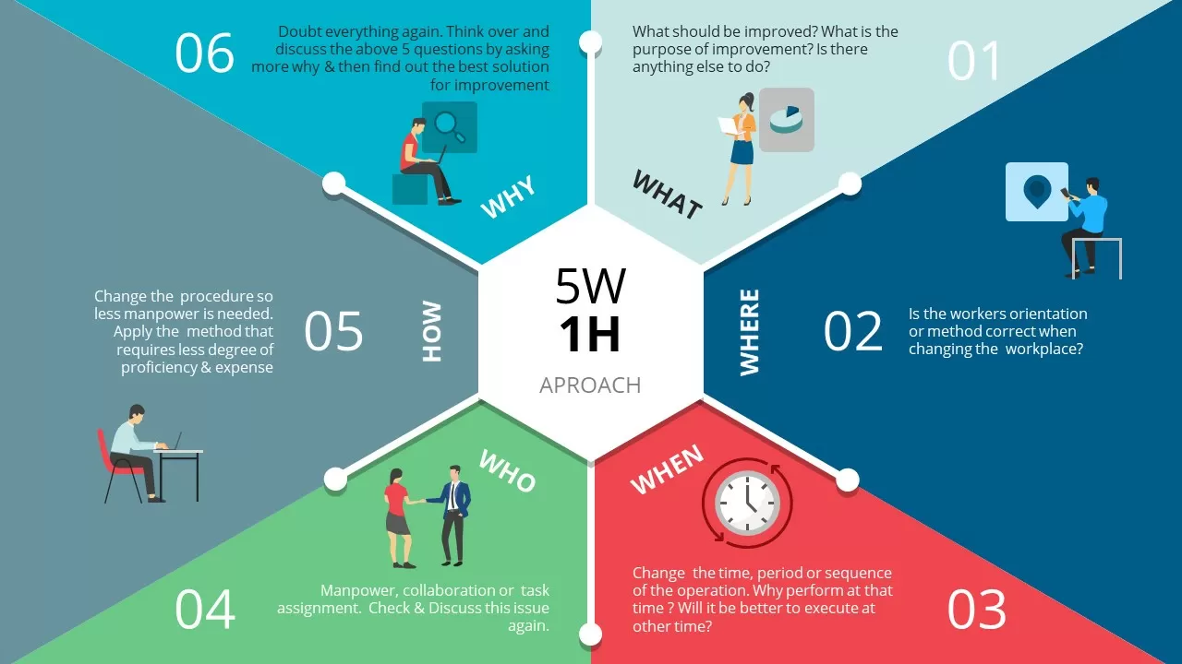

Real-Time Scenario:
Scenario:
Your team receives a complaint that a web application crashes when users submit a form.
Applying 5W & 1H:
- Who: Users from the client’s marketing team.
- What: The application crashes during form submission.
- When: The issue started after the recent deployment.
- Where: On the "Contact Us" page of the website.
- Why: Possibly due to a missing field validation in the latest code update.
- How: The form submits a null value to the database, causing a crash.
Outcome:
With this structured analysis, the development team quickly locates the issue, rolls out a hotfix, and adds more form validations and automated test cases to prevent future errors.

EXAMPLE :
1. Bug in a Software Application
Problem: A client reports that an application crashes when clicking "Generate Report."
5W & 1H:
- Who: Client's finance team using the reporting feature.
- What: App crashes during report generation.
- When: After the latest software update.
- Where: On the "Reports" page, specifically when selecting the PDF option.
- Why: Likely due to a recent code change not handling empty data sets.
- How: The PDF export function fails when the database returns no records.
Result: Developers quickly fix the null data check, update the code, and prevent similar issues.

2. Decline in Team Productivity
Problem: A manager notices a drop in output from the development team.
5W & 1H:
- Who: The entire backend development team.
- What: Significant decline in task completion over the last sprint.
- When: After introducing a new task management tool.
- Where: Across remote teams working from different locations.
- Why: The team is unfamiliar with the new tool, causing confusion and delays.
- How: Tasks are not being updated or tracked properly in the new system.
Result: The manager organizes a quick training session on the tool and assigns a team member as a point of contact for any future queries.

3. Missed Project Deadline
Problem: A project milestone was missed, affecting the client’s launch schedule.
5W & 1H:
- Who: The project delivery team and client.
- What: Milestone for "API Integration" was missed.
- When: Originally due last Friday.
- Where: In the integration module of the HRM system.
- Why: Dependencies from a third-party vendor were delayed.
- How: No buffer was planned for third-party timelines.
Result: PM revises the project plan to include contingency buffers and introduces a dependency tracker.
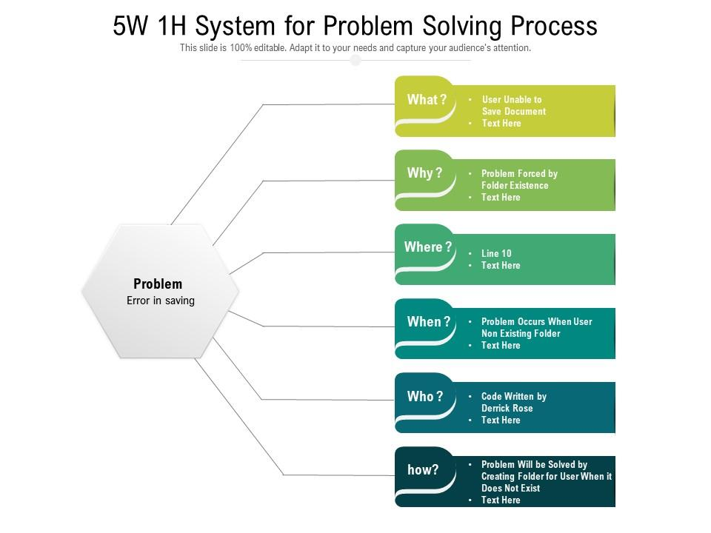

Fishbone Analysis

What is Fishbone Analysis?
Fishbone Analysis, also known as the Ishikawa Diagram or Cause-and-Effect Diagram, is a visual tool used to systematically identify and analyze the root causes of a specific problem or effect. It resembles the skeleton of a fish, hence the name "fishbone."
This method was introduced by Kaoru Ishikawa, a Japanese quality control expert, to aid in quality management and process improvement. It's widely used in corporate environments to identify bottlenecks, inefficiencies, or defects in operations, customer service, manufacturing, software development, and more.

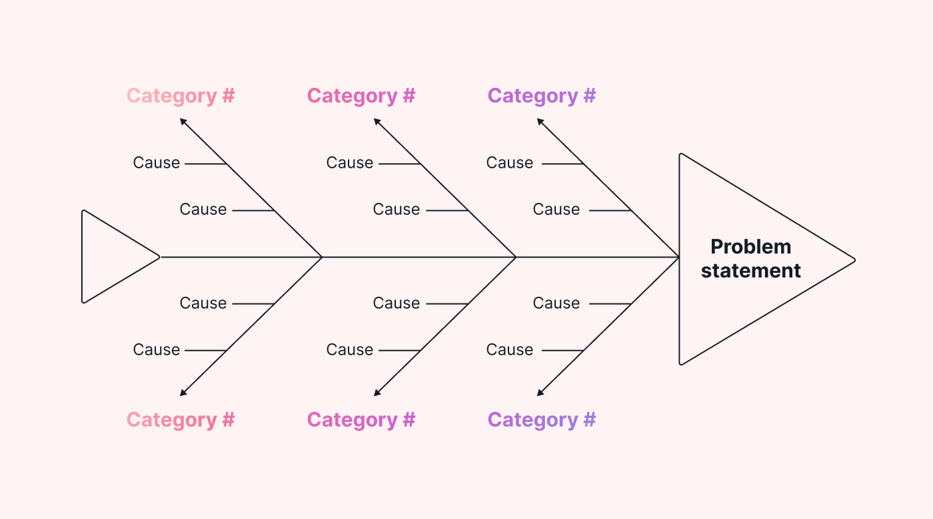
Anatomy of a Fishbone Diagram

Real-Life Corporate Example: Decline in Online Sales for an E-commerce Company

Problem:
An e-commerce company noticed a 25% decline in online sales over the last two months. This issue directly impacts revenue and stakeholder expectations.

Applying Fishbone Analysis:

Step 1: Define the Problem Clearly
- Significant Drop in Online Sales
Step 2: Identify Major Cause Categories
For a corporate e-commerce setting, the team select these categories:
- People (Human Resources)
- Process (Operational Workflows)
- Technology (Website and Backend Systems)
- Marketing (Customer Engagement)
- External Factors (Market Trends, Competitors)
- Product (Inventory, Pricing)
Step 3: Brainstorm Potential Causes (Branches)
Step 4: Analyze and Validate Root Causes
The company uses:
- Website analytics
- Customer feedback
- Abandoned cart data
- A/B testing
- Competitor price benchmarking
Step 5: Take Corrective Actions
- Technology: Fixed bugs and improved site speed.
- Marketing: Refined audience targeting and re-launched campaigns.
- Product: Re-stocked bestsellers and added a low-stock alerts.
- Process: Simplified the checkout process from 5 steps to 3.
Step 6: Monitor Results
How Fishbone Analysis Helped:
- Visual clarity: Mapped all potential issues in one place.
- Cross-functional collaboration: Marketing, IT, product, and customer service teams worked together.
- Root-cause identification: Helped avoid surface-level fixes and targeted actual problems.
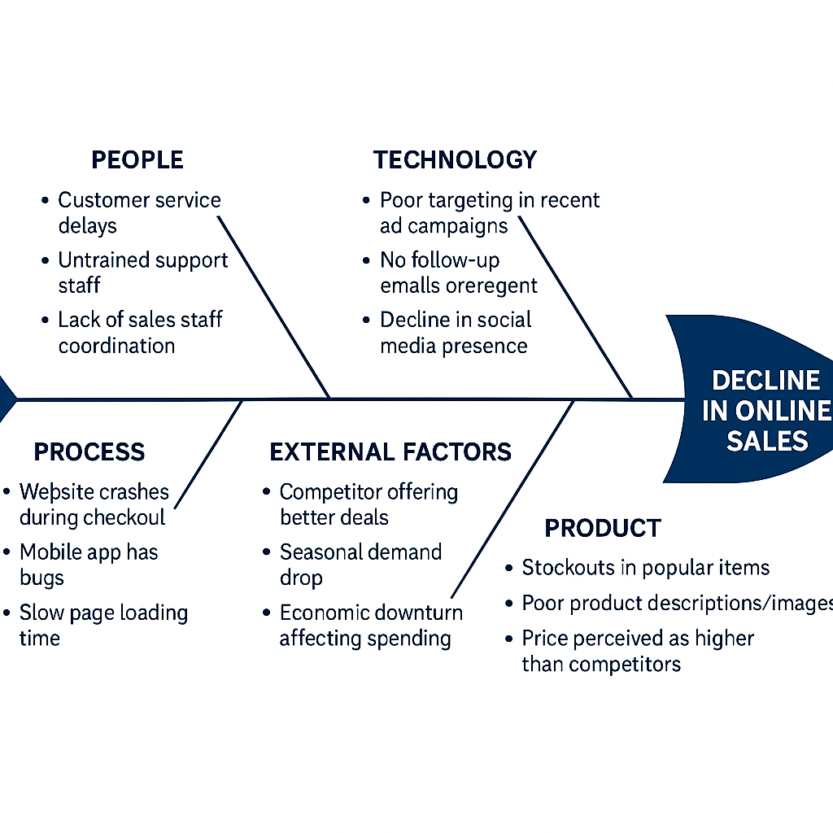
- Strategic decision-making: Enabled data-driven corrective measures.

Conclusion:
This example shows how Fishbone Analysis enables corporate teams to look beyond symptoms and diagnose root causes of business challenges. By organizing ideas visually and methodically, organizations can implement more effective, long-lasting solutions that improve performance and customer experience.

TOPIC: PMI TECHNIQUE AND IT’S USAGE IN PROBLEM SOLVING

Description

The PMI Technique was developed by Dr. Edward de Bono, a psychologist, physician, and author known for his work in creative thinking. PMI is part of his broader approach to lateral thinking, which encourages people to look at problems from different angles and step outside traditional logical patterns.

What Is PMI?

PMI stands for:
- Plus (P) – The positive aspects of an idea or decision.

- Minus (M) – The negative aspects or drawbacks.

- Interesting (I) – Neutral, unclear, or thought-provoking points that don’t fit easily into ‘good’ or ‘bad’ categories but may affect outcomes.
Instead of immediately forming a judgment (good/bad, yes/no), PMI encourages a more exploratory, balanced, and open-minded approach to thinking.
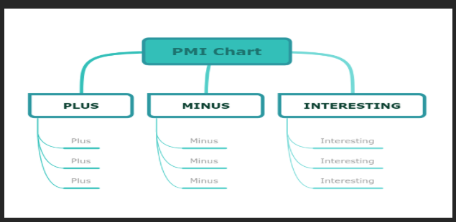

Structure of the Technique

- Identify the idea or decision to be evaluated.

- Draw three columns or sections titled Plus, Minus, and Interesting.

- Brainstorm and list all possible factors in each column.

- Review and reflect on the entries, giving equal consideration to all perspectives.

- Use the insights to make a well-rounded decision.

Optional: Assign weights or scores to each point based on importance to aid in decision- making.

Purpose

- Encourage critical thinking by looking beyond first impressions

- Train the brain to consider multiple viewpoints

- Help individuals or groups arrive at more informed and rational decisions

- Promote creative solutions by identifying surprising or less obvious factors

How Do We Use It in Problem Solving?
  - Identify the problem or decision to be made.
  - Create three columns labeled Plus, Minus, and Interesting.
  - Brainstorm and list all the positive points in the Plus column.
  - Note the negative aspects in the Minus column.
  - List intriguing or neutral observations in the Interesting column.
  - Review all aspects to make a more informed and balanced decision.

PMI Table Example

Plus | Minus | Interesting
Exposure to new culture | High cost | Learn new Language
Better opportunities | Homesickness | Global Networking
Personal Growth | Visa issues | Different teaching style

Real Life Example
Consider a student deciding whether to study abroad:
Plus:
- Exposure to new cultures
- Better education opportunities
- Independence and personal growth
Minus:
- High cost of living and tuition
- Homesickness
- Visa and legal paperwork issues
Interesting:
- Chance to learn a new language
- Global networking opportunities
- Adapting to different teaching styles

Example Scenario
Imagine a company considering implementing a 4-day work week:
Plus:
- Improved employee well-being
- Higher productivity
- Reduced office costs
Minus:
- Scheduling challenges
- Potential decrease in customer service hours
- Adjustments in workload
Interesting:
- Changes in team dynamics
- Possibility of becoming an industry trend
- Employee attraction and retention impact

Brainstorming – A Creative Tool for Problem Solving

Description:
Brainstorming is a group or individual technique used to generate a large number of ideas or solutions for a specific problem. It encourages free thinking, non-judgmental discussion, and creativity. The main goal is to explore all possible options without evaluating or criticizing ideas during the session. It's especially useful in the early stages of problem-solving to unlock new perspectives and innovative solutions.

How Do We Use It in Problem Solving?

- Define the Problem
Clearly state the issue to be solved so everyone is aligned.
- Set Ground Rules
- No criticism or judgment.
- Encourage wild ideas.
- Build on others’ suggestions.
- Generate Ideas
Allow participants to freely share ideas. Use a whiteboard,
sticky notes, or digital tools to record everything.
- Group and Analyze Ideas
After brainstorming, group similar ideas and discuss the most feasible or innovative options.

- Select the Best Solutions
Choose the best ideas and develop them into actionable plans.
Real Life Example:

Company Product Development
A tech company wants to design a new smartphone feature. The team holds a brainstorming session where everyone—engineers, designers, and marketers—shares ideas. Suggestions include voice-activated shortcuts, customizable widgets, and eye-tracking controls. After the session, the team shortlists ideas based on feasibility and user value, eventually developing a popular feature that boosts sales.

Example Scenario:

Scenario: Tackling Student Tardiness in a School
Problem:
A local high school has been facing a growing issue with student tardiness. More than 40% of students are arriving late to their first class, disrupting lessons and affecting overall academic performance. Despite several warnings and parent notifications, the problem continues.

Brainstorming Session:
The school principal decides to hold a brainstorming session involving a diverse group: teachers, student representatives, school counselors, and a few parents. The objective is to explore all possible reasons for tardiness and come up with creative and practical solutions.
Rules for the Session:
- No judgment or criticism of ideas
- Encourage creative and even “crazy” suggestions
- All ideas are welcome, no matter how unusual
- Focus on the quantity of ideas first, then quality later
Ideas Generated:
- Introduce a “Punctuality Rewards Program” where students earn points or certificates for being on time regularly.
- Create a fun, engaging morning announcement show that students won’t want to miss.
- Offer flexible homeroom start times for older students.
- Launch a classroom competition where the class with the best punctuality wins a small prize at the end of the month.
- Add motivational music or quotes through the school intercom in the morning.
- Collaborate with local transport services to improve bus schedules for students traveling from far areas.
- Conduct a survey to understand the most common reasons for being late.

Follow-Up:
After evaluating the ideas, the school decides to:
- Implement the Punctuality Rewards Program
- Start a pilot classroom competition
- Send out a short student survey to identify key barriers

Outcome:
Within a month of implementation, morning tardiness drops by 30%. Students feel more motivated to arrive on time, and teachers report smoother starts to their lessons. The school plans to expand the program and explore additional ideas from the original brainstorming session.

DESIGN THINKING

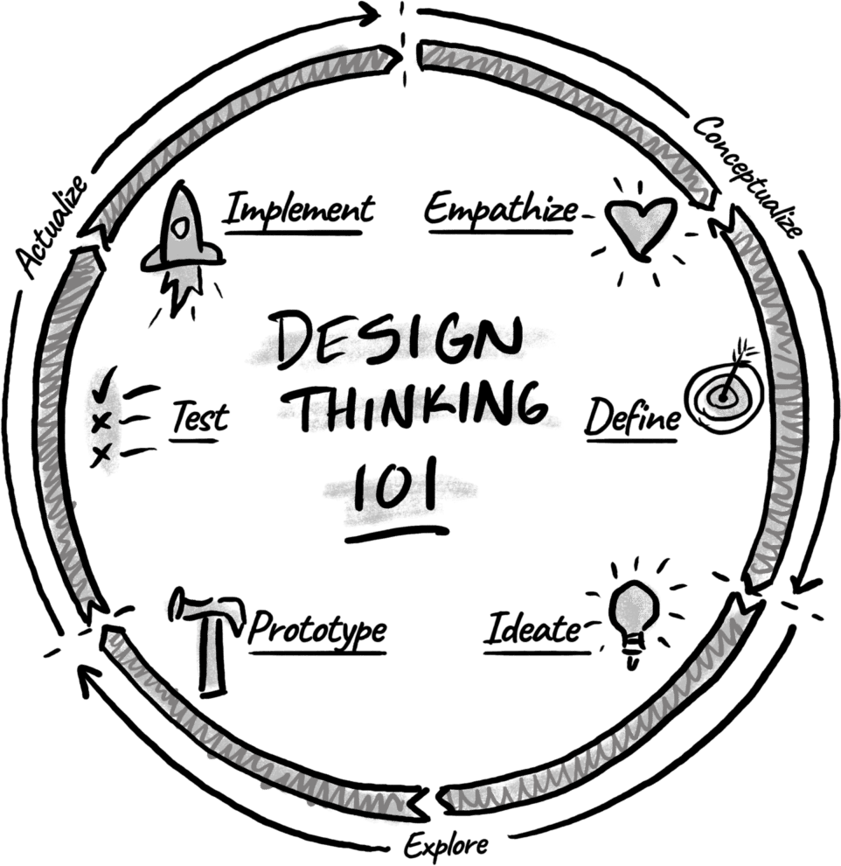

What is the Design Thinking Process?
Design thinking is a process for creative problem-solving that helps teams move past the first “good ideas” and discover creative solutions. Rather than a one-shoe-fits- all mindset, the design thinking approach encourages a holistic view where uncertainty and ambiguity are welcomed and embraced to consider all sides of a problem. A design mindset can be applied to any life situation, and it aids in developing innovative ideas by considering the bigger picture and allowing that to shape our decisions as we move forward.
The method is steeped in a deep belief that the end-user should be at the heart of all decision-making. The benefit of design thinking is that, through empathy for your customer, consumer, or client, you are able to create products and experiences that truly help people and even change lives.

The 5-Step Design Thinking Process:
- Empathize
The first stage of the design process is to develop a deep understanding of the target audience/customer/consumer and their unique perspective to identify and address the problem at hand. To do this, design thinkers are encouraged to cast aside all assumptions because assumptions can stifle innovation about the problem, the consumers, and the world at large. This allows them to objectively consider any and all possibilities about the customers and their needs.
Typical activities:
  - Observations: You’ll go where your users go and see what they care about.
  - Qualitative Interviews: You’ll hold one-on-one interviews with a handful of your users to understand their attitudes on the topic you are exploring. Asking someone to tell a story about the last time they experienced the problem you’re investigating provides a rich description that highlights details you might not have otherwise considered. Check out our Interview Observation template to interview someone that is close to the problem you are having and observe the behavior, success, and pain points.
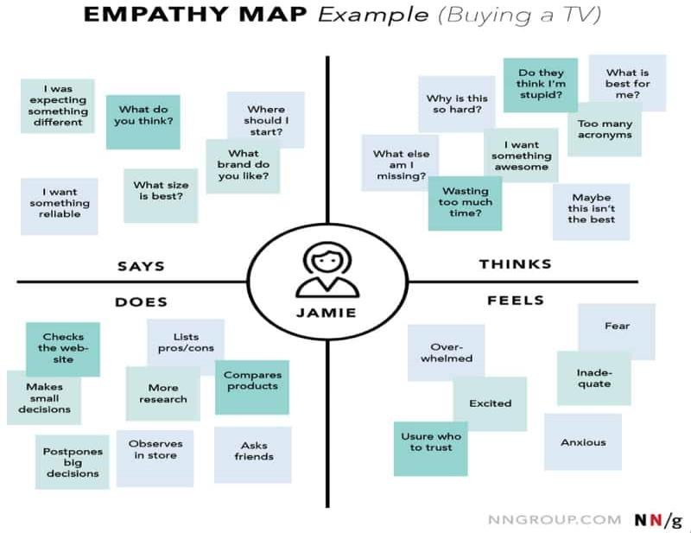

Define
Putting together all of the information gathered from emphasizing in the previous step. The next step is to define the problem statement clearly. The ideal problem statement should be captured from the perspective of human-centered needs rather than focused on business goals. For example, instead of setting a goal to increase signups by 5%, a human-centered target would be to help busy moms provide healthy food for their families.
Based on the frustrations you observed or heard about, come up with questions for how you might solve them.

Typical Activities
  - Clustering and Themes: There are a lot of different ways to go about the Define phase, but it’s safe to say you’ll need a wall of sticky notes; these will be filled with the quotes, observations, and ideas you heard throughout your research. Group and cluster ideas together until you find the prevailing or most prominent themes.
  - Problem Statement: Take time to properly articulate the problem statement. Answer the following questions: 1) What is the problem? 2) Who has the problem? 3) Where is the problem? 4) Why does it matter

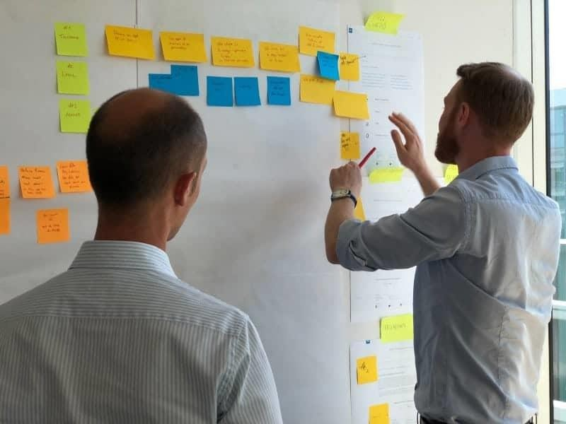
Define your problem statement clearly: group and cluster ideas together until you find the prevailing or most prominent themes.

Ideate
Now that the problem you intend to solve is clear, it’s time to brainstorm ways to address those unmet needs. You collect as many ideas as possible at the start, so your team can investigate and test them by the end.

Typical Activities
  - Brainstorming: Brainstorming is a critical part of the ideation phase, it is the best way to generate of a wide variety of ideas, all aimed at addressing the problem or challenge at hand. Brainstorming allows the entire team to bring their perspectives, experiences, and insights to the table, fostering diversity and richness in idea generation. Ideas shared can serve as stepping stones lead to innovative, out-of-the-box solutions that might not have been uncovered with a more conventional, linear thinking process.
  - Worst Possible Idea: The “Worst Possible Idea” activity may seem counterproductive, but it can encourage creativity and eliminate psychological holdups that stall innovative thinking. It allows team members to brainstorm and share their ‘worst ideas’ without fear of judgment or criticism. This fosters an environment where coming up with the “perfect” ideas is eliminated, allowing freedom and creativity to shine. The process of identifying why an idea is ‘the worst’ can help in understanding the parameters and constraints of a problem, offering insights into what an ideal solution should avoid. This exercise also brings a sense of humor and fun into the brainstorming process!
The ideation phase is usually a very creative and freeing phase for a team because they have permission to think of out-of-the-box ideas before deciding what they are going to prototype.

Prototype
It’s time to experiment! Through trial and error, your team identifies which of the possible solutions can best solve the identified problem(s). This typically will include scaled-down versions of a finished product or systems in question so you can present and get feedback from the people they are intended to serve.

Typical Activities
  - Create a Vision Board: This visual representation of ideas, inspirations, and intended outcomes allows team members to envision the desired final product. By gathering images, drawings, materials, or words that symbolize the goals, functions, and user experience of the prototype, the vision board is a shared reference point for the whole team. It facilitates communication, aligns understanding, and encourages creative problem-solving. The actual process of creating the vision board itself promotes a deeper engagement with the project’s objectives and encourages innovative thinking.
  - Rapid Prototyping: The aim of rapid prototyping is to create low-cost, scaled-down versions of the product or specific features quickly for initial testing. Using paper, sticky notes, cardboard, or digital mockup tools, have the team put their ideas into tangible or visible models. This can be done by drawing, making 3D models, or even creating a storyboard to showcase user interactions. It helps teams understand the look and feel of their solutions, identify potential issues, and validate whether the prototype aligns with users’ needs and expectations. Check out our Take 5 template when you want to collect diverse ideas from the entire room. Within 5 minutes, everyone will be sharing from an intentional perspective using visuals!



Test
The prototype is at the center of the final phase as we put all our ideas to the test. It’s important to note that the testing phase is part of an interactive cycle. You’ll have the opportunity to hear from your users again —just as you did in the early phase, Empathize. User testing is critical to understand how your audience will react to the ideas in your prototype and how desirable that experience will be. Unlike usability testing, where we are seeking to learn how difficult it is to perform certain tasks, you are allowing them to interact with your prototype to observe their responses and gain insights on whether or not it solves their problem.

Typical Activities
  - Observational Testing: In this exercise, real users interact with the final prototype in a controlled setting, while the design team observes their behavior and responses. The goal is not just to confirm if the solution works as intended but to gain deeper insights into how the user interacts with the product, how they approach the problem the product is meant to solve, and where difficulties or confusion arise. Observational testing can offer valuable, sometimes unexpected, insights into user behavior and experience that might be missed with traditional feedback. It’s an empathetic approach that focuses on observing and understanding the users needs and wants.
  - Iterative Testing: This process is all about using the results of the initial testing to make improvements, and then testing again! Check out our 5 act Interview Cheat Sheet to build the best team for the project. The objective is to constantly refine and enhance the solution based on user feedback. Each iteration of the prototype is tested with users, and the insights gathered are used to further refine the solution. This could involve making minor tweaks or massive changes depending on the feedback received. Iterative testing helps in ensuring that the final product is as effective, user-friendly, and problem-solving as possible. The process keeps going until the team is confident that they have the most innovative and best possible version of the solution ready for launch.

REAL TIME EXAMPLE:

Problem statement: Long Waiting Time at a Hospital Reception
Patients often wait in long lines at the reception just to fill forms and get appointment tokens. This creates frustration, stress, and sometimes delays in treatment.
Step 1: Empathize (Understand the People) We observe and talk to:
Patients: "I’m already sick, and standing in line makes it worse." Staff: "We’re overloaded with forms and questions."
Goal: Understand the pain points of both patients and staff.

Step 2: Define (State the Core Problem) Problem Statement:
"Patients have to wait too long at the reception to fill out forms and get appointment tokens."

Step 3: Ideate (Generate Ideas) Brainstorm possible solutions:
A self-service kiosk where patients enter details and print tokens An online form filled before arriving at the hospital
A QR code system that opens a registration form on the phone

Step 4: Prototype (Build a Simple Version) Let’s build a basic digital kiosk:
A touch screen with a simple form
Automatic token printing or create a Google Form with a hospital-branded link to simulate the online version.

Step 5: Test (Try It Out and Improve) We test the digital kiosk at the entrance:
10 patients try it and Staff observe and help

THINKING HATS. HOW DO WE USE IN PROLEM SOLVING?
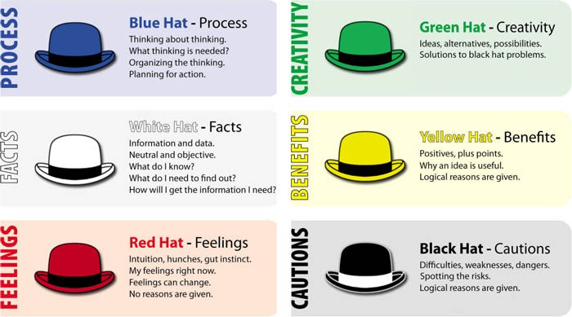
The Six Thinking Hats method, developed by Edward de Bono, is a powerful tool for group discussion and individual thinking. It helps people look at problems from different perspectives in a structured way, improving decision-making and problem-solving.
Here's how each hat works and how it's used in problem-solving:

🎩 1. White Hat (Information)
- Focus: Facts, data, and information available or needed.
- Use: Ask questions like:
  - What do we know?
  - What information is missing?
  - What can we learn from the data?
Example in problem-solving: Gather all relevant statistics, evidence, and information about the problem before making a decision.

🎩 2. Red Hat (Emotions)
- Focus: Feelings, hunches, and intuition.
- Use: Express emotions or gut feelings without needing to justify them.
Example in problem-solving: Understand how team members feel about a proposed solution — fear, excitement, resistance.

🎩 3. Black Hat (Caution)
- Focus: Critical judgment and identifying potential problems.
- Use: Point out risks, weaknesses, and why something might not work.
Example in problem-solving: Assess the drawbacks of a plan before implementation.

🎩 4. Yellow Hat (Optimism)
- Focus: Positive thinking, benefits, and value.
- Use: Explore the positives and potential gains.
Example in problem-solving: Highlight what will work well and the benefits of a proposed solution.

🎩 5. Green Hat (Creativity)
- Focus: New ideas, possibilities, and alternative solutions.
- Use: Think outside the box; encourage brainstorming.
Example in problem-solving: Come up with innovative solutions that haven't been tried yet.

🎩 6. Blue Hat (Process)
- Focus: Managing the thinking process.
- Use: Set the agenda, control the discussion, summarize ideas, and ensure all hats are used effectively.
Example in problem-solving: Decide how the group will proceed and keep the discussion focused.

Real-Life Example
Situation: A company is deciding whether to allow employees to work from home permanently.
They use the Six Thinking Hats approach in a meeting:
- 🎩 White Hat: Looks at productivity data, employee surveys, and internet costs.
- 🎩 Red Hat: Some managers feel uneasy losing face-to-face control. Employees feel happier at home.
- 🎩 Black Hat: Raises concerns about collaboration, security, and accountability.
- 🎩 Yellow Hat: Sees benefits—less office rent, higher job satisfaction, fewer sick days.
- 🎩 Green Hat: Suggests hybrid models, monthly team meetups, or virtual collaboration tools.
- 🎩 Blue Hat: Sets a 30-minute agenda, leads the discussion, and decides to test a 3-month trial work-from-home policy.

Example Scenario
Situation: A college group project is failing because two team members aren't contributing.
They use the Six Thinking Hats:
- 🎩 White Hat: Notes deadlines, who completed what, and how much work is pending.
- 🎩 Red Hat: One member feels angry. Another feels stressed and unsupported.
- 🎩 Black Hat: Warns the project might fail and grades could drop.
- 🎩 Yellow Hat: Points out that there's still time and others are willing to help.
- 🎩 Green Hat: Suggests redistributing tasks and holding short daily check-ins.
- 🎩 Blue Hat: Sets rules, tracks who does what, and decides the new plan.

s

CONCLUSION
The implementation of Design Thinking in addressing the issue of long patient waiting times at the hospital reception has proven to be both effective and impactful. By engaging with
patients and staff through interviews and direct observation, the team gained valuable insights into the challenges faced during the registration process.
Using these insights, the problem was clearly defined, and several user-centred solutions were ideated and prototyped, including self-service kiosks and digital registration forms.
Testing and feedback revealed that these solutions significantly reduced wait times, improved the flow of patients, and enhanced the overall experience for both patients and administrative staff.

