Countable/Uncountable. An infinite set A is countable if there is a one-to-one correspondence
between the elements of A and the set of natural numbers {1, 2, 3, . . .}. A
set is uncountable if it is neither finite nor countable. If we say that a set has at most
countably many elements, we mean that the set is either finite or countable.

Every infinite sequence of distinct items is a countable set, as its indexing puts it in
one-to-one correspondence with the natural numbers
What is Infinite Sequence?

Examples of uncountable sets
include the real numbers, the positive reals, the numbers in the interval [0, 1], and the
set of all ordered pairs of real numbers. An argument to show that the real numbers
are uncountable appears at the end of this section. Every subset of the integers has
at most countably many elements.
Learned Something New !!
Figure 1.4 Partition of S determined by three events A1, A2, A3. (pg- 11)
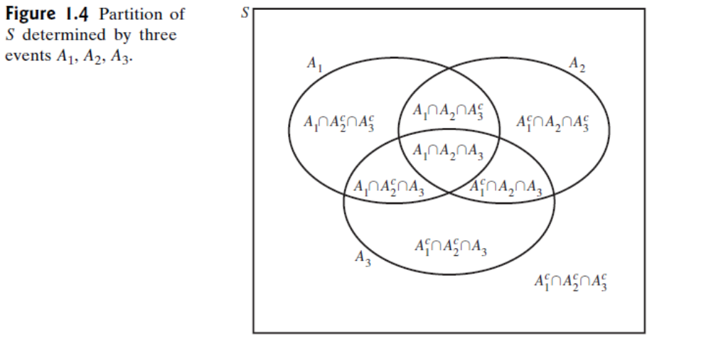
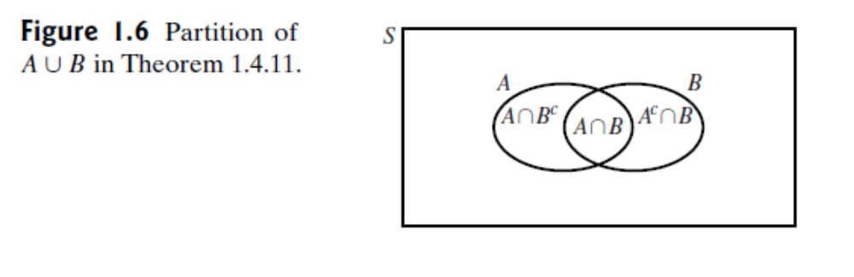
Proof That the Real Numbers Are Uncountable -George Cantor (pg-13)
Watch Infinite Series- Probability

Theorem 1.5.4
If A ⊂ B, then Pr(A) ≤ Pr(B).
Proof As illustrated in Fig. 1.8, the event B may be treated as the union of the
two disjoint events A and B ∩ Ac. Therefore, Pr(B) = Pr(A) + Pr(B ∩ Ac). Since
Pr(B ∩ Ac) ≥ 0, then Pr(B) ≥ Pr(A).
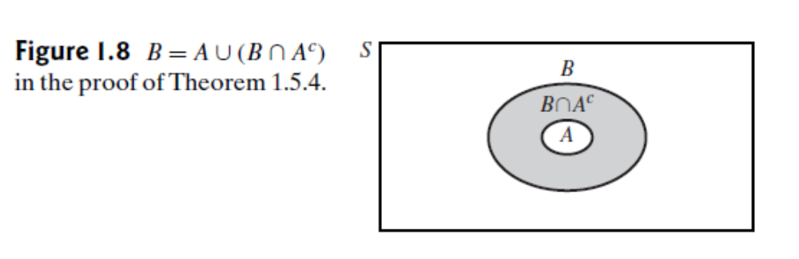
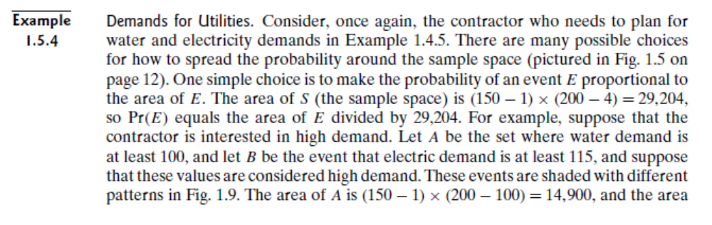
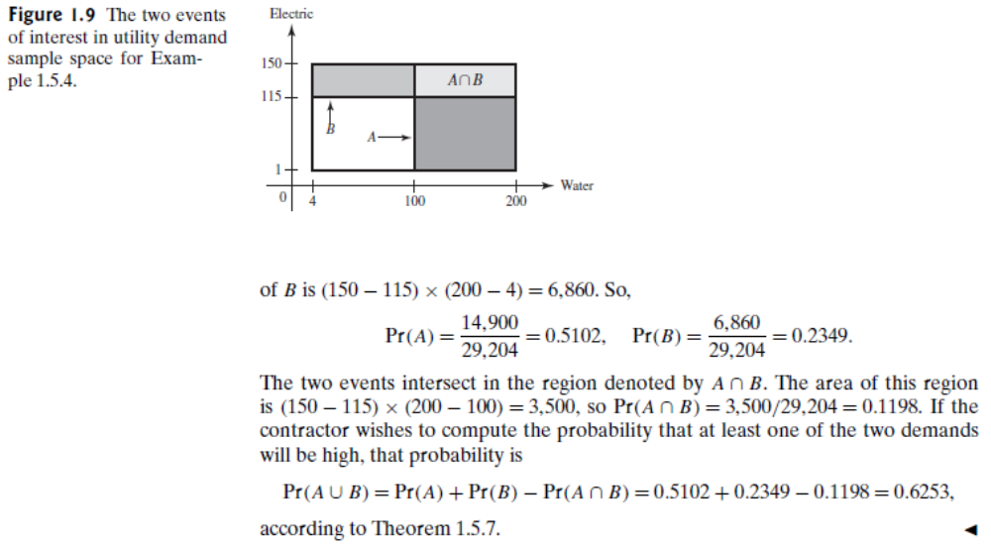

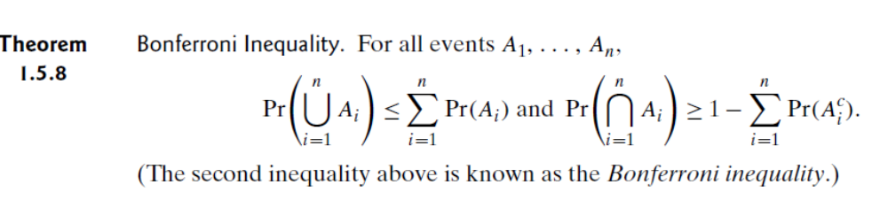
What is Bonferroni Inequality
You can Check it out in free time : Stirling’s Formula (used To approximate large calculations of Permutation )
The Tennis Tournament
Example": 2.14 A Clinical Trial. (pg-57)

Learn From Online:
Prove for Multiplication Rule For Conditional Probability (pg-59)
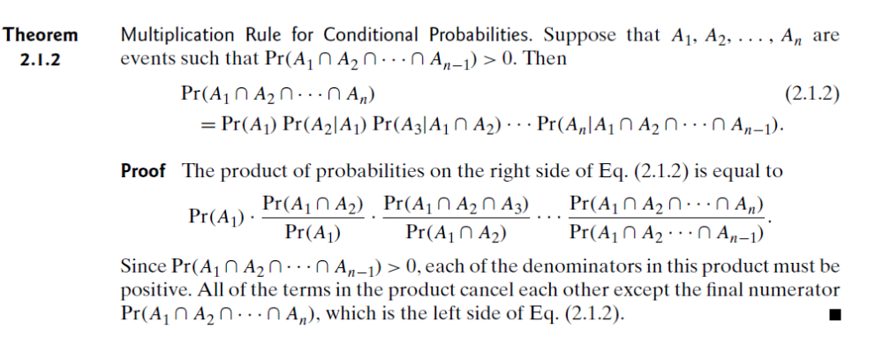
Definition of Independence
The conditional probability of the event A given that the event B has occurred is
the revised probability of A after we learn that B has occurred. It might be the case,
however, that no revision is necessary to the probability of A even after we learn that
B occurs. This is precisely what happened in Example 2.2.1. In this case, we say that
A and B are independent events. As another example, if we toss a coin and then roll
a die, we could let A be the event that the die shows 3 and let B be the event that the
coin lands with heads up. If the tossing of the coin is done in isolation of the rolling
of the die, we might be quite comfortable assigning Pr(A|B) = Pr(A) = 1/6. In this
case, we say that A and B are independent events.
In general, if Pr(B) > 0, the equation Pr(A|B) = Pr(A) can be rewritten as Pr(A ∩
B)/ Pr(B) = Pr(A). If we multiply both sides of this last equation by Pr(B), we obtain
the equation Pr(A ∩ B) = Pr(A) Pr(B). In order to avoid the condition Pr(B) > 0, the
mathematical definition of the independence of two events is stated as follows:
Definition
2.2.1
Independent Events. Two events A and B are independent if
Pr(A ∩ B) = Pr(A) Pr(B).
Independence of Two Events
If two events A and B are considered to be independent because the events are
physically unrelated, and if the probabilities Pr(A) and Pr(B) are known, then the
definition can be used to assign a value to Pr(A ∩ B).
The next example shows that two events A and B, which are physically related,
can, nevertheless, satisfy the definition of independence.
Example
2.2.3
Rolling a Die. Suppose that a balanced die is rolled. Let A be the event that an even
number is obtained, and let B be the event that one of the numbers 1, 2, 3, or 4 is
obtained. We shall show that the events A and B are independent.
In this example, Pr(A) = 1/2 and Pr(B) = 2/3. Furthermore, since A ∩ B is the
event that either the number 2 or the number 4 is obtained, Pr(A ∩ B) = 1/3. Hence,
Pr(A ∩ B) = Pr(A) Pr(B). It follows that the events A and B are independent events,
even though the occurrence of each event depends on the same roll of a die.
The independence of the eventsAand B in Example 2.2.3 can also be interpreted
as follows: Suppose that a person must bet on whether the number obtained on the
die will be even or odd, that is, on whether or not the event A will occur. Since three
of the possible outcomes of the roll are even and the other three are odd, the person
will typically have no preference between betting on an even number and betting on
an odd number.
Suppose also that after the die has been rolled, but before the person has learned
the outcome and before she has decided whether to bet on an even outcome or on an
odd outcome, she is informed that the actual outcome was one of the numbers 1, 2, 3,
or 4, i.e., that the event B has occurred. The person now knows that the outcome was
1, 2, 3, or 4. However, since two of these numbers are even and two are odd, the
person will typically still have no preference between betting on an even number
and betting on an odd number. In other words, the information that the event B has
occurred is of no help to the person who is trying to decide whether or not the event
A has occurred
Bayes’ Theorem
Suppose that we are interested in which of several disjoint events B1, . . . , Bk will
occur and that we will get to observe some other event A. If Pr(A|Bi) is available
for each i, then Bayes’ theorem is a useful formula for computing the conditional
probabilities of the Bi events given A.

Probability Function/p.f./Support. If a random variable X has a discrete distribution,
the probability function (abbreviated p.f.) of X is defined as the function f such that
for every real number x,
f (x) = Pr(X = x).
The closure of the set {x : f (x)>0} is called the support of (the distribution of) X.
Some authors refer to the probability function as the probability mass function, or
p.m.f. We will not use that term again in this text.
Example
3.1.6
Demands for Utilities. The random variable Z in Example 3.1.3 equals 1 if at least one
of the utility demands is high, and Z = 0 if neither demand is high. Since Z takes only
two different values, it has a discrete distribution. Note that {s : Z(s) = 1} = A ∪ B,
where A and B are defined in Example 1.5.4. We calculated Pr(A ∪ B) = 0.65253 in
Example 1.5.4. If Z has p.f. f , then
f (z) =
⎧⎨
⎩
0.65253 if z = 1,
0.34747 if z = 0,
0 otherwise.
The support of Z is the set {0, 1}, which has only two elements.

3.4 Bivariate Distributions
We generalize the concept of distribution of a random variable to the joint distribution
of two random variables. In doing so, we introduce the joint p.f. for two
discrete random variables, the joint p.d.f. for two continuous random variables,
and the joint c.d.f. for any two random variables.We also introduce a joint hybrid
of p.f. and p.d.f. for the case of one discrete random variable and one continuous
random variable.
Joint/Bivariate Distribution. Let X and Y be random variables. The joint distribution
or bivariate distribution of X and Y is the collection of all probabilities of the form
Pr[(X, Y ) ∈ C] for all setsC of pairs of real numbers such that {(X, Y ) ∈ C} is an event.
It is a straightforward consequence of the definition of the joint distribution of X and
Y that this joint distribution is itself a probability measure on the set of ordered pairs
of real numbers. The set {(X, Y ) ∈ C} will be an event for every set C of pairs of real
numbers that most readers will be able to imagine.
In this section and the next two sections, we shall discuss convenient ways to
characterize and do computations with bivariate distributions. In Sec. 3.7, these
considerations will be extended to the joint distribution of an arbitrary finite number
of random variables.
Specifying a Discrete Joint Distribution by a Table of Probabilities. In a certain suburban
area, each household reported the number of cars and the number of television sets
that they owned. Let X stand for the number of cars owned by a randomly selected
household in this area. Let Y stand for the number of television sets owned by that
same randomly selected household. In this case, X takes only the values 1, 2, and 3;
Y takes only the values 1, 2, 3, and 4; and the joint p.f. f of X and Y is as specified in
Table 3.2.

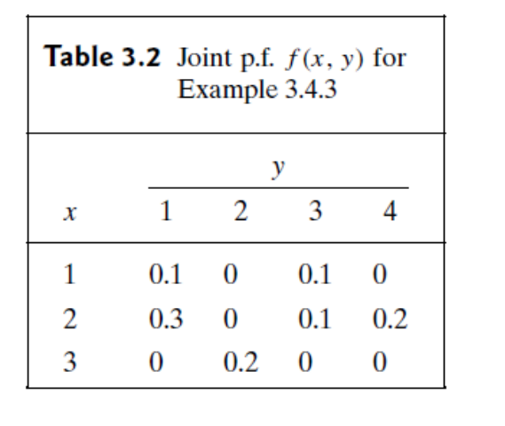
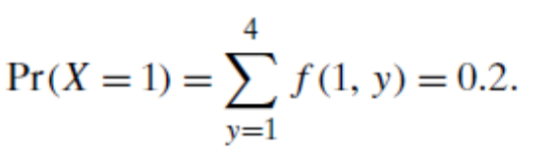
Continuous Joint Distributions
Example
3.4.4
Demands for Utilities. Consider again the joint distribution of X and Y in Example
3.4.1.When we first calculated probabilities for these two random variables back
in Example 1.5.4 on page 19 (even before we named them or called them random
variables), we assumed that the probability of each subset of the sample space was
proportional to the area of the subset. Since the area of the sample space is 29,204,
the probability that the pair (X, Y ) lies in a regionC is the area ofC divided by 29,204.
We can also write this relation as
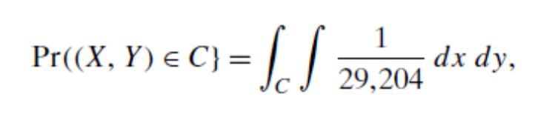
assuming that the integral exists
Calculating aNormalizing Constant. Suppose that the joint p.d.f. ofXand Y is specified
as follows:
